Title: 5G coverage data visualization

GitHub link: [qmzhao26/Information-Visualization (github.com)](https://github.com/qmzhao26/Information-Visualization)

**Figure-1: Bubble chart**

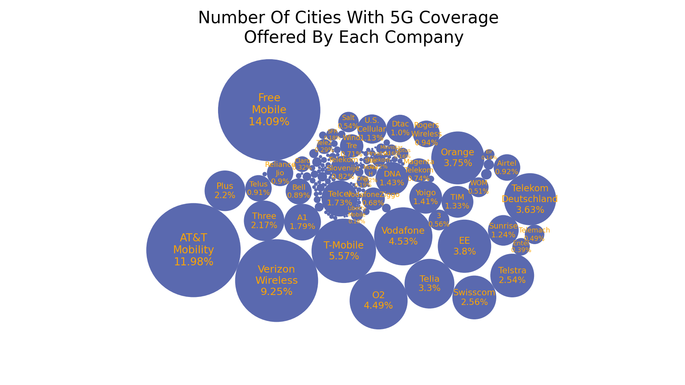

**Legend:**

1. Circle: 5G Operator Companies
2. Circle-size: Number of cities offered by the particular company
3. Text: Company names and its percentage value of the total
4. Text-size: Logarithm of the number of cities

**Findings text introducing highlights of the produced figure in bulletin points:**

1. This is a bubble chart containing all the operators in the world that offer 5G.

2. The size of the bubbles and the size of the text represent the number of cities in

which the operator offers 5G coverage, the higher the number the bigger the

bubble and the text size.

3. Due to the large number of operators (236), the bubble chart visually highlights

information about important carriers (those with more cities covered) and ignores

those that are less important (those with fewer cities covered).

4. By comparing the size of two bubbles, it is possible to visualize the difference in

size between two different operators.

**Source of the dataset: 5G Coverage Worldwide**

[**https://www.kaggle.com/datasets/ddosad/5g-coverage-worldwide**](https://www.kaggle.com/datasets/ddosad/5g-coverage-worldwide)

**Figure-2: Geographic World Map**

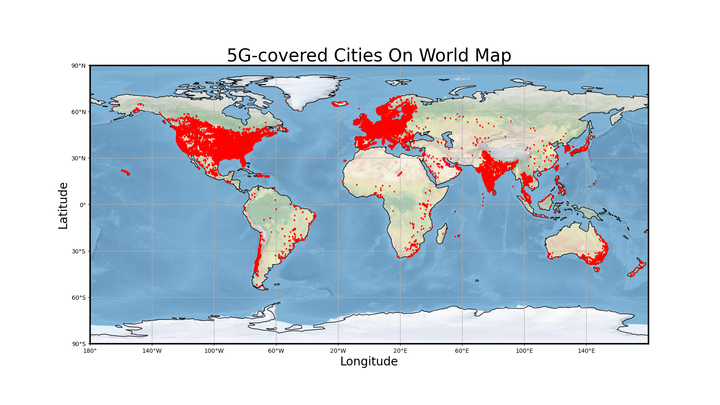

**Legend:**

1. X-axis: The longitude coordinate from -180 degrees to 180 degrees, with the midpoint being exactly the point of 0 degrees west longitude, with a scale line every 40 degrees.
2. Y-axis: The latitude coordinate, from -90 degrees to 90 degrees, with a scale line every 30 degrees.
3. Red triangular point: Red triangular dots, representing the latitude and longitude coordinate points on the map of the cities covered by 5G. The coordinates have undergone Mercator projection to enable them to be displayed in the correct position in the plan spread.
4. Background: The background image is a flat unfolded world map, also Mercator projection mapped.

**Findings text introducing highlights of the produced figure in bulletin points:**

1. This is a geographically informed world map of cities covered by 5G.

2. Each small red triangle represents a 5G-covered city.

3. The geographic map visualizes the data, including which cities have 5G coverage and their geographic locations. By mapping latitude and longitude, it is possible to show the spatial relationship between cities covered by 5G on a flat map. And reveals some geographic patterns in the data, such as clusters, trends, etc. For example, the U.S., Europe, and India have the highest density urban coverage.

4. The geo-graphs are also easy to interact with and can be made into an interactive visualization tool on a web page.

**Figure-3: City Coverage Scatter Maps of the Three Major U.S. Carriers**

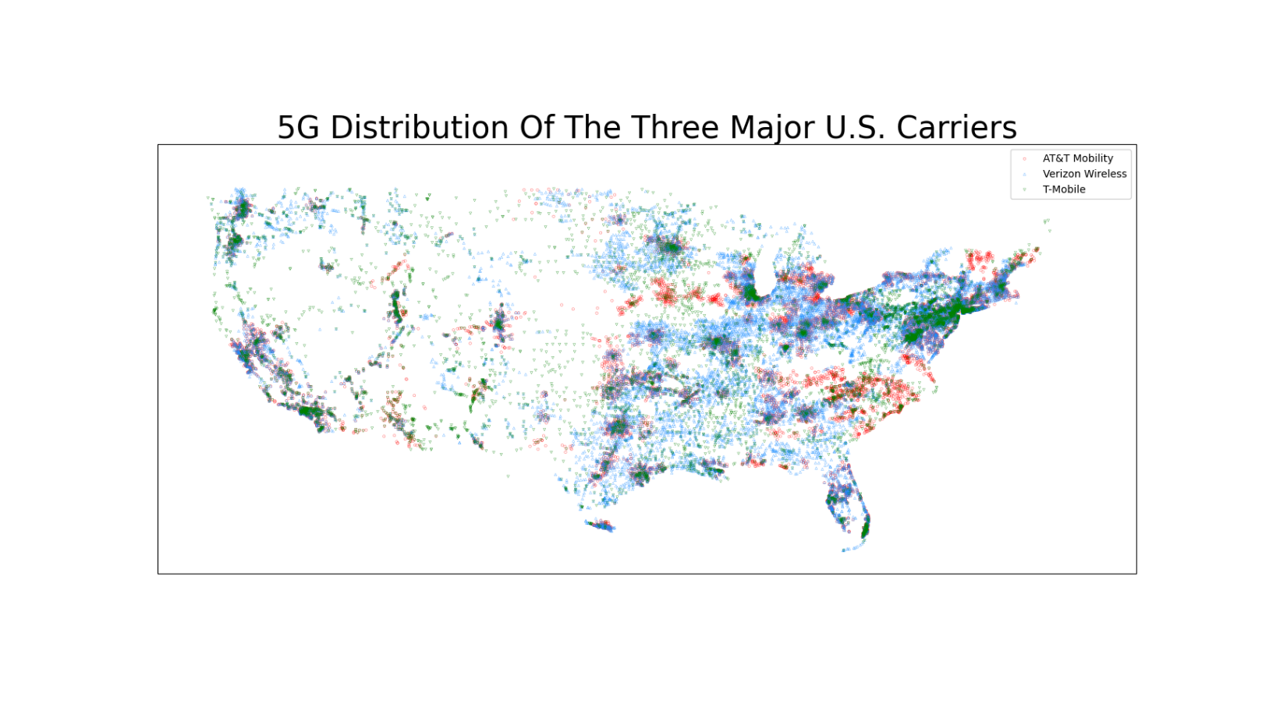

**Legend:**

1. X-axis: The longitude coordinate from -128 degrees to -62 degrees. It's basically the longitude range of the continental United States.
2. Y-axis: The latitude coordinate, from 23 degrees to 52 degrees, with a scale line every 30 degrees. It's basically the latitude range of the continental United States.
3. Red circle point: "AT&T Mobility" covered city, one of the three largest telecommunications carriers in the United States
4. Blue upward triangle: "Verizon Wireless" covered city, one of the three largest telecommunications carriers in the United States
5. Green downward triangle: "T-Mobile" covered city, one of the three largest telecommunications carriers in the United States

**Findings text introducing highlights of the produced figure in bulletin points:**

**1.** This is a scatter plot of cities with 5G coverage from the three major U.S. telcos.

2. Mercator projection was done on all data points to make them display correctly on a 2D plane. The cities covered by the three major carriers are colored in red, blue and green and marked with different markers. The markers have a transparency of only 0.7 so that overlapping points are not completely covered. As shown in the figure, the color is almost a direct reflection of the density of cities covered by 5G signals, as the city coordinates are very dense and somewhat transparent.

3. This chart visualizes the cities covered by the three major carriers in the U.S. and shows the deployment strategies of the three major carriers and how they differ from each other. For example, Verizon in blue is more densely deployed in the eastern part of the U.S., while T-mobile in green has a more even distribution across the U.S. AT&T, in red, also has a greater presence in densely populated cities.

4. This scatterplot visualizes the differences in deployment strategies between different companies, as well as the major carriers in different regions.

**Data and method text describing the data and method used in this process:**

1. All images are plotted based on matplotlib.
2. Geographic information maps use the library “cartopy” for coordinate conversion as well as map display.
3. The bubble map drawing algorithm accomplishes the drawing by iteratively trying to see if there are collisions between the bubbles.
4. Geo chart are Mercator projected using "cartopy" for all coordinates, and are plotted using its own coastline and world map spreads.
5. The scatterplot combines matplotlib's scatter() and set_extent() from the cartopy library to plot the U.S. portion of the region and perform a coordinate transformation

**Significance statement on why the presented figure is important:**

1. The dataset contains 104,033 cities and 236 operators worldwide, totaling 145,629 pieces of data. It can fully demonstrate the relationship between 5G operators and covered cities.
2. The bubble chart allows us to analyze the volume comparisons between carriers by the number of cities they cover with 5G, as well as the percentage of global carriers overall. It can be used to determine a company's business value and capabilities.
3. Geographic information maps can visualize the differences in 5G coverage between different countries, and can reveal to some extent the differences in technology construction between different countries. It also implicitly shows which cities are emerging cities, as it is the trending cities in terms of population and growth that will have companies deploying 5G as soon as possible
4. The scatterplot of the three major U.S. carriers, on the other hand, reflects the differences in deployment strategies between the different carriers and visualizes that the major carriers differ from city to city or state to state. The big cities, especially in the east, are quite densely populated by the three major carriers, and the major carriers in the east are quite densely populated by the three major carriers. It can be used to analyze business strategies and city relationships.