Quynh-anh Nguyen

CSC 3320 Lab 4 In-Lab

4. This will output any line with the string “CSC 3” in it.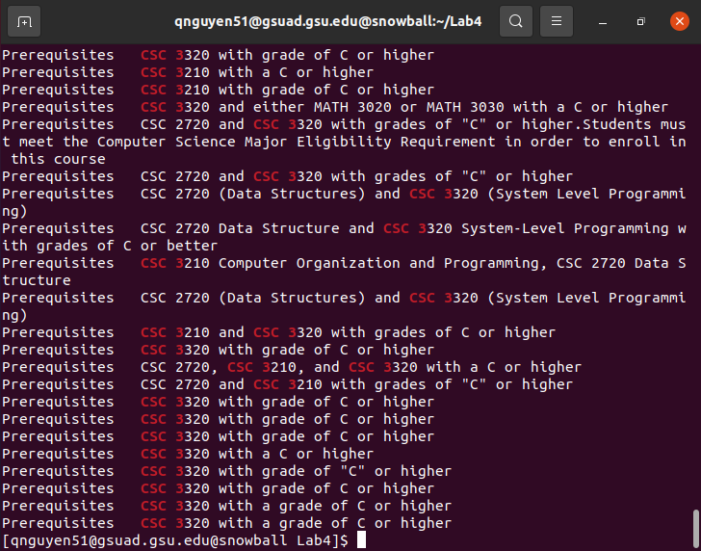

5. No output because grep only looks for one certain string/line, not extended.

6. The output shows any line that contains either CSC 1 or CSC 3, using extended grep to show extended lines.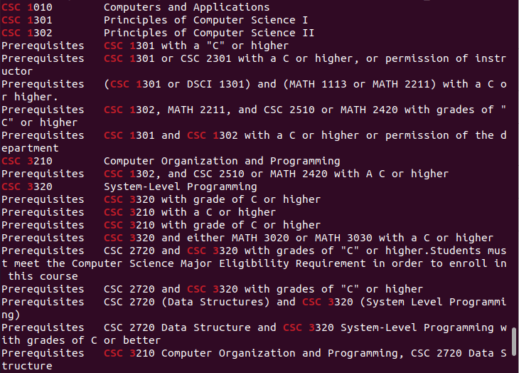

7. egrep is the same as grep -E, so the output will be the same as question 6, showing resulting lines that include CSC 3 or CSC 1.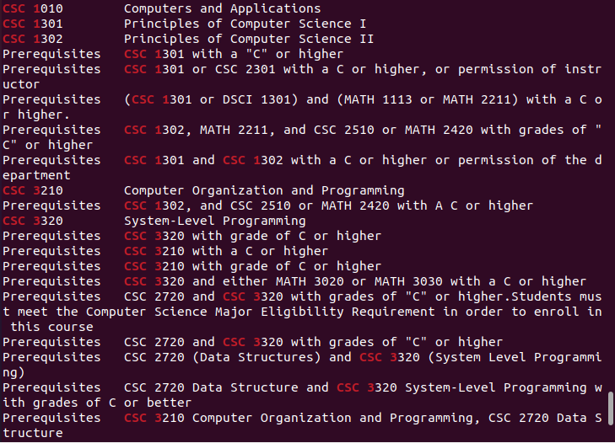

8. fgrep looks for fixed strings in each line, and there are no results as output because there are no lines with that exact expression.

9. This looks for a whole line containing this expression, and there are none containing this, so there is no result.

10. This outputs any line that starts with CSC and ends with Programming, with anything before and after the statement.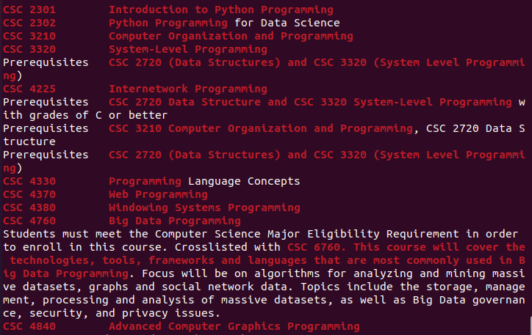

11. This results in any line that exactly starts with CSC and ends in Programming.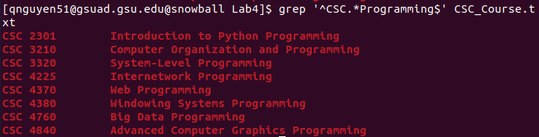

12. This looks for any line that starts with CSC, not including 3 after the CSC, and including 3 twice.

13. This will look for any line that starts with CSC, not including 3 after, and including 3 twice anywhere in the line. 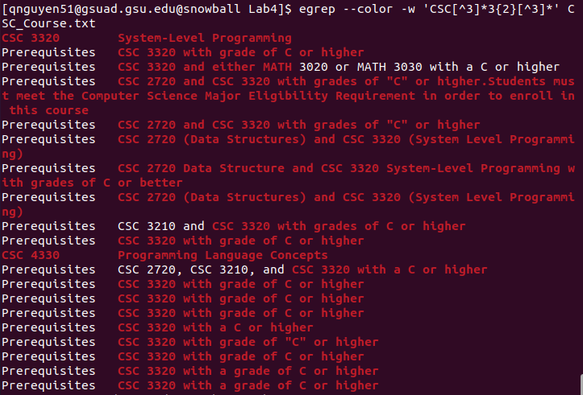

14. This looks for any line that starts with CSC and ends with C++.

15. This looks for any line that starts with CSC and ends with C++.

16. This finds any line that starts with CSC and ends with C.