Quynh-anh Nguyen

CSC 3320

Lab 4 Out of Lab

4a. 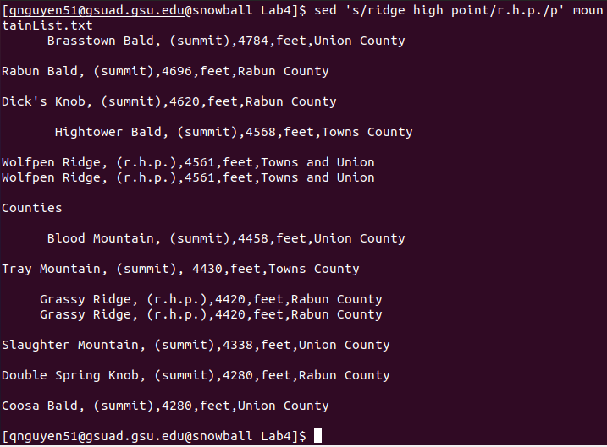

4b. 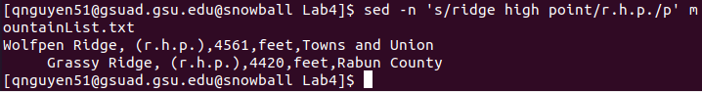

4c. -n will block the sed command from automatically printing every line, rather, it’ll print only specified lines.

4d. It will replace “ridge high point “ from any line that contains it with “r.h.p.”.

15. **sed -E ‘s/,.\*,/,/’ mountainList.txt**