Quynh-anh Nguyen

Lab 5 In Lab

CSC 3320

**1.** -bash: simple.sh: command not found

**2.** -bash: ./simple.sh: Permission denied

**3.** 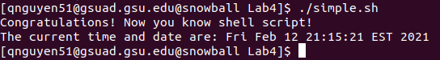

**4.** -n is used to remove newline character from the output.

**5.** Yes

**6.** No, because the line is specifying that the script should be run with bash.

**7.** 5

**8.** No, the directory is now added to path so it can be executed without ./ .

**9.** This command only works during the time we have it open, otherwise, it will revert back.

**10.** Since it only lasted during the duration that we had terminal open, we need to use ./ in order to navigate back to simple.sh or we can add it back to path in order to use simple.sh without the ./ .