Quynh-anh Nguyen

CSC 3320 Lab 6 Out of Lab

**Part A:**



x is set as 0 and i is set as 1; the while loop checks if i is equal or less than to 3 and will loop if it is until it does not meet the conditions; within the loop contains s = i*i (s is equal to the value of i multiplied by i) and x = x+s (the value of x is equal to x added to s) and this will continue to run until the conditions are not met in the while loop. After the loop exits, the command echo x=$x will print “x=” and the value of x after the loop runs.

**Part B:**



**Part C:**

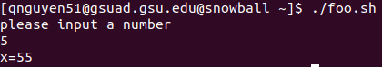

**Part D:**

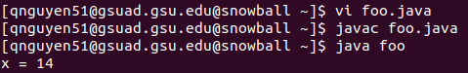

public class foo {

public static void main (String args[]) {

int x = 0;

int i = 1;

int s;

while (i <= 3) {

s = i * i;

x = s + x;

i++;

}

System.out.println(“x = “ + x);

}

}

**Part E:**



The command cc -o hello hello.c creates a file named hello





#include <stdio.h>

int main(void)

{

printf(“My name is Quynh-anh Nguyen\n”);

return 0;

}