Quynh-anh Nguyen

CSC 3320 Lab 7 Out of Lab

1.

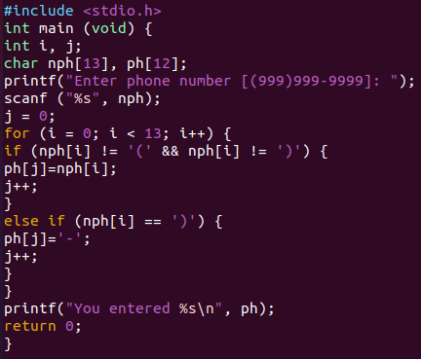



#include <stdio.h>

int main (void) {

int i, j;

char nph[13], ph[12];

printf("Enter phone number [(999)999-9999]: ");

scanf ("%s", nph);

j = 0;

for (i = 0; i < 13; i++) {

if (nph[i] != '(' && nph[i] != ')' {

ph[j]=nph[i];

j++;

}

else if (nph[i] == ')' {

ph[j]='-';

j++;

}

}

printf ("You entered %s\n", ph);

return 0;}

2.

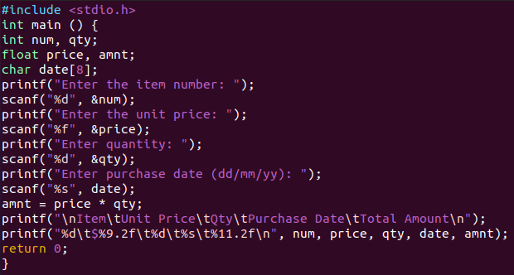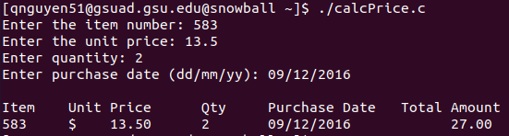

#include<stdio.h>

int main() {

int num, qty;

float price, amNt;

char date[8];

printf("Enter the item number: ");

scanf("%d", &num);

printf("Enter the unit price: ");

scanf("%f", &price);

printf("Enter quantity: ");

scanf("%d", &qty);

printf("Enter purchase date (dd/mm/yy): ");

scanf("%s", date);

amnt = price \* qty;

printf("\nItem\tUnit Price\tQty\tPurchase Date\tTotal Amount\n");

printf("%d\t$%9.2f\t%d\t%s\t$%11.2f\n", num, price, qty, date, amnt);

return 0;

}