Quynh-anh Nguyen

CSC 3320 Lab 9

**Part A:**

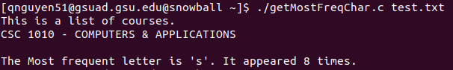

**Part 2:**

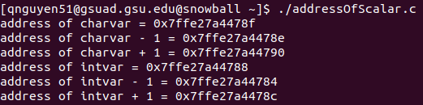

#include<stdio.h>

int main() {

char charvar='\0';

printf("address of charvar = %p\n",(void*)(&charvar));

printf("address of charvar -1 = %p\n",(void*)(&charvar-1));

printf("address of charvar +1 = %p\n",(void*)(&charvar+1));

int intvar=1;

printf("address of intvar = %p\n",(void*)(&intvar));

printf("address of intvar -1 = %p\n",(void*)(&intvar-1));

printf("address of intvar +1 = %p\n",(void*)(&intvar+1));

}

Intvar is initialized as an integer therefore, it is incremented by 4 bytes rather than 1.

**Part 3:**

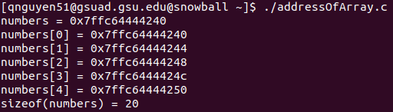

Same

printf("length(numbers)= %lu\n", sizeof(numbers)/sizeof(numbers[0]));