Lab 2 Computer Networks

1. Exploring the Wireshark Interface
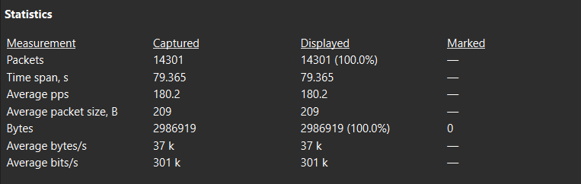
1. How many packets were captured?
14301
2. List the different protocols observed in the Protocol column.
http, eth, dns, data-text-lines, quic, ip, data, ipv6, icmpv6, udp, llmnr, smb, msdo, arp, dhcp, frame, nat-pmp, portcontrol, tls, smpp, nbdgm, mailslot, nbns, browser, _ws.malformed,tcp,mdns,ssdp,json
3. Which protocol appears most frequently?
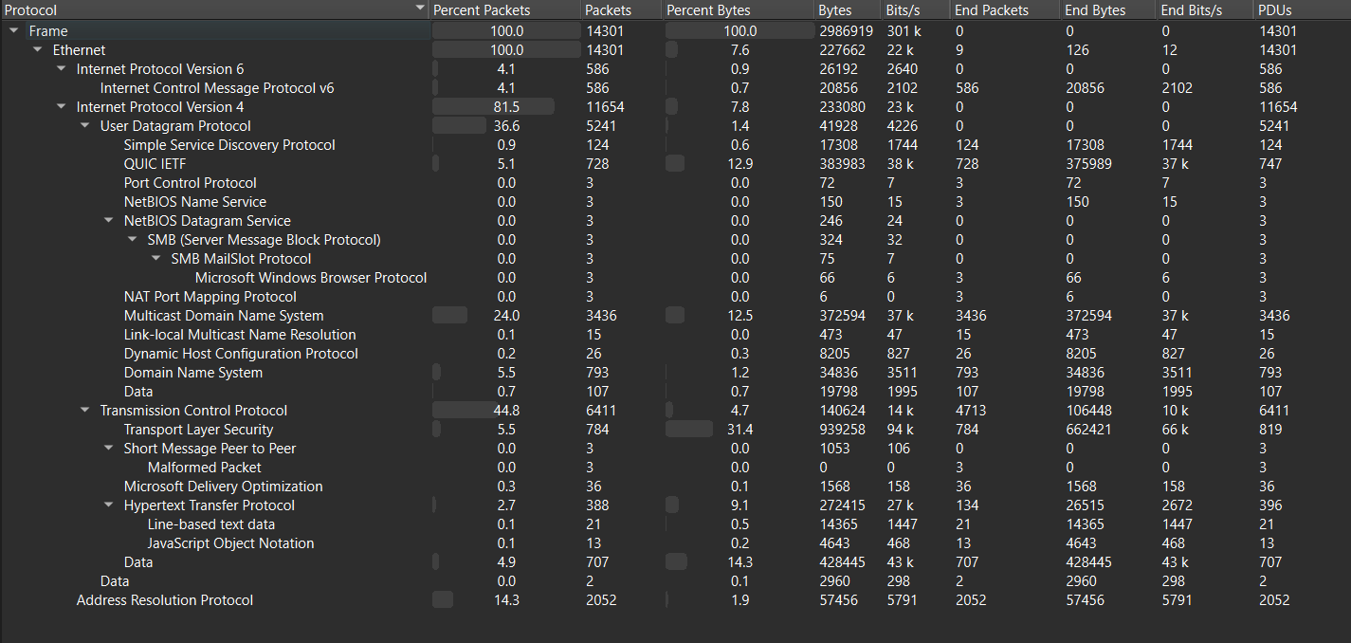
UDP had somewhat more packets than TCP
4. Explain the purpose of the three panes in the Wireshark window.
Packet List: one row per packet — time, source, destination, protocol, summary
Packet Details: expandable tree of the selected packet's headers — Ethernet → IP → TCP/UDP → payload
Packet Bytes: raw hex/ASCII of the selected packet

2. ICMP Packet Analysis
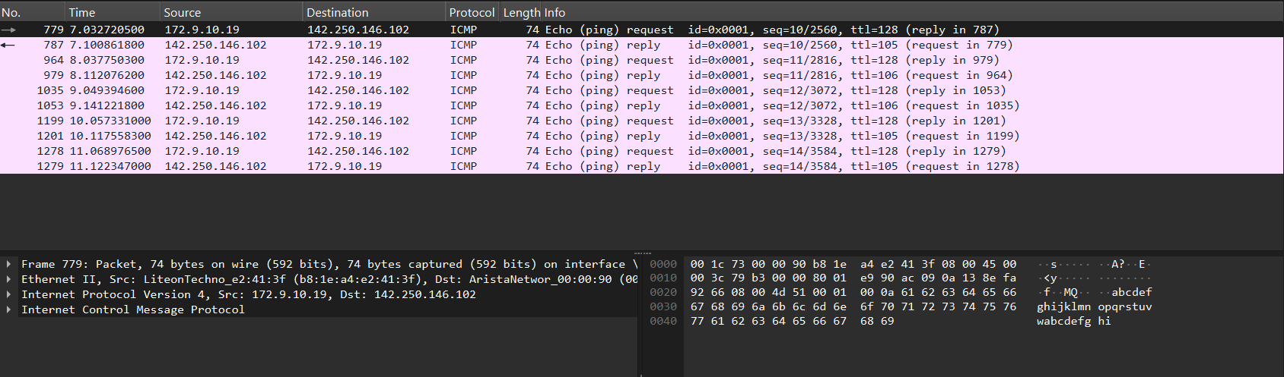
1. What are the source and destination IP addresses?
Source: 172.9.10.19
Destination: 142.250.146.102
2. What is the size of the ICMP packet?
74 bytes
3. What is the TTL (Time to Live) value?
Requests: 128
Replies: 105-106
4. What protocol encapsulates the ICMP message?
Internet Protocol (IP)
5. What is the time difference between the Echo Request and Echo Reply?
~0.068s
6. Repeat the experiment for three different websites and compare their round-trip times. Explain why they are different.
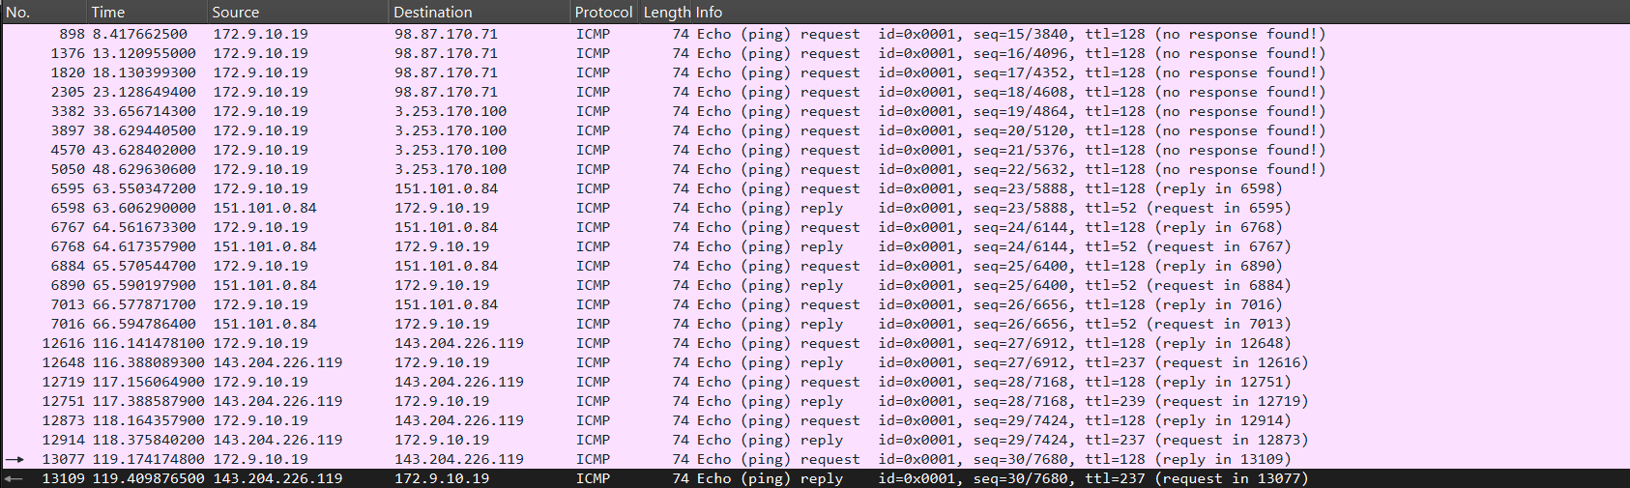
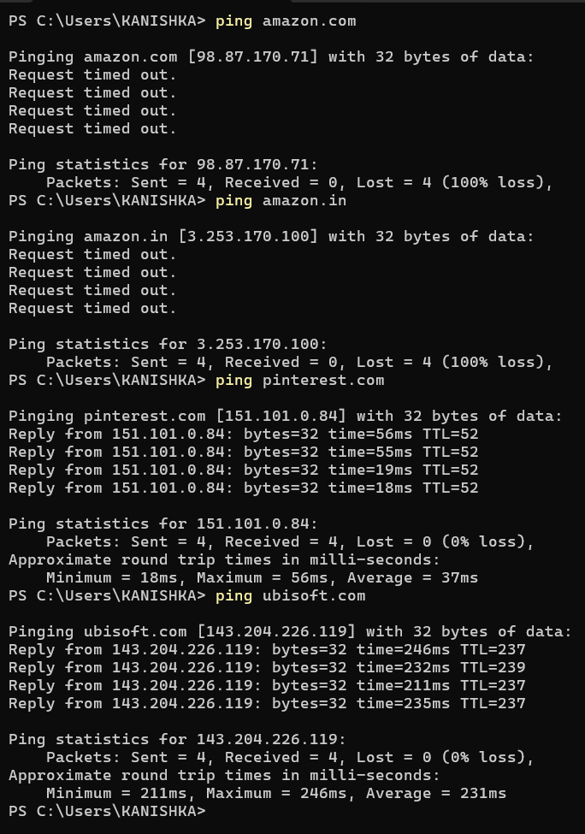
- Amazon didn’t respond
- Pinterest, Ubisoft responded

- Pinterest took 37ms on avg for roundtrip
- Ubisoft took 231ms on avg

The difference is because of the physical distance and number of network hops

3. DNS Packet Analysis
1. What domain name is being queried?

2. How many IP addresses are returned?

3. Record the returned IP address(es).

4. Which device responded to the DNS query?

5. Measure the time between the DNS query and its response.

6. Why is DNS required before a webpage can be accessed?

