Name: GAO QIANXI

Class: DIT/FT/1B/06

Admin no.: 2241434

**ENDPOINT 1:** Return actor information of the given actor_id.

Code 200:

Code 204:

**ENDPOINT 2:** Return the list of actors ordered by first_name, limited to 20 records offset 0 by default.

Code 200:

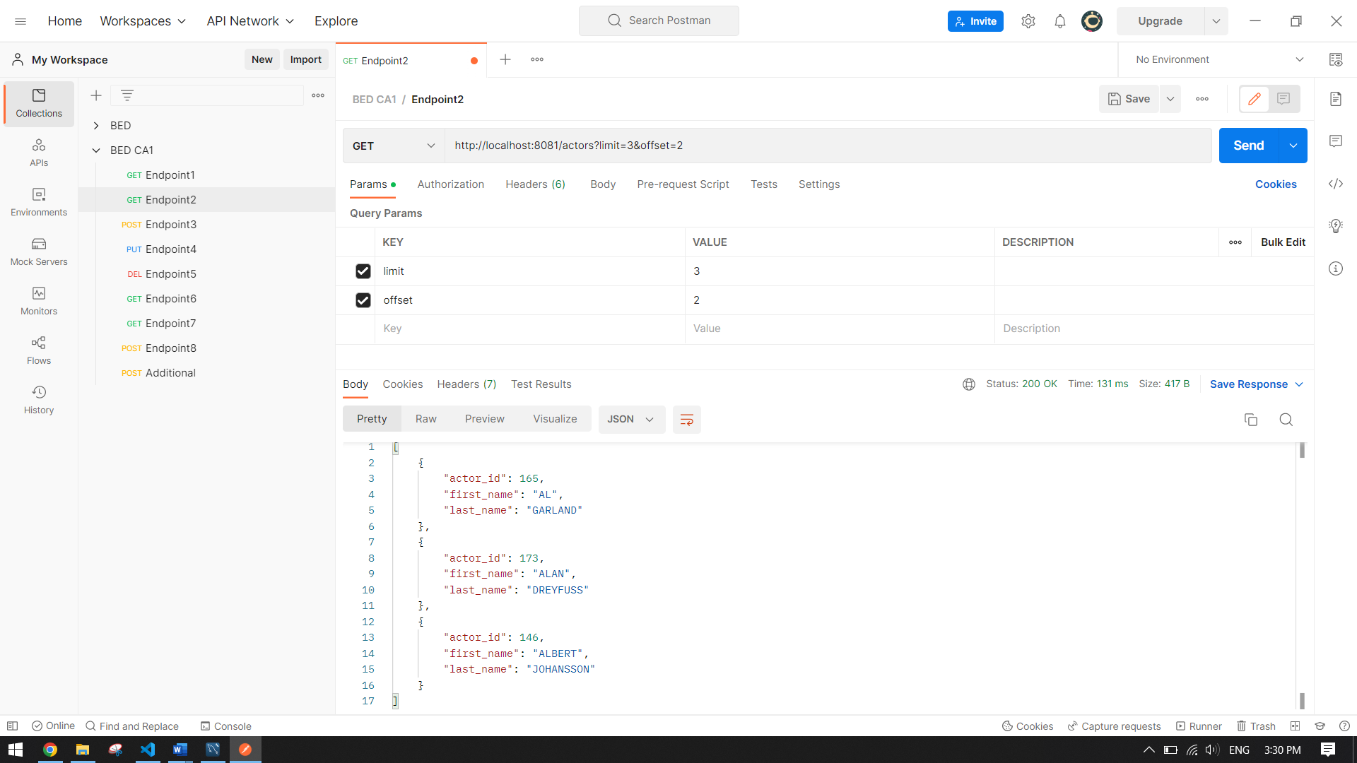

No record found:

**ENDPOINT 3:** Add a new actor to the database (note: actors can have the same first_name and last_name).

Code 201:

Code 400:

**ENDPOINT 4:** Update actor’s first name or last name or both.

Code 200:

Code 204:

Code 400:

**ENDPOINT 5:** Remove actor from database.

Code 200:

Code 204:

**ENDPOINT 6:** Return the film_id, title, rating, release_year and length of all films belonging to a category.

Code 200:

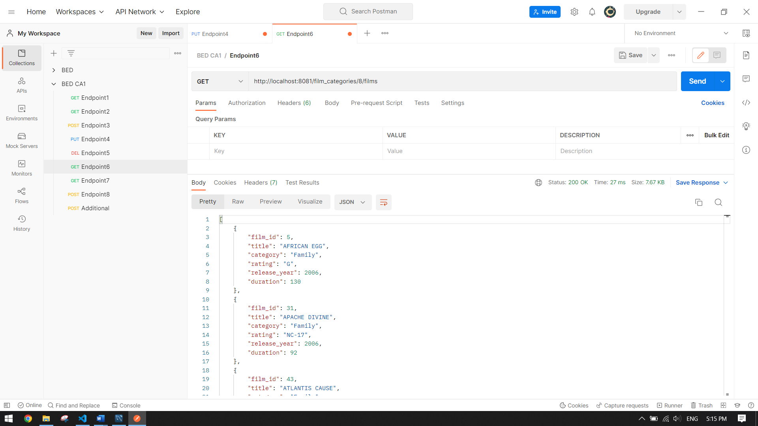

No record found:

**ENDPOINT 7:** Return the payment detail of a customer between the provided period.

Code 200:

No payment details found for given period:

**ENDPOINT 8:** Add a new customer to the database (note: customer’s email address is unique).

Code 201:

Code 400: Remove district California

Code 409:

**ADDITIONAL ENDPOINT:** Add a staff to the database.

Code 201:

Code 400: Remove district California

