Comparison of results between Matlab R2015b and Matlab R2010a

With Matlab R2015b: fmincon with the sequential quadratic programming (sqp) algorithm applied to the function dcc_mvgarch_likelihood.

=== First Step : Estimation of GJR-GARCH ===

Estimating GJR-GARCH model for Series 1

Local minimum possible. Constraints satisfied.
fmincon stopped because the size of the current step is less than
the default value of the step size tolerance and constraints are
satisfied to within the selected value of the constraint tolerance.
<stopping criteria details>

Estimating GJR-GARCH model for Series 2

Local minimum possible. Constraints satisfied.
fmincon stopped because the size of the current step is less than
the default value of the step size tolerance and constraints are
satisfied to within the selected value of the constraint tolerance.
<stopping criteria details>

=== Second Step : Estimation of the DCC ===

Local minimum possible. Constraints satisfied.
fmincon stopped because the size of the current step is less than
the default value of the step size tolerance and constraints are
satisfied to within the selected value of the constraint tolerance.
<stopping criteria details>

=== Third Step : Estimation of the MES ===

Average MES = 0.0315

=== Fourth Step : SRISK computation ===

Average LRMES = 0.3674

Average SRISK = 4694.3953

=== Fifth Step : Estimation of CoVaR and DCoVaR ===

Average DCoVaR (DCC) = 0.0129

Average DCoVaR (quantile regression) = 0.0091

Average DCoVaR (OLS regression) = 0.0099

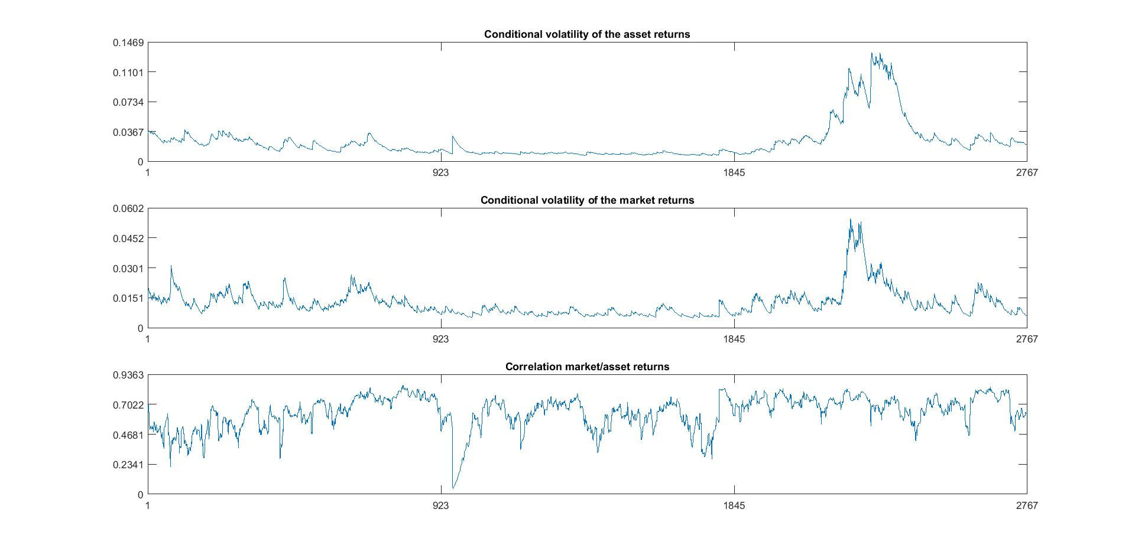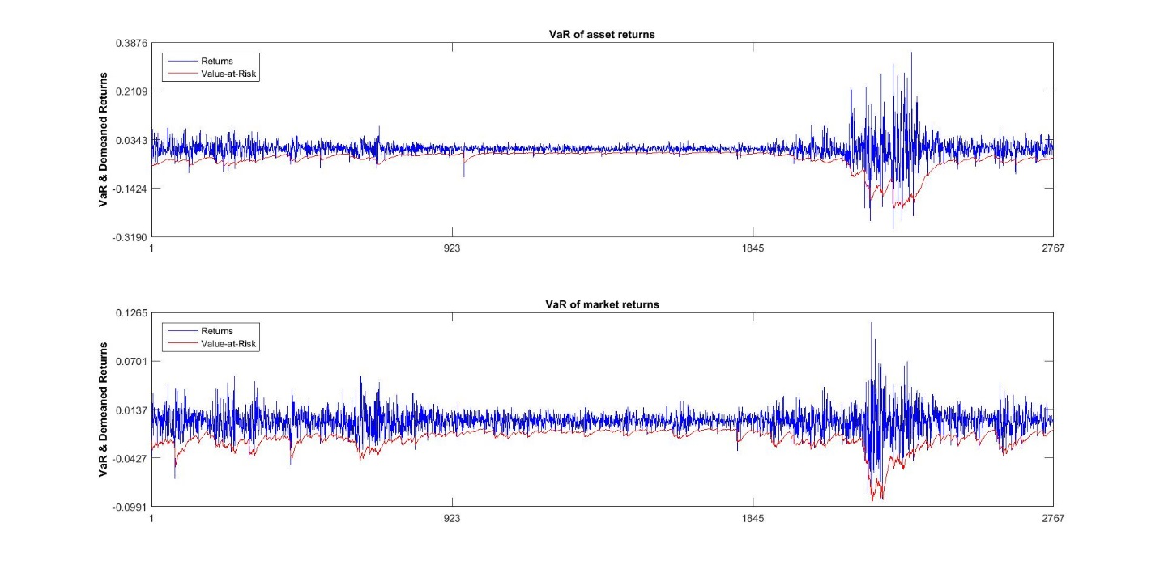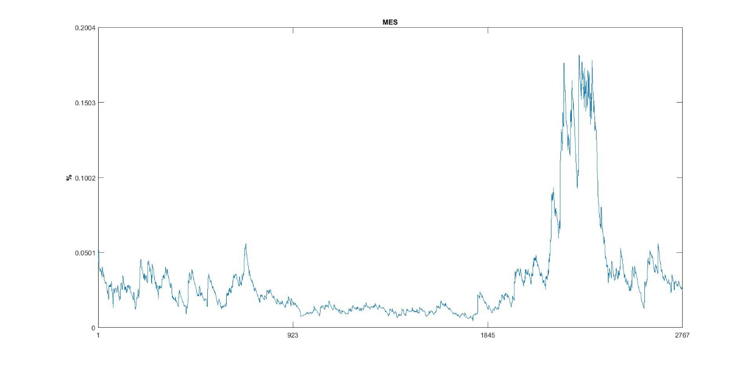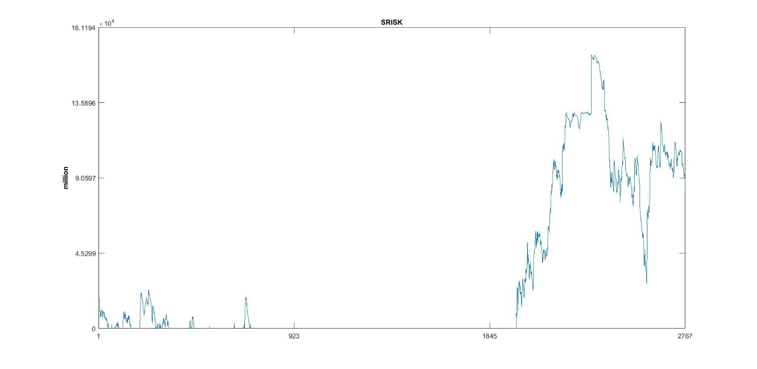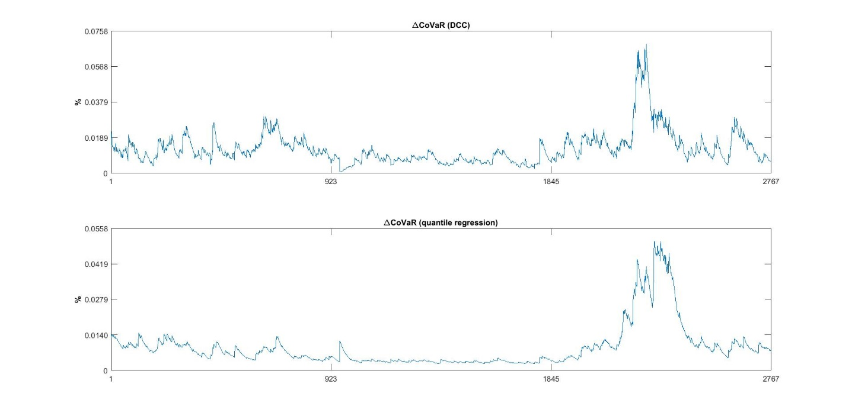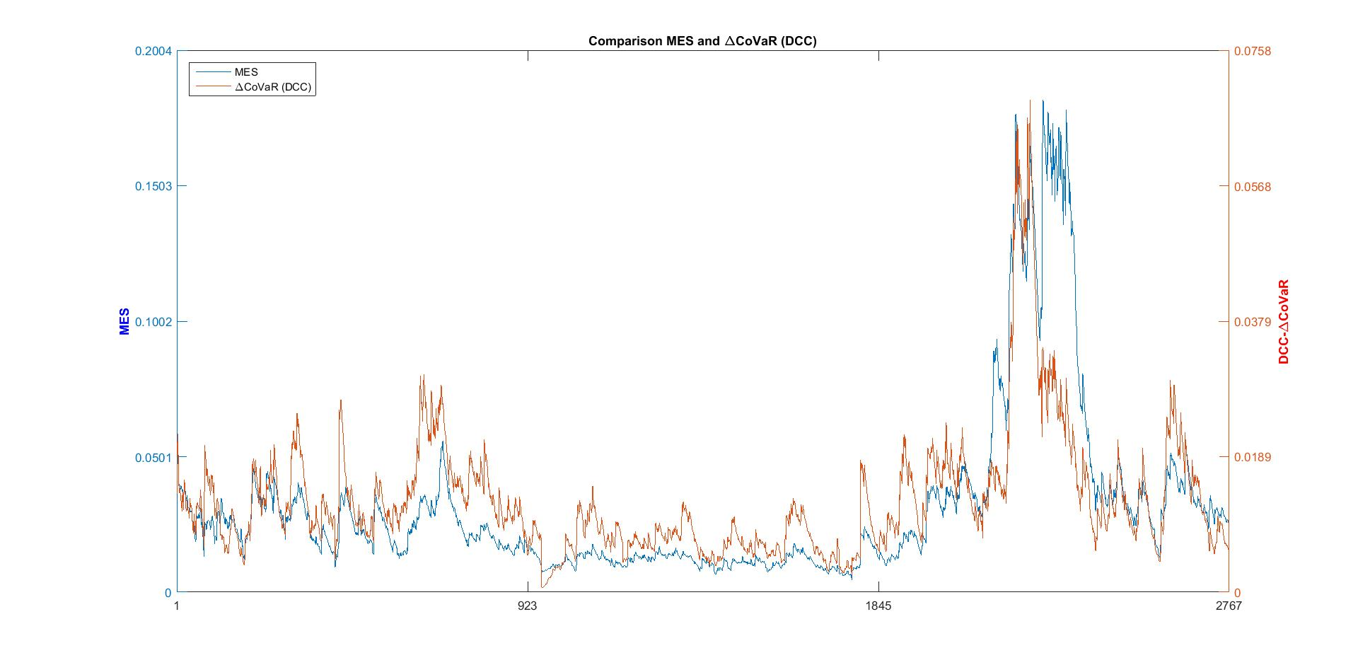

With Matlab R2010a: fmincon with the Levenberg-Marquardt algorithm applied to the function dcc_mvgarch_likelihood.

=== First Step : Estimation of GJR-GARCH ===

Estimating GJR-GARCH model for Series 1

Local minimum possible. Constraints satisfied.
fmincon stopped because the size of the current search direction is less than
twice the default value of the step size tolerance and constraints were
satisfied to within the selected value of the constraint tolerance.
<stopping criteria details>
Active inequalities (to within options.TolCon = 1e-006):
lower upper ineqlin ineqnonlin
1

Estimating GJR-GARCH model for Series 2

Local minimum possible. Constraints satisfied.
fmincon stopped because the size of the current search direction is less than
twice the default value of the step size tolerance and constraints were
satisfied to within the selected value of the constraint tolerance.
<stopping criteria details>
No active inequalities.

=== Second Step : Estimation of the DCC ===

Local minimum possible. Constraints satisfied.
fmincon stopped because the size of the current search direction is less than
twice the default value of the step size tolerance and constraints were
satisfied to within the selected value of the constraint tolerance.
<stopping criteria details>
No active inequalities.

=== Third Step : Estimation of the MES ===

Average MES = 0.0315

=== Fourth Step : SRISK computation ===

Average LRMES = 0.3674

Average SRISK = 4694.3914

=== Fifth Step : Estimation of CoVaR and DCoVaR ===

Average DCoVaR (DCC) = 0.0129

Average DCoVaR (quantile regression) = 0.0091

Average DCoVaR (OLS regression) = 0.0099

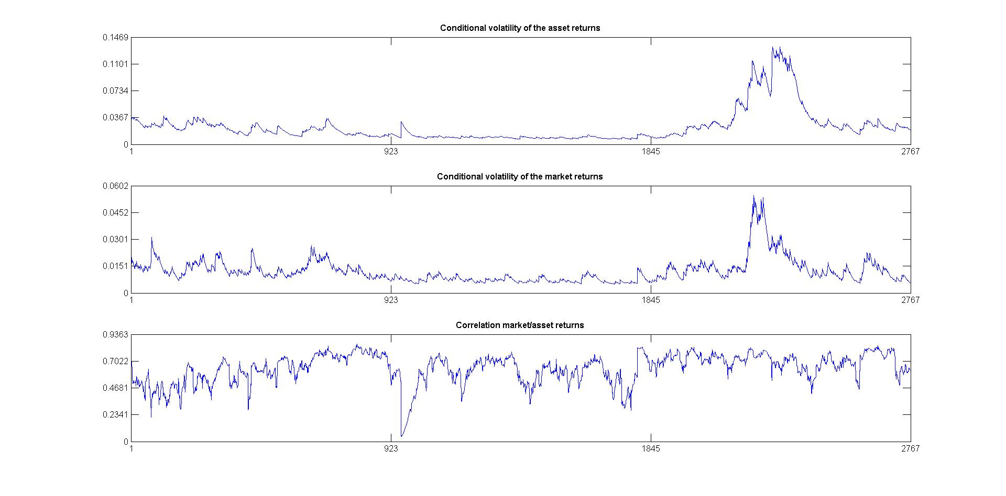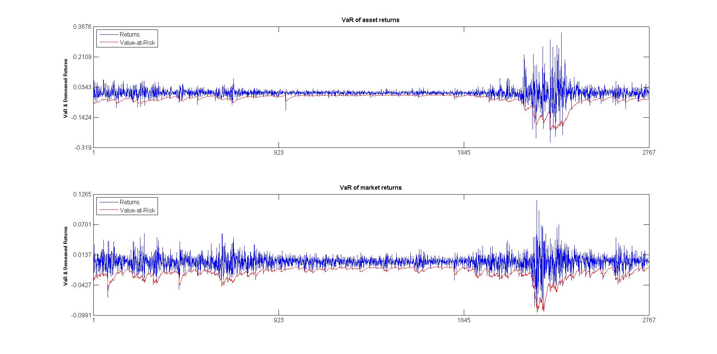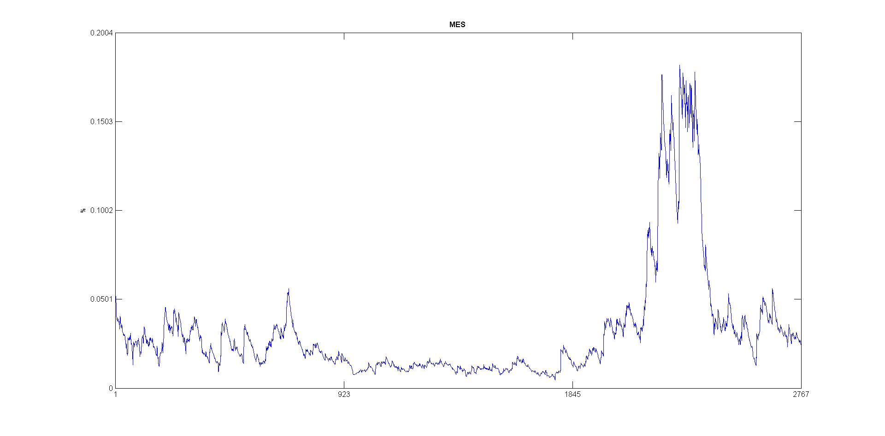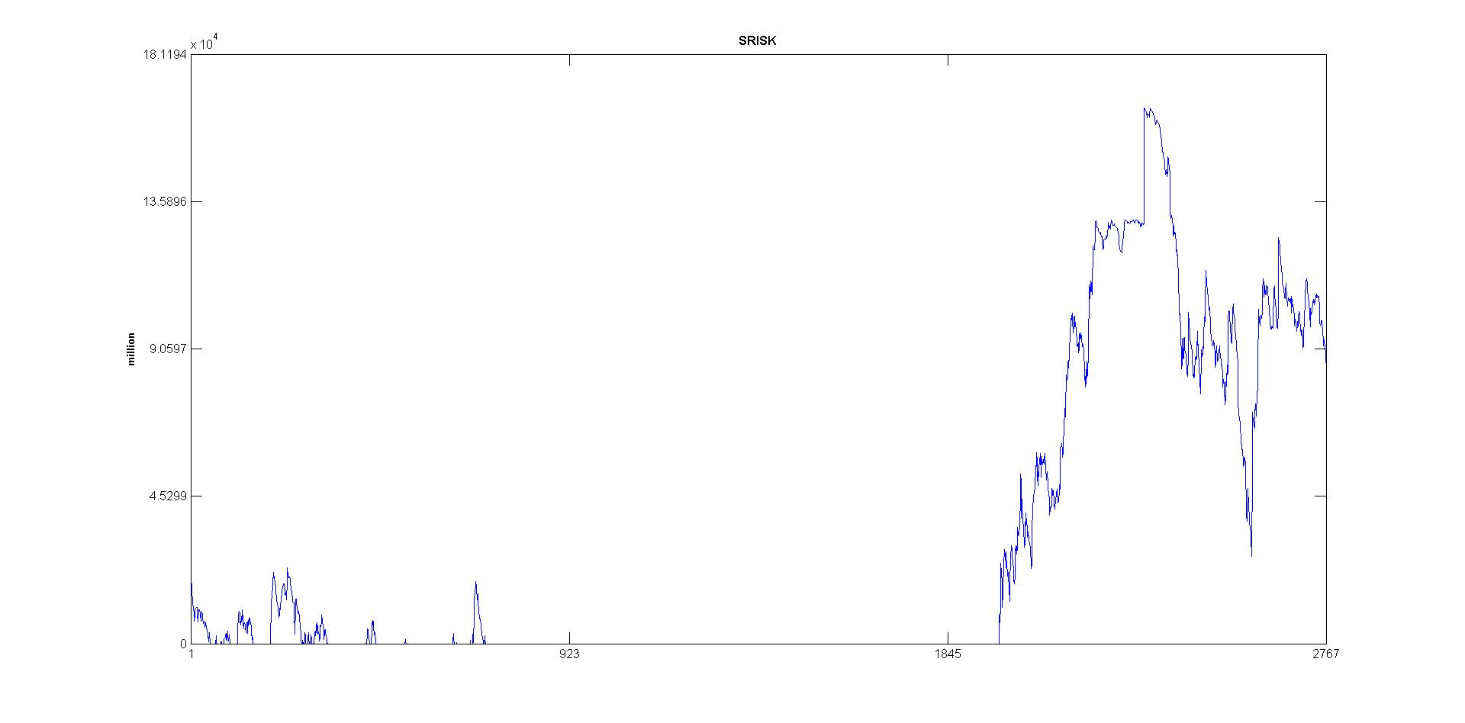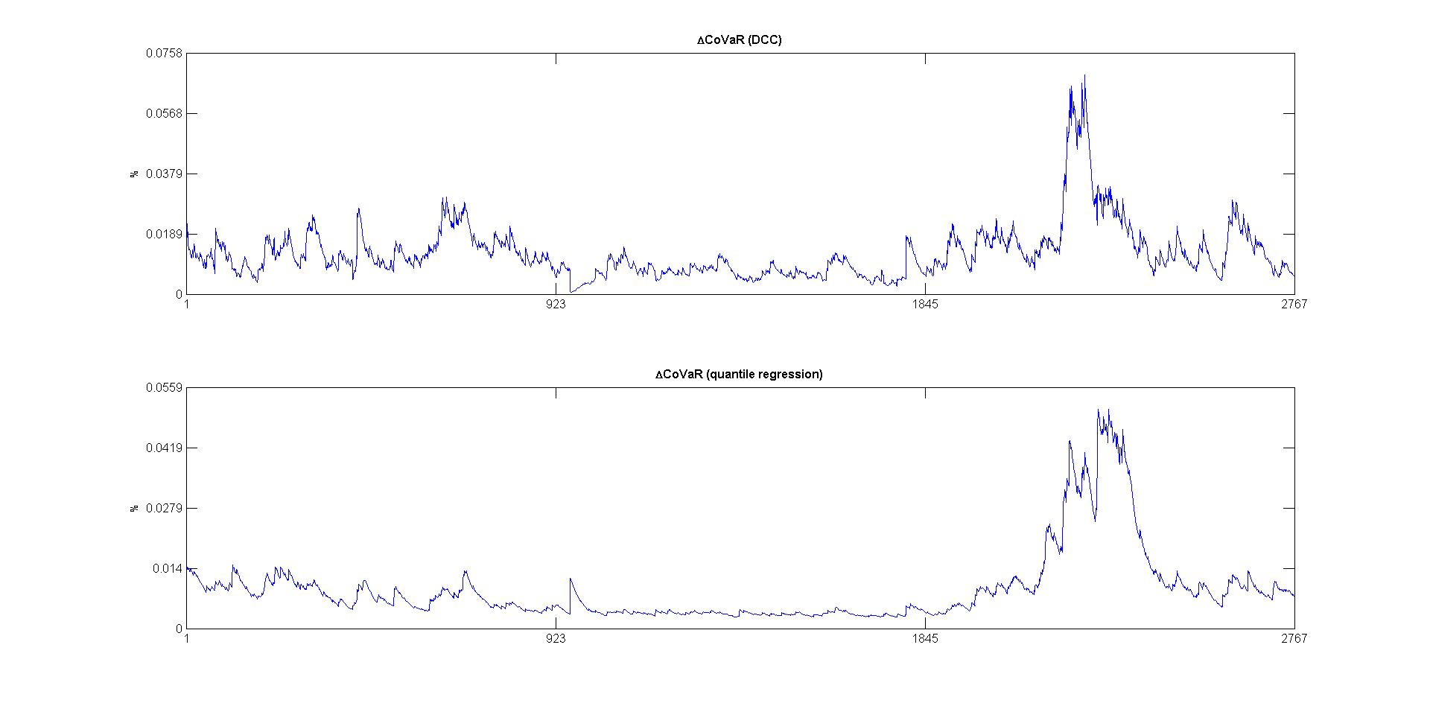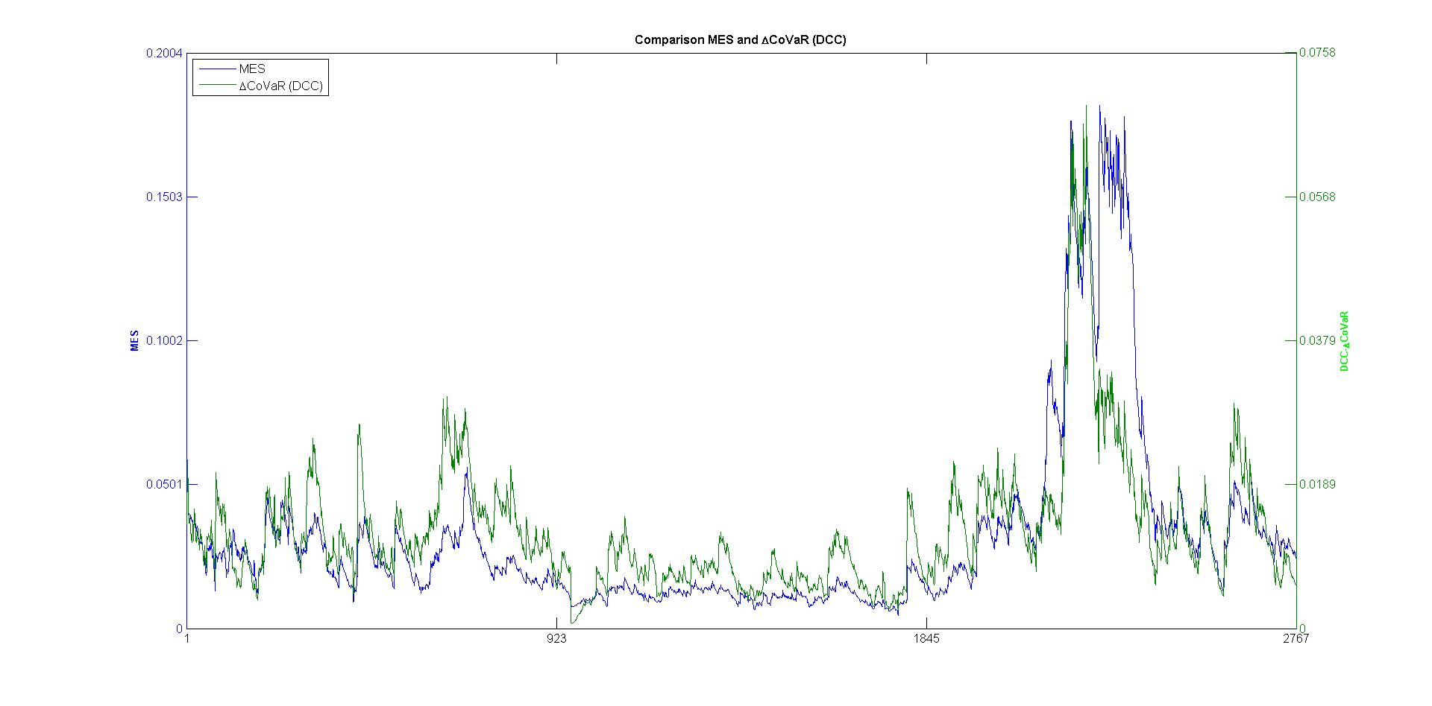
Conclusion: No significant differences are displayed with the example dataset Data_RMC.xls.

