

|  |  |
| --- | --- |
| Objective tests |  |
| Theory |  |
| Practical |  |
| **Total Score** |  |
| **Percentage** |  |

**Do not open until you are told to do so**

**For official use only**

**Follow the instructions:**

* Answer all questions
* Do not write on the question paper
* In case you need clarifications, raise a quiet hand until the invigilator sees you.
* If you cannot answer a question, leave it and go to the next one.

Name:_____________________________________ Date: _________________

Total Marks: 60 Examiner: Mr. Bamidele

Time Allowed: 1 Hour

**Year 8: ICT**

2021/2022 Session

**Summer Term Examination**

**WALDORF KNOLL ACADEMY**

Linking Education to Life

**OBJECTIVE**

1. Which is the physical part of the computer system?
2. Software
3. Hardware
4. OS
5. Processor
6. What type of Application would best be used for typing a letter?
7. Word processing
8. Database
9. Spreadsheet
10. Microsoft Outlook
11. A computer program (set of computer instructions) that coordinates all the activities of computer hardware such as memory, storage devices, and printers, and provides the capability for you to communicate with the computer.
12. Application software
13. Operating system
14. User Account
15. Amazon Web service
16. Data is defined as…
17. Raw unorganized facts, figures and symbols
18. Manipulated facts, figures and symbols
19. Reduced facts, figures and symbols
20. Refined analytics
21. Advantages of having effective information management strategies include:
22. It allows for organisations to collect large amounts of data about their customers.
23. Can be time consuming and costly to implement.
24. Legal obligations and legislations must be factored into documentation or a business may risk their reputation.
25. It helps to hoard information
26. Information is defined as…
27. Data that has not been manipulated into meaningful and useful forms with context.
28. Data that has been manipulated into forms with context.
29. Data that has been manipulated into meaningful and useful forms with context.
30. Data that has to do with sports
31. The three key areas information management strategies must encompass are:
32. the control, storage and disposal of data & information.
33. the access, storage and disposal of data & information.
34. the control disposal of data & information.
35. Data disbursement, data analytics and data overload
36. ______________ a collection of hardware, software, data, people, and procedures that work together to produce quality information.
37. Information technology
38. Information system
39. Network
40. Database
41. We can use ____________________ to keep track of student statistics.
42. Office system
43. Payroll system
44. Accounting Management System
45. Student Information system
46. The process of checking data exists and falls within reasonable data types and range is known as:
47. Input
48. Validation
49. Processing
50. Output
51. Linux, Android, Mac OS are examples of _________ kind of software
52. Application
53. Utility
54. Open source
55. Operating
56. Which resource would have the MOST current information about presidents of the United States?
57. An encyclopedia
58. a book called American Presidents, copyright 2000
59. an article written in 2008
60. “*whitehouse.gov*”, updated daily
61. What is a sign that a website might have trustworthy information? (choose the two best responses)
62. the author is an expert
63. the information is current
64. It is not clear who the author is
65. the information comes from an unknown source
66. Which of the following is a clue that the source is NOT reliable?
67. date of last update is given
68. lots of spelling & grammar errors
69. page contains lots of advertising
70. URL ends in .gov
71. Prejudice in favor of or against one thing, person, or group compared with another, usually in a way considered to be unfair.
72. Bias
73. Propaganda
74. Symbolism
75. Media
76. You can tell that a website is associated with a college or university if the URL ends with...
77. .com
78. .edu
79. .gov
80. .org
81. Critically evaluating content on the Web is important because . . .
82. web authors are always less professional
83. printed information is always more accurate
84. anyone can put stuff on the internet
85. web authors are always biased
86. .org means the webpage is run by...
87. A non-profit organization
88. A commercial group
89. The military
90. The government
91. Which website would be the most reliable?
92. www.kidsastronomy.com
93. www.wikipedia.com
94. www.smithsonianeducation.org
95. www.gossipmagazine.com
96. What do you call the “brain” of the computer?
97. Hard drive
98. Central processing unit
99. Database
100. System software
101. What is the function of the hard drive disk?
102. Memory
103. Storage
104. Visual display
105. Type letter
106. Which of these networks are Private?
107. Intranet
108. Internet
109. MAN
110. Extranet
111. "The **world’s largest computer network** which connects millions of computer all over the world." This is the definition for ...
112. Communication
113. Network
114. World Wide Web
115. Internet
116. www.worldbookonline.com is an example of __________
117. an address bar
118. a URL
119. a browser
120. the internet
121. What is Firewall in a network?
122. The physical boundary of the network
123. A system designed to prevent unauthorized access
124. An operating system of Computer network
125. A web browsing software
126. Computer network is …
127. Interconnected by channels
128. Sharing of resources and information
129. Collection of hardware components and computers
130. All of the above
131. What is the use of Bridge in a network?
132. To control network speed
133. To connect LANs
134. To separate LANs
135. To detect virus
136. Each data packet that is sent in a network must contain………
137. Source and Destination address
138. Only source address
139. Only Destination address
140. Virus Payload
141. A device that connects to a network without the use of cables is said to be:
142. Distributed
143. Cabled
144. Centralized
145. Wireless
146. Which of the following is the communication protocol that sets the standard used by every computer that accesses web-based information?
147. XML
148. DML
149. HTTP
150. HTML

**THEORY**

1. Please fill in the gap for the following:
2. When you send a message over the Internet, your computer divides it into small chunks called **___________** that it sends individually, each on its own path. A **___________** can include any kind of data: text, numbers, lists, etc. Computers, servers, and routers are fairly reliable, but every once in a while a **___________** could be lost, and devices on the Internet need to tolerate these faults.

[1]

1. List **FOUR** protocols used in Internet Technology.
2. _________________________________________________________________________________________
3. _________________________________________________________________________________________
4. _________________________________________________________________________________________
5. _________________________________________________________________________________________

[4]

1. What is a **ROUTER** used for in a network?

______________________________________________________________________________________________________________________________________________________________________________________________________________________________________________________________________________________________[1]

1. What is an Antivirus software?

__________________________________________________________________________________________________________________________________________________________________________________________________________________________________________________________________________________________________________________________________________________________________________________________________________________________________________________________________________________________________________________[2]

1. ABC Supermarket has acquired an application to generate cash receipts for goods purchased by its customers as shown in the diagram below. The amount for each item is obtained by multiplying the unit price and quantity of goods purchased. The subtotal is a summation of the amounts obtained for all purchased items.

The tax payable is computed at the rate of 10% of the subtotal. The total amount to be paid is the summation of the subtotal and the tax payable on purchased items.

Using the diagram below, answer the questions that follow:

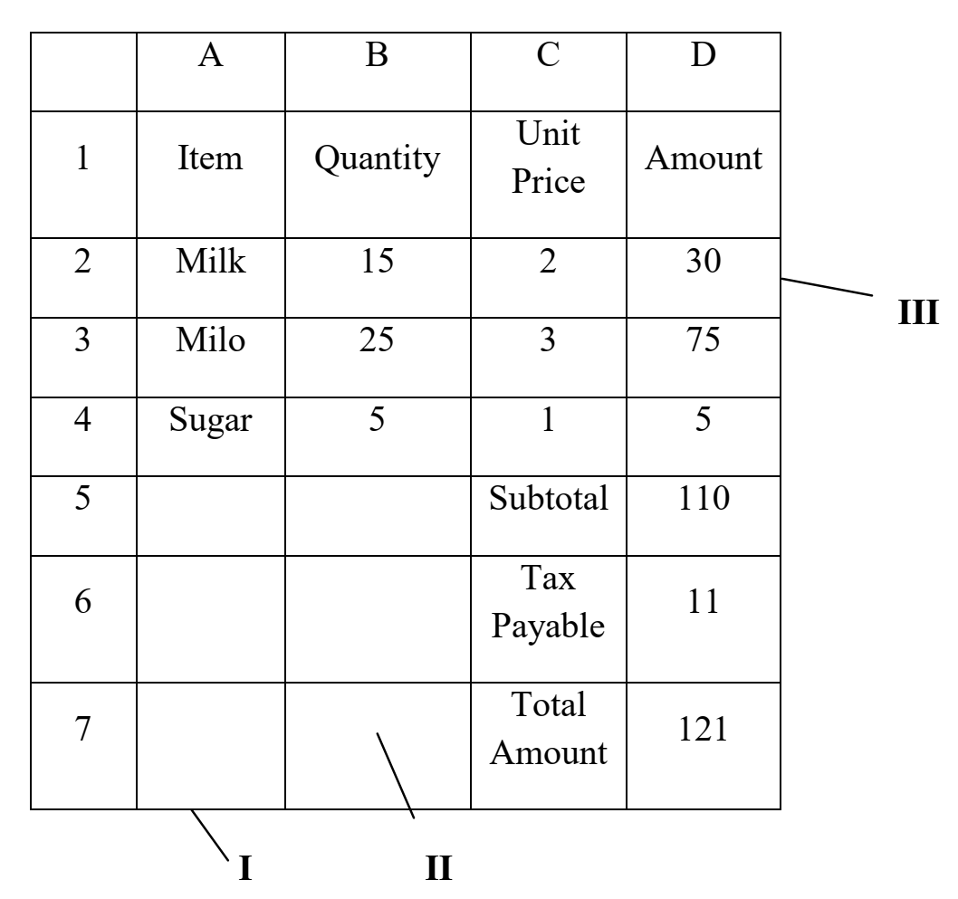

1. Name the Application program used in creating the above:

______________________________________________________________________________________________[2]

1. Identify the parts labelled I, II, and III.

______________________________________________________________________________________________________________________________________________________________________________________________________________________________________________________________________________________________[3]

1. Provide the formula used in calculating the following cells:

D2: ___________________________________________________________________________________________[2]

D5: ___________________________________________________________________________________________[2]

D6: ___________________________________________________________________________________________[2]

1. State **TWO**:
2. Positive uses of the Internet

______________________________________________________________________________________________________________________________________________________________________________________________________________________________________________________________________________________________________________________________________________________________________________________________[4]

1. Negative uses of the Internet

______________________________________________________________________________________________________________________________________________________________________________________________________________________________________________________________________________________________________________________________________________________________________________________________[4]

1. List THREE areas of learning where information and communication technology tools can be  
   integrated.

__________________________________________________________________________________________________________________________________________________________________________________________________________________________________________________________________________________________________________[3]

1. List **THREE** softwares that can be used in Video conferencing.

__________________________________________________________________________________________________________________________________________________________________________________________________________________________________________________________________________________________________________[3]