09-16-2018

1.

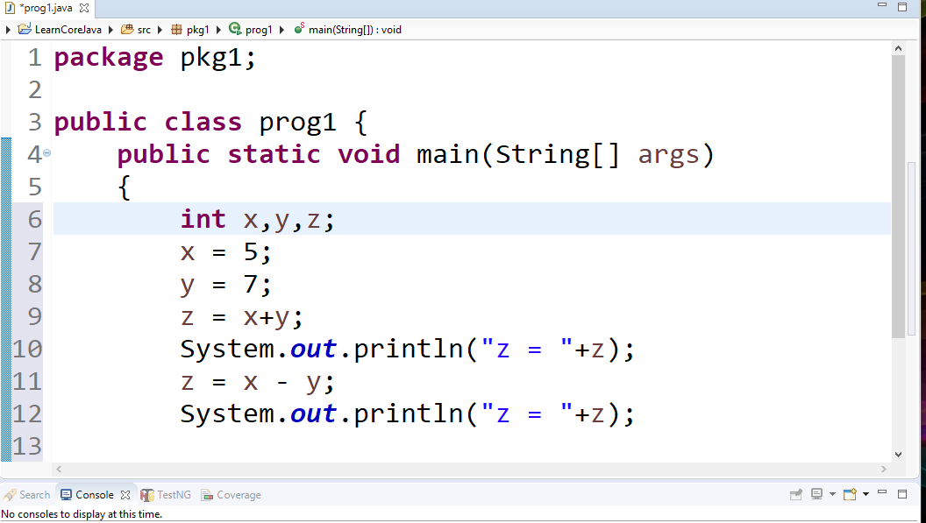

2:

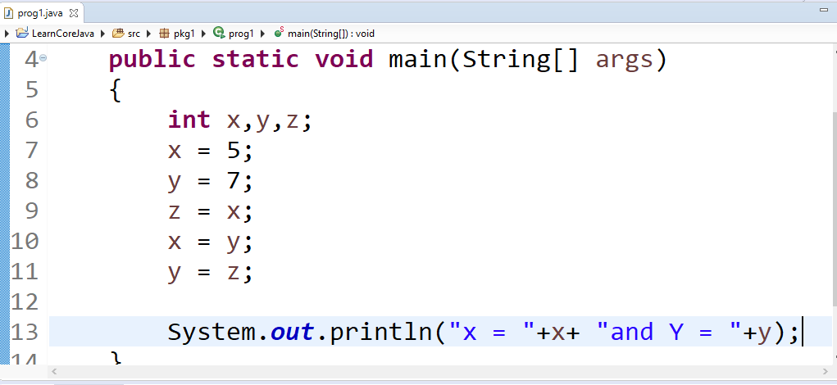

3.

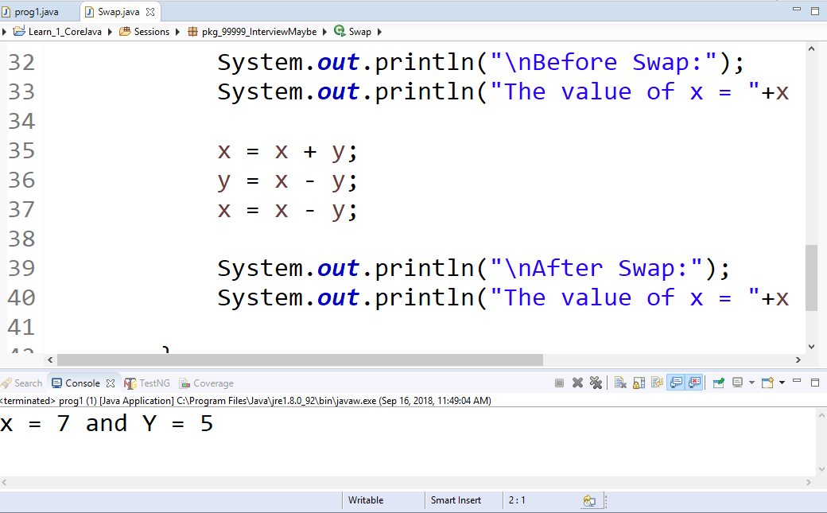

4.

**public** **class** oddAndeven {

**public** **static** **void** main(String[] args) {

**int** x = 59;

**if**((x % 2) == 0)

{

System.***out***.println("The number is even");

System.***out***.println("Thankyou");

}

**else**

{

System.***out***.println("The number is odd");

System.***out***.println("NOThankyou");

}

}

}

5.