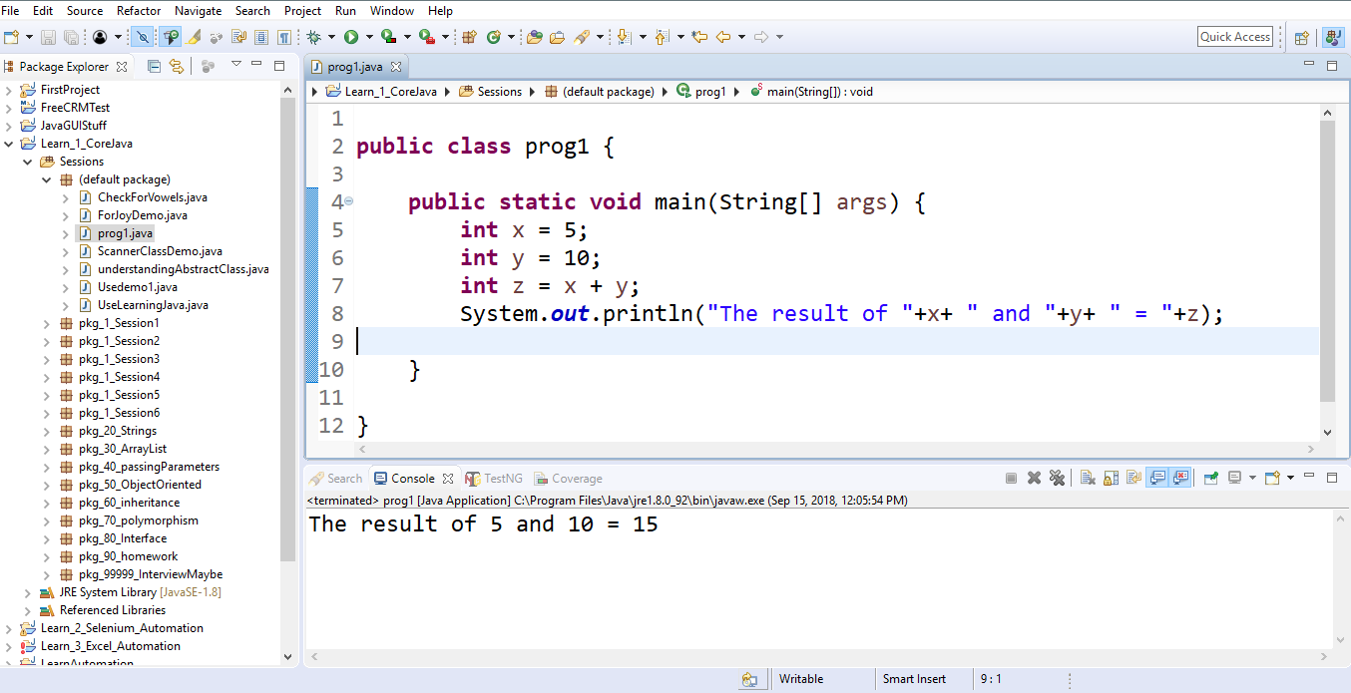

**public** **class** ifthenelse {

**public** **static** **void** main(String[] args)

{

**int** x,y;

x = 120;

y = 50;

//z = 50;

**if**(x > y)

{

System.***out***.println("X is greater than y");

}

**else**

**if**(x < y)

{

System.***out***.println("X is less than y");

}

**else**

**if**(x >= y)

{

System.***out***.println("X is greater than or equal to y");

}

**else**

**if**(x <= y)

{

System.***out***.println("X is less than or equal to y");

}

**else**

**if**(x != y)

{

System.***out***.println("X is NOT equal to y");

}

**else**

{

System.***out***.println("I dont know what's going on");

}

}

}