**1:**

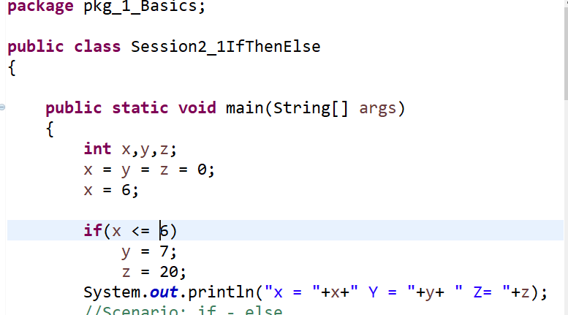

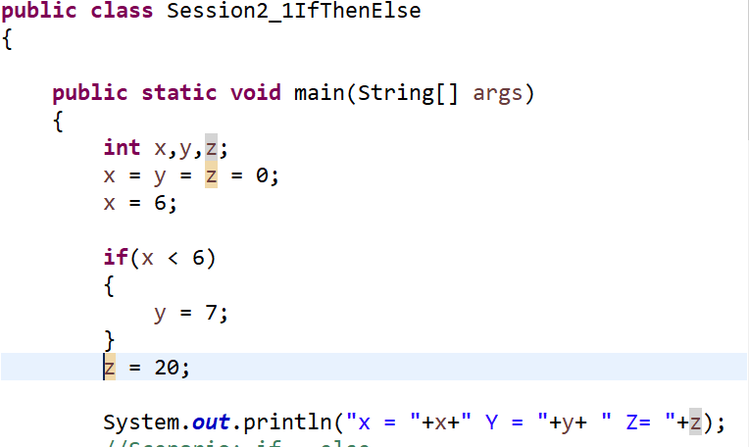

**2:**

**package** pkg_1_Basics;

**public** **class** Session2_4Switch

{

**public** **static** **void** main(String[] args)

{

**int** x = 23;

**switch**(x)

{

**case** 20:

System.***out***.println("This is case #1 [Value of x is 20]");

**break**;

**case** 21:

System.***out***.println("This is case #2 [Value of x is 21]");

**break**;

**case** 22:

System.***out***.println("This is case #3 [Value of x is 22]");

**break**;

**case** 23:

System.***out***.println("This is case #4 [Value of x is 23]");

**break**;

**case** 24:

System.***out***.println("This is case #5 [Value of x is 24]");

**break**;

// default:

// System.out.println("This is the default case -- Nothing Matched....");

// break;

}

}

}

**3:**

