KWAPRO

Software Deployment Instructions -Ubuntu-EN

Document State：  [ ] Draft  [√] Released  [ ] Modifying | Identify No.： | SDI_ubt_cn
Document State：  [ ] Draft  [√] Released  [ ] Modifying | Version No.： | 1.1
Document State：  [ ] Draft  [√] Released  [ ] Modifying | Author： | Hkr
Document State：  [ ] Draft  [√] Released  [ ] Modifying | Finished Date： | 2013-08-30

Version Log

Version/State | Author | Collaborator | Star & End Dates | Remark
1.0 | Hkr |  | 2013-08-12 ~ 2013-08-26 | No software and package download URL.
1.1 | Hkr |  | 2013-08-26 ~ 2013-08-30 | Released Version

Index
0. Introduction 5
0.1 Overview 5
0.2 Scope 5
0.3 Installation Requirements 5
0.4 References 5
0.5 Abbreviation & Note 5
1. Install LAMP (omitted) 5
2. Deploy the KWAPRO package 5
3. Create Database Information 6
3.1 Create new database 6
3.2 Add a new user. 7
3.3 Import initialization SQL 8
4. Install Memcached 8
5. Install Nginx 8
6. Install the Mail Server 9
7. Install and Configure Coreseek 9
7.1 Install coreseek 9
7.2 Coreseek Configuration 10
8. Start your KP service 10

0. Introduction

0.1 Overview
The document describes the steps necessary to deploy KWAPRO on Ubuntu12.04.

0.2 Scope
It describes the deployment steps, which has been tested on Ubuntu12.04, other Linux dialects has not been tested.
For deployment steps for Microsoft Windows, please see the document “Software Deployment Instructions -Windows-EN”

0.3 Installation Requirements
Operating system: Ubuntu 10.10+
PHP for linux 5.0+
Apache for linux 2.0+
MySQL for linux 5.0+

0.4 References
KWAPRO on GitHub：https://github.com/qonde-v/KWAPRO.git

0.5 Abbreviation & Note
Abbreviation | Note
KP | KWAPRO
kwapro.com | The website of KWAPRO
/KWAPRO/ | The root directory of KWAPRO on GitHub
…

Install LAMP (omitted)
You may need the root privilege during the installation process.

2. Deploy the KWAPRO package
- Use Git tool to clone source code.(https://github.com/qonde-v/KWAPRO.git) on the path: /var/www

~$ cd /var/www

~$ sudo git clone https://github.com/qonde-v/KWAPRO.git
- Change /var/www/KWAPRO/upload/ folder permission as readandwrite.

~$ sudo chmod 777 /var/www/KWAPRO/upload/*
- Enable Apache rewritemodule.

~$ sudo a2enmod rewrite
- Add directory in Apache configuration file(file path:/etc/apache2/sites-available/default) the additional content as:
Alias /KWAPRO/ "/var/www/KWAPRO/"
<Directory "/var/www/KWAPRO/">
Options Indexes FollowSymLinks MultiViews
AllowOverride All
Order allow,deny
Allow from all
</Directory>
- Restart Apache Service:

~$ /etc/init.d/apache2 restart

3. Create Database Information

3.1 Create new database
Create a new database named: kwaproQ2A with utf8_general_ci collation.
CREATE DATABASE `kwaproQ2A` DEFAULT CHARACTER SET utf8 COLLATE utf8_general_ci;
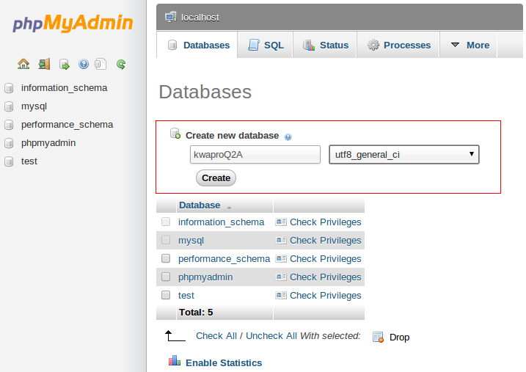

3.2 Add a new user.
1. Add a new user with User name: kwapro_user, Password: kwaprokendi851212.
2. Grant Global privileges and add privileges on the database:kwaproQ2A. The SQL command is shown as below, you can input it at the SQL script tab on PHPMyAdmin or other MySQL client software.:

CREATE USER 'kwapro_user'@'localhost' IDENTIFIED BY '***';
SET PASSWORD FOR 'kwapro_user'@'localhost' = PASSWORD( 'kwaprokendi851212' )

REVOKE ALL PRIVILEGES ON * . * FROM 'kwapro_user'@'localhost';

GRANT ALL PRIVILEGES ON * . * TO 'kwapro_user'@'localhost' WITH GRANT OPTION MAX_QUERIES_PER_HOUR 0 MAX_CONNECTIONS_PER_HOUR 0 MAX_UPDATES_PER_HOUR 0 MAX_USER_CONNECTIONS 0 ;

GRANT ALL PRIVILEGES ON `kwaproQ2A` . * TO 'kwapro_user'@'localhost' WITH GRANT OPTION ;

3.3 Import initialization SQL
Find database initialization SQL file kp.sql on /var/www/KWAPRO/sql/, then import it with following command:

mysql -ukwapro_user -pkwaprokendi851212 kwaproQ2A<kp.sql

4. Install Memcached

~$ sudo apt-get install memcached

~$ sudo apt-get install php5-memcache
Start Memcached:

~$ /usr/bin/memcached -d -m 512 -u root -p 11211 –P /tmp/memcached.pid
If your Ubuntu restart during the installation, Memcached must be restarted too.
After installing Memcached, restart Apache:

~$ /etc/init.d/apache2 restart

5. Install Nginx
- Find Nginx package in /var/www/KWAPRO/tools/linux/content_engine_server.zip
- Move content_engine_server.zip to path :/usr/local/app_server/ and unpack it.
Befor install Nginx, we must install some package as:
- libpython2.6.so.1.0

~$ sudo apt-get install python2.7

~$ sudo ln -s /usr/lib/libpython2.7.so.1.0 /usr/lib/libpython2.6.so.1.0
- libmysql.so.16

~$ sudo ln -s /usr/lib/i386-linux-gnu/libmysqlclient.so.18.0.0 /usr/lib/libmysql.so.16
- libcrypto.so.0.9.8

~$ sudo apt-get install libssl0.9.8
After the package installing, execute the command in the sbin path

~$ sudo ./nginx
If your Ubuntu restart during the installation, Nginx must be restarted too.

6. Install the Mail Server
Use Synaptic to install mail server. Open Synaptic Package Manager, search “mail server”, the mark for installation “mail-stack-delivery”, the click Apply to install it.
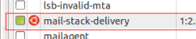
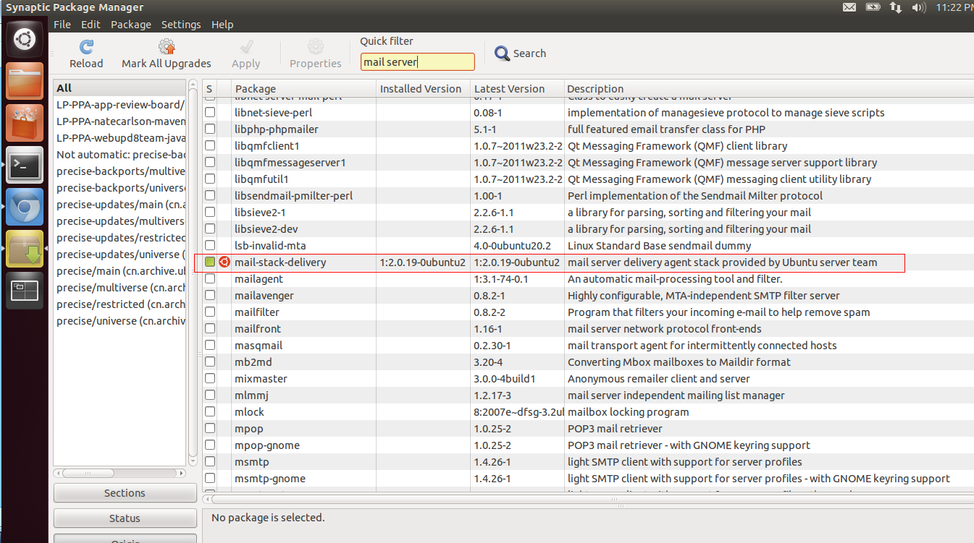

7. Install and Configure Coreseek

7.1 Install coreseek
Before install coreseek, we must install some softwares as:

~$ apt-get install make gcc g++ automake libtool mysql-client libmysqlclient-dev libxml2-dev libexpat1-dev
The coreseek install step please follow the instruction as “CoreSeek快速安装”( Coreseek version : 3.2.14).

7.2 Coreseek Configuration
- After Coreseek installed successful, the coreseek default path is sr/local/coreseek/.
- Find configuration file csft.conf on /var/www/KWAPRO/tools/linux.
- Move csft.conf to the folder /usr/local/coreseek/etc.
- Excute indexer command in /usr/local/coreseek/bin to create index.

~$ ./indexer --all
- Start searchd process(the process will used port 9312, make sure it cannot be used).

~$ ./searchd
If your Ubuntu restart during the installation, searchd process must be restarted too.

8. Start your KP service
- Start Apache Service

~$ sudo /etc/init.d/sudo /etc/init.d/apache2 start
- Start Memcached Service

~$ sudo /usr/bin/memcached -d -m 512 -u root -p 11211 –P /tmp/memcached.pid
- Start Nginx Service
/usr/local/app_server/content_engine_server/sbin# ./nginx
- Start Coreseek Service

/usr/local/coreseek/bin# ./searchd

