KWAPRO

Software Deployment Instructions-Windows-EN

Document State：  [ ] Draft  [√] Released  [ ] Modifying | Identify No.： | SDI_ubt_cn
Document State：  [ ] Draft  [√] Released  [ ] Modifying | Version No.： | 1.2
Document State：  [ ] Draft  [√] Released  [ ] Modifying | Author： | Hkr
Document State：  [ ] Draft  [√] Released  [ ] Modifying | Finished Date： | 2013-09-05

Version Log

Version/State | Author | Collaborator | Star & End Dates | Remark
1.0 | Hkr |  | 2013-08-14 ~ 2013-08-20 | No software and package download URL.
1.1 | Hkr |  | 2013-08-21 ~ 2013-08-30 | Released Version
1.2 | Hkr | Burley | 2013-09-01 ~ 2013-09-05 | Modify some Chinese screenshot and button into English.

Index
0. Introduction 4
0.1 Overview 4
0.2 Scope 4
0.3 Installation Requirements 4
0.4 References 4
0.5 Abbreviation & Note 4
1. Install AppServ (omitted) 4
2. Deploy the KWAPRO package 5
3. Create Database Information 6
3.1 Create new database 6
3.2 Add a new user 6
3.3 Import initialization SQL 7
4. Install Memcached 7
5. Install Nginx 8
6. Install the Mail Server 8
7. Install and Configure Coreseek 16
7.1 Install coreseek 16
7.2 Coreseek Configuration 16
8. Start your KP service 17

0. Introduction

0.1 Overview
The document describes the steps necessary to deploy KWAPRO on Microsoft Windows Server 2003 Enterprise Edition Service Pack 2 (Windows 2003 for short)

0.2 Scope
It describes the deployment steps, which has been tested on Windows 2003.
For deployment steps for Linux, Please see the document “Software Deployment Instructions - Ubuntu - EN”

0.3 Installation Requirements
Operating system: Windows Service 2000+
PHP for Windows 5.0+
Apache for Windows 2.0+
MySQL for Windows 5.0+

0.4 References
KWAPRO on GitHub：https://github.com/qonde-v/KWAPRO.git

0.5 Abbreviation & Note
Abbreviation | Note
KP | KWAPRO
kwapro.com | The website of KWAPRO
/KWAPRO/ | The root directory of KWAPRO on GitHub
…

Install AppServ (omitted)
If you decide to install MySQL, PHP, and Apache as a whole, we recommend to use AppSev, and you may need to remove local MySQL program before AppServ installing.

2. Deploy the KWAPRO package
- Use Git tool to clone source code.(https://github.com/qonde-v/KWAPRO.git) on the path: C:\AppServ\www

C:\AppServ\www> git clone https://github.com/qonde-v/KWAPRO.git
CAUTION: at present, The source code you clone form Git is running for the Linux, You may need to modify some source code to make sure KP can run in Windows. We will release the KP for windows soon.
- File :system\libraries\Email.php, Line:1540
if ( ! mail($this->_recipients, $this->_subject, $this->_finalbody, $this->_header_str, "-f ".$this->clean_email($this->_headers['From'])))
Modify into:
if ( ! mail($this->_recipients, $this->_subject, $this->_get_alt_message(), "MIME-Version: 1.0\r\nContent-type:text/html;charset=utf-8\r\nFrom: kwaproq2a@gmail.com", "-f ".$this->clean_email($this->_headers['From'])))
- Remove File application\models\q2a\http_process.php, Line 28. (Remove the Nginx submit request)
return $this->_send_http_request($server_data);
- Enable Apache rewritemodule.
- Open file C:\AppServ\Apache2.2\conf\httpd.conf
- Find “#LoadModule rewrite_module modules/mod_rewrite.so”, and remove the first character “#”.
- Add directory between <IfModule alias_module> </IfModule> tag in Apache configuration file (file path: C:\AppServ\Apache2.2\conf\httpd.conf), the additional content as:
Alias /KWAPRO/ "C:/AppServ/www/KWAPRO/"
<Directory "C:/AppServ/www/KWAPRO/">
Options Indexes FollowSymLinks MultiViews
AllowOverride All
Order allow,deny
Allow from all
</Directory>
- Restart Apache Service.
Click “Start”→ “Administrative Tools” → “Services”, then find “Apache2.2” server，then Right-Click to start the server.

3. Create Database Information

3.1 Create new database
Create a new database named: kwaproQ2A with utf8_general_ci collation.
CREATE DATABASE `kwaproQ2A` DEFAULT CHARACTER SET utf8 COLLATE utf8_general_ci;
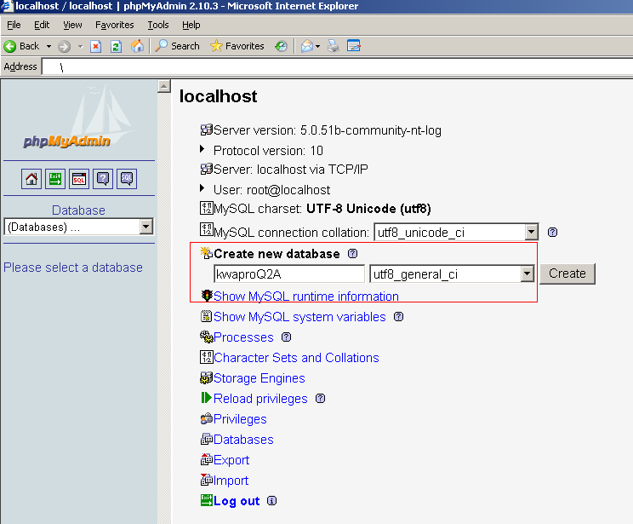

3.2 Add a new user
1. Add a new user with User name: kwapro_user, Password: kwaprokendi851212,
2. Grant Global privileges and add privileges on the database:kwaproQ2A. The SQL command is shown as below, you can input it at the SQL script tab on PHPMyAdmin or other MySQL client software.:
CREATE USER 'kwapro_user'@'localhost' IDENTIFIED BY '***';
SET PASSWORD FOR 'kwapro_user'@'localhost' = PASSWORD( 'kwaprokendi851212' )

REVOKE ALL PRIVILEGES ON * . * FROM 'kwapro_user'@'localhost';

GRANT ALL PRIVILEGES ON * . * TO 'kwapro_user'@'localhost' WITH GRANT OPTION MAX_QUERIES_PER_HOUR 0 MAX_CONNECTIONS_PER_HOUR 0 MAX_UPDATES_PER_HOUR 0 MAX_USER_CONNECTIONS 0 ;

GRANT ALL PRIVILEGES ON `kwaproQ2A` . * TO 'kwapro_user'@'localhost' WITH GRANT OPTION ;

3.3 Import initialization SQL
Find database initialization SQL file kp.sql on C:/AppServ/www/KWAPRO/sql/, then import it on PHPMyAdmin:
Click Import→Browse…，select kp.sql→Click “Go”. If import successful, you will see the message as: “Import has been successfully finished, xxx queries executed”.
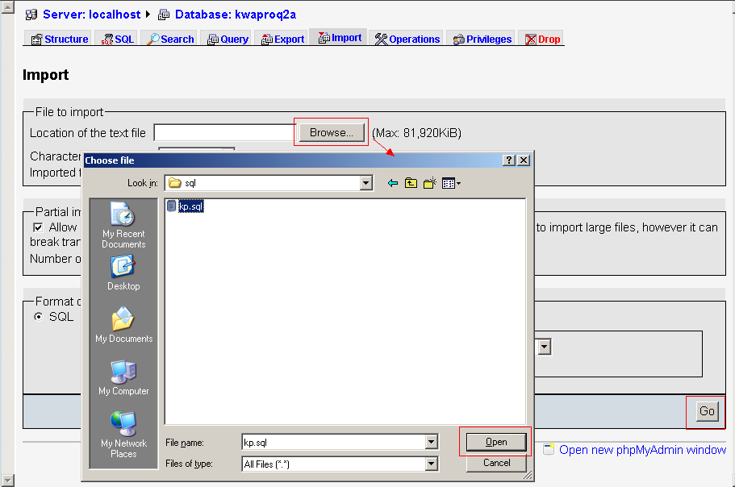

4. Install Memcached
- Download the Memcached package on:
http://downloads.northscale.com/memcached-win32-1.4.4-14.zip
- Unpack it on the path: c:/memcached, the execute the following command in windows cmd:

C:\memcached>memcached.exe -d install

C:\memcached>memcached.exe -d start
- Download php_memcache.dll, the move to C:\AppServ\php5\ext
- Open php.ini(C:\WINDOWS\php.ini), then add additional content as: extension=php_memcache.dll
- Restart Apache Service.

5. Install Nginx
Nginx for Windows is in development, it will be release latter. See also …(给出这条信息的出处链接)

6. Install the Mail Server
- Click “Start”→ “Administrative Tools”→ “Manage Your Server”
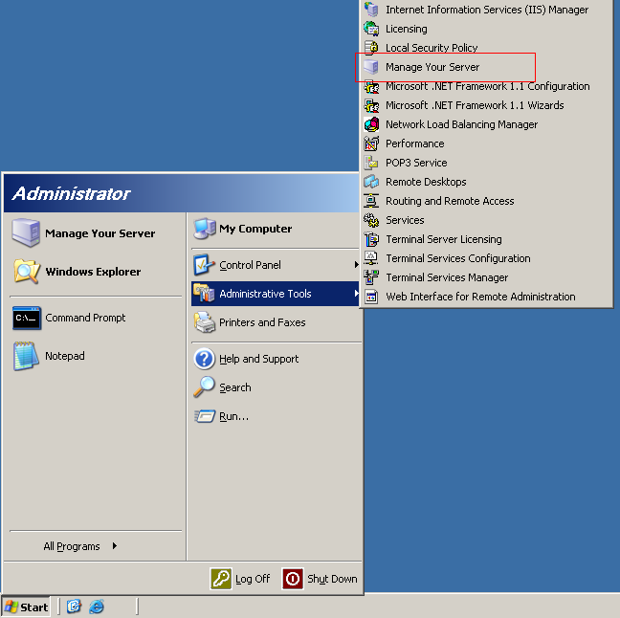
- Click “Add or remove a role” On “Manage Your Server” window;
Then click “Next >” on the pop-up window;
Select “Mail server (POP3，SMTP)” , then click “Next >”;
Input mail domain name on the input field “E-mail domain name:”, then click “Next >”;
Then click “Next >” to install mail server(this may need inset the Windows system CD);
Then click “Finish” to finish the installation.
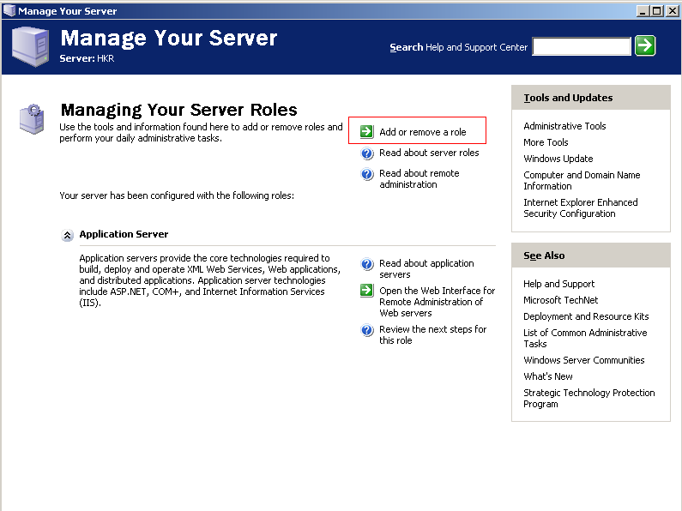
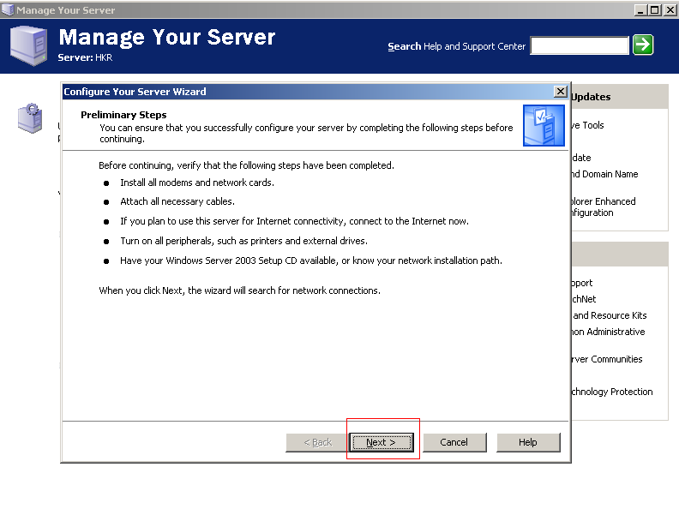
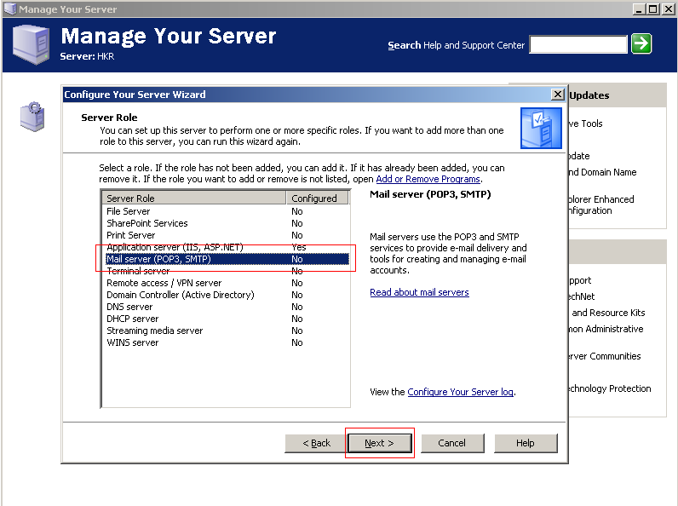
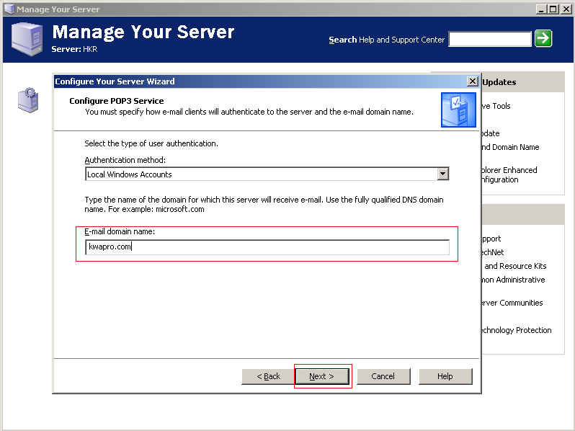
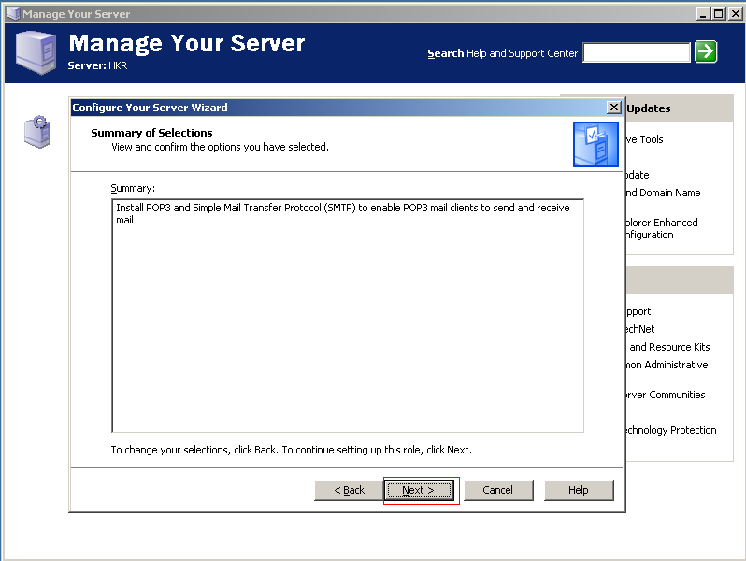
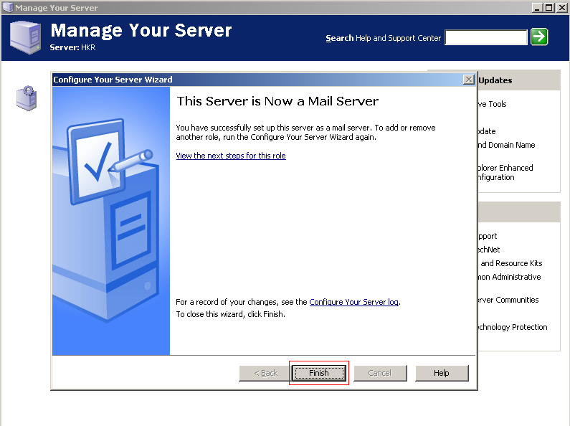
- After installing successful, a new option “Mail Server (POP3, SMTP)” will add into the “Manage Your Server” window. Click “Manage this mail server” to configure the mail.
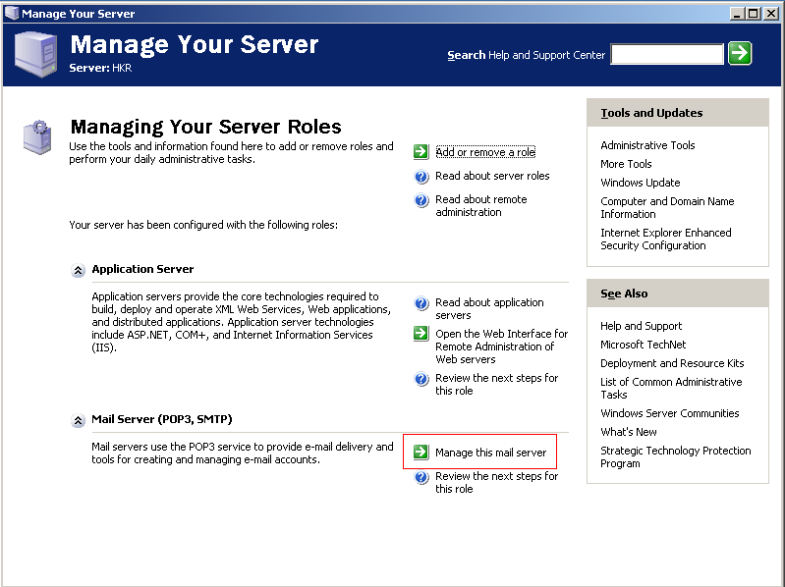
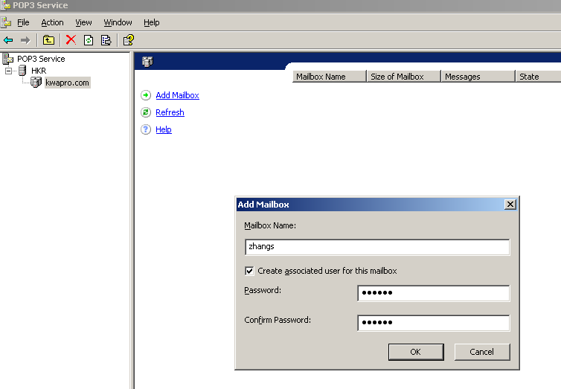
- Click “Start”→ “Administrative Tools”→ “Internet Information Services (II) Manager”.
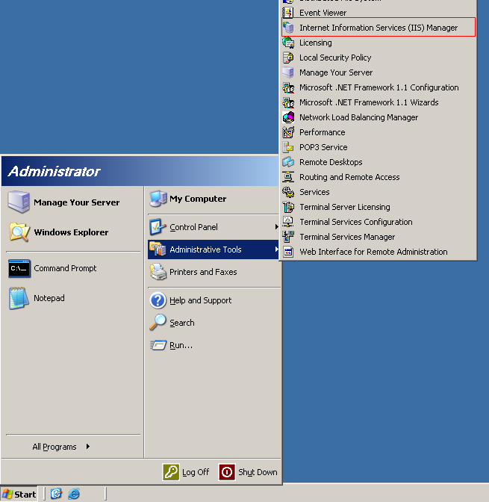
- Right-Click “Default SMTP Virtual Server”, then click “Properties” on the pop-up window.
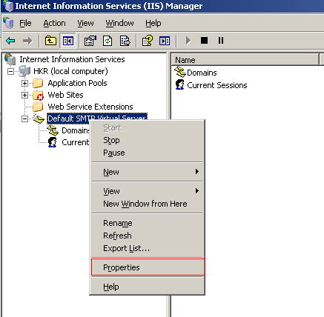
- Select “Access” tab → “Relay…” on the pop-up window.
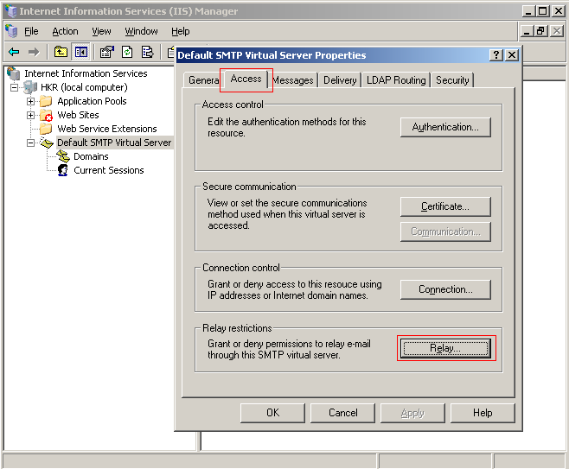
- Click “Add…” on the pop-up window.
Add “127.0.0.1” on the “Single computer” option, then click “OK”.
Click echo “OK” button on the different window.
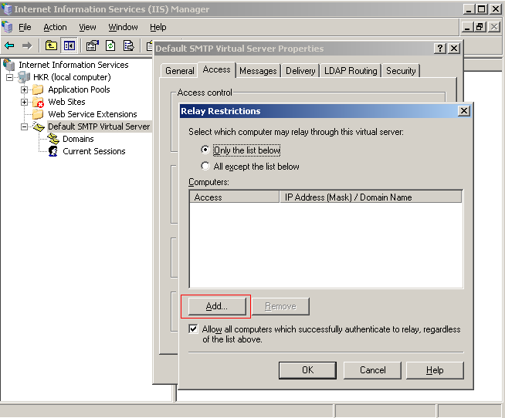
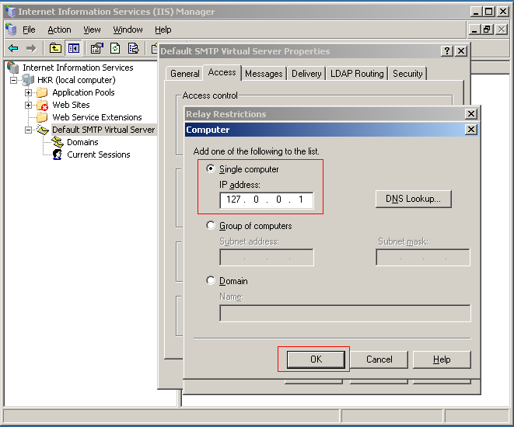
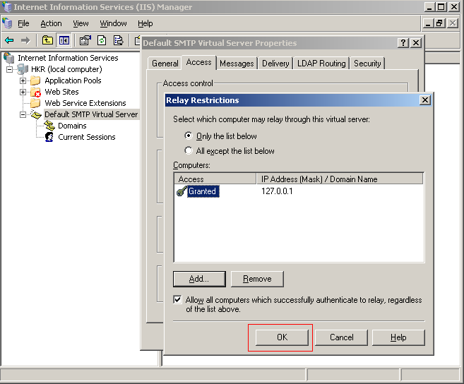

7. Install and Configure Coreseek

7.1 Install coreseek
- Before installing Coreseek, some software has to be installed, as listed below:
- ActivePython 2.6 Windows (x86)
- Microsoft Visual C++ 2008 SP1 Redistributable Package (x86)
- Download Coreseek package
Find the Coreseek for Windows and download: (we select version 3.2.14)
http://www.coreseek.cn/uploads/csft/3.2/coreseek-3.2.13-win32.zip
- Unpack it on the path: c:/coreseek

7.2 Coreseek Configuration
- Find the file csft.conf on the path: C:/AppServ/www/KWAPRO/tools/windows/
- Move csft.conf to the path c:/coreseek/etc
- Execute the following command in windows cmd: (coreseek is running in port 9312, make sure it will not be used)

C:\coreseek>set PATH=%CD%\bin;%PATH%

C:\coreseek>bin\searchd.exe --install

C:\coreseek>bin\indexer.exe -c etc\csft.conf --all

C:\coreseek>bin\searchd -c etc\csft.conf --console
(The command shell of Windows will keep open when Coreseek is running)

8. Start your KP service
- Start Apache Service
Click “Start”→ “Administrative Tools” → “Services”, then find “Apache2.2” server，then Right-Click to start the server.
- Start Memcached Service

C:\memcached>memcached.exe -d start
- Start Coreseek Service

C:\coreseek>bin\searchd -c etc\csft.conf --console

