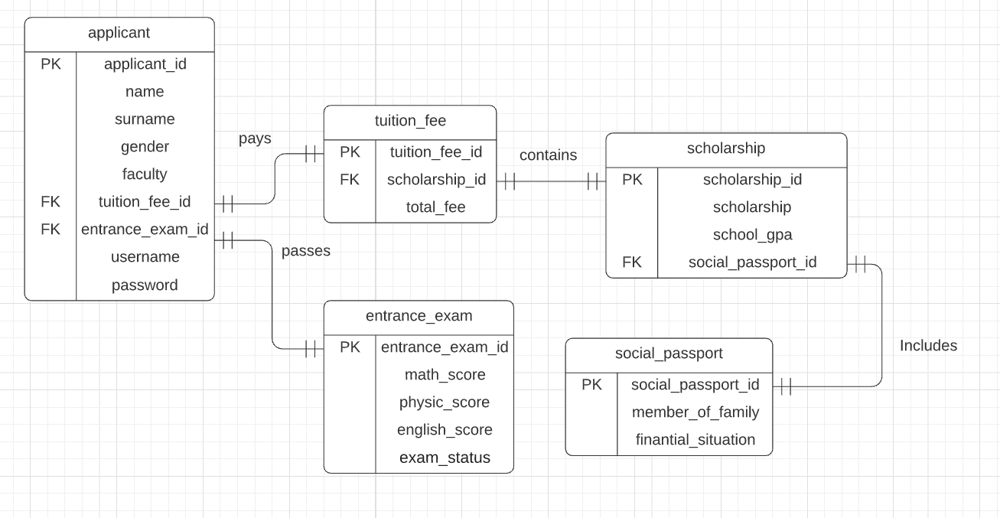

CREATE TABLE social_passport(

social_passport_id SERIAL PRIMARY KEY,

member_of_family DECIMAL(12),

finantial_situation VARCHAR (55)

);

CREATE TABLE scholarship (

scholarship_id SERIAL PRIMARY KEY,

scholarship DECIMAL,

school_gpa DECIMAL(12),

social_passport_id SERIAL,

FOREIGN KEY (social_passport_id) REFERENCES social_passport(social_passport_id)

);

CREATE TABLE tuition_fee(

tuition_fee_id SERIAL PRIMARY KEY,

scholarship_id SERIAL,

total_fee DECIMAL (12),

FOREIGN KEY (scholarship_id) REFERENCES scholarship(scholarship_id)

);

CREATE TABLE entrance_exam(

entrance_exam_id SERIAL PRIMARY KEY,

math_score DECIMAL (12),

physic_score DECIMAL (12),

english_score DECIMAL (12),

exam_status VARCHAR (10)

);

CREATE TABLE applicant (

applicant_id SERIAL PRIMARY KEY,

name VARCHAR (35),

surname VARCHAR (35),

gender VARCHAR (35),

faculty VARCHAR (35),

username VARCHAR (35) UNIQUE,

password VARCHAR (35),

tuition_fee_id SERIAL,

entrance_exam_id SERIAL,

FOREIGN KEY (tuition_fee_id) REFERENCES tuition_fee (tuition_fee_id),

FOREIGN KEY (entrance_exam_id) REFERENCES entrance_exam (entrance_exam_id)

);