[training data prep]

FCN_text.py

Prepare train3.txt

|  |
| --- |
|  |
| training/image_2/um_000000.png training/gt_image_2/um_road_000000.png |
|  |

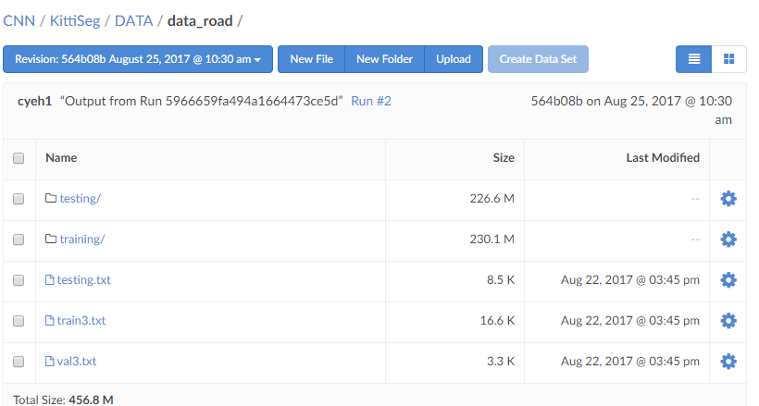

[run training script]

[set mask color]

<https://github.com/MarvinTeichmann/KittiSeg/blob/234bc43cc89c3ab4c6010ce16a4f54d7fa5400df/docu/inputs.md>

[remove old folder]

Rm -r KittiSeg

[install python2 + tensorflow] open terminal

curl -O https://repo.continuum.io/archive/Anaconda2-4.4.0-Linux-x86_64.sh

bash Anaconda2-4.4.0-Linux-x86_64.sh

~/anaconda2/bin/pip install tensorflow-gpu

Troubleshooting:

1. Incl sync problem in domino

zip -r myfiles.zip mydir

Remove incl

unzip

Syntax:

unzip {.zip-file-name}-d {/path/to/extract}

For example extract package.zip into /opt, enter:

# unzip package.zip -d /opt