Jobs
See work certificates for more details. Summaries available at:
qoolixiloop.wordpress.com/about-me/#jobs

1985 | … | 1994 | 1995 | … | 2005 | 2006 | … | 2013 | 2014 | … | 2019
Commercial apprenticeship and military service as well as jobs in shipping and accounting. (Maag, NCR, AT&T).
1985 | … | 1994 | 1995 | … | 2005 | 2006 | … | 2013 | 2014 | … | 2019
Highschool and study at the ETH. Study projects, secondary jobs in event marketing, social work and cleaning (Emergency Shelter, Spool, Milo cleaning). Mandatory internships (Sulzer, Alstom Power) and voluntary internships during and shortly after graduation (Esec, Innopark, Prose). The last five jobs during this period were all in the field of mechanical engineering and had a significant programming, CAD or calculation share with software such as Matlab or Inventor.
1985 | … | 1994 | 1995 | … | 2005 | 2006 | … | 2013 | 2014 | … | 2019
Preparation for international financial examinations and temporary jobs in the financial-, social- or agricultural sectors (Zurich Insurance, UBS, ETH, Feinschliff, Syngenta). At Zurich Insurance, I worked with portfolio data for a profitability analysis. At UBS, I had a project in Global Risk Mana-gement as a programmer. At the ETH, I was in the Department of Safety, Health, Environment. At the social firm Feinschliff, I worked part-time in bookkeeping. At Syngenta, I mainly worked as a programmer in Project- and Profolio Management Excellence. Most jobs had a very large amount of Excel and programming with software like SAS and VBA, and filter tools like Pivot tables and SQL.
1985 | … | 1994 | 1995 | … | 2005 | 2006 | … | 2013 | 2014 | … | 2019
Study at the University of Zurich. Study projects, building my websites (GitHub, WordPress) and social projects.

Education
Further details available at:
qoolixiloop.wordpress.com/about-me/#educations

Academic education, Vocational training and further education
1990 KV | Commercial Apprenticeship | Clerk with diploma
1997 KME | High-School | Matura-Diploma
2004 ETH | Mechanical Engineering | Master's Degree
2008 GARP | Financial Risk Manager | Diploma
2010 CAIA | Financial Analyst | 1st exam passed *
2011 CFA | Financial Analyst | 1st exam passed **
2018 UZH | Informatics | no formal diploma *
* 2nd exam not taken
** 2nd exam not passed
*** 171 credits; more information on my website

Languages

Swiss-German* | 
High-German
English** | 
French** | 
Spanish
Italian | 
* Native language
** Internationally recognized diplomas

Informatics
Detailed list available at:
qoolixiloop.wordpress.com/about-me/#informatics

Operating System | Linux; Windows; Android; MacOS
Word processing | MS-Word; LibreOffice-Writer
Spreadsheet | MS-Excel; LibreOffice-Calc
Databases | MS-Access; LibreOffice-Base
Presentations | MS-PowerPoint; LibreOffice-Impress
Website design | HTML, CSS, JavaScript; Jekyll
Websites | WordPress
Computer-graphics | Blender
Foto editing | GIMP
Programming | C-Family; Java; TypeScript; Python; Bash; VBA
Furthermore | Theory; Modelling; OOP; Machine Learning; Control Theory; ERP

Other qualities and competencies

Self-initiative | Automation; Lead in difficult tasks
Teamwork | Transfer of knowledge; Help with planning tasks
Method of Working | Analytical; Work through task lists
Health | Do sports regularly; No stimulants except coffee

References

Download of credentials, diplomas and certificates:
github.com/qoolixiloop/qool-cv-loop
To check the authenticity please contact the issuers directly.
Any oral reference information may also be obtained.

My Showcase

Core competence
Anyone who relies on experience, i.e. years of practical routine, and would like to buy it globally as cheaply as possible does not look for me. That suits me fine, because personally, I prefer an environment with fairly paid, broadly trained, creative knowledge workers.
My websites
In addition to the usual tables, this document also contains links to my own websites. These serve as work samples and contain blog pages and project descriptions around the topic of informatics. There you will find animations, tutorials, and links to the source code.

 | 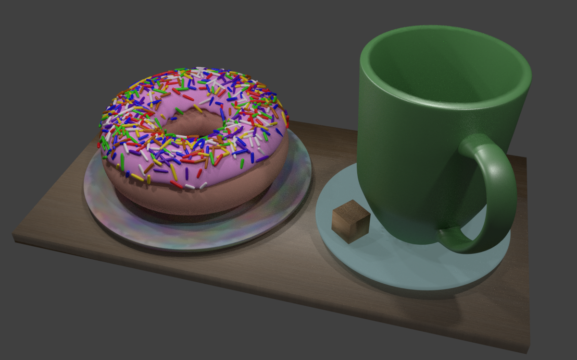
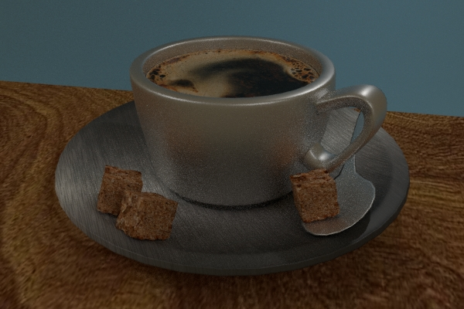 | 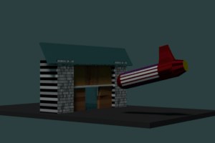
Reality or animated computer-graphics mit Blender?

