First steps in Vim

Basics

version
:version
:!vim -- version
:echo has('python') #has if echoes a 1
:echo has('python3') #has if echoes a 1

getting help
:help, F1  >quickref  >user-manual  >reference  >index  :help command | help| start help  help| chapter tag| overview of most common commands  help| chapter tag| editing tasks (direct access :help user-manual)  help| chapter tag| every detail  help| chapter tag| lists all internal key bindings of every mode  help| jumps to help about command

getting help jump history
:jump  Ctrl-]  Ctrl-t  Ctrl-o  Ctrl-i | info| navigation or jump history (automatically set navigation points)  motion| jump into a link  motion| jump back to link  motion| move up the navigation history (navigate the tree back)  motion| move down the navigation history (navigate the tree forward)

open unnamed buffer
:enen  :new  :vnew  :tabnew | command| open an unnamed buffer in the current window  command| open an unnamed buffer in a horizontal split window  command| open an unnamed in a vertical split window  command| open an unnamed in a new tab (:tabn, :tabp to navigate)

open existing file or new named buffer
:edit [file]  :split [file]  :vsplit [file]  :tabedit [file] | command| open an existing file or a new named buffer in current window  command| open an existing file or a new named buffer in horizontal split  command| open an existing file or a new named buffer in vertical split  command| open an existing file or a new named buffer in new tab (:tabn, :tabp, “gt” to navigate)

$ vimtutor

enter an external command
:!_<CR> | command| “:!”execute “_” an external shell command

command completion
:_<Ctrl-D>  :_<Tab> | command| shows list of word completions  command| goes through list of word completions

read from / write to file
v_:w_  :r_  :r:_ | operator-motion-command| “v” select “_” text and “:w” write it to “_” file  command| read “_” file and paste it at cursor position  command| read “:_” external shell command and place result at cursor position

search in text, command or help
/, ?  n, N  set hlsearch?  set hlsearch!  set ic?  set ic | search| “/” search below, “?” search above  motion| “n” next below, “N” next above  option| shows current option state| highlight search matches?  option| toggles option| hightlight search maches  option| shows current option state| ignore case matches?  option| toggles option| ignore case matches

find matching parentesis
% | motion| jumps to matching parentesis ( ),[ ],{ }

move cursor vertically to a certain line
Ctrl-G  gg  G  500g | info| file name + file status + current cursor location  motion| go to start of file  motion| go to end of file  motion| go to line 500

move cursor horizontally to a certain word
w, e  5w, 5e  0, $ | motion| (in normal mode “w” jumps from word to word, “e” to the end of word)  motion| counts (jump 5 words)  motion| “0” move to start of line “$” move to the end of line

N: switch from normal mode to insert mode
a, A  i  o, O  r_, R_ | command| switch to insert mode | jumps “a” one character to the right or “A” to end of line  command| switch to insert mode | stays put. insertion is always left of cursor  command| switch to insert mode | adds new line “o” below or “O” above and jumps there  command| stay in normal mode | replace “r” one or “R” more “_” characters

N: delete one character and paste it somewhere else
x  5x  p | command| delete a character  command| delete five characters  command| paste deleted character after cursor

N: operator c: delete (change) character(s) and go to insert mode
c  ce | operator| change (delete and go into insert mode)  command||operator-movement| delete to the end of word and goes into insert mode

N: operator d: delete word(s) and paste it somewhere else
d  dw  d3w  d$  p | operator| delete (delete and stay in normal mode)  command||operator-motion| delete word (from cursor to next space)  command||operator-motion| delete three words (from cursor to three next spaces)  command||operator-motion| delete to the end of line  command| paste deleted words after cursor

N: delete lines and paste it somewhere else
dd  3dd  p | command| delete line  command| delete three lines  command| paste deleted line after line with cursor

N, I: operator y: copy (yank) word(s) or selected text into register or clipboard
y  “+y  yw, “+yw  y3w, “+y3w  y$, “+y$ | operator| yank (copy to register)  operator| yank to external clipboard  command| yank word  command| yank 3 words  command| yank to the end of line

N: undo, redo
u  U  Ctrl-r | command| undo last command  command| fix whole line  command| redo last undo

N: search and replace (substitute)
:help find-replace
:help cmdline-ranges
:s/old/new  :s/old/new/g  :25,50s/old/new/g  :25,50s/old/new/g  :%s/old/new/g  :%s/old/new/gc | substitue| one line | first occurrence |  substitue| one line | all occurrences |  substitue| line 25 to 50 | all occurrences |  substitue| line 25 to 50 | ask confirmation for every occurence |  substitue| all lines | all occurrences |  substitue| all line | ask confirmation for every occurrence |

Own Commands in .vimrc
:DiffOrig | command| open scratch and buffer Window| compare buffer before :w with file (:DiffOff to close)  file ~/.vimrc:  command! DiffOrig vert new | set bt=nofile | r # | 0d_ | diffthis | wincmd p | diffthis

Own key bindings

Own key bindings in normal mode: editor settings and functions

files
.vimrc and .vim/own_plugs

get definitions
:nmap -

" define leader key
let mapleader = "-"

" N: Maximize your current window pane and toogle back
file: ~/vim/own_plugs/MaximzeToggle()
nnoremap <leader>tw :call MaximizeToggle()<CR>

" N: Diff between buffer and file with bash diff command
nnoremap <leader>di :w !diff % - <CR>

“ N: Grep
file: ~/vim/own_plugs/grep-operator.vim
" viw<leader>g: Visually select a word, then grep for it.
" <leader>g4w: Grep for the next four words.
" <leader>gt;: Grep until semicolon.
" <leader>gi[: Grep inside square brackets.
nnoremap <leader>g :set operatorfunc=<SID>GrepOperator<cr>g@

" N: Write and Source current Buffer
nnoremap <leader>ws :w<CR>:so %<CR>

" VimScript: Write and Source and run current Buffers Main Function
file: ~/vim/own_plugs/Build()
nnoremap <leader>wb :call Build()<CR>

" N: toggle :set wrap; (wr)ap
nnoremap <leader>wr :set wrap! wrap?<CR>

" N: toggle :set list and :set listchars to set nolist; (n)ot (v)isible
nnoremap <leader>nv :set list! list?<CR>

" N: toggle :set line numbers; (n)umbe(r)
nnoremap <leader>nr :set nonumber! number?<CR>

" N: toggle Gundo Plugin
nnoremap <leader><F7> :GundoToggle<CR>

" N: change vim window directory to buffer's path (all windows within one tmux window)
" % gives the name of the current file, %:p gives its full path, and %:p:h gives its directory.
nnoremap <leader>cd :cd %:p:h<CR>:pwd<CR>

" N: change local window directory to buffer's path (only local window within one tmux window)
" % gives the name of the current file, %:p gives its full path, and %:p:h gives its directory.
nnoremap <leader>lcd :lcd %:p:h<CR>:pwd<CR>

Own key bindings in normal mode

" N: backspace
nnoremap <leader><BS> X

" N: space
nnoremap <leader><space> i<space><esc>

" N: return
nnoremap <leader><return> i<CR><esc>

" N: add newline below
nnoremap <leader>o $a<CR><esc>

Own key bindings in visual mode

get definitions
:vmap -

" V: comment and uncomment (in visual mode highlight blocks)
vnoremap <leader>cc :call Comment()<CR>
vnoremap <leader>cx :call Uncomment()<CR>

“ V: grep
file: ~/vim/own_plugs/grep-operator.vim()
:<c-u> moves from visual mode into command line mode
vnoremap <leader>g :<c-u>call <SID>GrepOperator(visualmode())<cr>

" V: move from visual mode into insert mode
vnoremap <leader>i <esc><esc>i

" V: copy from visual mode and go into insert mode
vnoremap <leader>y "+yi

" V: cut from visual mode and go into insert mode
vnoremap <leader>d "+di

Own key bindings in insert mode

get definitions
:imap -

" I: move from insert into visual mode
inoremap <leader><leader>v <esc>lv
inoremap <leader><leader><S-v> <esc>l<S-v>
inoremap <leader><leader><C-v> <esc>l<C-v>

" I: copy whole words to clipboard
inoremap <leader><leader>w <esc>llbve"+y<esc>i
inoremap <leader><leader>ww <esc>llbvee"+y<esc>i
inoremap <leader><leader>www <esc>llbveee"+y<esc>i
inoremap <leader><leader>wwww <esc>llbveeee"+y<esc>i
inoremap <leader><leader>wwwww <esc>llbveeeee"+y<esc>i
inoremap <leader><leader>wwwwww <esc>llbveeeeee"+y<esc>i

" I: copy whole lines to clipboard
inoremap <leader><leader>q <esc><S-v>"+y<esc>i
inoremap <leader><leader>qq <esc><S-v>j"+y<esc>i
inoremap <leader><leader>qqq <esc><S-v>jj"+y<esc>i
inoremap <leader><leader>qqqq <esc><S-v>jjj"+y<esc>i
inoremap <leader><leader>qqqqq <esc><S-v>jjjj"+y<esc>i
inoremap <leader><leader>qqqqqq <esc><S-v>jjjjj"+y<esc>i

" I: cut line to clipboard
inoremap <leader><leader>dd <esc><S-v>"+y<esc>dd<esc>i

" I: paste
inoremap <leader><leader>e <esc>"+p<esc>i

" I: undo
inoremap <leader><leader>u <esc>u<esc>i

Vim command line and Vimscript
Command-line mode is used to enter Ex commands (":"), search patterns ("/" and "?"), and filter commands ("!").).
(On a side note: Ex command means commands started with a colon (“:”), and have their name from the editor Ex. shell commands means commands started with (“:!”).)
For more infos type :help cmdline.txt.

getting help
to get a list of all Vim builti commands or functions (then use Ctrl ] to jump to function description and Ctrl t, o, i to move back and forth)
:help expression-commands
:help ex-cmd-index #:help index.txt
:help function #:help index.txt
to get the function description directly
:help funcname()
to get a description for some syntax peculiarities like the motion or highlighted range ‘<,>’ or the call for an operator function g@, or about the scope of b:var, and so on
:help ‘< #help cmdline-ranges
:help g@
:help b:
to get a description about the register @@ you have to know that it is an alias for register “”
:help “”

commands

commands vs functions
commands are executed from command line with a “:”
vim functions or user defined functions are executed with call, echo, ...

vim commands
:help ex-cmd-index

user-defined commands
user-defined commands must start with a capital letter.
the following line defines a user-defined command.
commands can have arguments, which you define with the option -nargs.
you can have zero “0”, one “1”, any number “*”, zero or one “?”, one or more “+”
:command DeleteFirst 1delete
:command -nargs=0 DeleteFirst 1delete
by executing :DeleteFirst in the command line, it calls the vim command :delete and deletes the first line.
:DeleteFirst
Inside the command definition, the arguments are represented by the <args>, <q-args>, <f-args> keyword.
:command -nargs=+ Say :echo "<args>"
:command -nargs=+ SayQuote :echo <q-args>
:command -nargs=* DoIt :call Afunction(<f-args>)
To get special characters turned into a string, properly escaped to use as an expression, use "<q-args>".
The <f-args> keyword contains the same information as the <args> keyword, except in a format suitable for use as function call arguments.
:Say Hello World #he said "hello" fails because of the double quotes
:SayQuote he said "hello" #executes :echo "he said \"hello\""
:DoIt a b c #executes :call AFunction("a", "b", "c")

list of user defined commands
:command

command line executions
execute or exe to construct a sting and after that execute it. Often used to pass arguments to commands
:exe 'echo' 'max('.'[1,2,3]'.')'
call to call a function
:call max([1,2,3])
echo to call a function and print the result into the command line
echo does work with lists
:echo max([1,2,3])
echom to call a function and print the result into the command line and the messages register
echom does not work with lists, it needs to be iterated through it
:echom max([1,2,3])
:! to execute a bash shell command and write the output into bash command line
!echo Hello, world.
silent! leaves you with a black bash screen, but access to the command line, so type :redraw! to get back to vim
:silent !echo Hello, world.
:redraw!
system calls a bash shell command and writes the output as sting into :messages register.
systemlist does the same but outputs a list and that does not work with echom
(on a side note for filename-modifiers :_:_: % means current file, :h means file head, :S means escape special characters.)
:echom system("wc -c", "abcdefg")
:echo systemlist("ls")
:let files = system("ls " . shellescape(expand('%:h')))
:let files = system('ls ' . expand('%:h:S'))

execute vs call 1):
:call: Used to call functions:
function! s:foo(id)
execute 'buffer' a:id #load a buffer (a: function argument)
endfunction

let target_id = 1
call foo(target_id)
:execute: Used for two things:
1) Construct a string and evaluate it. This is often used to pass arguments to commands:
execute 'source' fnameescape('l:path') #source a file (l: local variable)
2) Evaluate the return value of a function (arguably the same):
function! s:bar(id)
return 'buffer ' . a:id #return string
endfunction

let target_id = 1 #define variable
execute s:bar(target_id) #execute returned string

execute vs call 1):
You may see call as first evaluate the expression and then discard the result. So only the side effects are useful.
Define:
function! Foo()
echo 'echoed' #echo string
return 'returned' #return string
endfunction
Call:
:call Foo() #output: echoed
Execute:
:execute Foo() #output: Exxx: Not an editor command: returned
Echo:
:silent let foo = Foo()
:echo foo #output: returned

Macro recording
One of my favorite parts about registers is using them as macros!
Let's say you are dealing with a tab-delimited value file as such:
ID Df %Dev Lambda
1 0 0.000000 0.313682
2 1 0.023113 0.304332
3 1 0.044869 0.295261
4 1 0.065347 0.286460
5 1 0.084623 0.277922
6 1 0.102767 0.269638
7 1 0.119845 0.261601
Now you decide that you need to add a percentage sign at the end of the %Dev field (starting from 2nd line). We'll make a simple macro in the (arbitrarily selected) m register as follows:
- Press: qm: To start recording macro under m register.
- EE: Go to the end of the 3rd column.
- a: Insert mode to append to the end of this column.
- %: Type the percent sign we want to add.
- <ESC>: Get back into command mode.
- j0: Go to beginning of next line.
- q: Stop recording macro
We can now just type @m to run this macro on the current line. Furthermore, we can type @@ to repeat, or 100@m to do this 100 times! Life's looking pretty good.
At this point you should be saying, "BUT WAIT, WHAT THE HECK DOES THIS HAVE TO DO WITH REGISTERS?"
Excellent point. Let's investigate what is in the contents of the m register by typing "mp. We then get the following:
EEa%<ESC>j0
At first this looks like you accidentally opened a binary file in notepad, but upon second glance, it's the exact sequence of characters in our macro!
You are a curious person, so let's do something interesting and edit this line of text to insert a ! instead of boring old %.
EEa!<ESC>j0
Then let's yank this into the n register by typing B"nyE. Then, just for kicks, let's run the n macro on a line of our data using @n....
OMG, IT ADDED A !
Essentially, running a macro is like pressing the exact sequence of keys in that macro's register. If that isn't a cool register trick, I'll eat my hat.

3. Complex repeats *complex-repeat*

*q* *recording*
q{0-9a-zA-Z"} Record typed characters into register {0-9a-zA-Z"}
(uppercase to append). The 'q' command is disabled
while executing a register, and it doesn't work inside
a mapping and |:normal|.

Note: If the register being used for recording is also
used for |y| and |p| the result is most likely not
what is expected, because the put will paste the
recorded macro and the yank will overwrite the
recorded macro. {Vi: no recording}

q Stops recording. (Implementation note: The 'q' that
stops recording is not stored in the register, unless
it was the result of a mapping) {Vi: no recording}

*@*
@{0-9a-z".=*+} Execute the contents of register {0-9a-z".=*+} [count]
times. Note that register '%' (name of the current
file) and '#' (name of the alternate file) cannot be
used.
The register is executed like a mapping, that means
that the difference between 'wildchar' and 'wildcharm'
applies.
For "@=" you are prompted to enter an expression. The
result of the expression is then executed.
See also |@:|. {Vi: only named registers}

*@@* *E748*
@@ Repeat the previous @{0-9a-z":*} [count] times.

:[addr]*{0-9a-z".=+} *:@* *:star*
:[addr]@{0-9a-z".=*+} Execute the contents of register {0-9a-z".=*+} as an Ex
command. First set cursor at line [addr] (default is
current line). When the last line in the register does
not have a <CR> it will be added automatically when
the 'e' flag is present in 'cpoptions'.
Note that the ":*" command is only recognized when the
'*' flag is present in 'cpoptions'. This is NOT the
default when 'nocompatible' is used.
For ":@=" the last used expression is used. The
result of evaluating the expression is executed as an
Ex command.
Mappings are not recognized in these commands.
{Vi: only in some versions} Future: Will execute the
register for each line in the address range.

*:@:*
:[addr]@: Repeat last command-line. First set cursor at line
[addr] (default is current line). {not in Vi}

:[addr]@ *:@@*
:[addr]@@ Repeat the previous :@{0-9a-z"}. First set cursor at
line [addr] (default is current line). {Vi: only in
some versions}

4. Using Vim scripts *using-scripts*

For writing a Vim script, see chapter 41 of the user manual |usr_41.txt|.

*:so* *:source* *load-vim-script*
:so[urce] {file} Read Ex commands from {file}. These are commands that
start with a ":".
Triggers the |SourcePre| autocommand.

:so[urce]! {file} Read Vim commands from {file}. These are commands
that are executed from Normal mode, like you type
them.

Key mappings examples

N: insert date (with vim builtin function)
N: type an a this puts you in insert mode. By pressing Ctrl-r your cursor becomes a colored “ and waits for you to enter a registername. = is the name of the expression register which you choose to enter a function, and which gets you to the command line. strftime() is a vim builtin function, use :help strftime() to get more infos.
:map <F2> a<C-R>=strftime("%c")<CR><Esc> #Fr 02 Nov 2018 13:56:58 CET

N: insert date (with shell function)
N: type G goes to the end of the file, o opens insert mode and appends a line. Writing Date: inserts the text. <Esc> goes back to normal mode. :read is a builtin command, it reads a file or a command output and inserts it below the cursor. !date is a unix command and acts as the argument for the :read command
:map <F2> GoDate: <Esc>:read !date<CR>kJ #Date: Fr Nov 2 13:53:14 CET 2018

V,N: comment selected lines with #
V, N: (@ and “ mean the same @@ ist the same as “”, etc.)
:[range]s[ubstitute]/{pattern}/{string}/[flags] [count] is the vim builtin command for search and replace, similar to sed in unix shell: it applies to [range] which is the cursor position in normal mode or the selected text in visual mode. Here it searches for ^ which means start of line and replaces it (actually append at start of lin) with #. g is a flag and stands for global, meaning apply to whole line vs first appearance in each line. This substiturion filled the @/ search pattern register with the pattern, with let @/ = “” we set the register to the empty string.
:map cc :s/^/#/g<CR>:let @/ = ""<CR> #comment
:map cx :s/^#//g<CR>:let @/ = ""<CR> #uncomment

V: comment selected lines for each filetype
V: the key mappings in the .vimrc file just call the respective vim user function.
the functions first check the filetype of the buffer in which the keys mapping call was made, depending on this filetype the search substitute function is slightly different.
vnoremap <leader>cc :call Comment()<CR>
vnoremap <leader>cx :call Uncomment()<CR>
File: ~/.vim/own_plugs/vim_un_comment.vim
function! Comment()
let ft = &filetype
if ft == 'php' || ft == 'ruby' || ft == 'sh' || ft == 'make' || ft == 'python' || ft == 'perl'
silent s/^/\# /
elseif ft == 'javascript' || ft == 'c' || ft == 'cpp' || ft == 'java' || ft == 'objc' || ft == 'scala' || ft == 'go'
silent s:^:\/\/ :g
elseif ft == 'tex'
silent s:^:% :g
elseif ft == 'vim'
silent s:^:\" :g
endif
endfunction
function! Uncomment()
let ft = &filetype
if ft == 'php' || ft == 'ruby' || ft == 'sh' || ft == 'make' || ft == 'python' || ft == 'perl'
silent s/^\# //
elseif ft == 'javascript' || ft == 'c' || ft == 'cpp' || ft == 'java' || ft == 'objc' || ft == 'scala' || ft == 'go'
silent s:^\/\/ ::g
elseif ft == 'tex'
silent s:^% ::g
elseif ft == 'vim'
silent s:^\" ::g
endif
endfunction

N: comment uncomment lines from normal mode
N: the first three lines define the buffer variable b:comment_marker depending on the filetype, default assignment is #. \ is used to escape the special characters #, / or “. =b:comment_marker inserts the value of the variable.
:norm lets you execute expressions as if you were in normal mode, in case you are not.
let b:comment_marker=”#”
au FileType php,js let b:comment_marker = ‘//’
au FileType vim let b:comment_marker = ‘”‘
nmap cc :s/^/\=b:comment_marker/:norm j:let @/=””
nmap cx :s/^=escape(b:comment_marker,”\/”)*//:norm j:let @/=””

Pipe or <bar> sign “|” in command line

getting help
help: :bar
help map_bar

uses
it’s a vi feature to separate commands in the command line and has the same function as the “;” in other languages.
(So, nothing like the pipe in bash, with subshells and the like, just a statement separator in C-Style languages)
there is a list of commands it does not work, because the bar | is interpreted as argument

examples
N: vim default meaning
5 |
it can be used in key bindings, but must be used as <Bar> or \| or ^V|
:map _l :!ls <Bar> more^M #doesn’t work in my vim
to be able to use another command anyway, use the ":execute" command.
:execute 'r !ls' | '[ # append the output of "ls" and jump to the first line
in some cases it works without execute
:r !ls | wc #insert the same output in the text. :r[ead] is a builtin
:%g/foo/p|> #moves all matching lines one shiftwidth
:vimgrep /pattern/ file | copen #grep for pattern in file and open

Normal
:norm[al][!] {commands} *:norm* *:normal*
Execute Normal mode commands {commands}. This makes
it possible to execute Normal mode commands typed on
the command-line. {commands} are executed like they
are typed. For undo all commands are undone together.
Execution stops when an error is encountered.

If the [!] is given, mappings will not be used.
Without it, when this command is called from a
non-remappable mapping (|:noremap|), the argument can
be mapped anyway.

{commands} should be a complete command. If
{commands} does not finish a command, the last one
will be aborted as if <Esc> or <C-C> was typed.
This implies that an insert command must be completed
(to start Insert mode, see |:startinsert|). A ":"
command must be completed as well. And you can't use
"Q" or "gQ" to start Ex mode.

The display is not updated while ":normal" is busy.

{commands} cannot start with a space. Put a count of
1 (one) before it, "1 " is one space.

The 'insertmode' option is ignored for {commands}.

This command cannot be followed by another command,
since any '|' is considered part of the command.

This command can be used recursively, but the depth is
limited by 'maxmapdepth'.

An alternative is to use |:execute|, which uses an
expression as argument. This allows the use of
printable characters to represent special characters.

Example: >
:exe "normal \<c-w>\<c-w>"
< {not in Vi, of course}

:{range}norm[al][!] {commands} *:normal-range*
Execute Normal mode commands {commands} for each line
in the {range}. Before executing the {commands}, the
cursor is positioned in the first column of the range,
for each line. Otherwise it's the same as the
":normal" command without a range.
{not in Vi}

Redirection
:redi[r][!] > {file} Redirect messages to file {file}. The messages which
are the output of commands are written to that file,
until redirection ends. The messages are also still
shown on the screen. When [!] is included, an
existing file is overwritten. When [!] is omitted,
and {file} exists, this command fails.

Only one ":redir" can be active at a time. Calls to
":redir" will close any active redirection before
starting redirection to the new target. For recursive
use check out |execute()|.

To stop the messages and commands from being echoed to
the screen, put the commands in a function and call it
with ":silent call Function()".
An alternative is to use the 'verbosefile' option,
this can be used in combination with ":redir".
{not in Vi}

:redi[r] >> {file} Redirect messages to file {file}. Append if {file}
already exists. {not in Vi}

:redi[r] @{a-zA-Z}
:redi[r] @{a-zA-Z}> Redirect messages to register {a-z}. Append to the
contents of the register if its name is given
uppercase {A-Z}. The ">" after the register name is
optional. {not in Vi}
:redi[r] @{a-z}>> Append messages to register {a-z}. {not in Vi}

:redi[r] @*>
:redi[r] @+> Redirect messages to the selection or clipboard. For
backward compatibility, the ">" after the register
name can be omitted. See |quotestar| and |quoteplus|.
{not in Vi}
:redi[r] @*>>
:redi[r] @+>> Append messages to the selection or clipboard.
{not in Vi}

:redi[r] @"> Redirect messages to the unnamed register. For
backward compatibility, the ">" after the register
name can be omitted. {not in Vi}
:redi[r] @">> Append messages to the unnamed register. {not in Vi}

:redi[r] => {var} Redirect messages to a variable. If the variable
doesn't exist, then it is created. If the variable
exists, then it is initialized to an empty string.
The variable will remain empty until redirection ends.
Only string variables can be used. After the
redirection starts, if the variable is removed or
locked or the variable type is changed, then further
command output messages will cause errors. {not in Vi}
To get the output of one command the |execute()|
function can be used.

:redi[r] =>> {var} Append messages to an existing variable. Only string
variables can be used. {not in Vi}

:redi[r] END End redirecting messages. {not in Vi}

Filters
4.1 Filter commands *filter*

A filter is a program that accepts text at standard input, changes it in some
way, and sends it to standard output. You can use the commands below to send
some text through a filter, so that it is replaced by the filter output.
Examples of filters are "sort", which sorts lines alphabetically, and
"indent", which formats C program files (you need a version of indent that
works like a filter; not all versions do). The 'shell' option specifies the
shell Vim uses to execute the filter command (See also the 'shelltype'
option). You can repeat filter commands with ".". Vim does not recognize a
comment (starting with '"') after the `:!` command.

*!*
!{motion}{filter} Filter {motion} text lines through the external
program {filter}.

*!!*
!!{filter} Filter [count] lines through the external program
{filter}.

*v_!*
{Visual}!{filter} Filter the highlighted lines through the external
program {filter} (for {Visual} see |Visual-mode|).
{not in Vi}

:{range}![!]{filter} [!][arg] *:range!*
Filter {range} lines through the external program
{filter}. Vim replaces the optional bangs with the
latest given command and appends the optional [arg].
Vim saves the output of the filter command in a
temporary file and then reads the file into the buffer
|tempfile|. Vim uses the 'shellredir' option to
redirect the filter output to the temporary file.
However, if the 'shelltemp' option is off then pipes
are used when possible (on Unix).
When the 'R' flag is included in 'cpoptions' marks in
the filtered lines are deleted, unless the
|:keepmarks| command is used. Example: >
:keepmarks '<,'>!sort
< When the number of lines after filtering is less than
before, marks in the missing lines are deleted anyway.

*=*
={motion} Filter {motion} lines through the external program
given with the 'equalprg' option. When the 'equalprg'
option is empty (this is the default), use the
internal formatting function |C-indenting| and
|'lisp'|. But when 'indentexpr' is not empty, it will
be used instead |indent-expression|. When Vim was
compiled without internal formatting then the "indent"
program is used as a last resort.

*==*
== Filter [count] lines like with ={motion}.

*v_=*
{Visual}= Filter the highlighted lines like with ={motion}.
{not in Vi}

*tempfile* *setuid*
Vim uses temporary files for filtering, generating diffs and also for
tempname(). For Unix, the file will be in a private directory (only
accessible by the current user) to avoid security problems (e.g., a symlink
attack or other people reading your file). When Vim exits the directory and
all files in it are deleted. When Vim has the setuid bit set this may cause
problems, the temp file is owned by the setuid user but the filter command
probably runs as the original user.
On MS-DOS and OS/2 the first of these directories that works is used: $TMP,
$TEMP, c:\TMP, c:\TEMP.
For Unix the list of directories is: $TMPDIR, /tmp, current-dir, $HOME.
For MS-Windows the GetTempFileName() system function is used.
For other systems the tmpnam() library function is used.

:filt[er][!] {pat} {command}
:filt[er][!] /{pat}/ {command}
Restrict the output of {command} to lines matching
with {pat}. For example, to list only xml files: >
:filter /\.xml$/ oldfiles
< If the [!] is given, restrict the output of {command}
to lines that do NOT match {pat}.

{pat} is a Vim search pattern. Instead of enclosing
it in / any non-ID character (see |'isident'|) can be
used, so long as it does not appear in {pat}. Without
the enclosing character the pattern cannot include the
bar character.

The pattern is matched against the relevant part of
the output, not necessarily the whole line. Only some
commands support filtering, try it out to check if it
works.

Only normal messages are filtered, error messages are
not.

Registers
:help registers
important alias, those two are the same
@
“

There are ten types of registers
1. The unnamed register ""
2. 10 numbered registers "0 to "9
3. The small delete register "-
4. 26 named registers "a to "z or "A to "Z
5. three read-only registers ":, "., "%
6. alternate buffer register "#
7. the expression register "=
8. The selection and drop registers "*, "+ and "~
9. The black hole register "_
10. Last search pattern register "/

N or V: Paste from register in normal and visual mode
"xp pastes the contents of the register x.
"+p pastes the contents of the clipboard (like Ctrl-Shift-p; e.g. copied (Ctrl-C) text in libreoffice writer).
"*p pastes what you have selected in visual mode, with the mouse (e.g. selected text in libreoffice writer).
"/p pastes the last search.
":p pastes the previous command.
".p pastes what you previously have copy pasted with Ctrl-C, Ctrl-V
"=p pastes the last expression evaluated from insert mode with Ctrl-R= ( e.g <Ctrl-R>=strftime(“%c”) )
"%p pastes the active file inclusive path of currently active window (switch with Ctrl-6)
"#p pastes the former active file inclusive path of any window (switch with Ctrl-6)
""p pastes what you have deleted with d or yanked with y in visual mode, or deleted with dd in normal mode
"1p pastes what you have deleted with d in visual mode or with dd in normal mode
"0p pastes what you have yanked with y in visual mode
"-p pastes what you have deleted with x or dw in normal mode

N: copy paste in normal mode
registers in Vim let you run actions or commands
if you want to copy the current line into register k, you can type
"kyy
or you can append to a register by using a capital letter
"Kyy
you can then move through the document and paste it elsewhere using
"kp

N: copy, delete and paste in normal mode
Yank the text you want to copy - this text is saved in " and 0 registers
y[motion]
Delete the text you want to replace with - this text is saved in " rand 1 registers
d[motion]
Paste the yanked text with
"0p
Paste the deleted text with
"1p

N: clear one register in normal mode
q[registername]q

N: set a register to any value. ‘’ to clear it.
:let @[registername] = ‘’

N: clears all registers
but afterwards you have them all listed in the :reg list
let regs='abcdefghijklmnopqrstuvwxyzABCDEFGHIJKLMNOPQRSTUVWXYZ0123456789/-"' | let i=0 | while (i<strlen(regs)) | exec 'let @'.regs[i].'=""' | let i=i+1 | endwhile | unlet regs

VimScript: clear and remove all registers from the :reg list
let regs=split('abcdefghijklmnopqrstuvwxyzABCDEFGHIJKLMNOPQRSTUVWXYZ0123456789/-"', '\zs')
for r in regs
call setreg(r, [])
endfor

I: clipboard hijacking (Ctrl-R)
after executing that in the command line
:let @a = "abc\<Esc>:echo 'gotcha'\<CR>"
you have the following in the register
abc^[:echo 'gotcha'^M^J
going into insert mode and press Ctrl-R a executes the code
abc #in editor
gotcha #in command line
1) if you copy this from a website abc^[:echo 'gotcha'^M^J and paste it nothing bad happens. +, * are safe registers.
2) do only use Ctrl-R [register name] if you want to execute a macro, but not to paste text

Python
version information
:py3 import sys
:py3 print(sys.version) #3.6.6 of 12.9.2018

Shell (use that)
Run python code
$ python3 [filename]
<leader>r #(python-mode) do not use it together with debugger pdb
Run python code with debugger
$ python3 -m pdb [filename]
Add/remove breakpoints
<leader>b #(python-mode) imports pdb and sets a breakpoint

Vim Command line (don’t use it, no interrupt Ctrl-C)
command to execute a python 3 command
:py3 print(“hello”) #hello
:python3
command to execute a python3 command for each line
:py3do
command to execute a python 3 script
:py3file
python code can be integrated into vimscript code
function! IcecreamInitialize()
python << EOF
class StrawberryIcecream:
def __call__(self):
print 'EAT ME'
EOF
endfunction
vimscript functions can be integrated into python via the vim-module
:py3 import vim
:py3 print("Hello") # displays a message
:py3 vim.command(‘cmd’) # execute an Ex command

Plugins

package manager

Vim-Plug
Command | Description
PlugInstall [name ...] [#threads] | Install plugins
PlugUpdate [name ...] [#threads] | Install or update plugins
PlugClean[!] | Remove unused directories (bang version will clean without prompt)  - Delete or comment out Plug commands for the plugins you want to remove.  - Reload vimrc (:source ~/.vimrc) or restart Vim  - Run :PlugClean. It will detect and remove undeclared plugins.
PlugUpgrade | Upgrade vim-plug itself
PlugStatus | Check the status of plugins
PlugDiff | Examine changes from the previous update and the pending changes
PlugSnapshot[!] [output path] | Generate script for restoring the current snapshot of the plugins

how to install new plugins
in file .vimrc: add github URL to vim-plug block
in Vim run
:PlugInstall

installed plugins in vim

Vim-javacomplete2
works perfectly when installed by package manager.
for search use.
C-x C-o

Syntastic, Synaxchecks
Syntastic doesn't know how to do any syntax checks by itself. In order to get meaningful results you need to install external checkers corresponding to the types of files you use. Please consult the manual (:help syntastic-checkers in Vim) for a list of supported checkers.

ScrollColors
1.) Type
:SCROLL #:COLOR is an alias
2.) Use arrows to scroll thgough colorschemes.
3.) When done, press Esc to exit. You will be prompted wether to save color scheme

Colo(u)r Sampler Pack
Top 100(ish) Themes, GUI Menu

fugitive.vim: a Git wrapper
features:
View any blob, tree, commit, or tag in the repository with :
:Gedit
(and :Gsplit, :Gvsplit, :Gtabedit, ...). Edit a file in the index and write to it to stage the changes.
:Gdiff
to bring up the staged version of the file side by side with the working tree version and use Vim's diff handling capabilities to stage a subset of the file's changes.
:Gstatus
Bring up the output of git status with :Press - to add/reset a file's changes, or p to add/reset --patch. Use :Gcommit % to commit the current file, editing the commit message inside the currently running Vim.
:Gblame
brings up an interactive vertical split with git blame output. Press enter on a line to edit the commit where the line changed, or o to open it in a split. When you're done, use :Gedit in the historic buffer to go back to the work tree version.
:Gmove
does a git mv on a file and simultaneously renames the buffer. :Gdelete does a git rm on a file and simultaneously deletes the buffer.
:Ggrep
to search the work tree (or any arbitrary commit) with git grep, skipping over that which is not tracked in the repository. :Glog loads all previous revisions of a file into the quickfix list so you can iterate over them and watch the file evolve!
:Gread
is a variant of git checkout -- filename that operates on the buffer rather than the filename. This means you can use u to undo it and you never get any warnings about the file changing outside Vim. :Gwrite writes to both the work tree and index versions of a file, making it like git add when called from a work tree file and like git checkout when called from the index or a blob in history.
:Gbrowse
to open the current file on the web front-end of your favorite hosting provider, with optional line range (try it in visual mode!). Plugins are available for popular providers such as GitHub, GitLab, and Bitbucket.
Add following to 'statusline' plugin to get an indicator with the current branch in (surprise!) your statusline.
%{FugitiveStatusline()}
for running any arbitrary command
:Git
to open the output of a command in a temp file.
:Git!

Gundo
only works with a Vim compiled with old +python
graphs your Vim undo tree in style.
nnoremap <F5> :GundoToggle<CR>

Python-mode, a Python IDE for Vim
it is some sort of wrapper for the plugins lint (syntax, error checker) and rope (intellisense, find definition). It contains all you need to develop python applications in Vim. It supports Python version 2.6+ and 3.2+. Additionally to the mentioned features below, it also has Virtualenv support. Improved Python indentation. Improved Python folding. Syntax highlighting. Code refactoring. And more, more ...
to swich features on and of off
vim .vimrc #got to function StartPymode()
To read python-mode documentation in Vim, use
:help pymode
Run python code
$ python3 [filename] #use that toghether with debugger pdb
<leader>r #do not use it together with debugger pdb, no interrupt Ctrl-C
Run python code with debugger
$ python3 -m pdb [filename]
Add/remove breakpoints
<leader>b #imports pdb and sets a breakpoint
Python motions and operators
(]], 3[[, ]]M, vaC, viM, daC, ciM, ...)
Code completion, intellisense (rope)
Ctrl-Space #popup
[].[] #(rope) popup after a dot, can be turned on or off in .vimrc
Ctrl-n #
Ctrl-p #
Ctrl-x Ctrl-o #
Go to definition (rope)
<C-c>g
g:pymode_rope_completion_bind (rope)
<C-Space>
g:pymode_rope_autoimport_bind (rope)
<C-c>ra
g:pymode_rope_module_to_package_bind (rope)
<C-c>r1p
g:pymode_rope_extract_method_bind (rope)
<C-c>rm
g:pymode_rope_extract_variable_bind (rope)
<C-c>rl
Run multiple code checkers simultaneously (lint)
:PymodeLint
Autofix PEP8 errors (lint)
:PymodeLintAuto
Search in python documentation
<leader>K

Powerline
adds a nice statusline to vim, bash or tmux
swich it on an off in their respective configuration file

Startify
startup screen for vim. shows last open files and sessions.

Vim Commands Cheat Sheet

How to Change Number and Size of Screens
:split | split the Vim viewport horizontally.
:10split | splits the viewport horizontally, making the new window 10 characters wide.
:30winc +  30 CTRL-w + | Increase horizontal size by 30 columns  In command line  In normal mode
:30winc -  30 CTRL-w – | Decrease horizontal size by 30 columns  In command line  In normal mode
:vsplit  :vs | split the Vim viewport vertically.
:30vs | splits the viewport vertically, making the new window 30 characters wide.
:30winc >  10 CTRL-w > | Increase vertical size by 10 rows  In command line  In normal mode
:30winc <  10 CTRL-w < | Decrease vertical size by 10 rows  In command line  In normal mode
:winc =  CTRL-w = | Same split screen size  In command line  In normal mode
:close | Close active split screen
CTRL-w CTRL-w | Move from split screen to the next
CTRL-w "arrow" | Move from split screen in direction of arrow
CTRL-w _ or | | Maximize split screen down or to the right  downside: there is no easy way to toggle back
:tabedit % | opens current buffer in new tab
:tabclose | closes the tab

How to Change Colour and Colourscheme
Scroll with arrow keys:  :SCROLL | Sets a new colour scheme (feature of plugin: .vim/plugin/ScrollColor.vim and .vim/plugin/color_sample_pack.vim)
Scroll with (shift-)tab key(s):  :colorscheme [name] | Sets a new colour scheme
In home/benzro/.vimrc  :colorscheme [name] | Make permanent change, e.g. :colorscheme desert256

How to Save and Load Screen Session
:SSave | Asks for sessionname and saves session in .vim/session (feature of plugin: .vim/plugged/vim-startify)
:SLoad | Loads session from .vim/session (feature of plugin: .vim/plugged/vim-startify)

How to Load Plugins
In home/benzro/.vimrc:  call plug#begin('~/.vim/plugged') | Plugin manager in autoload/plug.vim  Plugins will be downloaded under the specified directory.
In home/benzro/.vimrc:  Plug '[Pluginname]' | Declare the list of plugins, e.g. Plug 'mhinz/vim-startify'  For each plugin go to website of startify or plugin.
In home/benzro/.vimrc:  call plug#end() | List ends here. Plugins become visible to Vim after this call.

How to Exit
:q[uit] | Quit Vim. This fails when changes have been made.
:q[uit]! | Quit without writing.
:cq[uit] | Quit always, without writing.
:wq | Write the current file and exit.
:wq! | Write the current file and exit always.
:wq {file} | Write to {file}. Exit if not editing the last
:wq! {file} | Write to {file} and exit always.
:[range]wq[!] | [file] Same as above, but only write the lines in [range].
ZZ | Write current file, if modified, and exit.
ZQ | Quit current file and exit (same as ":q!").
:b#|bd# | Closes buffer but without closing split screen window

How to Edit a File
:e[dit] | Edit the current file. This is useful to re-edit the current file, when it has been changed outside of Vim.
:e[dit]! | Edit the current file always. Discard any changes to the current buffer. This is useful if you want to start all over again.
:e[dit] {file} | Edit {file}.
:e[dit]! {file} | Edit {file} always. Discard any changes to the current buffer.
gf | Edit the file whose name is under or after the cursor. Mnemonic: "goto file".

How to Open an Empty Buffer
:enew | Opens a new empty buffer in the current screen
:vnew / :new | Opens a new empty buffer in a vertically / horizontally split screen

How to Close Buffers
:bdelete [name] or bwipeout | Unloads the buffer [name], bwipeout also removes also systembuffers
:[ns,ne]bdelete or [ns,ne]bwipeout | Unload several buffers from ns to ne, wipeout also removes systembuffers

How to List and Switch to Buffers
:buffers or  :ls or :files | Shows all the listed current buffers.
:buffers! or  :ls! or :files! | Shows listed and unlisted buffers.
:buffer [name] | Switch to buffer with file [name].  Use Tab for word completion and to switch through buffer names

How to Insert Text
a | Append text after the cursor [count] times.
A | Append text at the end of the line [count] times.
i | Insert text before the cursor [count] times.
I | Insert text before the first non-blank in the line [count] times.
gI | Insert text in column 1 [count] times.
o | Begin a new line below the cursor and insert text, repeat [count] times.
O | Begin a new line above the cursor and insert text, repeat [count] times.

How to Undo/Redo/Repeat
u | Undo [count] changes.
:u[ndo] | Undo one change.
CTRL-R | Redo [count] changes which were undone.
:red[o] | Redo one change which was undone.
U | Undo all latest changes on one line. {Vi: while not moved off of it}
. | Repeat last change, with count replaced with [count].

How to Delete Text
<Del> or  x | Delete [count] characters under and after the cursor
X | Delete [count] characters before the cursor
d{motion} | Delete text that {motion} moves over
dd | Delete [count] lines
D | Delete the characters under the cursor until the end of the line
{Visual}x or  {Visual}d | Delete the highlighted text (for {Visual} see Selecting Text).
{Visual}CTRL-H or  {Visual} | When in Select mode: Delete the highlighted text
{Visual}X or  {Visual}D | Delete the highlighted lines
:[range]d[elete] | Delete [range] lines (default: current line)
:[range]d[elete] {count} | Delete {count} lines, starting with [range]

How to Open internal File Manager (Explorer)
$vim . or $vim [Directory] | Opens File Manager from terminal promt
:Explorer | Opens the file manager in the active screen
:Sexplore | Opens file manager in a new screen above
:Vexplore | Opens the file manager in a new screen to the right
v (and with :close or :q back) | Opens file in split screen left
o (and with :close or :q back) | Opens file in split screen above
p(and with :close or :q back) | Opens file in split screen below
Enter (and with CTRL-6 back) | Opens file in file manager screen

How to Create, Move, Rename, Copy, Delete File, Buffer or Folder in internal File Manager (Explorer)
d. [folder name] | Create Folder
% [file name] | Create File
(select File or Folder) R | Move File or Folder: Select the file and hit R. Enter new path.
(select File or Folder) R | Rename File or Folder: Select the file and hit R. Enter new fullname. ((
1.) (go to target Folder) mt  2.) (go to sources) mf  3.) mc or cmc (target=dest.) | Copy File or Folder: Select ./ of the target folder and hit mt  Select the File(s) and Folder(s) to be copied and hit mf  Hit mc, or cmc if target folder =destination folder
(select File or empty Folder) D | Delete File or empty Folder: Select the file and hit D. Confirm with Y.

How to Move, Rename, Delete File with Linux Commands (no Tab-Complete for the files)
:!mv -i FileFrom FileTo | Move File. -i interactive. Will prompt you if the file you've selected will overwrite an existing file in the destination directory.
:!mv -i File FileNew | Rename File. -i interactive. Will prompt you if the file you've selected will overwrite an existing file in the destination directory.
:!mv -i FileFrom ~./trash | DeleteFile: Move to trash. -i interactive. Will prompt you if the file you've selected will overwrite an existing file in the destination directory.
:!rm -i File1, File2…  (File1.*: carful with wildcard)  (never use -r -f) | Delete File-i interactive. Will ask again. -v verbose. Shows list of files deleted.  Wildcard can delete wrong files.  Recurive and force can delete the entire harddrive
:!cp -i -v File FileTo | Copy File: -i interactive. Will prompt you if the file you've selected will overwrite an existing file in the destination directory. -v verbose. Shows progress.
:!touch -i File | Add empty File. -i interactive. Will prompt you if the file you've selected will overwrite an existing file in the destination directory

How to Move, Rename, Delete Folder with Linux command (no Tab-Complete for the files)
:!mv -i FolderFrom FolderTo | Move File. -i interactive. Will prompt you if the file you've selected will overwrite an existing file in the destination directory. -v verbose. Shows list of files moved.
:!mv -i Folder FolderNew | Rename File. -i interactive. Will prompt you if the file you've selected will overwrite an existing file in the destination directory
:!mv -i FolderFrom ~./trash | DeleteFile: Move to trash. -i interactive. Will prompt you if the file you've selected will overwrite an existing file in the destination directory
:!rm -r -i -v Folder  (File1.*: carful with wildcard)  (never use -r -f) | Delete File. -r recursive. Needed if folder is not empty. -i interactive. Will ask again. -v verbose. Shows list of objects deleted.  Wildcard can delete wrong files.  Recurive and force can delete the entire harddrive
:!cp -i -v Folder FolderTo | Copy Folder without SubFolders: -i interactive. Will prompt you if the file you've selected will overwrite an existing file in the destination directory. -v verbose. Shows progress.
:!cp -a -i -v Folder FolderTo | Copy Folder and SubFolders: -i interactive. Will prompt you if the file you've selected will overwrite an existing file in the destination directory. -v verbose. Shows progress.
:!mkdir -i Folder | Add directory. -i interactive. Will prompt you if the file you've selected will overwrite an existing file in the destination directory

How to Move, Rename, Copy several files from Source Folder to Destination Folder on Command Line (i.e. leave Vim if you need Tab-Complete for the Files as well)
cd /path/to/src/ | 1.) Move to Source Folder
cp -i -t /path/to/dst/ file1 file2 file3 ... | 2.) -i: interactive, -t: Destination Folder, Files to copy space separated (With Tab-Complete)

How to Search Pattern
/{pattern}[/] | Search forward for the [count]'th occurrence of {pattern}
/{pattern}/{offset} | Search forward for the [count]'th occurrence of {pattern} and go {offset} lines up or down.
/<CR> | Search forward for the [count]'th latest used pattern
//{offset}<CR> | Search forward for the [count]'th latest used pattern with new. If {offset} is empty no offset is used.
?{pattern}[?]<CR> | Search backward for the [count]'th previous occurrence of {pattern}
?{pattern}?{offset}<CR> | Search backward for the [count]'th previous occurrence of {pattern} and go {offset} lines up or down
?<CR> | Search backward for the [count]'th latest used pattern
??{offset}<CR> | Search backward for the [count]'th latest used pattern with new {offset}. If {offset} is empty no offset is used.
n | Repeat the latest "/" or "?" [count] times.
N | Repeat the latest "/" or "?" [count] times in opposite direction.

How to Substitute Text
:[range]s[ubstitute]/{pattern}/{string}/[c][e][g][p][r][i][I] [count] | For each line in [range] replace a match of {pattern} with {string}.
:g/{searchPattern}/s/{replacePattern}/{string}/[c][e][g][p][r][i][I] [count] | Ex.: :g/\w[.]\w/s/[.]/#/g  Find all words connected by a dot and replace dot with hashtag.
:[range]s[ubstitute] [c][e][g][r][i][I] [count] :[range]&[c][e][g][r][i][I] [count] | Repeat last :substitute with same search pattern and substitute string, but without the same flags. You may add extra flags
The arguments that you can use for the substitute commands: | Use:  /cg  or:  /g
[c] | Confirm each substitution.Vim positions the cursor on the matching string. You can type:  'y' to substitute this match  'n' to skip this match to skip this match  'a' to substitute this and all remaining matches {not in Vi}  'q' to quit substituting {not in Vi}  CTRL-E to scroll the screen up {not in Vi}  CTRL-Y to scroll the screen down {not in Vi}.
[e] | When the search pattern fails, do not issue an error message and, in particular, continue in maps as if no error occurred.
[g] | Replace all occurrences in the line. Without this argument, replacement occurs only for the first occurrence in each line.
[i] | Ignore case for the pattern.
[I] | Don't ignore case for the pattern.
[p] | Print the line containing the last substitute.

How to Record a Macro
q[a-z] | 1.) Start recording by pressing q[a-z] in normal mode.
Be general. Try to move around in normal mode and manipulate line in normal or insert mode. | 2.) Now your steps are being recorded in a .
q | 3.) Once you are done with all your steps, just press q in normal mode. This will end the recording.
Move cursor to next line to run the macro | 4.) To replay these steps, just keep the cursor at the same place where it was placed during macro.
@a (first time) or @@(afterwards) | 5.) Press @a (first time) or @@(afterwards) to run the macro

How to Run a Shell Command
:![Command] | Run 1 command in shell, e.g. :!ls.  Back with Enter
:shell  (do your stuff, and hit exit to go back) | Open a shell for several commands  Back with exit

Copying and Moving Text
"{a-zA-Z0-9.%#:-"} | Use register {a-zA-Z0-9.%#:-"} for next delete, yank or put (use uppercase character to append with delete and yank) ({.%#:} only work with put).
:reg[isters] | Display the contents of all numbered and named registers.
:reg[isters] {arg} | Display the contents of the numbered and named registers that are mentioned in {arg}.
:di[splay] [arg] | Same as :registers.
["x]y{motion}  or  Ctrl-Shift-c | Yank {motion} text [into register x].  Example for global register:  place cursor at start position  ma  move cursor(motion) to end position  "*d'a
["x]yy | Yank [count] lines [into register x]
["x]Y | yank [count] lines [into register x] (synonym for yy).
{Visual}["x]y | Yank the highlighted text [into register x] (for {Visual} press Shift-v).
{Visual}["x]Y | Yank the highlighted lines [into register x]
:[range]y[ank] [x] | Yank [range] lines [into register x].
:[range]y[ank] [x] {count} | Yank {count} lines, starting with last line number in [range] (default: current line), [into register x].
["x]p  or  Ctrl-Shift-v | Put the text [from register x] after the cursor [count] times.  Example for global register:  "*p
["x]P | Put the text [from register x] before the cursor [count] times.
["x]gp | Just like "p", but leave the cursor just after the new text.
["x]gP | Just like "P", but leave the cursor just after the new text.
:[line]pu[t] [x] | Put the text [from register x] after [line] (default current line).
:[line]pu[t]! [x] | Put the text [from register x] before [line] (default current line).

How to easily Copy or Cut (also to other Applications)
$ cat [filename] | From bash with Ctrl-Shift-c, Ctrl-Shift-v
v | 1.1) Character-Visual Mode
Shift-v | 1.1) Line-Visual Mode
Selecting Text | 2.) Use arrows OR gg (top) OR Shift-g (end)
“+y | 3.1) Yank (copy) selected text into the clipboard (system wide, not only vim like “*y)
“+d | 3.2) Cut selected text into the clipboard (system wide, not only vim like “*d)
Ctrl-v  “+Shift-p | 4.1a) Paste it before cursor (also in other Applications)  4.1b)Paste it before cursor.
“+p | 4.2) Paste it after cursor.

Marks
Set marks
m{a-zA-Z} | Set mark {a-zA-Z} at cursor position (does not move the cursor, this is not a motion command).
m' or  m` | Set the previous context mark. This can be jumped to with the "''" or "``" command (does not move the cursor, this is not a motion command).
:[range]ma[rk] {a-zA-Z} | Set mark {a-zA-Z} at last line number in [range], column 0. Default is cursor line.
:[range]k{a-zA-Z} | Same as :mark, but the space before the mark name can be omitted.
Using marks (jump to mark)
'{a-z} | To the first non-blank character on the line with mark {a-z} (linewise).
'{A-Z0-9} | To the first non-blank character on the line with mark {A-Z0-9} in the correct file
`{a-z} | To the mark {a-z}
`{A-Z0-9} | To the mark {A-Z0-9} in the correct file
]' | jump to next line with a lowercase mark
[' | jump to previous line with a lowercase mark
]` | jump to next lowercase mark
[` | jump to previous lowercase mark
`. | Jump to position where last change occurred in current buffer (automatically set mark by Vim)
`" | Jump to position where last exited current buffer (automatically set mark by Vim)
Using marks to cut text into local registers " and 1 (cut/paste)
d'{a-z} | Delete from current line to line of mark a-z
d`{a-z} | Delete from current cursor position to position of mark a-z
Using marks to cut text into global registers + or * (cut/paste)
ma  move cursor(motion)  "*d'a or  "+d'a | (mark a)  ["x]y{motion}
Using marks to copy text into register " and 0 (copy/paste)
y'{a-z} | Yank text to unnamed buffer from current line to line of mark a-z
y`{a-z} | Yank text to unnamed buffer from cursor to position of mark a-z
ma  move cursor(motion)  "*y'a or  "+y'a | (mark a)  ["x]y{motion}
List all marks
:marks | List all the current marks (not a motion command).
:marks {arg} | List the marks that are mentioned in {arg} (not a motion command). For example:
Delete marks
:delmarks {a-z} | Deletete mark a-z
:delm! | Delete all marks for the current buffer, but not marks  A-Z or 0-9. (global set of marks)  {not in Vi}
:delm! | delm A-Z0-9 | Delete all marks

Moving Around (green ones are useful for Operator Pending Mappings)
h  Arrow-left | #→ | [count] characters to the left (exclusive). [count] means apply many times
l  Arrow-right | #← | [count] characters to the right (exclusive).
k  CTRL-P  Arrow-up | #↑ | [count] lines upward
j  CTRL-J  CTRL-N  Arrow-down | #↓ | [count] lines downward (linewise).
0 | ↔← | To the first character of the line (exclusive).
<Home> | ↔← | To the first character of the line (exclusive).
^ | ↔← | To the first non-blank character of the line
$  <End> | →#↓ | To the end of the line and [count - 1] lines downward. [count-1] means apply several times
g0  g<Home> | ↔← | When lines wrap ('wrap on): To the first character of the screen line (exclusive). Differs from "0" when a line is wider than the screen. When lines don't wrap ('wrap' off): To the leftmost character of the current line that is on the screen. Differs from "0" when the first character of the line is not on the screen.
g^ | ↔← | When lines wrap ('wrap' on): To the first non-blank character of the screen line (exclusive). Differs from "^" when a line is wider than the screen. When lines don't wrap ('wrap' off): To the leftmost non-blank character of the current line that is on the screen. Differs from "^" when the first non-blank character of the line is not on the screen.
g$  g<End&gr; | →#↓ | When lines wrap ('wrap' on): To the last character of the screen line and [count - 1] screen lines downward (inclusive). Differs from "$" when a line is wider than the screen. When lines don't wrap ('wrap' off): To the rightmost character of the current line that is visible on the screen. Differs from "$" when the last character of the line is not on the screen or when a count is used.
f{char} | #c→ | To [count]'th occurrence of {char} to the right. The cursor is placed on {char} (inclusive).
F{char} | #c← | To the [count]'th occurrence of {char} to the left. The cursor is placed on {char} (inclusive).
t{char} | #c→ | Till before [count]'th occurrence of {char} to the right. The cursor is placed on the character left of {char} (inclusive).
T{char} | #c← | Till after [count]'th occurrence of {char} to the left. The cursor is placed on the character right of {char} (inclusive).
; | # | Repeat latest f, t, F or T [count] times.
, | # | Repeat latest f, t, F or T in opposite direction [count] times.
-  <minus> | #↑↔ | [count] lines upward, on the first non-blank character (linewise).
+  CTRL-M  <CR> | #↓↔ | [count] lines downward, on the first non-blank character (linewise).
_  <underscore> | #↓↔ | [count] - 1 lines downward, on the first non-blank character (linewise).
Ctrl-Home  gg | Max↑ | go to top of file
[num]gg | #↑ | Example go to line 50: 50gg
Ctrl-End  G | Max↓ | go to end of file
[num]G | #↓ | Example go to line 50: 50G
<S-Right>  w | #w→ | [count] words forward
<C-Right>  W | #W→ | [count] WORDS forward
e | #w→ | Forward to the end of word [count]
E | #W→ | Forward to the end of WORD [count]
<S-Left>  b | #w← | [count] words backward
<C-Left>  B | #W← | [count] WORDS backward
ge | #w← | Backward to the end of word [count]
gE | #W← | Backward to the end of WORD [count]
( | #s← | [count] sentences backward
) | #s→ | [count] sentences forward
{ | #p← | [count] paragraphs backward
} | #p→ | [count] paragraphs forward
]] | #s {→ | [count] sections forward or to the next '{' in the first column. When used after an operator, then the '}' in the first column.
][ | #s }→ | [count] sections forward or to the next '}' in the first column
[[ | #s {← | [count] sections backward or to the previous '{' in the first column
[] | #s }← | [count] sections backward or to the previous '}' in the first column
z. |  | Center the screen on the cursor
zt |  | Scroll the screen so the cursor is at the top
zb |  | Scroll the screen so the cursor is at the bottom

How to Select Text (Visual Mode)
v | start Visual mode per character.
V | start Visual mode linewise.
<Esc> | exit Visual mode without making any changes
To select text, enter visual mode with V or v, and use motion commands to highlight the text you are interested in. Then, use some command on the text. The operators that can be used are (there are more, see tables below):
~ | switch case
d | delete
c | change
y | yank
> | shift right
< | shift left
! | filter through external command
= | filter through 'equalprg' option command
gq | format lines to 'textwidth' length

How to Insert a File or Standard Output of Cmd
:r[ead] [name] | Insert the file [name] below the cursor.
:r[ead] !{cmd} | Execute {cmd} and insert its standard output below the cursor.

How to Change (or Replace) Text
r{char} | replace the character under the cursor with {char}.
R | Enter Insert mode, replacing characters rather than inserting
~ | Switch case of the character under the cursor and move the cursor to the right. If a [count] is given, do that many characters.
~{motion} | switch case of {motion} text.
{Visual}~ | Switch case of highlighted text

How to Suspend
CTRL-Z | Suspend Vim, like ":stop". Works in Normal and in Visual mode. In Insert and Command-line mode, the CTRL-Z is inserted as a normal character.
:sus[pend][!] or  :st[op][!] | Suspend Vim. If the '!' is not given and 'autowrite' is set, every buffer with changes and a file name is written out. If the '!' is given or 'autowrite' is not set, changed buffers are not written, don't forget to bring Vim back to the foreground later!

Vim scripting cheatsheet

Start hacking
let name = "John"
echo "Hello, " . name
You can either put this in a script (script.vim) and run it (:source script.vim), or you can type the commands individually in normal mode as :let and :echo.

Learn by example
function! SuperTab()
let l:part = strpart(getline('.'),col('.')-2,1)
if (l:part=~'^\W\?$')
return "\<Tab>"
else
return "\<C-n>"
endif
endfunction

imap <Tab> <C-R>=SuperTab()<CR>
Here’s another example with functions, variables and mapping.

#Variables

Defining
let var = "hello"

Variable prefixes
let g:ack_options = '-s -H' " g: global
let s:ack_program = 'ack' " s: local (to script)
let l:foo = 'bar' " l: local (to function)
The s: prefix is also available in function names. See :help local-variables

Other prefixes
let w:foo = 'bar' " w: window
let b:state = 'on' " b: buffer
let t:state = 'off' " t: tab
echo v:var " v: vim special
let @/ = '' " @ register (this clears last search pattern)
echo $PATH " $ env

Vim options (:set option)
echo 'tabstop is ' . &tabstop
if &insertmode
echo &g:option
echo &l:option
Prefix Vim options with &

Operators
a + b " numbers only!
'hello ' . name " concat
let var -= 2
let var += 5
let var .= 'string' " concat

Options as Variables
You can read and set options as variables by using a special syntax. Run the following commands:
:set textwidth=80
:echo &textwidth
Vim will display 80. Using an ampersand in front of a name tells Vim that you're referring to the option, not a variable that happens to have the same name.
Let's see how Vim works with boolean options. Run the following commands:
:set nowrap
:echo &wrap
Vim displays 0. Now try these commands:
:set wrap
:echo &wrap
This time Vim displays 1. This is a very strong hint that Vim treats the integer 0 as "false" and the integer 1 as "true". It would be reasonable to assume that Vim treats any non-zero integer as "truthy", and this is indeed the case.
We can also set options as variables using the let command. Run the following commands:
:let &textwidth = 100
:set textwidth?
Vim will display textwidth=100.
Why would we want to do this when we could just use set? Run the following commands:
:let &textwidth = &textwidth + 10
:set textwidth?
This time Vim displays textwidth=110. When you set an option using set you can only set it to a single literal value. When you use let and set it as a variable you can use the full power of Vimscript to determine the value

Local Options
If you want to set the local value of an option as a variable, instead of the global value, you need to prefix the variable name.
Open two files in separate splits. Run the following command:
:let &l:number = 1
Now switch to the other file and run this command:
:let &l:number = 0
Notice that the first window has line numbers and the second does not.

Registers as Variables
You can also read and set registers as variables. Run the following command:
:let @a = "hello!"
Now put your cursor somewhere in your text and type "ap. This command tells Vim to "paste the contents of register a here". We just set the contents of that register, so Vim pastes hello! into your text.
Registers can also be read. Run the following command:
:echo @a
Vim will echo hello!.
Select a word in your file and yank it with y, then run this command:
:echo @"
Vim will echo the word you just yanked. The " register is the "unnamed" register, which is where text you yank without specifying a destination will go.
Perform a search in your file with /someword, then run the following command:
:echo @/
Vim will echo the search pattern you just used. This lets you programmatically read and modify the current search pattern, which can be very useful at times.

#Strings

Strings
let str = "String"
let str = "String with \n newline"

let literal = 'literal, no \ escaping'
let literal = 'that''s enough' " double '' => '

echo "result = " . re " concatenation
Also see :help literal-string and :help expr-quote. See: Strings

String functions
strlen(str) " length
len(str) " same
strchars(str) " character length

split("one two three") "=> ['one', 'two', 'three']
split("one.two.three", '.') "=> ['one', 'two', 'three']

join(['a', 'b'], ',') "=> 'a,b'

tolower('Hello')
toupper('Hello')
Also see :help functions See: String functions

#Functions

" 1.a) Source the file in Vim command line :source Snip_1.vim
" .b) or source the file in another script Snip_2.vim
" .c) or source the file in .vimrc
" 2.a) Use function in Vim command line :echo MyFoo('jake', 'bella')
" .b) or use function in other script
" a:0 nr of parameters; a:1,2,3,... additional parameters
There are two different ways of calling functions in Vimscript.
:call foo() “does not display return value
:echo foo() “displays return value, or zero if foo() has no return statement

:function Varg2(foo, ...)
: echom a:foo
: echom a:0
: echom a:1
: echo a:000
:endfunction

:call Varg2("a", "b", "c")
We can see that Vim puts "a" into the named argument a:foo, and the rest are put into the list of varargs.

Functional Programming

function! Sorted(l)
let new_list = deepcopy(a:l)
call sort(new_list)
return new_list
endfunction

function! Reversed(l)
let new_list = deepcopy(a:l)
call reverse(new_list)
return new_list
endfunction

function! Append(l, val)
let new_list = deepcopy(a:l)
call add(new_list, a:val)
return new_list
endfunction

function! Assoc(l, i, val)
let new_list = deepcopy(a:l)
let new_list[a:i] = a:val
return new_list
endfunction

function! Pop(l, i)
let new_list = deepcopy(a:l)
call remove(new_list, a:i)
return new_list
endfunction

function! Mapped(l, fn)
let new_list = deepcopy(a:l)
call map(new_list, string(a:fn) . '(v:val)') “string(a:fn) returns name of fn, so the line produces fn_name(v:val)
return new_list
endfunction

function! Mapped2(l, fn)
let new_list = deepcopy(a:l)
call map(new_list, a:fn . '(v:val)') “look at the calls
return new_list
endfunction

function! Filtered(l, fn)
let new_list = deepcopy(a:l)
call filter(new_list, string(a:fn) . '(v:val)') “string(a:fn) returns name of fn, so the line produces fn_name(v:val)
return new_list
endfunction

function! Removed(l, fn)
let new_list = deepcopy(a:l)
call filter(new_list, '!' . string(a:fn) . '(v:val)') “string(a:fn) returns name of fn, so the line produces fn_name(v:val)
return new_list
endfunction

Vimscript supports using variables to store functions, but the syntax is a bit obtuse. Run the following commands:
:let Myfunc = function("Append")
:echo Myfunc([1, 2], 3)
Vim will display [1, 2, 3]

Functions can be stored in lists just like any other kind of variable. Run the following commands:
:let funcs = [function("Append"), function("Pop")]
:echo funcs[1](['a', 'b', 'c'], 1)
Vim displays ['a', 'c']

Let's create a few of the most commonly-used higher-order functions. If you're not familiar with that term, higher-order functions are functions that take other functions and do something with them.
:let mylist = [[1, 2], [3, 4]]
:echo Mapped(mylist, function("Reversed"))
:echo "Mapped2:Reversed: " Mapped2(mylist, string(function("Reversed")))
:echo "Mapped2:Reversed: " Mapped2(mylist, "Reversed")
Vim displays [[2, 1], [4, 3]]

Filtered() takes a predicate function and a list. It returns a copy of the list that contains only the elements of the original where the result of calling the function on it is "truthy". In this case we use the built-in len() function, so it filters out all the elements whose length is zero.
:let mylist = [[1, 2], [], ['foo'], []]
:echo Filtered(mylist, function('len'))
Vim displays [[1, 2], ['foo']]

Removed() is like Filtered() except it only keeps elements where the predicate function does not return something truthy. The only difference in the code is the single '!' . we added to the call command, which negates the result of the predicate.
:let mylist = [[1, 2], [], ['foo'], []]
:echo Removed(mylist, function('len'))
Vim displays [[], []].

Functions
Name must start with an uppercase letter:
Exception together with namespaces: my#library#foo(),
" prefix with s: for local script-only functions
function! s:Initialize(cmd, args)
" a: prefix for arguments
echo "Command: " . a:cmd

return true
endfunction
See: Functions

Namespacing
function! myplugin#hello()

Calling functions
call s:Initialize()
call s:Initialize("hello")

Consuming return values
echo "Result: " . s:Initialize()

Abortable
function! myfunction() abort
endfunction
Aborts when an error occurs.

Var arguments
function! Infect(var1, var2, ...)
let x=a:var1 “function cannot change its input arguments
let y=a:var2 “therefore assign the to internal variables

function! Infect(...)
echo a:0 "=> 2
echo a:1 "=> jake
echo a:2 "=> bella

for s in a:000 " a list
echon ' ' . s
endfor
endfunction

Infect('jake', 'bella')
See :help function-argument. See: Var arguments

#Loops
for s in list
echo s
continue " jump to start of loop
break " breaks out of a loop
endfor
while x < 5
endwhile

#Custom commands

Custom commands
command! Save :set fo=want tw=80 nowrap
Custom commands start with uppercase letters. The ! redefines a command if it already exists.

Commands calling functions
command! Save call <SID>foo()
function! s:foo()
...
endfunction

Commands with arguments
command! -nargs=? Save call script#foo(<args>)
-nargs=0 | 0 arguments, default
-nargs=1 | 1 argument, includes spaces
-nargs=? | 0 or 1 argument
-nargs=* | 0+ arguments, space separated
-nargs=+ | 1+ arguments, space reparated

#Flow

Conditionals
let char = getchar()
if char == "\<LeftMouse>"
" ...
elseif char == "\<RightMouse>"
" ...
else
" ...
endif

Truthiness
if 1 | echo "true" | endif
if 0 | echo "false" | endif
if 1 "=> 1 (true)
if 0 "=> 0 (false)
if "1" "=> 1 (true)
if "456" "=> 1 (true)
if "xfz" "=> 0 (false)
No booleans. 0 is false, 1 is true. See: Truthiness

Operators
if 3 > 2
if a && b
if (a && b) || (c && d)
if !c
See :help expression-syntax. See: Operators

Strings
What does this mean? It means that you can never trust the == comparison when writing a plugin for other people to use. A bare == should never appear in your plugins' code.
This idea is the same as the "nmap versus nnoremap" one. Never trust your users' settings. Vim is old, vast, and complicated. When writing a plugin you have to assume that users will have every variation of every setting.
Using ==# and ==? with integers will work just fine, and if you change them to strings in the future it will work correctly. Always use ==#, >=#, >#, ….

if name ==# 'John' " case-sensitive
if name ==? 'John' " case-insensitive
if name == 'John' " depends on :set ignorecase (that means don’t use it!!!)

" also: is#, is?, >=#, >=?, and so on

Identity operators
a is b
a isnot b
Checks if it’s the same instance object.

Regexp matches
Before we start we need to turn on search highlighting so we can see what we're doing. Run the following command:
:set hlsearch incsearch
hlsearch tells Vim to highlight all matches in a file when you perform a search, and incsearch tells Vim to highlight the next match while you're still typing out your search pattern.
:execute "normal! gg/for .\\+ in .\\+:\<cr>"
:execute takes a String, so the double backslashes we used turn into single backslashes by the time they get to normal!. Vim has four different "modes" of parsing regular expressions! The default mode requires a backslash before the + character to make it mean "1 or more of the preceding character" instead of "a literal plus sign". The double backslashes were only used because we were passing the pattern as a String to execute
Vim allows you to use single quotes to define a "literal string" that passes through characters directly. For example, the string 'a\nb' is four characters long.
:execute 'normal! gg/for .\+ in .\+:\<cr>'
The command doesn't work because we need the \<cr> in the pattern to be escaped into a real carriage return character, which tells the search command to actually run. Because we're in a literal string, it's the equivalent of typing /for .\+ in .\+:\<cr> in vanilla Vim, which obviously isn't what we want.
:execute "normal! gg" . '/for .\+ in .\+:' . "\<cr>"
This concatenates the three smaller strings before sending them to execute, and lets us use a literal string for the regex while using normal strings for everything else.
USE THIS!
:execute "normal! gg" . '/\vfor .+ in .+:' . "\<cr>"
If you simply start all of your regular expressions with \v you'll never need to worry about Vimscript's three other crazy regex modes.
“ script provides an operator <leader>g that greps the current path
“ sourced in .vimrc
“ ~/.vim/own_plugs/grep-operator.vim
nnoremap <leader>g :set operatorfunc=<SID>GrepOperator<cr>g@
vnoremap <leader>g :<c-u>call <SID>GrepOperator(visualmode())<cr>
function! s:GrepOperator(type)
let saved_unnamed_register = @@
if a:type ==# 'v'
normal! `<v`>y
elseif a:type ==# 'char'
normal! `[v`]y
else
return
endif
silent execute "grep! -R " . shellescape(@@) . " ."
copen
let @@ = saved_unnamed_register
endfunction
The function name to start with s: which places it in the current script's namespace.
We prepended the GrepOperator function name with <SID> so the mappings could find the function. If we hadn't done this they would have tried to find the function in the global namespace, which wouldn't have worked.

"hello" =~ '/x/'
"hello" !~ '/x/'

Single line
if empty(a:path) | return [] | endif
a ? b : c if (a) | b | else c | endif
Use | to join lines together.

Boolean logic
if g:use_dispatch && s:has_dispatch
···
endif

#Lists

Lists
let two=”two”
let mylist = [1, two, 3, "four"]

let first = mylist[0] “ first element
let last = mylist[-1] “ last element
let slice = mylist[0:2] “first three elements, same as [:2]
let slice = mylist[-2:-1] “last two elements, same as [-2:]

" Suppresses errors
let second = get(mylist, 1)
let second = get(mylist, 1, "NONE")

Functions
len(mylist) “ number of elements
empty(mylist) “ checks if list is empty

sort(mylist) “ sort elements
let sortedlist = sort(copy(mylist)) “ clone list
reverse(mylist) “reverse indexes, i.e. elements in indexes 0,1,2,3,4 becomes elements in indexes 4,3,2,1,0

split('hello there world', ' ') “split string to list
join(mylist, delimiter) “join list to string

index(mylist, 'four')
index(mylist, 'nope')
The index function returns the first index of the given item in the given list, or -1 if the item is not in the list.

Concatenation
let longlist = mylist + [5, 6] “ results in longlist=[1, two, 3, "four", 5, 6]
let mylist += [7, 8] “ results in mylist= [1, two, 3, "four", 7, 8]

Sublists
let shortlist = mylist[2:-1]
let shortlist = mylist[2:] " same

let shortlist = mylist[2:2] " one item

Push
let alist = [1, 2, 3]
let alist = add(alist, 4) “ same as: alist + [4]

Map and Filter
call map(files, "bufname(v:val)") " goes through list (files) and applies mapping (bufname) on each element (v:val)
call filter(files, 'v:val != ""') “ goes through list (files) and checks each element (v:val) to be not empty (“”)

#Dictionaries
The last type of Vimscript variable we'll talk about is the dictionary. Vimscript dictionaries are similar to Python's dicts, Ruby's hashes, and Javascript's objects.

Dictionaries (HashMap, Key-Value Pairs)
let colors = {
\ "apple": "red",
\ "banana": "yellow"
}

echo colors["a"] ” get value of key “a”
echo colors.a " javascript style, works if letters, digits and/or underscores
echo get(colors, "apple", “default”) " same, suppress error

let foo[“a”] = 100 “ adds or reassigns new key-value pair
let foo.a = 100 “ reassigns new key-value pair (but does not always work, e.g with function arguments)

See :help dict

Using dictionaries
remove(colors, "apple") “ remove key-value pair
let test = remove(foo, 'a') “returns the value of the removed key-value pair
unlet foo.b “just removes the key-value pair

" :help E715
if has_key(dict, 'foo') “ returns true if key is found
if empty(dict) “ returns true if empty dict
keys(dict) “ returns all keys in a list
values(dict) “ returns all value in a list
items(dict) “ returns a list of lists with all key-value pairs
len(dict) “ returns nr of key-value pairs
max(dict) “ returns biggest value
min(dict) “ returns smallest value
count(dict, 'x') “ returns nr of elements with value “x”
string(dict) “ returns a string of values
map(dict, '<>> " . v:val') “ apply mapping on each value of the dict

Iteration
for key in keys(mydict)
echo key . ': ' . mydict(key)
endfor

Prefixes
keys(s:)
Prefixes (s:, g:, l:, etc) are actually dictionaries.

Extending
" Extending with more
let extend(s:fruits, { ... }) “ add key-value pairs

#Casting
The moral of this story is that Vim is a lot like Javascript: it allows you to play fast and loose with types sometimes, but it's a really bad idea to do so because it will come back to bite you at some point.
When writing Vimscript, make sure you know what the type of each of your variables is. If you need to change that type you should use a function to explicitly change it, even if it's not strictly necessary at the moment. Don't rely on Vim's coercion because at some point you will regret it.

str2float("2.3")
str2nr("3")
float2nr(3.14)

#Numbers

Numbers
let int = 1000
let int = 0xff
let int = 0755 " octal
See :help Number. See: Numbers

Floats
let fl = 100.1
let fl = 5.4e4
See :help Float

Arithmetic
3 / 2 "=> 1, integer division
3 / 2.0 "=> 1.5
3 * 2.0 "=> 6.0

Math functions
sqrt(100)
floor(3.5)
ceil(3.3)
abs(-3.4)

sin() cos() tan()
sinh() cosh() tanh()
asin() acos() atan()

#Vim-isms

Execute a command
Prepare by opening a file in Vim, then using :edit foo.txt in the same window to open a new buffer. Now run the following command:
:execute "rightbelow vsplit " . bufname("#")
Vim will open the first file in a vertical split to the right of the second file.
What happened here?
First, Vim builds the command string by concatenating "rightbelow vsplit " with the result of the bufname("#") call.
We'll look at the function more later, but for now just trust that it returns the path of the previous buffer. You can play with it using echom if you want to see for yourself.
Once bufname is evaluated Vim builds the string "rightbelow vsplit bar.txt". The execute command evaluates this as a Vimscript command which opens the split with the file.
In most programming languages the use of such an "eval" construct to evaluate strings as program code is frowned upon (to put it lightly). Vimscript's execute command doesn't have the same stigma for two reasons.
First, most Vimscript code only ever takes input from a single person: the user. If the user wants to input a tricky string that will cause an execute command to do something bad, well, it's their computer! Contrast this with other languages, where programs constantly take input from untrusted users. Vim is a unique environment where the normal security concerns simply aren't common.
The second reason is that because Vimscript has sometimes arcane and tricky syntax, execute is often the easiest, most straightforward way to get something done. In most other languages using an "eval" construct won't usually save you much typing, but in Vimscript it can collapse many lines into a single one.

execute "vsplit"
execute "e " . fnameescape(filename)
Runs an ex command you typically run with :. Also see :help execute. See: Execute a command

Running keystrokes
:normal ggdd
Vim will move to the first line in the file (gg) and then delete it (dd).
The normal command simply takes a sequence of keys and pretends they were typed in normal mode. Seems simple enough.
Run the following command to map the G key to something else:
:nnoremap G dd
Now pressing G in normal mode will delete a line. Try this command:
:normal G
Vim will delete the current line. The normal command will take into account any mappings that exist.
This means that we need something like the nnoremap version of nmap for normal, otherwise we'll never be able to use it since we can't know what keys our users have mapped.
Luckily Vim has a normal! command that does exactly this. Run this command:
:normal! G
This time Vim moves to the bottom of the file even though G has been mapped.
When writing Vim scripts you should always use normal!, and never use plain old normal. You can't trust what keys your users will have mapped in their ~/.vimrc files.
:normal! /foo<cr>
At first glance it may seem like this should perform a search for foo, but you'll see that it doesn't work. The problem is that normal! doesn't parse special character sequences like <cr>.
In this case Vim thinks you wanted to search for the character sequence "f, o, o, left angle bracket, c, r, right angle bracket", and doesn't realize that you even pressed return to perform the search! We'll talk about how to get around this in the next chapter.
:execute "normal! mqA;\<esc>`q"
What does this do? Let's break it apart:
- :execute "normal! ...": run the sequence of commands as if they were entered in normal mode, ignoring all mappings, and replacing string escape sequences with their results.
- mq: store the current location in mark "q".
- A: move to the end of the current line and enter insert mode after the last character.
- ;: we're now in insert mode, so just put a literal semicolon in the file.
- \<esc>: this is a string escape sequence which resolves to a press of the escape key, which takes us out of insert mode.
- `q: return to the exact location of mark "q".

normal G
normal! G " skips key mappings (which means always use “normal!” )

execute "normal! gg/foo\<cr>dd" (This will move to the top of the file, search for the first occurrence of foo, and delete the line that contains it.)
Use :normal to execute keystrokes as if you’re typing them in normal mode. Combine with :execute for special keystrokes. See: Running keystrokes

Getting filenames
echo expand("%") " path/file.txt
echo expand("%:t") " file.txt
echo expand("%:p:h") " /home/you/path/file.txt
echo expand("%:r") " path/file
echo expand("%:e") " txt
See :help expand

Silencing
silent g/Aap/p
Suppresses output. See :help silent

Echo
echoerr 'oh it failed'
echomsg 'hello there'
echo 'hello'

echohl WarningMsg | echomsg "=> " . a:msg | echohl None

Settings (to change Vim GUI)
set number
set nonumber
set number! " toggle
set numberwidth=5
set guioptions+=e

Prompts (User Interaction)
let result = confirm("Sure?")
execute "confirm q"

Built-ins
has("feature") " :h feature-list
executable("python")
globpath(&rtp, "syntax/c.vim")

exists("$ENV")
exists(":command")
exists("variable")
exists("+option")
exists("g:...")

#Mapping (bind key strokes to execute a function, option change, etc.)

Mapping commands
nmap
vmap
imap
xmap
nnoremap
vnoremap
inoremap
xnoremap
...

Explanation
[nvixso](nore)map
│ └ don't recurse
│
└ normal, visual, insert,
eX mode, select, operator-pending

Arguments
<buffer> | only in current buffer
<silent> | no echo
<nowait>

#Syntax

Highlights
hi Comment
term=bold,underline
gui=bold
ctermfg=4
guifg=#80a0ff

Filetype detection
augroup filetypedetect
au! BufNewFile,BufRead *.json setf javascript
augroup END

au Filetype markdown setlocal spell

Conceal
set conceallevel=2
syn match newLine "<br>" conceal cchar=}
hi newLine guifg=green

Region conceal
syn region inBold concealends matchgroup=bTag start="<b>" end="</b>"
hi inBold gui=bold
hi bTag guifg=blue

Syntax
syn match :name ":regex" :flags

syn region Comment start="/\*" end="\*/"
syn region String start=+"+ end=+"+ skip=+\\"+

syn cluster :name contains=:n1,:n2,:n3...

flags:
keepend
oneline
nextgroup=
contains=
contained

hi def link markdownH1 htmlH1

Include guards
if exists('g:loaded_myplugin')
finish
endif

" ...

let g:loaded_myplugin = 1

Vim Plugins

Plugin Layout in the Dark Ages
The first thing we need to talk about is how to structure our plugin. In the past this was a messy affair, but now there's a tool that makes the process of installing Vim plugins much, much saner.
We need to go over the basic layout first, then we'll talk about how to restore our sanity.

Basic Layout
Vanilla Vim supports splitting plugins into multiple files. There are a number of different directories you can create under ~/.vim that mean various things.
We'll cover the most important directories now, but don't stress out too much about them. We'll go over them one at a time as we create our Potion plugin.
Before we continue we need to talk about some vocabulary.
I've been using the word "plugin" to mean "a big ol' hunk of Vimscript that does a bunch of related stuff". Vim has a more specific meaning of "plugin", which is "a file in ~/.vim/plugin/".
Most of the time I'll be using the first definition. I'll try to be clear when I mean the second.

~/.vim/colors/
Files inside ~/.vim/colors/ are treated as color schemes. For example: if you run :color mycolors Vim will look for a file at ~/.vim/colors/mycolors.vim and run it. That file should contain all the Vimscript commands necessary to generate your color scheme.
We're not going to cover color schemes in this book. If you want to create your own you should copy an existing scheme and modify it. Remember that :help is your friend.

~/.vim/plugin/
Files inside ~/.vim/plugin/ will each be run once every time Vim starts. These files are meant to contain code that you always want loaded whenever you start Vim.

~/.vim/ftdetect/
Any files in ~/.vim/ftdetect/ will also be run every time you start Vim.
ftdetect stands for "filetype detection". The files in this directory should set up autocommands that detect and set the filetype of files, and nothing else. This means they should never be more than one or two lines long.

~/.vim/ftplugin/
Files in ~/.vim/ftplugin/ are different.
The naming of these files matters! When Vim sets a buffer's filetype to a value it then looks for a file in ~/.vim/ftplugin/ that matches. For example: if you run set filetype=derp Vim will look for ~/.vim/ftplugin/derp.vim. If that file exists, it will run it.
Vim also supports directories inside ~/.vim/ftplugin/. To continue our example: set filetype=derp will also make Vim run any and all *.vim files inside ~/.vim/ftplugin/derp/. This lets you split up your plugin's ftplugin files into logical groups.
Because these files are run every time a buffer's filetype is set they must only set buffer-local options! If they set options globally they would overwrite them for all open buffers!

~/.vim/indent/
Files in ~/.vim/indent/ are a lot like ftplugin files. They get loaded based on their names.
indent files should set options related to indentation for their filetypes, and those options should be buffer-local.
Yes, you could simply put this code in the ftplugin files, but it's better to separate it out so other Vim users will understand what you're doing. It's just a convention, but please be a considerate plugin author and follow it.

~/.vim/compiler/
Files in ~/.vim/compiler/ work exactly like indent files. They should set compiler-related options in the current buffer based on their names.
Don't worry about what "compiler-related options" means right now. We'll cover that later.

~/.vim/after/
The ~/.vim/after/ directory is a bit of a hack. Files in this directory will be loaded every time Vim starts, but after the files in ~/.vim/plugin/.
This allows you to override Vim's internal files. In practice you'll rarely need this, so don't worry about it until you find yourself thinking "Vim itself sets option x, but I want something different".

~/.vim/autoload/
The ~/.vim/autoload/ directory is an incredibly important hack. It sounds a lot more complicated than it actually is.
In a nutshell: autoload is a way to delay the loading of your plugin's code until it's actually needed. We'll cover this in more detail later when we refactor our plugin's code to take advantage of it.

~/.vim/doc/
Finally, the ~/.vim/doc/ directory is where you can add documentation for your plugin. Vim has a huge focus on documentation (as evidenced by all the :help commands we've been running) so it's important to document your plugins.

A New Hope: Plugin Layout with Pathogen (or Vim-Plug)
Vim's vanilla layout for plugin files makes sense if you're just adding a file here and there to customize your own Vim experience, but turns into a mess when you want to use plugins other people have written.
In the past, when you wanted to use a plugin someone else wrote you would download the files and place them, one-by-one, into the appropriate directories. You could also use zip or tar to do the placing for you.
There are a few significant problems with this approach:
- What happens when you want to update a plugin? You can overwrite the old files, but how do you know if the author deleted a file that you now need to delete by hand?
- What if two plugins happen to have a file with the same name (like utils.vim or something generic like that)? Sometimes you can simply rename it, but if it's in autoload/ or another directory where the names matter you've got to edit the plugin yourself. Not fun.
People came up with several hacks to try to make things easier, like Vimballs. Luckily we don't need to suffer through these ugly hacks any more. Tim Pope created the wonderful Pathogen plugin that makes managing multiple plugins a breeze, as long as plugin authors structure their plugins in a sane way.
Let's take a quick look at how Pathogen works and what we need to do to make our plugin compatible.

Runtimepath
When Vim looks for files in a specific directory, like syntax/, it doesn't just look in a single place. Much like PATH on Linux/Unix/BSD systems, Vim has the runtimepath setting which tells it where to find files to load.
Test: Create a colors directory on your Desktop. Create a file in that directory called ~Desktop/colors/mycolor.vim (you can leave it empty for this demonstration). Open Vim and run this command:
:color mycolor
Vim will display an error, because it doesn't know to look on your Desktop for files.
Now run this command:
:set runtimepath=/Users/sjl/Desktop
You'll need to change the path to match the path of your own Desktop, of course. Now try the color command again:
:color mycolor
This time Vim doesn't throw an error, because it was able to find the mycolor.vim file. Because the file was blank it didn't actually do anything, but we know it was found because it didn't throw an error.

Pathogen
The Pathogen plugin automatically adds paths to your runtimepath when you load Vim. Any directories inside ~/.vim/bundle/ will each be added to the runtimepath.
This means that each directory inside bundle/ should contain some or all of the standard Vim plugin directories, like colors/ and syntax/. Vim can now load files from each of those directories, which makes it simple to keep each plugin's files in its own directory.
This makes it trivial to update plugins. You can simply blow away the old plugin's directory entirely and replace it with the new version. If you keep your ~/.vim directory under version control (and you should) you can use Mercurial's subrepos or Git's submodules to directly check out each plugin's repository into ~/.vim/bundle/ and then update it with a simple hg pull; hg update or git pull origin master.

Being Pathogen-Compatible
When we write our Potion plugin we want to let our users use it with Pathogen. Doing this is simple: we simply put our files in the appropriate directories inside the plugin's repository!
Our plugin's repository will wind up looking like this:
potion/
README
LICENSE
doc/
potion.txt
ftdetect/
potion.vim
ftplugin/
potion.vim
syntax/
potion.vim
... etc ...
We can put this on GitHub or Bitbucket and users can simply clone it down into bundle/ and everything will just work!

Detecting Filetypes
Let's create a Potion (Potion is a simple language. Normally you would use Java, Python, C#) file we can use as a sample as we're working on our plugin.
Create a anyfolder/onyourdisk/factorial.pn file somewhere and put the following Potion code inside it:
factorial = (n):
total = 1
n to 1 (i):
total *= i.
total.
10 times (i):
i string print
'! is: ' print
factorial (i) string print
"\n" print.
This code creates a simple factorial function and calls it ten times, printing the results each time. Go ahead and run it with potion factorial.pn. (does he mean :!potion factorial.pn ?)The output should look like this:
0! is: 0
1! is: 1
2! is: 2
3! is: 6
4! is: 24
5! is: 120
6! is: 720
7! is: 5040
8! is: 40320
9! is: 362880

Detecting Potion Files
Test: Open factorial.pn in Vim and run the following command:
:set filetype?
Vim will display filetype= because it doesn't know what a .pn file is yet. Let's fix that.
Create ftdetect/potion.vim in your plugin's repo. Put the following lines into it, This creates a single autocommand (au short for autocommand), a command to set the filetype of .pn files to potion. Pretty straightforward. Notice that we didn't use an autocommand group like we usually would. Vim automatically wraps the contents of ftdetect/*.vim files in autocommand groups for you, so you don't need to worry about it.
au BufNewFile,BufRead *.pn set filetype=potion
Test: Close the factorial.pn file and reopen it. Now run the previous command again:
:set filetype?
This time Vim displays filetype=potion.
When Vim started up it loaded the autocommand group inside ~/.vim/bundle/potion/ftdetect/potion.vim, and when it opened factorial.pn the autocommand fired, setting the filetype to potion.
Now that we've taught Vim to recognize Potion files we can move on to actually creating some useful behavior in our plugin.
Create a syntax/potion.vim file in your plugin's repo.
Put the following code into the file. The lines at the beginning and end of the file are a convention that prevents it from being loaded if syntax highlighting has already been enabled for this buffer.
if exists("b:current_syntax")
finish
endif
echom "Our syntax highlighting code will go here."
syntax keyword potionKeyword to times
syntax keyword potionKeyword loop times to while
syntax keyword potionKeyword if elsif else
syntax keyword potionKeyword class return
syntax keyword potionFunction print join string
“match for regex, \v for magic mode, comments start with # and include anything to the end of line
syntax match potionComment "\v#.*$"
“match for regex, search operators
syntax match potionOperator "\v\*"
syntax match potionOperator "\v/"
syntax match potionOperator "\v\+"
syntax match potionOperator "\v-"
syntax match potionOperator "\v\?"
syntax match potionOperator "\v\*\="
syntax match potionOperator "\v/\="
syntax match potionOperator "\v\+\="
syntax match potionOperator "\v-\="
“with region we can define start pattern, end pattern, and part to ignore
syntax region potionString start=/\v"/ skip=/\v\\./ end=/\v"/
“tells Vim to highlight anything in the potionString syntax group as a String
highlight link potionString String
“tells Vim to highlight anything in the potionOperator syntax group as an Operator
highlight link potionOperator Operator
“tells Vim to highlight anything in the potionComment syntax group as a Comment
highlight link potionComment Comment
“tells Vim to highlight anything in the potionKeyword syntax group as a Keyword
highlight link potionKeyword Keyword
“tells Vim to highlight anything in the potionFunction syntax group as a Function
highlight link potionFunction Function
let b:current_syntax = "potion"
Test: Close Vim, and then open your factorial.pn file. You may or may not see the message, depending on whether you have any other plugins that perform commands after this one gets run. If you run :messages you'll definitely see that the file was indeed loaded.
Test: Close the factorial.pn file and reopen it. The to and times words will be highlighted as keywords in your color scheme!
Note: Whenever I tell you to open the Potion file I want you to do it in a new Vim window/instance instead of in a split/tab. Opening a new Vim window causes Vim to reload all your bundled files for that window, whereas using a split does not.
The (blue) lines show the basic structure of simple syntax highlighting in Vim. To highlight a piece of syntax:
- You first define a "chunk" of syntax using syntax keyword or a related command (which we'll talk about later).
- You then link "chunks" to highlighting groups. A highlighting group is something you define in a color scheme, for example "function names should be blue".
This lets plugin authors define the "chunks" of syntax in ways that make sense to them, and then link them to common highlighting groups. It also lets color scheme creators define colors for a common set of programming constructs so they don't need to know about individual languages.
One obvious part of Potion that we need to highlight is comments. The problem is that Potion comments start with # which is (almost always) not in iskeyword. Because # isn't a keyword character we need to use a regular expression to match it (and the rest of the comment). We'll do this with syntax match instead of syntax keyword. The second line is simple: it tells Vim to highlight anything in the potionComment syntax group as a Comment. The first line is something new. We use syntax match which tells Vim to match regexes instead of literal keywords.
Notice that the regular expression we're using starts with \v which tells Vim to use "very magic" mode.
Regions have a "start" pattern and an "end" pattern that specify where they start and end. In this case, a Potion string starts when we see a double quote and ends when we see the next double quote.
The "skip" argument to syntax region allows us to handle string escapes like "She said: \"Vimscript is tricky, but useful\"!".

Create a potion/ftplugin/potion/running.vim file in your plugin's repo. This is where we'll create the mappings for compiling and running Potion files.
if !exists("g:potion_command")
let g:potion_command = "potion"
endif
function! PotionCompileAndRunFile()
silent !clear
execute "!" . g:potion_command . " " . bufname("%")
endfunction
function! PotionShowBytecode()
" Get the bytecode. potion -c -V buffername is a command from the potion language
let bytecode = system(g:potion_command . " -c -V " . bufname("%") . " 2>&1")
" Open a new split and set it up.
vsplit __Potion_Bytecode__
normal! ggdG
setlocal filetype=potionbytecode
setlocal buftype=nofile
" Insert the bytecode.
call append(0, split(bytecode, '\v\n'))
endfunction
nnoremap <buffer> <localleader>r :call PotionCompileAndRunFile()<cr>
nnoremap <buffer> <localleader>b :call PotionShowBytecode()<cr>

The first chunk stores the command used to execute Potion in a global variable, if that variable isn't already set.
This will allow users to override it if potion isn't in their $PATH by putting a line like let g:potion_command = "/Users/sjl/src/potion/potion" in their ~/.vimrc file.
To run an external command without the Press ENTER or type command to continue prompt, use :silent !.
:silent !echo Hello, world.
If you run it in a terminal Vim, your results may vary depending on your configuration. You may need to run :redraw!
First we run a silent !clear command, which should clear the screen without a Press ENTER... prompt. This will make sure we only see the output of this run, which is helpful when you're running the same commands over and over.
The next line uses our old friend execute to build a command dynamically. The command it builds will look something like this:
!potion factorial.pn
Notice that there's no silent here, so the user will see the output of the command and will have to press enter to go back to Vim.
The system() Vim function takes a command string as a parameter and returns the output of that command as a String.
You can pass a second string as an argument to system(). Run the following command. Vim will display 7.
:echom system("wc -c", "abcdefg")
We're going to create a "scratch" split: a split containing a buffer that's never going to be saved and will be overwritten each time we run the mapping.
vsplit creates a new vertical split for a buffer named __Potion_Bytecode__. We surround the name with underscores to make it clearer to the user that this isn't a normal file (it's a buffer just to hold the output). The underscores aren't special, they're just a convention.
Next we delete everything in this buffer with normal! ggdG. The first time the mapping is run this won't do anything, but subsequent times we'll be reusing the __Potion_Bytecode__ buffer, so this clears it.
Next we prepare the buffer by setting two local settings. First we set its filetype to potionbytecode, just to make it clear what it's holding. We also change the buftype setting to nofile, which tells Vim that this buffer isn't related to a file on disk and so it should never try to write it.
All that's left is to dump the bytecode that we saved into the bytecode variable into this buffer.
The append() Vim function takes two arguments: a line number to append after, and a list of Strings to append as lines. For example, try running the following command:
:call append(3, ["foo", "bar"])
This will append two lines, foo and bar, below line 3 in your current buffer.
In this case we're appending below line 0, which means "at the top of the file". We need a list of Strings to append, but we just have a single string with newline characters embedded in it from when we used system(). We use Vim's split() function to split that giant hunk of text into a list of Strings. split() takes a String to split and a regular expression to find the split points.

How Autoload Works
Currently when a user loads our plugin (by opening a Potion file) all of its functionality is loaded. Our plugin is still small so this probably isn't a big deal, but for larger plugins loading all of their code can take a noticeable amount of time.
Vim's solution to this is something called "autoload". Autoload lets you delay loading code until it's actually needed. You'll take a slight performance hit overall, but if your users don't always use every single bit of code in your plugin autoloading can be a huge speedup.
Here's how it works. Look at the following command:
:call somefile#Hello()
When you run this command, Vim will behave a bit differently than a normal function call.
If this function has already been loaded, Vim will simply call it normally.
Otherwise Vim will look for a file called autoload/somefile.vim in your ~/.vim directory (and any Pathogen bundles).
If this file exists, Vim will load/source the file. It will then try to call the function normally.
Inside this file, the function should be defined like this:
function somefile#Hello()
" ...
endfunction
You can use multiple # characters in the function name to represent subdirectories. For example:
:call myplugin#somefile#Hello()
This will look for the autoloaded file at autoload/myplugin/somefile.vim. The function inside it needs to be defined with the full autoload path:
function myplugin#somefile#Hello()
" ...
endfunction
Tests: To get a feel for how this works, let's give it a try. Create a ~/.vim/autoload/example.vim file and add the following to it:
echom "Loading..."

function! example#Hello()
echom "Hello, world!"
endfunction

echom "Done loading."
Save the file and run :call example#Hello(). Vim will output the following:
Loading...
Done loading.
Hello, world!
This little demonstration proves a few things:
- Vim really does load the example.vim file on the fly. It didn't even exist when we opened Vim, so it couldn't have been loaded on startup!
- When Vim finds the file it needs to autoload, it loads the entire file before actually calling the function.
Without closing Vim, change the definition of the function to look like this:
echom "Loading..."
function! example#Hello()
echom "Hello AGAIN, world!"
endfunction
echom "Done loading."
Save the file and without closing Vim run :call example#Hello(). Vim will simply output:
Hello, world!
Vim already has a definition for example#Hello, so it doesn't need to reload the file, which means:
- The code outside the function wasn't run again.
- It didn't pick up the changes to the function.
Now run :call example#BadFunction(). You'll see the loading messages again, as well as an error about a nonexistent function. But now try running :call example#Hello() again. This time you'll see the updated message!
By now you should have a pretty clear grip on what happens when Vim encounters a call to a function with an autoload-style name:
- It checks to see if it has a function by that name defined already. If so, just call it.
- Otherwise, find the appropriate file (based on the name) and source it.
- Then attempt to call the function. If it works, great. If it fails, just print an error.
If that's not completely solid in your mind yet, go back and work through this demonstration again and try to see where each rule takes effect.

So what kind of things can be safely autoloaded? The answer is basically anything that's not directly called by your users. Mappings and custom commands can't be autoloaded (because they wouldn't be available for the users to call), but many other things can be.

Adding Autoloading to the Potion Plugin
We'll start with the compile and run functionality. Remember our ftplugin/potion/running.vim file. This file is already only called when a Potion file is loaded, so it doesn't add to the overhead of Vim's startup in general. But there may be some users who simply don't need this functionality, so if we can autoload some of it we'll save them a few milliseconds every time they open a Potion file.
Let's get started. Create an autoload/potion/running.vim file in your plugin repo. Then move the two functions into it and adjust their names, so they look like this:
echom "Autoloading..."
function! potion#running#PotionCompileAndRunFile()
silent !clear
execute "!" . g:potion_command . " " . bufname("%")
endfunction
function! potion#running#PotionShowBytecode()
" Get the bytecode.
let bytecode = system(g:potion_command . " -c -V " . bufname("%"))
" Open a new split and set it up.
vsplit __Potion_Bytecode__
normal! ggdG
setlocal filetype=potionbytecode
setlocal buftype=nofile
" Insert the bytecode.
call append(0, split(bytecode, '\v\n'))
endfunction

Now change the ftplugin/potion/running.vim file to look like this:
if !exists("g:potion_command")
let g:potion_command = "potion"
endif
nnoremap <buffer> <localleader>r
\ :call potion#running#PotionCompileAndRunFile()<cr>
nnoremap <buffer> <localleader>b
\ :call potion#running#PotionShowBytecode()<cr>

How Documentation Works
When you read a :help topic in Vim you've surely noticed that some things are highlighted differently than others. Let's take a look at how this works.
Open up any help topic (such as :help help) and run
:set filetype?
Vim will display filetype=help.
Now run :set filetype=text, and you'll see that the highlighting goes away. :set filetype=help again and it will come back. It turns out that Vim help files are simply syntax-highlighted text files like any other file format! This means you can write your own and get the same highlighting.
Create a file called doc/potion.txt in your plugin repo. Vim/Pathogen looks for files inside doc folders when indexing help topics, so this is where we'll write the help for our plugin.
Open this file in Vim and run the following so you can see the syntax highlighting as you type.
:set filetype=help
The first line of the file should contain the filename of the help file, followed by a one-line description of what the plugin does. Add the following as the first line of your potion.txt file:
*potion.txt* functionality for the potion programming language
Surrounding a word with asterisks in a help file creates a "tag" that can be jumped to. Run the following to tell Pathogen to rebuild the index of help tags, and then open a new Vim window and
:Helptags
run the following Vim will open your help document like any other one.
:help potion.txt.

Table of Contents
Now that we have an idea of what sections we'll include, add the following to the potion.txt file:
====================================================================
CONTENTS *PotionContents*

1. Usage ................ |PotionUsage|
2. Mappings ............. |PotionMappings|
3. License .............. |PotionLicense|
4. Bugs ................. |PotionBugs|
5. Contributing ......... |PotionContributing|
6. Changelog ............ |PotionChangelog|
7. Credits .............. |PotionCredits|
There are a couple things to note here. First, the line of = characters will be syntax highlighted. You can use these lines to visually divide up sections of your help document. You can also use lines of - characters for subsections, if you want.
The *PotionContents* will create another tag, so a user can type :help PotionContents to go directly to the table of contents.
Each of the words surrounded by | characters creates a link to a tag. Users can place their cursor on the word in the help file and press <c-]> to jump to the tag, just as if they had typed :help TheTag. They can also click them with their mouse. Vim will hide these * and | characters and syntax highlight them, so the result will be a nice, pretty table of contents people can use to get to what they're looking for.

Sections
You can create section headers like this:
====================================================================
Section 1: Usage *PotionUsage*

This plugin with automatically provide syntax highlighting for
Potion files (files ending in .pn).

It also...

Examples: copy the raw source of the documentation into a Vim buffer and set its filetype to help to see how it renders. Switch back to text when you want to see how an effect was created

Distribution
By now you have the Vimscript skills to make Vim plugins many other people might find useful. This chapter will go over getting your plugins online and making them easily available, as well as how to get the word out about them to potential users.

Hosting
The first thing you'll need to do is get your plugin online so other people can download it.
The canonical place for Vim plugins to live is the scripts section of the Vim website.
You'll need a free account on the website. Once you've got one you can click the "Add Script" link and fill out the form. It should be pretty self explanatory.
A recent trend in the past few years has been to distribute plugins by hosting their repositories in a public place like Bitbucket or GitHub. The rise in popularity of this method can probably be attributed to two factors. First, Pathogen has made it trivial to keep each installed plugin's code in its own separate location. The rise of distributed version control systems like Mercurial and Git and public hosting sites like Bitbucket and GitHub has also probably had an impact.
Providing repositories is handy for people who keep their dotfiles in a version-controlled repository of their own. Mercurial users can use Mercurial's "subrepositories" to keep track of plugin versions, and Git users can use submodules (though only for other Git repos, unlike Mercurial's subrepos).
Having a full repository for each of your installed plugins also makes it easier to debug when something goes wrong with them. You can use blame, bisection, and any of the other tools your VCS provides available to figure out what's going on. It's also easier to contribute fixes back if you already have the repository on your machine.
Hopefully I've convinced you that you should also make your plugin's repository available publicly. It doesn't really matter which service you use, as long as the repository is available somewhere.

Documentation
You've already documented your plugin thoroughly in Vim's internal help format, but your job isn't quite over yet. You're still going to want to come up with a quick overview that summarizes a few things:
- What is your plugin all about?
- Why would the user want to use it?
- Why is it better than competing plugins (if any)?
- What's the license?
- A link to a pretty version of the full documentation, rendered by the vim-doc website.
This should go in your README file (which will be displayed on the landing page of Bitbucket and GitHub repos), and you can use it as the description for the plugin's entry on Vim.org.
Including some screenshots is almost always a great idea. Being a text-only editor doesn't mean Vim doesn't have a user interface.

Publicity
Once you've got your plugin settled into all its various homes on the web: tell the world about it! You could share it with your followers on Twitter, post it to the /r/vim section of Reddit, write a blog entry about it on your own personal website, and announce it on the Vim mailing list for starters.

Displaying the current Vim environment

created 2007 · complexity basic · author Yegappan Lakshmanan · version 7.0

You can display the current Vim environment (settings, options, commands, maps, etc) using the following commands:
:abbreviate - list abbreviations
:args - argument list
:augroup - augroups
:autocmd - list auto-commands
:buffers - list buffers
:breaklist - list current breakpoints
:cabbrev - list command mode abbreviations
:changes - changes
:cmap - list command mode maps
:command - list commands
:compiler - list compiler scripts
:digraphs - digraphs
:file - print filename, cursor position and status (like Ctrl-G)
:filetype - on/off settings for filetype detect/plugins/indent
:function - list user-defined functions (names and argument lists but not the full code)
:function Foo - user-defined function Foo() (full code list)
:highlight - highlight groups
:history c - command history
:history = - expression history
:history s - search history
:history - your commands
:iabbrev - list insert mode abbreviations
:imap - list insert mode maps
:intro - the Vim splash screen, with summary version info
:jumps - your movements
:language - current language settings
:let - all variables
:let FooBar - variable FooBar
:let g: - global variables
:let v: - Vim variables
:list - buffer lines (many similar commands)
:lmap - language mappings (set by keymap or by lmap)
:ls - buffers
:ls! - buffers, including "unlisted" buffers
:map! - Insert and Command-line mode maps (imap, cmap)
:map - Normal and Visual mode maps (nmap, vmap, xmap, smap, omap)
:map<buffer> - buffer local Normal and Visual mode maps
:map!<buffer> - buffer local Insert and Command-line mode maps
:marks - marks
:menu - menu items
:messages - message history
:nmap - Normal-mode mappings only
:omap - Operator-pending mode mappings only
:print - display buffer lines (useful after :g or with a range)
:reg - registers
:scriptnames - all scripts sourced so far
:set all - all options, including defaults
:setglobal - global option values
:setlocal - local option values
:set - options with non-default value
:set termcap - list terminal codes and terminal keys
:smap - Select-mode mappings only
:spellinfo - spellfiles used
:syntax - syntax items
:syn sync - current syntax sync mode
:tabs - tab pages
:tags - tag stack contents
:undolist - leaves of the undo tree
:verbose - show info about where a map or autocmd or function is defined
:version - list version and build options
:vmap - Visual and Select mode mappings only
:winpos - Vim window position (gui)
:xmap - visual mode maps only

NotesEdit
Additional information is available to a Vim script. For example, :help tabpagebuflist() shows how to list all buffers in all tabs.
A script called bugreport.vim is provided with Vim. When run, the script produces a file with information about Vim's environment. To see the script, use the command :view $VIMRUNTIME/bugreport.vim in Vim.

How to setup vimscript command to call a function?

Define your function (note the uppercase letter for user-defined functions):
:fun! Hellosir()
: echo 'hello sir'
:endfun
Now call it:
:call Hellosir()
hello sir
It is also possible to define your own ex command:
:command! Hello :call Hellosir()
:Hello
hello sir
EDIT
You can combine both: Make the function script-local and access it with your (global) ex command:
fun! s:hellosir()
echo 'hello sir'
endfun
command! Hello call s:hellosir()
com! is short version for command!

Diff current buffer and the original file

a) Super-simple non-function command version:
:w !diff % -
How it works: :w (filename) writes the current buffer (%) to a file, but here the file is a shell command (!diff % -) and therefore the buffer is written to the standard output/input (-). !diff

b) State of the art, uses bash $vimdiff -o file1 file2 command. -O for vertical splits, -o for horizontal split.
Define:
command DiffOrig vert new | set bt=nofile | r # | 0d_ | diffthis | wincmd p | diffthis
Call:
DiffOrig
This opens 2 split Windows: The Scratch with the file left and the buffer to right.
To get out of diff view :diffoff command then go to Scratch window Ctrl-W leftarrow and :q

Using tab pages

When starting Vim, the -p option opens each specified file in a separate tab (up to the value of the 'tabpagemax' option)
$ vim -p first.txt second.txt
$ gvim -p *.txt

Once Vim has been launched, there are many commands that directly create or close tabs:
:tabedit {file} edit specified file in a new tab
:tabfind {file} open a new tab with filename given, searching the 'path' to find it
:tabclose close current tab
:tabclose {i} close i-th tab
:tabonly close all other tabs (show only the current tab)

When you want to edit a file, it is easy to use
:tabedit filename “instead of :e filename so that usually there is one file per tab.
: tabe filename

You can have multiple full-page Vim help topics, each in its own conveniently-labeled tab page
:tab help toc “ instead of :help toc

If you have already opened a document in a window and would like it in a tab
Ctrl-W T.

To use a new tab instead of a new window for commands that would normally split a window.
:tab ball show each buffer in a tab (up to 'tabpagemax' tabs)
:tab help open a new help window in its own tab page
:tab drop {file} open {file} in a new tab, or jump to a window/tab containing the file if there is one
:tab split copy the current window to a new tab of its own

A command like :sp myfile.txt creates a new window in the current tab editing the specified file. That window can be moved to a new tab by pressing Ctrl-W T, and can be copied to a new tab with the command :tab sp (split the current window, but open the split in a new tab).

Navigation
:tabs list all tabs including their displayed windows
:tabm 0 move current tab to first
:tabm move current tab to last
:tabm {i} move current tab to position i+1
:tabn go to next tab
:tabp go to previous tab
:tabfirst go to first tab
:tablast go to last tab
In normal mode, you can type:
[num]gt go to next tab, or go to [num] tab
gT go to previous tab
{i}gt go to tab in position I

Open files from netrw in new tabs
So in the netrw window simply press t when your cursor is on the file or on the directory you want to open in the new tab.
SelectFilename t
To do that with multiple files you need to mark them, put them in the arglist and then use the arg list to open the tabs.
To mark a file in a netrw window use mf.
SelectFilenames mf
Once the files are marked put them in the arglist with ma.
ma
:argdo tabnew.

netrw file browser

1.) : help netrw
2.) zM to close all foldings
3.) za to toggle a folding
4.) go to green link and press Ctrl ]
5.) :jump opens the jump list

--- ----------------- ----
Map Quick Explanation Link
--- ----------------- ----
< <F1> Causes Netrw to issue help
<cr> Netrw will enter the directory or read the file |netrw-cr|
<del> Netrw will attempt to remove the file/directory |netrw-del|
<c-h> Edit file hiding list |netrw-ctrl-h|
<c-l> Causes Netrw to refresh the directory listing |netrw-ctrl-l|
<c-r> Browse using a gvim server |netrw-ctrl-r|
<c-tab> Shrink/expand a netrw/explore window |netrw-c-tab|
- Makes Netrw go up one directory |netrw--|
a Toggles between normal display, |netrw-a|
hiding (suppress display of files matching g:netrw_list_hide)
showing (display only files which match g:netrw_list_hide)
c Make browsing directory the current directory |netrw-c|
C Setting the editing window |netrw-C|
d Make a directory |netrw-d|
D Attempt to remove the file(s)/directory(ies) |netrw-D|
gb Go to previous bookmarked directory |netrw-gb|
gd Force treatment as directory |netrw-gd|
gf Force treatment as file |netrw-gf|
gh Quick hide/unhide of dot-files |netrw-gh|
gn Make top of tree the directory below the cursor |netrw-gn|
i Cycle between thin, long, wide, and tree listings |netrw-i|
mb Bookmark current directory |netrw-mb|
mc Copy marked files to marked-file target directory |netrw-mc|
md Apply diff to marked files (up to 3) |netrw-md|
me Place marked files on arg list and edit them |netrw-me|
mf Mark a file |netrw-mf|
mF Unmark files |netrw-mF|
mg Apply vimgrep to marked files |netrw-mg|
mh Toggle marked file suffices' presence on hiding list |netrw-mh|
mm Move marked files to marked-file target directory |netrw-mm|
mp Print marked files |netrw-mp|
mr Mark files using a shell-style |regexp| |netrw-mr|
mt Current browsing directory becomes markfile target |netrw-mt|
mT Apply ctags to marked files |netrw-mT|
mu Unmark all marked files |netrw-mu|
mv Apply arbitrary vim command to marked files |netrw-mv|
mx Apply arbitrary shell command to marked files |netrw-mx|
mX Apply arbitrary shell command to marked files en bloc|netrw-mX|
mz Compress/decompress marked files |netrw-mz|
o Enter the file/directory under the cursor in a new |netrw-o|
browser window. A horizontal split is used.
O Obtain a file specified by cursor |netrw-O|
p Preview the file |netrw-p|
P Browse in the previously used window |netrw-P|
qb List bookmarked directories and history |netrw-qb|
qf Display information on file |netrw-qf|
qF Mark files using a quickfix list |netrw-qF|
qL Mark files using a |location-list| |netrw-qL|
r Reverse sorting order |netrw-r|
R Rename the designated file(s)/directory(ies) |netrw-R|
s Select sorting style: by name, time, or file size |netrw-s|
S Specify suffix priority for name-sorting |netrw-S|
t Enter the file/directory under the cursor in a new tab|netrw-t|
u Change to recently-visited directory |netrw-u|
U Change to subsequently-visited directory |netrw-U|
v Enter the file/directory under the cursor in a new |netrw-v|
browser window. A vertical split is used.
x View file with an associated program |netrw-x|
X Execute filename under cursor via |system()| |netrw-X|

% Open a new file in netrw's current directory |netrw-%|

*netrw-mouse* *netrw-leftmouse* *netrw-middlemouse* *netrw-rightmouse*
<leftmouse> (gvim only) selects word under mouse as if a <cr>
had been pressed (ie. edit file, change directory)
<middlemouse> (gvim only) same as P selecting word under mouse;
see |netrw-P|
<rightmouse> (gvim only) delete file/directory using word under
mouse
<2-leftmouse> (gvim only) when:
* in a netrw-selected file, AND
* |g:netrw_retmap| == 1 AND
* the user doesn't already have a <2-leftmouse>
mapping defined before netrw is autoloaded,
then a double clicked leftmouse button will return
to the netrw browser window. See |g:netrw_retmap|.
<s-leftmouse> (gvim only) like mf, will mark files. Dragging
the shifted leftmouse will mark multiple files.
(see |netrw-mf|)

Display value of :set option
There are several set related goodies you can find at :help set
You can learn ways to query options from vim-wiki. You can list all options with :set all.
Use the :set command.
- :set autoindent? prints the option, and its value, if any. Vim toggle options (booleans, options that are on/off), like autoindent, are prefixed with no to indicate that they're turned off, so :set autoindent? will display autoindent or noautoindent.
- :set autoindent turns autoindent on.
  - this form turns toggle options on
  - for number or string options, this shows the value of the option, so :set textwidth will also print the value of the option. For number or string options, :set option is equivalent to :set option?.
- :set autoindent! inverts the option. autoindent becomes noautoindent.
- :set option& reverts option to its default value.
- Set number or string options with :set option=value.
Use :set textwidth? to show the value of textwidth.
Use :verbose set textwidth? to show where this value was last set.
In general, you can add ? after the setting name to show its current value.

Make Vim show ALL white spaces as a character
As others have said, you could use
:set list
which will, in combination with
:set listchars=...
display invisible characters.
Now, there isn't an explicit option which you can use to show whitespace, but in listchars, you could set a character to show for everything BUT whitespace. For example, mine looks like this
:set listchars=eol:$,tab:>-,trail:~,extends:>,precedes:<
so, now, after you use
:set list
everything that isn't explicitly shown as something else, is then, really, a plain old whitespace.
As usual, to understand how listchars works, use the help. It provides great information about what chars can be displayed (like trailing space, for instance) and how to do it:
:help listchars
It might be helpful to add a toggle to it so you can see the changes mid editing easily (source: VIM :set list! as a toggle in .vimrc):
You can put this in your .vimrc file:
noremap <F5> :set list!<CR>
inoremap <F5> <C-o>:set list!<CR>
cnoremap <F5> <C-c>:set list!<CR>
Read more about the various mapping modes at :help map-modes
¶
:set list to enable.
:set nolist to disable.

Easiest method is to do :set list, which will show tabs as ^I and end of line as $.
I like to use a mapping that calls
:set invlist
to toggle between regular display and list display.
For example:
:nmap <leader>l :set invlist<cr>
This allows me to quickly check if there are tab vs space problems and then go back to a regular display.

I personally like the use of the plugin indentLine, which displays a vertical line at indentation levels.
It is of great help especially in python, where the indentation is important.
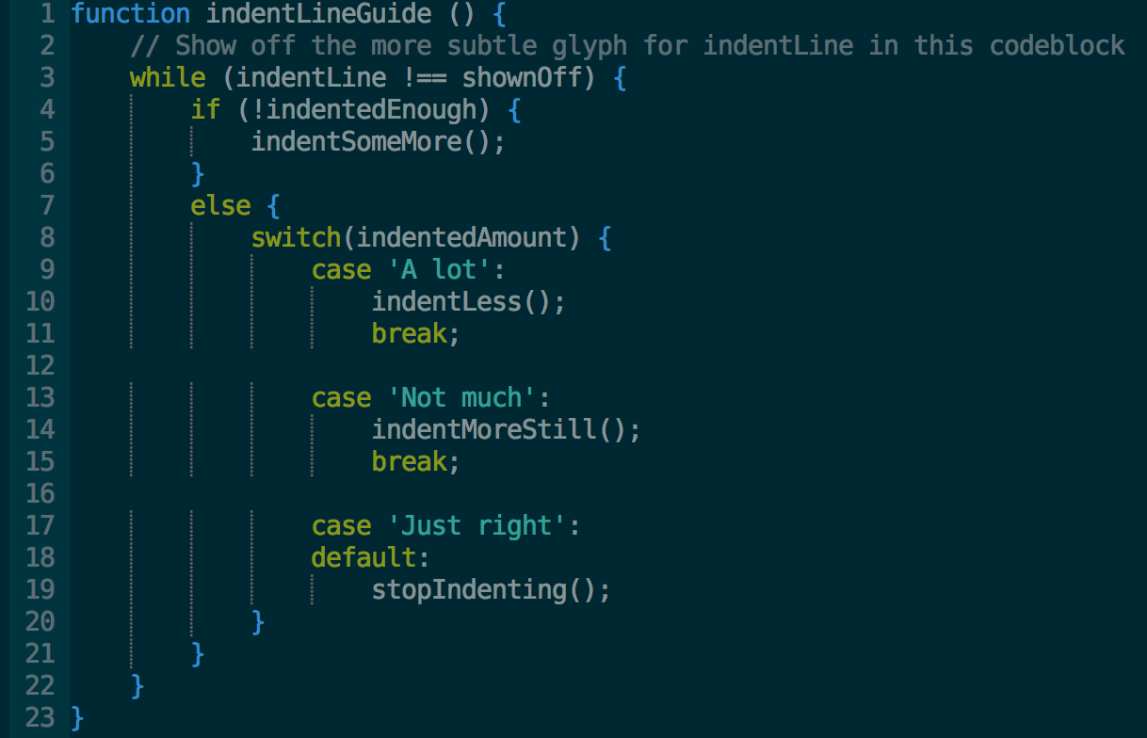
Among other things, it provides a toggle command, that can be mapped to a key combination, so that you can turn it off, when you don't need it.

What is the difference between the remap, map, noremap, nnoremap and vnoremap...?

remap is an option that makes mappings work recursively. By default it is on and I'd recommend you leave it that way. The rest are mapping commands, described below:
:map and :noremap are recursive and non-recursive versions of the various mapping commands. What that means is that if you do:
:map j gg
:map Q j
:noremap W j
j will be mapped to gg. Q will also be mapped to gg, because j will be expanded for the recursive mapping. W will be mapped to j (and not to gg) because j will not be expanded for the non-recursive mapping.
Now remember that Vim is a modal editor. It has a normal mode, visual mode and other modes.
For each of these sets of mappings, there is a mapping that works in normal, visual, select and operator modes (:map and :noremap), one that works in normal mode (:nmap and :nnoremap), one in visual mode (:vmap and :vnoremap) and so on.
For more guidance on this, see:
:help :map
:help :noremap
:help recursive_mapping
:help :map-modes

I think the vim documentation should've explained the meaning behind the naming of these commands. Just telling you what they do doesn't help you remember the names.
map is the "root" of all recursive mapping commands. The root form applies to "normal", "visual+select", and "operator-pending" modes. (I'm using the term "root" as in linguistics.)
noremap is the "root" of all non-recursive mapping commands. The root form applies to the same modes as map. (Think of the nore prefix to mean "non-recursive".)
(Note that there are also the ! modes like map! that apply to insert & command-line.)
See below for what "recursive" means in this context.
Prepending a mode letter like n modify the modes the mapping works in. It can choose a subset of the list of applicable modes (e.g. only "visual"), or choose other modes that map wouldn't apply to (e.g. "insert").
Use help map-modes will show you a few tables that explain how to control which modes the mapping applies to.
Mode letters:
- n: normal only
- v: visual and select
- o: operator-pending
- x: visual only
- s: select only
- i: insert
- c: command-line
- l: insert, command-line, regexp-search (and others. Collectively called "Lang-Arg" pseudo-mode)
"Recursive" means that the mapping is expanded to a result, then the result is expanded to another result, and so on.
The expansion stops when one of these is true:
- the result is no longer mapped to anything else.
- a non-recursive mapping has been applied (i.e. the "noremap" [or one of its ilk] is the final expansion).
At that point, vim's default "meaning" of the final result is applied/executed.
"Non-recursive" means the mapping is only expanded once, and that result is applied/executed.
Example:
nmap K H
nnoremap H G
nnoremap G gg
The above causes K to expand to H, then H to expand to G and stop. It stops because of the nnoremap, which expands and stops immediately. The meaning of G will be executed (i.e. "jump to last line"). At most one non-recursive mapping will ever be applied in an expansion chain (it would be the last expansion to happen).
The mapping of G to gg only applies if you press G, but not if you press K. This mapping doesn't affect pressing K regardless of whether G was mapped recursively or not, since it's line 2 that causes the expansion of K to stop, so line 3 wouldn't be used.

One difference is that:
- :map does nvo == normal + (visual + select) + operator pending
- :map! does ic == insert + command-line mode
as stated on help map-modes tables.
So: map does not map to all modes.
To map to all modes you need both :map and :map!.

Useful Mappings: Toggle Wrap, linenumbers, whitespace characters, undotree
:help local-options / options
:help setlocal / set
:help map-local / map
:help unmap.
Also: To define a <buffer> map or abbreviation in .vimrc makes no sense since it would only affect the .vimrc buffer itself.

" benzro: Toggle (key bindings)
" left: key combination
" right: called command
" ! (do toggle); ? (show value);
" <C-o> in insert mode let's you type : to access command line
"----------------------------------------------------------------

" define leader key
let mapleader = "-"

" toggle :set wrap
noremap <leader><F4> :set wrap! wrap?<CR>
inoremap <leader><F4> <C-o>:set wrap! wrap?<CR>

" toggle :set list and :set listchars to set nolist
noremap <leader><F5> :set list! list?<CR>
inoremap <leader><F5> <C-o>:set list! list?<CR>

" toggle :set numbers
nnoremap <leader><F6> :set nonumber! number?<CR>
inoremap <leader><F6> <C-o>:set list! number?<CR>

" toggle Gundo Plugin
nnoremap <leader><F7> :GundoToggle<CR>

" comment and uncomment (in visual mode highlight blocks)
source ~/vim_un_comment.vim
map <leader>cc :call Comment()<CR>
map <leader>xc :call Uncomment()<CR>
“ the two called function comment / uncomment according to their filetype
function! Comment()
let ft = &filetype
if ft == 'php' || ft == 'ruby' || ft == 'sh' || ft == 'make' || ft == 'python' || ft == 'perl'
silent s/^/\#/
elseif ft == 'javascript' || ft == 'c' || ft == 'cpp' || ft == 'java' || ft == 'objc' || ft == 'scala' || ft == 'go'
silent s:^:\/\/:g
elseif ft == 'tex'
silent s:^:%:g
elseif ft == 'vim'
silent s:^:\":g
endif
endfunction
function! Uncomment()
let ft = &filetype
if ft == 'php' || ft == 'ruby' || ft == 'sh' || ft == 'make' || ft == 'python' || ft == 'perl'
silent s/^\#//
elseif ft == 'javascript' || ft == 'c' || ft == 'cpp' || ft == 'java' || ft == 'objc' || ft == 'scala' || ft == 'go'
silent s:^\/\/::g
elseif ft == 'tex'
silent s:^%::g
elseif ft == 'vim'
silent s:^\"::g
endif
endfunction

Abbreviations
Mappings don't take into account what characters come before or after the map -- they only look at the specific sequence that you mapped to. Abbreviations pay attention to the characters before and after the map and only expand it when we want.
Use it as a mean to insert text sequences you often need. Like your email, or Java Templates for Main, Getter, Setter etc.
:iabbrev @@ steve@stevelosh.com
:iabbrev ccopy Copyright 2013 Steve Losh, all rights reserved.
Correcting typos like this is a great use for abbreviations. Run these commands:
:iabbrev waht what
:iabbrev tehn then
Vim will replace the --- for you local to the buffer you set it.
:iabbrev <buffer> --- &mdash;
To define a <buffer> map or abbreviation in .vimrc makes no sense since it would only affect the .vimrc buffer itself.

Autocommand Structure
:help autocmd-events
This autocommand saves the file the moment you create it with :e filename
:autocmd BufNewFile * :write
^ ^ ^
| | |
| | The command to run. (also option, own function etc)
| |
| A "pattern" to filter the event.
|
The "event" to watch for.

This is almost the same as the last command, but this time it will only apply to files whose names end in .txt.
:autocmd BufNewFile *.txt :write

To save this file with :w. reindents the file before saving it!
:autocmd BufWritePre *.html :normal gg=G

This will also reindent the code whenever we read an HTML file as well as when we write it.
:autocmd BufWritePre,BufRead *.html :normal gg=G

This will turn line wrapping off whenever you're working on an HTML file. Whether it’s a new or an existing file.
:autocmd BufNewFile,BufRead *.html setlocal nowrap

Open a Javascript file (a file that ends in .js), pick a line and type <localleader>c. This will comment out the line. Now open a Python file (a file that ends in .py), pick a line and type <localleader>c. This will comment out the line, but it will use Python's comment character
:autocmd FileType javascript nnoremap <buffer> <localleader>c I//<esc>
:autocmd FileType python nnoremap <buffer> <localleader>c I#<esc>

Grouping Autocommands
The problem is that sourcing your ~/.vimrc file rereads the entire file, including any autocommands you've defined! This means that every time you source your ~/.vimrc you'll be duplicating autocommands, which will make Vim run slower because it executes the same commands over and over. Vim has a solution to the problem. The first step is to group related autocommands into named groups.
The indentation in the middle two lines is insignificant.
:augroup testgroup
: autocmd BufWrite * :echom "Foo"
: autocmd BufWrite * :echom "Bar"
:augroup END
When you use augroup multiple times Vim will combine the groups each time.
:augroup testgroup
: autocmd BufWrite * :echom "Baz"
:augroup END
If you want to clear a group you can use autocmd! inside the group. Run the following commands:
:augroup testgroup
: autocmd!
: autocmd BufWrite * :echom "Cats"
:augroup END

We enter the filetype_html group, immediately clear it, define an autocommand, and leave the group. If we source ~/.vimrc again the clearing will prevent Vim from adding duplicate autocommands. Add the following to your ~/.vimrc file:
augroup filetype_html
autocmd!
autocmd FileType html nnoremap <buffer> <localleader>f Vatzf
augroup END

Operator-Pending Mappings
An operator is a command that waits for you to enter a movement command, and then does something on the text between where you currently are and where the movement would take you.
Some examples of operators are d, y, and c.
Keys Operator Movement
---- -------- -------------
dw Delete to next word
ci( Change inside parentesis
yt, Yank until comma
When you're trying to think about how to define a new operator-pending movement, you can think of it like this. It's your job to fill in step three with the appropriate keys.
- Start at the cursor position.
- Enter visual mode (charwise).
- ... mapping keys go here ... (If your operator-pending mapping ends with some text visually selected, Vim will operate on that text. Otherwise, Vim will operate on the text between the original cursor position and the new position. )
- All the text you want to include in the movement should now be selected.

Movement Mappings
Vim lets you create new movements that work with all existing commands.
:onoremap key modus movement

Do something (d, y, c) inside parentesis (movement “i(“ ) after pressing operator (d, y, c) and binding key (p)
:onoremap p i(

So something until searchpattern (return). Inside a function definition this db deletes from cursor to return statement.
:onoremap b /return<cr

"inside next parentheses". E.g. cin(. Vim will delete the contents of the parentheses and place you in insert mode between them.
:onoremap in( :<c-u>normal! f(vi(<cr>

"inside last/previous parentheses
:onoremap il( :<c-u>normal! F)vi(<cr>

The following line means, even thought you are in insert mode, vim acts as if keys are pressed in normal mode. For example, running :normal! dddd will delete two lines, just like pressing dddd. <cr> means carriage return or enter-key.
:<c-u>normal! <cr>

“F{char}” Move backwards to the nearest “)” character.
F)
“v” Visually select “i(“ inside the parentheses.
vi(

"change inside heading"
:onoremap ih :<c-u>execute "normal! ?^==\\+$\r:nohlsearch\rkvg_"<cr>

The execute command takes a Vimscript string (which we'll cover in more detail later) and performs it as a command. Vim will write your file, just as if you had typed :write<cr>.
:execute "write"
When execute looks at the string you tell it to run, it will substitute any special characters it finds before running it. normal! would parse it literally.
\\ needs to become \
\r needs to become <cr>. (<cr> is understood by the normal! parser)
performs a search backwards for any line that consists of two or more equal signs and nothing else
?^==\+$
This simply clears the search highlighting from the search we just performed
:nohlsearch
k: move up a line. v: enter (characterwise) visual mode. g_: move to the last non-blank character of the current line.

Vim Cheat Sheet

Global
- :help keyword - open help for keyword
- :saveas file - save file as
- :close - close current pane
- K - open man page for word under the cursor

Cursor movement
- h - move cursor left
- j - move cursor down
- k - move cursor up
- l - move cursor right
- H - move to top of screen
- M - move to middle of screen
- L - move to bottom of screen
- w - jump forwards to the start of a word
- W - jump forwards to the start of a word (words can contain punctuation)
- e - jump forwards to the end of a word
- E - jump forwards to the end of a word (words can contain punctuation)
- b - jump backwards to the start of a word
- B - jump backwards to the start of a word (words can contain punctuation)
- % - move to matching character (default supported pairs: '()', '{}', '[]' - use :h matchpairs in vim for more info)
- 0 - jump to the start of the line
- ^ - jump to the first non-blank character of the line
- $ - jump to the end of the line
- g_ - jump to the last non-blank character of the line
- gg - go to the first line of the document
- G - go to the last line of the document
- 5G - go to line 5
- fx - jump to next occurrence of character x
- tx - jump to before next occurrence of character x
- Fx - jump to previous occurence of character x
- Tx - jump to after previous occurence of character x
- ; - repeat previous f, t, F or T movement
- , - repeat previous f, t, F or T movement, backwards
- } - jump to next paragraph (or function/block, when editing code)
- { - jump to previous paragraph (or function/block, when editing code)
- zz - center cursor on screen
- Ctrl + e - move screen down one line (without moving cursor)
- Ctrl + y - move screen up one line (without moving cursor)
- Ctrl + b - move back one full screen
- Ctrl + f - move forward one full screen
- Ctrl + d - move forward 1/2 a screen
- Ctrl + u - move back 1/2 a screen
Tip Prefix a cursor movement command with a number to repeat it. For example, 4j moves down 4 lines.

Insert mode - inserting/appending text
- i - insert before the cursor
- I - insert at the beginning of the line
- a - insert (append) after the cursor
- A - insert (append) at the end of the line
- o - append (open) a new line below the current line
- O - append (open) a new line above the current line
- ea - insert (append) at the end of the word
- Esc - exit insert mode

Editing
- r - replace a single character
- J - join line below to the current one with one space in between
- gJ - join line below to the current one without space in between
- gwip - reflow paragraph
- cc - change (replace) entire line
- c$ - change (replace) to the end of the line
- ciw - change (replace) entire word
- cw - change (replace) to the end of the word
- s - delete character and substitute text
- S - delete line and substitute text (same as cc)
- xp - transpose two letters (delete and paste)
- u - undo
- Ctrl + r - redo
- . - repeat last command

Marking text (visual mode)
- v - start visual mode, mark lines, then do a command (like y-yank)
- V - start linewise visual mode
- o - move to other end of marked area
- Ctrl + v - start visual block mode
- O - move to other corner of block
- aw - mark a word
- ab - a block with ()
- aB - a block with {}
- ib - inner block with ()
- iB - inner block with {}
- Esc - exit visual mode

Visual commands
- > - shift text right
- < - shift text left
- y - yank (copy) marked text
- d - delete marked text
- ~ - switch case

Registers
- :reg - show registers content
- "xy - yank into register x
- "xp - paste contents of register x
Tip Registers are being stored in ~/.viminfo, and will be loaded again on next restart of vim.
Tip Register 0 contains always the value of the last yank command.

Marks
- :marks - list of marks
- ma - set current position for mark A
- `a - jump to position of mark A
- y`a - yank text to position of mark A

Macros
- qa - record macro a
- q - stop recording macro
- @a - run macro a
- @@ - rerun last run macro

Cut and paste
- yy - yank (copy) a line
- 2yy - yank (copy) 2 lines
- yw - yank (copy) the characters of the word from the cursor position to the start of the next word
- y$ - yank (copy) to end of line
- p - put (paste) the clipboard after cursor
- P - put (paste) before cursor
- dd - delete (cut) a line
- 2dd - delete (cut) 2 lines
- dw - delete (cut) the characters of the word from the cursor position to the start of the next word
- D - delete (cut) to the end of the line
- d$ - delete (cut) to the end of the line
- x - delete (cut) character

Exiting
- :w - write (save) the file, but don't exit
- :w !sudo tee % - write out the current file using sudo
- :wq or :x or ZZ - write (save) and quit
- :q - quit (fails if there are unsaved changes)
- :q! or ZQ - quit and throw away unsaved changes
- :wqa - write (save) and quit on all tabs

Search and replace
- /pattern - search for pattern
- ?pattern - search backward for pattern
- \vpattern - 'very magic' pattern: non-alphanumeric characters are interpreted as special regex symbols (no escaping needed)
- n - repeat search in same direction
- N - repeat search in opposite direction
- :%s/old/new/g - replace all old with new throughout file
- :%s/old/new/gc - replace all old with new throughout file with confirmations
- :noh - remove highlighting of search matches

Search in multiple files
- :vimgrep /pattern/ {file} - search for pattern in multiple files :(e.g. :vimgrep /foo/ **/* )
- :cn - jump to the next match
- :cp - jump to the previous match
- :copen - open a window containing the list of matches

Working with multiple files
- :e file - edit a file in a new buffer
- :bnext or :bn - go to the next buffer
- :bprev or :bp - go to the previous buffer
- :bd - delete a buffer (close a file)
- :ls - list all open buffers
- :sp file - open a file in a new buffer and split window
- :vsp file - open a file in a new buffer and vertically split window
- Ctrl + ws - split window
- Ctrl + ww - switch windows
- Ctrl + wq - quit a window
- Ctrl + wv - split window vertically
- Ctrl + wh - move cursor to the left window (vertical split)
- Ctrl + wl - move cursor to the right window (vertical split)
- Ctrl + wj - move cursor to the window below (horizontal split)
- Ctrl + wk - move cursor to the window above (horizontal split)

Tabs
- :tabnew or :tabnew file - open a file in a new tab
- Ctrl + wT - move the current split window into its own tab
- gt or :tabnext or :tabn - move to the next tab
- gT or :tabprev or :tabp - move to the previous tab
- #gt - move to tab number #
- :tabmove # - move current tab to the #th position (indexed from 0)
- :tabclose or :tabc - close the current tab and all its windows
- :tabonly or :tabo - close all tabs except for the current one
- :tabdo command - run the command on all tabs (e.g. :tabdo q - closes all opened tabs)

Why I love Vim: It’s the lesser-known features that make it so amazing

Vim tab-pages

Did you mention tabs in Vim? I didn’t know that existed!
I know, right! A tab page is a page with one or more windows with a label (aka tab) at the top.
If you are interested in knowing more about windows, buffers, tab pages: technical details
Have a look:
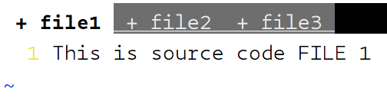
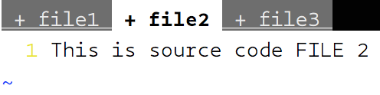
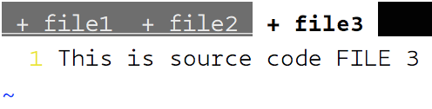
Steps:
- Open Vim with any file or just Vim: $ vim file1
- Type the contents of file and get into command mode (Press Esc )
- :tabedit file2 , will open a new tab and take you to edit file2
- :tabedit file3 , will open a new tab and take you to edit file3
- To navigate between these tabs, you can be in normal mode and type : gt or gT to go to next tab or previous tab respectively. You can also navigate to a particular index tab (indexed from 1) using {i}gt where, i is the index of your tab. Example: 2gt takes you to 2nd tab
- To directly move to first tab or last tab, you can enter the following in command mode: :tabfirst or :tablast for first or last tab respectively. To move back and forth : :tabn for next tab and :tabp for previous tab
- You can list all the open tabs using : :tabs
- To open multiple files in tabs: $ vim -p source.c source.h
- To close a single tab: :tabclose and to close all other tabs except the current one: :tabonly . Use the suffix! to override changes of unsaved files
[DEMO] Tabs in VIM
VIM supports tabs to open multiple files and work with themasciinema.org
I think this feature enables us to effectively save time by sharing the buffer between tabs and enabling us to copy paste between tabs and keep multiple sessions of different tab set for category of work. Example: You can have a terminal tab with all Vim tabs of source code C files only and you can have another terminal tab with all Vim tabs of header files (.h).

Tabs provide so much convenience to keep all my files open and access them when I want. However, isn’t it a pain to open all tabs every time I reboot or close and open the terminal?
Right! We all like to have our own sessions of work in which we work with a set of files and would like Vim to restore that session of tabs the way we left it.
Vim allows us to save and restore those tab sessions! ✋
Steps:
- Open any number of tabs you wish to work with
- From any tab, press Esc and enter the command mode
- Type :mksession header-files-work.vim and hit enter
- Your current session of open tabs will be stored in a file header-files-work.vim
- To see restore in action, close all tabs and Vim
- Either start vim with your session using : $ vim -S header-files-work.vim or open vim with any other file and enter command mode to type: :source header-files-work.vim and BOOM! All your tabs are opened for you just the way you saved it!
- If you change any session tabs (close/open new), you can save that back using : :mks! while you are in the session
[DEMO] Sessions in VIM
VIM allows users to store their work sessions separately based on the projects they are working on. Users can easily…asciinema.org

Can I copy/cut paste without having to know line numbers?
Oh Yes! Earlier I used to see the line numbers ( :set nu ) of the functions I wanted to copy/cut. Let’s say I want to copy/cut lines 34 to 65. I used :34,65y (Copy/Yank) or :34,65d (Cut/Delete).
Of course counting the lines and using {n}yy or {n}dd (where n is number of lines) is not an option for hundreds of lines ??
There can be some functions that span multiple pages and you don’t want to go down only to forget what was the first line number. There’s a simple way to achieve this without worrying anything about line numbers!
Steps:
- Enter normal mode, go to the start line
- Type mk (Mark point with alphabet ‘k’ or use any other alphabet)
- Move down (page down or whatever) and move to the end line
- y'k will yank/copy all the lines from start to end
- d'k will cut/delete all the lines from start to end

I have some annoying long functions at the top of my file and I don’t want to waste my time scrolling or jumping to lines. This may be a lot to ask because this is not an IDE but, by any chance can we fold the code blocks?
Absolutely! Let’s say you want to skip remembering those line numbers and walk around with your new found love *the markers*. Go to the beginning of the function body and type mb . Now, just go to the end of the function body using % (brace matching) or any other convenient technique and press zf'b and you’re done!
Before and after:
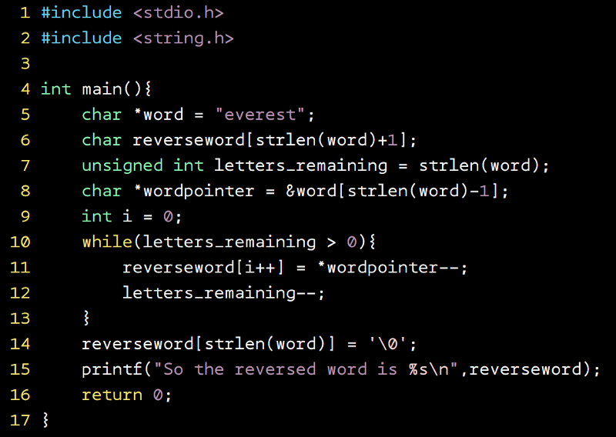

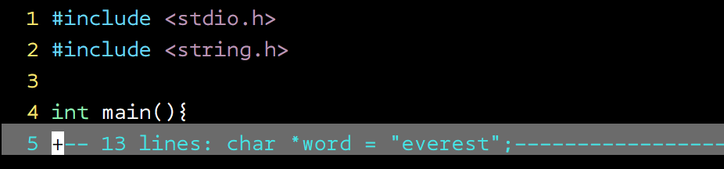
If you are comfortable using the line numbers, the command is even easier to remember: :5,16fo (fo stands for code fold). Once you have folded your code, it’s easy to toggle between open and closed views using zo (Open the code fold) and zc (Close the code fold). Don’t stress it so much. Just use za to toggle between open and closed folds ??
Let’s say you spent considerable time folding your functions in a large file, you would obviously want to retain those folds every time you open that file right? (If not, why did you waste your energy folding them!?), so there’s a solution right in your ~/.vimrc . Insert the following lines in ~/.vimrcand your code folds are saved and restored:
autocmd BufWinLeave *.* mkview
autocmd BufWinEnter *.* silent loadview

I’m usually careful with my indentation but sometimes, I have to edit some other idiot’s source code and it bugs me to edit his/her code without indentation. Are there any magical keystrokes to make that happen?
Sure! It’s as simple as: =i{ . Really that’s all ! ( i is inner object)
[DEMO] Indentation in VIM
VIM allows blocks of code to be indented with a few keystrokes. All you have to do is place the cursor in a block of…asciinema.org
Before-after:
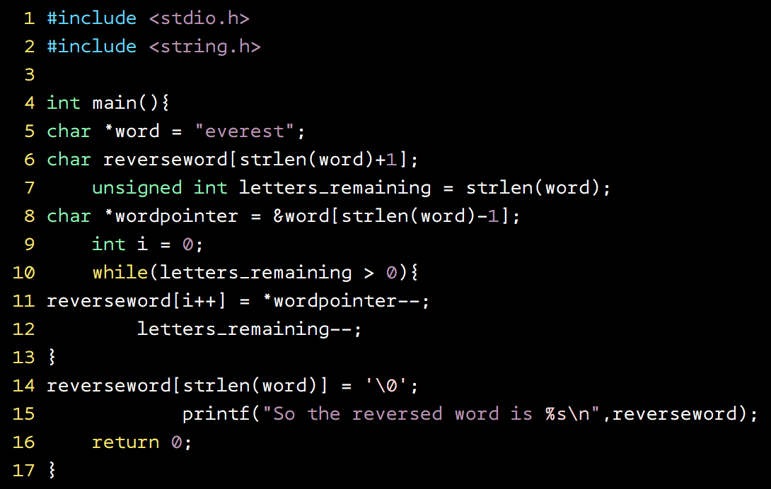

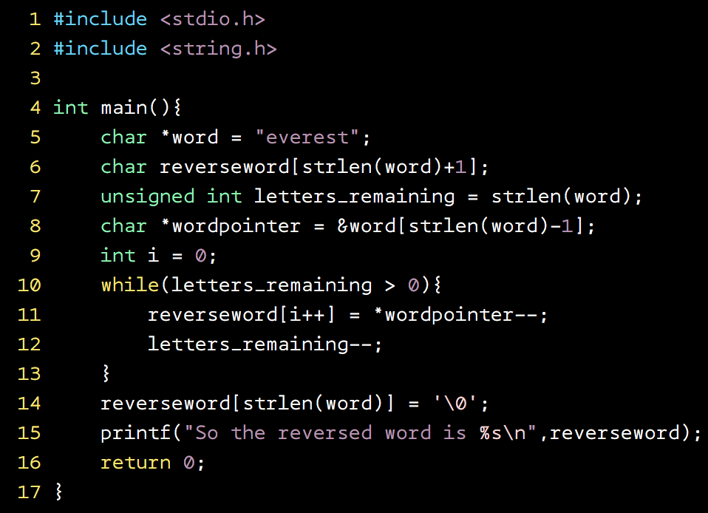
All you have to do is place the cursor anywhere within a block you want to indent, press Esc to enter normal mode and then: =i{ . Boom! Your entire function body (including inner blocks) is indented.
NOTE: Don’t expect indentation of your python files ??. It only works when Vim can identify the start and end using opening and closing parenthesis)
You can also increase/decrease the indentation within a block using : >i{ to increase and <i{ to decrease in normal mode.

I may be dreaming but (*quavering voice*), I mean I just want to give it a try, Uhmm, I may be pushing it really far with this one but (*5 second pause*)..never mind, lets move on to my next question
Vim is quite open-minded to take criticism or face the fact that it’s not an IDE, go ahead, let’s see what you’ve got.

Uhmmm, sorry but by any chance (*panting*) with any plugin or something, does vim have autocomplete like an IDE?
?? You may be surprised but yes it does! ?? and guess what…
* drum rolls *
* drum rolls *
* drum rolls *
* drum rolls *
Without a plugin!
You heard me right! The only condition for Vim to show you options is “Vim should know what you’re talking about.” It could be through an included source file or defined functions or variables.
All you have to do is start typing and then press Ctrl+n in insert mode.
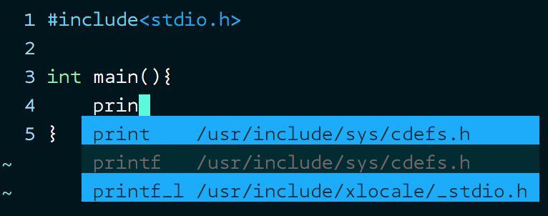
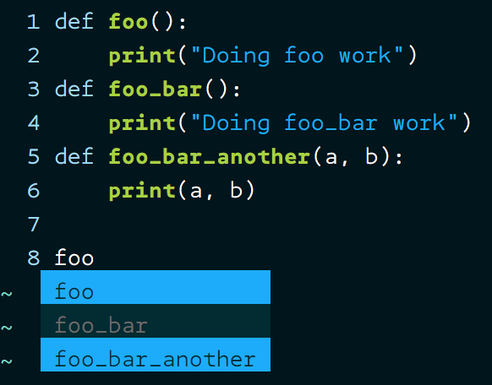
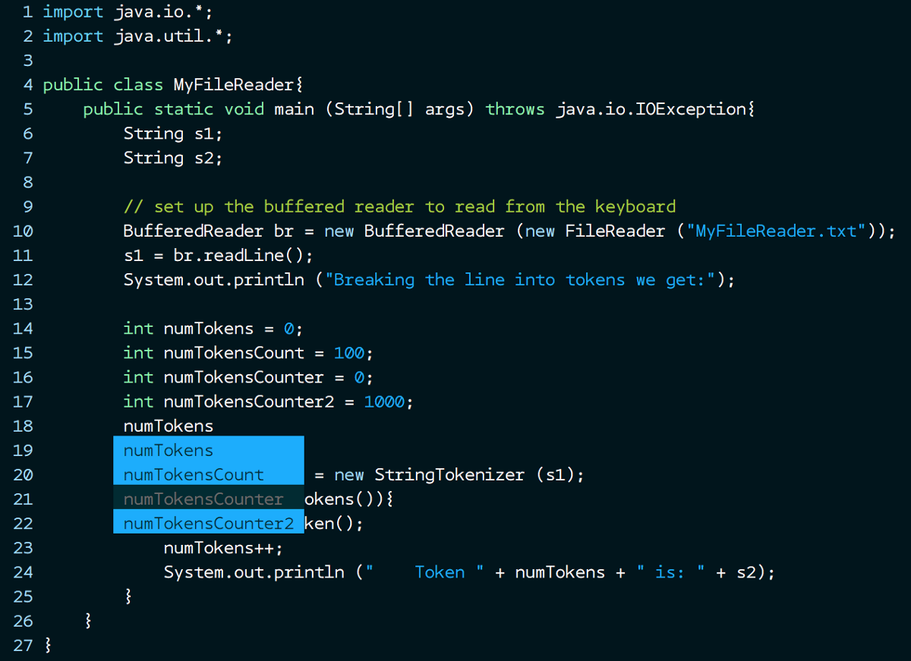
Just imagine the uses! Specially if you’re writing C code and you cannot recollect the exact OpenSSL library call, all you have to do is include the header!
[DEMO] Autocomplete feature in VIM
VIM has autocomplete suggestions for keywords, function names if the appropriate header files are included or if the…asciinema.org
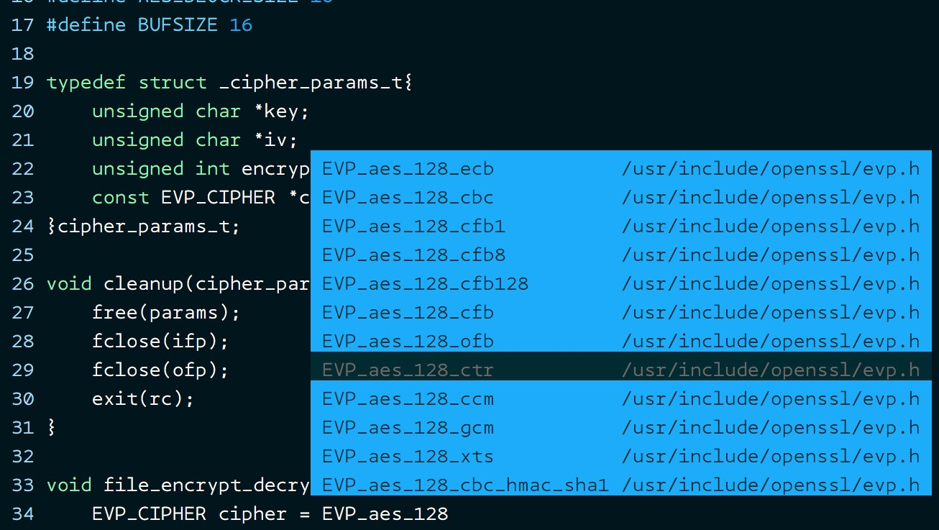
Let me remind again: No plugins required ??
NOTE: The header files may be at some other locations on Mac and Vim may not be able to find them. I just use a Mac to login to a linux machine. So, if you’re using Mac, sorry about that.

I understand Vim is just a text editor but if you want me to work without losing focus and without exiting Vim every now and then, what options do I have if I can’t remember all the file names?
Simple, use the file explorer provided by VIM ?? Yes, Vim provides a simple file explorer (*without any plugins*). Just type : :Explore from any Vim window and you will see an easy to navigate file explorer which can be navigated using ⬆️ and ⬇️ arrow keys. Press Enter/Return key to open a file/directory.
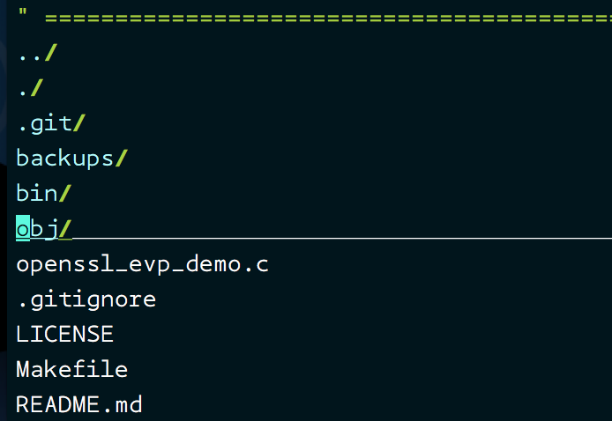
NOTE: You can also use the short command :Ex to open the file explorer

Sometimes I have to repeat same steps on some lines to edit something. I am pretty sure Vim will have some feature that enables me to do this. Am I right?
100% Right! You are talking about macros and Vim supports macros. Repeating the last executed command is simple and can accomplish simple repetitive tasks. However, if the text processing is made up of several steps to achieve a result, macros come in handy.
Consider an example C header file :
void encrypt_text(char *text, int bytes)
void decrypt_text(char *text, int bytes)
void process_text(char *text, int bytes)
void another_important_function(int bytes, double precision)
Oops! You forgot to put a semicolon at the end of each line and also you just realized that all these functions return an integer error code instead of void.
The steps you need to perform for making change in one line are:
- Place the cursor at the beginning of the word void
- Press cw in normal mode to delete the word void and type int
- Press Esc , move to the end of line using Shift+a to insert ;
- Press Esc and press ^ (müsste “0” sein) to return to the beginning of the edited line
Resulting in:
int encrypt_text(char *text, int bytes);
void decrypt_text(char *text, int bytes)
void process_text(char *text, int bytes)
void another_important_function(int bytes, double precision)
You can just record this sequence of steps and replay it on all 4 lines.
1.) All you have to do is, before you start the sequence, start recording the macro in any alphabet (let’s say a) by pressing qa in normal mode.
2.) Now your steps are being recorded in a . Once you are done with all your steps, just press q in normal mode. This will end the recording.
3.) To replay these steps, just keep the cursor at the same place where it was placed during macro.
4.) Press @a and we’re done! BOOM! Vim will repeat the same steps for you on that line! To repeat it on multiple lines, you can also use @@ after using @a command once

I know Vim is nowhere close to an IDE and I may be having some unreasonable hopes but just a quick question: Remote editing of files possible with Vim?
If you think of it considering the available resources:
[1] Vim
[2] openssh-client (Comes installed with most Linux flavors)
You are in luck my friend! Yes, Vim supports remote editing of files ??
Vim just utilizes the secure connection established by scp (secure copy) provided by openssh-client. There are times when you are working with files on multiple remote machines and it’s a waste of time to log into a machine just to edit one single file! You can relax in your current machine if you just know your remote machine credentials and path.
vim scp://remoteuser@remote_IP_or_hostname/relative/path/of/file
For example: I need to edit a file on 10.0.18.12 stored in /home/dev-john/project/src/main.c and I have login credentials for dev-john, I can access the main.c using:
$ vim scp://dev-john@10.0.18.12/project/src/main.c
I can use the relative path because, I can start looking for the file from the home directory of dev-john
TIP: If you access a remote machine frequently, you can create an ssh config file to create a shortcut for the connection. Create a file ~/.ssh/config with
Host remote-dev-machine
Hostname 10.0.18.12
User dev-john
IdentityFile ~/.ssh/id_rsa
Now you can access your file using:
$ vim scp://remote-dev-machine/project/src/main.c
If it’s confusing to remember the relative path and not intuitive, you can also specify it with an alternative:
$ vim scp://remote-dev-machine/~dev-john/project/src/main.c

Awesome! I’m already thrilled at the out-of-the-box capabilities of Vim. Looks like you’ve a solution to a lot of common editing problems. Let’s see.

I have a file with over 2000 lines and the functions of my interest are located at line 9, line 768 and line 1898. I know I can jump to a line using line number but I’m not so good at remembering those numbers. Got anything for me?
Hell yeah! What you’re looking for is a local bookmark solution in Vim using letters. All you have to do is :
- Place your cursor on any line at any position
- Press Esc to make sure you’re in normal mode
- Press m{lowercaseletter} where {lowercaseletter} is any letter from a-z
- You just created a local bookmark to navigate in your file
To view all your bookmarks: Press Esc and enter command mode, type :marks and hit Enter/Return . You’ll see a list of your bookmarks. To visit any bookmark at any time, just press Esc and type `{lowercaseletter} . Kaboom! You’ll arrive at the exact same location with cursor where you bookmarked. Example:
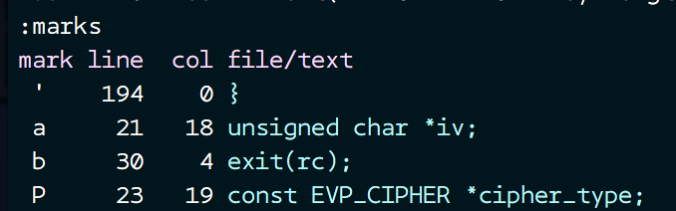
I have created a local bookmark to line 21, column 18 using a . If I’m editing something on line 1783, I would just press Esc and type `a :
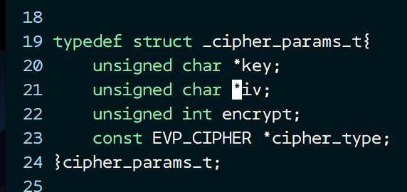
To solve your problem, all you’ve to do is create 3 local bookmarks and quickly jump to them by looking at :marks .
Problem solved ??
What if I told you that you can create global bookmarks too?! ?? Yes, it is possible to create global bookmarks too! These are equivalent to your windows or GUI shortcuts (or linux soft/hardlinks) except you don’t need to create an actual link. You heard me right! You can literally jump from editing a file in /dir1 to another file and line in /project/src/ from your Vim without exiting ! ??
Fret not, it’s not a big new thing to remember. All you have to do is:
Use an uppercase letter instead of lower case letter to create a global bookmark. That’s all! Really! You navigate to the global bookmark using the same process. Example: If you’ve created a bookmark using mP , all you’ve to do is press Esc and type `P and BAM! You jump to your global bookmark (Vim remembers the path, so you don’t have to type anything about the path)
You can access the global bookmarks in the same way as local : :marks
:marks
mark line col file/text
P 53 4 ~/project/src/large-file.c
A 11 0 ~/project/README.md
NOTE: If you are not interested in the cursor position and just want to be there at the beginning of you bookmarked line, use 'P instead of `P (Use a single quote instead of back tick to be positioned at the beginning of the line)

I’ve heard that Vim supports window splitting along with tabs! I understand tabs are great and you get to work with multiple open files at once. But, what about splitting? Why would I want that?
Scenarios:
- You may want to edit a file by looking at another file simultaneously (May be you are defining a C function by looking at it’s declaration in a header file)
- You may want to edit some portion of a file by looking at the top/bottom portion of the same file simultaneously
- Your work may require you to edit a file by looking at different portions of different files simultaneously
Vim supports splitting of screen both horizontally and vertically. Even better, you can even browse file system to open a file when you split your screen.
Here are the available options:
:split filename - split window horizontally and load filename
:vsplit file - vertical split and open file
ctrl-w up arrow - move cursor up a window
ctrl-w ctrl-w - move cursor to another window (cycle)
ctrl-w _ - maximize current window vertically (eher horizontal, dh. rauf, runter)
ctrl-w | - maximize current window horizontally (eher vertikal, dh links, rechts=
ctrl-w = - make all equal size
:sview file - same as split, but readonly
:close - close current window
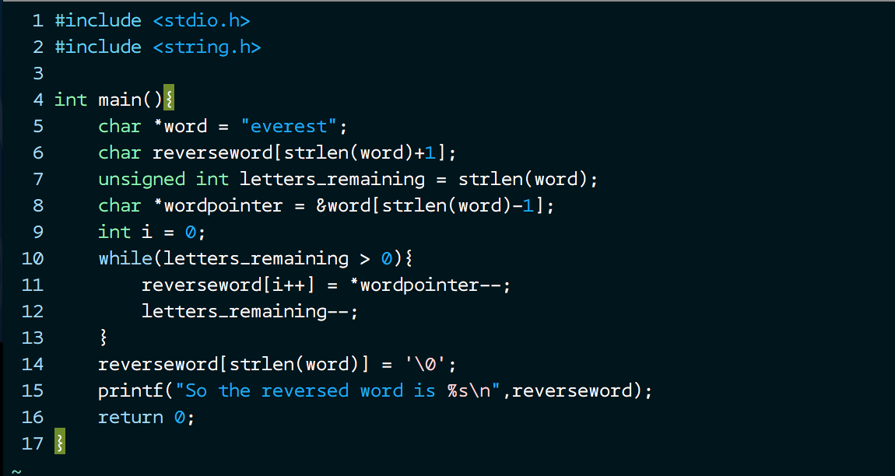

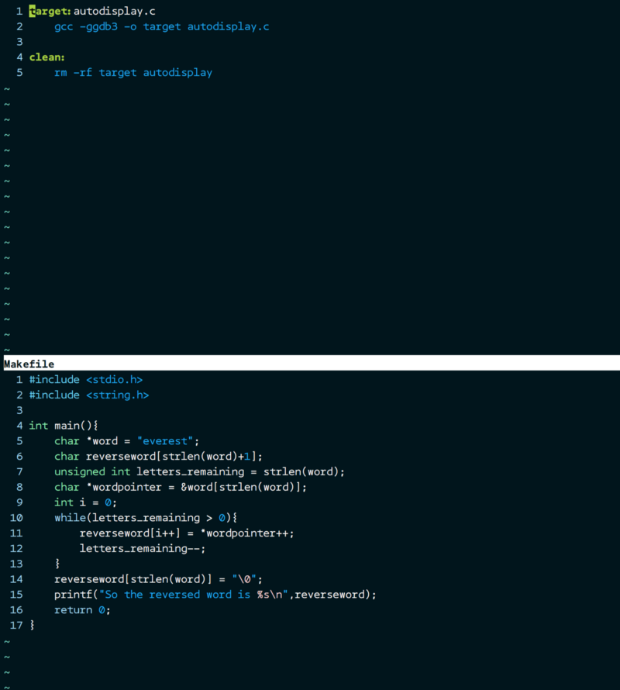
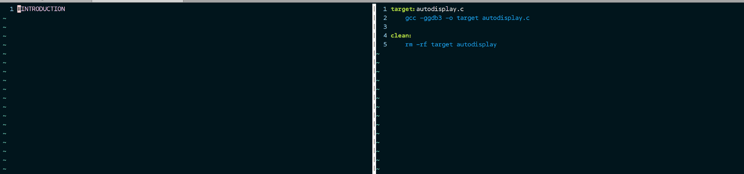
Maximizing a window for work:
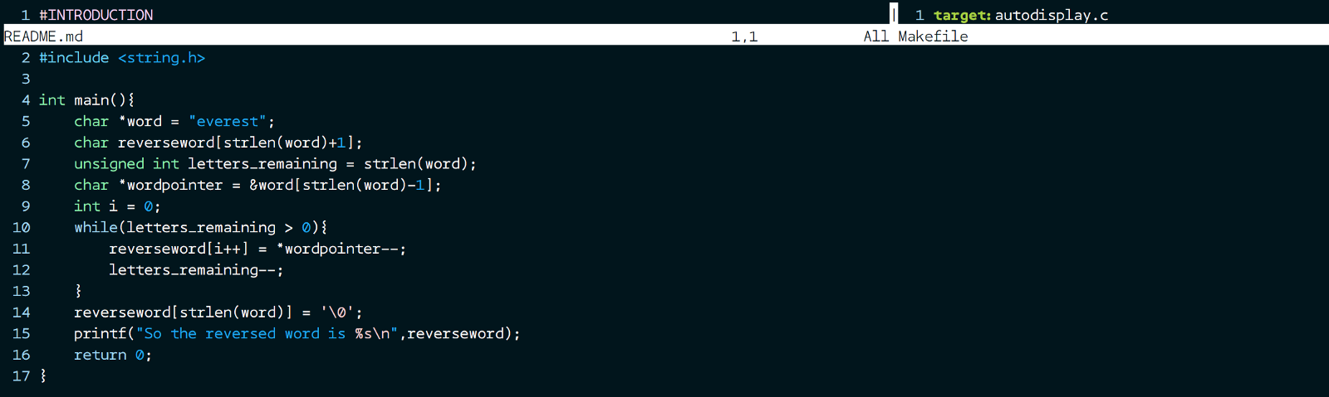
Resizing:
CTRL-W [N] - Decrease current window height by N (default 1)
CTRL-W [N] + Increase current window height by N (default 1)
CTRL-W [N] < Decrease current window width by N (default 1)
CTRL-W [N} > Increase current window width by N (default 1)
Is there a way to use file explorer while I split panes? (I can’t remember and type the file names always!)
Of course, all you have to do is type : :Sexplore for horizontal file explorer and :Vexplore for vertical file explorer. You can also use :Vexplore! to open the file explorer on right side (instead of default left)
Again, all this works *without any extra plugins* ??

I am in the middle of editing some code and I quickly need to run a shell command. Should I save my work, exit Vim and run my commands? I bet there is a better way out with Vim
You bet! Vim just doesn’t want you to leave Vim and wants you to continue focussing on your work. Hence the option to execute shell commands from within your Vim. Don’t worry, all your unsaved work is not discarded, you just execute your command and BAM! you are back in your unsaved/saved file safely!
Let’s say you are in the middle of a coding session and you quickly need to head out to take a look at man page of file operations because you forgot the signature! You don’t have to save your work, exit Vim and then check man pages or you don’t have to open another tab just for the man page. You can issue the command from right within the Vim editor.
:!Command
[DEMO] Unix commands from VIM
VIM allows users to execute shell commands from within VIM without exiting. All you have to do is enter the command…asciinema.org
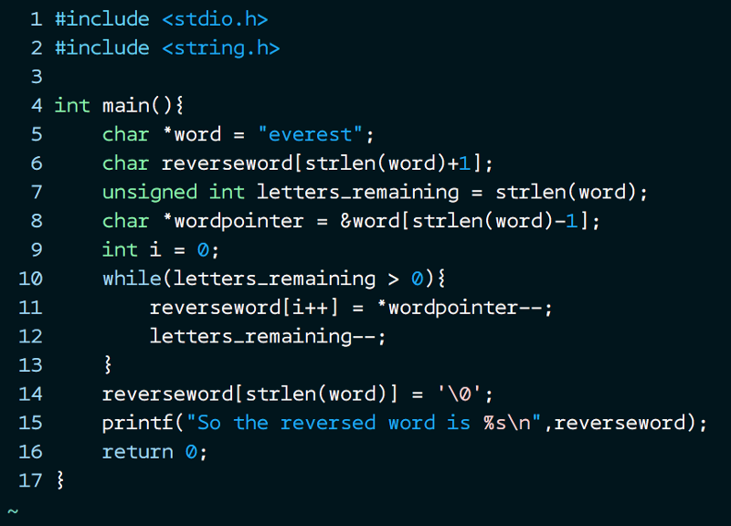
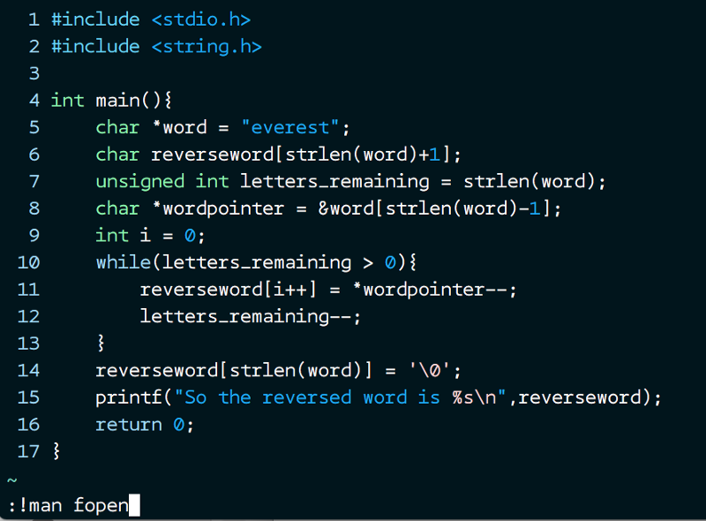
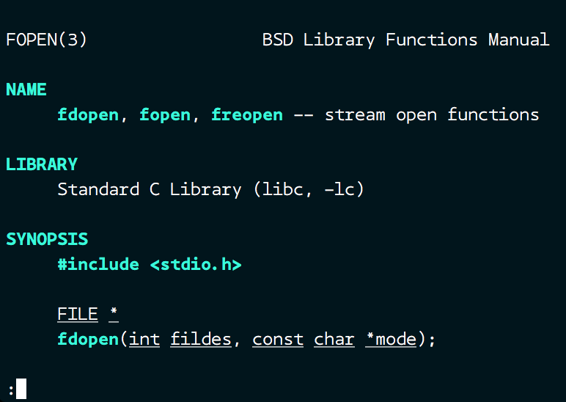
Guess what! Prepare to be amazed. Vim also supports make command from within your file! All you have to do is navigate to a directory with Makefile . Open any file (Could be your source code) and make all the changes and save it. Wait, there’s no need to exit to see the compilation result. You can trigger your make build from right within Vim:
[DEMO] Trigger make builds from vim
VIM allows users to trigger make builds without exiting VIM. All we have to do is enter the command mode and type :makeasciinema.org
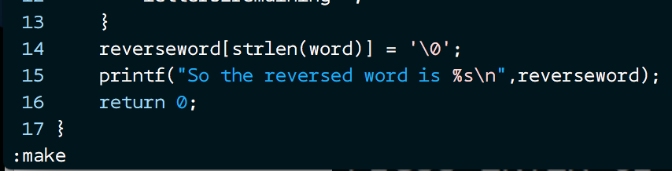
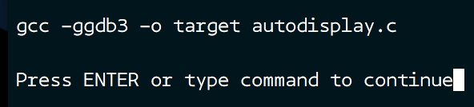
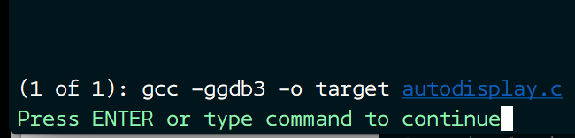
Similarly you can build other targets in your Makefile!
Exam
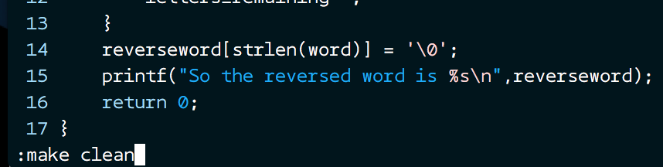
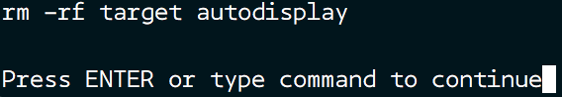
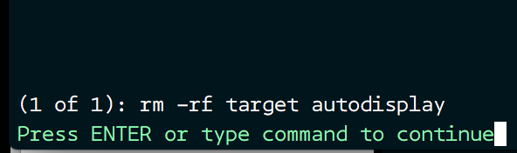
I hope these cool features will help you to use Vim more productively.

Vim-Plug: A minimalist Vim plugin manager.


Pros.
- Easier to setup: Single file. No boilerplate code required.
- Easier to use: Concise, intuitive syntax
- Super-fast parallel installation/update (with any of +job, +python, +python3, +ruby, or Neovim)
- Creates shallow clones to minimize disk space usage and download time
- On-demand loading for faster startup time
- Can review and rollback updates
- Branch/tag/commit support
- Post-update hooks
- Support for externally managed plugins

Installation
Download plug.vim and put it in the "autoload" directory.

Vim

Unix
curl -fLo ~/.vim/autoload/plug.vim --create-dirs \
https://raw.githubusercontent.com/junegunn/vim-plug/master/plug.vim
You can automate the process by putting the command in your Vim configuration file as suggested here.

Windows (PowerShell)
md ~\vimfiles\autoload
$uri = 'https://raw.githubusercontent.com/junegunn/vim-plug/master/plug.vim'
(New-Object Net.WebClient).DownloadFile(
$uri,
$ExecutionContext.SessionState.Path.GetUnresolvedProviderPathFromPSPath(
"~\vimfiles\autoload\plug.vim"
)
)

Neovim

Unix
curl -fLo ~/.local/share/nvim/site/autoload/plug.vim --create-dirs \
https://raw.githubusercontent.com/junegunn/vim-plug/master/plug.vim

Windows (PowerShell)
md ~\AppData\Local\nvim\autoload
$uri = 'https://raw.githubusercontent.com/junegunn/vim-plug/master/plug.vim'
(New-Object Net.WebClient).DownloadFile(
$uri,
$ExecutionContext.SessionState.Path.GetUnresolvedProviderPathFromPSPath(
"~\AppData\Local\nvim\autoload\plug.vim"
)
)

Getting Help
- See tutorial page to learn the basics of vim-plug
- See tips and FAQ pages for common problems and questions
- See requirements page for debugging information & tested configurations
- Create an issue

Usage
Add a vim-plug section to your ~/.vimrc (or ~/.config/nvim/init.vim for Neovim):
- Begin the section with call plug#begin()
- List the plugins with Plug commands
- call plug#end() to update &runtimepath and initialize plugin system
  - Automatically executes filetype plugin indent on and syntax enable. You can revert the settings after the call. e.g. filetype indent off, syntax off, etc.

Example
" Specify a directory for plugins
" - For Neovim: ~/.local/share/nvim/plugged
" - Avoid using standard Vim directory names like 'plugin'
call plug#begin('~/.vim/plugged')

" Make sure you use single quotes

" Shorthand notation; fetches https://github.com/junegunn/vim-easy-align
Plug 'junegunn/vim-easy-align'

" Any valid git URL is allowed
Plug 'https://github.com/junegunn/vim-github-dashboard.git'

" Multiple Plug commands can be written in a single line using | separators
Plug 'SirVer/ultisnips' | Plug 'honza/vim-snippets'

" On-demand loading
Plug 'scrooloose/nerdtree', { 'on': 'NERDTreeToggle' }
Plug 'tpope/vim-fireplace', { 'for': 'clojure' }

" Using a non-master branch
Plug 'rdnetto/YCM-Generator', { 'branch': 'stable' }

" Using a tagged release; wildcard allowed (requires git 1.9.2 or above)
Plug 'fatih/vim-go', { 'tag': '*' }

" Plugin options
Plug 'nsf/gocode', { 'tag': 'v.20150303', 'rtp': 'vim' }

" Plugin outside ~/.vim/plugged with post-update hook
Plug 'junegunn/fzf', { 'dir': '~/.fzf', 'do': './install --all' }

" Unmanaged plugin (manually installed and updated)
Plug '~/my-prototype-plugin'

" Initialize plugin system
call plug#end()
Reload .vimrc and :PlugInstall to install plugins.

Commands
Command | Description
PlugInstall [name ...] [#threads] | Install plugins
PlugUpdate [name ...] [#threads] | Install or update plugins
PlugClean[!] | Remove unused directories (bang version will clean without prompt)
PlugUpgrade | Upgrade vim-plug itself
PlugStatus | Check the status of plugins
PlugDiff | Examine changes from the previous update and the pending changes
PlugSnapshot[!] [output path] | Generate script for restoring the current snapshot of the plugins

Plug options
Option | Description
branch/tag/commit | Branch/tag/commit of the repository to use
rtp | Subdirectory that contains Vim plugin
dir | Custom directory for the plugin
as | Use different name for the plugin
do | Post-update hook (string or funcref)
on | On-demand loading: Commands or <Plug>-mappings
for | On-demand loading: File types
frozen | Do not update unless explicitly specified

Global options
Flag | Default | Description
g:plug_threads | 16 | Default number of threads to use
g:plug_timeout | 60 | Time limit of each task in seconds (Ruby & Python)
g:plug_retries | 2 | Number of retries in case of timeout (Ruby & Python)
g:plug_shallow | 1 | Use shallow clone
g:plug_window | vertical topleft new | Command to open plug window
g:plug_pwindow | above 12new | Command to open preview window in PlugDiff
g:plug_url_format | https://git::@github.com/%s.git | printf format to build repo URL (Only applies to the subsequent Plug commands)

Keybindings
- D - PlugDiff
- S - PlugStatus
- R - Retry failed update or installation tasks
- U - Update plugins in the selected range
- q - Close the window
- :PlugStatus
  - L - Load plugin
- :PlugDiff
  - X - Revert the update

Example: A small sensible Vim configuration
call plug#begin()
Plug 'tpope/vim-sensible'
call plug#end()

On-demand loading of plugins
" NERD tree will be loaded on the first invocation of NERDTreeToggle command
Plug 'scrooloose/nerdtree', { 'on': 'NERDTreeToggle' }

" Multiple commands
Plug 'junegunn/vim-github-dashboard', { 'on': ['GHDashboard', 'GHActivity'] }

" Loaded when clojure file is opened
Plug 'tpope/vim-fireplace', { 'for': 'clojure' }

" Multiple file types
Plug 'kovisoft/paredit', { 'for': ['clojure', 'scheme'] }

" On-demand loading on both conditions
Plug 'junegunn/vader.vim', { 'on': 'Vader', 'for': 'vader' }

" Code to execute when the plugin is lazily loaded on demand
Plug 'junegunn/goyo.vim', { 'for': 'markdown' }
autocmd! User goyo.vim echom 'Goyo is now loaded!'
for option is generally not needed as most plugins for specific file types usually don't have too much code in plugin directory. You might want to examine the output of vim --startuptime before applying the option.

Post-update hooks
There are some plugins that require extra steps after installation or update. In that case, use do option to describe the task to be performed.
Plug 'Shougo/vimproc.vim', { 'do': 'make' }
Plug 'Valloric/YouCompleteMe', { 'do': './install.py' }
If the value starts with :, it will be recognized as a Vim command.
Plug 'fatih/vim-go', { 'do': ':GoInstallBinaries' }
If you need more control, you can pass a reference to a Vim function that takes a single argument.
function! BuildYCM(info)
" info is a dictionary with 3 fields
" - name: name of the plugin
" - status: 'installed', 'updated', or 'unchanged'
" - force: set on PlugInstall! or PlugUpdate!
if a:info.status == 'installed' || a:info.force
!./install.py
endif
endfunction

Plug 'Valloric/YouCompleteMe', { 'do': function('BuildYCM') }
Both forms of post-update hook are executed inside the directory of the plugin and only run when the repository has changed, but you can force it to run unconditionally with the bang-versions of the commands: PlugInstall! and PlugUpdate!.
Make sure to escape BARs and double-quotes when you write do option inline as they are mistakenly recognized as command separator or the start of the trailing comment.
Plug 'junegunn/fzf', { 'do': 'yes \| ./install' }
But you can avoid the escaping if you extract the inline specification using a variable (or any Vimscript expression) as follows:
let g:fzf_install = 'yes | ./install'
Plug 'junegunn/fzf', { 'do': g:fzf_install }

PlugInstall! and PlugUpdate!
The installer takes the following steps when installing/updating a plugin:
- git clone or git fetch from its origin
- Check out branch, tag, or commit and optionally git merge remote branch
- If the plugin was updated (or installed for the first time)
  - Update submodules
  - Execute post-update hooks
The commands with ! suffix ensure that all steps are run unconditionally.

Articles
- Writing my own Vim plugin manager
- Vim plugins aTutorial
- What is a Vim plugin and why would I need a plugin manger?nd startup time
- Thoughts on Vim plugin dependency
  - Support for Plugfile has been removed since 0.5.0

License
MIT

Tutorial

What is a Vim plugin and why would I need a plugin manger?
A Vim plugin is a set of Vimscript files that are laid out in a certain directory structure. Before plugin managers became popular, Vim plugins were usually distributed as tarballs. Users would manually download the file and extract it in a single directory called ~/.vim, and Vim would load the files under the directory during startup.
This simplistic "download & unzip" method might work for a tiny number of plugins but the effectiveness of it degenerates quickly as the number of plugins grows. All the files from different plugins share the same directory structure and you can't easily tell which file is from which plugin of which version. The directory becomes a mess, and it's really hard to update or remove a certain plugin.
vim-plug, a modern Vim plugin manager, downloads plugins into separate directories for you and makes sure that they are loaded correctly. It allows you to easily update the plugins, review (and optionally revert) the changes, and remove the plugins that are no longer used.

Setting up
vim-plug is distributed as a single Vimscript file. All you have to do is to download the file in a directory so that Vim can load it.
# Vim (~/.vim/autoload)
curl -fLo ~/.vim/autoload/plug.vim --create-dirs \
https://raw.githubusercontent.com/junegunn/vim-plug/master/plug.vim

# Neovim (~/.config/nvim/autoload)
curl -fLo ~/.config/nvim/autoload/plug.vim --create-dirs \
https://raw.githubusercontent.com/junegunn/vim-plug/master/plug.vim

Installing plugins
With vim-plug, you declare the list of plugins you want to use in your Vim configuration file. It's ~/.vimrc for ordinary Vim, and ~/.config/nvim/init.vim for Neovim. The list should start with call plug#begin(PLUGIN_DIRECTORY) and end with call plug#end().
" Plugins will be downloaded under the specified directory.
call plug#begin('~/.vim/plugged')

" Declare the list of plugins.
Plug 'tpope/vim-sensible'
Plug 'junegunn/seoul256.vim'

" List ends here. Plugins become visible to Vim after this call.
call plug#end()
After adding the above to the top of your Vim configuration file, reload it (:source ~/.vimrc) or restart Vim. Now run :PlugInstall to install the plugins.

Updating plugins
Run :PlugUpdate to update the plugins. After the update is finished, you can review the changes by pressing D in the window. Or you can do it later by running :PlugDiff.

Reviewing the changes
Updated plugins may have new bugs and no longer work correctly. With :PlugDiff command you can review the changes from the last :PlugUpdate and roll each plugin back to the previous state before the update by pressing X on each paragraph.

Removing plugins
- Delete or comment out Plug commands for the plugins you want to remove.
- Reload vimrc (:source ~/.vimrc) or restart Vim
- Run :PlugClean. It will detect and remove undeclared plugins.

javacomplete : Omni Completion for JAVA (Erzeugt Errors)
script karma | Rating 711/452, Downloaded by 25778 | Comments, bugs, improvements | Vim wiki
created by
fang cheng
script type
ftplugin
description
This is javacomplete, an omni-completion script of JAVA language for vim 7.
It includes javacomplete.vim, java_parser.vim, Reflection.java, and
javacomplete.txt
Features:
- List members of a class, including (static) fields, (static) methods and ctors.
- List classes or subpackages of a package.
- Provide parameters information of a method, list all overload methods.
- Complete an incomplete word.
- Provide a complete JAVA parser written in Vim script language.
- Use the JVM to obtain most information.
- Use the embedded parser to obtain the class information from source files.
- Tags generated by ctags can also be used.
- JSP is supported, Builtin objects such as request, session can be recognized.
The classes and jar files in the WEB-INF will be appended automatically to classpath.
Requirements:
It works on all the platforms where
- Vim version 7.0 and above
- JDK version 1.1 and above
existed
Input context:
It recognize nearly all kinds of Primary Expressions (see langspec-3.0)
except for "Primary.new Indentifier". Casting conversion is also supported.
Samples of input contexts are as following: ('|' indicates cursor)
(1). after '.', list members of a class or a package
- package.| subpackages and classes of a package
- Type.| static members of the 'Type' class and "class"
- var.| or field.| members of a variable or a field
- method().| members of result of method()
- this.| members of the current class
- ClassName.this.| members of the qualified class
- super.| members of the super class
- array.| members of an array object
- array[i].| array access, return members of the element of array
- "String".| String literal, return members of java.lang.String
- int.| or void.| primitive type or pseudo-type, return "class"
- int[].| array type, return members of a array type and "class"
- java.lang.String[].|
- new int[].| members of the new array instance
- new java.lang.String[i=1][].|
- new Type().| members of the new class instance
- Type.class.| class literal, return members of java.lang.Class
- void.class.| or int.class.|
- ((Type)var).| cast var as Type, return members of Type.
- (var.method()).| same with "var.|"
- (new Class()).| same with "new Class().|"
(2). after '(', list matching methods with parameters information.
- method(|) methods matched
- var.method(|) methods matched
- new ClassName(|) constructors matched
- this(|) constructors of current class matched
- super(|) constructors of super class matched
Any place between '(' and ')' will be supported soon.
Help information of javadoc is not supported yet.
(3). after an incomplete word, list all the matched beginning with it.
- var.ab| subset of members of var beginning with `ab`
- ab| list of all maybes
(4). import statement
- " import java.util.|"
- " import java.ut|"
- " import ja|"
- " import java.lang.Character.|" e.g. "Subset"
- " import static java.lang.Math.|" e.g. "PI, abs"
(5). package declaration
- " package com.|"
The above are in simple expression.
(6). after compound expression:
- PrimaryExpr.var.|
- PrimaryExpr.method().|
- PrimaryExpr.method(|)
- PrimaryExpr.var.ab|
e.g.
- "java.lang . System.in .|"
- "java.lang.System.getenv().|"
- "int.class.toString().|"
- "list.toArray().|"
- "new ZipFile(path).|"
- "new ZipFile(path).entries().|"
(7). Nested expression:
- "System.out.println( str.| )"
- "System.out.println(str.charAt(| )"
- "for (int i = 0; i < str.|; i++)"
- "for ( Object o : a.getCollect| )"
Limitations:
The embedded parser works a bit slower than expected.
TODO:
- Improve performance of the embedded parser. Incremental parser.
- Add quick information using balloonexpr, ballooneval, balloondelay.
- Add javadoc
- Give a hint for class name conflict in different packages.
- Support parameter information for template
- Make it faster and more robust.
Screenshots:
members of a package, http://blog.chinaunix.net/photo/44758_070917101010.jpg
members of a type, http://blog.chinaunix.net/photo/44758_070917101048.jpg
local variable, http://blog.chinaunix.net/photo/44758_070917101134.jpg
special reference super, http://blog.chinaunix.net/photo/44758_070917101158.jpg
object of method result, http://blog.chinaunix.net/photo/44758_070917101236.jpg
FeedBack:
Any problem, bug or suggest are welcome to send to fangread@yahoo.com.cn
BTW, If you want to get more functions on writting java program besides code completion,
you can try VJDE. http://www.vim.org/scripts/script.php?script_id=1213
install details
1. Unzip javacomplete.zip to a directory of 'runtimepath', e.g.
$HOME/.vim (unix/linux), $VIM/vimfiles (windows).
> unzip javacomplete.zip -d ~/.vim
To update Vim help tags, run vim and run command:
:helptags $HOME/.vim/doc
or
:helptags $VIM/vimfiles/doc
NOTE: javacomplete.vim, java_parser.vim and Reflection.java should be in one
autoload directory of 'runtimepath'.
javacomplete.txt should be in one doc directory of 'runtimepath'.
2. Set 'omnifunc' option. e.g.
:setlocal omnifunc=javacomplete#Complete
Or, use autocmd:
:" Only do this part when compiled with support for autocommands.
:if has("autocmd")
: autocmd Filetype java setlocal omnifunc=javacomplete#Complete
:endif
You can add this command to your .vimrc or _vimrc.
3. Set 'completefunc' option to show parameters information IF YOU LIKE. e.g.
:setlocal completefunc=javacomplete#CompleteParamsInfo
You can map as follows for better display:
:inoremap <buffer> <C-X><C-U> <C-X><C-U><C-P>
:inoremap <buffer> <C-S-Space> <C-X><C-U><C-P>
Das oben hat nicht funktioniert, so hats funktioniert
Vollen Pfad: java.lang.String. <C-X><C-O>

4. Reflection.java will be automatcally compiled and placed to $HOME when you
use first time. Assure that Reflection.java is in the same directory with
javacomplete.vim to be searched in autoload subdirectory of &rtp.
If no Reflection.class is generated, check that you have the write permission
in $HOME directory.
If a previous Reflection.java is not compatible with the new version
javacomplete.vim, please compile Reflection.java manually.

Vim-javacomplete2 (works perfectly when installed by package manager; use C-x C-o for search)
Updated version of the original javacomplete plugin for vim.

Demo

Generics demo

Intro
This is vim-javacomplete2, an omni-completion plugin for Java requiring vim 7.
It includes javacomplete.vim, java_parser.vim, javavi (reflecton and source parsing library), javavibridge.py, and the javaparser library.
I have kept java_parser.vim for local (live) continuous parsing, because the javaparser library can't parse unfinished files.
For now the main difference from the original plugin is the existence of a server-like java library, that allows communication over sockets. This speeds up reflection and parsing.
One more issue I had with the original javacomplete plugin is losing my classpath and as a result, completion not working. So now the javacomplete2 plugin detects the JRE library path, thus bringing standard java completion out of the box - no configuration required! The plugin will scan child directory tree for src directory and add it to the sources path (For this, it is nice to have vim-rooter plugin).
For the first run the plugin will compile the Javavi library.

Features
Features:
- Server side java reflection class loader and parsing library;
- Searches class files automatically, using maven, gradle or Eclipse's .classpath file to append completion classpath;
- Generics;
- Lambdas;
- Annotations completion;
- Nested classes;
- Adding imports automatically, includes static imports and imports of nested classes;
- Complete methods declaration after '@Override';
- Jsp support, without taglibs;
- Cross-session cache;
- Auto insert methods that need to be implemented;
- toString, equals, hashCode, Constructors, Accessors generation;
- Class creation.
Features (originally existed):
- List members of a class, including (static) fields, (static) methods and ctors;
- List classes or subpackages of a package;
- Provide parameters information of a method, list all overload methods;
- Complete an incomplete word;
- Provide a complete JAVA parser written in Vim script language;
- Use the JVM to obtain most information.
Features borrowed and ported to vimscript from vim-javacompleteex:
- Complete class name;
- Add import statement for a given class name.

Requirements
- Vim version 7.4 or above with python support;
- JDK8.

Installation

pathogen
Run:
cd ~/.vim/bundle
git clone https://github.com/artur-shaik/vim-javacomplete2.git

Vundle
Add to .vimrc:
Plugin 'artur-shaik/vim-javacomplete2'

NeoBundle
Add to .vimrc:
NeoBundle 'artur-shaik/vim-javacomplete2'

vim-plug
Add to .vimrc:
Plug 'artur-shaik/vim-javacomplete2'

Configuration

Required
Add this to your .vimrc file:
autocmd FileType java setlocal omnifunc=javacomplete#Complete
To enable smart (trying to guess import option) inserting class imports with F4, add:
nmap <F4> <Plug>(JavaComplete-Imports-AddSmart)
imap <F4> <Plug>(JavaComplete-Imports-AddSmart)
To enable usual (will ask for import option) inserting class imports with F5, add:
nmap <F5> <Plug>(JavaComplete-Imports-Add)
imap <F5> <Plug>(JavaComplete-Imports-Add)
To add all missing imports with F6:
nmap <F6> <Plug>(JavaComplete-Imports-AddMissing)
imap <F6> <Plug>(JavaComplete-Imports-AddMissing)
To remove all unused imports with F7:
nmap <F7> <Plug>(JavaComplete-Imports-RemoveUnused)
imap <F7> <Plug>(JavaComplete-Imports-RemoveUnused)
Default mappings:
nmap <leader>jI <Plug>(JavaComplete-Imports-AddMissing)
nmap <leader>jR <Plug>(JavaComplete-Imports-RemoveUnused)
nmap <leader>ji <Plug>(JavaComplete-Imports-AddSmart)
nmap <leader>jii <Plug>(JavaComplete-Imports-Add)

imap <C-j>I <Plug>(JavaComplete-Imports-AddMissing)
imap <C-j>R <Plug>(JavaComplete-Imports-RemoveUnused)
imap <C-j>i <Plug>(JavaComplete-Imports-AddSmart)
imap <C-j>ii <Plug>(JavaComplete-Imports-Add)

nmap <leader>jM <Plug>(JavaComplete-Generate-AbstractMethods)

imap <C-j>jM <Plug>(JavaComplete-Generate-AbstractMethods)

nmap <leader>jA <Plug>(JavaComplete-Generate-Accessors)
nmap <leader>js <Plug>(JavaComplete-Generate-AccessorSetter)
nmap <leader>jg <Plug>(JavaComplete-Generate-AccessorGetter)
nmap <leader>ja <Plug>(JavaComplete-Generate-AccessorSetterGetter)
nmap <leader>jts <Plug>(JavaComplete-Generate-ToString)
nmap <leader>jeq <Plug>(JavaComplete-Generate-EqualsAndHashCode)
nmap <leader>jc <Plug>(JavaComplete-Generate-Constructor)
nmap <leader>jcc <Plug>(JavaComplete-Generate-DefaultConstructor)

imap <C-j>s <Plug>(JavaComplete-Generate-AccessorSetter)
imap <C-j>g <Plug>(JavaComplete-Generate-AccessorGetter)
imap <C-j>a <Plug>(JavaComplete-Generate-AccessorSetterGetter)

vmap <leader>js <Plug>(JavaComplete-Generate-AccessorSetter)
vmap <leader>jg <Plug>(JavaComplete-Generate-AccessorGetter)
vmap <leader>ja <Plug>(JavaComplete-Generate-AccessorSetterGetter)

nmap <silent> <buffer> <leader>jn <Plug>(JavaComplete-Generate-NewClass)
nmap <silent> <buffer> <leader>jN <Plug>(JavaComplete-Generate-ClassInFile)
The default mappings could be disabled with following setting:
let g:JavaComplete_EnableDefaultMappings = 0

Optional
g:JavaComplete_LibsPath - path to additional jar files. This path appends with your libraries specified in pom.xml. Here you can add, for example, your glassfish libs directory or your project libs. It will be automatically append your JRE home path.
g:JavaComplete_SourcesPath - path of additional sources. Don't try to add all sources you have, this will slow down the parsing process. Instead, add your project sources and necessary library sources. If you have compiled classes add them to the previous config (g:JavaComplete_LibsPath) instead. By default the plugin will search the src directory and add it automatically.
let g:JavaComplete_MavenRepositoryDisable = 1 - don't append classpath with libraries specified in pom.xml of your project. By default is 0.
let g:JavaComplete_UseFQN = 1 - use full qualified name in completions description. By default is 0.
let g:JavaComplete_PomPath = /path/to/pom.xml - set path to pom.xml explicitly. It will be set automatically, if pom.xml is in underlying path.
let g:JavaComplete_ClosingBrace = 1 - add close brace automatically, when complete method declaration. Disable if it conflicts with another plugins.
let g:JavaComplete_JavaviLogDirectory = '' - directory, where to write server logs.
let g:JavaComplete_JavaviLogLevel = 'debug' - enables server side logging (log4j logging levels).
let g:JavaComplete_BaseDir = '~/.your_cache_dir' - set the base cache directory of javacomplete2. By default it is ~/.cache.
let g:JavaComplete_ImportDefault = 0 - the default selection of import options. By default it is 0, which means automatically select first one. To make nothing on default set -1.
let g:JavaComplete_GradleExecutable = 'gradle' - use your own path to gradle executable file.
let g:JavaComplete_ImportSortType = 'jarName' - imports sorting type. Sorting can be by jar archives jarName or by package names packageName.
let g:JavaComplete_StaticImportsAtTop = 1 - imports sorting with static imports at the top. By default this is 0.
let g:JavaComplete_ImportOrder = ['java.', 'javax.', 'com.', 'org.', 'net.'] - Specifies the order of import groups, when use packageName sorting type. An import group is a list of individual import statements that all start with the same beginning of package name surrounded by blank lines above and below the group. A * indicates all packages not specified, for 'google style' import ordering, e.g. let g:JavaComplete_ImportOrder = ['com.google.', *, 'java.', 'javax.']
let g:JavaComplete_RegularClasses = ['java.lang.String', 'java.lang.Object'] - Regular class names that will be used automatically when you insert import. You can populate it with your custom classes, or it will be populated automatically when you choose any import option. List will be persisted, so it will be used next time you run the same project.
let g:JavaComplete_CustomTemplateDirectory = '~/jc_templates' - set directory that contains custom templates, for class creation. By default this options is null.
let g:JavaComplete_AutoStartServer = 0 - Disable automatic startup of server
let g:JavaComplete_CompletionResultSort = 1 - Sort completion results alphabetically.

Commands
JCimportsAddMissing - add all missing 'imports';
JCimportsRemoveUnused - remove all unsused 'imports';
JCimportAdd - add 'import' for classname that is under cursor, or before it;
JCimportAddSmart - add 'import' for classname trying to guess variant without ask user to choose an option (it will ask on false guessing).
JCgenerateAbtractMethods - generate methods that need to be implemented;
JCgenerateAccessors - generate getters and setters for all fields;
JCgenerateAccessorSetter - generate setter for field under cursor;
JCgenerateAccessorGetter - generate getter for field under cursor;
JCgenerateAccessorSetterGetter - generate getter and setter for field under cursor;
JCgenerateToString - generate toString method;
JCgenerateEqualsAndHashCode - generate equals and hashCode methods;
JCgenerateConstructor - generate constructor with chosen fields;
JCgenerateConstructorDefault - generate default constructor;
JCclassNew - open prompt to enter class creation command;
JCclassInFile - open prompt to choose template that will be used for creation class boilerplate in current empty file;
JCserverShowPort - show port, through which vim plugin communicates with server;
JCserverShowPID - show server process identificator;
JCserverStart - start server manually;
JCserverTerminate - stop server manually;
JCserverCompile - compile server manually;
JCdebugEnableLogs - enable logs;
JCdebugDisableLogs - disable logs;
JCdebugGetLogContent - get debug logs;
JCcacheClear - clear cache manually.

Class creation
Prompt scheme, for class creation:
template:[subdirectory]:/package.ClassName extends SuperClass implements Interface(String str, public Integer i):contructor(*):toString(1)
A: (optional) template - which will be used to create class boilerplate. Some existed templates: junit, interface, exception, servlet, etc;
B: (optional) subdirectory in which class will be put. For example: test, androidTest;
C: class name and package. With / will use backsearch for parent package to put in it. Without / put in relative package to current;
D: (optional) extends and implements classes will be automatically imported;
E: (optional) private str variable, and public i variable will be added to class;
F: (optional) contructor using all fields and toString override method with only str field will be created. Also hashCode and equals can be used.
There is autocompletion in command prompt that will try to help you. Your current opened file shouldn't have dirty changes or hidden should be set.

Limitations:
- First run can be slow;
- The embedded parser works a bit slower than expected.

Todo
- Add javadoc;
- Lambda support;
- Cross session cache;
- Most used (classes, methods, vars) at first place (smart suggestions);
- FXML support;
- Check for jsp support;
- Refactoring support?;
- Class creation helpers;
- Generics;
- etc...

Thanks
- Cheng Fang author of original javacomplete plugin;
- Zhang Li author of vim-javacompleteex plugin;
- http://github.com/javaparser/javaparser library.

FeedBack
Any problems, bugs or suggestions are welcome to send to ashaihullin@gmail.com

Syntastic, Synaxchecks
Introduction
- Installation
2.1. Requirements
2.2. Installing syntastic with Pathogen
- Recommended settings
- FAQ
4.1. I installed syntastic but it isn't reporting any errors...
4.2. Syntastic supports several checkers for my filetype, how do I tell it which one(s) to use?
4.3. How can I run checkers for "foreign" filetypes against the current file?
4.4. I have enabled multiple checkers for the current filetype. How can I display all errors from all checkers together?
4.5. How can I pass additional arguments to a checker?
4.6. I run a checker and the location list is not updated...
4.6. I run:lopen or :lwindow and the error window is empty...
4.7. How can I jump between the different errors without using the location list at the bottom of the window?
4.8. The error window is closed automatically when I :quit the current buffer but not when I :bdelete it?
4.9. My favourite checker needs to load a configuration file from the project's root rather than the current directory...
4.10. What is the difference between syntax checkers and style checkers?
4.11. How can I check scripts written for different versions of Python?
4.12. How can I check scripts written for different versions of Ruby?
4.13. The perl checker has stopped working...
4.14. What happened to the rustc checker?
4.15. What happened to the tsc checker?
4.16. What happened to the xcrun checker?
- Resources

1. Introduction
Syntastic is a syntax checking plugin for Vim created by Martin Grenfell. It runs files through external syntax checkers and displays any resulting errors to the user. This can be done on demand, or automatically as files are saved. If syntax errors are detected, the user is notified and is happy because they didn't have to compile their code or execute their script to find them.
At the time of this writing, syntastic has checking plugins for ACPI Source Language, ActionScript, Ada, Ansible configurations, API Blueprint, AppleScript, AsciiDoc, Assembly languages, BEMHTML, Bro, Bourne shell, C, C++, C#, Cabal, Chef, CMake, CoffeeScript, Coco, Coq, CSS, Cucumber, CUDA, D, Dart, DocBook, Dockerfile, Dust, Elixir, Erlang, eRuby, Fortran, Gentoo metadata, GLSL, Go, Haml, Haskell, Haxe, Handlebars, HSS, HTML, Java, JavaScript, JSON, JSX, Julia, LESS, Lex, Limbo, LISP, LLVM intermediate language, Lua, Markdown, MATLAB, Mercury, NASM, Nix, Objective-C, Objective-C++, OCaml, Perl, Perl 6, Perl POD, PHP, gettext Portable Object, OS X and iOS property lists, Pug (formerly Jade), Puppet, Python, QML, R, Racket, RDF TriG, RDF Turtle, Relax NG, reStructuredText, RPM spec, Ruby, SASS/SCSS, Scala, Slim, SML, Solidity, Sphinx, SQL, Stylus, Tcl, TeX, Texinfo, Twig, TypeScript, Vala, Verilog, VHDL, Vim help, VimL, Vue.js, xHtml, XML, XSLT, XQuery, YACC, YAML, YANG data models, YARA rules, z80, Zope page templates, and Zsh. See the manual for details about the corresponding supported checkers (:help syntastic-checkers in Vim).
A number of third-party Vim plugins also provide checkers for syntastic, for example: merlin, omnisharp-vim, rust.vim, syntastic-extras, syntastic-more, tsuquyomi, vim-crystal, vim-eastwood, and vim-swift.
Below is a screenshot showing the methods that Syntastic uses to display syntax errors. Note that, in practise, you will only have a subset of these methods enabled.
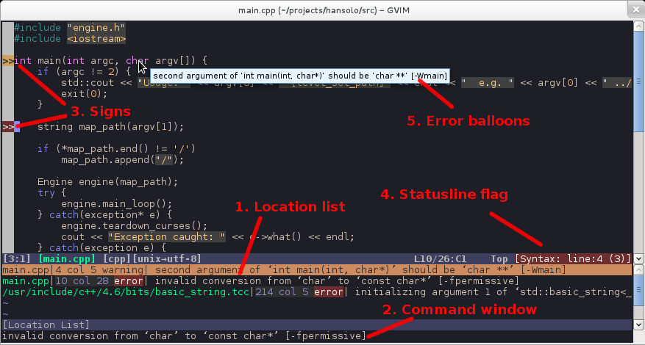
- Errors are loaded into the location list for the corresponding window.
- When the cursor is on a line containing an error, the error message is echoed in the command window.
- Signs are placed beside lines with errors - note that warnings are displayed in a different color.
- There is a configurable statusline flag you can include in your statusline config.
- Hover the mouse over a line containing an error and the error message is displayed as a balloon.
- (not shown) Highlighting errors with syntax highlighting. Erroneous parts of lines can be highlighted.

2. Installation

2.1. Requirements
Syntastic itself has rather relaxed requirements: it doesn't have any external dependencies, and it needs a version of Vim compiled with a few common features: autocmd, eval, file_in_path, modify_fname, quickfix, reltime, statusline, and user_commands. Not all possible combinations of features that include the ones above make equal sense on all operating systems, but Vim version 7 or later with the "normal", "big", or "huge" feature sets should be fine.
Syntastic should work with any modern plugin managers for Vim, such as NeoBundle, Pathogen, Vim-Addon-Manager, Vim-Plug, or Vundle. Instructions for installing syntastic with Pathogen are included below for completeness.
Starting with Vim version 7.4.1486 you can also load syntastic using the standard mechanism of packages, without the help of third-party plugin managers (see :help packages in Vim for details). Beware however that, while support for packages has been added in Vim 7.4.1384, the functionality needed by syntastic is present only in versions 7.4.1486 and later.
Last but not least: syntastic doesn't know how to do any syntax checks by itself. In order to get meaningful results you need to install external checkers corresponding to the types of files you use. Please consult the manual (:help syntastic-checkers in Vim) for a list of supported checkers.

2.2. Installing syntastic with Pathogen
If you already have Pathogen working then skip Step 1 and go to Step 2.

2.2.1. Step 1: Install pathogen.vim
First I'll show you how to install Tim Pope's Pathogen so that it's easy to install syntastic. Do this in your terminal so that you get the pathogen.vim file and the directories it needs:
mkdir -p ~/.vim/autoload ~/.vim/bundle && \
curl -LSso ~/.vim/autoload/pathogen.vim https://tpo.pe/pathogen.vim
Next you need to add this to your ~/.vimrc:
execute pathogen#infect()

2.2.2. Step 2: Install syntastic as a Pathogen bundle
You now have pathogen installed and can put syntastic into ~/.vim/bundle like this:
cd ~/.vim/bundle && \
git clone --depth=1 https://github.com/vim-syntastic/syntastic.git
Quit vim and start it back up to reload it, then type:
:Helptags
If you get an error when you do this, then you probably didn't install Pathogen right. Go back to Step 1 and make sure you did the following:
- Created both the ~/.vim/autoload and ~/.vim/bundle directories.
- Added the execute pathogen#infect() line to your ~/.vimrc file
- Did the git clone of syntastic inside ~/.vim/bundle
- Have permissions to access all of these directories.

3. Recommended settings
Syntastic has numerous options that can be configured, and the defaults are not particularly well suitable for new users. It is recommended that you start by adding the following lines to your vimrc file, and return to them after reading the manual (see :help syntastic in Vim):
set statusline+=%#warningmsg#
set statusline+=%{SyntasticStatuslineFlag()}
set statusline+=%*

let g:syntastic_always_populate_loc_list = 1
let g:syntastic_auto_loc_list = 1
let g:syntastic_check_on_open = 1
let g:syntastic_check_on_wq = 0

4. FAQ
4.1. Q. I installed syntastic but it isn't reporting any errors...
A. The most likely reason is that none of the syntax checkers that it requires are installed. For example: by default, python requires either flake8 or pylint to be installed and in your $PATH. Read the manual (:help syntastic-checkers in Vim) to find out what executables are supported. Note that aliases do not work; the actual executables must be available in your $PATH. Symbolic links are okay though. You can see syntastic's idea of available checkers by running :SyntasticInfo.
A second probable reason is that none of the available checkers are enabled. Syntastic comes preconfigured with a default list of enabled checkers per filetype, but this list is kept short in order to prevent slowing down Vim or trying to run conflicting checks. The command :SyntasticInfo will show you which checkers are enabled. You can tell syntastic which checkers (among the available ones) you want to run by setting g:syntastic_<filetype>_checkers in your vimrc (see below).
A third possible reason is that the $PATH seen by syntastic might not be same as the $PATH in your login shell. Syntastic runs checkers using the shell pointed to by Vim's shell (or by g:syntastic_shell, if set), and that's the shell you need to configure to set the proper $PATH and environment variables for your checkers. You can see syntastic's idea of $PATH by running
:echo syntastic#util#system('echo "$PATH"')
on UNIX and Mac OS-X systems, or
:echo syntastic#util#system('echo %PATH%')
on Windows.
Finally, another reason it could fail is that either the command line options or the error output for a syntax checker may have changed. In this case, make sure you have the latest version of the syntax checker installed. If it still fails then post an issue - or better yet, create a pull request.
4.2. Q. Syntastic supports several checkers for my filetype, how do I tell it which one(s) to use?
A. Add a line like this to your vimrc:
let g:syntastic_<filetype>_checkers = ['<checker-name>']
To see the list of supported checkers for your filetype read the manual (:help syntastic-checkers in Vim).
For example, Python has the following checkers, among others: flake8, pyflakes, pylint and a native python checker. To tell syntastic to use pylint, you would use this setting:
let g:syntastic_python_checkers = ['pylint']
Checkers can be chained together like this:
let g:syntastic_php_checkers = ['php', 'phpcs', 'phpmd']
This is telling syntastic to run the php checker first, and if no errors are found, run phpcs, and then phpmd.
You can also run checkers explicitly by calling :SyntasticCheck <checker>. For example to run phpcs and phpmd:
:SyntasticCheck phpcs phpmd
This works for any checkers available for the current filetype, even if they aren't listed in g:syntastic_<filetype>_checkers.
4.3. Q. How can I run checkers for "foreign" filetypes against the current file?
A. You need to qualify the name of the "foreign" checker with the name of its filetype. For example to check tex files with the checker language_check (which normally acts only on files of type text), you can add text/language_check to the list fo checkers for tex:
let g:syntastic_tex_checkers = ['lacheck', 'text/language_check']
This also works with :SyntasticCheck, e.g. the following command runs text/language_check against the current file regardless of the current filetype:
:SyntasticCheck text/language_check
Of course, the checkers specified this way need to be known to syntastic, and they need to be shown as available when you run :SyntasticInfo. You can't just make up a combination of a filetype and a program name and expect it to work as a checker.
4.4. Q. I have enabled multiple checkers for the current filetype. How can I display all errors from all checkers together?
A. Set g:syntastic_aggregate_errors to 1 in your vimrc:
let g:syntastic_aggregate_errors = 1
See :help syntastic-aggregating-errors for more details.
4.5. Q. How can I pass additional arguments to a checker?
A. In most cases a command line is constructed using an internal function named makeprgBuild(), which provides a number of options that allow you to customise every part of the command that gets run. You can set these options using global variables.
The general form of the global args variable is syntastic_<filetype>_<checker>_args. Thus if you wanted to pass --my --args --here to the Ruby mri checker you would add this line to your vimrc:
let g:syntastic_ruby_mri_args = "--my --args --here"
See :help syntastic-checker-options for more information.
A number of checkers don't use the makeprgBuild() function mentioned above, or have additional options that can be configured. For these checkers the exact list of options should be included in the manual (:help syntastic-checkers in Vim).
4.6. Q. I run a checker and the location list is not updated...
4.6. Q. I run:lopen or :lwindow and the error window is empty...
A. By default the location list is changed only when you run the :Errors command, in order to minimise conflicts with other plugins. If you want the location list to always be updated when you run the checkers, add this line to your vimrc:
let g:syntastic_always_populate_loc_list = 1
4.7. Q. How can I jump between the different errors without using the location list at the bottom of the window?
A. Vim provides several built-in commands for this. See :help :lnext and :help :lprevious.
If you use these commands a lot then you may want to add shortcut mappings to your vimrc, or install something like unimpaired, which provides such mappings (among other things).
4.8. Q. The error window is closed automatically when I :quit the current buffer but not when I :bdelete it?
A. There is no safe way to handle that situation automatically, but you can work around it:
nnoremap <silent> <C-d> :lclose<CR>:bdelete<CR>
cabbrev <silent> bd <C-r>=(getcmdtype()==#':' && getcmdpos()==1 ? 'lclose\|bdelete' : 'bd')<CR>
4.9. My favourite checker needs to load a configuration file from the project's root rather than the current directory...
A. You can set up an autocmd to search for the configuration file in the current directory and upwards, and add it to the checker's options when found. For example for jscs:
function! FindConfig(prefix, what, where)
let cfg = findfile(a:what, escape(a:where, ' ') . ';')
return cfg !=# '' ? ' ' . a:prefix . ' ' . shellescape(cfg) : ''
endfunction

autocmd FileType javascript let b:syntastic_javascript_jscs_args =
\ get(g:, 'syntastic_javascript_jscs_args', '') .
\ FindConfig('-c', '.jscsrc', expand('<afile>:p:h', 1))
4.10. Q. What is the difference between syntax checkers and style checkers?
A. The errors and warnings they produce are highlighted differently and can be filtered by different rules, but otherwise the distinction is pretty much arbitrary. There is an ongoing effort to keep things consistent, so you can generally expect messages produced by syntax checkers to be mostly related to syntax, and messages produced by style checkers to be mostly about style. But there can be no formal guarantee that, say, a style checker that runs into a syntax error wouldn't die with a fatal message, nor that a syntax checker wouldn't give you warnings against using some constructs as being bad practice. There is also no guarantee that messages marked as style are less severe than the ones marked as syntax (whatever that might mean). And there are even a few Frankenstein checkers (for example flake8 and pylama) that, by their nature, produce both kinds of messages. Syntastic is not smart enough to be able to sort out these things by itself.
Generally it's more useful to look at this from the perspective of filtering unwanted messages, rather than as an indicator of severity levels. The distinction between syntax and style is orthogonal to the distinction between errors and warnings, and thus you can turn off messages based on level, on type, or both.
e.g. To disable all style messages:
let g:syntastic_quiet_messages = { "type": "style" }
See :help syntastic_quiet_messages for more information.
4.11. Q. How can I check scripts written for different versions of Python?
A. Install a Python version manager such as virtualenv or pyenv, activate the environment for the relevant version of Python, and install in it the checkers you want to use. Set g:syntastic_python_checkers accordingly in your vimrc, and run Vim from the virtual environment.
If you're starting Vim from a desktop manager rather than from a terminal you might need to write wrapper scripts around your checkers, to activate the virtual environment before running the actual checks. Then you'll need to point the relevant g:syntastic_python_<checker>_exec variables to the wrapper scripts.
4.12. Q. How can I check scripts written for different versions of Ruby?
A. Install a Ruby version manager such as rvm or rbenv, activate the relevant version of Ruby, and install in it the checkers you want to use. Set g:syntastic_ruby_checkers accordingly in your vimrc, and run Vim under the relevant Ruby version.
If you're starting Vim from a desktop manager rather than from a terminal and depending on the version manager you use you might need to write wrapper scripts around your checkers, to activate the relevant version of Ruby before running the actual checks. Then you'll need to point the relevant g:syntastic_ruby_<checker>_exec variables to the wrapper scripts.
4.13. Q. The perl checker has stopped working...
A. The perl checker runs perl -c against your file, which in turn executes any BEGIN, UNITCHECK, and CHECK blocks, and any use statements in your file (cf. perlrun). This is probably fine if you wrote the file yourself, but it's a security problem if you're checking third-party files. Since there is currently no way to disable this behaviour while still producing useful results, the checker is now disabled by default. To (re-)enable it, make sure the g:syntastic_perl_checkers list includes perl, and set g:syntastic_enable_perl_checker to 1 in your vimrc:
let g:syntastic_enable_perl_checker = 1
4.14. Q. What happened to the rustc checker?
A. It is now part of the rust.vim plugin. If you install this plugin the checker should be picked up automatically by syntastic.
4.15. Q. What happened to the tsc checker?
A. It didn't meet people's expectations and it has been removed. The plugin tsuquyomi comes packaged with a checker for TypeScript. If you install this plugin the checker should be picked up automatically by syntastic.
4.16. Q. What happened to the xcrun checker?
A. The xcrun checker used to have a security problem and it has been removed. A better checker for Swift is part of the vim-swift plugin. If you install this plugin the checker should be picked up automatically by syntastic.

5. Resources
The preferred place for posting suggestions, reporting bugs, and general discussions related to syntastic is the issue tracker at GitHub. A guide for writing syntax checkers can be found in the wiki. There are also a dedicated google group, and a syntastic tag at StackOverflow.
Syntastic aims to provide a common interface to syntax checkers for as many languages as possible. For particular languages, there are, of course, other plugins that provide more functionality than syntastic. You might want to take a look at ghcmod-vim, jedi-vim, python-mode, vim-go, or YouCompleteMe.

ScrollColors : Colorsheme Scroller, Chooser, and Browser
script karma | Rating 417/160, Downloaded by 14356 | Comments, bugs, improvements | Vim wiki
created by
Yakov Lerner
script type
utility
description
SYNOPSIS:
This is colorscheme Scroller/Chooser/Browser.
With this plugin, you walk through installed colorschemes using arrow keys.
SHORT USAGE DESCRIPTION:
Drop ScrollColors.vim into your plugin directory.
Type :SCROLL
Use arrow keys to walk through colorschemes, ? for help, Esc to exit.
DETAILED DESCRIPTION:
1. source ScrollColors.vim " or drop ScrollColors.vim into
" your ~/.vim/plugins directory
2. Type :SCROLL
Another synonym is :COLOR
3. Use arrows to scroll thgough colorschemes.
4. When done, press Esc to exit. You will be prompted
wether to
You can download 140 colorschemes pack from:
http://www.vim.org/scripts/script.php?script_id=625
Having 140 installed colorschemes is in no way prerequisite for ScrollColors. But with ScrollColors you can preview 140 colorschemes in couple of minutes. Have fun.
CUSTOM KEY MAPPINGS:
You can map two keys of your choice to NextColor and PrevColor actions.
Choose pair of shortcut keys (for example <F2> and <f3>, or \n and \p)
and map them as follows:
map <silent><F3> :NEXTCOLOR<cr>
map <silent><F2> :PREVCOLOR<cr>
Works both in vim6 and vim7.
install details
Download file ScrollColors.vim and put it into your $HOME/.vim/plugin
directory. Create this directory if it does not exists, like:
mkdir -p $HOME/.vim/plugin
Restart vim.
script versions (upload new version)
Click on the package to download.
package | script version | date | Vim version | user | release notes
ScrollColor.vim | 20060719 | 2006-07-18 | 6.0 | Yakov Lerner | Script cksum is 2186132668.  Last change: sort speedup on vim7 using builtin sort()

Colo(u)r Sampler Pack : [[[Oct 2012 Update]]] Top 100(ish) Themes, GUI Menu
script karma | Rating 4018/1527, Downloaded by 97534 | Comments, bugs, improvements | Vim wiki
created by
Robert Melton
script type
color scheme
description
This package is simply to help people who want to try out a lot of color schemes. It is the top 100(ish) rated color schemes on vim.sf.net as of Oct 28th, 2012 that are are not "evil" (binding keys, changing fonts, hiding the damned cursor (!?) ) -- zipped up in a single package. Every single theme was updated to its newest revision, and converted to unix formatted line endings.
The menu has been simplified based on feedback to simply three categories. Dark / Light / Other.
This package was put together simply to save others time in downloading the color schemes. If you are a scheme author and for some reason do not want your scheme included, please simply drop me a note. robert -at- robertmelton.com
Now, the pack comes with an organized GUI menu, but no tool for console users. I recommend you pick up http://www.vim.org/scripts/script.php?script_id=1488 which is a colorscheme scroller / chooser and browser.
Now includes the very cool Mimic schemes and menu: http://www.vim.org/scripts/script.php?script_id=2831
Many of these schemes are Gvim only, and do not support consoles well... but there is a plugin to allow Gvim only themes to work in 88/256 color terminals -> http://www.vim.org/scripts/script.php?script_id=2390.
Love it or Hate it -- Rate it. :)
install details
Simply unzip, and place the files in ~/.vim/plugin and ~/.vim/colors --- it will unzip with correct dir structure, so you can just unzip to ~/.vim
Hope this helps you... join #vim on irc.freenode.net for all your vim help needs :)
script versions (upload new version)
Click on the package to download.
package | script version | date | Vim version | user | release notes
ColorSamplerPack.zip | 2012.10.28 | 2012-10-28 | 7.3 | Robert Melton | *** Oct 28th, 2012 *** 23 new colorschemes, 44 updated colorschemes, and the inclusion of the very cool MimicPak (http://www.vim.org/scripts/script.php?script_id=2831)

fugitive.vim: a Git wrapper
features:
View any blob, tree, commit, or tag in the repository with :
Gedit
(and :Gsplit, :Gvsplit, :Gtabedit, ...). Edit a file in the index and write to it to stage the changes.
Gdiff
to bring up the staged version of the file side by side with the working tree version and use Vim's diff handling capabilities to stage a subset of the file's changes.
Gstatus
Bring up the output of git status with :Press - to add/reset a file's changes, or p to add/reset --patch. Use :Gcommit % to commit the current file, editing the commit message inside the currently running Vim.
Gblame
brings up an interactive vertical split with git blame output. Press enter on a line to edit the commit where the line changed, or o to open it in a split. When you're done, use :Gedit in the historic buffer to go back to the work tree version.
Gmove
does a git mv on a file and simultaneously renames the buffer. :Gdelete does a git rm on a file and simultaneously deletes the buffer.
Ggrep
to search the work tree (or any arbitrary commit) with git grep, skipping over that which is not tracked in the repository. :Glog loads all previous revisions of a file into the quickfix list so you can iterate over them and watch the file evolve!
Gread
is a variant of git checkout -- filename that operates on the buffer rather than the filename. This means you can use u to undo it and you never get any warnings about the file changing outside Vim. :Gwrite writes to both the work tree and index versions of a file, making it like git add when called from a work tree file and like git checkout when called from the index or a blob in history.
Gbrowse
to open the current file on the web front-end of your favorite hosting provider, with optional line range (try it in visual mode!). Plugins are available for popular providers such as GitHub, GitLab, and Bitbucket.
Add %{FugitiveStatusline()} to 'statusline' to get an indicator with the current branch in (surprise!) your statusline.
Last but not least, there's :Git for running any arbitrary command, and Git! to open the output of a command in a temp file.

Screencasts
- A complement to command line git
- Working with the git index
- Resolving merge conflicts with vimdiff
- Browsing the git object database
- Exploring the history of a git repository

Installation
If you don't have a preferred installation method, one option is to install pathogen.vim, and then copy and paste:
cd ~/.vim/bundle
git clone https://github.com/tpope/vim-fugitive.git
vim -u NONE -c "helptags vim-fugitive/doc" -c q
If your Vim version is below 7.2, I recommend also installing vim-git for syntax highlighting and other Git niceties.

FAQ
Why don't any of the commands exist?
Fugitive cares about the current file, not the current working directory. Edit a file from the repository. To avoid the blank window problem, favor commands like :split and :tabedit over commands like :new and :tabnew.
Here's a patch that automatically opens the quickfix window after :Ggrep.
This is a great example of why I recommend asking before patching. There are valid arguments to be made both for and against automatically opening the quickfix window. Whenever I have to make an arbitrary decision like this, I ask what Vim would do. And Vim does not open a quickfix window after :grep.
Luckily, it's easy to implement the desired behavior without changing fugitive.vim. The following autocommand will cause the quickfix window to open after any grep invocation:
autocmd QuickFixCmdPost *grep* cwindow

Self-Promotion
Like fugitive.vim? Follow the repository on GitHub and vote for it on vim.org. And if you're feeling especially charitable, follow tpope on Twitter and GitHub.

License
Copyright (c) Tim Pope. Distributed under the same terms as Vim itself. See :help license.

Gundo

Graph your Vim undo tree in style.
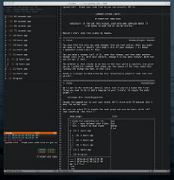
You know that Vim lets you undo changes like any text editor. What you might not know is that it doesn't just keep a list of your changes — it keeps a tree of them.
Say you make a change (call it X), undo that change, and then make another change (call it Y). With most editors, change X is now gone forever. With Vim you can get it back.
The problem is that trying to do this in the real world is painful. Vim gives you an :undolist command that shows you the leaves of the tree. Good luck finding the change you want in that list.
Gundo is a plugin to make browsing this ridiculously powerful undo tree less painful.
Check out this quick screencast if you want to see it in action.
- Requirements
- Installation
- Usage
- Configuration
  - g:gundo_width
  - g:gundo_preview_height
  - g:gundo_preview_bottom
  - g:gundo_right
  - g:gundo_help
  - g:gundo_disable
  - g:gundo_map_move_[older/newer]
  - g:gundo_close_on_revert
  - g:gundo_[preview/tree]_statusline
  - g:gundo_auto_preview
  - g:gundo_playback_delay
  - g:gundo_return_on_revert
- License
- Bugs
- Contributing
- Changelog
- Credits

Requirements
Gundo requires Vim 7.3+ compiled with Python support, and Python 2.4+.

Installation
Use Pathogen. Don't use pathogen? Start.
hg clone http://bitbucket.org/sjl/gundo.vim ~/.vim/bundle/gundo
There's a git mirror if you prefer:
git clone http://github.com/sjl/gundo.vim.git ~/.vim/bundle/gundo
Add a mapping to your ~/.vimrc (change the key to suit your taste):
nnoremap <F5> :GundoToggle<CR>

Usage
We'll get to the technical details later, but if you're a human the first thing you need to do is add a mapping to your vimrc file to toggle the undo graph:
nnoremap <F5> :GundoToggle<CR>
Change the mapped key to suit your taste. We'll stick with <F5> because that's what the author uses.
Now you can press <F5> to toggle the undo graph and preview pane, which will look something like this:
Undo graph File
+-----------------------------------+---------------------------+
| " Gundo for something.txt [1] |one |
| " j/k - move between undo states |two |
| " <cr> - revert to that state |three |
| |five |
| @ [5] 3 hours ago | |
| | | |
| | o [4] 4 hours ago | |
| | | | |
| o | [3] 4 hours ago | |
| | | | |
| o | [2] 4 hours ago | |
| |/ | |
| o [1] 4 hours ago | |
| | | |
| o [0] Original | |
+-----------------------------------+ |
| --- 3 2010-10-12 06:27:35 PM | |
| +++ 5 2010-10-12 07:38:37 PM | |
| @@ -1,3 +1,4 | |
| one | |
| two | |
| three | |
| +five | |
+-----------------------------------+---------------------------+
Preview pane
Your current position in the undo tree is marked with an @ character. Other nodes are marked with an o character.
When you toggle open the graph Gundo will put your cursor on your current position in the tree. You can move up and down the graph with the j and k keys.
You can move to the top of the graph (the newest state) with gg and to the bottom of the graph (the oldest state) with G.
As you move between undo states the preview pane will show you a unified diff of the change that state made.
Pressing return on a state (or double clicking on it) will revert the contents of the file to match that state.
You can use p on a state to make the preview window show the diff between your current state and the selected state, instead of a preview of what the selected state changed.
Pressing P while on a state will initiate "play to" mode targeted at that state. This will replay all the changes between your current state and the target, with a slight pause after each change. It's mostly useless, but can be fun to watch and see where your editing lags — that might be a good place to define a new mapping to speed up your editing.
Pressing q while in the undo graph will close it. You can also just press your toggle mapping key.

Configuration
You can tweak the behavior of Gundo by setting a few variables in your :vimrc file. For example:
let g:gundo_width = 60
let g:gundo_preview_height = 40
let g:gundo_right = 1

g:gundo_width
Set the horizontal width of the Gundo graph (and preview).
Default: 45

g:gundo_preview_height
Set the vertical height of the Gundo preview.
Default: 15

g:gundo_preview_bottom
Force the preview window below current windows instead of below the graph. This gives the preview window more space to show the unified diff.
Example:
+--------+ +--------+
!g! ! ! !g!
!g! ! or ! !g!
!g!______! !______!g!
!g!pppppp! !pppppp!g!
+--------+ +--------+
Default: 0

g:gundo_right
Set this to 1 to make the Gundo graph (and preview) open on the right side instead of the left.
Default: 0 (off, open on the left side)

g:gundo_help
Set this to 0 to disable the help text in the Gundo graph window.
Default: 1 (show the help)

g:gundo_disable
Set this to 1 to disable Gundo entirely.
Useful if you use the same ~/.vim folder on multiple machines, and some of them may not have Python support.
Default: 0 (Gundo is enabled as usual)

g:gundo_map_move_[older/newer]
These options let you change the keys that navigate the undo graph. This is useful if you use a Dvorak keyboard and have changed your movement keys.
Default:
gundo_map_move_older: "j"
gundo_map_move_newer: "k"

g:gundo_close_on_revert
Set this to 1 to automatically close the Gundo windows when reverting.
Default: 0 (windows do not automatically close)

g:gundo_[preview/tree]_statusline
Set this to 0 to disable automatically rendering preview diffs as you move through the undo tree (you can still render a specific diff with r). This can be useful on large files and undo trees to speed up Gundo.
Default: unset (windows use the default statusline)

g:gundo_auto_preview
Set this to 1 to rendering diff automatically with cursor move.
Default: 1 (auto preview diff)

g:gundo_playback_delay
This is the delay in milliseconds between each change when running 'play to' mode. Set this to a higher number for a slower playback or to a lower number for a faster playback.
Default: 60

g:gundo_return_on_revert
Set this to 0 to keep focus in the Gundo window after a revert.
Default: 1



Python-mode, a Python IDE for Vim

This project needs contributors.
Documentation:
- :help pymode
- https://github.com/python-mode/python-mode/wiki
Please use python-mode tag on Stackoverflow to ask questions: https://stackoverflow.com/questions/tagged/python-mode


Important: From 2017-11-19 onwards python-mode uses submodules instead of hard coding 3rd party libraries into its codebase. Please issue the command: git submodule update --init --recursive inside your python-mode folder.
If you are a new user please clone the repos using the recursive flag: git clone --recursive https://github.com/python-mode/python-mode

Python-mode is a Vim plugin that magically converts Vim into a Python IDE.
Why Python-mode?
- Be more productive: Pymode saves time by bringing all the tools necessary for professional developers so that you can focus on bigger things. It has been finely tuned based on decades of experience working with Vim and is constantly kept up to date.
- Get smart assistance: Pymode knows all about your code. We use the best-in-class intellisense code completion, on-the-fly error checking and quick-fixes; easy project navigation and much more.
- Use the full power and capabilities of Vim: Unlike traditional IDEs which can only provide a small subset of Vim functionalities, you can do everything and anything that you can in Vim.
- Modular structure: We attempt to create Python-mode with the same principles of python: i.e. have a modular structure, so that as and when better libraries evolve, we can provide you the best experience, while abstracting the details so that you can get back to what you do best.
- Written mostly in Python: 96.1% written in Python. Well, we love Python :)
The plugin contains all you need to develop python applications in Vim.
- Support Python version 2.6+ and 3.2+
- Syntax highlighting
- Virtualenv support
- Run python code (<leader>r)
- Add/remove breakpoints (<leader>b)
- Improved Python indentation
- Python motions and operators (]], 3[[, ]]M, vaC, viM, daC, ciM, ...)
- Improved Python folding
- Run multiple code checkers simultaneously (:PymodeLint)
- Autofix PEP8 errors (:PymodeLintAuto)
- Search in python documentation (<leader>K)
- Code refactoring
- Intellisense code-completion
- Go to definition (<C-c>g)
- And more, more ...
See a screencast here: http://www.youtube.com/watch?v=67OZNp9Z0CQ Another old presentation here: http://www.youtube.com/watch?v=YhqsjUUHj6g
To read python-mode documentation in Vim, use :help pymode.

Requirements
Vim >= 7.3 (most features needed +python or +python3 support) (also --with-features=big if you want g:pymode_lint_signs).

How to install

Manually (according to vim's package structure)
As of vim8 there is an officially supported way of adding plugins. See :tab help packages in vim for details.
cd ~/.vim/pack/foo/start
git clone https://github.com/python-mode/python-mode.git
cd python-mode
git submodule update --init --recursive

Using pathogen
cd ~/.vim
mkdir -p bundle && cd bundle
git clone --recursive https://github.com/python-mode/python-mode.git
Enable pathogen in your ~/.vimrc:
" Pathogen load
filetype off

call pathogen#infect()
call pathogen#helptags()

filetype plugin indent on
syntax on

Using vim-plug
Include the following in the vim-plug section of your ~/.vimrc:
Plug 'python-mode/python-mode', { 'branch': 'develop' }

Manually
% git clone --recursive https://github.com/python-mode/python-mode.git
% cd python-mode
% cp -R * ~/.vim
Then rebuild helptags in vim:
:helptags ~/.vim/doc/
filetype-plugin (:help filetype-plugin-on) and filetype-indent (:help filetype-indent-on) must be enabled to use python-mode.

Troubleshooting/Debugging
First read our short FAQ or using :help pymode-faq. If your question is not described there then you already know what to do (because you read the first item of our FAQ :) ).
Nevertheless just a refresher on how to submit bugs:
(From the FAQ) Start python mode with: vim -i NONE -u <path_to_pymode>/debugvimrc.vim Reproduce the error and submit your python mode debug file. You can check its location with :messages for something like: pymode debug msg 1: Starting debug on: 2017-11-18 16:44:13 with file /tmp/pymode_debug_file.txt. Please submit the entire content of the file along with a reasoning of why the plugin seems broken.
Do check for sensitive information in the file before submitting.

Frequent problems
Read this section before opening an issue on the tracker.

Python 3 syntax
By default python-mode uses python 2 syntax checking. To enable python 3 syntax checking (e.g. for async) add:
let g:pymode_python = 'python3'
To your vimrc or exrc file.

Documentation
Documentation is available in your vim :help pymode.

Bugtracker
If you have any suggestions, bug reports or annoyances please report them to the issue tracker at: https://github.com/python-mode/python-mode/issues

Contributing
The contributing guidelines for this plugin are outlined at :help pymode-development.
- Author: Kirill Klenov (https://github.com/klen)
- Maintainers:
  - Felipe Vieira (https://github.com/fmv1992)
  - Diego Rabatone Oliveira (https://github.com/diraol)
Also see the AUTHORS file.
Development of python-mode happens at github: https://github.com/python-mode/python-mode
Please make a pull request to development branch and add yourself to AUTHORS.

Python libraries
Vendored Python modules are located mostly in pymode/libs/.

Copyright
Copyright © 2013-2015 Kirill Klenov (https://github.com/klen).

License
Licensed under a GNU lesser general public license.
If you like this plugin, I would very appreciated if you kindly send me a postcard :) My address is here: "Russia, 143500, MO, Istra, pos. Severny 8-3" to "Kirill Klenov". Thanks for support!

Powerline

Vim statusline
Mode-dependent highlighting
Automatic truncation of segments in small windows

The font in the screenshots is Pragmata Pro by Fabrizio Schiavi.

Introduction
Powerline is a font set and command-line program addon that beautifies the terminal, giving it a breadcrumbs-like appearance and making certain things in the terminal look more distinctive. In the past, you had to use pip with git to install all the files you needed to make Powerline functional, but nowdays all you need is one command;
sudo apt-get install powerline
With that, the program and fonts are installed. But if you run your terminal now, you won't know it's working because it's not invoked. To invoke it on terminal load, the following needs to be in the respective files;

Enabling Powerline
Shell: Bourne Again shell (usually ~/.bashrc)
# Powerline
if [ -f /usr/share/powerline/bindings/bash/powerline.sh ]; then
source /usr/share/powerline/bindings/bash/powerline.sh
fi
Editor: Vim (usually ~/.vimrc)
additional tipp from official source: python3 line to work to have the fancy affect:
python3 from powerline.vim import setup as powerline_setup
python3 powerline_setup()
python3 del powerline_setup

some effect with these:
set rtp+=/usr/share/powerline/bindings/vim/
" Always show statusline
set laststatus=2
" Use 256 colours (Use this setting only if your terminal supports 256 colours)
set t_Co=256
Command-line: tmux (usually ~/.tmux.conf)
# Powerline
source /usr.share/powerline/bindings/tmux/powerline.conf
set-option -g default-terminal "screen-256color"

Font stuff
Powerline requires modified fonts in order to use it without the embellishments it provides looking super-janky. Previously, I made it seem like there were no fonts at all which work with Powershell, but its author had released a multitude of fonts. Below is the old way I illustrated, just in case you still don't want to install Git and have these fonts only available to you:
#The author misspelled these. I fixed that, While it does not matter, I fixed it anyway.
mkdir -p ~/.fonts
wget https://github.com/powerline/fonts/raw/master/LiberationMono/Literation%20Mono%20Powerline.ttf -O ~/.fonts/Liberation\ Mono\ Powerline.ttf
wget https://github.com/powerline/fonts/raw/master/LiberationMono/Literation%20Mono%20Powerline%20Bold.ttf -O ~/.fonts/Liberation\ Mono\ Powerline\ Bold.ttf
wget https://github.com/powerline/fonts/raw/master/LiberationMono/Literation%20Mono%20Powerline%20Italic.ttf -O ~/.fonts/Liberation\ Mono\ Powerline\ Italic.ttf
wget https://github.com/powerline/fonts/raw/master/LiberationMono/Literation%20Mono%20Powerline%20Bold%20Italic.ttf -O ~/.fonts/Liberation\ Mono\ Powerline\ Bold\ Italic.ttf
fc-cache -vf ~/.fonts
another tipp: didnt have any affect
wget https://github.com/Lokaltog/powerline/raw/develop/font/PowerlineSymbols.otf https://github.com/Lokaltog/powerline/raw/develop/font/10-powerline-symbols.conf
mkdir -p ~/.fonts/ && mv PowerlineSymbols.otf ~/.fonts/
fc-cache -vf ~/.fonts
mkdir -p ~/.config/fontconfig/conf.d/ && mv 10-powerline-symbols.conf ~/.config/fontconfig/conf.d/

another tipp, but didn’t do it because install was already done, probably with sudo apt install powerline
git clone https://github.com/powerline/fonts.git --depth=1
cd fonts
./install.sh
cd ..
rm -rf fonts

