CURRICULUM VITAE

Kyelema Pisana

Personal Particulars

Direct: +54 9 354 846 8819
Whatsapp: +54 9 354 846 8819
E-mail: kiizaa@gmail.com

Date & Place of Birth:
11/09/1979, Sussex, East Sussex
Place of Residence: Cordoba, Argentina
Salary Requirement: Please refer to my application letter
Availability Date: Please refer to my application letter

Profile
Kyelema has approximately seventeen years of software and architecture development experience. He is proficient in Python, Java and DevOps practices, specialing in Data Architecture, Machine Learning, AWS based services and DevOps related technologies. In the past he had leadership roles, leading teams of up to seven Developers. He has extensive hands on experience with DevOps (CI/CD) on MS Azure, Atlassian, AWS DevOps, Jfrog Maven, Gradle GitHub, Bitbucket, Docker, and Ansible .
I believe to be confidant and posses a high personal drive to expand and experience in all fields of Information and Communications Technology (ICT) and our developing technlogical future. I also believe to be an adaptive, motivated, friendly and organized person aspiring to high-caliber professionalism. In addition I have had experience of working on large-scale projects in teams as an independent contractor.
Career objective
To obtain a position in a technical field where I can remain a resourceful part of the enterprise, absorbing fresh skills and experience within a growing and challenging environment. To tackle customer related issues and to give back these aquired skills, in the long run establishing myself as a valuable resource to an organization.
Skills and Experience
- A proven track record in picking-up programming languages and code bases to be up to speed in completing deliverables.
- Experience in Java and Python languages.
- Unix /GNULinux experience
- A working knowledge of SQL and noSQL, experience with PostgreSQL, MySQL,,MS SQL Server, SQLite, Oracle databases, in addition to MongoDB, Cassandra, Spark.
- Mature understanding of OOP and MVC Software Architectures
- Ability to effectively my own workloads and take project ownership from the initial design phase to deployment
- Unit testing and software life-cycles.

Core Skills:
Development Experience:
- Back-end
- API (Rest)
- AJAX
- Micro-services
- Data Extraction: Web Crawling / Scraping
- Installation and Integration
- Docker / Kubernetes
- Azure
- Amazon Web Services
- AWS EC2, Lambda
- Continuous Integration
- DevOps

Programming Languages:
- Python [v2.7, v3.4, pypy]
- Python Django
- Python Flask
- Python Celery, ZeroMQ
- Jupyter (algorithm development/prototyping renamed from ipython notebook)
- Pandas, Numpy (for numerical analysis, operations involving matrices and vectorized functions)
- Cython, Numba, kernprof, line_profiler, memory_profiler (Profiling & Optimizing Python)
- ZMQ, Kafka[Apache] (for message queue requirements)
- UDP messaging (UDP socket programming)
- Puppet (Provisioning in the cloud)
- GIT (SCM)
- SOA (enabling multi-platform/device UI access)

Programming Paradigm:
- Object Oriented Programming (OOP)
- Data Structures
- Design Patterns
- Model View Controller (MVC)
- Model View View-Model (MVVM)

Website Development:
- HTML 5
- CSS 3
- Bootstrap 3 and Bootstrap 4
- JavaScript (JQuery)
- PHP (Laravel. CodeIgniter)

Mobile Application Development
- Android (Native)
- Android Studio
- React Native (for Android and iOS)

Databases:
Relational Databases:
- Microsoft SQL Server-
- MySQL
- Oracle
- PostgresQL
noSQL Databases:
- MongoDB
- HBase

Compute:
- OpenCL & CUDA (for Parallel compute)
- Spark
- H2O, Tensorflow (Machine Learning)
- H2O on Spark via SparklingWater

Operating Systems:
- Server-side: Unix GNULinux FreeBSD, Debian or Ubuntu, Mac OS X

I. Professional Experience

Data Engineer
at QoreLogic
Cordoba, Argentina
June 2014 – Present
Responsible for the development of conceptual ideas to working prototypes and enhancing existing prototypes in order to bring up-stream feature improvements, server-side algorithm optimizations, significantly reducing performance bottlenecks and improving end-to-end horizontal & vertical scaling.
Tasks include but not limited to:
- Research and Development (R&D) for Product, including the implementation of Machine Learning, Datamining techniques and methodologies, development of in-house applications to improve processing work-flows and day to day operations.
- Extract, Transform Load (ETL) Development of Mission-critical Data Pipelines.
- Data Acquisition and Persistent Storage.
- Python, Bash, Linux.
- Visualization (Gephi, GraphViz).
- Server Systems Administration & Management.

Field Researcher
at Glovo
Cordoba, Argentina
August 2019 – November 2019

Machine Learning & Natural Language Processing (NLP) Engineer
at Efecto Brazil, S.A
Buenos Aires, Argentina
May 2017 – December 2017
Responsible for the implementation of algorithms relevant to Natural Language Processing (NLP).
Tasks include but not limited to:
- Development of Python applications including Machine Learning, Data-mining, etc.
- Python, Bash, Linux, HBase.
- ElasticSearch, NLTK.
- AWS, EC2, S3, Hadoop, NLP, Machine Learning, Data-mining.

Senior Web Developer: Homebounce LLC. – www.homebounce.com
Menlo Park, CA
August 2011 – June 2014
Responsible for the front-end across the whole development stak. Various GUI enhancements for UI/UX.
- Python, GoogleAppEngine on Google Cloud Computing (GCP), Heroku, Ruby on Rails, customized web applications and front-end widget in JQuery.
- Front-end template engine implemented.
- Python Django.Framework.
- PyTest unit testing implementation.
- Designed React components for the user and admin Dashboards.

CTO: QoreLogic
Cordoba, Argentina
December 2007 – Present

PHP, PostgreSQL Developer: PPI – www.farmship.com
Augusta,GA
December 2006 – March 2007
Responsible for the front-end end various GUI enhancements to improve its usability.
- PHP, PostgreSQL, customized web application developed for farmship.com
- Front-end template engine implemented
- Regression Testing

PHP/MySQL Developer, Web Developer: Rodeck Solutions – www.radiofence.com
Montreal, Canada
March 2006 – June 2006
Added new modules and features to site according to customer requirements.
- PHP, MySQL, osCommerce and custom scripts.
- Bug tracking and performance optimization.

PHP/MySQL Developer: DLS Digital Corp.
New York, NY
November 2005 – September 2006
Responsible for program maintenance of www.forexfactory.com domain; vBulletin forum written in PHP with XML templates.
- PHP, MySQL, XML, vBulletin, phpAdsNew (renamed to OpenX) and custom scripts.
- Worked on the Forex Calendar code and Ad system
- Various deliverables.

AJAX PHP/MySQL Developer: Sublime IP Pty. – www.sublimeip.com.au
Melbourne, Australia
March 2006 – May 2006
Developed a web server configuration program for customers to setup, configure and order co-locational and dedicated servers at a web hosting datacenter.
- CSS, PHP, AJAX, XML and MySQL.
- Bug tracking, fixing and testing

PHP Coder: WyWare Inc. – www.wyware.com, www.wypos.com
Brisbane, Australia
September 2005 – January 2006
Responsible for writing scripts guided by a senior programmer.
- Escribir algoritmos y codificar scripts para varios modulos y aplicaciones web.
- Bug tracking and fixing and testing.
- Implementation and roll-out of an AJAX version of the web based POS application.

Website Administrator: Harbourlists – www.harbourlists.com, www.mmaco.net
Mississippi, USA
July 2005 – July 2006
Responsible for application maintenance of Harbourlists core Safelist Email Marketing program.
- Escribir algoritmos y codificar scripts para varios modulos y aplicaciones web.

Team Leader – SiS SoftwareFactory S.A. – www.sissoftwarefactory.com, www.ink.ltd.uk (now http://inkaviation.com)

Buenos Aires, Argentina & London, UK

March 2005 – August 2005

Development and maintenance of PHP 5 web scripts following coding standards set by Ink Ltd. Collaboration to code libraries. Project Management and leading a team of developers.
Main tasks included:
- Liasing with clients.
- Code Testing, Design Flow, Quality Control
- Translating

Content Developer – E-Academy (T) Ltd.
Dar es Salaam, Tanzania
March 2002 – October 2002

Development of Web applications geared towards online e-learning courses.
Main tasks included:

Writing algorithms and coding scripts for various web applications

Configuring and administering LMS Server Software

Liaising with content experts

Independent Contractor
Dar es Salaam, Tanzania
October 2001 – September 2003

Main tasks included:
  - Web Design and consultancy
  - Multimedia (New Media) consultancy.
  - Writing CGI scripts.
  - Website Management.

Previous clients:
  - FEMINA HIP Magazine – East African Movies (T) Ltd.
  - Tanzania Investment Guide 2002 – Tanzania Investment Centre (TIC)
  - Infotech – Infotech Investments Group.
  - Raha.com – Star Telecom (T) Ltd. www.raha.com
  - Sustainable Cities Programme - President’s Office Regional Administration and Local Government.
  - tritel - TRI Telecommunications (Tanzania) Ltd.

Web Designer
Dar es Salaam, Tanzania
September 2000 - May 2001
Posted as Web designer, in a collaborative project sponsored by UNIDO. Regular clientele were based in Harare (Zimbabwe) and Amsterdam (Netherlands) while design was executed in Dar es Salaam, liaising via teleconferencing. My main responsibilities included:
  - Graphic design of front-end templates to websites
  - Designing text and format including animation and logos
  - Occasional updating
  - Maintenance

Teaching and Network Services
Dar es Salaam, Tanzania
January - March 1998
Gaining practical work experience at Computing Centre (UCC), University of Dar es Salaam (U Dsm). My main responsibilities included:
  - Tutoring in Introduction to computers, MS-DOS and MS related applications for part-time students at U Dsm.
  - Configuring dial-up connections to UCC’s clients.
  - Administering the UCC Mail and Web servers (Unix/Linux and WinNT based).
  - Extending network coverage via wireless IP links to external UCC clients to the main U Dsm Campus Area Network fiber -optic backbone.

II. Academics

Undergraduate Studies: Universidad Blas Pascal
Córdoba, Argentina.
March 2003 – 2007
B.Tech . Telecommunications Engineering.

III. Courses and Seminars

Java – Object Oriented Ramp-up course.
April 2005 - May 2005
Vates S.A. (CMM 3) Software Engineering Consultancy - Cordoba, Argentina
www.vates.com

Programacion Web PHP – Nivel Profesional
September 2004 - October 2004
Consultora Informatica C.UNIX - Cordoba, Argentina

Japanese Language
April 2003 - December 2003
Universidad Blas Pascal – Cordoba, Argentina

PHP & MySQL
June 2003 - August 2003
Universidad Blas Pascal – Cordoba, Argentina

III. Skills and Interests.

Languages
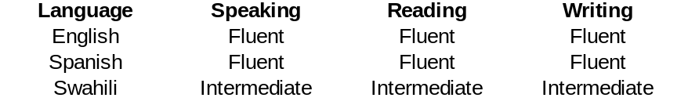
V: INFORMÁTICS
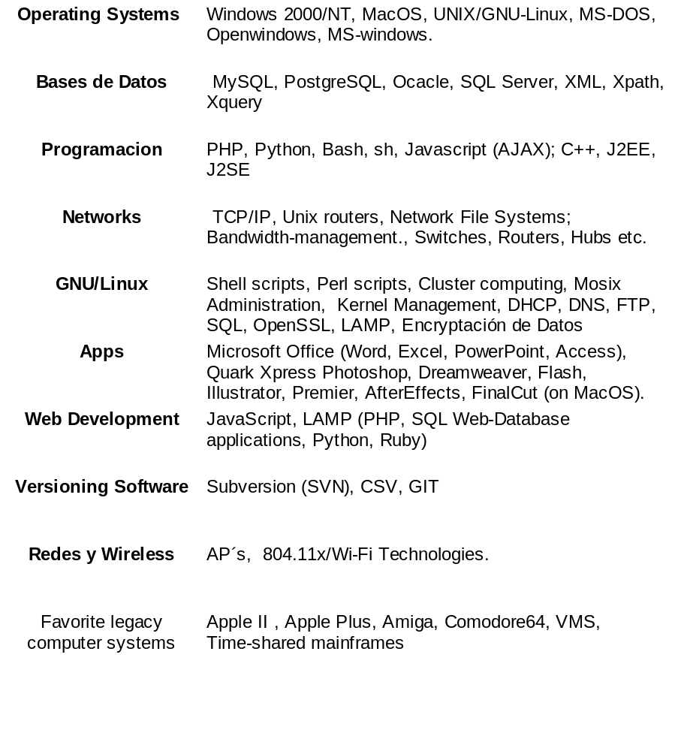

May 8, 2014

