Enhancing Pedagogical Feedback Quality of Large Language Models via Learning Analytics in a Kanban-Based Platform for Student Self-Regulated Learning Support
Qornain Aji$​^{1}$, Indriana Hidayah$​^{2}$, Syukron Abu Ishaq A.$​^{3}$
Department of Electrical and Information Engineering, Faculty of Engineering
Universitas Gadjah Mada, Yogyakarta, Indonesia
$​^{1}$qornain.aji@mail.ugm.ac.id $​^{2}$indriana.h@ugm.ac.id $​^{3}$syukron.abu@ugm.ac.id
Abstract— While visualization tools like Kanban boards facilitate process monitoring, they lack the capacity for adaptive guidance. To address this limitation and the scalability crisis of human expert feedback, this study aims to enhance the quality of pedagogical feedback generated by Large Language Models (LLMs) to support student Self-Regulated Learning (SRL). The enhancement focuses on three core functions which are feedback, motivation, and appreciation. A comparative experimental method was employed without fine-tuning, evaluating various Context Engineering schemes enriched with Learning Analytics (LA) on two models: Llama 3.1 8B and Llama 3.3 70B. Evaluation was quantitative (BERTScore, BARTScore, LLM-as-a-Judge) and qualitatively validated by an educational psychology expert.
Results indicate that feedback quality is strongly mediated by model size. The 8B model’s LLM-as-a-Judge F1, our measure of pedagogical criterion satisfaction, improved monotonically with context complexity, with ReAct + LA achieving the largest gain (+0.075 over Baseline). Conversely, the 70B model performed best under lighter context (Material List) and degraded under ReAct + LA, suggesting that prescriptive agentic structures over-constrain larger models. The top-performing 8B configuration (ReAct + LA) was validated by an educational psychology expert as “Usable with minor revision” (overall mean 3.87/5.00). The study concludes that LA-enriched context engineering is an effective, fine-tuning-free strategy for improving pedagogical feedback quality, particularly for smaller LLMs.
Index Terms— Large Language Model, Self-Regulated Learning, Learning Analytics, Context Engineering, Pedagogical Feedback

I. Introduction
Self-Regulated Learning (SRL), encompassing Zimmerman’s cyclical phases of forethought, performance, and self-reflection, is strongly linked to academic achievement [1], [2], yet many students lack the skills to apply it effectively [3], [4]. Personalized expert feedback is the most effective scaffold for SRL development [5], [6], but faces a scalability crisis as rising class sizes limit lecturer–student interaction [7], [8].
Large Language Models (LLMs) offer a scalable complement, yet their feedback tends to be generic, overly generous, and process-agnostic rather than guiding self-regulation [9], [10]. This study addresses these limitations through context engineering, the systematic enrichment of LLM prompts with structured information, without model fine-tuning. Specifically, Learning Analytics (LA) signals derived from a Kanban-based platform (card movements, completion timestamps, stuck indicators) are injected into the prompt to enable personalized, data-driven pedagogical feedback across three dimensions: feedback, motivational support, and appreciative support [5], [11].
This study evaluates the extent to which Learning Analytics-enriched context engineering improves LLM pedagogical feedback quality over a structured Baseline prompt. It further assesses human expert perception of the quality, relevance, and usability of feedback generated by the top-performing 8B configuration. Finally, it investigates how model size (8B vs. 70B) influences the effectiveness of context engineering for pedagogical feedback generation.
The main contributions are (1) a comparative evaluation of four Learning Analytics-enriched context engineering schemes on two open-source LLMs of contrasting scales, and (2) an empirical finding that model size strongly shapes the optimal context complexity across the two Llama scales tested, validated through automated metrics (BERTScore, BARTScore, LLM-as-a-Judge) and expert assessment.

II. Related Work

A. LLM Feedback Alignment via Fine-Tuning
Alignment training, including RLHF [12] and Direct Preference Optimization (DPO) [13], has been shown to improve LLM feedback quality beyond what parameter scaling achieves. InstructGPT (1.3B, RLHF) outperforms GPT-3 (175B), and a DPO-tuned Llama 3.1 8B surpasses GPT-4o in preference and tone positivity in educational grading tasks. However,
both approaches require substantial labeled data and computational resources, limiting applicability in resource-constrained academic settings.

B. Prompt Engineering and Learning Analytics
Without retraining, prompt quality is the primary lever for LLM feedback improvement, Jacobsen and Weber [14] show that only high-quality prompts reliably produce outputs that surpass novice teacher feedback, though affective dimensions remain inconsistent. Enriching prompts with learning analytics further advances this direction. Li and Ma [15] demonstrate that LA-informed context engines (LACE, KCE) yield curriculum-aligned SRL feedback in programming education, while Strickroth et al. [11] confirm that Kanban process traces are both pedagogically meaningful and practically extractable (teacher SUS 92). Existing work, however, evaluates prompts in isolation or within a single domain and model scale, leaving open the question of how context complexity and model size jointly determine feedback quality across multiple SRL-relevant dimensions.

III. Methodology

A. Research Design
This study employs a comparative experimental design to evaluate four prompt variation conditions across two open-source LLMs, namely Llama 3.1 8B Instant and Llama 3.3 70B Versatile, without model fine-tuning, yielding eight experimental configurations applied to 40 synthetic student datasets. The system was implemented in Python 3.12 with LangChain and LangGraph for prompt orchestration, inference via the Groq API, and GPT-4o (OpenAI API) as the LLM-as-a-Judge evaluator. Evaluation combines automated quantitative metrics with qualitative expert validation, as illustrated in Fig. 1.

B. Theoretical Framework
To formally characterize the role of context engineering in LLM inference, this study adopts the lens of implicit Bayesian inference [16]. This formulation provides a principled explanation of how enriching the prompt with SRL rubrics and learning analytics signals shapes the model’s internal belief about the student’s learning state, thereby directing the generated feedback toward pedagogically appropriate responses.

Variable Definitions
Let $M$ denote the LLM used for inference. The input to $M$ consists of two components:
- Context Engineering $C=\left(c_{1},c_{2},c_{3},c_{4},c_{5}\right)$, comprising five components: role and persona definition ($c_{1}$), internal logic and assessment rubric ($c_{2}$), SRL phase mapping ($c_{3}$), assessment prompt ($c_{4}$), and output format specification ($c_{5}$).
- Student Data $D=\left(K,A\right)$, where $K=\{κ_{1},κ_{2},…,κ_{m}\}$ is the set of $m$ Kanban board cards with attributes $κ_{j}=\left({\text{title}}_{j},{\text{status}}_{j},t_{j}^{\text{created}},t_{j}^{\text{moved}},{\text{label}}_{j}\right)$, and $A=φ\left(K\right)$ is the learning analytics vector derived from $K$ through a transformation function $φ$ that computes descriptive indicators such as completion rate, stuck rate, and velocity.
The complete prompt provided to the model is the concatenation:
$$\text{Prompt}=\left[C, D\right]=\left[c_{1},c_{2},c_{3},c_{4},c_{5}, K, φ\left(K\right)\right]$$

Inference Formulation
The model $M$ generates a response $y=\left(y_{1},y_{2},…,y_{T}\right)$ as a sequence of $T$ tokens. At each step, the model implicitly marginalizes over a set of latent concepts $Θ$ learned during pretraining, where each $θ∈Θ$ represents a student learning pattern (e.g., on-track, struggling, procrastinating):
pMyt∣C,D,y<t=θ∈Θ​pyt∣θ,C,y<t⋅pθ∣C,D,y<t dθ
Here, $p\left(θ∣C,D,y_{<t}\right)$ is the model’s implicit posterior belief about the student’s learning pattern. The context engineering $C$ forms a prior expectation by defining assessment criteria and SRL phases, while the student data $D$ provides observational evidence for updating that belief. The final response is obtained by:
$$y^{*}=arg\max_{y} p_{M}\left(y∣C,D\right)$$
This response $y^{*}$ constitutes the pedagogical feedback covering three functions, namely feedback, motivation, and appreciation, which is evaluated as described in Section 3.5.

C. Dataset Construction and Model Selection
Synthetic data was used due to the absence of public Kanban-based SRL datasets. Each of the 40 datasets represents a student’s Kanban board in JSON format, derived from the Gamatutor platform schema and covering the OOP domain, generated across five behavioral profiles: Lazy (5), Slightly Lazy (10), Average (10), Diligent (10), and Very Diligent (5). Each profile was operationalized into explicit rules governing card counts and checklist-completion percentages, within the Object-Oriented Programming (OOP) domain across five subtopics; these constraints were transformed into structured prompts using role-play, few-shot, and Chain-of-Thought (CoT) techniques, and the 40 datasets were generated using the ChatGPT-5 Thinking model. Ground truth $y_{\text{ref}}$ was established by three university lecturers with expertise in educational psychology, who independently provided structured feedback across the three target dimensions. Two open-source LLMs were selected for evaluation, namely Llama 3.1 8B Instant (USD 0.05/1M tokens, 840 tokens/s) and Llama 3.3 70B Versatile (USD 0.59/1M tokens, 394 tokens/s) via the Groq API [17], to contrast a small, cost-efficient model against a large, high-capacity counterpart under identical context conditions [18], [19].

D. Context Engineering and Prompt Variations
The feedback improvement approach rests on three interdependent pillars in which are context engineering, learning analytics integration, and systematic prompt variation experiments.
The first pillar is the design of a theoretically grounded Baseline prompt, structured into five logical components (Role Definition, Internal Logic, SRL Phase Mapping, Assessment Prompt, and Input/Output Format) to fulfill specific pedagogical objectives, including adaptive guidance and self-efficacy support. Prompt quality was validated using the theory-driven prompt manual of Jacobsen and Weber [14], where this study’s prompt scored 13 out of 16, classifying it as high quality. The Baseline prompt structure is illustrated in Fig. 1.
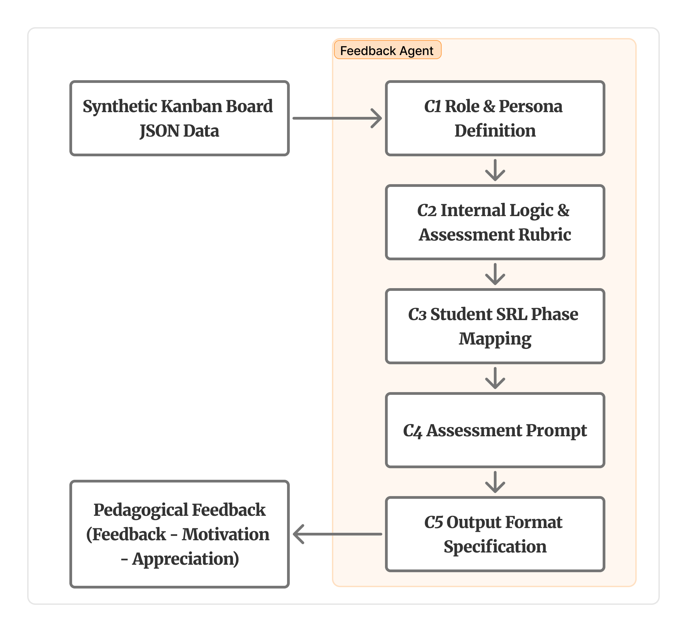
Baseline prompt structure and its five context engineering components $C=\left(c_{1},c_{2},c_{3},c_{4},c_{5}\right)$.
The second pillar is the integration of descriptive learning analytics to inject situational awareness into the model. A transformation function $φ$ processes raw JSON Kanban data into 12 descriptive indicators (including aging_wip_h, stuck, and alerts) calibrated with a 2-hour threshold appropriate for the study’s context. The resulting analytic summary is appended to the prompt, enabling the model to generate personalized, data-driven feedback.
The third pillar is a systematic experiment across four distinct prompt variation conditions to isolate the contribution of each contextual addition. Began with the Baseline, which is then compared with enriched Baseline prompt with Material List. The third condition, referred to as LA, enriched the Baseline with a descriptive analytics summary, while the final ReAct + LA condition integrated that enriched prompt into a Reasoning and Acting agent built on LangGraph. The ReAct agent structures inference through a Thought–Action–Observation loop with an internal Error Checker to minimize formatting errors, as shown in Fig. 2. All four conditions were applied to both models, yielding eight experimental configurations.
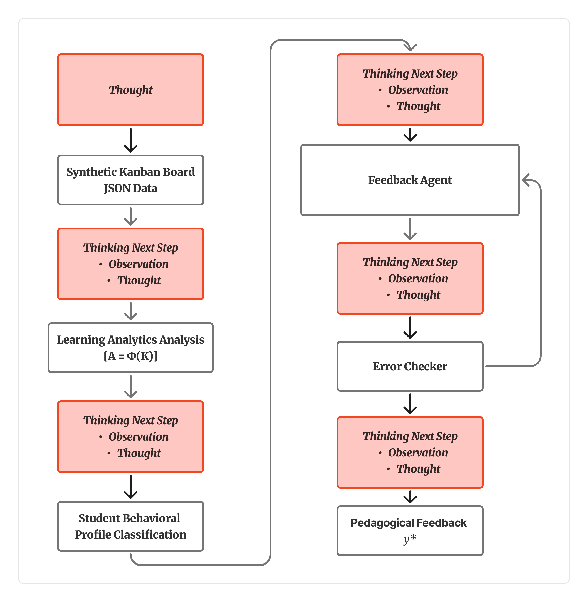
ReAct agent mechanism structure.

E. Evaluation Framework
Evaluation compares $y^{*}$ (Eq. [eq:generation]) against expert ground truth $y_{\text{ref}}$ through three automated quantitative metrics and qualitative expert validation.

BERTScore
BERTScore [20] uses contextual BERT embeddings to compute token-level Precision ($P_{\text{BERT}}$), Recall ($R_{\text{BERT}}$), and F1 between $y^{*}$ and $y_{\text{ref}}$, capturing semantic similarity beyond lexical overlap:
$$F_{\text{BERT}}=2 \frac{P_{\text{BERT}}⋅R_{\text{BERT}}}{P_{\text{BERT}}+R_{\text{BERT}}}$$

BARTScore
BARTScore [21] evaluates $y^{*}$ against $y_{\text{ref}}$ by computing the weighted log-likelihood of $y^{*}$ under a pretrained BART model conditioned on $y_{\text{ref}}$, assessing fluency and semantic coverage without retraining. Let $ϕ$ denote the BART model parameters:
$$\text{BARTScore}\left(y^{*}∣y_{\text{ref}}\right)=\frac{1}{\left|y^{*}\right|}\sum_{t=1}^{\left|y^{*}\right|}{log}p_{ϕ}​\left(y_{t}^{*}∣y_{<t}^{*}, y_{\text{ref}}\right)$$
where $\frac{1}{\left|y^{*}\right|}$ normalises by sequence length for fair comparison across responses of varying length. A less negative score indicates better semantic coverage. Both directions are computed and aggregated as Precision, Recall, and F1.

LLM-as-a-Judge
GPT-4o [22] acts as an automated evaluator, assigning binary quality labels per pedagogical dimension by comparing $y^{*}$ against $y_{\text{ref}}$, achieving moderate-to-high agreement with expert human raters.
For each data point $i∈\{1,…,N=40\}$ and dimension $d∈D$, the judge returns a binary label $e_{d}^{\left(i\right)}∈\{0,1\}$ by comparing $y^{*\left(i\right)}$ against $y_{\text{ref}}^{\left(i\right)}$ using rubric $I_{d}$ and analytics context $A^{\left(i\right)}$. Since expert labels are ${\hat{e}}_{d}^{\left(i\right)}=1$ by construction, per-dimension Recall simplifies to the mean binary score, while Precision and F1 are computed accordingly. The reported scores are macro-averaged over all three dimensions $D$.
The prompt supplies four fields corresponding to Eqs. [eq:prompt]–[eq:generation]: dimension definitions $I_{d}$, the analytics summary $A^{\left(i\right)}$, the expert reference $y_{\text{ref}}^{\left(i\right)}$, and the candidate response $y^{*\left(i\right)}$.

Expert Validation
An independent educational psychology expert assessed the best-performing model’s outputs using a 15-indicator Likert-scale questionnaire grounded in Self-Determination Theory [23], Positive Psychology [24], and the Hattie–Timperley feedback model [25], covering the feedback, motivation, and appreciation dimensions.

IV. Results and Discussion
This section presents the experimental results and analysis across three evaluation dimensions, namely semantic alignment, pedagogical relevance, and qualitative expert assessment, and discusses the findings in relation to the three objectives stated in Section 1.

A. Semantic Alignment BERTScore and BARTScore
Table 1 reports the BERTScore and BARTScore F1 scores for all eight experimental configurations. For the 8B model, both metrics show a net improvement as context complexity increases, with a slight dip at the Material List condition before recovering; the ReAct + LA variant achieves the highest BERTScore F1 ($F_{\text{BERT}}=0.6663$) and BARTScore F1 ($\text{BARTScore}=−11.40$), representing gains of $+0.0055$ and $+0.32$ respectively over the Baseline. For the 70B model, the trend is reversed, the Material List variant achieves the best performance on both metrics ($F_{\text{BERT}}=0.6710$; $\text{BARTScore}=−11.61$), while the ReAct + LA variant yields no consistent improvement over the Baseline.
Quantitative Evaluation Results (F1 Scores) per Variant
Variant | Model | BERTScore F1 | BARTScore F1 | LLM-as-a-Judge F1
Baseline | 8B | 0.6608 | ‒11.72 | 0.5371
Baseline | 70B | 0.6687 | ‒11.69 | 0.7271
Material List | 8B | 0.6597 | ‒11.85 | 0.5627
Material List | 70B | 0.6710 | ‒11.61 | 0.7571
LA | 8B | 0.6657 | ‒11.54 | 0.5896
LA | 70B | 0.6648 | ‒11.69 | 0.6399
ReAct + LA | 8B | 0.6663 | ‒11.40 | 0.6121
ReAct + LA | 70B | 0.6658 | ‒11.67 | 0.6715

While the absolute magnitude of these improvements is modest, this is consistent with the nature of BERTScore and BARTScore that both metrics measure token-level semantic proximity to the reference $y_{\text{ref}}$, and expert-written feedback exhibits idiomatic variation that limits the ceiling of embedding-based similarity regardless of output quality. The more informative signal therefore lies in the consistency of the direction of improvement, particularly the steady gain observed across all three metrics for the 8B model under increasing context complexity.

B. Pedagogical Relevance with LLM-as-a-Judge
Table 1 also reports the LLM-as-a-Judge F1 for all variants. This metric reveals a much larger performance differential than the embedding-based metrics, particularly for the 8B model. The Baseline 8B achieves an F1 of only 0.5371, indicating that without structured context the model satisfies fewer than half of the pedagogical criteria on average. The ReAct + LA variant raises this to 0.6121, a gain of $+0.0750$, more than ten times the magnitude of the corresponding BERTScore gain. For the 70B model, the Baseline already achieves F1 = 0.7271, and the best variant (Material List, F1 = 0.7571) adds only a modest $+0.0300$.
The consistently high Precision values (1.0000 for most configurations) reflect the binary scoring design described in Section 3.5 when the model satisfies a criterion, it virtually always does so correctly relative to the expert reference. The primary driver of F1 variance is therefore Recall, the proportion of expert-defined criteria actually addressed, which increases substantially for the 8B model under richer context (from 0.4567 to 0.5217) but remains near its ceiling for the 70B model (0.6417 to 0.6600 at best). This divergence suggests that the 70B model’s superior pretraining already endows it with broad pedagogical criterion coverage, leaving limited headroom for context-driven improvement.
Table 1 summarizes the full quantitative comparison across all variants and metrics, revealing a divergent response pattern between the two model sizes under increasing context complexity.

C. Qualitative Expert Validation
The top-performing configuration for the 8B model, Llama 3.1 8B with ReAct + LA, was submitted for qualitative review by an educational psychology expert independent of the three lecturers who provided $y_{\text{ref}}$, because it represented the strongest setup for the smaller, cost-efficient model rather than the single highest quantitative score across both models. The expert assessed 15 indicators across three pedagogical functions using a five-point Likert scale (Table 2), and rendered an overall verdict of “Usable with minor revision.”
Expert Qualitative Assessment (Llama 3.1 8B, ReAct + LA)
Dimension (ID) | Criterion | Score
Feedback (F1) | Clarity | 4
Feedback (F2) | Specificity | 4
Feedback (F3) | Relevance | 3
Feedback (F4) | Constructiveness | 4
Feedback (F5) | Feed-forward | 4
Feedback – Mean |  | 3.80
Motivation (M1) | Intrinsic drive | 4
Motivation (M2) | Goal orientation | 5
Motivation (M3) | Autonomy | 4
Motivation (M4) | Competence | 4
Motivation (M5) | Relatedness (empathy) | 3
Motivation – Mean |  | 4.00
Appreciation (A1) | Effort recognition | 5
Appreciation (A2) | Proportionality | 3
Appreciation (A3) | Confidence | 4
Appreciation (A4) | Emotional support | 4
Appreciation (A5) | Positive reinforcement | 3
Appreciation – Mean |  | 3.80
Overall Mean |  | 3.87

The Feedback dimension (mean = 3.80) is strongest in clarity, constructiveness, and feed-forward orientation (F1, F4, F5 = 4), while relevance to the specific learning context (F3 = 3) is the primary weakness, consistent with the model’s limited ability to reference specific Kanban card content in its analysis. The Motivation dimension (mean = 4.00) shows the highest overall scores, with particularly strong goal-orientation (M2 = 5) aligned with Self-Determination Theory’s emphasis on goal salience [23]. However, the lower relatedness score (M5 = 3) indicates a gap in empathetic connection, a finding consistent with prior work showing that affective dimensions of feedback remain difficult for LLMs to produce reliably [14]. The Appreciation dimension (mean = 3.80) demonstrates strong effort recognition (A1 = 5), grounded in Positive Psychology’s emphasis on acknowledging process over outcome [24], but scores for sincerity and positive reinforcement (A2, A5 = 3) suggest the language is perceived as formulaic rather than genuinely warm, a characteristic the expert attributed to the repetitive phrasing patterns of the 8B model noted earlier.

D. Discussion
Context engineering enriched with LA consistently improved feedback quality for the 8B model across all three metrics, with the ReAct + LA variant achieving the highest quantitative scores, confirming that this approach is an effective, fine-tuning-free strategy for improving pedagogical feedback quality. The improvement pattern is consistent with the Bayesian interpretation in Eq. [eq:marginal], where the richer context $C$ and student data $D$ sharpen the model’s posterior belief $p\left(θ∣C,D,y_{<t}\right)$ about the student’s learning pattern, directing generation toward more criterion-satisfying outputs.
Expert evaluation returned an overall verdict of “Usable with minor revision,” validating the practical feasibility of the approach as a complementary scaffolding system. The average expert scores across all three dimensions ($\overset{‾}{s}=3.87/5.00$) indicate adequate pedagogical quality, with the primary revision targets being contextual specificity (F3), empathetic tone (M5), and language naturalness (A2, A5). These improvements do not require architectural changes and can be addressed through targeted prompt refinement.
Model size strongly shapes the optimal context complexity within the two Llama scales compared here. Even at Baseline, the 70B model substantially outperforms the 8B model on pedagogical criterion satisfaction (LLM-as-a-Judge F1: 0.7271 vs. 0.5371, $Δ=0.1900$) while the BERTScore gap remains narrow ($Δ=0.0079$), confirming that 70B’s advantage is pedagogical rather than lexical and setting a performance floor that context engineering struggles to raise further. The 8B model benefits overall from richer context, with the most consistent gains on pedagogical criterion satisfaction, consistent with the hypothesis that smaller models compensate for limited internal capacity by relying on explicit structured guidance [18], [19]. Conversely, the 70B model achieves its best performance with minimal additional context (Material List), and its performance degrades under the ReAct + LA framework. Two complementary explanations are plausible. First, the prescriptive ReAct loop over-constrains the 70B model’s generation distribution, forcing it to mimic the step-by-step, descriptive style characteristic of the 8B model rather than leveraging its superior generation capacity, consistent with the over-prompting effect in which added scaffolding degrades performance once a model already possesses the required competence [18]. Second, under the implicit Bayesian view of in-context learning [16], context is informative only insofar as it sharpens an otherwise diffuse posterior; the 70B model’s strong Baseline pedagogical performance indicates a prior already concentrated on criterion-satisfying feedback, so prescriptive context adds little signal while imposing stylistic constraints that pull generation away from it. This also explains why 70B’s Baseline feedback is more linguistically varied, while 8B’s is more repetitive and less clearly differentiated between appreciation and critique.
A cross-cutting finding is the divergence between metric sensitivities: BERTScore improvements are small (max $ΔF1=0.0055$) while LLM-as-a-Judge improvements are substantially larger (max $ΔF1=0.0750$ for 8B). This suggests that pedagogical criterion satisfaction is more sensitive to context engineering than surface-level semantic similarity, and that LLM-as-a-Judge is a more discriminative metric for this task. Finally, a prompt scoring 13/16 on the theory-driven quality manual [14] not guaranteeing optimal output, especially for 70B, shows that prompt quality scores are necessary but not sufficient, and must be interpreted alongside model capacity and context complexity.
Practically, the gains matter most where they are largest. The 8B ReAct + LA configuration raises pedagogical criterion satisfaction by $ΔF1=0.0750$, recovering part of the gap to the untuned 70B Baseline at a fraction of the deployment cost, which is the operative trade-off for institutions that cannot host large models. The narrow BERTScore and BARTScore margins, by contrast, should be read as exploratory: this study reports no statistical significance testing, so differences of that magnitude cannot be separated from run-to-run variance, and only the larger LLM-as-a-Judge and expert-rated differences support cautious interpretation. Together with the synthetic dataset ($N=40$) and the single expert validator, these constraints mean the results establish feasibility and direction rather than deployment-ready effect sizes.

V. Conclusion
This study investigated context engineering enriched with learning analytics (LA) as a fine-tuning-free strategy for improving the pedagogical feedback quality of open-source LLMs in a Kanban-based self-regulated learning platform. Four prompt variants were evaluated on two contrasting model scales (Llama 3.1 8B and Llama 3.3 70B) using BERTScore, BARTScore, LLM-as-a-Judge, and expert validation.
Regarding the first objective, LA-enriched context consistently improved feedback quality for the 8B model, with ReAct + LA achieving the largest gain in pedagogical criterion satisfaction (LLM-as-a-Judge F1: $Δ+0.075$ over Baseline).
Regarding expert validation, expert evaluation of the top-performing 8B configuration (ReAct + LA) returned a verdict of “Usable with minor revision” ($\overset{‾}{s}=3.87/5.00$).
Regarding model size, scale strongly shapes the optimal context complexity, and the larger model is not necessarily the more context-receptive one: the 8B model improved with context richness, while the 70B model peaked at Material List and degraded under the prescriptive ReAct + LA framework. These findings establish LA-enriched context engineering as an effective, resource-efficient strategy for improving LLM pedagogical feedback quality without fine-tuning.
Limitations remain: a synthetic dataset ($N=40$), a single expert validator, two model scales within one family, and no significance testing.
Understanding why the 70B model degrades under the ReAct + LA framework warrants further investigation, with DPO or alternative agentic strategies as candidates. Future studies should replicate these experiments on real student Kanban interaction logs, apply paired significance testing over per-instance scores (paired $t$-test or Wilcoxon signed-rank with bootstrap confidence intervals) to establish which margins are reliable, and expand the expert panel to enable statistically robust inter-rater agreement analysis. Prompt personalization for tone and empathy, particularly for the indicators flagged by experts (M5, A2, A5), and evaluation of models with stronger target-language proficiency remain open avenues for improvement.

Acknowledgment
The authors thank the educational psychology experts who provided qualitative validation, and the three university lecturers who authored the ground-truth feedback. This work was conducted as part of the undergraduate research program at Universitas Gadjah Mada.

References
[1] C. Liu, Z. A. Bakar, and Q. Xu, “Self-regulated learning and academic achievement in higher education: A decade systematic review,” International Journal of Research and Innovation in Social Science (IJRISS), vol. 9, no. 03, pp. 4488–4504, 2025. DOI: 10.47772/IJRISS.2025.90300358.
[2] B. J. Zimmerman and A. R. Moylan, “Self-regulation: Where metacognition and motivation intersect,” in Handbook of Metacognition in Education (D. J. Hacker, J. Dunlosky, and A. C. Graesser, eds.), pp. 299–315, New York, NY: Routledge, 2009. DOI: 10.4324/9780203876428-23.
[3] S. Xiao, K. Yao, and T. Wang, “The relationships of self-regulated learning and academic achievement in university students,” SHS Web of Conferences, vol. 60, p. 01003, 2019. PHECSS2018; DOI: 10.1051/shsconf/20196001003.
[4] E. Chitra, N. Hidayah, M. Chandratilake, and V. D. Nadarajah, “Self-regulated learning practice of undergraduate students in health professions programs,” Frontiers in Medicine, vol. 9, p. 803069, 2022. DOI: 10.3389/fmed.2022.803069.
[5] L. F. Yang, Y. Liu, and Z. Xu, “Examining the effects of self-regulated learning-based teacher feedback on english-as-a-foreign-language learners’ self-regulated writing strategies and writing performance,” Frontiers in Psychology, vol. Volume 13 - 2022, 2022. DOI: 10.3389/fpsyg.2022.1027266.
[6] T. Bock, E. Thomm, J. Bauer, and B. Gold, “Fostering student teachers’ research-based knowledge of effective feedback,” European Journal of Teacher Education, vol. 47, no. 2, pp. 389–407, 2024. DOI: 10.3389/feduc.2024.1418297.
[7] H. E. Schaffer, K. R. Young, E. W. Ligon, and D. D. Chapman, “Automating individualized formative feedback in large classes based on a directed concept graph,” Frontiers in Psychology, vol. 8, p. 260, 2017. Article 260; DOI: 10.3389/fpsyg.2017.00260.
[8] A. Pardo, J. Jovanović, S. Dawson, D. Gašević, and N. Mirriahi, “Using learning analytics to scale the provision of personalised feedback,” British Journal of Educational Technology, vol. 50, pp. 128–138, Jan. 2019. DOI: 10.1111/bjet.12592.
[9] M. Usher, “Generative ai vs. instructor vs. peer assessments: a comparison of grading and feedback in higher education,” Assessment & Evaluation in Higher Education, 2025. Published online: Apr. 9, 2025; DOI: 10.1080/02602938.2025.2487495.
[10] K. K. Maurya, K. V. A. Srivatsa, K. Petukhova, and E. Kochmar, “Unifying ai tutor evaluation: An evaluation taxonomy for pedagogical ability assessment of llm-powered ai tutors,” arXiv preprint arXiv:2412.09416, 2025. Version 2; DOI: 10.18653/v1/2025.naacl-long.57.
[11] S. Strickroth, M. Kreidenweis, and Z. Wurm, “Learning from agile methods: Using a kanban board for classroom orchestration,” in Proceedings of the 25th International Conference on Interactive Collaborative Learning (ICL 2022) (M. E. Auer, W. Pachatz, and T. Rüütmann, eds.), vol. 633 of Lecture Notes in Networks and Systems, pp. 68–79, Springer, 2022. DOI: 10.1007/978-3-031-26876-2_7.
[12] L. Ouyang, J. Wu, X. Jiang, D. Almeida, C. L. Wainwright, P. Mishkin, C. Zhang, S. Agarwal, K. Slama, A. Ray, J. Schulman, J. Hilton, F. Kelton, L. Miller, M. Simens, A. Askell, P. Welinder, P. Christiano, J. Leike, and R. Lowe, “Training language models to follow instructions with human feedback,” 2022. DOI: 10.48550/arXiv.2203.02155.
[13] J. Woodrow, S. Koyejo, and C. Piech, “Improving generative ai student feedback: Direct preference optimization with teachers in the loop,” in Proceedings of the 2025 International Conference on Educational Data Mining (EDM 2025), International Educational Data Mining Society, 2025. DOI: 10.5281/zenodo.15870266.
[14] L. J. Jacobsen and K. E. Weber, “The promises and pitfalls of large language models as feedback providers: A study of prompt engineering and the quality of ai-driven feedback,” AI, vol. 6, no. 2, 2025. DOI: 10.3390/ai6020035.
[15] H. Li and B. Ma, “Design of ai-powered tool for self-regulation support in programming education,” 2025. DOI: 10.48550/arXiv.2504.03068.
[16] S. M. Xie, A. Raghunathan, P. Liang, and T. Ma, “An explanation of in-context learning as implicit bayesian inference,” arXiv preprint arXiv:2111.02080, 2022. DOI: 10.48550/arXiv.2111.02080.
[17] “Groq API Pricing.”
[18] Y. Tang, D. Tuncel, C. Koerner, and T. Runkler, “The Few-shot Dilemma: Over-prompting Large Language Models,” arXiv preprint arXiv:2509.13196, Sep 2025. DOI: 10.1109/FLLM67465.2025.11391015.
[19] L. Pawlik, “How the choice of llm and prompt engineering affects chatbot effectiveness,” Electronics, vol. 14, 2 2025. DOI: 10.3390/electronics14050888.
[20] T. Zhang, V. Kishore, F. Wu, K. Q. Weinberger, and Y. Artzi, “Bertscore: Evaluating text generation with bert,” in International Conference on Learning Representations (ICLR), 2020. Also available as arXiv:1904.09675; DOI: 10.48550/arXiv.1904.09675.
[21] W. Yuan, G. Neubig, and P. Liu, “Bartscore: Evaluating generated text as text generation,” in Advances in Neural Information Processing Systems (NeurIPS), vol. 34, pp. 27263–27277, 2021. DOI: 10.48550/arXiv.2106.11520.
[22] C. Koutchéme, N. Dainese, S. Sarsa, A. Hellas, J. Leinonen, and P. Denny, “Open source language models can provide feedback: Evaluating llms’ ability to help students using gpt-4-as-a-judge,” 2024. DOI: 10.48550/arXiv.2405.05253.
[23] E. L. Deci and R. M. Ryan, Intrinsic Motivation and Self-Determination in Human Behavior. New York: Plenum, 1985. DOI: 10.1007/978-1-4899-2271-7.
[24] B. L. Fredrickson, “The role of positive emotions in positive psychology: The broaden-and-build theory of positive emotions,” American Psychologist, vol. 56, no. 3, pp. 218–226, 2001. DOI: 10.1037/0003-066X.56.3.218.
[25] J. Hattie and H. Timperley, “The power of feedback,” Review of Educational Research, vol. 77, no. 1, pp. 81–112, 2007. DOI: 10.3102/003465430298487.

