An independent replication of bootstrap confidence-interval calibration for small samples
Kyunghan Bae
Independent researcher, South Korea
11 October 2026

Abstract
We independently implement seven confidence-interval procedures from Hesterberg's study of resampling inference. All 20 printed numerical cells of Table 5 in the extended manuscript agree with direct calculations at the published precision. A fixed-seed experiment evaluates normal and exponential sample means at n=10,20,40, using 5,000 original samples and 1,999 bootstrap resamples per condition. Conditioning on centered or normalized residuals reduces outer simulation noise. The experiment compares one-sided miss probabilities and their Monte Carlo uncertainty, and a paired experiment checks sensitivity to 9,999 resamples. For exponential data at n=10, bootstrap-t coverage is 0.9407, compared with 0.9001 for Student t. The largest-magnitude finite-B tail-probability change is -0.00081. The replication concerns a prespecified small-sample subset of the original study.

Original study and target
Hesterberg (2015), Figure 10, compares one-sided miss probabilities for normal and exponential populations. We independently implement its selected small-sample conditions. The publicly accessible 2014 extended manuscript provides detailed methods and exact numerical targets (Hesterberg, 2014, 2015). Table 5 and Figures 20–22 refer to that extended manuscript; Figure 10 refers to the journal article. The exact anchor supplements the simulation target. The interval algorithms are newly written from the equations.

Methods
The sample mean is the parameter estimate. The seven intervals are Student t, skewness-corrected t, t with bootstrap standard error, percentile, reverse percentile, expanded percentile, and bootstrap t. Their endpoints are implemented in replicate.py, directly from the manuscript definitions. All variances used for Student standard errors have divisor n-1. Bootstrap standard error uses the sample standard deviation of the B resampled means. Empirical quantiles use linear interpolation (Hyndman–Fan type 7).
Write the sample mean as , its standard error as 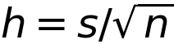, and 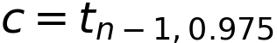. For bootstrap means 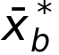, let 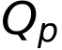 denote the empirical 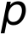 quantile,  their sample standard deviation, and 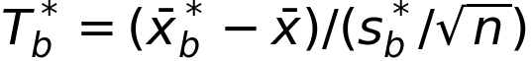. The intervals are:
Procedure | Lower and upper endpoints
Student t | 
t with bootstrap SE | 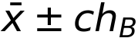
Percentile | 
Reverse percentile
Expanded percentile | 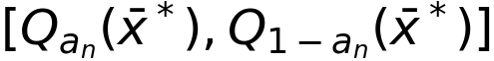
Bootstrap t
Here 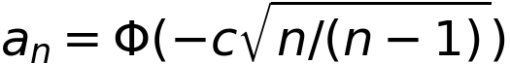. For the skewness-corrected t interval define 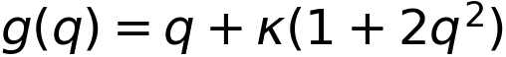 and 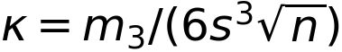, where 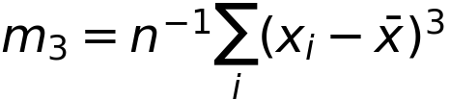. Its endpoints are 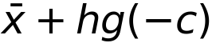 and 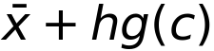 after the flattening rule below. If , arguments below 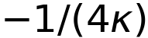 are set to that value; if , arguments above it are set to it. The zero-skewness limit equals Student t.
The skewness correction uses 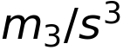. Its quadratic is flattened at the extremum when a nominal endpoint lies beyond it, specifying the source's instruction explicitly. Constant resamples have undefined studentized statistics; the implementation counts and excludes only those statistics from bootstrap-t quantiles. It fails if fewer than 99% remain finite.
Two source populations are studied, N(0,1) and Exponential(mean=1). The six main conditions each use 5,000 independently generated original samples and B=1,999 resamples. The finite-B comparison uses 1,500 fresh exponential samples at n=10 and n=40, with B=1,999 and B=9,999 sharing original samples and the initial resample prefix. PCG64DXSM seeds are fixed before calculation.
Let a left miss mean 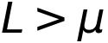 and a right miss mean 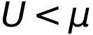. For normal data, 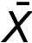 is independent of , and the intervals are translation equivariant. Conditional on  and the resample indices, 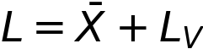 and . Since 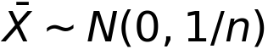, the conditional probabilities are
For exponential data, 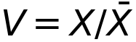 is independent of and the intervals are positively scale equivariant. Thus 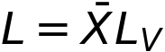 and . If  is the CDF of that gamma law, the conditional probabilities are
when the corresponding residual endpoint is positive. For  the left probability is zero; for  the right probability is one. We average these conditional weights over independent residual vectors and independently drawn resample indices. The law of total expectation gives the same unconditional miss probability as binary simulation, while conditioning removes the sample-mean component of Monte Carlo variance.
Reported Monte Carlo standard errors are the sample standard deviation of the conditional weights divided by sqrt(R); pointwise 95% intervals use a Student critical value with R-1 degrees of freedom. Paired B differences use the standard error of within-sample differences and the normal critical value 1.96. These intervals quantify outer simulation uncertainty at the specified B. The separate paired experiment assesses finite-B sensitivity. Prespecified sample sizes cover three small-sample conditions.
For descriptive comparisons we use . This operationalizes the source's qualitative statement about overall coverage accuracy; the source does not specify this particular loss function. Individual tail estimates and their uncertainty remain the primary simulation results.

Results
All 20/20 numerical targets in Table 5 agree at their printed precision. The full values and discrepancies are available in table5_comparison.csv.
For the deterministic anchor, let 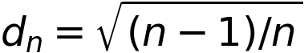 and 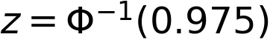. The four calculated quantities are , , 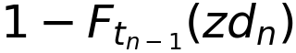, and 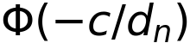, respectively. The following table reports our calculations with more digits than the source's three or four decimal places.
n | Narrowness | z/t | One-sided size | Adjusted alpha/2
5 | 0.894427 | 0.705926 | 0.077233 | 0.000954
10 | 0.948683 | 0.866414 | 0.047954 | 0.008551
20 | 0.974679 | 0.936427 | 0.035651 | 0.015881
40 | 0.987421 | 0.968988 | 0.030114 | 0.020258
80 | 0.993730 | 0.984684 | 0.027503 | 0.022588
The exponential experiment gives the following newly computed results. A nominal 95% interval has target left and right miss probabilities of 0.025 each.
n | Method | Left miss | Right miss | Coverage | MC SE, left | MC SE, right
10 | Student t | 0.0040 | 0.0959 | 0.9001 | 0.00017 | 0.00060
10 | Skew-corrected t | 0.0122 | 0.0714 | 0.9163 | 0.00027 | 0.00068
10 | t with bootstrap SE | 0.0056 | 0.1049 | 0.8895 | 0.00021 | 0.00063
10 | Percentile | 0.0181 | 0.1206 | 0.8613 | 0.00036 | 0.00074
10 | Reverse percentile | 0.0112 | 0.1497 | 0.8391 | 0.00032 | 0.00059
10 | Expanded percentile | 0.0068 | 0.0863 | 0.9069 | 0.00021 | 0.00066
10 | Bootstrap t | 0.0096 | 0.0497 | 0.9407 | 0.00024 | 0.00074
20 | Student t | 0.0058 | 0.0749 | 0.9193 | 0.00014 | 0.00044
20 | Skew-corrected t | 0.0213 | 0.0506 | 0.9281 | 0.00023 | 0.00046
20 | t with bootstrap SE | 0.0070 | 0.0792 | 0.9138 | 0.00016 | 0.00045
20 | Percentile | 0.0158 | 0.0807 | 0.9034 | 0.00024 | 0.00051
20 | Reverse percentile | 0.0084 | 0.1058 | 0.8858 | 0.00019 | 0.00044
20 | Expanded percentile | 0.0097 | 0.0653 | 0.9250 | 0.00017 | 0.00046
20 | Bootstrap t | 0.0160 | 0.0381 | 0.9459 | 0.00021 | 0.00049
40 | Student t | 0.0086 | 0.0595 | 0.9319 | 0.00013 | 0.00031
40 | Skew-corrected t | 0.0255 | 0.0389 | 0.9355 | 0.00019 | 0.00031
40 | t with bootstrap SE | 0.0095 | 0.0616 | 0.9289 | 0.00014 | 0.00032
40 | Percentile | 0.0165 | 0.0589 | 0.9246 | 0.00018 | 0.00035
40 | Reverse percentile | 0.0090 | 0.0779 | 0.9131 | 0.00015 | 0.00032
40 | Expanded percentile | 0.0131 | 0.0520 | 0.9349 | 0.00015 | 0.00033
40 | Bootstrap t | 0.0207 | 0.0321 | 0.9472 | 0.00019 | 0.00033
At n=10, Bootstrap t has the smallest point-estimated sum of absolute one-sided calibration errors (0.0401). At n=20, Bootstrap t has the smallest point-estimated sum of absolute one-sided calibration errors (0.0221). At n=40, Bootstrap t has the smallest point-estimated sum of absolute one-sided calibration errors (0.0114).
For exponential data at n=10, the bootstrap-t right miss probability is 0.0497 (95% Monte Carlo interval [0.0483, 0.0512]), compared with 0.0959 for Student t. Their total coverages are 0.9407 and 0.9001, respectively. Bootstrap t ranks first here while retaining appreciable right-tail error relative to the 0.025 target.
For normal data, all three Student-t estimates have Monte Carlo intervals containing their exact one-sided probability of 0.025. Bootstrap-t miss estimates at n=20 and n=40 are slightly above the nominal target; their pointwise intervals and the percentile undercoverage are shown below and in the comparison ledger.
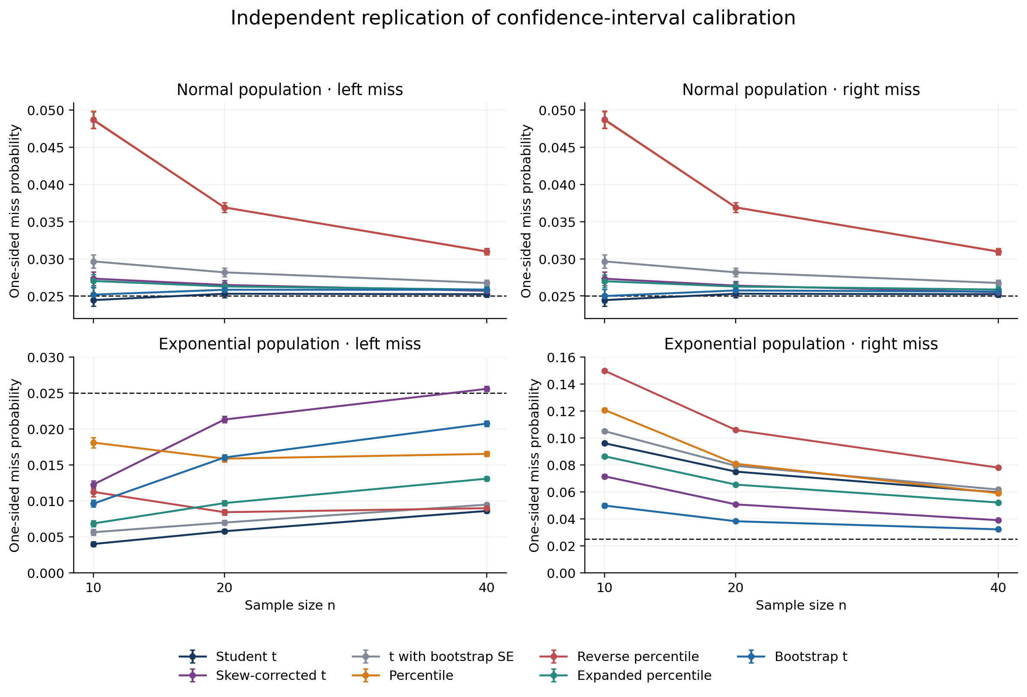
Figure 1. One-sided miss probabilities with pointwise 95% Monte Carlo intervals. All points are newly computed; the dashed line is 0.025. The exponential panels use different vertical ranges.
The largest-magnitude finite-B point change is -0.00081 (expanded_B9999_minus_B1999, n=10, right tail; paired 95% Monte Carlo interval [-0.00109, -0.00053]). All paired differences are reported in paired_comparisons.csv.
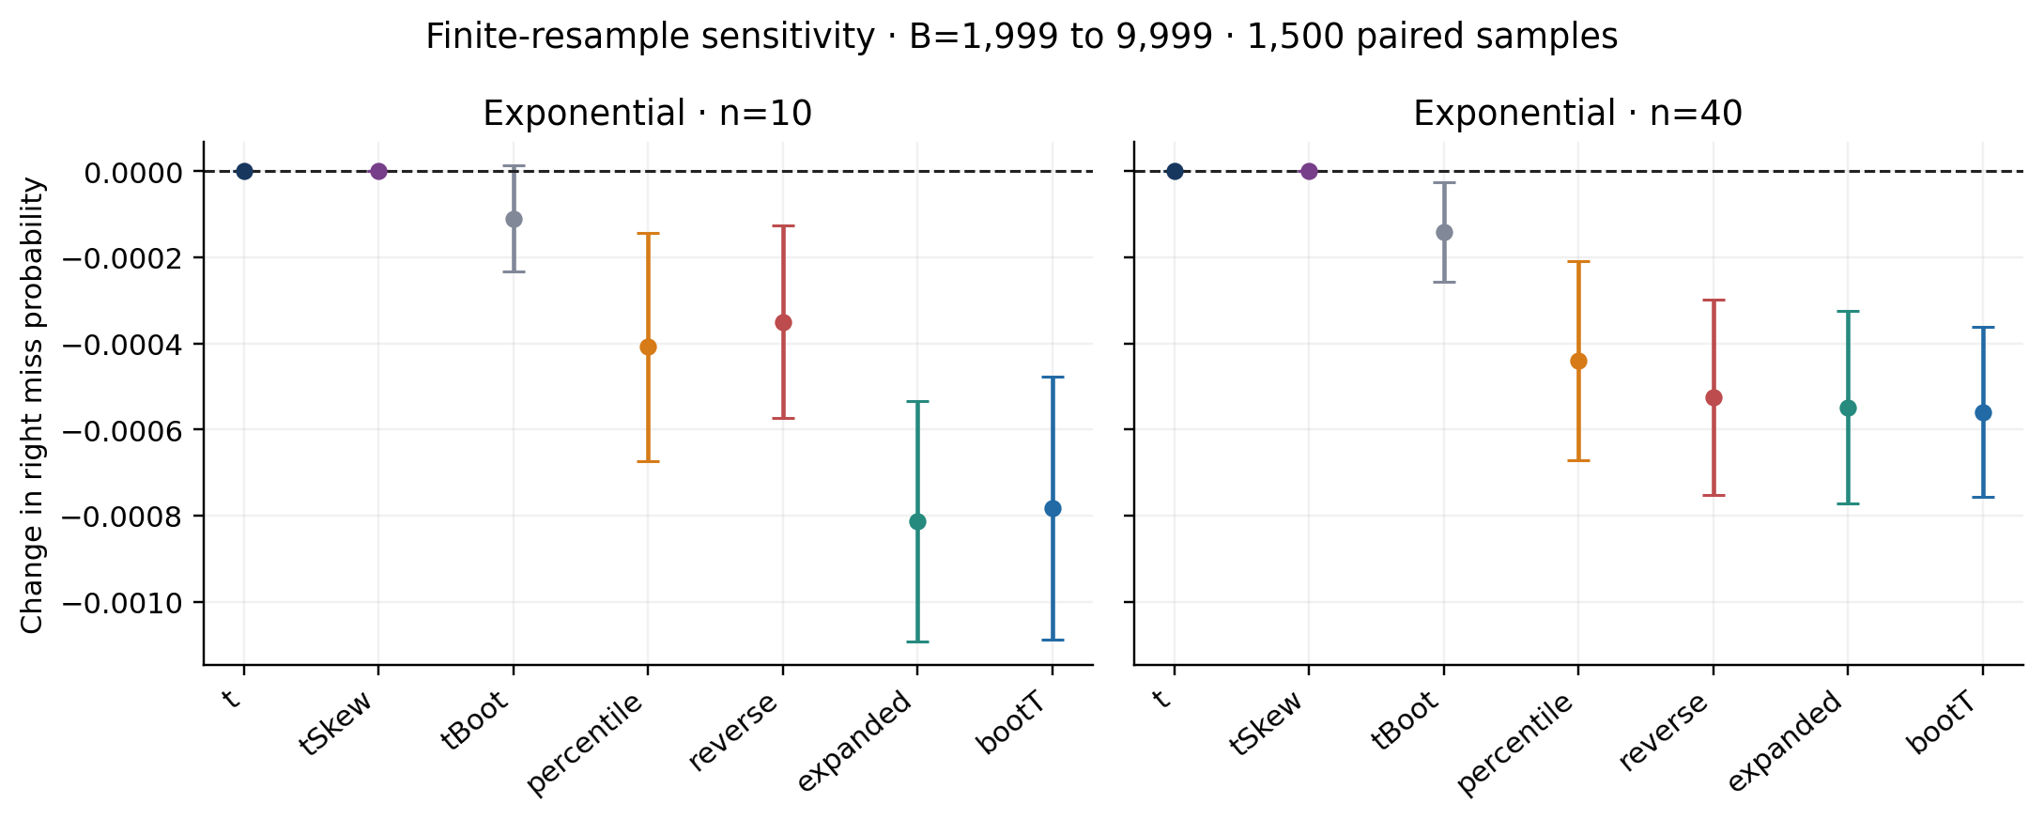
Figure 2. Paired changes in right-tail miss probability from 1,999 to 9,999 resamples, with 95% Monte Carlo intervals. Original samples and initial resamples are shared; the dashed line is zero.
The run recorded 0 degenerate studentized resamples and 57 skewness-flattening events across the main and sensitivity calculations. The latter count includes the same sensitivity original samples once per B. The primary experiment took 731.6 seconds.

Interpretation and scope
The deterministic anchor is reproduced at source precision. The simulation comparison provides independent small-sample evidence about the original interval-calibration conclusions. The original curves are supplied as figures without tabulated ordinates. table5_comparison.csv contains the exact numerical anchor. original_results_comparison.csv distinguishes theoretical Student-t probabilities, nominal calibration targets and qualitative ranking checks. Point-estimate rankings are descriptive, and the Monte Carlo intervals are pointwise.
We explicitly reduce R and B relative to the source and quantify both outer uncertainty and finite-B sensitivity. The target is the selected small-sample regime. The large-n cutoffs in extended Figure 22, second-order convergence rates and dependent, discrete or heavy-tailed populations require separate experiments. The conditioning argument uses the stated normal and exponential distributional assumptions.

Reproducibility
Python 3.12 and the pinned requirements suffice. python run_all.py generates all numerical results; python analyze.py creates this article and figures. The numeric source trace, seeds, versions, per-condition timings and failure counts are supplied. All main and finite-B conditional weights are archived in conditional_miss_samples.npz, allowing independent reanalysis. The source paper and figures are linked in SOURCE_TRACE.md. All observations are generated from the stated probability distributions.

References
Hesterberg, T. C. (2015). What Teachers Should Know About the Bootstrap: Resampling in the Undergraduate Statistics Curriculum. The American Statistician, 69(4), 371–386. doi:10.1080/00031305.2015.1089789 (https://doi.org/10.1080/00031305.2015.1089789).
Hesterberg, T. (2014). What Teachers Should Know about the Bootstrap: Resampling in the Undergraduate Statistics Curriculum. Extended manuscript, arXiv:1411.5279v1. Version 1 (https://arxiv.org/abs/1411.5279v1).

