Домашняя Работа №6 по Дискретной Математике

Цалапов Александр Михайлович

Группа 191-322

Вариант - 27

Преподаватели: Набебин А.А.,

Будылина Е.А.

Московский Политех 2020

**Задача 9.27**

{0,1,4,6,7}; {3,4,5,6,7}; {4,5,7}

|  |  |  |  |  |  |  |  |  |  |  |
| --- | --- | --- | --- | --- | --- | --- | --- | --- | --- | --- |
| N | x | y | z | f1 | f2 | f3 | f1&f2 | f1&f3 | f2&f3 | f1&f2&f3 |
| 0 | 0 | 0 | 0 | 1 | 0 | 0 | 0 | 0 | 0 | 0 |
| 1 | 0 | 0 | 1 | 1 | 0 | 0 | 0 | 0 | 0 | 0 |
| 2 | 0 | 1 | 0 | 0 | 0 | 0 | 0 | 0 | 0 | 0 |
| 3 | 0 | 1 | 1 | 0 | 1 | 0 | 0 | 0 | 0 | 0 |
| 4 | 1 | 0 | 0 | 1 | 1 | 1 | 1 | 1 | 1 | 1 |
| 5 | 1 | 0 | 1 | 0 | 1 | 1 | 0 | 0 | 1 | 0 |
| 6 | 1 | 1 | 0 | 1 | 1 | 0 | 1 | 0 | 0 | 0 |
| 7 | 1 | 1 | 1 | 1 | 1 | 1 | 1 | 1 | 1 | 1 |

f1=(x y’ z) (x y’ z’) (x’ y z’) = (x V y’) (x’ V y V z’) = xy V xz’ V x’y’ V y’z’ = xz’ V y’z’

f2 = (x y z) (x y z’) (x y’ z) = (x y) (x y’ z) = x V xy’ V xz V xy V yz = x V yz

f3 = (x y z) (x y z’) (x y’ z) (x y’ z’) (x’ y’ z) = (xy) (y’z’) (x y’ z) = y’z’ V xz

f1&f2 = (xyz)(xyz’)(xy’z)(xy’z’)(x’yz’) = (xy)(xy’)(x’yz’) = xy’ V yz’

f2&f3 = (xyz)(xyz’)(xy’z)(xy’z’)(x’yz’)(x’y’z) = (xy V xy’) (x’ V x’y’ V x’z V x’y V yz V x’z’ V y’z’) = (xy V xy’) (x’ V yz V y’z’) = x’ V xy V xy’

1. f1&f3 = (xyz)(xyz’)(xy’z)(xy’z’)(x’yz’)(x’y’z) = xy V xy’ V x’z’

f1&f2&f3 = (xyz)(xyz’)(xy’z)(xy’z’)(x’yz’)(x’y’z) = xy V xy’ V x’z’

n1=xz’

n2=y’z’

n3=x

n4=yz

n5=xz

n6=xy’

n7=yz’

n8=x’

n9=xy

n10=x’z’

%3CmxGraphModel%3E%3Croot%3E%3CmxCell%20id%3D%220%22%2F%3E%3CmxCell%20id%3D%221%22%20parent%3D%220%22%2F%3E%3CmxCell%20id%3D%222%22%20value%3D%22%22%20style%3D%22ellipse%3BwhiteSpace%3Dwrap%3Bhtml%3D1%3Baspect%3Dfixed%3BfillColor%3D%23000000%3B%22%20vertex%3D%221%22%20parent%3D%221%22%3E%3CmxGeometry%20x%3D%22275%22%20y%3D%22395%22%20width%3D%2210%22%20height%3D%2210%22%20as%3D%22geometry%22%2F%3E%3C%2FmxCell%3E%3C%2Froot%3E%3C%2FmxGraphModel%3E

|  |  |  |  |  |  |  |  |  |  |  |  |  |  |  |
| --- | --- | --- | --- | --- | --- | --- | --- | --- | --- | --- | --- | --- | --- | --- |
| n | | F1 | | | | | F2 | | | | | F3 | | |
| 000 | 001 | 100 | 110 | 111 | 011 | 100 | 101 | 110 | 111 | 100 | 101 | 111 |
| 1 | 1*0 | - | - | + | + | - | - | + | - | + | - | + | - | - |
| 2 | *00 | + | - | + | - | - | - | + | - | - | - | + | - | - |
| 3 | 1** | - | - | + | + | + | - | + | + | + | + | + | + | + |
| 4 | *11 | - | - | - | - | + | + | - | - | - | + | - | - | + |
| 5 | 1*1 | - | - | - | - | + | - | - | + | - | + | - | + | + |
| 6 | 10* | - | - | + | - | - | - | + | + | - | - | + | + | - |
| 7 | *10 | - | - | - | + | - | - | - | - | + | - | - | - | - |
| 8 | 0** | + | + | - | - | - | + | - | - | - | - | - | - | - |
| 9 | 11* | - | - | - | + | + | - | - | - | + | + | - | - | + |
| 10 | 0*0 | + | - | - | - | - | - | - | - | - | - | - | - | - |

E1 = n8 (n2Vn8Vn10) (n1Vn2Vn3Vn6) (n1Vn3Vn7Vn9) (n3Vn4Vn5Vn9) = n3 V n9 V n1n4 V n1n5 V n1n8 V n2n8 V n4n7 V n5n7 V n6n8

E2 = (n4Vn8) (n1Vn3Vn7Vn9) (n3Vn5Vn6) (n1Vn3Vn7Vn9) (n3Vn4Vn5Vn9) = n3n4 V n3n8 V n1n4n5 V n1n4n6 V n1n5n8 V n4n5n7 V n4n5n9 V n4n6n7 V n4n6n9 V n5n7n8 V n5n8n9 V n6n8n9

E3 = (n1Vn2Vn3Vn6) (n3Vn5Vn6) (n3Vn4Vn5Vn9) = n3 V n1n5 V n2n5 V n4n6 V n5n6 Vn6n9

ПЛМ, совместно реализующая функции f1,f2,f3 имеет следующий вид

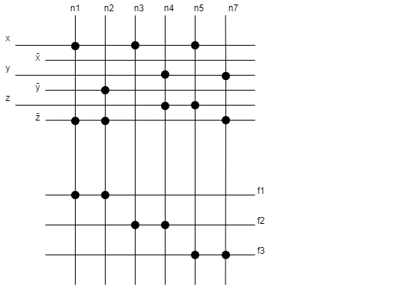

Построенная ПЛМ имеет тип 3,6,3. 3 переменных, ширина 6, 3 функции