ZARS
Developer's Guide

© soomsam.net. This document is subject to the terms and conditions outlined in the CC BY-NC-SA 3.0 license.

Project | ZARS
Version | 0.1
Status | Draft
Authors | Liebmann, Erich
Reviewers | -
Last Updated | 2012-01-29

Change Log
Version | Author | Date | Comment
0.1 | Liebmann, Erich | 2012-01-29 | initial version

Table of Contents
1. Purpose and Scope 4
1.1. Notes 4
1.2. Conventions 4
1.3. Prerequisites 4
2. Development Environment Setup 5
2.1. Setup Eclipse Installation 5
2.1.1. Specify the JVM for Eclipse 5
2.1.2. Install Suggested Plug-ins 5
3. Eclipse Workspace Setup 7
3.1. Checkout ZARS 7
3.2. Building and Starting ZARS using Eclipse 7
3.3. Building and Starting ZARS using Maven 7
4. Building, Packaging, and Releasing 9
4.1. Environment Specific Settings 9
4.2. Build and Package in Eclipse 9
4.3. Build and Package on the Command Line 9
4.4. Releasing 9
5. Setup and Installation 11
5.1. Database Setup 11
5.1.1. HyperSQL 11
5.1.2. MySQL 11
5.1.3. PostgreSQL 12
5.2. Servlet Container Setup 12
5.2.1. Jetty 12
5.2.2. Tomcat 12
5.3. Deployment 13
5.4. Management and Monitoring 13
6. Testing 14
6.1. Unit Testing 14
6.2. Integration Testing 14
6.3. Acceptance Testing 14
7. Development Guidelines 15
7.1. System Architecture 15
7.2. Software Architecture 15
7.3. Best Practices 18
7.3.1. Quality Assurance 18
7.3.2. Source Code Commit 18
7.4. Best Practices 20
7.5. Coding Guidelines 21

Purpose and Scope
This Developer's Guide will help to get you started developing and maintaining ZARS. It illustrates (a) how to setup the development environment, (b) how to start and stop ZARS, (c) how to unit, integration, and acceptance test the application, and (d) how to create a dev, test, uat, and prod build of ZARS.

Notes
This guide assumes that you are going to use the Eclipse IDE to develop and maintain ZARS. All instructions are given based on Eclipse Indigo (3.7) Java EE IDE for Web Developers and may differ in earlier / later / different versions of the Eclipse IDE.
Note
All paths specified in this guide are relative to the Eclipse workspace of ZARS.

Conventions
This guide uses the typographic conventions outlined in table Typographic Conventions.
Typographic Style | Usage
italic | Used to emphasize single words or parts of a sentence, to introduce product names, and new terms where they are defined.
underline | Used for cross-references in the document.
dotted-underline | A special term defined in appendix Terms and Definitions.
constant width | Used for GUI labels / text, keywords, operators, datatypes, method names, variable names, class names, and interface names.
# | Indicates an Operating System prompt.
> | Indicates the prompt of a command line tool (e.g. RDBMS query tool)
Table 1 Typographic Conventions

Prerequisites
To develop and maintain ZARS the following software has be installed:
- Oracle / Sun JDK 1.6
- Eclipse Indigo (3.7)
To facilitate development it is recommended to install the following Eclipse plug-ins:
- Subversive
- Eclipse m2e
- Spring IDE
- FindBugs
- PMD

Development Environment Setup

Setup Eclipse Installation
After downloading and unpacking Eclipse perform the steps outlined below to configure the IDE and to install all recommended plug-ins.

Specify the JVM for Eclipse
Perform the following steps to get Eclipse to run on the (correct version of the) JDK:
- open the eclipse.ini file (located in the Eclipse installation directory)
- specify the -vm parameter with the correct path to your JDK installation
Note
Setting the -vm option in the eclipse.ini file will ensure seamless operation of the Eclipse Maven Integration (Eclipse m2e) and define the Java installation used by Maven plug-ins.

Install Suggested Plug-ins

Install m2e and Subversive
Perform the following steps to install the m2e and Subversive plug-ins:
- navigate to Help > Install New Software...
- select Indigo - http://download.eclipse.org/releases/indigo from the Work with dropdown box
- expand section Collaboration and select m2e - Maven Integration for Eclipse and Subversion SVN Team Provider
- proceed through the wizard to install the plug-ins and restart Eclipse when prompted
- navigate to Window > Open Perspective > Other... and select SVN Repository Exploring to trigger Subversive Connector Discovery
- in the Subversive Connector Discovery dialog select the latest version of SVN Kit and the latest version of Native JavaHL
- confirm the selection in the dialog, proceed through the wizard, and accept any security warnings to install the selected Subversive Connectors, restart Eclipse when prompted

Install Spring IDE
Perform the following steps to install the Spring IDE plug-in:
- navigate to Help > Install New Software...
- specify http://dist.springsource.com/release/TOOLS/update/2.8.1.RELEASE/e3.7 in the Work with dropdown box
- expand section Core / Spring IDE and select Spring IDE Core
- proceed through the wizard to install the plug-in and restart Eclipse when prompted

Install FindBugs
Perform the following steps to install the FindBugs plug-in:
- navigate to Help > Install New Software...
- specify http://findbugs.cs.umd.edu/eclipse in the Work with dropdown box
- expand section FindBugs and select FindBugs Feature
- proceed through the wizard and accept any security warnings to install the plug-in, restart Eclipse when prompted

Install PMD
Perform the following steps to install the PMD plug-in:
- navigate to Help > Install New Software...
- specify http://pmd.sf.net/eclipse in the Work with dropdown box
- expand section PMD for Eclipse 3 and select PMD Plug-in
- proceed through the wizard and accept any security warnings to install the plug-in, restart Eclipse when prompted
Hint
Setting up a new Eclipse workspace for ZARS? Why don't you try a new / different programming font? When it comes to programming fonts tastes and preferences definitely vary but I personally like Droid Sans Mono, Deja Vu Sans Mono, and Lucida Console.
TODO: Cobertura/Emma, code coverage...?
http://www.copperykeenclaws.com/notes-on-cobertura-vs-emma-vs-clover/
http://www.copperykeenclaws.com/notes-on-cobertura-vs-emma-vs-clover/

Eclipse Workspace Setup

Checkout ZARS
The ZARS source code is managed in an Apache Subversion (SVN) repository. To start developing / maintaining ZARS checkout the project from the following SVN repository:
ZARS SVN Repository URL
https://svn.soomsam.net/zirmegghuette/
Perform the following steps to checkout ZARS into your Eclipse Workspace:
- open the SVN Repository Exploring perspective
- right-click on an empty spot (the background) in the SVN Repositories panel and select New > Repository Location...
- specify (above mentioned) ZARS SVN Repository URL as the URL, set User and Password to your SVN credentials, tick Save authentication (could trigger secure storage login), and press Finish to confirm
- navigate to and expand trunk in the ZARS SVN Repository, right-click on zars and select Check Out to start the SVN checkout
After the SVN checkout is completed Eclipse should automatically start to build the project. The first build could run for quite a while since Maven might have to download a number of dependencies.
Note
Please note that the project has been setup with separate Maven and Eclipse output folders. The Maven build uses output folder target/ while the Eclipse build uses output folder target-eclipse/.

Building and Starting ZARS using Eclipse
Perform the following steps to build ZARS with Eclipse during development:
- navigate to Project > Clean...
- select Clean all projects
or alternatively
- select Clean projects selected below and tick zars.
Perform the following steps to start ZARS with Eclipse during development:
- navigate to Run > Run Configurations...
- expand Maven Build, select the pre-configured Run Configuration eclipse-jetty-run and execute it
Note
ZARS will be started in an embedded Jetty instance using the Eclipse output folder. Modifications to source code files will be detected automatically and will result in a redeployment of ZARS. The in- memory DB HyperSQL is used in this execution mode. All modifications to the DB are lost upon shutdown / restart of Jetty.

Building and Starting ZARS using Maven
Perform the following steps to build and start ZARS with Maven during development:
- navigate to Run > Run Configurations...
- expand Maven Build, select the pre-configured Run Configuration maven-jetty-run and execute it
Note
ZARS will be started in an embedded Jetty instance using the Maven output folder. Modifications to source code files will not be detected automatically. The in-memory DB HyperSQL is used in this execution mode. All modifications to the DB are lost upon shutdown / restart of Jetty.

Building, Packaging, and Releasing

Environment Specific Settings
ZARS uses Maven profiles to customize the build and package process for each target environment. All target environment specific settings and configuration options are maintained in a dedicated folder under src/config/webapp/.
An overview of all supported Maven profiles / target environments is provided in table Target Environment Configurations.
Maven Profile | RDBMS | Target Environment Specific Settings | Tests
dev | HyperSQL | src/config/webapp/dev/ | executed
test-mysql | MySQL | src/config/webapp/test-mysql/ | executed
test-pgsql | PostgreSQL | src/config/webapp/test-pgsql/ | executed
uat | MySQL | src/config/webapp/test-uat/ | not executed
prod | MySQL | src/config/webapp/test-prod/ | not executed
Table 2 Target Environment Configurations
Note
The Maven profile dev is activated by default in Eclipse.
Note
Each Maven profile contains deployment descriptors / configuration files for all supported Servlet Containers / Application Servers.
Note
The goal is to keep ZARS as independent of the DB and Servlet Container / Application Server as possible.

Build and Package in Eclipse
Perform the following steps to build and package ZARS in Eclipse:
- execute the pre-configure (Maven Build) Run Configuration package-<PROFILE>
Note
The resulting WAR file zars-<PROFILE>-<VERSION>.war will be placed in the output folder target/.

Build and Package on the Command Line
Perform the following steps to build and package ZARS on the command line:
- zars# mvn -P<PROFILE> clean package
Note
The resulting WAR file zars-<PROFILE>-<VERSION>.war will be placed in the output folder target/.

Releasing
Perform the following steps to create a UAT or production release of ZARS:
- ensure all changes have been committed to SVN
- ensure that the workspace is fully in sync with SVN
- edit the Maven project file pom.xml file, set / increase the project version, and commit the changes to SVN
- create a new tag zars-<VERSION> from the Head revision of trunk
- create a uat or prod build of ZARS (in Eclipse or on the command line)

Setup and Installation

Database Setup
Depending on the selected Maven profile ZARS is configured to either use HyperSQL, PostgreSQL, or MySQL as the database backend. Please find an overview of the configured database for each target environment in table Database Environments.
Maven Profile | RDBMS | Version | Database | Username | Password
dev | HyperSQL | 1.8.0.10+ | zars_dev | sa
test-mysql | MySQL | 5.1.47+ | zars_test | zars_test | zars_test
test-pgsql | PostgreSQL | 8.4.4-1+ | zars_test | zars_test
uat | MySQL | 5.1.47+ | e_zars_uat | zars_uat | zars_uat
prod | MySQL | 5.1.47+ | e_zars | zars | zars
Table 3 Database Environments

HyperSQL
No specific setup is required for HyperSQL, the database zars_dev will be created / setup automatically.

MySQL
Install MySQL Community Server, perform the following steps to start and stop the RDBMS, and to setup or teardown the database objects for ZARS. Please use the database name, username, and password for the respective target environment as indicated in table Database Environments.

Start RDBMS
- # mysqld

Shutdown RDBMS
- # mysqladmin.exe -u root -p shutdown

Setup Database
- # mysql -u root -p
> create database <DATABASE>;
> alter database <DATABASE> charset=utf8;
> create user '<USERNAME>'@'localhost' identified by '<PASSWORD>';
> grant all on <DATABASE>.* to '<USERNAME>'@'localhost';
> quit;
- # mysql -u <USERNAME> -p
> show databases;
> quit;

Teardown Database
- # mysql -u root -p
> revoke all on <DATABASE>.* from '<USERNAME>'@'localhost';
> drop database <DATABASE>;
> drop user '<USERNAME>'@'localhost';

PostgreSQL
Install PostgreSQL, perform the following steps to setup, start, and stop the RDBMS, and to setup or teardown the database objects for ZARS. Please use the database name, username, and password for the respective target environment as indicated in table Database Environments.

Setup RDBMS
- # initdb -E UTF8 -D <DATA_DIR>

Start RDBMS
- # postgres -D <DATA_DIR>

Shutdown RDBMS
- # pg_ctl.exe stop -D <DATA_DIR>

Setup Database
- # createuser root
- # createuser zars
- # createdb -O zars -E UTF8 zars

Teardown Database
- # dropdb zars

Servlet Container Setup
Each Maven profile contains deployment descriptors / configuration files for all supported Servlet Containers / Application Servers. Please find an overview of the supported Servlet Containser / Application Servers in table Supported Servlet Containers.
Servlet Container | Version | Note
Jetty | 6.1.26+ | embedded or standalone
Tomcat | 7.0.6+ | embedded or standalone
Table 4 Supported Servlet Containers

Jetty
No specific setup is required for Jetty, all infrastructure services used by ZARS are defined and configured in the application itself.

Tomcat
No specific setup is required for Tomcat, all infrastructure services used by ZARS are defined in the application itself.

Deployment
No specific instructions are required to deploy ZARS. Follow the instructions of the Servlet Container or Application Server used to deploy the ZARS WAR.
Note
The persistence framework used has been setup to automatically perform all schema modifications. Under normal circumstances it should, therefore, not be necessary to run any SQL DDL scripts before or after deployment. To migrate data it can, however, be necessary to prepare a SQL DML script which is executed before and /or after the deployment.
Note
It is recommended to perform a health check after each deployment to UAT and production. As part of the health check it should be verified that there are no exceptions or errors in the logs and that it is possible to login and logout of ZARS.

Management and Monitoring
Ideally JMX should be used to manage and monitor ZARS in UAT and production. Since ZARS is deployed on a public server directly connected to the Internet access to ports other than HTTP and HTTPS have been restricted for security reasons.
External monitoring (provided by the hosting provider) has been setup for ZARS and the server ZARS is deployed to. All application level management and monitoring capabilities should be built directly into the admin section of the web interface.

Testing
For us developers' manual, monotonous, and repetitive work feels particularly mind numbing, boring, and tedious. Yet, surprisingly, many of us do some seemingly small tasks over and over again to test our code, to verify the performance characteristics of our application, and to determine the scalability of our platform.
Writing reliable, readable, and sustainable automated tests that cover all aspects of an application is a challenging task. This is especially true when it comes to testing persistence, threads, and asynchronous code. But as developers don't we strive to solve challenging and interesting coding tasks? Why do we treat the source code that makes up automated tests any different from the source code that makes up the application? Why don't we treat coding automated tests as an integral part of the application coding and development experience?
In fact, designing flexible automated tests that reliably test all aspects of an application by constructing complex test data in a reusable way while simplify test diagnostics is a very interesting and rewarding task. Often more so than assembling the actual application out of all these pre-packaged frameworks we usually end up chaining together.
As you might suspect from this introduction, particular focus is on testing ZARS. You might want to pick up the books Growing Object-Oriented Software, Guided By Tests and Design Driven Testing to help you get started writing sustainable automated tests.
Automated tests for ZARS are organized into three distinct categories, namely unit tests, integration tests, and acceptance tests.

Unit Testing
TODO JDave, Mockito, PowerMock, Spring Unit Testing Support

Integration Testing
TODO
Backend: Spring Integration Testing Support
Frontend: JSFUnit

Acceptance Testing
TODO Thucydides, JSFUnit

Development Guidelines

System Architecture
The UML deployment diagram in figure System Architecture depicts the system architecture of ZARS in production. The ZARS components outlined in the diagram are:
- ZARS VHost
The Apache Virtual Host and mod_jk configuration delegating all requests to the Apache Tomcat server.
- ZARS WebApp
The Web Application containing all software layers described in the next section.
- ZARS Database
The database / schema used to store all ZARS data.

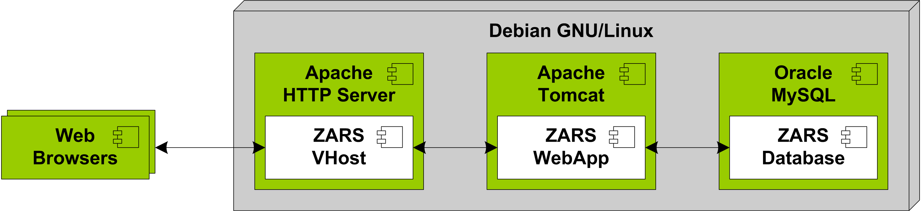
Figure 1 System Architecture

Software Architecture
The diagram in figure Software Architecture provides an overview of the software architecture of ZARS.
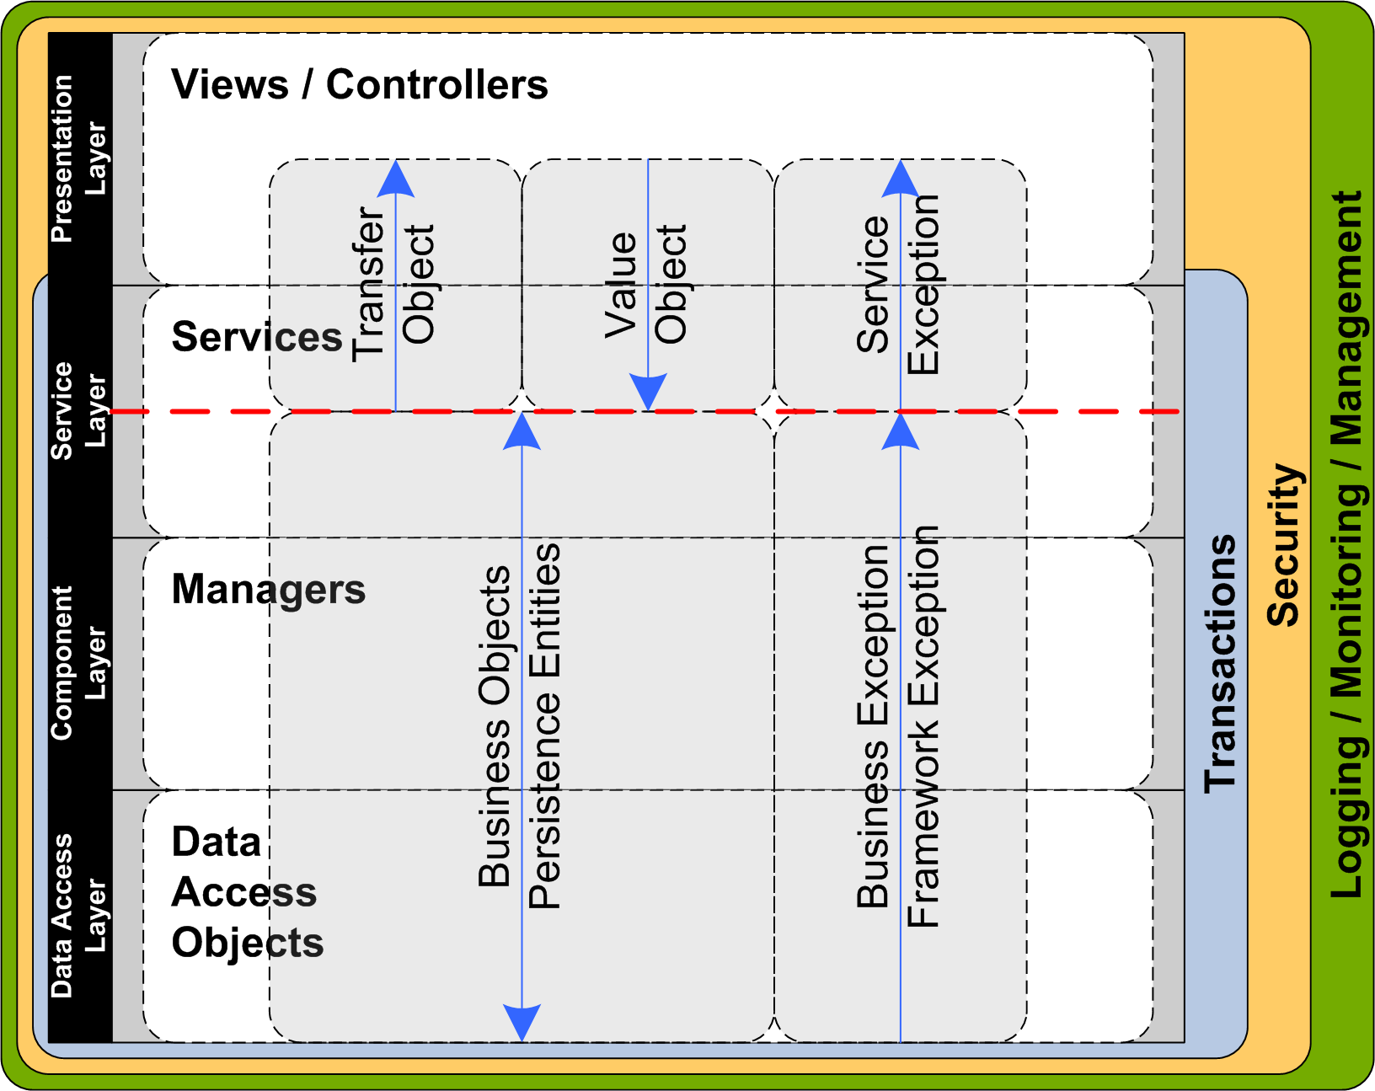
Figure 2 Software Architecture
ZARS consists of the following software layers (structural and logical components):
- Presentation Layer
The Presentation Layer consists of (1) controllers, (2) view definitions and the (3) data model exchanged with the Service Layer in form of Transfer Objects and Value Objects. Please note that the Persistence Layer only ever interacts with the Service Layer and with no other layer of the software architecture.
- Service Layer
The Service Layer consists of the service implementations and acts as the transaction demarcation boundary. The Service Layer maps between the internal (Business Objects, Persistence Objects, Business Exceptions, and Framework Exceptions) and external (Transfer Object, Value Object, Service Exception) data representation highlighted by a red line in the diagram.
Usually service implementations rely on one or more managers to implement functionality. In rare cases it can, however, be necessary to call services from other services. This kind of service orchestration should be the exception rather than the norm.
- Component Layer
The Component Layer consists of manager implementations that implement the actual business logic and business workflows. Managers operate directly on Business and Persistence Objects and do not perform any translation of business or framework exception. This effectively makes reusing logic implemented in other managers efficient and straight forward and is advocated.
- Data Access Layer
The Data Access Layer uses a persistence framework to map data from the relational database to persistence entities. The Data Access Layer is also the place where all database queries and bulk operations are implemented.

ZARS relies on the following data / object models:
- Transfer Objects
Transfer Objects are used to send data from the Service Layer to the Presentation Layer. They should be designed as generic as possible and intentionally contain all properties of the backing business objects and persistence entities even if they are currently not required for the use case at hand. Transfer Objects should confirm to the Java Bean specification.
If required, Transfer Objects can be nested in other Transfer objects effectively creating a hierarchical data model for presentation needs. In rare cases it can be necessary to create use case specific Transfer Objects hierarchies that bundle the data in specific ways.
- Value Objects
In general it is preferred to use primitive types as input parameters for all service methods. For complex input data, especially when Sets, Lists, or Maps of complex structures have to be transferred back to the service layer the creation of a dedicated Value Object is suggested. Make Value Objects as specific as possible by creating dedicated versions for create, update, or delete operations.
- Service Exceptions
All exceptions thrown in the service layer should be part of a single service exception hierarchy. All exceptions propagating up from lower levels should be converted into or wrapped by a service exception. To guarantee that all kind of expected and unexpected service exceptions are always translated into a service exception an around advice applying to all service methods should be put in place.
To avoid ClassNotFoundExceptions for unknown exception classes nested in service exceptions for potential remote clients it is suggested to include the entire stack trace of the cause as a String not the original Exception.
- Persistence Entities
All tables in the ZARS database are mapped to persistence entities. Avoid the anemic domain model anti-pattern and feel free to implement business logic directly in the persistence entities.
- Business Objects
Business Objects are objects used in addition to persistence entities to implement business logic, business workflows, and pass data back and forth between layers.
- Business and Framework Exceptions
All exceptions defined in the Data Access Layer or Component Layer to communicate errors and all exceptions thrown by third party frameworks.
Note
We will use the term Domain Objects to refer to Persistence Entities and Business Objects.
Note
We will use the term Application Exceptions to refer to Business Exceptions and Framework Exceptions.
Please refer to table Software Layer and Data Model Usage for a tabular view of the software layer access and data model usage policies outlined in diagram System Architecture.
 | Views / Controllers | Services | Managers | Data Access Objects
Views / Controllers
Services
Managers
Data Access Objects
Table 5 Software Layer Usage

 | Views / Controllers | Services | Managers | Data Access Objects
Transfer Objects
Value Objects
Service Exceptions
Domain Objects
Application Exceptions
Table 6 Data Model Usage
A mapping of the software artifacts to Java packages can be found in table Java Package Overview.
Software Architecture Item | Java Source Code Package
Controllers | net.soomsam.zirmegghuette.zars.web.controller
Services | net.soomsam.zirmegghuette.zars.service.*
Managers | net.soomsam.zirmegghuette.zars.manager.*
Data Access Objects | net.soomsam.zirmegghuette.zars.persistence.dao
Transfer Objects | net.soomsam.zirmegghuette.zars.service.to
Value Objects | net.soomsam.zirmegghuette.zars.service.vo
Service Exceptions | net.soomsam.zirmegghuette.zars.service.*
Persistence Entities | net.soomsam.zirmegghuette.zars.persistence.entity
Business Objects | net.soomsam.zirmegghuette.zars.service.*  net.soomsam.zirmegghuette.zars.manager.*  net.soomsam.zirmegghuette.zars.persistence.dao
Business Exceptions | net.soomsam.zirmegghuette.zars.service.*  net.soomsam.zirmegghuette.zars.manager.*  net.soomsam.zirmegghuette.zars.persistence.dao  net.soomsam.zirmegghuette.zars.persistence.entity
Table 7 Java Package Overview
Due to the size of the application, individual software artifacts have not been defined as separate Maven modules. The software architecture is defined solely by the Java package conventions outlined in table Java Package Overview.
A carefully designed package structure is crucial since most structural code analysis tools and dependency checkers analyze Java projects at the package level. A static code analysis tool such as Headway Structure 101, Lattix LDM/LDV, hello2morrow Sonargraph, or SonarSource will be used to review dependencies and linkage and used as the basis to improving the code structure.
Note
ClassCycle and/or Macker will be used to automatically check the conventions and architectural rules outlined above.
TODO consider using annotations to identifying classes belonging to particular design patterns and to associate classes with components, modules, or layers in an application

Best Practices

Quality Assurance
The static source code analysis tools FindBugs and PMD will be used with project specific settings to ensure a certain level of code quality. The software architecture outlined in Software Architecture will be validated with ClassCycle and/or Macker.
A manual review of source code dependencies and linkage across ZARS will be performed with one of the static code analysis tool such as Headway Structure 101, Lattix LDM/LDV, hello2morrow Sonargraph, or SonarSource.

Source Code Commit
When committing source code to the ZARS project ensure that the best practices in table Source Code Commit Practices are fulfilled.
Source Code Commit Practice | Note
ensure to commit only Java source code without errors and warnings | Try to avoid writing Java code that is marked with a warning in Eclipse, if it can't be avoided suppress the warning with @SuppressWarnings
ensure to supply a meaningful description of your changes in the commit message | Never commit with an empty commit message.
ensure that every commit either references, refers, closes, or fixes a Trac ticket | Every commit should be associated with at least one Trac ticket. If no ticket for the current commit exists create one before committing your changes. Please refer to the Trac documentation on how to reference Trac tickets in the commit log message.
try to ensure that each commit contains only one logical change. | Unrelated / independent code changes should be committed separately. In some cases, when a change leads to the necessarily to perform other code changes or refactorings these additional changes should be committed first and independent of the initial change..
try to ensure to commit only Java source code without FindBugs errors or warnings | Respect the project specific FindBugs settings and commit only code that is warning and error free. If a warning can't be avoided suppress the warning using the appropriate FindBugs annotation.
try to ensure to commit only Java source code without PMD errors or warnings | Respect the project specific PMD settings and commit only code that is warning and error free. If a warning can't be avoided suppress the warning using the appropriate PMD annotation.
minimize the number of other warnings and errors | Strive to create source code and project files without warnings or errors shown by the respective tooling (e.g. XML, JSF, Spring, ...) in Eclipse.
Table 8 Source Code Commit Practices
TODO

Best Practices
TODO - stability and capacity, start and shutdown, infrastructure service
3.3.1. Stability and Capacity
Develop components for the Saturn Services Platform with stability and capacity in mind. In particular ensure the following when developing bundles / components:
▪ avoid memory leaks
▪ avoid thread leaks
▪ avoid classloader leaks
▪ ensure graceful startup, shutdown, and restart
3.3.2. Startup and Shutdown
Graceful startup and shutdown can be tricky since the order in which bundles are started and stopped is (by default) not defined. If required, one can set a start-level in the config.ini to specify the startup and shutdown order of bundles. Bundles calling OSGi service references should do so from daemon threads or specify the timeout attribute on the osgi:reference tag. Otherwise threads could block (and cause shutdown to hang infinitely) if a referenced bundle is shutdown before the bundles that depend on it.
3.3.3. Infrastructure Services
Since we are not deploying to a conventional Java EE application server a number of infrastructure services (that would otherwise be provided by the container) may have to be configured in your components. These infrastructure services include:

▪ JDBC connection pool
One of numerous standalone JDBC connection pools such as C3P0, Jakarta Commons, DBCP, or XAPool can be used for this purpose

▪ JTA transaction manager
Standalone transaction managers such as Atomikos Transactions and JOTM can be bundled with the application to obtain JTA capabilities such as transaction suspension (REQUIRES_NEW, NOT_SUPPORTED) frequently required for logging and auditing to the database.

▪ JMS connection pool
When using JMS to send or process messages it is important to ensure that connections and sessions are pooled. Pooling of JMS connections and sessions is usually performed by the underlying JCA/MDB container. In a standalone application a dedicated pooling JMS connection provider has to be configured and used.

When using Spring's JmsTemplate be aware of it's gotchas, configure it with either a pooling JMS connection factory (such as ActiveMQ's PooledConnectionFactory ) or have a look at Spring's CachingConnectionFactory and the Spring manual to achieve efficient JMS message handling with pooled message senders and listeners for MDPs (message driven POJO). When consuming messages the preferred way is to setup a DefaultMessageListenerContainer .

The very helpful Efficient Lightweight JMS with Spring and ActiveMQ blog post and the How do I use JMS efficiently section in the ActiveMQ documentation describe how Spring can be used efficiently without using JCA (an application server).

▪ scheduling / thread pool
There are standalone thread pool implementations and scheduling libraries such as OpenSymphony Quartz and the JDK Timer that can be bundled with the application. The simplest way to configure a thread pool is probably the use of Spring’s ThreadPoolTaskExecutor .

Coding Guidelines
project specific clean up/save/formatter settings
exception and logging

TODO
Exception and Logging
The BusinessException should be used as the super-class for all checked exceptions throughout the Saturn Services project. The BusinessException should be used to express expected conditions demanding an alternative response from the caller. The BusinessException should be seen as an alternative to returning an error code, hence creating a separate subclass for each different business error type is encouraged.

Use the following considerations to determine whether to throw a BusinessException or a RuntimeException
• BusinessException (contingency)
o is considered to be a part of the design
o is expected to happen regularly but rarely
o is taken care of by the upstream code that invokes the method
o should be seen as an alternative return mode
• RuntimeException (fault)
o is considered to be a nasty surprise
o is expected to happen never or very rarely
o is taken care of the people who know the method's implementation details and those who need to fix the problem
o should be used for missing files, unavailable network resources, networking problems, programming bugs, hardware malfunctions, and configuration mistakes

The distinction between contingency and fault is based on the Effective Java Exceptions Dev2Dev article.
Source Code Commenting / Documentation
Please follow the official How to Write Doc Comments for the Javadoc Tool documentation and use Javadoc intensively to document your code. Layout your Javadoc using HTML tags and consider the following when describing your code:
• describe why the logic is implemented/necessary not what it does (which is apparent from the code itself)
• describe what a class is for
• describe how the parameters of a method effect the result
• document the nonobvious background knowledge, the intention and not the result
• try to capture the concepts in a central place - for example, a wiki - and only reference the contents
• escape obvious facts with marker tags - don't describe them over and over again, be dry
• include samples, how-to's, and so on in your documentation
• don't allow default Javadoc comments generated by the IDE
• sometimes no doc is the best doc - try to minimize the amount of documentation and describe only the key concepts

http://pietrowski.info/2008/09/maven-project-raports/
TODO
service signature
service exception (aspect, nested exception, ...)
business exception
internationalization
exceptions
- Maven Goal Reference
TODO
used maven build goals

Maven Goals | Description
jetty:run | executes Jetty with the web application deployed
clean compile jetty:run | TODO
xml:transform | creates XSD schemas out of the taglibs
clean compile | TODO
clean package | TODO
site | TODO
clean test | TODO
clean verify | TODO
TODO describe all reports created
http://pietrowski.info/2008/09/maven-project-raports/
- Terms and Definitions
Term | Definition
infrastructure services | Services and SPIs conventionally provided by the runtime container (e.g. Java EE application server or Servlet container) such as (1) JDBC data sources and connection pools, (2) transaction managers, (3) JMS connection factories, destinations, and connection pools, (3) scheduling, and (4) thread pools.

preferable the Java EE Developers edition
Subversive is the recommended Subversion plug-in for Eclipse
The Maven default profile is highlighted in bold.
Please refer to section Environment Specific Settings for details.
The Maven default profile is highlighted in bold.
On Windows it's not necessary to use the installer, simply download the ZIP archive und extract it.
On Windows it's not necessary to use the installer, simply download the ZIP archive und extract it.

