Q Pathformer version 0 4
  - Routing and circuit contribution study
QPATH RPT005 | Internal research | Prepared for Anthony Siljeg
Completed local simulator study. The attached evidence package contains all registered arms, endpoint histories, independent checks and reproduction material.

Decision from the completed study
The spatial router remains a useful part of Q Pathformer, but these tasks do not justify choosing the circuit as the best prediction model. The two layer circuit improved substantially when its five banks were assigned by k means instead of a coordinate hash. However, conventional trigonometric models and the larger global MLP achieved higher mean macro F1 and lower binary cross entropy on every confirmation population.
Model | Circle 1 F1 | Circle 2 F1 | Ellipse F1
Q2 k means | 98.32% | 97.16% | 94.41%
MLP global | 99.39% | 99.11% | 99.16%
Trig global | 99.57% | 99.67% | 99.56%
Trig k means | 99.75% | 99.65% | 99.56%
These are five-seed means on separate fresh populations; the complete nine-model results and uncertainty follow. The circuit versus hash loss reduction exceeded the registered 0.01 practical reference on all three populations, with both separately reported adjusted intervals entirely below minus 0.01. Against the tiny routed MLP, favorable mean differences were accompanied by wide seed intervals spanning zero. Against the routed trigonometric control, the circuit had clearly higher loss.
All 54 development and 135 confirmation runs finished the full 15000 updates. Independent audits passed every saved validation round; held-out predictions and statistics were independently replayed after the authorized release. The local circuit, compilation, noise and finite-shot checks also passed their verification requirements. All computation used classical CPUs and local simulators.
Recommendation: keep this as an internal mechanism result and prioritize a controlled study of classical capacity and circuit readout flexibility. IBM execution can later test implementation fidelity, but it would not resolve the predictive gap identified here. No hardware or cloud job was submitted.

Why this study follows version 0 3
Version 0.3 found a useful combination of shallow circuits and classical spatial routing on a synthetic circle task. Its k means routed two layer model averaged 97.42 percent test macro F1 and 0.1897 binary cross entropy, compared with 90.10 percent and 0.2897 for hash routing with the same forty circuit angles. The larger classical MLP averaged 98.70 percent and 0.0275. Those findings motivated a direct test of what the circuit contributes after the router is shared across model families.
Version 0.4 crosses three model families with three routing choices. It asks whether spatial routing also helps conventional models, whether the circuit retains a useful predictive tradeoff against those models, and whether the pattern survives independent circle populations and a changed decision boundary. All nine combinations were fixed before official training; no development ranking removes a model from confirmation.
The historical figures provide context, not a paired improvement estimate. Version 0.4 has fresh data, fresh training seeds and different model inputs. In particular, its global MLP uses two raw inputs and 32 hidden units, whereas the v0.3 MLP with 129 parameters used six inputs and 16 hidden units. Equal parameter count does not make them the same model. The relevant controlled comparisons in this report are the registered comparisons on the same fresh population, with the same split and training seed.
All training and evaluation in this study run on classical compute. The quantum models are mathematical circuits executed in a local simulator. Their accuracy measures how those circuit functions fit the classification tasks; it does not measure a speedup or advantage from a physical quantum processor.
The completed v0.3 evidence and Baseline3 remain the historical reference. Version 0.4 is a separate internal package; no changes to those preserved artifacts are part of this study.

Model architecture and shared routing
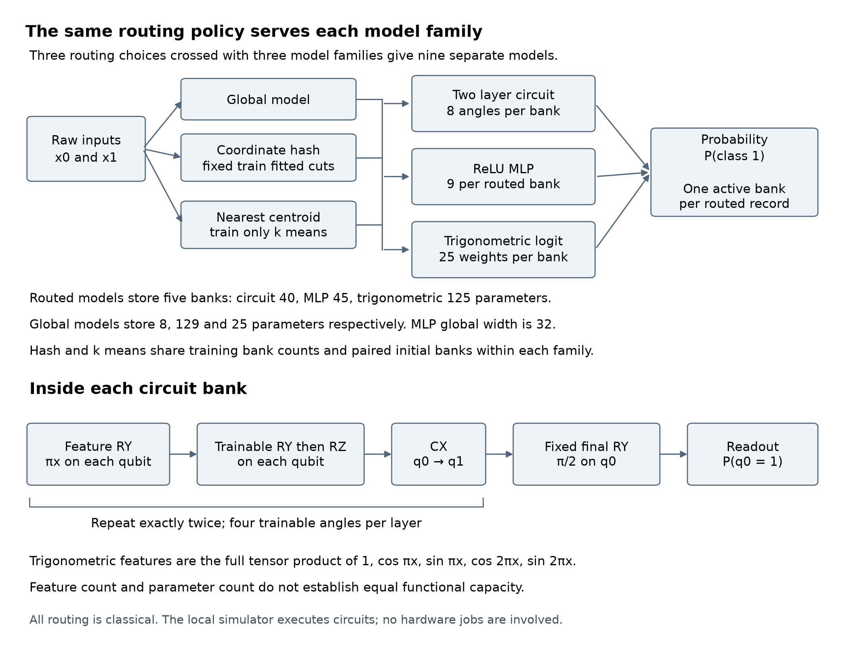
Figure 1 Registered model and routing design
The router runs classically on the two raw coordinates. K means fits five centroids using training coordinates only. The hash control uses a fixed salted coordinate hash and training fitted cuts to match the five k means training bank counts. Both policies are shared unchanged across all three model families. Validation and test bank counts can differ between policies. Routing never uses labels, task geometry or record identity.
Each routed record activates one bank. The training order is shared across methods within a population and seed, and hash and k means start from identical banks within each model family. Within each family, hash versus k means changes the partition while preserving bank capacity, training order and initial parameters. Sharing the router across families tests how this benefit depends on the model recipe.

Model capacity and interpretation
Family | Global parameters | Routed parameters | Bank function
Two layer circuit | 8 | 40 | Two qubits and eight trainable angles
ReLU MLP | 129 | 45 | Global width 32 or routed width 2
Trigonometric logit | 25 | 125 | 25 features followed by a sigmoid
K means adds ten fitted centroid coordinates; its routing parameters are separate from the model counts. Hash routing retains its salt and fitted cut values. A routed circuit and routed MLP are close in allocated trainable count, forty versus forty five, but neither this count nor the number of active parameters proves equal functional capacity. The routed trigonometric control deliberately has more coefficients.
The circuit repeats RY feature encoding, trainable RY and RZ rotations on each qubit, and a controlled X gate exactly twice. A fixed final RY rotation by pi over two precedes the probability of qubit zero being one. Each bank has eight trained angles, and parameter shift gradients are evaluated by the classical simulator.
For each coordinate t, the trigonometric basis is 1, cos(pi t), sin(pi t), cos(2 pi t) and sin(2 pi t). Its full tensor product gives 25 features. A linear logit on those features passes through a sigmoid. This is a conventional feature control motivated by the Fourier structure of feature encoded circuits [1]. The two layer circuit probability lies in a constrained trigonometric family, but the sigmoid of a trigonometric logit is a different, generally nonnested probability family. This control is not a literal probability emulator.
A route by family interaction therefore describes the behavior of the implemented recipes. It cannot by itself attribute an observed difference to a uniquely quantum resource. Capacity, feature transformation, link function and the optimizer all remain relevant explanations.

Fresh data and registered comparisons
Seven independent synthetic populations contain 8000 records each, with 4800 training, 1600 validation and 1600 sealed test records. Coordinates are independent uniform draws on the square from minus one to one. Splitting is stratified by binary label only. The finite samples are not forced to contain exactly equal class counts.
Stage | Populations | Training seeds | Runs
Engineering | Circle and rotated ellipse | 9701 pilot | 18 short runs
Development A | Circle and rotated ellipse | 701 to 703 | 54 full runs
Confirmation B | Two independent circles and one rotated ellipse | 801 to 805 | 135 full runs
For the circle task, class one lies inside radius sqrt(2/pi). The ellipse rotates coordinates by 45 degrees and uses semiaxes sqrt(2/pi) times sqrt(1.5) and sqrt(2/pi) divided by sqrt(1.5). Both positive regions have area two and lie inside the sampling square. The ellipse changes the label boundary while retaining the input distribution. It is a second synthetic task, not evidence of real world transfer or out of distribution robustness.
All 56000 new coordinates were checked for exact signed zero normalized float64 overlap against 56000 registered historical coordinates and one another. No duplicate redraw was needed. Independent reconstruction reproduced all 126 arrays in 21 split payloads exactly and independently checked the fitted policies and 140 k means restarts. Exact novelty does not imply distributional novelty.
The nine primary comparisons are three paired contrasts on each confirmation population: routed circuit versus hash circuit, routed circuit versus routed MLP, and routed circuit versus routed trigonometric model. Binary cross entropy is primary because it evaluates probability quality as well as thresholded classification. Lower values are better. A mean reduction of 0.01 was declared a practical reference threshold; interval evidence and that threshold are reported separately.

Spatial partitions on the fresh tasks
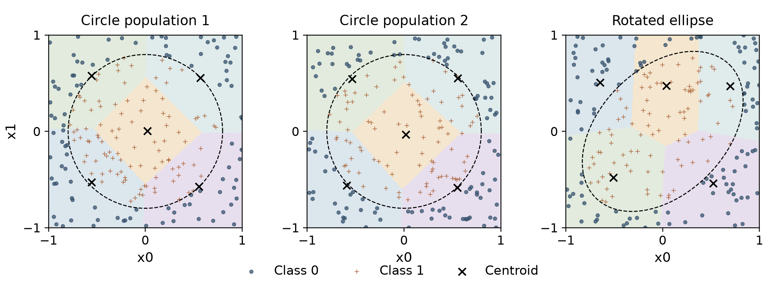
Figure 2 Training fitted spatial regions and task boundaries
Background colors indicate the five nearest centroid regions. Each panel shows the 200 training records with the smallest record IDs; this display selection does not depend on labels. The dashed curve is the known label boundary, drawn for explanation. Neither this boundary nor the labels are used to fit the router.
The input distribution is the same for all three populations, but a newly fitted spatial partition need not have the same shape or orientation. The two circle samples test whether the observed behavior repeats under fresh records and a fresh router. The ellipse adds a changed boundary. Three populations still provide a narrow basis for generalization.
A spatial partition can make a complex boundary easier to represent locally. That benefit is available to classical models as well as circuits. Sharing the exact partition across families is therefore essential to interpreting the circuit contribution. The hash control preserves training bank occupancy while removing coherent spatial neighborhoods; it does not match the local label composition or difficulty.

Training budgets and evaluation controls
Every official model receives 200 complete rounds of the 4800 training records, batch size 64 and 75 optimizer updates per round, for 15000 updates. Adam uses learning rate 0.01, betas 0.9 and 0.999, epsilon 1e-8 and no weight decay. The selected checkpoint is the earliest exact minimum of full validation binary cross entropy. All 200 rounds are charged even when the selected checkpoint is earlier. There is no early stopping.
Loss probabilities are clipped to the interval from 1e-7 to one minus 1e-7. The gradient contribution outside that interval is zero under the retained implementation. Circuit angles start from small uniform draws. MLP weights use Xavier initialization and zero biases. Trigonometric coefficients start at zero. These initialization rules are part of the compared recipes. Adam updates all stored coordinates, so momentum can still move an inactive bank even when that batch gives it zero raw gradient.
For every round, the package saves the parameters, all validation probabilities, record order, metrics and work counters. It also retains selected generations, the selected and final Adam states, raw gradient diagnostics and endpoint hashes. Failed attempts and partial outputs must be preserved. No run is silently replaced, dropped or shortened.
The independent audit reconstructs every validation round with a separate matrix, MLP or trigonometric implementation and checks selection, sampling orders, counters and committed payloads. It also checks scalar circuit fixtures. This verifies all saved validation states and predictions; it is not a second execution of every optimizer update. The test release requires every confirmation endpoint, not just a preferred model, to pass the gate.
The registered numerical policy uses absolute tolerance 2e-12 for independent probabilities, 1e-8 for independent aggregate clipped loss, and 2e-12 when recalculating metrics from the saved canonical probabilities. The wider cross-implementation loss tolerance was set before official training because clipping can amplify probability differences. Canonical prediction remains class one at probability at least 0.5. Any independent class disagreement must place both probabilities within 32 float64 epsilons of 0.5; all raw differences and sensitivity diagnostics are retained.

How to read the uncertainty and learning milestones
Each confirmation population has five paired training seeds. Differences are computed within seed, then summarized with a t interval using four degrees of freedom. Primary binary cross entropy intervals use Bonferroni confidence 99.4444 percent for the family of nine comparisons. Ordinary 95 percent intervals for secondary measures are descriptive. Five seeds give limited precision, and t based coverage relies on its assumptions.
A separate paired record bootstrap uses 5000 resamples of the 1600 test records. The same multiplicities are applied to every method and all five checkpoints within a population. Macro F1 is recalculated per checkpoint before averaging. These intervals describe record sampling conditional on the fixed trained models. They are not extra training replications and are not combined with the seed intervals. Populations are reported separately; fifteen seed by population observations are not treated as fifteen independent tasks.
Macro F1 averages the class specific F1 scores, giving equal weight to both classes. A value near 97 percent means the two class scores average about 0.97 under the fixed threshold. It does not mean that the model is 97 percent certain or that it has learned a generally useful reasoning ability. Accuracy and binary cross entropy answer related but different questions.
The learning analysis records the first validation check at or above 97 percent macro F1 and the earliest run of three consecutive qualifying checks. Checks occur every 75 updates, so the third confirming check is 150 updates after the first check in that sequence. Nonreachers remain in the denominator, and medians among successful runs are explicitly conditional. Every model still trains for the full budget; these milestones are not realized compute savings and do not provide a test score at the earlier update.
All seed values, accuracy contrasts and additional record bootstrap intervals are retained in each population statistics JSON. No across-population pooling is used for inference.

Confirmation outcomes
Each entry is the mean ± sample standard deviation across five training seeds on the same population. Circuit and MLP initialization varies by seed; the trigonometric models always start at zero, while training order varies. Macro F1 and accuracy are percentages; binary cross entropy uses natural logarithms and lower is better. The 1,600 test records in a population are shared by its models. These standard deviations describe training seed dispersion and are not confidence intervals.
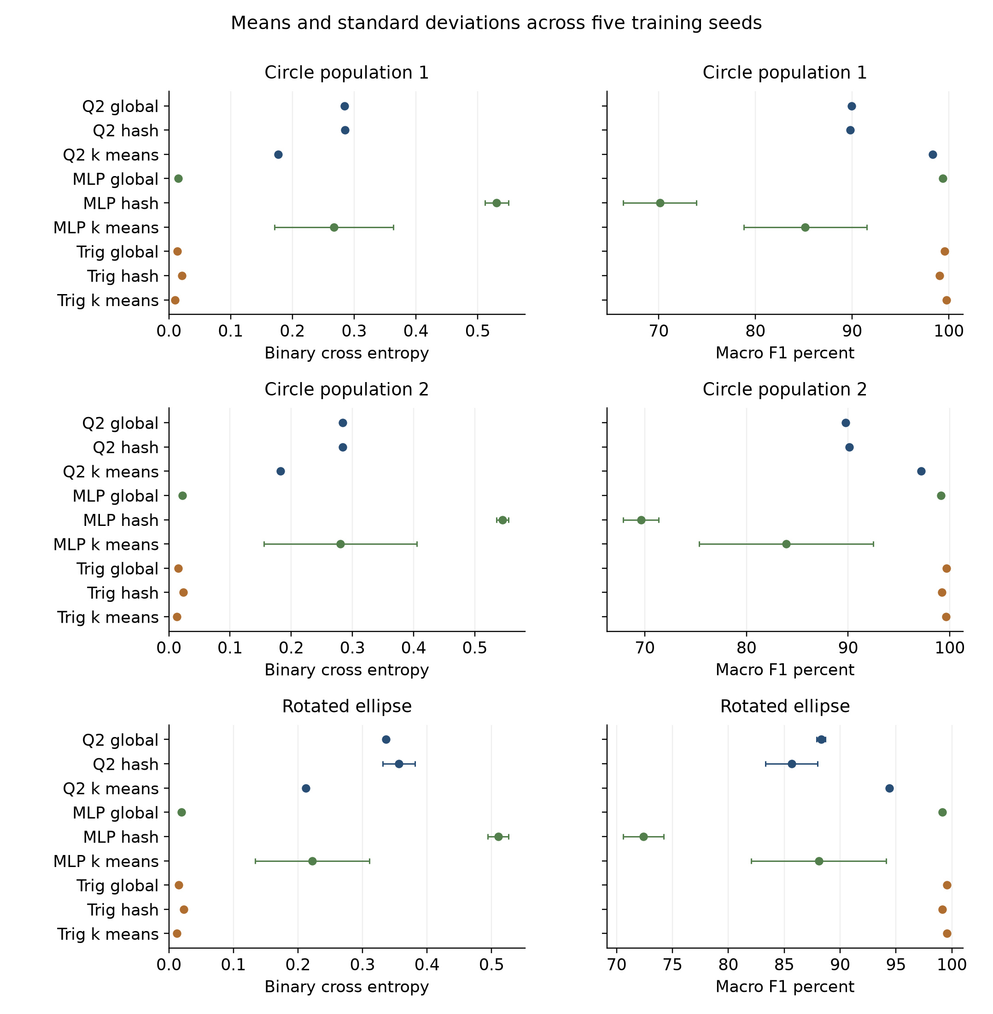
Figure 3. All confirmation outcomes. Every model completed the full training budget before test release.

Circle population 1 test results
Model | BCE | Macro F1 percent | Accuracy percent
Q2 global | 0.2841 ± 0.0001 | 89.95 ± 0.05 | 90.05 ± 0.05
Q2 hash | 0.2853 ± 0.0003 | 89.81 ± 0.19 | 89.91 ± 0.18
Q2 k means | 0.1769 ± 0.0003 | 98.32 ± 0.16 | 98.32 ± 0.16
MLP global | 0.0155 ± 0.0018 | 99.39 ± 0.09 | 99.39 ± 0.09
MLP hash | 0.5307 ± 0.0190 | 70.12 ± 3.79 | 71.32 ± 2.82
MLP k means | 0.2671 ± 0.0962 | 85.15 ± 6.35 | 85.40 ± 6.06
Trig global | 0.0135 ± 0.0001 | 99.57 ± 0.03 | 99.57 ± 0.03
Trig hash | 0.0212 ± 0.0001 | 99.06 ± 0.00 | 99.06 ± 0.00
Trig k means | 0.0103 ± 0.0002 | 99.75 ± 0.06 | 99.75 ± 0.06
Across the 45 checkpoints and their 72,000 checkpoint-record predictions, the official numerical check counted 0 canonical probabilities within the registered band around 0.5, 0 raw oracle class disagreements and 0 disagreements outside the permitted band. These are repeated checkpoint-record counts, not additional independent observations. The full per-model sensitivity and raw-oracle records are retained in the evidence package.

Circle population 2 test results
Model | BCE | Macro F1 percent | Accuracy percent
Q2 global | 0.2843 ± 0.0004 | 89.77 ± 0.14 | 89.86 ± 0.14
Q2 hash | 0.2838 ± 0.0009 | 90.13 ± 0.10 | 90.21 ± 0.09
Q2 k means | 0.1828 ± 0.0001 | 97.16 ± 0.16 | 97.16 ± 0.16
MLP global | 0.0220 ± 0.0011 | 99.11 ± 0.11 | 99.11 ± 0.11
MLP hash | 0.5451 ± 0.0099 | 69.63 ± 1.75 | 70.51 ± 1.34
MLP k means | 0.2803 ± 0.1250 | 83.91 ± 8.58 | 84.33 ± 7.83
Trig global | 0.0156 ± 0.0001 | 99.67 ± 0.05 | 99.67 ± 0.05
Trig hash | 0.0239 ± 0.0001 | 99.21 ± 0.06 | 99.21 ± 0.06
Trig k means | 0.0132 ± 0.0002 | 99.65 ± 0.07 | 99.65 ± 0.07
Across the 45 checkpoints and their 72,000 checkpoint-record predictions, the official numerical check counted 0 canonical probabilities within the registered band around 0.5, 0 raw oracle class disagreements and 0 disagreements outside the permitted band. These are repeated checkpoint-record counts, not additional independent observations. The full per-model sensitivity and raw-oracle records are retained in the evidence package.

Rotated ellipse population test results
Model | BCE | Macro F1 percent | Accuracy percent
Q2 global | 0.3366 ± 0.0005 | 88.30 ± 0.39 | 88.45 ± 0.38
Q2 hash | 0.3566 ± 0.0251 | 85.66 ± 2.33 | 85.81 ± 2.36
Q2 k means | 0.2121 ± 0.0004 | 94.41 ± 0.21 | 94.41 ± 0.21
MLP global | 0.0199 ± 0.0011 | 99.16 ± 0.09 | 99.16 ± 0.09
MLP hash | 0.5102 ± 0.0160 | 72.42 ± 1.82 | 73.10 ± 1.50
MLP k means | 0.2220 ± 0.0885 | 88.09 ± 6.04 | 88.12 ± 6.04
Trig global | 0.0153 ± 0.0001 | 99.56 ± 0.00 | 99.56 ± 0.00
Trig hash | 0.0229 ± 0.0002 | 99.16 ± 0.06 | 99.16 ± 0.06
Trig k means | 0.0127 ± 0.0002 | 99.56 ± 0.00 | 99.56 ± 0.00
Across the 45 checkpoints and their 72,000 checkpoint-record predictions, the official numerical check counted 0 canonical probabilities within the registered band around 0.5, 0 raw oracle class disagreements and 0 disagreements outside the permitted band. These are repeated checkpoint-record counts, not additional independent observations. The full per-model sensitivity and raw-oracle records are retained in the evidence package.

Primary comparisons
Differences are Q2 k means minus the named comparator. Negative BCE differences favor Q2 k means. The three comparisons on each of three populations form the registered family of nine. Each interval uses 99.4444 percent nominal confidence after Bonferroni adjustment. Paired seed intervals and conditional record bootstrap intervals answer different uncertainty questions and are shown separately. The practical reference is a BCE reduction of 0.01; a mean beyond that reference does not by itself establish a robust practical benefit.
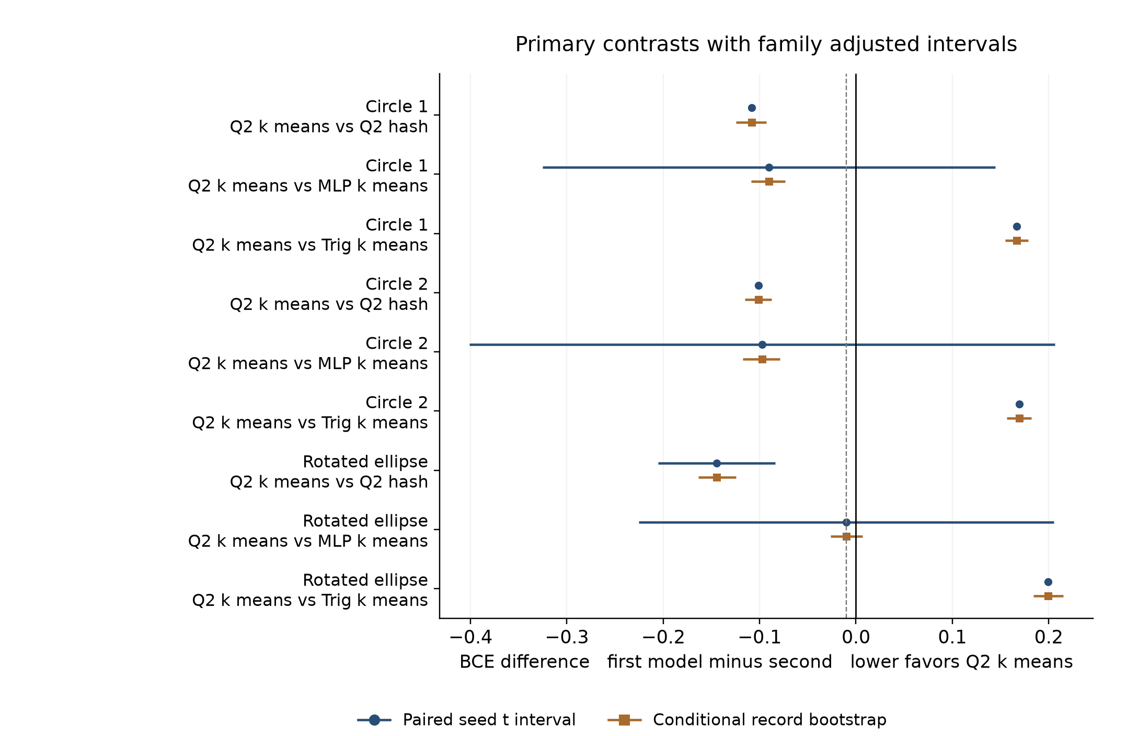
Figure 4. Registered primary comparisons. The dashed reference marks a BCE difference of minus 0.01.

Primary comparison intervals

Circle population 1
Comparator | Mean delta | Adjusted seed interval | Adjusted record interval
Q2 hash | -0.1084 | [-0.1097, -0.1071] | [-0.1243, -0.0932]
MLP k means | -0.0903 | [-0.3249, 0.1444] | [-0.1085, -0.0733]
Trig k means | 0.1666 | [0.1660, 0.1672] | [0.1547, 0.1790]

Circle population 2
Comparator | Mean delta | Adjusted seed interval | Adjusted record interval
Q2 hash | -0.1010 | [-0.1031, -0.0989] | [-0.1151, -0.0875]
MLP k means | -0.0975 | [-0.4013, 0.2063] | [-0.1176, -0.0787]
Trig k means | 0.1696 | [0.1692, 0.1700] | [0.1567, 0.1821]

Rotated ellipse population
Comparator | Mean delta | Adjusted seed interval | Adjusted record interval
Q2 hash | -0.1445 | [-0.2055, -0.0835] | [-0.1637, -0.1245]
MLP k means | -0.0099 | [-0.2254, 0.2055] | [-0.0263, 0.0065]
Trig k means | 0.1993 | [0.1979, 0.2008] | [0.1840, 0.2153]

What the measured differences establish
The strongest within-family result is reproducible spatial routing benefit. Q2 k means reduced test BCE relative to Q2 hash by 0.10838, 0.10103 and 0.14453 on circle 1, circle 2 and the ellipse. Its corresponding macro F1 gains were 8.52, 7.03 and 8.74 percentage points. These comparisons preserve circuit bank count, initialization pairing and training order; coherent spatial partitions help this shallow recipe.
The same router is available to conventional models. Both routed MLP and routed trigonometric models improved mean BCE over their hash controls on each population. The global trigonometric control, with 25 coefficients and no fitted spatial router, already reached 99.57, 99.67 and 99.56 percent mean macro F1. Therefore, successful classification of these smooth synthetic boundaries does not require a quantum circuit or even a banked model.
Q2 k means had higher BCE than Trig k means by 0.16658, 0.16961 and 0.19932. Both adjusted uncertainty summaries were above zero for each comparison. This is strong evidence against this circuit recipe as the preferred predictor on these tasks. It is not a universal statement about all quantum learning models: the control has a different function family and more coefficients, and all recipes used a single frozen optimizer setting.
The compact routed MLP is not a sufficient basis for a quantum superiority claim. Its mean BCE was 0.26715, 0.28028 and 0.22199, with substantial seed dispersion. Q2's adjusted paired-seed intervals against it crossed zero on every population. The circle record-bootstrap intervals excluded zero because they condition on the five fitted checkpoints; they do not remove the training instability. On the ellipse the mean improvement was only 0.00992, just below the predeclared 0.01 reference.
The circuit's training BCE was also relatively high: approximately 0.1820, 0.1809 and 0.2132 at selected k means checkpoints, while test BCE was 0.1769, 0.1828 and 0.2121. The small loss gaps do not suggest a large train-to-test deterioration. They are consistent with a limitation of the fitted recipe, but do not distinguish restricted representation, fixed readout and optimization. High F1 alongside appreciable BCE motivates probability-quality investigation; BCE alone does not isolate calibration.

Learning milestones and charged work
All five Q2 k means seeds reached and sustained 97 percent validation F1 on both circle populations; none reached it on the ellipse. All global MLP and global or routed trigonometric runs reached and sustained it on all three populations. None of the compact routed MLP runs reached it. The detailed tables retain nonreachers and conditional update medians. Every run still completed the full budget, so no early-stopping savings were realized.
Each circuit run used 16.32 million recorded circuit evaluations during training, including parameter-shift evaluations. Each global or routed trigonometric run computed 48 million feature values under the accounting convention. Those counts are different units, not comparable hardware FLOPs. Measured training loops for Q2 k means took roughly 467 to 488 seconds per run across populations, compared with about 10 to 11 seconds for Trig k means on this shared CPU host. The timing comparison describes these implementations under concurrency.

Local execution and shot sensitivity
The capsule covered all 45 selected circuit checkpoints with 32 label-independent validation fixtures per population. All 1440 ideal and compiled fixture checks met the frozen tolerance; the maximum compiled Aer probability discrepancy was 1.24e-13 against a 2e-12 limit. Independent density reconstruction checked all 4320 circuit-scenario evaluations and reproduced all 1350 conditional sampling arrays exactly. The separate 720 measured Aer experiments used 737280 simulated shots; the binomial arrays represented 199065600 trials. Neither count describes quantum hardware execution.
For Q2 k means, the mild logical-noise scenarios shifted probabilities by mean absolute amounts of about 0.0162 to 0.0182; stress scenarios shifted them by about 0.0526 to 0.0592. No density-level class flips occurred for this model on these 32-record fixtures, but finite shots still caused some threshold changes. Increasing from 1024 to 8192 shots reduced conditional probability error in the reported tables. Few class flips on this small fixture set are not evidence of device robustness or unchanged full-test F1.

Circle population 1 secondary comparisons
Ordinary 95 percent intervals are descriptive and are not adjusted for the secondary comparison family. BCE is first minus second; macro F1 differences are percentage points. Routing interactions subtract the comparator family k means minus hash difference from the corresponding Q2 difference. They depend on the registered architectures and optimization recipes; they do not isolate quantum advantage.
Comparison | BCE delta and seed interval | BCE record interval | F1 delta and seed interval
MLP k means minus MLP hash | -0.2636  [-0.3945, -0.1326] | [-0.2811, -0.2461] | 15.03  [4.82, 25.25]
Trig k means minus Trig hash | -0.0109  [-0.0112, -0.0107] | [-0.0147, -0.0075] | 0.69  [0.61, 0.77]
Q2 k means minus Q2 global | -0.1072  [-0.1075, -0.1069] | [-0.1190, -0.0965] | 8.37  [8.12, 8.62]
Q2 hash minus Q2 global | 0.0011  [0.0007, 0.0016] | [-0.0003, 0.0027] | -0.14  [-0.44, 0.15]
MLP k means minus MLP global | 0.2517  [0.1338, 0.3695] | [0.2365, 0.2678] | -14.24  [-22.03, -6.45]
MLP hash minus MLP global | 0.5153  [0.4917, 0.5388] | [0.5029, 0.5283] | -29.27  [-33.98, -24.56]
Trig k means minus Trig global | -0.0032  [-0.0034, -0.0030] | [-0.0044, -0.0020] | 0.18  [0.11, 0.24]
Trig hash minus Trig global | 0.0078  [0.0076, 0.0079] | [0.0049, 0.0109] | -0.51  [-0.55, -0.48]
Q2 k means minus MLP global | 0.1614  [0.1589, 0.1640] | [0.1528, 0.1701] | -1.06  [-1.37, -0.76]
Q2 k means minus Trig global | 0.1634  [0.1631, 0.1637] | [0.1549, 0.1719] | -1.25  [-1.46, -1.04]
Q2 global minus Trig global | 0.2706  [0.2705, 0.2707] | [0.2584, 0.2836] | -9.62  [-9.71, -9.53]
Q2 global minus MLP global | 0.2687  [0.2664, 0.2710] | [0.2562, 0.2821] | -9.44  [-9.56, -9.32]

Circle population 2 secondary comparisons
Ordinary 95 percent intervals are descriptive and are not adjusted for the secondary comparison family. BCE is first minus second; macro F1 differences are percentage points. Routing interactions subtract the comparator family k means minus hash difference from the corresponding Q2 difference. They depend on the registered architectures and optimization recipes; they do not isolate quantum advantage.
Comparison | BCE delta and seed interval | BCE record interval | F1 delta and seed interval
MLP k means minus MLP hash | -0.2648  [-0.4236, -0.1060] | [-0.2829, -0.2468] | 14.28  [2.96, 25.61]
Trig k means minus Trig hash | -0.0108  [-0.0110, -0.0106] | [-0.0146, -0.0072] | 0.44  [0.29, 0.58]
Q2 k means minus Q2 global | -0.1015  [-0.1021, -0.1009] | [-0.1112, -0.0922] | 7.39  [7.11, 7.68]
Q2 hash minus Q2 global | -0.0005  [-0.0019, 0.0010] | [-0.0021, 0.0012] | 0.36  [0.24, 0.48]
MLP k means minus MLP global | 0.2583  [0.1023, 0.4143] | [0.2429, 0.2741] | -15.21  [-25.95, -4.46]
MLP hash minus MLP global | 0.5231  [0.5103, 0.5359] | [0.5101, 0.5363] | -29.49  [-31.71, -27.26]
Trig k means minus Trig global | -0.0024  [-0.0027, -0.0021] | [-0.0037, -0.0011] | -0.03  [-0.09, 0.04]
Trig hash minus Trig global | 0.0084  [0.0082, 0.0086] | [0.0051, 0.0121] | -0.46  [-0.55, -0.37]
Q2 k means minus MLP global | 0.1608  [0.1594, 0.1622] | [0.1520, 0.1692] | -1.95  [-2.18, -1.72]
Q2 k means minus Trig global | 0.1672  [0.1671, 0.1673] | [0.1584, 0.1757] | -2.51  [-2.70, -2.33]
Q2 global minus Trig global | 0.2687  [0.2681, 0.2693] | [0.2571, 0.2808] | -9.91  [-10.11, -9.71]
Q2 global minus MLP global | 0.2623  [0.2614, 0.2632] | [0.2505, 0.2747] | -9.35  [-9.62, -9.07]

Rotated ellipse population secondary comparisons
Ordinary 95 percent intervals are descriptive and are not adjusted for the secondary comparison family. BCE is first minus second; macro F1 differences are percentage points. Routing interactions subtract the comparator family k means minus hash difference from the corresponding Q2 difference. They depend on the registered architectures and optimization recipes; they do not isolate quantum advantage.
Comparison | BCE delta and seed interval | BCE record interval | F1 delta and seed interval
MLP k means minus MLP hash | -0.2882  [-0.4064, -0.1700] | [-0.3085, -0.2676] | 15.68  [7.13, 24.22]
Trig k means minus Trig hash | -0.0101  [-0.0104, -0.0099] | [-0.0146, -0.0061] | 0.40  [0.33, 0.47]
Q2 k means minus Q2 global | -0.1246  [-0.1254, -0.1238] | [-0.1395, -0.1098] | 6.11  [5.38, 6.84]
Q2 hash minus Q2 global | 0.0200  [-0.0112, 0.0511] | [0.0141, 0.0263] | -2.64  [-5.58, 0.31]
MLP k means minus MLP global | 0.2021  [0.0928, 0.3114] | [0.1887, 0.2158] | -11.07  [-18.51, -3.63]
MLP hash minus MLP global | 0.4903  [0.4710, 0.5096] | [0.4726, 0.5079] | -26.75  [-29.01, -24.49]
Trig k means minus Trig global | -0.0025  [-0.0027, -0.0024] | [-0.0039, -0.0011] | 0.00  [0.00, 0.00]
Trig hash minus Trig global | 0.0076  [0.0074, 0.0078] | [0.0042, 0.0115] | -0.40  [-0.47, -0.33]
Q2 k means minus MLP global | 0.1922  [0.1906, 0.1938] | [0.1812, 0.2031] | -4.75  [-5.07, -4.44]
Q2 k means minus Trig global | 0.1968  [0.1962, 0.1974] | [0.1862, 0.2076] | -5.15  [-5.41, -4.89]
Q2 global minus Trig global | 0.3214  [0.3207, 0.3220] | [0.3074, 0.3352] | -11.26  [-11.75, -10.78]
Q2 global minus MLP global | 0.3168  [0.3154, 0.3181] | [0.3023, 0.3307] | -10.86  [-11.33, -10.40]

Routing interactions across model families
These secondary interactions subtract the MLP or trigonometric k means minus hash difference from the corresponding Q2 difference. Negative BCE interaction means a larger loss reduction for Q2; positive F1 interaction means a larger F1 gain for Q2. Ordinary 95 percent intervals are descriptive. These are recipe-dependent comparisons, not isolated quantum-resource effects.

Circle population 1
Comparison | BCE delta and seed interval | BCE record interval | F1 delta and seed interval
Q2 minus MLP routing gain | 0.1552  [0.0237, 0.2866] | [0.1336, 0.1766] | -6.52  [-16.76, 3.72]
Q2 minus trig routing gain | -0.0974  [-0.0981, -0.0968] | [-0.1095, -0.0858] | 7.83  [7.62, 8.04]

Circle population 2
Comparison | BCE delta and seed interval | BCE record interval | F1 delta and seed interval
Q2 minus MLP routing gain | 0.1638  [0.0049, 0.3226] | [0.1419, 0.1859] | -7.25  [-18.67, 4.18]
Q2 minus trig routing gain | -0.0903  [-0.0913, -0.0892] | [-0.1011, -0.0801] | 6.60  [6.43, 6.76]

Rotated ellipse population
Comparison | BCE delta and seed interval | BCE record interval | F1 delta and seed interval
Q2 minus MLP routing gain | 0.1436  [-0.0016, 0.2889] | [0.1179, 0.1694] | -6.93  [-18.12, 4.25]
Q2 minus trig routing gain | -0.1344  [-0.1654, -0.1034] | [-0.1489, -0.1199] | 8.34  [5.36, 11.33]

Circle population 1 validation steps to 97 percent
Validation was checked every 75 optimizer updates. First crossing means the first logged macro F1 of at least 97 percent. Sustained crossing is the third consecutive qualifying check. Its completion is 150 updates after its own sequence start, which may be later than the first-ever crossing. Medians are conditional on reaching; nonreachers remain visible. Every run still completed 15,000 updates, and no test score was computed at an early milestone.
Model | First reached of 5 | First median updates | Sustained reached of 5 | Sustained median updates
Q2 global | 0 | Not reached | 0 | Not reached
Q2 hash | 0 | Not reached | 0 | Not reached
Q2 k means | 5 | 450 | 5 | 750
MLP global | 5 | 150 | 5 | 375
MLP hash | 0 | Not reached | 0 | Not reached
MLP k means | 0 | Not reached | 0 | Not reached
Trig global | 5 | 225 | 5 | 375
Trig hash | 5 | 225 | 5 | 375
Trig k means | 5 | 75 | 5 | 225

Circle population 2 validation steps to 97 percent
Validation was checked every 75 optimizer updates. First crossing means the first logged macro F1 of at least 97 percent. Sustained crossing is the third consecutive qualifying check. Its completion is 150 updates after its own sequence start, which may be later than the first-ever crossing. Medians are conditional on reaching; nonreachers remain visible. Every run still completed 15,000 updates, and no test score was computed at an early milestone.
Model | First reached of 5 | First median updates | Sustained reached of 5 | Sustained median updates
Q2 global | 0 | Not reached | 0 | Not reached
Q2 hash | 0 | Not reached | 0 | Not reached
Q2 k means | 5 | 525 | 5 | 1,650
MLP global | 5 | 300 | 5 | 450
MLP hash | 0 | Not reached | 0 | Not reached
MLP k means | 0 | Not reached | 0 | Not reached
Trig global | 5 | 225 | 5 | 375
Trig hash | 5 | 300 | 5 | 450
Trig k means | 5 | 75 | 5 | 225

Rotated ellipse population validation steps to 97 percent
Validation was checked every 75 optimizer updates. First crossing means the first logged macro F1 of at least 97 percent. Sustained crossing is the third consecutive qualifying check. Its completion is 150 updates after its own sequence start, which may be later than the first-ever crossing. Medians are conditional on reaching; nonreachers remain visible. Every run still completed 15,000 updates, and no test score was computed at an early milestone.
Model | First reached of 5 | First median updates | Sustained reached of 5 | Sustained median updates
Q2 global | 0 | Not reached | 0 | Not reached
Q2 hash | 0 | Not reached | 0 | Not reached
Q2 k means | 0 | Not reached | 0 | Not reached
MLP global | 5 | 225 | 5 | 375
MLP hash | 0 | Not reached | 0 | Not reached
MLP k means | 0 | Not reached | 0 | Not reached
Trig global | 5 | 150 | 5 | 300
Trig hash | 5 | 225 | 5 | 375
Trig k means | 5 | 150 | 5 | 300

Development outcomes and stage accounting
Development had two populations, three training seeds and all nine models. Every arm continued to confirmation regardless of development rank. The following validation figures describe selected checkpoints; they are not confirmation test results or a second primary family.

Development circle
Model | Selected validation BCE | Selected validation F1 percent
Q2 global | 0.2872 ± 0.0000 | 89.40 ± 0.07
Q2 hash | 0.2879 ± 0.0001 | 88.81 ± 0.13
Q2 k means | 0.2202 ± 0.0001 | 94.32 ± 0.10
MLP global | 0.0204 ± 0.0002 | 99.50 ± 0.06
MLP hash | 0.5623 ± 0.0049 | 66.68 ± 0.49
MLP k means | 0.2047 ± 0.0733 | 89.14 ± 4.80
Trig global | 0.0189 ± 0.0001 | 99.62 ± 0.00
Trig hash | 0.0315 ± 0.0001 | 98.96 ± 0.04
Trig k means | 0.0158 ± 0.0002 | 99.62 ± 0.11

Development ellipse and stage accounting
Model | Selected validation BCE | Selected validation F1 percent
Q2 global | 0.3412 ± 0.0001 | 87.64 ± 0.16
Q2 hash | 0.3404 ± 0.0001 | 88.08 ± 0.13
Q2 k means | 0.2230 ± 0.0073 | 94.81 ± 0.19
MLP global | 0.0147 ± 0.0005 | 99.58 ± 0.13
MLP hash | 0.5258 ± 0.0278 | 70.16 ± 2.12
MLP k means | 0.2232 ± 0.0803 | 88.54 ± 5.16
Trig global | 0.0142 ± 0.0001 | 99.85 ± 0.04
Trig hash | 0.0214 ± 0.0001 | 99.56 ± 0.00
Trig k means | 0.0111 ± 0.0000 | 99.81 ± 0.06
The launcher measured 32.8 minutes for Stage A and 56.2 minutes for Stage B. These exclude subsequent independent audits, evaluation, readiness checks and report production. Summed endpoint training-loop time was 1.63 process-hours for A and 4.64 process-hours for B; parallel processes overlap.

Circle population 1 descriptive training diagnostics
Means across five selected checkpoints. Each model was selected by its earliest minimum validation BCE. Gaps subtract metrics from that same checkpoint: validation minus training, and test minus validation. They are descriptive; validation-based selection and different split sizes affect their interpretation. They do not establish a mechanism or a generalization guarantee.
Model | Train BCE | Val−train BCE | Test−val BCE | Clip visits % | Full-train gradient norm
Q2 global | 0.2823 | -0.0003 | 0.0021 | 0.000 | 0.01212
Q2 hash | 0.2816 | 0.0008 | 0.0029 | 0.000 | 0.008417
Q2 k means | 0.1820 | -0.0071 | 0.0020 | 0.002 | 0.01125
MLP global | 0.0128 | -0.0002 | 0.0029 | 53.439 | 0.04619
MLP hash | 0.5254 | 0.0082 | -0.0029 | 0.015 | 0.0181
MLP k means | 0.2738 | -0.0127 | 0.0060 | 2.167 | 0.04216
Trig global | 0.0122 | 0.0006 | 0.0007 | 29.413 | 0.0007151
Trig hash | 0.0142 | 0.0062 | 0.0009 | 18.118 | 0.0004942
Trig k means | 0.0081 | 0.0015 | 0.0007 | 33.978 | 0.0007443
Clipping counts probability visits outside the registered BCE clipping interval across 960,000 training-record visits; it is not gradient-norm clipping. The gradient norm is the recorded full-training diagnostic at the selected checkpoint. Raw norms depend on architecture and parameterization, so this table does not rank optimization difficulty. Complete train/validation/test BCE, seed values, first/selected/final batch-gradient summaries, and bank exposures are in the diagnostic supplement.

Circle population 2 descriptive training diagnostics
Means across five selected checkpoints. Each model was selected by its earliest minimum validation BCE. Gaps subtract metrics from that same checkpoint: validation minus training, and test minus validation. They are descriptive; validation-based selection and different split sizes affect their interpretation. They do not establish a mechanism or a generalization guarantee.
Model | Train BCE | Val−train BCE | Test−val BCE | Clip visits % | Full-train gradient norm
Q2 global | 0.2838 | 0.0025 | -0.0020 | 0.000 | 0.02458
Q2 hash | 0.2832 | 0.0051 | -0.0044 | 0.000 | 0.008543
Q2 k means | 0.1809 | 0.0016 | 0.0003 | 0.002 | 0.01137
MLP global | 0.0150 | 0.0064 | 0.0006 | 53.452 | 0.05401
MLP hash | 0.5184 | 0.0116 | 0.0151 | 0.026 | 0.01776
MLP k means | 0.2696 | 0.0068 | 0.0039 | 2.200 | 0.0365
Trig global | 0.0143 | 0.0039 | -0.0026 | 28.023 | 0.0008119
Trig hash | 0.0153 | 0.0146 | -0.0060 | 17.725 | 0.0004854
Trig k means | 0.0099 | 0.0051 | -0.0018 | 33.005 | 0.0008121
Clipping counts probability visits outside the registered BCE clipping interval across 960,000 training-record visits; it is not gradient-norm clipping. The gradient norm is the recorded full-training diagnostic at the selected checkpoint. Raw norms depend on architecture and parameterization, so this table does not rank optimization difficulty. Complete train/validation/test BCE, seed values, first/selected/final batch-gradient summaries, and bank exposures are in the diagnostic supplement.

Rotated ellipse population descriptive training diagnostics
Means across five selected checkpoints. Each model was selected by its earliest minimum validation BCE. Gaps subtract metrics from that same checkpoint: validation minus training, and test minus validation. They are descriptive; validation-based selection and different split sizes affect their interpretation. They do not establish a mechanism or a generalization guarantee.
Model | Train BCE | Val−train BCE | Test−val BCE | Clip visits % | Full-train gradient norm
Q2 global | 0.3393 | 0.0055 | -0.0081 | 0.000 | 0.02176
Q2 hash | 0.3528 | 0.0070 | -0.0032 | 0.000 | 0.008417
Q2 k means | 0.2132 | -0.0051 | 0.0040 | 0.000 | 0.01933
MLP global | 0.0121 | 0.0034 | 0.0044 | 53.582 | 0.02548
MLP hash | 0.4753 | 0.0106 | 0.0242 | 1.034 | 0.01843
MLP k means | 0.2192 | 0.0035 | -0.0008 | 14.465 | 0.03945
Trig global | 0.0128 | 0.0011 | 0.0014 | 31.241 | 0.0006641
Trig hash | 0.0145 | 0.0093 | -0.0010 | 17.238 | 0.0004958
Trig k means | 0.0086 | 0.0016 | 0.0026 | 38.759 | 0.0007237
Clipping counts probability visits outside the registered BCE clipping interval across 960,000 training-record visits; it is not gradient-norm clipping. The gradient norm is the recorded full-training diagnostic at the selected checkpoint. Raw norms depend on architecture and parameterization, so this table does not rank optimization difficulty. Complete train/validation/test BCE, seed values, first/selected/final batch-gradient summaries, and bank exposures are in the diagnostic supplement.

Recorded operation counts
Training counts cover all 15,000 updates, including parameter-shift circuit evaluations and repeated feature or activation computation. They are software work counters, not measured FLOPs, multiply-accumulate counts, energy or quantum hardware latency. Validation, selected-checkpoint diagnostics and inference have separate complete counters in the supplement.
For each model, these training counts were identical in every seed and confirmation population; the common per-run value is shown.
Model | Circuit eval. M | 1q gates M | CX gates M | MLP activations M | Trig features M
Q2 global | 16.320 | 212.160 | 32.640 | 0.000 | 0.000
Q2 hash | 16.320 | 212.160 | 32.640 | 0.000 | 0.000
Q2 k means | 16.320 | 212.160 | 32.640 | 0.000 | 0.000
MLP global | 0.000 | 0.000 | 0.000 | 61.440 | 0.000
MLP hash | 0.000 | 0.000 | 0.000 | 3.840 | 0.000
MLP k means | 0.000 | 0.000 | 0.000 | 3.840 | 0.000
Trig global | 0.000 | 0.000 | 0.000 | 0.000 | 48.000
Trig hash | 0.000 | 0.000 | 0.000 | 0.000 | 48.000
Trig k means | 0.000 | 0.000 | 0.000 | 0.000 | 48.000
M denotes one million recorded applications. These counter types are not interchangeable units of cost. Every training record uses one bank; per-bank assignment and exposure counts are retained for each population, model and seed. Preparation charges and CPU timing are reported separately.

Circle population 1 measured timing
Times are means across five runs on the shared CPU host. Training loop time includes validation and in-loop evidence writes. Charged time also allocates reused preparation costs; summed charges are not project elapsed time. Uncached prediction includes routing and model execution after loading inputs, with one warmup and three timed repeats. These are concurrent CPU implementation measurements, not physical quantum processor speed or hardware cost.
Model | Training loop seconds | Charged loop seconds | Uncached microseconds per record
Q2 global | 116.9 | 116.9 | 1.54
Q2 hash | 482.6 | 483.1 | 4.34
Q2 k means | 487.9 | 488.5 | 3.27
MLP global | 4.2 | 4.2 | 0.14
MLP hash | 9.4 | 9.9 | 1.76
MLP k means | 9.8 | 10.3 | 0.48
Trig global | 4.7 | 4.7 | 0.39
Trig hash | 11.0 | 11.5 | 2.03
Trig k means | 10.8 | 11.3 | 0.70

Circle population 2 measured timing
Times are means across five runs on the shared CPU host. Training loop time includes validation and in-loop evidence writes. Charged time also allocates reused preparation costs; summed charges are not project elapsed time. Uncached prediction includes routing and model execution after loading inputs, with one warmup and three timed repeats. These are concurrent CPU implementation measurements, not physical quantum processor speed or hardware cost.
Model | Training loop seconds | Charged loop seconds | Uncached microseconds per record
Q2 global | 111.0 | 111.0 | 1.10
Q2 hash | 474.7 | 475.4 | 5.69
Q2 k means | 473.4 | 474.1 | 3.44
MLP global | 4.1 | 4.1 | 0.10
MLP hash | 9.2 | 9.9 | 1.96
MLP k means | 9.5 | 10.2 | 0.37
Trig global | 4.4 | 4.4 | 0.30
Trig hash | 10.3 | 11.0 | 2.08
Trig k means | 9.9 | 10.6 | 0.71

Rotated ellipse population measured timing
Times are means across five runs on the shared CPU host. Training loop time includes validation and in-loop evidence writes. Charged time also allocates reused preparation costs; summed charges are not project elapsed time. Uncached prediction includes routing and model execution after loading inputs, with one warmup and three timed repeats. These are concurrent CPU implementation measurements, not physical quantum processor speed or hardware cost.
Model | Training loop seconds | Charged loop seconds | Uncached microseconds per record
Q2 global | 113.0 | 113.0 | 1.25
Q2 hash | 472.5 | 473.1 | 4.41
Q2 k means | 467.0 | 467.5 | 3.22
MLP global | 3.6 | 3.6 | 0.10
MLP hash | 8.8 | 9.3 | 1.63
MLP k means | 9.7 | 10.3 | 0.43
Trig global | 4.5 | 4.5 | 0.31
Trig hash | 10.7 | 11.2 | 2.32
Trig k means | 10.5 | 11.0 | 0.70

Circle population 1 local noise and shot diagnostics
Fixed local simulator scenarios on 32 label-independent validation fixtures reused across five selected checkpoints. Mild and stress refer to the registered logical-gate depolarizing/readout settings, not device calibration. Noise flips compare noisy and ideal raw classes; finite-shot flips compare sampled and density-probability raw classes. No accuracy or hardware benefit is inferred.
Model | Scenario | Noise MAE | Noise flips % | Shot MAE 1024 / 8192 | Shot flips % 1024 / 8192
Q2 global | Ideal | 0.0000 | 0.00 | 0.0084 / 0.0031 | 0.62 / 0.00
Q2 global | Mild | 0.0159 | 0.00 | 0.0090 / 0.0033 | 0.75 / 0.00
Q2 global | Stress | 0.0515 | 0.00 | 0.0096 / 0.0035 | 0.75 / 0.00
Q2 hash | Ideal | 0.0000 | 0.00 | 0.0083 / 0.0030 | 0.50 / 0.00
Q2 hash | Mild | 0.0159 | 0.00 | 0.0090 / 0.0032 | 0.50 / 0.00
Q2 hash | Stress | 0.0515 | 0.00 | 0.0098 / 0.0035 | 0.62 / 0.00
Q2 k means | Ideal | 0.0000 | 0.00 | 0.0074 / 0.0027 | 0.75 / 0.25
Q2 k means | Mild | 0.0173 | 0.00 | 0.0079 / 0.0029 | 0.38 / 0.25
Q2 k means | Stress | 0.0561 | 0.00 | 0.0096 / 0.0033 | 0.50 / 0.00
Shot means first average five conditional sampling repeats within each checkpoint, then average the five training checkpoints. Repeats and reused fixtures are not extra independent training seeds. Complete 4,320 circuit-scenario records, 1,350 sampling-repeat records, per-checkpoint summaries and descriptive seed dispersion are retained in JSON/CSV. Actual measured Aer counts are separate from these conditional binomial summaries.

Circle population 2 local noise and shot diagnostics
Fixed local simulator scenarios on 32 label-independent validation fixtures reused across five selected checkpoints. Mild and stress refer to the registered logical-gate depolarizing/readout settings, not device calibration. Noise flips compare noisy and ideal raw classes; finite-shot flips compare sampled and density-probability raw classes. No accuracy or hardware benefit is inferred.
Model | Scenario | Noise MAE | Noise flips % | Shot MAE 1024 / 8192 | Shot flips % 1024 / 8192
Q2 global | Ideal | 0.0000 | 0.00 | 0.0091 / 0.0031 | 1.25 / 1.00
Q2 global | Mild | 0.0148 | 0.62 | 0.0094 / 0.0034 | 1.62 / 1.00
Q2 global | Stress | 0.0481 | 0.62 | 0.0103 / 0.0036 | 2.00 / 0.75
Q2 hash | Ideal | 0.0000 | 0.00 | 0.0085 / 0.0033 | 0.75 / 0.50
Q2 hash | Mild | 0.0147 | 0.00 | 0.0099 / 0.0034 | 0.62 / 0.50
Q2 hash | Stress | 0.0476 | 0.00 | 0.0104 / 0.0040 | 1.50 / 0.50
Q2 k means | Ideal | 0.0000 | 0.00 | 0.0067 / 0.0023 | 0.00 / 0.00
Q2 k means | Mild | 0.0182 | 0.00 | 0.0082 / 0.0028 | 0.00 / 0.00
Q2 k means | Stress | 0.0592 | 0.00 | 0.0095 / 0.0034 | 0.00 / 0.00
Shot means first average five conditional sampling repeats within each checkpoint, then average the five training checkpoints. Repeats and reused fixtures are not extra independent training seeds. Complete 4,320 circuit-scenario records, 1,350 sampling-repeat records, per-checkpoint summaries and descriptive seed dispersion are retained in JSON/CSV. Actual measured Aer counts are separate from these conditional binomial summaries.

Rotated ellipse population local noise and shot diagnostics
Fixed local simulator scenarios on 32 label-independent validation fixtures reused across five selected checkpoints. Mild and stress refer to the registered logical-gate depolarizing/readout settings, not device calibration. Noise flips compare noisy and ideal raw classes; finite-shot flips compare sampled and density-probability raw classes. No accuracy or hardware benefit is inferred.
Model | Scenario | Noise MAE | Noise flips % | Shot MAE 1024 / 8192 | Shot flips % 1024 / 8192
Q2 global | Ideal | 0.0000 | 0.00 | 0.0101 / 0.0037 | 1.38 / 0.87
Q2 global | Mild | 0.0118 | 0.00 | 0.0098 / 0.0037 | 1.88 / 0.87
Q2 global | Stress | 0.0383 | 0.00 | 0.0108 / 0.0039 | 2.38 / 1.00
Q2 hash | Ideal | 0.0000 | 0.00 | 0.0104 / 0.0037 | 2.00 / 0.88
Q2 hash | Mild | 0.0114 | 0.00 | 0.0106 / 0.0038 | 1.62 / 0.75
Q2 hash | Stress | 0.0371 | 0.00 | 0.0105 / 0.0038 | 2.00 / 0.87
Q2 k means | Ideal | 0.0000 | 0.00 | 0.0081 / 0.0028 | 0.50 / 0.38
Q2 k means | Mild | 0.0162 | 0.00 | 0.0085 / 0.0029 | 0.62 / 0.12
Q2 k means | Stress | 0.0526 | 0.00 | 0.0096 / 0.0034 | 1.00 / 0.25
Shot means first average five conditional sampling repeats within each checkpoint, then average the five training checkpoints. Repeats and reused fixtures are not extra independent training seeds. Complete 4,320 circuit-scenario records, 1,350 sampling-repeat records, per-checkpoint summaries and descriptive seed dispersion are retained in JSON/CSV. Actual measured Aer counts are separate from these conditional binomial summaries.

Limits of the conclusions
The study uses two independently drawn circle populations and one rotated ellipse, all in two dimensions. They share a simple uniform input distribution and deterministic labels. These are controlled mechanism tasks, not language benchmarks, real data or a test of large-scale quantum learning. The ellipse changes the boundary, not the input distribution. No raw F1 difference from v0.3 should be presented as a controlled version improvement.
Parameter counts do not equal functional capacity. The routed circuit has 40 angles, the routed MLP has 45 parameters and the routed trigonometric model has 125 coefficients; k means adds ten centroid coordinates. The global MLP uses 129 parameters but a different architecture from v0.3. Global versus routed comparisons can change capacity as well as routing. Within-family hash versus k means is the cleaner partition comparison.
One optimizer, learning rate, budget and initialization recipe were registered for each model. The tiny width-two MLP banks showed substantial seed variation, and no activation or width sweep was performed. Large fractions of training probability visits were clipped in some classical models; the retained clipping rule makes outside-interval gradient contributions zero. High clipping rates are not automatically an error or a proof of optimization failure. Raw gradient norms depend on parameterization and cannot establish barren plateaus or compare optimization difficulty by themselves.
Five training seeds leave wide uncertainty for unstable recipes. Paired-seed intervals condition on a fixed population and fitted router; record-bootstrap intervals condition on the fitted checkpoints. Their assumptions and sources of variability differ. The analyses do not combine them or treat the 15 population-seed cells as independent tasks. Secondary intervals and interactions are descriptive, and non-significance is not equivalence.
The local noise model uses predeclared logical-gate depolarization and symmetric readout error. It is not an IBM calibration model and is not noise applied to the compiled target. The abstract two-qubit compilation is not a hardware mapping exercise. The independent capsule audit reconstructed density and shot arithmetic and checked committed QASM coverage and recorded residuals; it did not independently recompile QASM or rerandomize the measured Aer experiments.
Full validation replay validates saved parameter states, predictions, selection and counters, but is not a second run of all Adam updates. Recorded CPU times include concurrent execution and evidence writes. Integrity manifests detect byte changes against their saved inventory; they are not digital signatures, atomic filesystem snapshots or proof of correctness of every unobserved computation.

Recommended next local study
Keep v0.4 fixed as the baseline for a proposed v0.5. The next study should answer whether stronger compact classical banks and a less restricted circuit readout explain the remaining gap. Extending training duration alone is not the first priority: the completed runs already show substantial training loss in the circuit recipe and strong results from simple classical feature controls.

Separate capacity from partition choice
Retain the exact global, hash and train-only k means comparisons within each model family. Predeclare a compact MLP width sweep, for example 2, 4 and 8 units per bank, with a small activation comparison and equal development tuning budgets. Keep both global and routed trigonometric controls. Report allocated parameters, active parameters, centroid costs and record exposure separately. Select any recipe using development validation only, then confirm it on new records and seeds.

Test representation and readout explicitly
Compare the current single circuit probability with a predeclared trainable classical readout of several circuit expectation values, charging the additional coefficients and measurements. Add a bounded classical trigonometric probability model if the goal is to compare circuit constraints more directly than the current sigmoid-logit control. Hold routing fixed for these ablations. This would test whether readout flexibility or the feature representation accounts for the gap; it would still not isolate computational quantum advantage.

Measure probability quality and task breadth
Register calibration curves, Brier score and any validation-only calibration method before the next confirmation data are opened. Retain BCE and macro F1, the complete loss histories and censored steps-to-threshold reporting. Add controlled boundary complexity and label noise in separate populations rather than making the present smooth tasks larger without changing the scientific question. Preserve realistic strong classical baselines throughout.

Use hardware for a clearly bounded fidelity question
If an IBM pilot is later approved, start with a small frozen inference capsule and compare measured circuit probabilities against the committed local references. Specify the backend, physical layout, transpiled gates, calibration snapshot, shot budget and acceptance criteria before submission. Keep hardware fidelity and statistical classification questions separate. Current evidence supports further local mechanism work before spending hardware time on training.
These are proposed follow-up experiments, not changes to the completed v0.4 protocol or an instruction to launch another study. Publication should wait for a clearer mechanism claim, stronger capacity controls and a manuscript that reports the unfavorable classical comparisons as prominently as the circuit routing gains.

Completion and reproducibility record
The registered study completed all 189 full endpoints, representing 2,835,000 optimizer updates, in addition to the 18 short engineering pilots. There were no recorded official training, evaluation or readiness failures, no dropped arms and no shortened budgets. Development fixture and report-layout corrections are retained with their review evidence; they did not change the frozen official training sources.
All 54 development endpoints were independently audited before Stage B approval. All 135 confirmation endpoints were independently audited before the root release on 18 October 2026 at 23:00:50 UTC. Official test access began at 23:02:03 UTC and the independent replay followed the official commit. Across 216000 test checkpoint-record predictions, the independent replay found no class disagreements or near-threshold ambiguity. Its maximum probability error was 5.06e-15 and the maximum statistic discrepancy was 7.11e-15.
The Word tables and figures bind a root-approved manifest of 20 final evidence inputs. Detailed per-seed reports, all registered contrasts, exact bootstrap multiplicities, learning milestones, complete operation counters and the noise/shot diagnostics accompany the report. Before-and-after verification passed for all 5192 v0.3 payloads and all 21 Baseline3 files. Those historical artifacts remain unchanged.
Evidence | Location within the package
Frozen design and analysis | governance/STUDY_PLAN.json and ANALYSIS_PROTOCOL.json
Fresh data and fitted routing | quantum/data
Training histories and commits | quantum/stage_A and quantum/stage_B
Canonical held-out scores | quantum/confirmation_evaluation
Independent replay | analysis/independent_replay/confirmation_replay
Learning and resource records | analysis/learning_resources/stage_A_v01 and stage_B_v01
Local simulator capsule | quantum/local_readiness_confirmation
Independent audits | analysis/classical_review
Report inputs and diagnostics | report_work and report_work/diagnostic_tables
Use REPRODUCTION_GUIDE.txt for the observed environment and commands. Run the delivered governance/Verify_Delivery.ps1 to check the final inventory. Perform any reproduction in a new copy, retaining the original verified package unchanged. The delivery manifest and its two separate verification records establish the final package state after report production.

References and evidence scope
[1] Maria Schuld, Ryan Sweke and Johannes Jakob Meyer. The effect of data encoding on the expressive power of variational quantum machine learning models. Physical Review A 103, 032430, 2021. https://arxiv.org/abs/2008.08605. This source motivates the frequency based control; the specific two layer model and its numerical reconstruction are checked in the study evidence.
The scientific conclusions in this report come from the local committed experiment artifacts. The cited paper supplies background, not validation of this implementation or a claim that these models provide quantum advantage. The v0.3 report and analyses are retained historical context. All measured v0.4 figures should be traced to the accompanying protocol, endpoint, evaluation, replay and readiness records.

Study v0.4 report edition note
Report edition 1 prepared 29 October 2026. Repository edition v1.0 is separate from study v0.4.
Anthony Siljeg — Founder, Alnotrea Labs · Company affiliation: Alnotrea Pty Ltd · Q-Pathformer Initiative. Anthony Siljeg is the licensor; company affiliation does not transfer ownership.
The preceding historical report is preserved in full, including its results, figures, tables, limitations, internal labels and recommendations. Those labels describe the original study. This edition appends this note and updates descriptive metadata only. It does not claim new experiments, hardware execution or present-day device qualification.
Controlled original report prose, table presentation and original report figures are licensed under CC BY 4.0 by Anthony Siljeg, as identified in the accompanying report scope and adoption records. https://creativecommons.org/licenses/by/4.0/ . Previously applicable grants remain in force for inherited expression. This report grant does not cover datasets, third-party dependencies, software, model artifacts, architecture documents or complete archives.
Original source: QPATH-RPT-005_Routing_and_Circuit_Contribution_Study_v0.4.docx. Original SHA-256: 54ffcb4182d61471865ac457aa4da8647aa309f339709334252ba7dbf0e48a52. See the accompanying edition-change and source records for the preservation checks.

