Q Pathformer v0 9 Plan B Findings
  - Geometric Routing Learned Routing and Capacity Controls
QPATH RPT010 | INTERNAL RESEARCH — NOT FOR PUBLICATION | Prepared for Anthony Siljeg
This report evaluates the restricted Q-Pathformer implementation on fresh synthetic tasks and a secondary real-data check. It explains which routing mechanisms help, the controls that limit that conclusion, and the classical deployment costs. All results are local classical computations; real quantum testing remains planned for v1.1.
Learned routing helps in specific settings, but the evidence does not support one universally superior Q-Pathformer variant. Of the twelve registered primary BCE comparisons, C_L wins five, loses three and remains inconclusive in four. Three wins also establish an improvement greater than the 0.01 BCE practical reference. The correct paper message is a controlled account of when routing helps, when a simpler mechanism suffices, and when the strong global baseline is substantially better. These are classical results; they establish no physical quantum performance.
Keep ETEL as the stable execution layer. It scheduled whole fits and preserved recoverable evidence; the learned router is a model component, not a replacement for ETEL. Model choice remains task dependent: the global G121 control is substantially stronger on checkerboard and spiral, while the routed models are competitive on noisy annulus. No single arm is established as a universal winner.
For a selected circuit model deployed on this CPU stack, use the verified trigonometric conversion. It preserves the original model and was faster in all 2,484 matched endpoint, batch and session comparisons. These are repeated technical comparisons across the retained models, not independent accuracy replicates or a hardware advantage. The all-arm timing tables below remain necessary when choosing between different model families.
Read the primary comparison section for corrected uncertainty, the task sections for every arm, and the evidence index for the complete machine-readable diagnostics. Decimal rounding is for display only. A high score on these tasks does not establish performance on language, large state spaces or the full proposed architecture.

Study purpose and design
Q-Pathformer v0.9 Plan B asks whether learning how inputs are shared among small experts improves prediction beyond fixed geometric routing, and whether any benefit exceeds an equally sized output correction. This is a local classical study of five-bank predictors containing two-qubit circuit emulation or freely learned trigonometric experts. It examines a limited mechanism within the proposed architecture. It does not evaluate large quantum states, language modeling, semantic memory or the complete architectural design. Physical quantum execution and a matched hardware comparison remain future v1.1 work; no quantum advantage claim follows from this experiment. The aim is useful classical implementation and a transparent future comparison, with unfavorable results retained alongside strengths and unresolved questions.

Historical context
The sealed v0.8 report found modest, task-dependent benefits from loss-based priority sampling. Four of eight direct priority comparisons favored priority under the registered intervals; the other four were inconclusive. None established an improvement exceeding the 0.01 BCE practical reference across its whole interval. The global trigonometric control retained a substantial advantage over the routed circuit on checkerboard and spiral. Geometric routing was more promising than the tested hash routing in descriptive comparisons, while priority increased visits to flipped annulus labels without establishing a clear primary benefit. These observations motivate a routing and capacity study. They do not establish which mechanism caused the earlier gaps. The approved v0.9 design uses uniform sampling and fresh data; historical scores are context, not paired v0.9 comparisons or evidence of improvement across versions.

The compared predictors
Nine arms are evaluated on each synthetic task. Circuit arms C_H, C_S, C_L and C_R use hard geometric routing, fixed soft routing, learned soft routing and fixed soft routing with an output residual, respectively. Each circuit expert has eight angles, five Pauli readout weights and a bias: 14 trainable parameters, or 70 across five banks. C_L and C_R each add 12 parameters, giving 82. Parallel trigonometric arms T_H, T_S, T_L and T_R have 125, 125, 137 and 137 parameters. G121 is a global 121-parameter trigonometric control. Banknote adds a 65-parameter two-input MLP, a 97-parameter four-input MLP and three-parameter logistic regression. Equal additional parameter counts help test the learned-gate explanation, but do not make the residual and gate function classes, optimization paths or computational costs identical.
Arm | Expert family | Routing | Parameters
C_H | circuit | hard geometric | 70
C_S | circuit | fixed soft | 70
C_L | circuit | learned soft | 82
C_R | circuit | fixed soft plus residual | 82
T_H | classical | hard geometric | 125
T_S | classical | fixed soft | 125
T_L | classical | learned soft | 137
T_R | classical | fixed soft plus residual | 137
G121 | classical | global | 121
MLP2 | classical | global | 65
MLP4 | classical | global | 97
LR2 | classical | global | 3

Routing and capacity
All routed arms use the same five centroids fitted to training coordinates alone, with deterministic k-means initialization, 20 restarts and a 500-iteration limit. Hard routing chooses the nearest centroid. Fixed soft weights are the softmax of negative squared distances divided by a training-derived temperature. Dense predictors mix expert probabilities, rather than averaging their logits. Learned routing adds four affine corrections in the two input coordinates and an intercept; the fifth correction is fixed at zero, leaving 12 identifiable coefficients. The residual control retains the fixed soft mixture and adds 12 degree-two through degree-four monomials to its output logit, with scales fitted only on training inputs. Soft routing evaluates all five experts, whereas hard routing evaluates one.
Within each expert family, S, L and R share expert initialization and minibatch draws. New gate and residual coefficients start at zero and remain frozen for 750 updates, so their experts and predictions are identical throughout the warmup. At update 751 the new coefficients begin Adam at local step one with learning rate 0.001; expert Adam retains its accumulated moments and uses learning rate 0.01. Adam uses beta values 0.9 and 0.999 and epsilon 1e-8. Sampling is uniform with replacement, with minibatches of 64 and 75 updates per round. There is no gate balancing, gradient clipping, weight decay or hyperparameter search. The sole declared regularizer is the logistic-regression weight penalty. Both engineering audits checked full 750-update warmup agreement.

Data and measurement scope
Four task families retain the earlier mathematical generators: checkerboard, spiral, noisy annulus and rare disks. Forty fresh populations contain 8,000 records each, divided into 4,800 training, 1,600 validation and 1,600 test records. Four populations support engineering, four support development and 32 support confirmation. Coordinates are drawn from the two-dimensional unit box with natural class prevalence; annulus labels have independent 10% flips. Exact canonical float64 coordinates are excluded against available historical inputs and earlier new populations. The independent data audit checked all 204 payloads and the 320,000 fresh synthetic coordinates. Hidden clean labels and flip flags are stored separately and cannot inform training or model selection. Freshness prevents exact coordinate reuse; it does not establish generalization to unrelated real tasks.

Banknote data and transforms
The secondary check uses the 1,372-row UCI Banknote Authentication dataset, DOI 10.24432/C55P57, licensed CC BY 4.0. Identical raw four-feature vectors are grouped regardless of label before a deterministic, approximately 60/20/20 class-stratified split. Standardization, PCA, component scaling and bounded input transforms are fitted on training records alone. Most arms receive two PCA-derived features; MLP4 receives all four standardized, bounded features. Its information and capacity therefore differ from the two-input models. Five optimization seeds share one fixed split: they measure optimization variability, not five independent datasets. The available records lack specimen or capture-session identifiers, so feature grouping cannot establish independence at those acquisition levels. Banknote results remain descriptive and cannot support the synthetic population-level confidence statements.

Hardware and software
The recorded host uses an AMD Ryzen AI 9 HX 370 processor with 12 physical cores and 24 logical processors. Its recorded physical memory is 67,772,469,248 bytes. Computation uses the preserved local Python 3.12.14 environment with NumPy 2.5.4, SciPy 1.18.1 and float64 arithmetic. The OpenBLAS build identifies version 0.3.34.106.0; the effective worker thread count is one, independently of the library's larger compiled maximum. No GPU is used. Two-qubit amplitudes and readouts are calculated on this classical CPU. These measurements describe this host and software configuration; they are not quantum-device resource measurements or portable performance guarantees.

Study budgets and independent checks
The registered sequence comprises 48 engineering fits of 20 rounds and 1,500 updates, 72 development fits, and 636 confirmation fits. Every development and confirmation fit completes 200 rounds and 15,000 updates regardless of rank. Confirmation includes 576 synthetic fits and 60 Banknote fits. Four additional preselected clean retrains bring the total to 760 fits, including engineering, and 10,752,000 updates. Each selected checkpoint is the earliest strict minimum of common validation BCE after clipping probabilities to [1e-7, 1−1e-7]. Classification uses probability at least 0.5. Validation thresholds of 90%, 95% and 97% macro-F1 are descriptive milestones with non-reaching counts, not early-stopping rules or test-set targets.
Q-Path Multiplier (ETEL) schedules complete fits in isolated CPU processes; model routing assigns an input to experts within a fit. These are distinct functions. The ETEL 0.2.0 core remains unchanged, with a versioned study adapter, at most five workers and one BLAS thread per worker. A durable ledger, process-creation identities and committed artifacts prevent duplicate live or completed work. Failures remain recorded; recovery requires root approval of a new attempt with the same frozen recipe. Author and independent endpoint audits precede stage release. All 636 confirmation endpoints must be committed and audited before root authorizes hash-bound test evaluation. Scoring then requires separate prediction and statistics replay. Development rankings cannot remove arms or alter confirmation budgets.
The primary family comprises 12 BCE contrasts: learned circuit routing against fixed soft routing, the parameter-count-matched residual control and G121, separately for each synthetic task. Two paired seed differences are averaged within each population, yielding eight independent population means per task, not 16 independent replicates. Student-t intervals use seven degrees of freedom and Bonferroni control across the 12 contrasts, giving nominal 99.5833% intervals. An upper bound below zero favors the first arm; below −0.01 exceeds the registered practical reference. An interval crossing zero does not establish equivalence. Small-sample distributional assumptions remain a limitation. Tasks are analyzed separately. Macro-F1, accuracy, raw Brier score, fixed-bin calibration error, minority precision and recall, average precision, native loss and routing diagnostics supplement the primary analysis.
Stage | Fits | Rounds per fit | Updates per fit | Role
Engineering | 48 | 20 | 1,500 | Implementation qualification
Development A | 72 | 200 | 15,000 | Development without arm removal
Confirmation B | 636 | 200 | 15,000 | 576 synthetic and 60 Banknote fits
Clean reproduction | 4 | 200 | 15,000 | Preselected reproducibility checks
All confirmation outcomes were released only after complete endpoint checks. Independent scoring includes separately implemented model and statistical calculations. The retained recovery history explains the diagnostic numerical primitive that is deliberately shared; independence is not claimed for that one primitive.

All primary comparisons
Learned routing helps in specific settings, but the evidence does not support one universally superior Q-Pathformer variant. Of the twelve registered primary BCE comparisons, C_L wins five, loses three and remains inconclusive in four. Three wins also establish an improvement greater than the 0.01 BCE practical reference. The correct paper message is a controlled account of when routing helps, when a simpler mechanism suffices, and when the strong global baseline is substantially better. These are classical results; they establish no physical quantum performance.
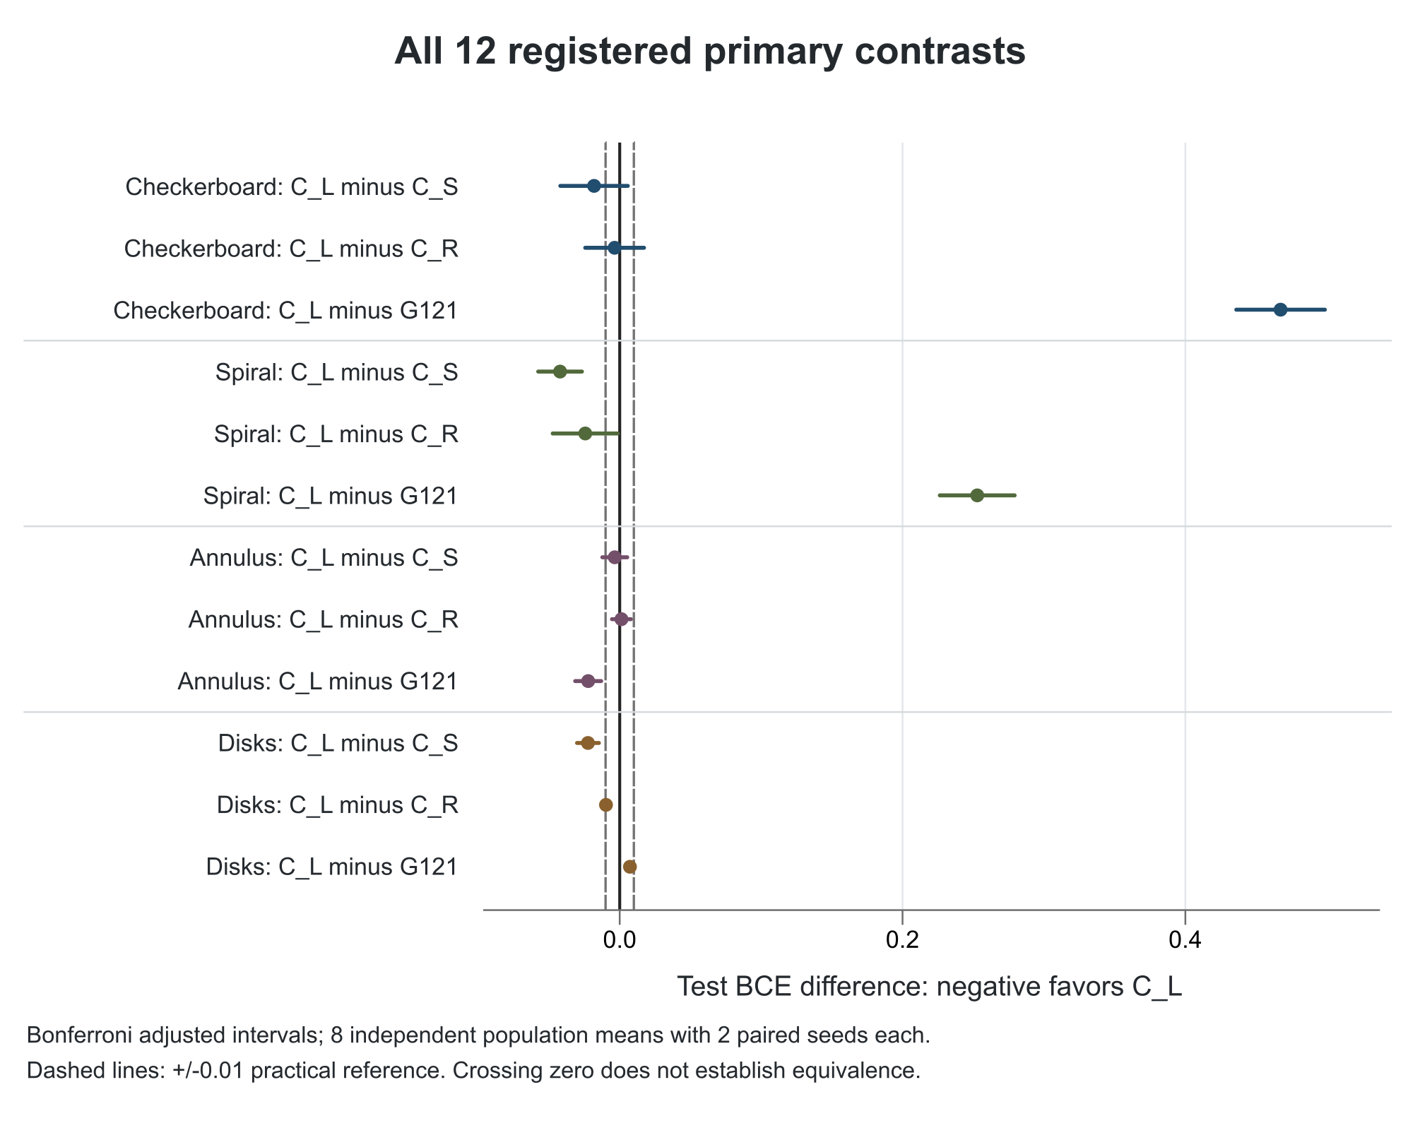
Figure 1. All 12 registered BCE contrasts with Bonferroni-adjusted intervals. Negative differences favor C_L. Dashed lines show the 0.01 practical reference.
Task | Contrast | Mean BCE difference | Adjusted interval | Direction | Gain over 0.01
Checkerboard | C_L minus C_S | -0.0181 | -0.0420 to 0.0057 | Inconclusive | Not established
Checkerboard | C_L minus C_R | -0.0036 | -0.0244 to 0.0172 | Inconclusive | Not established
Checkerboard | C_L minus G121 | 0.4673 | 0.4360 to 0.4987 | Favors G121 | Not established
Spiral | C_L minus C_S | -0.0422 | -0.0576 to -0.0267 | Favors C_L | Yes
Spiral | C_L minus C_R | -0.0244 | -0.0474 to -0.0013 | Favors C_L | Not established
Spiral | C_L minus G121 | 0.2528 | 0.2264 to 0.2793 | Favors G121 | Not established
Annulus | C_L minus C_S | -0.0035 | -0.0123 to 0.0053 | Inconclusive | Not established
Annulus | C_L minus C_R | 0.0012 | -0.0055 to 0.0079 | Inconclusive | Not established
Annulus | C_L minus G121 | -0.0223 | -0.0315 to -0.0131 | Favors C_L | Yes
Disks | C_L minus C_S | -0.0225 | -0.0302 to -0.0147 | Favors C_L | Yes
Disks | C_L minus C_R | -0.0097 | -0.0131 to -0.0064 | Favors C_L | Not established
Disks | C_L minus G121 | 0.0072 | 0.0044 to 0.0101 | Favors G121 | Not established
The final column asks specifically whether C_L establishes at least 0.01 lower BCE throughout its adjusted interval. It is not a generic label for either direction. Intervals crossing zero remain inconclusive rather than evidence of equivalence. There is no pooled task score.

Checkerboard results
Checkerboard is an adverse result for the circuit family. C_L has mean BCE 0.5156: its differences from C_S and C_R remain inconclusive after the family correction. G121 is clearly better, with a C_L-minus-G121 interval of [0.4360, 0.4987]. All four trigonometric routed arms have lower descriptive BCE than all four circuit arms. Within each routed family, hard routing has the lowest mean BCE: C_H 0.5012 and T_H 0.2743. Learned soft routing improves the fixed-soft mean but does not recover the global baseline performance.
Each row averages the two paired seeds within each of eight populations, then averages the population means. SD describes variation among those eight means; it is not a confidence interval. All nine registered arms are shown.
Arm | BCE | BCE SD | Macro F1 | F1 SD | Accuracy
C_H | 0.5012 | 0.0260 | 0.7801 | 0.0268 | 0.7802
C_L | 0.5156 | 0.0224 | 0.7569 | 0.0313 | 0.7575
C_R | 0.5192 | 0.0133 | 0.7532 | 0.0208 | 0.7536
C_S | 0.5337 | 0.0137 | 0.7408 | 0.0185 | 0.7414
G121 | 0.0482 | 0.0046 | 0.9833 | 0.0038 | 0.9833
T_H | 0.2743 | 0.0152 | 0.9045 | 0.0091 | 0.9045
T_L | 0.3091 | 0.0136 | 0.8971 | 0.0105 | 0.8971
T_R | 0.3626 | 0.0149 | 0.8832 | 0.0107 | 0.8832
T_S | 0.3747 | 0.0164 | 0.8795 | 0.0128 | 0.8795

Calibration and class outcomes
Arm | Native BCE | Brier | ECE | Positive precision | Positive recall | Average precision
C_H | 0.5012 | 0.1622 | 0.0739 | 0.7794 | 0.7832 | 0.8350
C_L | 0.5156 | 0.1708 | 0.0764 | 0.7580 | 0.7639 | 0.8338
C_R | 0.5192 | 0.1721 | 0.0765 | 0.7542 | 0.7572 | 0.8299
C_S | 0.5337 | 0.1781 | 0.0750 | 0.7417 | 0.7467 | 0.8170
G121 | 0.0482 | 0.0136 | 0.0177 | 0.9833 | 0.9834 | 0.9991
T_H | 0.2743 | 0.0791 | 0.0676 | 0.9009 | 0.9095 | 0.9616
T_L | 0.3091 | 0.0897 | 0.0932 | 0.8959 | 0.8993 | 0.9574
T_R | 0.3626 | 0.1075 | 0.1315 | 0.8833 | 0.8839 | 0.9458
T_S | 0.3747 | 0.1112 | 0.1322 | 0.8738 | 0.8882 | 0.9423
Brier and ECE use raw probabilities; common BCE clips probabilities at the registered limits, while native BCE uses stable logits. Positive-class precision, recall and average precision do not automatically describe the minority class in every dataset. The full reliability bins, confusion matrices and clipping counts remain available per endpoint.

Validation milestones
Arm | 90 percent | 95 percent | 97 percent
C_H | 0/16; Undefined | 0/16; Undefined | 0/16; Undefined
C_S | 0/16; Undefined | 0/16; Undefined | 0/16; Undefined
C_L | 0/16; Undefined | 0/16; Undefined | 0/16; Undefined
C_R | 0/16; Undefined | 0/16; Undefined | 0/16; Undefined
T_H | 14/16; 9,514 | 0/16; Undefined | 0/16; Undefined
T_S | 4/16; 11,269 | 0/16; Undefined | 0/16; Undefined
T_L | 9/16; 10,542 | 0/16; Undefined | 0/16; Undefined
T_R | 2/16; 11,850 | 0/16; Undefined | 0/16; Undefined
G121 | 16/16; 300 | 16/16; 994 | 16/16; 2,841
Milestone cells show reached/endpoints; mean updates among those that reached the validation threshold. Non-reaching endpoints are retained in the denominator. These are round-level validation observations, with no early stopping, no test accuracy claim and no inference that unobserved intermediate updates crossed a threshold.

Spiral results
Spiral provides the clearest routing-specific circuit evidence. C_L beats C_S by 0.0422 BCE, with the entire adjusted interval beyond the 0.01 reference. It also beats the residual control C_R by 0.0244, but that interval extends to only 0.0013 improvement: statistical evidence does not establish a minimum 0.01 practical gain. C_L has the lowest circuit BCE, while C_H has a slightly higher descriptive macro-F1. T_L has the lowest routed trigonometric BCE; T_H and T_R have higher descriptive F1. G121 nevertheless beats C_L decisively and has the best descriptive BCE among all nine arms.
Each row averages the two paired seeds within each of eight populations, then averages the population means. SD describes variation among those eight means; it is not a confidence interval. All nine registered arms are shown.
Arm | BCE | BCE SD | Macro F1 | F1 SD | Accuracy
C_H | 0.3648 | 0.0713 | 0.8629 | 0.0359 | 0.8630
C_L | 0.3339 | 0.0189 | 0.8598 | 0.0157 | 0.8600
C_R | 0.3582 | 0.0112 | 0.8453 | 0.0145 | 0.8458
C_S | 0.3760 | 0.0128 | 0.8339 | 0.0199 | 0.8342
G121 | 0.0810 | 0.0104 | 0.9650 | 0.0036 | 0.9650
T_H | 0.2357 | 0.0437 | 0.9229 | 0.0180 | 0.9229
T_L | 0.2175 | 0.0091 | 0.9185 | 0.0109 | 0.9185
T_R | 0.2361 | 0.0120 | 0.9219 | 0.0111 | 0.9220
T_S | 0.2521 | 0.0164 | 0.9181 | 0.0128 | 0.9182

Calibration and class outcomes
Arm | Native BCE | Brier | ECE | Positive precision | Positive recall | Average precision
C_H | 0.3654 | 0.1066 | 0.0651 | 0.8674 | 0.8571 | 0.9253
C_L | 0.3339 | 0.1010 | 0.0706 | 0.8743 | 0.8425 | 0.9389
C_R | 0.3582 | 0.1095 | 0.0847 | 0.8714 | 0.8149 | 0.9371
C_S | 0.3760 | 0.1169 | 0.0858 | 0.8554 | 0.8075 | 0.9268
G121 | 0.0810 | 0.0249 | 0.0099 | 0.9645 | 0.9656 | 0.9961
T_H | 0.2368 | 0.0621 | 0.0491 | 0.9254 | 0.9202 | 0.9713
T_L | 0.2175 | 0.0615 | 0.0498 | 0.9211 | 0.9162 | 0.9742
T_R | 0.2361 | 0.0663 | 0.0752 | 0.9187 | 0.9267 | 0.9733
T_S | 0.2521 | 0.0719 | 0.0788 | 0.9157 | 0.9223 | 0.9700
Brier and ECE use raw probabilities; common BCE clips probabilities at the registered limits, while native BCE uses stable logits. Positive-class precision, recall and average precision do not automatically describe the minority class in every dataset. The full reliability bins, confusion matrices and clipping counts remain available per endpoint.

Validation milestones
Arm | 90 percent | 95 percent | 97 percent
C_H | 2/16; 12,150 | 0/16; Undefined | 0/16; Undefined
C_S | 0/16; Undefined | 0/16; Undefined | 0/16; Undefined
C_L | 0/16; Undefined | 0/16; Undefined | 0/16; Undefined
C_R | 0/16; Undefined | 0/16; Undefined | 0/16; Undefined
T_H | 16/16; 4,336 | 0/16; Undefined | 0/16; Undefined
T_S | 16/16; 4,369 | 0/16; Undefined | 0/16; Undefined
T_L | 16/16; 5,189 | 0/16; Undefined | 0/16; Undefined
T_R | 16/16; 4,017 | 0/16; Undefined | 0/16; Undefined
G121 | 16/16; 131 | 16/16; 595 | 11/16; 7,555
Milestone cells show reached/endpoints; mean updates among those that reached the validation threshold. Non-reaching endpoints are retained in the denominator. These are round-level validation observations, with no early stopping, no test accuracy claim and no inference that unobserved intermediate updates crossed a threshold.

Annulus results
On noisy annulus, C_L beats G121 by 0.0223 BCE, with the entire interval beyond 0.01. Yet neither its C_S nor C_R comparison resolves a difference. This supports the routed circuit configuration here, without isolating learned routing as the necessary ingredient. C_R has slightly lower descriptive BCE than C_L; C_S is close, and C_H is worse. T_R, T_S and T_L form a similar low-loss group, ahead descriptively of T_H and the circuit arms. Close means and intervals crossing zero do not establish equivalence.
Each row averages the two paired seeds within each of eight populations, then averages the population means. SD describes variation among those eight means; it is not a confidence interval. All nine registered arms are shown.
Arm | BCE | BCE SD | Macro F1 | F1 SD | Accuracy
C_H | 0.3799 | 0.0193 | 0.8805 | 0.0111 | 0.8808
C_L | 0.3564 | 0.0224 | 0.8902 | 0.0094 | 0.8904
C_R | 0.3552 | 0.0228 | 0.8899 | 0.0095 | 0.8901
C_S | 0.3599 | 0.0245 | 0.8901 | 0.0099 | 0.8903
G121 | 0.3787 | 0.0225 | 0.8779 | 0.0103 | 0.8782
T_H | 0.3760 | 0.0217 | 0.8843 | 0.0085 | 0.8846
T_L | 0.3488 | 0.0232 | 0.8954 | 0.0096 | 0.8956
T_R | 0.3472 | 0.0251 | 0.8958 | 0.0091 | 0.8960
T_S | 0.3482 | 0.0238 | 0.8960 | 0.0088 | 0.8962

Calibration and class outcomes
Arm | Native BCE | Brier | ECE | Positive precision | Positive recall | Average precision
C_H | 0.3799 | 0.1093 | 0.0728 | 0.8795 | 0.8709 | 0.8814
C_L | 0.3564 | 0.1001 | 0.0590 | 0.8881 | 0.8827 | 0.8799
C_R | 0.3552 | 0.1001 | 0.0560 | 0.8889 | 0.8811 | 0.8809
C_S | 0.3599 | 0.1007 | 0.0602 | 0.8893 | 0.8811 | 0.8813
G121 | 0.3787 | 0.1073 | 0.0676 | 0.8786 | 0.8658 | 0.8798
T_H | 0.3760 | 0.1071 | 0.0751 | 0.8887 | 0.8683 | 0.8800
T_L | 0.3488 | 0.0966 | 0.0539 | 0.8943 | 0.8873 | 0.8775
T_R | 0.3472 | 0.0957 | 0.0539 | 0.8955 | 0.8868 | 0.8786
T_S | 0.3482 | 0.0963 | 0.0539 | 0.8954 | 0.8874 | 0.8793
Brier and ECE use raw probabilities; common BCE clips probabilities at the registered limits, while native BCE uses stable logits. Positive-class precision, recall and average precision do not automatically describe the minority class in every dataset. The full reliability bins, confusion matrices and clipping counts remain available per endpoint.

Validation milestones
Arm | 90 percent | 95 percent | 97 percent
C_H | 0/16; Undefined | 0/16; Undefined | 0/16; Undefined
C_S | 2/16; 6,525 | 0/16; Undefined | 0/16; Undefined
C_L | 2/16; 8,325 | 0/16; Undefined | 0/16; Undefined
C_R | 4/16; 7,800 | 0/16; Undefined | 0/16; Undefined
T_H | 0/16; Undefined | 0/16; Undefined | 0/16; Undefined
T_S | 5/16; 3,075 | 0/16; Undefined | 0/16; Undefined
T_L | 6/16; 5,988 | 0/16; Undefined | 0/16; Undefined
T_R | 6/16; 5,262 | 0/16; Undefined | 0/16; Undefined
G121 | 0/16; Undefined | 0/16; Undefined | 0/16; Undefined
Milestone cells show reached/endpoints; mean updates among those that reached the validation threshold. Non-reaching endpoints are retained in the denominator. These are round-level validation observations, with no early stopping, no test accuracy claim and no inference that unobserved intermediate updates crossed a threshold.

Disks results
On rare disks, C_L beats C_S beyond the 0.01 reference and beats C_R statistically without establishing that practical threshold. G121 beats C_L statistically, but its interval does not establish a 0.01 minimum advantage. All nine arms have high accuracy, so minority recall, calibration and macro-F1 remain important. C_S has the weakest mean minority recall, 0.9397, versus C_L 0.9814. T_L has the lowest trigonometric BCE; T_R has the highest descriptive macro-F1, narrowly above G121. Those different metric rankings must not be turned into an unregistered superiority claim.
Each row averages the two paired seeds within each of eight populations, then averages the population means. SD describes variation among those eight means; it is not a confidence interval. All nine registered arms are shown.
Arm | BCE | BCE SD | Macro F1 | F1 SD | Accuracy
C_H | 0.0168 | 0.0023 | 0.9856 | 0.0041 | 0.9943
C_L | 0.0157 | 0.0021 | 0.9889 | 0.0048 | 0.9956
C_R | 0.0254 | 0.0020 | 0.9874 | 0.0033 | 0.9950
C_S | 0.0382 | 0.0039 | 0.9788 | 0.0087 | 0.9919
G121 | 0.0085 | 0.0027 | 0.9924 | 0.0030 | 0.9970
T_H | 0.0141 | 0.0029 | 0.9887 | 0.0049 | 0.9955
T_L | 0.0133 | 0.0013 | 0.9915 | 0.0039 | 0.9966
T_R | 0.0149 | 0.0014 | 0.9925 | 0.0034 | 0.9970
T_S | 0.0158 | 0.0012 | 0.9923 | 0.0034 | 0.9970

Calibration and class outcomes
Arm | Native BCE | Brier | ECE | Positive precision | Positive recall | Average precision
C_H | 0.0168 | 0.0047 | 0.0070 | 0.9741 | 0.9751 | 0.9978
C_L | 0.0157 | 0.0041 | 0.0083 | 0.9793 | 0.9814 | 0.9987
C_R | 0.0254 | 0.0056 | 0.0169 | 0.9837 | 0.9718 | 0.9988
C_S | 0.0382 | 0.0094 | 0.0259 | 0.9874 | 0.9397 | 0.9978
G121 | 0.0085 | 0.0024 | 0.0036 | 0.9884 | 0.9845 | 0.9992
T_H | 0.0141 | 0.0039 | 0.0064 | 0.9784 | 0.9818 | 0.9985
T_L | 0.0133 | 0.0035 | 0.0075 | 0.9831 | 0.9867 | 0.9991
T_R | 0.0149 | 0.0036 | 0.0094 | 0.9865 | 0.9870 | 0.9994
T_S | 0.0158 | 0.0038 | 0.0102 | 0.9861 | 0.9867 | 0.9994
Brier and ECE use raw probabilities; common BCE clips probabilities at the registered limits, while native BCE uses stable logits. Positive-class precision, recall and average precision do not automatically describe the minority class in every dataset. The full reliability bins, confusion matrices and clipping counts remain available per endpoint.

Validation milestones
Arm | 90 percent | 95 percent | 97 percent
C_H | 16/16; 403 | 16/16; 727 | 16/16; 1,439
C_S | 16/16; 577 | 16/16; 2,306 | 14/16; 2,593
C_L | 16/16; 562 | 16/16; 919 | 16/16; 1,575
C_R | 16/16; 577 | 16/16; 1,214 | 16/16; 2,100
T_H | 16/16; 112 | 16/16; 244 | 16/16; 445
T_S | 16/16; 75 | 16/16; 155 | 16/16; 272
T_L | 16/16; 75 | 16/16; 155 | 16/16; 272
T_R | 16/16; 75 | 16/16; 155 | 16/16; 272
G121 | 16/16; 80 | 16/16; 131 | 16/16; 169
Milestone cells show reached/endpoints; mean updates among those that reached the validation threshold. Non-reaching endpoints are retained in the denominator. These are round-level validation observations, with no early stopping, no test accuracy claim and no inference that unobserved intermediate updates crossed a threshold.

Banknote results
Banknote is one fixed split with five optimization seeds, not five datasets. MLP4 stands apart descriptively: mean BCE 0.0165 and macro-F1 0.9912, versus G121 0.3661 and 0.8240, and C_L 0.4078 and 0.7792. C_L has the lowest circuit BCE and T_L the lowest routed trigonometric BCE. MLP2 and LR2 remain much weaker than MLP4. The different input representations and architectures prevent attributing that gap solely to routing. All twelve arms and seed ranges must remain visible; no synthetic confidence interval applies.
Each row summarizes five optimization seeds on one fixed grouped split. The displayed minimum and maximum are seed ranges, not confidence intervals.
Arm | BCE | BCE range | Macro F1 | F1 range | Accuracy
C_H | 0.4183 | 0.3953 to 0.4361 | 0.7742 | 0.7597 to 0.7959 | 0.7774
C_L | 0.4078 | 0.3895 to 0.4320 | 0.7792 | 0.7569 to 0.7907 | 0.7825
C_R | 0.4217 | 0.4110 to 0.4331 | 0.7499 | 0.7387 to 0.7632 | 0.7526
C_S | 0.4238 | 0.4136 to 0.4409 | 0.7578 | 0.7499 to 0.7885 | 0.7599
G121 | 0.3661 | 0.3539 to 0.3810 | 0.8240 | 0.7864 to 0.8408 | 0.8263
LR2 | 0.4423 | 0.4392 to 0.4436 | 0.7496 | 0.7464 to 0.7544 | 0.7547
MLP2 | 0.4142 | 0.3958 to 0.4241 | 0.7558 | 0.7358 to 0.7780 | 0.7577
MLP4 | 0.0165 | 0.0019 to 0.0279 | 0.9912 | 0.9889 to 1.0000 | 0.9912
T_H | 0.4028 | 0.3972 to 0.4128 | 0.7605 | 0.7523 to 0.7706 | 0.7635
T_L | 0.3945 | 0.3905 to 0.3989 | 0.7769 | 0.7706 to 0.7811 | 0.7803
T_R | 0.4146 | 0.4112 to 0.4169 | 0.7787 | 0.7745 to 0.7815 | 0.7818
T_S | 0.4176 | 0.4165 to 0.4192 | 0.7733 | 0.7643 to 0.7780 | 0.7759

Calibration and class outcomes
Arm | Native BCE | Brier | ECE | Positive precision | Positive recall | Average precision
C_H | 0.4183 | 0.1413 | 0.1049 | 0.7553 | 0.7410 | 0.8804
C_L | 0.4078 | 0.1397 | 0.0962 | 0.7637 | 0.7426 | 0.8875
C_R | 0.4217 | 0.1426 | 0.1130 | 0.7193 | 0.7295 | 0.8771
C_S | 0.4238 | 0.1435 | 0.1089 | 0.7224 | 0.7508 | 0.8763
G121 | 0.3661 | 0.1198 | 0.0819 | 0.8097 | 0.7984 | 0.9144
LR2 | 0.4423 | 0.1463 | 0.0647 | 0.7429 | 0.6869 | 0.8554
MLP2 | 0.4142 | 0.1442 | 0.1014 | 0.7178 | 0.7541 | 0.8746
MLP4 | 0.0165 | 0.0061 | 0.0076 | 0.9808 | 1.0000 | 1.0000
T_H | 0.4028 | 0.1377 | 0.1009 | 0.7353 | 0.7328 | 0.8785
T_L | 0.3945 | 0.1330 | 0.0967 | 0.7615 | 0.7377 | 0.8904
T_R | 0.4146 | 0.1377 | 0.1024 | 0.7596 | 0.7459 | 0.8891
T_S | 0.4176 | 0.1380 | 0.1066 | 0.7473 | 0.7508 | 0.8870
Brier and ECE use raw probabilities; common BCE clips probabilities at the registered limits, while native BCE uses stable logits. Positive-class precision, recall and average precision do not automatically describe the minority class in every dataset. The full reliability bins, confusion matrices and clipping counts remain available per endpoint.

Validation milestones
Arm | 90 percent | 95 percent | 97 percent
C_H | 0/5; Undefined | 0/5; Undefined | 0/5; Undefined
C_S | 0/5; Undefined | 0/5; Undefined | 0/5; Undefined
C_L | 0/5; Undefined | 0/5; Undefined | 0/5; Undefined
C_R | 0/5; Undefined | 0/5; Undefined | 0/5; Undefined
T_H | 0/5; Undefined | 0/5; Undefined | 0/5; Undefined
T_S | 0/5; Undefined | 0/5; Undefined | 0/5; Undefined
T_L | 0/5; Undefined | 0/5; Undefined | 0/5; Undefined
T_R | 0/5; Undefined | 0/5; Undefined | 0/5; Undefined
G121 | 0/5; Undefined | 0/5; Undefined | 0/5; Undefined
MLP2 | 0/5; Undefined | 0/5; Undefined | 0/5; Undefined
MLP4 | 5/5; 75 | 5/5; 75 | 5/5; 150
LR2 | 0/5; Undefined | 0/5; Undefined | 0/5; Undefined

Routing diagnostics and mechanism limits
The exploratory T_L-versus-T_S contrasts favor learned routing on checkerboard, spiral and disks; annulus remains unresolved. These nominal 95% intervals belong to the secondary analysis, not the corrected primary family. Circuit soft versus hard routing is also mixed: C_S improves annulus but worsens checkerboard and disks; spiral is inconclusive. Thus soft mixing and learning the gate are distinct choices, and improvements are not unique to circuit emulation.
The following compact diagnostic view uses C_S, C_L, C_R and G121 because they define the primary routing and capacity questions. This selection is fixed by the registered comparison, not by observed rank. All arms and raw bank-indexed diagnostics remain in the evidence JSON. Values are descriptive and add no corrected comparisons.
Task | Arm | Mean entropy | Effective experts | Largest mean weight | Largest occupancy
Checkerboard | C_S | 0.8992 | 2.5807 | 0.2241 | 0.2339
Checkerboard | C_L | 0.7642 | 2.2966 | 0.2699 | 0.2839
Checkerboard | C_R | 0.8992 | 2.5807 | 0.2241 | 0.2339
Checkerboard | G121 | 0.0000 | 1.0000 | 1.0000 | 1.0000
Spiral | C_S | 0.8734 | 2.5181 | 0.2258 | 0.2357
Spiral | C_L | 0.6517 | 2.0382 | 0.2760 | 0.2848
Spiral | C_R | 0.8734 | 2.5181 | 0.2258 | 0.2357
Spiral | G121 | 0.0000 | 1.0000 | 1.0000 | 1.0000
Annulus | C_S | 0.8797 | 2.5339 | 0.2228 | 0.2352
Annulus | C_L | 0.8831 | 2.5537 | 0.2517 | 0.2677
Annulus | C_R | 0.8797 | 2.5339 | 0.2228 | 0.2352
Annulus | G121 | 0.0000 | 1.0000 | 1.0000 | 1.0000
Disks | C_S | 0.8700 | 2.5110 | 0.2261 | 0.2393
Disks | C_L | 0.1904 | 1.2642 | 0.3778 | 0.3833
Disks | C_R | 0.8700 | 2.5110 | 0.2261 | 0.2393
Disks | G121 | 0.0000 | 1.0000 | 1.0000 | 1.0000
Banknote | C_S | 0.8501 | 2.4407 | 0.2467 | 0.2591
Banknote | C_L | 0.7595 | 2.2810 | 0.2573 | 0.2693
Banknote | C_R | 0.8501 | 2.4407 | 0.2467 | 0.2591
Banknote | G121 | 0.0000 | 1.0000 | 1.0000 | 1.0000
Effective experts is the test mean of exp(entropy), not exp of the mean entropy. Largest mean weight and largest argmax occupancy are invariant to relabeling banks. A global one-bank model has a different capacity ceiling from a five-bank model. These summaries do not align expert identities across populations.

Historical training exposure
Task | Arm | Class 1 mass share | Largest class 1 bank share | Effective class 1 banks
Checkerboard | C_S | 0.5009; n=8 | 0.2248; n=8 | 4.9817; n=8
Checkerboard | C_L | 0.5009; n=8 | 0.2607; n=8 | 4.9156; n=8
Checkerboard | C_R | 0.5009; n=8 | 0.2248; n=8 | 4.9817; n=8
Checkerboard | G121 | 0.5009; n=8 | 1.0000; n=8 | 1.0000; n=8
Spiral | C_S | 0.5000; n=8 | 0.2258; n=8 | 4.9752; n=8
Spiral | C_L | 0.5000; n=8 | 0.2650; n=8 | 4.8853; n=8
Spiral | C_R | 0.5000; n=8 | 0.2258; n=8 | 4.9752; n=8
Spiral | G121 | 0.5000; n=8 | 1.0000; n=8 | 1.0000; n=8
Annulus | C_S | 0.4799; n=8 | 0.2270; n=8 | 4.9745; n=8
Annulus | C_L | 0.4799; n=8 | 0.2460; n=8 | 4.9441; n=8
Annulus | C_R | 0.4799; n=8 | 0.2270; n=8 | 4.9745; n=8
Annulus | G121 | 0.4799; n=8 | 1.0000; n=8 | 1.0000; n=8
Disks | C_S | 0.1115; n=8 | 0.2835; n=8 | 4.8149; n=8
Disks | C_L | 0.1115; n=8 | 0.3380; n=8 | 3.7931; n=8
Disks | C_R | 0.1115; n=8 | 0.2835; n=8 | 4.8149; n=8
Disks | G121 | 0.1115; n=8 | 1.0000; n=8 | 1.0000; n=8
Banknote | C_S | 0.4446; n=5 | 0.2806; n=5 | 4.6400; n=5
Banknote | C_L | 0.4446; n=5 | 0.3828; n=5 | 4.3912; n=5
Banknote | C_R | 0.4446; n=5 | 0.2806; n=5 | 4.6400; n=5
Banknote | G121 | 0.4446; n=5 | 1.0000; n=5 | 1.0000; n=5
Each cell reports a mean and n, the number of defined population means (or Banknote seeds). Historical pre-update gate weights are applied to actual sampled training visits. Weighted mass is not an expert invocation count, and the dense arms still evaluate all five experts. The complete JSON also includes overall and class-0 exposure, entropy and concentration.

Replacing a learned soft gate after fitting
Task | Arm | Argmax BCE | BCE change | Argmax F1 | F1 change
Checkerboard | C_L | 1.5364 | 1.0209 | 0.7336 | -0.0233
Checkerboard | T_L | 0.5270 | 0.2178 | 0.8856 | -0.0115
Spiral | C_L | 1.5419 | 1.2080 | 0.8464 | -0.0135
Spiral | T_L | 1.2394 | 1.0218 | 0.8961 | -0.0224
Annulus | C_L | 0.7306 | 0.3741 | 0.8826 | -0.0075
Annulus | T_L | 0.7428 | 0.3940 | 0.8928 | -0.0025
Disks | C_L | 0.0153 | -0.0004 | 0.9881 | -0.0008
Disks | T_L | 0.0132 | -0.0001 | 0.9911 | -0.0004
Banknote | C_L | 1.2147 | 0.8069 | 0.7915 | 0.0123
Banknote | T_L | 1.4601 | 1.0656 | 0.7752 | -0.0017
The diagnostic substitutes the largest learned gate weight after fitting, with no retraining or reselection. Changes are within-endpoint argmax minus soft metrics, summarized with the same population nesting. A positive BCE change is worse; a positive F1 change is better. This does not evaluate a separately trained hard learned router.

Geometry boundaries and label noise
Common boundary slices use training-fitted centroid geometry. They are comparable across arms on the same population, but are not necessarily learned gate decision boundaries. Near and far refer to the lowest 10% and highest 50% of training geometric margins. Test records outside the observed training extrema still use the interior cutpoints.
Task | Arm | Near BCE | Far BCE | Near F1 | Far F1
Checkerboard | C_S | 0.5873; n=8 | 0.5035; n=8 | 0.6695; n=8 | 0.7674; n=8
Checkerboard | C_L | 0.5665; n=8 | 0.4930; n=8 | 0.6910; n=8 | 0.7729; n=8
Checkerboard | C_R | 0.5806; n=8 | 0.4908; n=8 | 0.6845; n=8 | 0.7728; n=8
Checkerboard | G121 | 0.0491; n=8 | 0.0512; n=8 | 0.9828; n=8 | 0.9810; n=8
Spiral | C_S | 0.4597; n=8 | 0.3115; n=8 | 0.7837; n=8 | 0.8907; n=8
Spiral | C_L | 0.4006; n=8 | 0.2723; n=8 | 0.8226; n=8 | 0.9103; n=8
Spiral | C_R | 0.4468; n=8 | 0.2966; n=8 | 0.8107; n=8 | 0.8925; n=8
Spiral | G121 | 0.0566; n=8 | 0.0965; n=8 | 0.9736; n=8 | 0.9601; n=8
Annulus | C_S | 0.3622; n=8 | 0.3704; n=8 | 0.8884; n=8 | 0.8812; n=8
Annulus | C_L | 0.3569; n=8 | 0.3695; n=8 | 0.8878; n=8 | 0.8804; n=8
Annulus | C_R | 0.3597; n=8 | 0.3626; n=8 | 0.8898; n=8 | 0.8807; n=8
Annulus | G121 | 0.3660; n=8 | 0.3877; n=8 | 0.8754; n=8 | 0.8694; n=8
Disks | C_S | 0.0606; n=8 | 0.0243; n=8 | 0.9753; n=8 | 0.9844; n=8
Disks | C_L | 0.0219; n=8 | 0.0111; n=8 | 0.9846; n=8 | 0.9900; n=8
Disks | C_R | 0.0390; n=8 | 0.0162; n=8 | 0.9882; n=8 | 0.9870; n=8
Disks | G121 | 0.0119; n=8 | 0.0050; n=8 | 0.9900; n=8 | 0.9944; n=8
Banknote | C_S | 0.6781; n=5 | 0.3217; n=5 | 0.5238; n=5 | 0.8410; n=5
Banknote | C_L | 0.7430; n=5 | 0.2956; n=5 | 0.5223; n=5 | 0.8492; n=5
Banknote | C_R | 0.6914; n=5 | 0.3265; n=5 | 0.5106; n=5 | 0.8410; n=5
Banknote | G121 | 0.9102; n=5 | 0.2240; n=5 | 0.4578; n=5 | 0.8964; n=5
The table shows mean; n. Collapsed training cutpoints produce explicitly undefined rank-band summaries. Empty slices keep zero record count and undefined outcome metrics. Complete four-band results, counts and class proportions for all arms are retained in SUPPLEMENTARY_DIAGNOSTICS.json; no unmatched bank indices are pooled.

Annulus outcomes against both label references
Arm | Unflipped observed BCE | Unflipped clean BCE | Flipped observed BCE | Flipped clean BCE
C_H | 0.1975; n=8 | 0.1975; n=8 | 2.1448; n=8 | 0.1965; n=8
C_S | 0.1669; n=8 | 0.1669; n=8 | 2.2224; n=8 | 0.1642; n=8
C_L | 0.1636; n=8 | 0.1636; n=8 | 2.2181; n=8 | 0.1611; n=8
C_R | 0.1674; n=8 | 0.1674; n=8 | 2.1685; n=8 | 0.1667; n=8
T_H | 0.1868; n=8 | 0.1868; n=8 | 2.2027; n=8 | 0.1854; n=8
T_S | 0.1468; n=8 | 0.1468; n=8 | 2.2921; n=8 | 0.1463; n=8
T_L | 0.1477; n=8 | 0.1477; n=8 | 2.2898; n=8 | 0.1482; n=8
T_R | 0.1444; n=8 | 0.1444; n=8 | 2.3018; n=8 | 0.1444; n=8
G121 | 0.1845; n=8 | 0.1845; n=8 | 2.2556; n=8 | 0.1861; n=8
The same predictions are evaluated against observed and latent clean labels within each flip stratum. This diagnostic does not replace the registered observed-label endpoint. Unflipped outcomes should agree across label references. The complete supplement retains F1, calibration, counts and class proportions for both strata.

Clean reproduction and exact conversion
Four preselected fits were rebuilt from frozen source and data in clean directories without copied checkpoints. Independent checks cover curves, sampling, selected parameters and predictions. These checks establish implementation reproducibility for the selected cases; they are not four new scientific population replicates.
Task | Arm | Seed | Validation max error | Test max error
Checkerboard | C_L | 1801 | 0.000e+00 | 0.000e+00
Spiral | C_R | 1801 | 0.000e+00 | 0.000e+00
Annulus | T_L | 1801 | 0.000e+00 | 0.000e+00
Banknote | MLP4 | 1901 | 0.000e+00 | 0.000e+00
All 276 circuit models and 1,380 expert cores were converted to exact 25-term trigonometric core representations. Independent Laurent coefficients and validation, test, boundary, off-grid and forced-bank predictions were checked. Router, gate, residual and Banknote preprocessing are retained. A probability mixture of converted experts does not become one global 25-term predictor.
Independent check | Maximum absolute error
Laurent coefficients | 2.132e-14
All pipeline probability probes | 8.382e-15
Arm | Converted models | Core conversion seconds sum | Serialized bytes range
C_H | 69 | 0.0791 | 10,619 to 11,962
C_S | 69 | 0.0768 | 10,619 to 11,962
C_L | 69 | 0.0782 | 10,715 to 12,058
C_R | 69 | 0.0772 | 10,715 to 12,058
Serialized sizes include coefficients and saved policy; storage tradeoffs differ from selected checkpoint compression. Core conversion time is distinct from the full producer wall and CPU counters, which include additional verification after their measurement start. No hardware feasibility inference follows from exact classical conversion.

Checkerboard inference latency
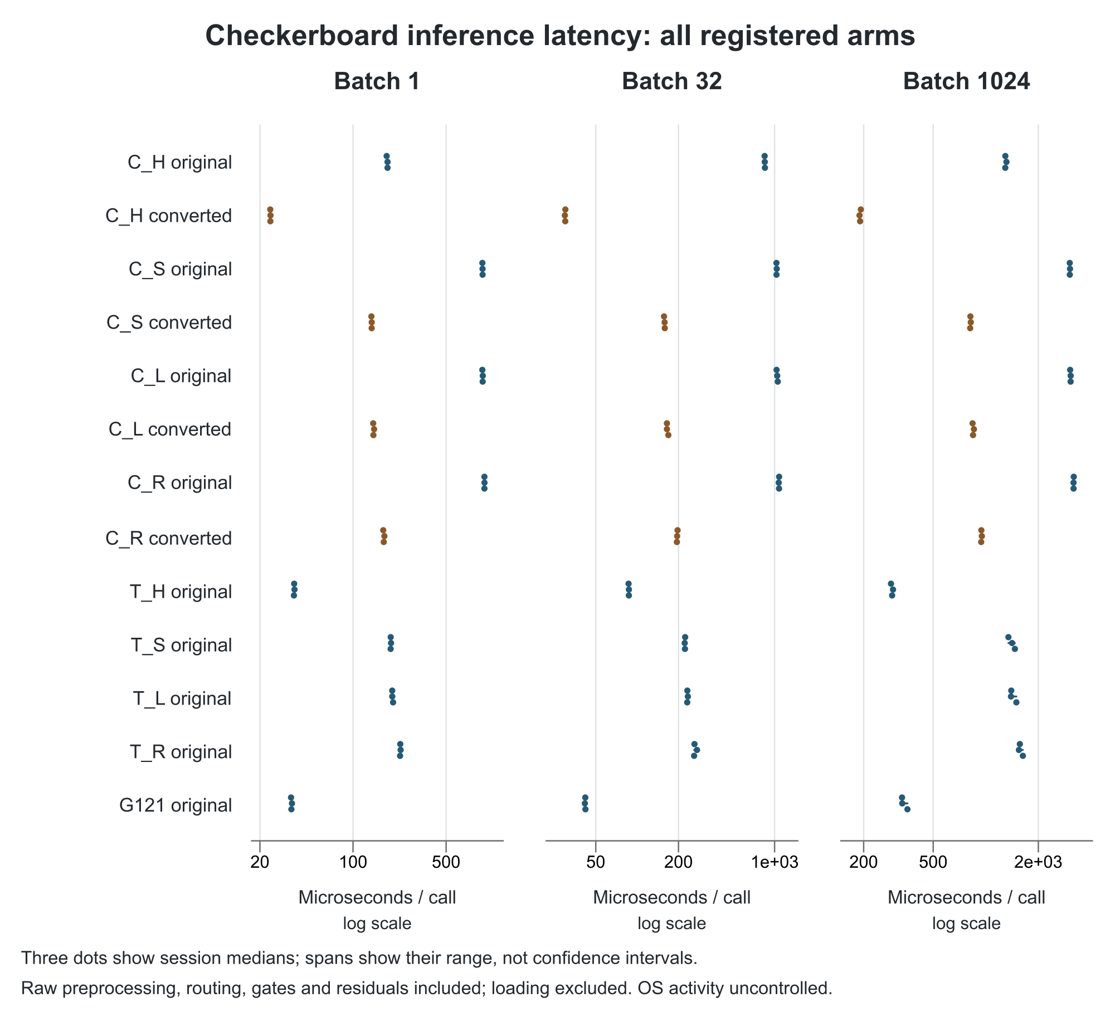
Technical timing for checkerboard. All registered original models and all converted circuit representations are shown at batches 1, 32 and 1,024.
Dots are the three session-level medians of endpoint medians, each endpoint based on 15 timed calls. The span is the observed session range, not an inferential confidence interval. Calls use fixed validation fixtures; they are technical repetitions. Banknote raw-feature preprocessing, routing and residuals are included; loading the model is excluded. Unrelated operating-system activity remains uncontrolled. Each table value is the median of those three session-level summaries, expressed in microseconds.
Arm | Representation | Batch 1 us | Batch 32 us | Batch 1024 us
C_H | original | 181.6 | 848.0 | 1,294.5
C_H | converted | 23.9 | 30.0 | 190.8
C_S | original | 938.9 | 1,032.5 | 3,027.3
C_S | converted | 138.1 | 158.4 | 816.5
C_L | original | 940.9 | 1,044.7 | 3,059.6
C_L | converted | 142.2 | 164.8 | 845.6
C_R | original | 969.6 | 1,077.0 | 3,181.4
C_R | converted | 170.2 | 195.4 | 943.1
T_H | original | 36.1 | 87.0 | 291.1
T_S | original | 191.8 | 222.8 | 1,415.0
T_L | original | 197.2 | 231.9 | 1,399.6
T_R | original | 226.3 | 261.4 | 1,567.0
G121 | original | 34.5 | 42.0 | 332.6

Spiral inference latency
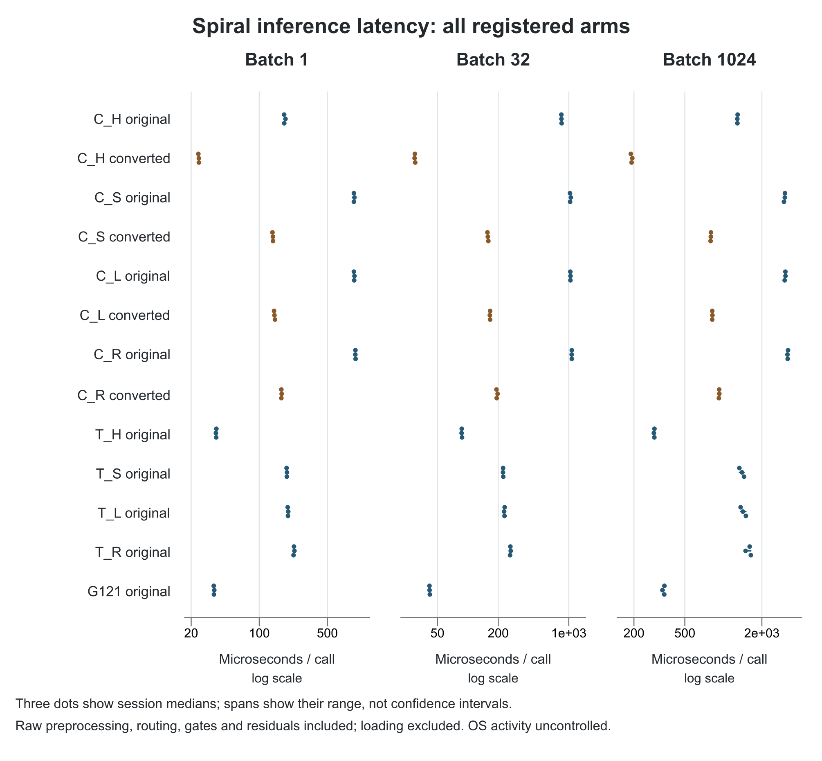
Technical timing for spiral. All registered original models and all converted circuit representations are shown at batches 1, 32 and 1,024.
Dots are the three session-level medians of endpoint medians, each endpoint based on 15 timed calls. The span is the observed session range, not an inferential confidence interval. Calls use fixed validation fixtures; they are technical repetitions. Banknote raw-feature preprocessing, routing and residuals are included; loading the model is excluded. Unrelated operating-system activity remains uncontrolled. Each table value is the median of those three session-level summaries, expressed in microseconds.
Arm | Representation | Batch 1 us | Batch 32 us | Batch 1024 us
C_H | original | 180.5 | 845.6 | 1,288.0
C_H | converted | 24.0 | 29.9 | 191.7
C_S | original | 935.8 | 1,030.2 | 3,021.2
C_S | converted | 138.0 | 157.8 | 798.4
C_L | original | 942.7 | 1,038.4 | 3,054.6
C_L | converted | 143.2 | 166.3 | 818.6
C_R | original | 970.2 | 1,071.0 | 3,183.7
C_R | converted | 168.6 | 193.1 | 927.6
T_H | original | 36.1 | 87.0 | 288.9
T_S | original | 191.8 | 223.5 | 1,397.3
T_L | original | 197.2 | 230.9 | 1,422.2
T_R | original | 227.2 | 263.9 | 1,605.8
G121 | original | 34.2 | 41.8 | 345.1

Annulus inference latency
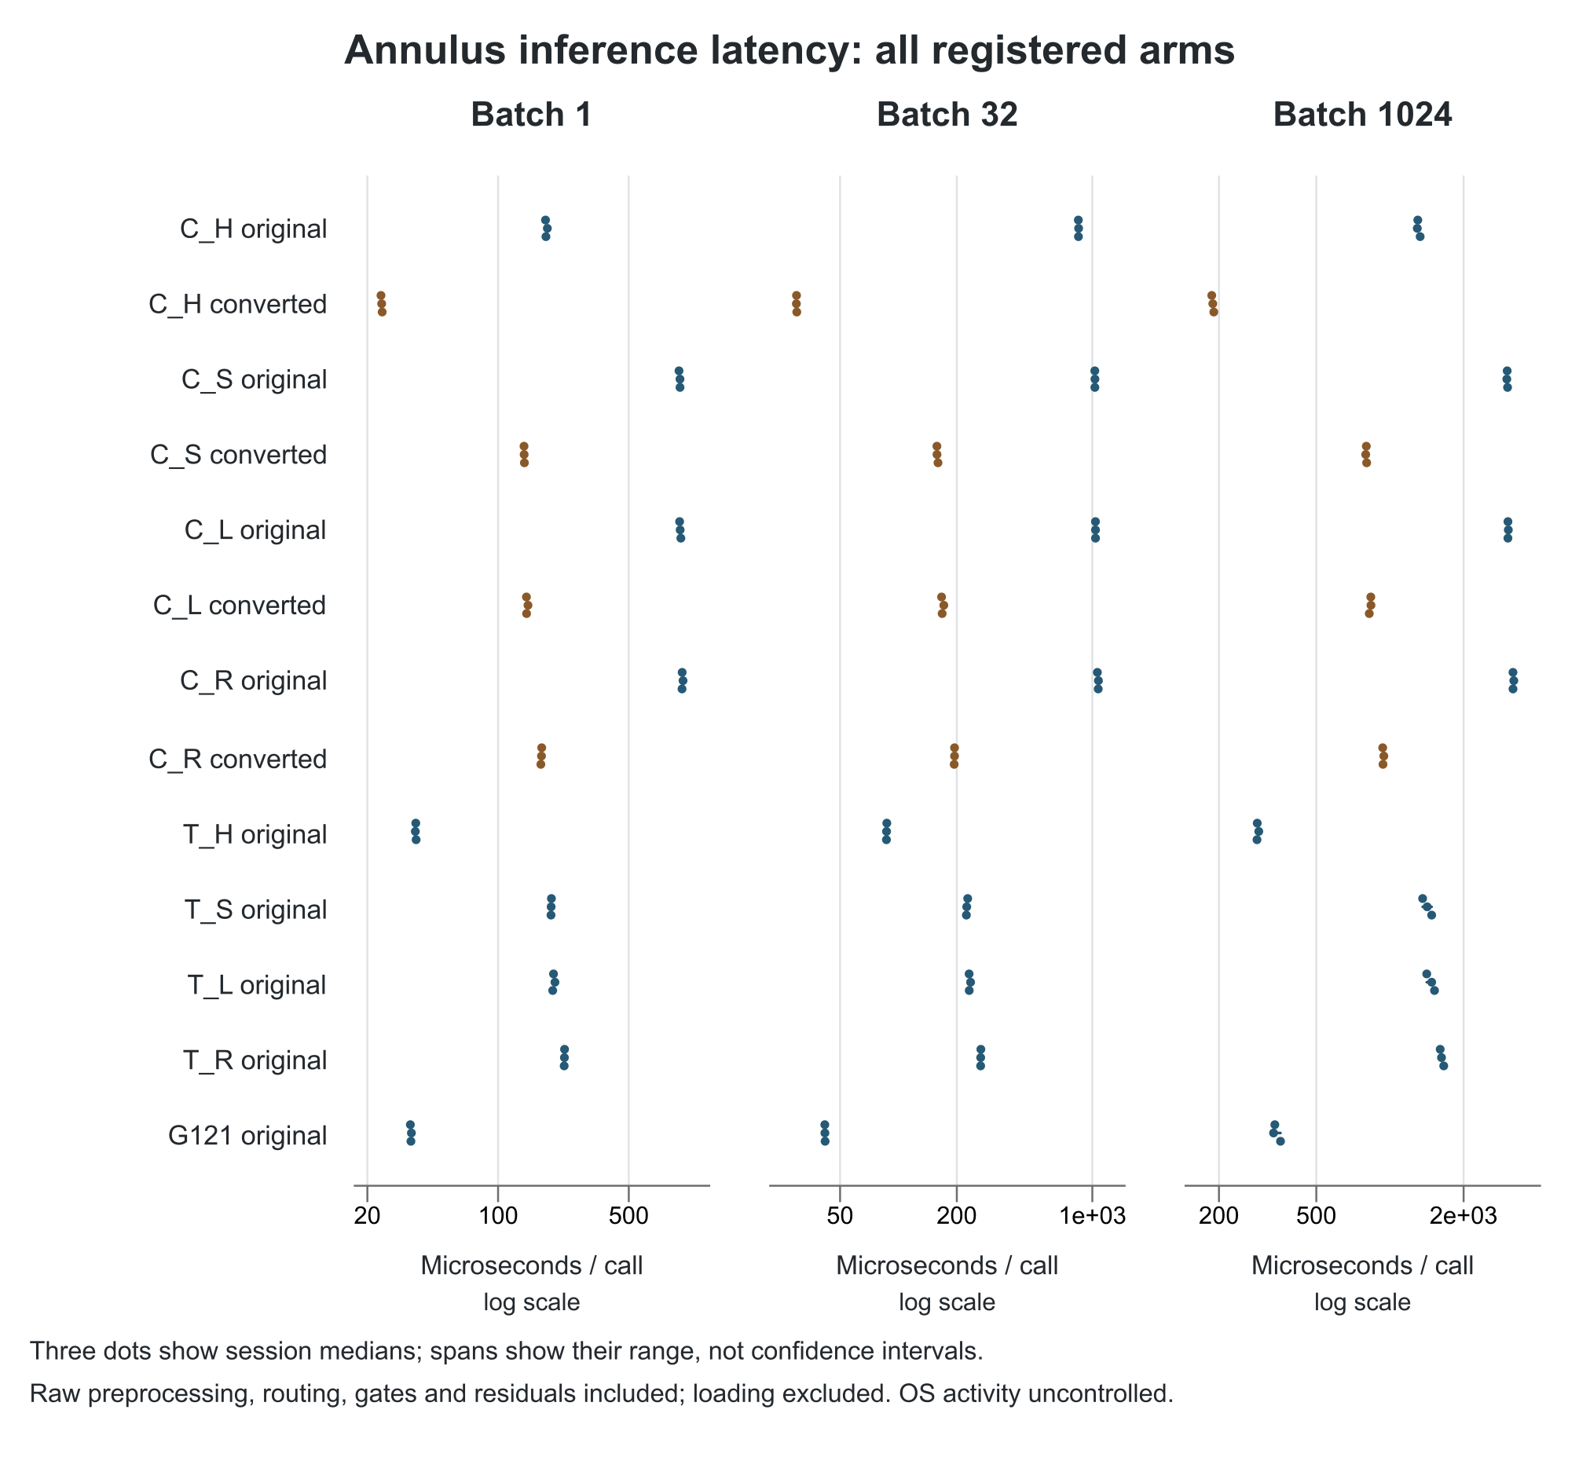
Technical timing for annulus. All registered original models and all converted circuit representations are shown at batches 1, 32 and 1,024.
Dots are the three session-level medians of endpoint medians, each endpoint based on 15 timed calls. The span is the observed session range, not an inferential confidence interval. Calls use fixed validation fixtures; they are technical repetitions. Banknote raw-feature preprocessing, routing and residuals are included; loading the model is excluded. Unrelated operating-system activity remains uncontrolled. Each table value is the median of those three session-level summaries, expressed in microseconds.
Arm | Representation | Batch 1 us | Batch 32 us | Batch 1024 us
C_H | original | 180.3 | 848.0 | 1,299.5
C_H | converted | 23.9 | 29.8 | 188.8
C_S | original | 939.3 | 1,030.8 | 3,013.9
C_S | converted | 137.8 | 158.1 | 800.5
C_L | original | 941.4 | 1,038.3 | 3,035.8
C_L | converted | 142.1 | 168.1 | 835.0
C_R | original | 964.9 | 1,072.5 | 3,183.7
C_R | converted | 170.7 | 194.7 | 936.6
T_H | original | 36.3 | 86.8 | 286.8
T_S | original | 192.2 | 225.0 | 1,419.4
T_L | original | 197.9 | 231.8 | 1,480.8
T_R | original | 226.3 | 265.6 | 1,624.5
G121 | original | 34.2 | 41.8 | 338.4

Disks inference latency
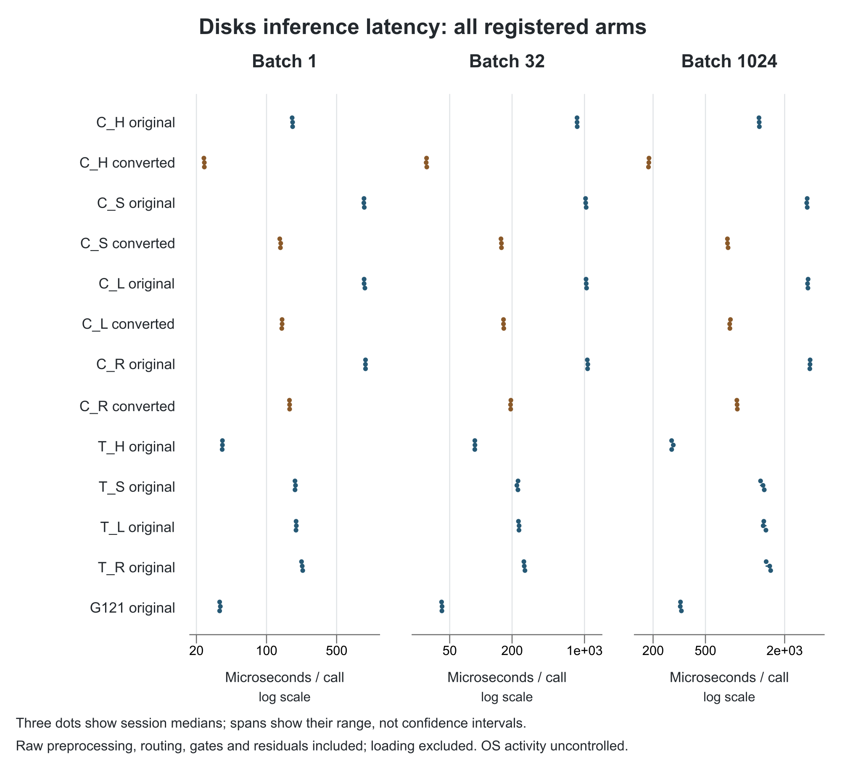
Technical timing for disks. All registered original models and all converted circuit representations are shown at batches 1, 32 and 1,024.
Dots are the three session-level medians of endpoint medians, each endpoint based on 15 timed calls. The span is the observed session range, not an inferential confidence interval. Calls use fixed validation fixtures; they are technical repetitions. Banknote raw-feature preprocessing, routing and residuals are included; loading the model is excluded. Unrelated operating-system activity remains uncontrolled. Each table value is the median of those three session-level summaries, expressed in microseconds.
Arm | Representation | Batch 1 us | Batch 32 us | Batch 1024 us
C_H | original | 181.9 | 847.8 | 1,280.8
C_H | converted | 24.0 | 29.9 | 185.8
C_S | original | 936.9 | 1,027.0 | 2,967.4
C_S | converted | 137.6 | 157.9 | 735.4
C_L | original | 939.6 | 1,039.2 | 3,005.7
C_L | converted | 142.9 | 165.3 | 767.2
C_R | original | 970.4 | 1,071.7 | 3,117.7
C_R | converted | 169.8 | 193.9 | 869.9
T_H | original | 36.4 | 87.5 | 277.0
T_S | original | 192.3 | 227.8 | 1,370.3
T_L | original | 197.2 | 233.2 | 1,388.7
T_R | original | 226.9 | 262.2 | 1,540.0
G121 | original | 34.1 | 42.0 | 323.1

Banknote inference latency
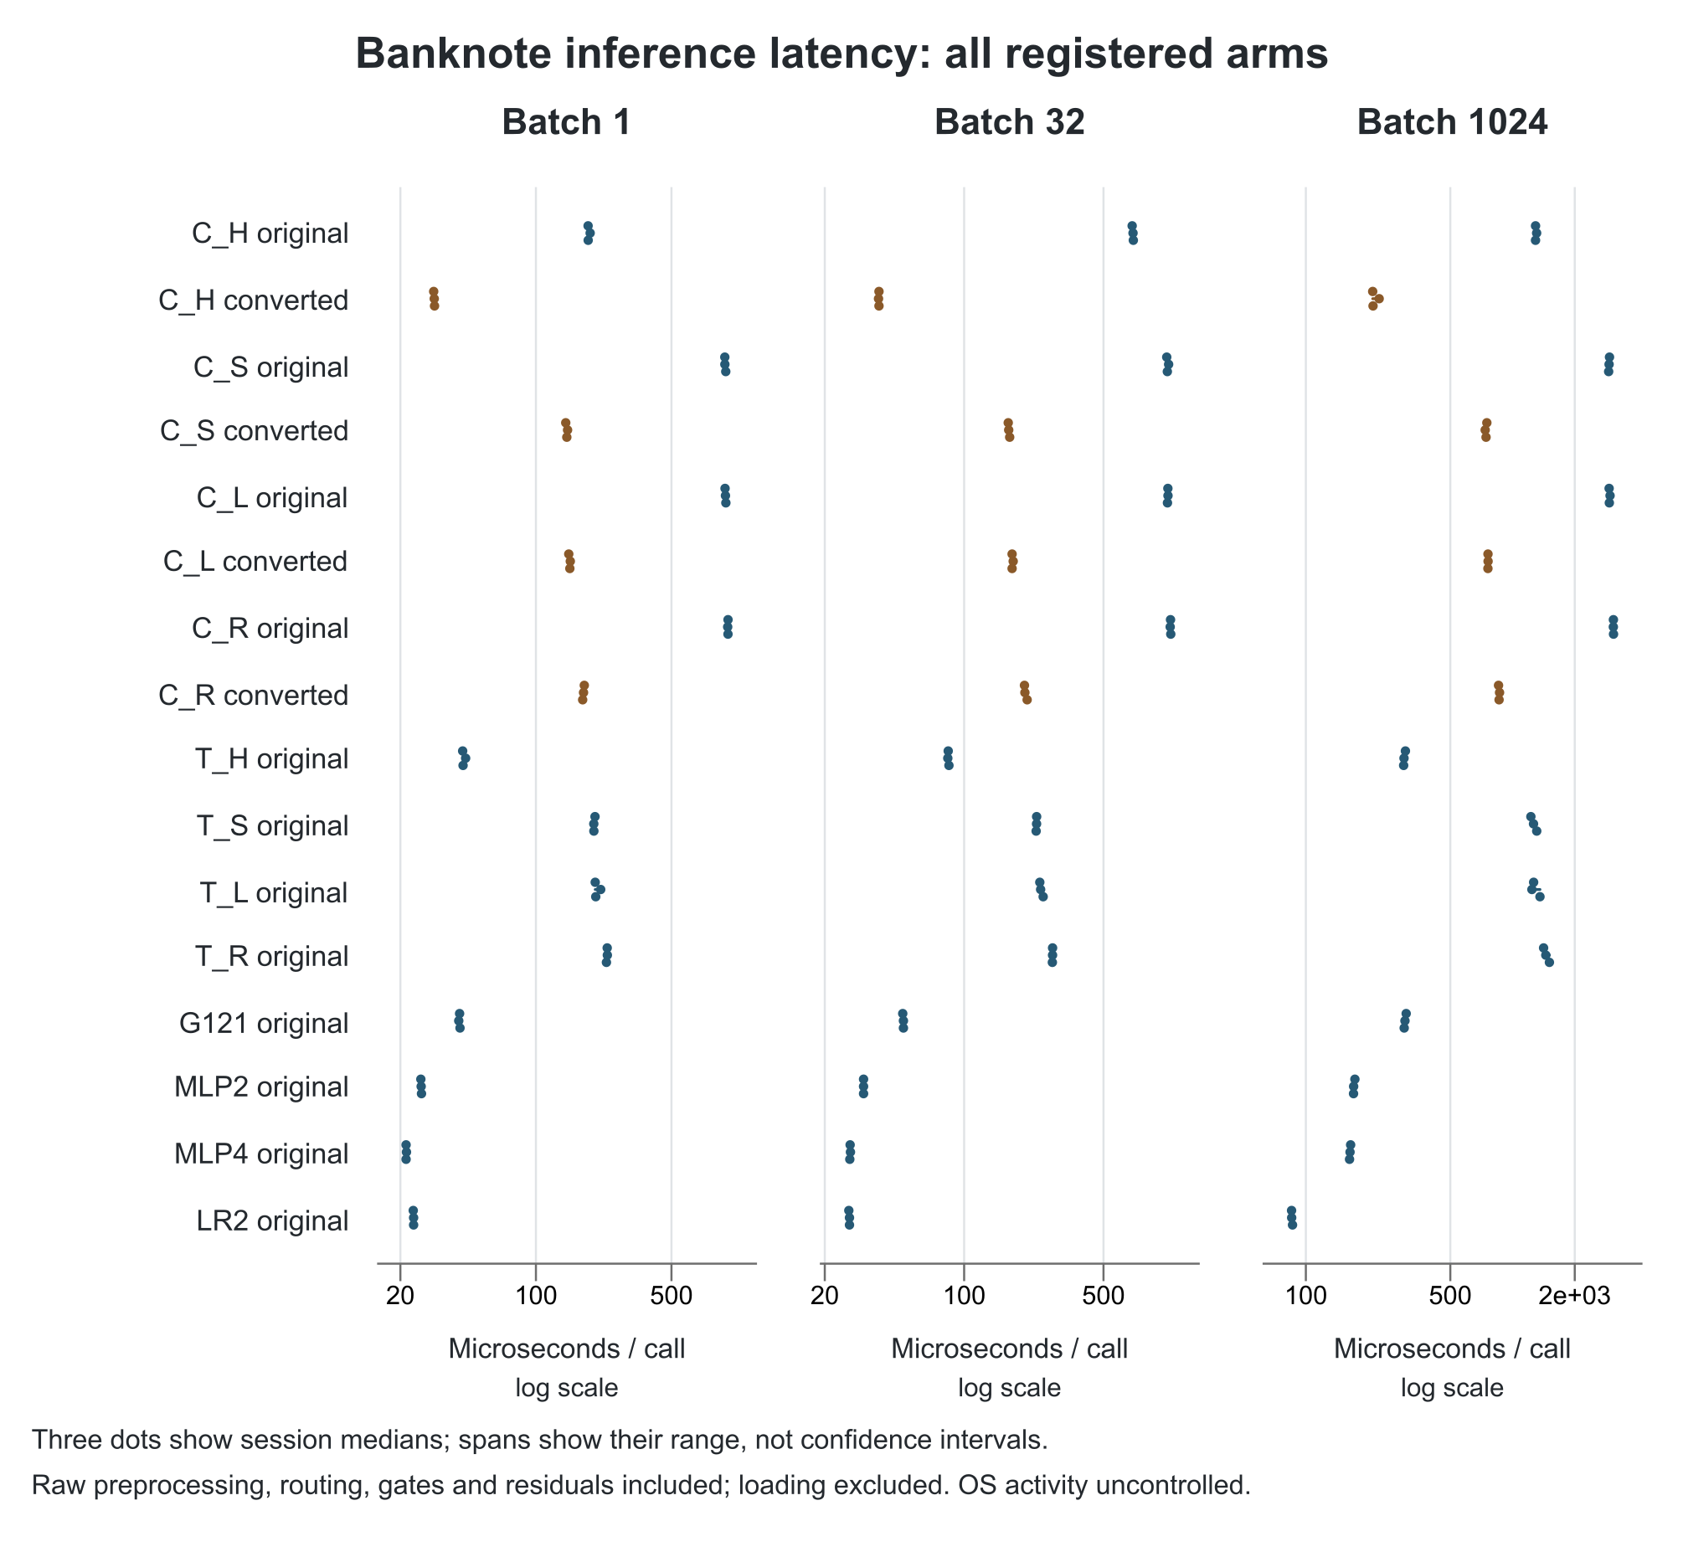
Technical timing for banknote. All registered original models and all converted circuit representations are shown at batches 1, 32 and 1,024.
Dots are the three session-level medians of endpoint medians, each endpoint based on 15 timed calls. The span is the observed session range, not an inferential confidence interval. Calls use fixed validation fixtures; they are technical repetitions. Banknote raw-feature preprocessing, routing and residuals are included; loading the model is excluded. Unrelated operating-system activity remains uncontrolled. Each table value is the median of those three session-level summaries, expressed in microseconds.
Arm | Representation | Batch 1 us | Batch 32 us | Batch 1024 us
C_H | original | 186.0 | 703.1 | 1,292.2
C_H | converted | 29.9 | 37.4 | 211.4
C_S | original | 942.7 | 1,045.2 | 2,931.7
C_S | converted | 144.3 | 167.3 | 744.5
C_L | original | 949.3 | 1,051.6 | 2,939.9
C_L | converted | 149.6 | 174.0 | 760.7
C_R | original | 978.2 | 1,084.3 | 3,076.4
C_R | converted | 176.0 | 201.7 | 860.8
T_H | original | 42.1 | 83.2 | 298.5
T_S | original | 199.0 | 230.8 | 1,263.2
T_L | original | 203.5 | 241.9 | 1,264.9
T_R | original | 233.1 | 277.6 | 1,448.5
G121 | original | 40.4 | 49.6 | 301.7
MLP2 | original | 25.6 | 31.3 | 170.3
MLP4 | original | 21.4 | 26.8 | 163.6
LR2 | original | 23.4 | 26.6 | 85.4
The three accepted sessions cover 123,120 timed trials and 16,416 warmup counters. Individual warmup records were not retained; deterministic source loops, counters and checksums support that count. Training, reproduction and recorded audits did not overlap the exclusive timing intervals. This supports a local deployment comparison on the recorded host, not a portable throughput guarantee.

Computation and resource costs
Stage | Fits | Worker envelope wall s | Native worker CPU s | Nested training CPU s | Training elapsed sum s
engineering | 48 | 128.8 | 623.1 | 585.6 | 589.5
A | 72 | 2,074.4 | 9,649.8 | 9,454.4 | 9,550.0
B | 636 | 26,513.2 | 131,854.0 | 125,515.9 | 125,343.2
The native resource inventory covers all 756 engineering, development and confirmation workers through their retained samples. Stage wall is the first registered worker start to the last finish, including intervening gaps. Summed training elapsed time is occupancy, not parallel stage wall. Training CPU is nested inside broader worker CPU and must not be added to it. Native lifetime peak memory is measured through the post-verification sample, not final exit or training alone.
Stage | Attempt status | Attempts | Measured | Largest sampled lifetime peak MiB
engineering | Success | 48 | 48 | 76.21
engineering | Other | 0 | 0 | Undefined
A | Success | 72 | 72 | 118.77
A | Other | 0 | 0 | Undefined
B | Success | 636 | 636 | 121.41
B | Other | 0 | 0 | Undefined
The accepted resource inventory covers all 756 engineering, development and confirmation workers. Its nested training counters, native whole-worker samples and stage envelopes have different boundaries and are not additive. Failed or rejected postprocessing costs are separate from these training totals.
The completed phase counters below begin at the start points defined by their scripts, often after gate or preflight work. They are not whole-project totals. Missing failure CPU counters remain unknown; elapsed process intervals, if later added, must be labeled separately.
Final derived-phase counters are reported at their recorded boundaries. Reproduction coordinator CPU excludes child-fit CPU; its separate child-training counter is shown explicitly. Timing and audit counters are phase measurements, and broader process samples overlap them. No total formed by adding these nested or differently scoped counters is claimed.
The full after-preservation scan is a separate file-integrity cost. It rehashed the delivered v0.8 payloads and all four Baseline8 files, including the archive. It performed no model evaluation or archive extraction.
Completed phase | Recorded wall seconds | Recorded CPU seconds | Scope
Official scoring | 252.223 | 249.578 | Phase timer; not whole process
Independent scoring v03 | 166.723 | 164.812 | Phase timer after preflight
Independent resources | 49.434 | 49.203 | Accounting phase after release gate
Author conversion | 25.372 | 24.359 | Producer phase after gate
Author conversion native sample | Not a separate wall measure | 132.406 | Broader process sample; overlaps phase CPU
Independent conversion v02 | 52.515 | 52.438 | Audit phase after gate
Clean reproduction coordinator | 531.104 | 1.547 | Coordinator phase; excludes child CPU
Independent reproduction | 45.955 | 45.828 | Audit phase after gate
Serial timing session 1 | 100.679 | 98.859 | Timing phase; broader than timed inference
Serial timing session 2 | 104.210 | 102.547 | Timing phase; broader than timed inference
Serial timing session 3 | 100.769 | 99.000 | Timing phase; broader than timed inference
Independent timing audit | 57.620 | 57.453 | Audit phase after gate
Clean reproduction child training | No summed wall total | 519.172 | Nested child training CPU only
Final prior-study preservation | 135.384 | 116.406 | Whole preservation checker; separate from scientific phases
Postprocessing wall_seconds and process_cpu_seconds often start after gate or preflight work. Native process snapshots have wider and different boundaries. Qualification, failures, audits, conversion, reproduction and timing retain separate receipts. These overlapping, partly bounded measurements are not an exhaustive CPU invoice. A worker-minus-training difference is not an isolated ETEL scheduler-overhead measurement.
The frozen trainer uses no precomputed input-feature cache; it computes features as used. Routing and transformed input fixtures retained for diagnostics do not replace measured inference. Dense routed models evaluate five experts, hard geometric routing evaluates one, and circuit gradient accounting includes parameter-shift evaluations. Measurement-setting counts are simulator work equivalents, not hardware shots or device jobs. The endpoint work inventories retain separate training, full-training diagnostic and validation counts.

Recovery usage and preservation
Independent scoring first stopped after one verified endpoint and a diagnostic scalar mismatch slightly above the frozen tolerance. A separately versioned recovery passed 20 endpoints before a postfit diagnostic probability/tie mismatch. The next candidate was rejected during constructed qualification before official endpoint access. No model, data, official score or tolerance was changed.
Accepted recovery03 deliberately shares the installed SciPy expit primitive only for postfit argmax diagnostic probabilities. The independent model oracle, AP/ECE and statistical algorithms remain separately implemented. The full replay subsequently passed all 636 endpoints under unchanged tolerances. This narrow shared numerical primitive is a disclosed limit on implementation independence.
The first independent conversion audit failed before numerical loops because its validator compared a nine-field runtime snapshot with a registration containing three additional metadata fields. Recovery04 was independently reviewed and qualified as a metadata-only repair. The fresh independent conversion audit then passed all 276 models and 1,380 bank cores. Numerical algorithms, tolerances, models, data and producer outputs remained unchanged.
The approximately 30,000-credit major checkpoint and its saved resume instructions are retained. The user subsequently authorized completion with cumulative accounting. Other preserved operational corrections include identifying already-present native memory counters and stopping an inert fixture preflight that unintentionally entered a full endpoint scan; neither caused a training recipe change.
An initial report-only chart render stopped because an optional Matplotlib dependency was unavailable. The partial data and failure were retained. A separately reviewed ReportLab and SVG renderer produced fresh charts from the same accepted data. No scientific result or environment was changed. Failure-phase CPU and wall costs were not captured and remain unknown.
Attempt or event | Recorded outcome | What changed
Independent scoring v01 | Failed after 1 verified endpoint | Diagnostic arithmetic diagnosis; original preserved
Independent scoring v02 | Failed after 20 verified endpoints | Postfit diagnostic tie/bin semantics; original preserved
Recovery02 candidate | Rejected constructed qualification | No official replay or endpoint access
Independent scoring v03 | PASS all 636; root accepted | Canonical postfit expit primitive only; frozen science unchanged
Independent conversion v01 | Failed before numerical loops | 9 runtime fields versus 12 registration fields
Metadata recovery04 | Qualified; fresh conversion audit PASS | Versioned metadata validation only; all 276 models and 1,380 cores verified
Report figure backend | Recovered in fresh output | Rendering only; original partial data and source retained

Usage at the recorded cutoff
The report accounting cutoff is 2026-10-22T22:43:18.179400+00:00. It includes the root and all three registered study agents. Cached input is part of input, and reasoning output is part of output; neither subset is counted twice. Later report assembly, packaging and delivery activity belongs in the append-only final cumulative receipt.
At that observation the account balance was 57340.71523 and cumulative positive observed account debit was 0. These account-wide observations have timing and attribution limits; they do not establish a study-specific charge. Standard token equivalents and the operational 6x proxy remain estimates, not billed debit. Weekly allowance resets do not reset cumulative study accounting.
The initial approximately 30,000-credit target was a major-checkpoint safeguard. A recoverable checkpoint was saved and completion was explicitly authorized later without a new numeric ceiling. Final report assembly, packaging and delivery activity must be included in the append-only cumulative receipt after the report cutoff.
Cumulative measure at cutoff | Value | Interpretation
Input tokens | 274,292,005 | Cumulative four-session observation
Cached input tokens | 269,154,560 | Cumulative four-session observation
Uncached input tokens | 5,137,445 | Cumulative four-session observation
Output tokens | 852,344 | Cumulative four-session observation
Reasoning output subset | 191,277 | Cumulative four-session observation
Input plus output tokens | 275,144,349 | Cumulative four-session observation
Standard credit equivalent | 9078.65525 | Token-derived estimate, not billed debit
Operational 6x credit proxy | 54471.9315 | Conservative estimate, not billed debit
Observed positive account debit | 0 | Account-wide observation
Pricing assumptions | 250 / 25 / 1250 per million | Uncached input / cached input / output; source retained in budget policy

Prior study preservation
The final preservation check and separate review passed for all 73,877 v0.8 payloads and all four Baseline8 seal files. The retained process exited zero and closed; both records are PASS without an error. Payload count, payload bytes, manifest hash, root metadata and seal-file inventory match exactly between before and after. Archive hash agreement is included in the accepted scan; no archive extraction is claimed.
Final delivery remains a separate gate: package assembly must preserve existing plan documents, retain source, data, protocols, logs, checkpoints, failures and analyses, and pass both root and independent manifest checks. The completed delivery seal binds the final Word document, its visual inspection evidence and the final cumulative usage receipt.

Interpretation limitations and next decisions
For v1.0, lead with conditional routing benefits, the residual-control comparison, and substantial global-baseline counterexamples. Retain all-arm BCE, F1, calibration and minority summaries; do not lead with a best seed. Eight synthetic populations support bounded conclusions for these tasks, while Banknote needs fresh splits or additional datasets before a broader claim. Parameter matching does not establish equal computation. When a circuit model is selected for a classical deployment, its verified trigonometric conversion is preferable to the slower emulator under this local CPU protocol; it preserves predictions and was faster in every recorded matched endpoint, batch and session condition. This does not establish superiority to the global alternatives or performance on another machine. The restricted two-qubit emulator does not test the wider architecture or quantum advantage. Keep v0.8 as historical context, not a matched cross-dataset improvement claim, and reserve real hardware comparison for v1.1.
Present the four clean retrains as implementation reproducibility evidence, the twelve corrected BCE comparisons as the confirmatory family, and Banknote as a descriptive check on one split. Retain failed audit attempts and the documented arithmetic and metadata recoveries. A future wider evaluation should add independent real-data splits or datasets and compare accuracy with measured compute at the intended batch size. Physical quantum experiments remain a separate v1.1 study.
This work tests two-dimensional inputs, small two-qubit circuit cores and five-bank mixtures at one fixed training budget. It does not test the full proposed Q-Pathformer architecture, scaling to large state spaces, text training, online adaptation, a broad hyperparameter search or physical quantum execution. Parameter matching controls one capacity count while leaving function class and optimization differences. Eight synthetic populations per task provide limited precision; Banknote has one grouped split and no specimen/session metadata.
For the classical v1.0 paper, present learned routing as a conditional mechanism supported by matched controls and counterexamples. Keep all primary intervals, the global-baseline defeats, the stronger four-feature Banknote MLP and the cost scope visible. A future v1.1 quantum comparison needs a separate predeclared hardware study, appropriate noise and shot accounting, and matched classical baselines. No hardware work has occurred here.

Evidence index and display definitions
Evidence | Contents | Location in final_report
Main extracted tables | All 36 synthetic rows, 12 Banknote arms, 12 primary intervals and all exploratory contrasts | extraction_final_v01\REPORT_TABLES.json
Supplementary diagnostics | All 192 boundary, 144 exposure and 36 annulus flip rows with endpoint pointers | supplement_final_v01\SUPPLEMENTARY_DIAGNOSTICS.json
Endpoint diagnostic inventory | All calibration bins, class and bank slices, margins, noise strata and milestones | extraction_final_v01\ALL_ENDPOINT_DIAGNOSTICS.json
Endpoint costs | All selected checkpoint and endpoint sizes, work and nested CPU/wall counters | extraction_final_v01\ALL_ENDPOINT_COSTS.json
Timing plot data | Every endpoint median and exact source pointer for all three sessions | figures_final_v02\LATENCY_PLOT_DATA.json
Composition evidence map | Exact JSON pointers and unrounded values behind displayed cells | content_final_v01/REPORT_CONTENT_REVIEWED_v05.json and CONTENT_COMPOSITION_RECEIPT.json in the same directory
BCE, Brier and ECE are lower-is-better. Macro-F1, accuracy and class metrics are shown on the 0 to 1 scale. Losses and scores use four decimal places; times use stated units. Tiny errors and full-precision values remain in source JSON, so a displayed 0.0000 must not be interpreted as exact zero. Undefined values are not imputed. Named source files in the evidence package retain complete hashes and row/endpoint identities.
All secondary contrasts remain available with nominal 95% exploratory intervals in REPORT_TABLES.json. Their status is distinct from the 12-comparison corrected family. Raw bank arrays are not averaged across unmatched expert numbers. No cross-task or synthetic-plus-real headline average is formed.
Table locations are relative to report_work/final_report/. The delivered evidence directory mirrors the study tree. Start with quantum/ for model and training source, quantum/data/DATA_SEAL.json for the generated data inventory, and quantum/raw/ for the retained Banknote source and provenance. Frozen plans, protocols and stage releases are under governance/. Execution and recovery commands are in execution/README_EXECUTION.txt; derived conversion, reproduction and timing commands are in analysis/deployment/README_DERIVED.txt. The delivery-root DELIVERY_MANIFEST.json maps file hashes, and the final delivery seal binds the separate package checks and cumulative usage receipt.
Report edition and rights
Study v0.9. Report edition 1 prepared on 29 October 2026.
Anthony Siljeg — Founder, Alnotrea Labs · Company affiliation: Alnotrea Pty Ltd · Q-Pathformer Initiative. Anthony is the licensor; company affiliation is not an ownership transfer.
All original report paragraphs, tables, figures, numerical findings, limitations and historical recommendations are retained without alteration. Original internal labels identify the historical source edition. This appended note and document metadata are the only editorial changes. No scientific result was recalculated or removed.
Historical local paths, host configuration, execution and usage accounting identify retained evidence. The full archive remains separately preserved under C:\Q2. This curated release does not include raw datasets, trained checkpoints, installed environments or full operational archives. Retained archive sizes are not download sizes or hardware minimums.
On 29 October 2026 Anthony Siljeg adopted the same scoped licensing scheme as studies v0.1 and v0.9.5. Controlled original report prose, table presentation and the original figures identified in REPORT_LICENSE_SCOPE.json are licensed under CC BY 4.0. The unchanged legal text and LICENSE_ADOPTION.json accompany this report. Third-party expression, datasets, model artifacts, architecture documents, full archives and dependencies retain their separate terms. Earlier applicable grants and permissions in reused expression remain in force.
The report remains a historical classical study. This editorial preparation does not run training, scoring, shot sampling or hardware jobs or establish physical quantum performance. Repository access and publication status are separate from the scoped content license.

