Q Pathformer Shallow Circuits and Routing Study
  - Internal Research Report Version 03
QPATH RPT004 • Version 0.3 • Prepared for Anthony Siljeg • 19 October 2026 • Internal only
The strongest circuit model in this local study combined two layer circuits with a classical k means router. On the fresh confirmation test it achieved 97.42 percent macro F1 and 0.1897 binary cross entropy, compared with 90.10 percent and 0.2897 for hash routing using the same forty circuit angles. The paired F1 gain was 7.32 percentage points. This supports useful input based partitioning on the circle task; it does not establish quantum advantage.
The larger classical MLP remained the strongest overall model at 98.70 percent macro F1 and 0.0275 BCE. The smaller MLP scored 96.42 percent F1 and 0.0767 BCE: its classification score was lower than k means routing, but its probability loss was substantially better. These metrics answer different questions and should not be reduced to a single superiority claim.
All three primary BCE comparisons favored the registered intervention. Removing the one layer allocation, training the readout angle, and replacing hash allocation with geometric routing each improved BCE beyond the registered 0.01 practical magnitude under both uncertainty summaries. One layer changes helped but remained below the two layer and routed alternatives. Simply adding five banks or averaging five circuits did not produce a useful gain here.

Completed scope
All 104 registered runs completed: 39 development runs and 65 fresh confirmation runs. Each ran 15000 optimizer updates. The report compares thirteen models over five confirmation training seeds, with 1600 common held out test records. All quantum models ran as local classical simulations; no IBM hardware, cloud jobs or publication were used.
Prioritize a fresh local replication of the routed two layer model against classical models using the same spatial partition and comparable resource budgets. Retain fixed depth two as the inexpensive circuit reference. Defer IBM hardware testing until that attribution study and a separate device noise and compilation plan justify a small hardware experiment.

What the earlier results mean
This study examines two questions raised by the sealed v0.2 results: whether a small change to a shallow circuit can improve its usable function, and whether spatial routing helps beyond allocating the same number of circuit angles to unstructured banks. It contains quantum circuit simulations and classical neural network controls on the circle task. It contains no new text training and no execution on a quantum processor.
Hash18 was evaluated on DBpedia14 author CSV Version 2: title and content text mapped to one of 14 classes. The selected balanced subset contained 100800 training, 11200 validation and 14000 sealed test records, with 1000 test records per class. Hash18 used canonical full input text to select one of eighteen adapter banks; it did not hash labels or provenance IDs. These details are recorded in the sealed v0.2 classical data protocol and README.
The approximately 97.6 percent macro F1 in the v0.2 report came from classical DBpedia text classification on the local RTX 5090 GPU. Macro F1 gives each of the 14 categories equal weight when averaging its precision and recall based F1 score. It is not, by definition, the percentage of correct predictions. That result shows strong performance on that held out classification task; the small differences between its routing models did not resolve a quality gain. It does not demonstrate quantum advantage or general language model ability.
The v0.2 quantum results also ran on classical compute, using circuit simulation on the CPU. The current study retrains relevant anchors on new records and seeds. Compare methods within this fresh confirmation population. Differences from historical v0.2 scores combine data, initialization and other study differences and are not paired improvement estimates.
Historical v02 model | Test BCE | Test macro F1 percent
Shared schedule | 0.519 ± 0.007 | 71.83 ± 1.53
Untied assigned | 0.374 ± 0.001 | 81.44 ± 0.24
Fixed depth 4 | 0.261 ± 0.000 | 93.32 ± 0.35
Classical MLP 41 | 0.157 ± 0.071 | 92.39 ± 3.67
Classical MLP 129 | 0.026 ± 0.003 | 99.04 ± 0.26

These historical means and sample standard deviations describe the v0.2 circle test. The primary evidence for improvement below comes from fresh v0.3 models tested together, not from subtracting these historical numbers.

Circuit and bank architecture
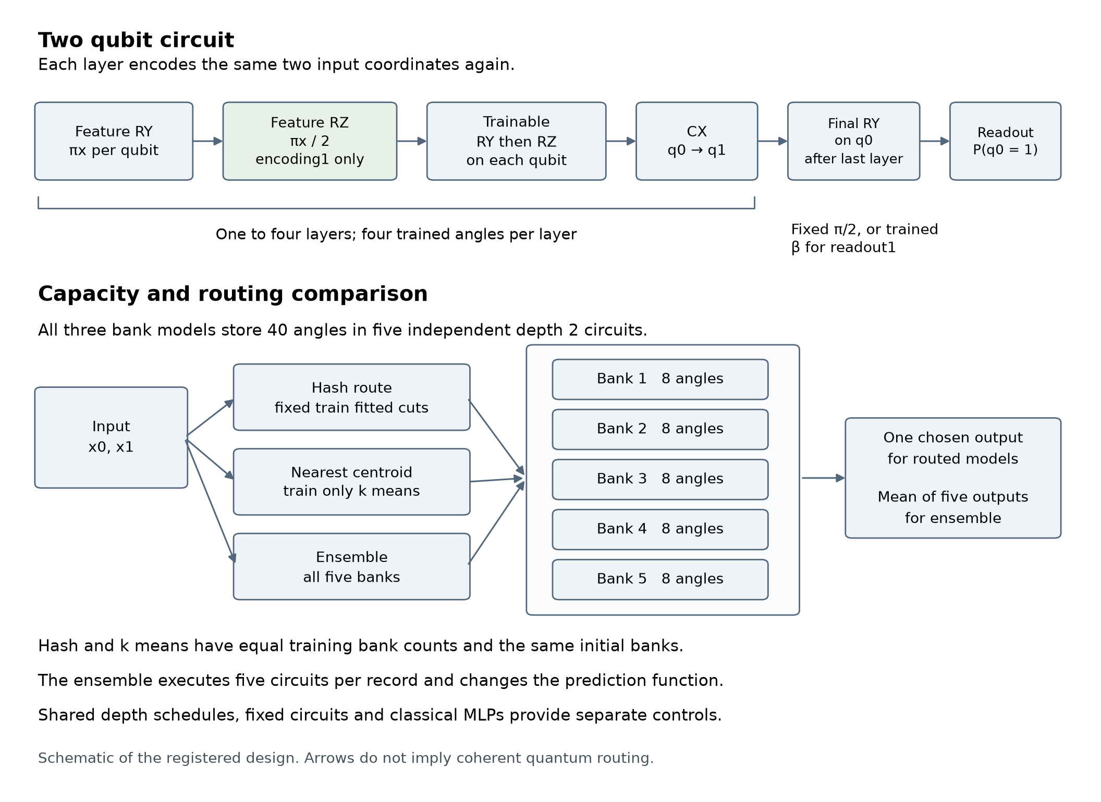
Registered architecture. The upper path describes each two qubit circuit; the lower path compares classical allocation of independent banks.
Each two qubit layer re-encodes the two coordinates with feature RY gates, applies trainable RY and RZ rotations on each qubit, and applies one CX. A final RY on qubit zero precedes the probability readout. The original architecture already re-uploads the inputs at every layer.
The encoding variant adds a fixed feature RZ with angle pi times the coordinate divided by two, between feature RY and the trained rotations. It retains four trained angles and adds two logical gates. The readout variant trains the final rotation, initialized at pi divided by two, rather than keeping it fixed. It has five trained angles and the same inference gate count as fixed depth one.

The thirteen model comparisons
Model | Circuit angles or MLP weights | Executed circuit depth | Selection or change
Shared schedule | 16 | 1 to 4 | Original random allocation class
Minimum depth 2 | 16 | 2 to 4 | Raise original depth 1 to 2
Untied assigned | 40 | 1 to 4 | Separate banks for each depth
Fixed depth 1 | 4 | 1 | One circuit for every record
Fixed depth 2 | 8 | 2 | One circuit for every record
Fixed depth 4 | 16 | 4 | One circuit for every record
Extra encoding | 4 | 1 | Two extra fixed feature gates
Trainable readout | 5 | 1 | One extra trained angle
Hash banks | 40 | 2 | One of five banks by coordinate hash
K means banks | 40 | 2 | One of five banks by nearest centroid
Five bank ensemble | 40 | 2 per bank | All five banks per record
Classical MLP 41 | 41 | Not applicable | Six inputs and five hidden units
Classical MLP 129 | 129 | Not applicable | Six inputs and sixteen hidden units

Hash, k means and ensemble models share five independently initialized depth two banks with 40 circuit angles. Hash and k means evaluate one selected bank per record. The ensemble evaluates every bank and optimizes cross entropy of their mean probability. This changes both the prediction function and each bank’s exposure, and executes five forward circuits per record. Routing is a classical choice; the design does not coherently superpose routing paths.
The bank comparison matches circuit angles, starting banks and total training occupancy per bank for hash and k means. It does not match total functional capacity. K means adds ten fitted centroid coordinates and a spatial partition; hash uses four train fitted occupancy cutpoints and a fixed salt. Both routing functions operate on raw coordinates without labels, target radius, record IDs or split membership.
The MLP controls receive both coordinates and a four element one hot representation of the original random depth. The extra allocation information has no designed relationship to the target. Parameter counts across a neural network, a circuit and a fitted router are not interchangeable measures of expressiveness or cost.

Fresh data and frozen training
The target is membership of a circle inside a uniformly sampled square. The square coordinates lie between minus one and one; class one has squared radius below two divided by pi. Eight independent allocation classes map to original depths 4, 4, 3, 3, 2, 2, 1 and 1. They are random categories, not measured semantic priorities.
Engineering, development and confirmation each contain 4800 training records, 1600 validation records and 1600 sealed test records. All 24000 coordinates are new relative to 32000 unique historical coordinates and to each other. The exact byte comparison normalizes signed zero. There were no rejected draws. This is exact duplicate exclusion on a single generator, not a near duplicate or new domain evaluation.
K means uses twenty deterministic restarts on training coordinates only. Its centroid ordering, tie rules and empty cluster handling are fixed in source. Hash cutpoints match k means training bank counts exactly. Validation and test use these fixed policies without rebalancing. Router preparation costs and held out occupancies are retained in the evidence.
Development uses seeds 501 to 503 and confirmation uses 601 to 605. Every one of the thirteen registered arms continues to confirmation regardless of its development ranking: 39 development and 65 confirmation runs. Each run has 200 rounds of Adam, 15000 optimizer updates, batch size 64 and learning rate 0.01, with no warmup. Every round visits all 4800 training records in the paired shuffled order. Adam uses betas 0.9 and 0.999, epsilon 1e-8 and no weight decay.
The selected checkpoint minimizes full validation binary cross entropy over all 200 rounds, breaking exact ties at the earliest round. This is a selection rule, not an early stopping rule. Every completed run incurs 960000 model record visits and its entire training budget, even when the selected checkpoint is earlier.
All source, data, analysis and evaluation contracts were hash-bound. The development endpoints are author-audited and independently audited before confirmation is approved. All 65 complete confirmation endpoints and their checkpoint choices are checked before root releases the held out evaluator. Separate matrix and scalar implementations then replay all predictions and registered statistics. The data seal is procedural, not encryption: provenance checks inspect data identities; the protected event is model inference on test records.

Confirmation outcomes
Values are mean ± sample standard deviation across five trained seeds. F1 and accuracy are percentages. The selected checkpoint minimizes validation BCE; all columns below use its single released test evaluation. F1 uses the saved canonical probabilities. The numerical sensitivity section qualifies any predictions unresolved at the hard decision threshold.
Model | Test BCE | Macro F1 percent | Accuracy percent
Shared schedule | 0.513 ± 0.006 | 72.53 ± 2.16 | 72.55 ± 2.14
Minimum depth 2 | 0.417 ± 0.007 | 83.38 ± 1.47 | 83.40 ± 1.46
Untied assigned | 0.381 ± 0.002 | 82.83 ± 0.26 | 82.86 ± 0.26
Fixed depth 1 | 0.681 ± 0.000 | 53.40 ± 0.19 | 53.41 ± 0.19
Fixed depth 2 | 0.289 ± 0.000 | 90.34 ± 0.24 | 90.41 ± 0.24
Fixed depth 4 | 0.267 ± 0.028 | 94.06 ± 2.03 | 94.06 ± 2.03
Extra encoding | 0.509 ± 0.001 | 81.88 ± 0.60 | 82.10 ± 0.62
Trainable readout | 0.517 ± 0.000 | 73.77 ± 0.03 | 73.77 ± 0.03
Hash banks | 0.290 ± 0.000 | 90.10 ± 0.12 | 90.18 ± 0.12
K means banks | 0.190 ± 0.013 | 97.42 ± 0.24 | 97.42 ± 0.24
Five bank ensemble | 0.289 ± 0.000 | 90.34 ± 0.24 | 90.41 ± 0.24
Classical MLP 41 | 0.077 ± 0.017 | 96.42 ± 0.85 | 96.43 ± 0.85
Classical MLP 129 | 0.027 ± 0.002 | 98.70 ± 0.20 | 98.70 ± 0.20

The original shared schedule reached 72.53 percent F1, the minimum depth two schedule 83.38 percent, and untied assigned banks 82.83 percent. Uniform depth two reached 90.34 percent and uniform depth four 94.06 percent. The spatially routed depth two model therefore exceeded the deeper uniform model on this test while executing a shorter circuit for each record.
Allocated circuit angles alone did not explain performance. Hash, k means and ensemble variants each allocated forty angles, yet their mean F1 values were 90.10, 97.42 and 90.34 percent. Their routing, per bank example exposure and executed work differ. Equal parameter counts are a control for one aspect of the model, not equality of total functional capacity.

Variation across trained seeds
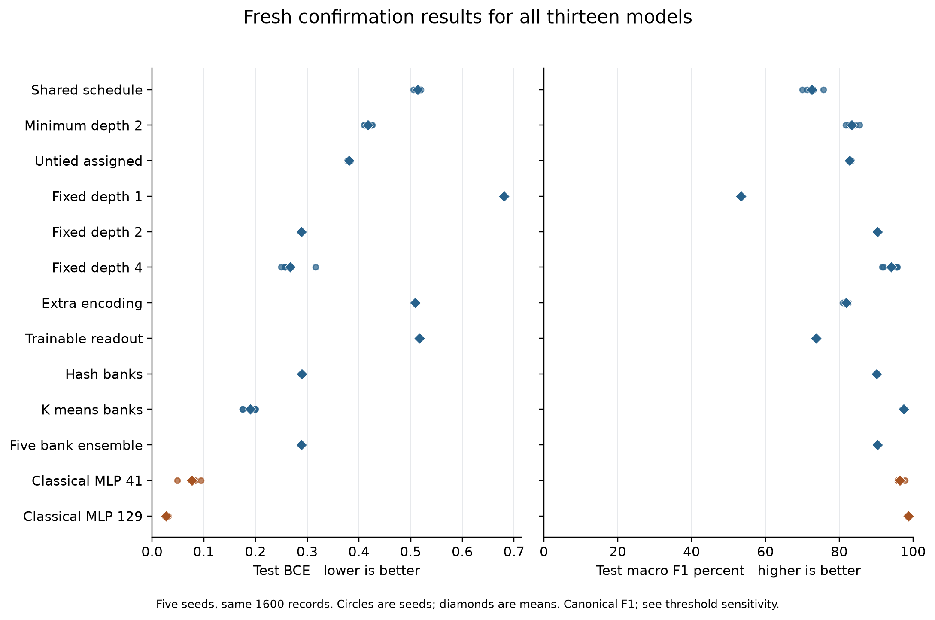
Confirmation test results for all thirteen models. Individual seeds remain visible so the mean does not hide unstable optimization.
K means routing had a test F1 sample standard deviation of 0.24 percentage points, with individual results from 97.06 to 97.62 percent. Its BCE varied more visibly, from approximately 0.1751 to 0.1997. Fixed depth four had a larger F1 standard deviation of 2.03 points and individual scores from 91.69 to 95.69 percent. Five seeds expose these differences but do not characterize the entire optimization distribution.
The same 1600 test records are reused across models and training seeds. They do not form 8000 independent tests of each architecture. Individual endpoint predictions, confusion matrices and selected checkpoint identities are retained in the evidence package.

Numerical threshold verification
The first full development endpoint audit failed on seed 502 of the untied assigned model. Its one layer bank produced probabilities numerically indistinguishable from 0.5. Independent implementations agreed on probabilities to about 15 decimal places and on BCE, but their floating point rounding produced different decisions at the hard 0.5 threshold. The author reference differed on 66 records; a separately implemented reference differed on 105. Both disagreements were confined to the same near chance branch.
This is a limitation of classification at a numerically unresolved threshold. The original failed audit and all original verification code were preserved. Before confirmation began, a documented verification amendment introduced a fixed ambiguity band of 32 times float64 epsilon, approximately 7.1e-15, around 0.5. This is an engineering convention, not a proof of a numerical error bound or a statistical interval. Every allowed decision disagreement must have both probabilities inside the band; discrepancies outside it still fail.
Canonical probabilities, the original p at least 0.5 decision rule, recorded F1, training source, budgets, checkpoint selection and primary BCE analysis remain unchanged. Canonical classification metrics are reconstructed exactly from saved probabilities. Independent probability and BCE agreement are checked separately, with all raw reference classification differences retained. Passing this amended verification does not mean exact classifier agreement.
Sensitivity calculations hold all resolved canonical decisions fixed and vary only records whose saved probability falls inside the band. Assigning these records all to class zero or all to class one gives two alternative conventions. Assigning all of them incorrectly or correctly gives pessimistic and optimistic numerical sensitivity extrema using labels for diagnosis. These are neither trained alternatives nor confidence intervals, and no favorable case replaces the canonical result.

Confirmation threshold sensitivity
Across all 104000 checkpoint record pairs, the official matrix reference found 0 class disagreements, with 0 outside the fixed ambiguity band. The separate tensor reference found 0 disagreements, with 0 outside the band. These implementations can round differently within the band; neither replaces the canonical decisions.
Canonical probabilities fell inside the band for 0 checkpoint record pairs; the official reference count was 0 and their union was 0. Counts reuse the same test records across checkpoints and are not independent sample sizes. Endpoint, original depth and route counts are saved with each report.
Model | Canonical F1 | Band to zero | Band to one | Diagnostic minimum | Diagnostic maximum
Shared schedule | 72.53 | 72.53 | 72.53 | 72.53 | 72.53
Minimum depth 2 | 83.38 | 83.38 | 83.38 | 83.38 | 83.38
Untied assigned | 82.83 | 82.83 | 82.83 | 82.83 | 82.83
Fixed depth 1 | 53.40 | 53.40 | 53.40 | 53.40 | 53.40
Fixed depth 2 | 90.34 | 90.34 | 90.34 | 90.34 | 90.34
Fixed depth 4 | 94.06 | 94.06 | 94.06 | 94.06 | 94.06
Extra encoding | 81.88 | 81.88 | 81.88 | 81.88 | 81.88
Trainable readout | 73.77 | 73.77 | 73.77 | 73.77 | 73.77
Hash banks | 90.10 | 90.10 | 90.10 | 90.10 | 90.10
K means banks | 97.42 | 97.42 | 97.42 | 97.42 | 97.42
Five bank ensemble | 90.34 | 90.34 | 90.34 | 90.34 | 90.34
Classical MLP 41 | 96.42 | 96.42 | 96.42 | 96.42 | 96.42
Classical MLP 129 | 98.70 | 98.70 | 98.70 | 98.70 | 98.70

Entries are mean F1 percentages across five checkpoints. The last two columns are label-assisted sensitivity extrema, not trained alternatives or uncertainty intervals. No confirmation prediction was ambiguous, so all four cases equal the canonical result. No BCE is assigned to hypothetical class vectors. Full per-seed diagnostics are retained.

Primary comparisons and uncertainty
Binary cross entropy is the primary metric, with probabilities clipped to the interval from 1e-7 to 1 minus 1e-7. It scores probability quality, including confidence in errors, and lower is better. Macro F1 and accuracy at a probability threshold of 0.5 are secondary. The three primary comparisons are minimum depth two against the original schedule, trained readout against fixed depth one, and k means against hash banks.
First model minus second | Mean BCE difference | Seed interval 98.333 percent | Record interval 98.333 percent
Minimum depth 2 minus Shared schedule | -0.0964 | [-0.1130, -0.0799] | [-0.1164, -0.0764]
Trainable readout minus Fixed depth 1 | -0.1637 | [-0.1643, -0.1631] | [-0.1958, -0.1267]
K means banks minus Hash banks | -0.1000 | [-0.1232, -0.0769] | [-0.1139, -0.0873]

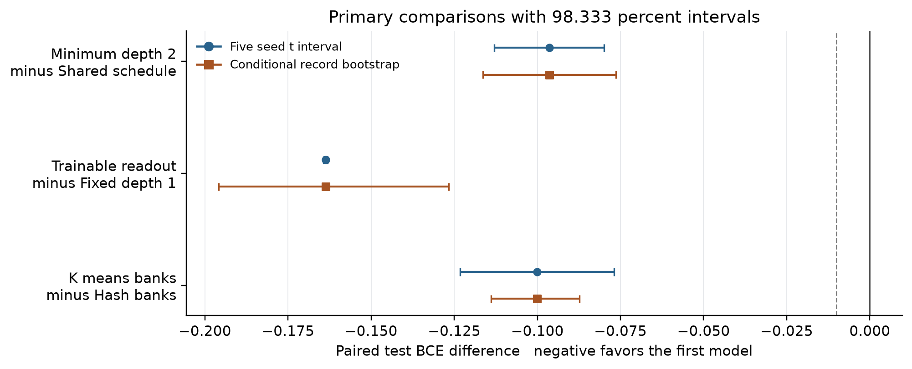
Primary paired BCE comparisons. Blue shows seed uncertainty; orange shows conditional record uncertainty. The dashed line marks the registered minus 0.01 practical magnitude.
The minimum depth intervention reduced BCE by 0.0964, the trained readout by 0.1637, and k means routing by 0.1000 relative to their respective controls. All adjusted seed and conditional record intervals are entirely below minus 0.01. These are consistent improvements within the registered task, model families and training schedule; they do not measure general gains across datasets.
For k means versus hash routing, the descriptive paired F1 gain was 7.32 points, with a 95 percent seed interval from 7.17 to 7.48 points and a separate conditional record interval from 6.09 to 8.71 points. The primary claim rests on BCE; these secondary F1 intervals are descriptive.

How to read the uncertainty
The replication unit is a trained model seed. Primary paired BCE differences have Bonferroni adjusted 98.333 percent Student t intervals with four degrees of freedom. Ordinary 95 percent seed intervals are descriptive. A separate 2000 replicate paired record bootstrap resamples the same test indices for every model and seed, recomputes each checkpoint metric, and averages seeds. Its intervals are conditional on fixed models and this test population; they exclude training, router fit, selection and new task uncertainty.
The registered practical magnitude is a mean BCE reduction of at least 0.01. Report its size separately from the uncertainty interval. An interval crossing zero or the practical threshold does not establish equivalence. Secondary contrasts and validation milestones are descriptive and do not inherit the primary family’s error control.

All registered secondary comparisons
First minus second | BCE difference | Seed 95 percent interval | F1 difference pp
Extra encoding minus Fixed depth 1 | -0.1717 | [-0.1733, -0.1701] | +28.48
Fixed depth 2 minus Fixed depth 1 | -0.3921 | [-0.3924, -0.3919] | +36.94
Fixed depth 4 minus Fixed depth 2 | -0.0213 | [-0.0555, 0.0128] | +3.72
Hash banks minus Fixed depth 2 | 0.0011 | [0.0009, 0.0014] | -0.24
K means banks minus Fixed depth 2 | -0.0989 | [-0.1154, -0.0825] | +7.08
Five bank ensemble minus Fixed depth 2 | 0.0000 | [-0.0000, 0.0000] | +0.00
Five bank ensemble minus Hash banks | -0.0011 | [-0.0014, -0.0009] | +0.24
K means banks minus Untied assigned | -0.1910 | [-0.2084, -0.1735] | +14.59
K means banks minus Fixed depth 4 | -0.0776 | [-0.1099, -0.0453] | +3.36
K means banks minus Classical MLP 129 | 0.1622 | [0.1461, 0.1784] | -1.28
K means banks minus Classical MLP 41 | 0.1130 | [0.0844, 0.1416] | +1.00
Untied assigned minus Shared schedule | -0.1328 | [-0.1395, -0.1260] | +10.31

Secondary intervals are descriptive and not adjusted for the number of comparisons. Full paired seed values and separate conditional bootstrap intervals for all metrics are in quantum/confirmation_evaluation/summary.json. A positive F1 difference favors the first model; a negative BCE difference favors it.

Mechanism diagnostics
Raising the minimum depth from one to two helps without adding allocated angles, but adds circuit work and changes shared optimization. Untying banks also helps relative to the original schedule while retaining a weak one layer branch. Neither intervention matches spatially routed depth two.
Fixed depth one reached 53.40 percent F1, extra encoding 81.88 percent and trained readout 73.77 percent. Analytic checks show that added RZ encoding changes the feature functions and trained readout adds a measurement component. The original already reuploads features. Extra encoding retains a one layer product structure separable across coordinates, limiting its decision geometry for a circle. This does not establish a numeric performance ceiling.
K means and hash share five depth two banks, initialization, angle budget and global record order, executing one bank per record. Geometric routing changes which examples reach each bank and adds a classical spatial partition with ten centroid coordinates. The gain belongs to this complete routing system; it is not evidence of uniquely quantum computation.
Ensemble and fixed depth two made identical class decisions on all 8000 paired checkpoint record comparisons. Their maximum probability gap was about 3.55e-6 and mean BCE difference 1.44e-8 despite distinct initial banks. This shows no useful ensemble gain here; it does not prove internal bank collapse or rule out gains elsewhere.

Test macro F1 by original allocation depth
Model | Original 1 | Original 2 | Original 3 | Original 4
Shared schedule | 51.92 | 77.35 | 79.47 | 81.77
Minimum depth 2 | 93.22 | 90.08 | 69.32 | 80.05
Untied assigned | 56.06 | 89.01 | 93.65 | 93.63
Fixed depth 4 | 94.65 | 92.66 | 94.96 | 93.99
K means banks | 97.76 | 97.09 | 97.92 | 96.95

Rows are means across the five checkpoints; subgroups are the original random allocation depths, including for models that change executed depth. They are diagnostic slices of the same test population. All per route results and training gradient diagnostics are retained; these slices are not additional independent experiments.
The original schedule scored only 51.92 percent F1 on records originally allocated to depth one. Minimum depth two raised that subgroup to 93.22 percent, but its original depth three subgroup scored 69.32 percent. Changing a shared prefix can redistribute performance across allocations; subgroup changes are not isolated causal effects. K means routing scored between 96.95 and 97.92 percent across the four original depth groups, consistent with using input geometry instead of the random allocation label.

Learning through the full budget
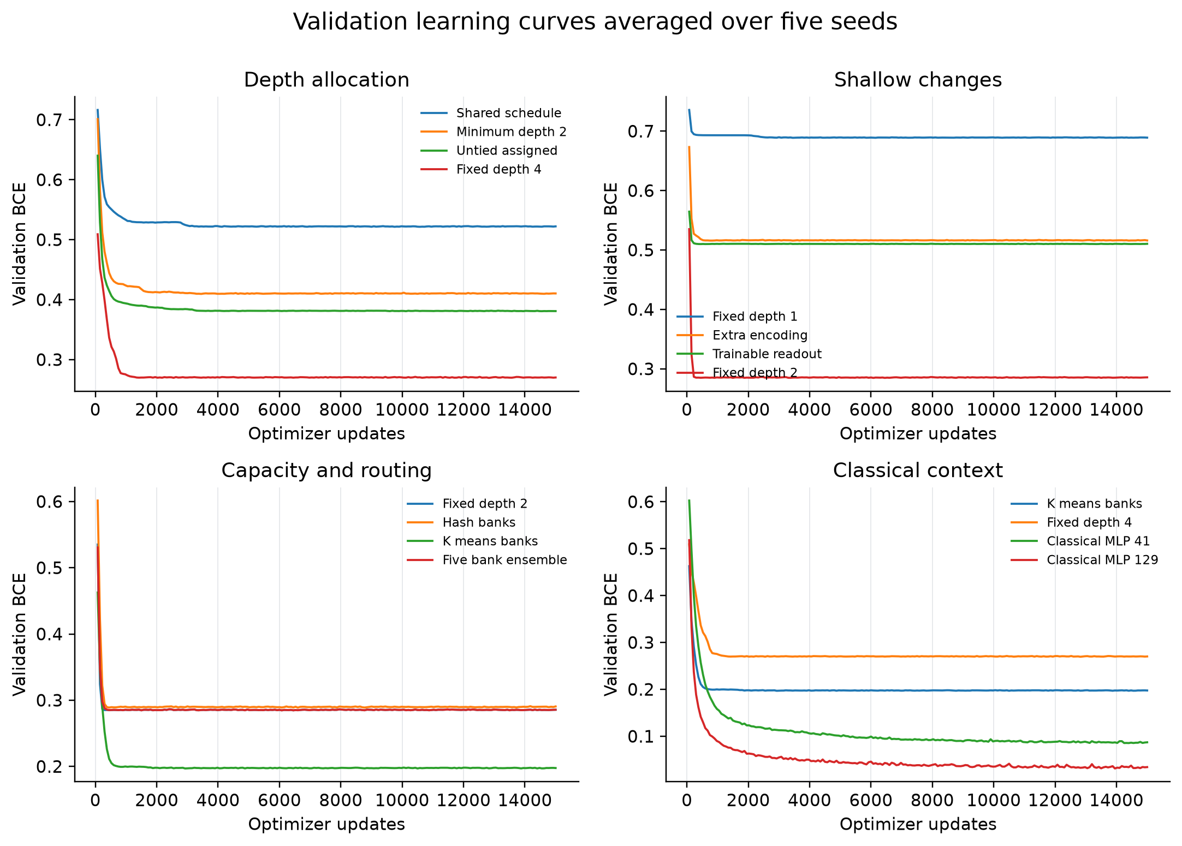
Mean validation BCE at each of the 200 logged rounds. Each panel uses all five confirmation seeds and every model still completes 15000 updates.
The curves show rapid initial learning followed by model dependent plateaus and fluctuations. Checkpoint selection is based on validation BCE, so a later or earlier F1 peak is not substituted into the results. Selected rounds ranged widely: k means chose rounds 192, 23, 39, 140 and 195, while fixed depth four chose 172, 163, 17, 19 and 151. All runs still incurred the complete 200 round budget.
The ensemble and fixed depth two models selected the same round within each seed. Their final test similarity and overlapping validation trajectories are consistent observations under this training setup, rather than a reason to omit either registered arm.

Steps to a target score
The supplement added during development counts validation steps to 97 percent macro F1. Checks occur every 75 updates. It records first attainment and the first three consecutive checks; confirmation occurs 150 updates after that run begins, and scores can decline later.
Nonreachers remain explicit at the 15000 update horizon. Medians describe reaching seeds only. This diagnostic neither selects checkpoints nor reduces budgets, and does not imply the same test score. Compare steps with record visits, circuit work and time because updates have different costs.
Model | First reached | First update median | Three checks reached | Confirmed update median
Shared schedule | 0/5 | Not reached | 0/5 | Not reached
Minimum depth 2 | 0/5 | Not reached | 0/5 | Not reached
Untied assigned | 0/5 | Not reached | 0/5 | Not reached
Fixed depth 1 | 0/5 | Not reached | 0/5 | Not reached
Fixed depth 2 | 0/5 | Not reached | 0/5 | Not reached
Fixed depth 4 | 0/5 | Not reached | 0/5 | Not reached
Extra encoding | 0/5 | Not reached | 0/5 | Not reached
Trainable readout | 0/5 | Not reached | 0/5 | Not reached
Hash banks | 0/5 | Not reached | 0/5 | Not reached
K means banks | 5/5 | 825 | 2/5 | 5,025
Five bank ensemble | 0/5 | Not reached | 0/5 | Not reached
Classical MLP 41 | 2/5 | 5,925 | 1/5 | 3,600
Classical MLP 129 | 5/5 | 450 | 5/5 | 750

K means first reached 97 percent validation F1 in all five seeds, at a median of 825 updates. Only two seeds confirmed three consecutive checks, at 3075 and 6975 updates. Their conditional median of 5025 is not a five-seed attainment estimate. First crossing alone overstates persistence.
The larger MLP reached the target in all five seeds: median first crossing 450 updates and confirmation 750. The smaller MLP reached it in two seeds and confirmed it in one. Every other circuit model remained below the target throughout the logged horizon. These are validation observations, not realized early stopping savings.

The v02 text milestone question
We can count optimizer updates to a chosen F1 target when validation scores are logged during training. A retrospective extraction of the sealed v0.2 ledgers found median first post branch validation crossings of 97 percent at 3000 total updates for shared and current content routing, and 3300 for hash18. All five seeds reached the target after branching. These totals include 1000 common warmup updates; later validation was checked every 100 main updates.
Three common warmup runs had already crossed 97 percent before branching, so the later crossings cannot be treated as each full trajectory’s earliest attainment or as evidence of a routing speed advantage. Requiring three consecutive checks gave median confirmation totals of 4600, 4200 and 4000 updates respectively. The first of those three checks occurs 200 updates earlier. All models still ran their full registered budget. These are post hoc validation diagnostics, not earlier test scores or demonstrated early stopping savings.
Classical text model | First post branch median updates | Three check confirmation median updates
Shared | 3000 | 4600
Current content | 3000 | 4200
Hash18 | 3300 | 4000

This read only retrospective extraction covers all 20 relevant v0.2 ledgers and 1550 logged checks. An independent replay verified the crossings and medians. It does not modify the sealed baseline. The original final test endpoints charged 1000 shared warmup updates plus 10000 main updates per model.
For future studies, select a target and a persistence rule before training, record validation at a common cadence, retain nonreachers, and report updates, record visits, circuit work and wall time together. A prospective stopping rule would need a separate registered experiment to measure actual savings.

Computation and timing
All circuit training and inference in this study are classical CPU simulation. Seed workers use one BLAS thread each and run concurrently. Model order is cyclic by seed, which only partly balances order. Recorded timings describe this host and execution schedule; they are not isolated throughput measurements, quantum processor runtime estimates, energy measurements or currency costs.
Model | Charged seconds | Training circuits millions | Training CX millions | Inference microseconds per record
Shared schedule | 315.8 | 20.09 | 59.80 | 1.652
Minimum depth 2 | 322.5 | 22.06 | 65.97 | 1.614
Untied assigned | 613.5 | 20.09 | 59.80 | 2.657
Fixed depth 1 | 35.3 | 8.64 | 8.64 | 0.758
Fixed depth 2 | 111.4 | 16.32 | 32.64 | 1.523
Fixed depth 4 | 388.2 | 31.68 | 126.72 | 2.227
Extra encoding | 44.0 | 8.64 | 8.64 | 1.053
Trainable readout | 43.8 | 10.56 | 10.56 | 0.825
Hash banks | 464.8 | 16.32 | 32.64 | 4.015
K means banks | 447.9 | 16.32 | 32.64 | 3.014
Five bank ensemble | 498.4 | 81.60 | 163.20 | 4.814
Classical MLP 41 | 2.0 | Not applicable | Not applicable | 0.102
Classical MLP 129 | 2.0 | Not applicable | Not applicable | 0.113

Per model values are means over five runs. Circuit and CX counts include training parameter shifts; they exclude validation and audits. MLPs use classical operations and therefore have no circuit count. Inference is the mean of three timed vectorized 1024 record fixture passes, with route calculation included where relevant.
Per training run, fixed depth two, hash routing and k means routing each executed 16.32 million circuit evaluations and 32.64 million CX applications, including parameter shifts. The ensemble used five times those totals: 81.60 million and 163.20 million. That additional work produced no useful observed improvement over fixed depth two.

Cost boundaries and execution record
Recorded charged training time averaged 447.90 seconds for k means routing, 111.43 seconds for fixed depth two and 2.01 seconds for the larger MLP. The equal circuit counts of routed and single bank models do not make this implementation equally fast: bank dispatch and smaller per bank arrays add overhead. Uncached vectorized inference averaged 3.01 microseconds per record for k means, 1.52 for fixed depth two and 0.113 for the larger MLP. These host-specific concurrent measurements show no classical simulation speed advantage for the circuit model.
Training work includes the base probability and parameter shift evaluations. One layer with four trained angles costs nine circuit evaluations per record per gradient; the five angle readout costs eleven. A bank ensemble executes all five branches. Allocated angle count therefore cannot substitute for executed circuit, layer or gate counts.
Preparation charged to each arm includes the applicable generation, router fitting and route cache costs. Those repeated accounting charges are not project wall time. Training, repeated validation, selected validation replay, gradient diagnostics, inference and verification have separate counters. The inference fixture contains a warmup and three timed passes on 1024 validation records, plus an additional cached comparison forward reconstructed by the documented accounting addendum. Its separate elapsed time was not measured; total endpoint time already includes it.
Development completed all 39 runs in 37.26 minutes and confirmation all 65 in 55.19 minutes of stage wall time. All seed workers exited successfully. The initial strict development endpoint audit failed on the documented numerical threshold case; its failed lock, traceback, independent diagnoses and original verification code remain preserved. A verification-only amendment was approved and peer reviewed before confirmation. No training restart, budget change or test-driven model change was made.
The endpoint audits checked complete ledgers, declared optimizer counts, record order, checkpoints, minimum validation BCE selection and resource identities. They independently regenerated selected validation probabilities. They were not a second execution of every optimizer update, and intermediate validation probabilities were not independently regenerated because per-round probability files were not saved.
Observed confirmation stage wall time was 55.19 minutes. This is distinct from sums of concurrent per arm times or repeatedly charged preparation costs.

Local runtime
CPU simulation used Python 3.12.14, NumPy 2.5.4, SciPy 1.18.1, Qiskit 2.6.0 and Qiskit Aer 0.17.2 on the local AMD Ryzen AI 9 HX 370 host. No package installation was required. The existing v0.1 environment was used read only. Runtime metadata, the observed package inventory, commands and process logs are included.

Local circuit readiness
The predetermined local readiness methods are extra encoding, trainable readout and k means banks. The fixture takes the union of the smallest validation record ID in each original allocation class and in each k means bank. No label or model outcome chooses the fixture. Matrix and Qiskit probabilities are compared, and Aer supplies actual local simulated measurement counts at 1024 and 4096 shots.
Check | Measured result
Committed checkpoint circuits | 150
Maximum Aer probability difference | 1.11e-15
Local Aer simulated measurement shots | 3,840,000
Hoeffding smoke flags | 0
Matrix exact status | PASS
Shot smoke status | PASS

The RY, RZ and CX compilation target is a simulator basis, not a chosen physical IBM instruction set. There is no device noise, calibration, connectivity or queue model. Passing these checks establishes local implementation consistency and ideal shot sensitivity only; it does not authorize or validate a hardware experiment.
The completed fixture covered ten validation records, three predetermined methods and five trained seeds: 150 circuits. All 300 matrix comparisons, 150 Aer exact probability checks and 1500 shot comparisons passed. The maximum compiled unitary difference was 3.37e-13, below the registered 1e-10 tolerance. The shot checks used 3.84 million simulated measurements and produced no Hoeffding flags.
This supports the correctness of the local circuit translation and measurement plumbing. It does not establish that the observed routing gain will survive a physical device, nor that either one layer variant is an effective replacement for the best circuit model.

Ideal finite shot sensitivity
The later full test sensitivity analysis draws binomial counts directly from verified ideal probabilities, using five measurement seeds within each of five trained checkpoints and independent draws at each shot budget. Those are probability level simulations, not Aer circuit executions or physical measurements. Twenty five nested repetitions are not twenty five independent trained models.
Model | Shots per record | BCE | Macro F1 percent | Prediction flips percent
Extra encoding | 1,024 | 0.509 ± 0.001 | 82.06 ± 1.00 | 3.828
Extra encoding | 4,096 | 0.509 ± 0.001 | 82.17 ± 0.74 | 2.222
Trainable readout | 1,024 | 0.518 ± 0.000 | 73.88 ± 0.10 | 0.990
Trainable readout | 4,096 | 0.517 ± 0.000 | 73.75 ± 0.07 | 0.483
K means banks | 1,024 | 0.190 ± 0.013 | 97.49 ± 0.32 | 0.653
K means banks | 4,096 | 0.190 ± 0.013 | 97.46 ± 0.30 | 0.315

Mean ± sample standard deviation is calculated over five checkpoint means, each averaging five measurement repetitions. The ideal comparator uses the same checkpoint probabilities without sampling. Flips compare sampled class decisions with those ideal decisions. Random seeds and all 150 integer count arrays are saved and independently reproduced.
K means routing averaged 97.49 percent F1 at 1024 shots and 97.46 percent at 4096 shots, versus 97.42 percent for ideal probabilities. Mean decision flips fell from 0.65 to 0.32 percent. These small sampled F1 increases are not evidence that noise improves the model; the nested uncertainty in the paired changes includes zero.
Extra encoding had more decisions close enough to the boundary for finite shots to matter: mean flips were 3.83 percent at 1024 shots and 2.22 percent at 4096. This is ordinary measurement sampling sensitivity and is distinct from the approximately 7e-15 numerical verification band, which contained no confirmation predictions. No device noise was simulated.

Limitations and next experiment
This is a small binary synthetic task with one confirmation population and five training seeds. The circle geometry is known to the study designers, although it is not supplied to either router. The fitted spatial partition can itself contribute substantial classical capacity. No result here establishes quantum advantage, general language model quality or transfer to a new task.
The controls reduce specific ambiguities without eliminating every one. Readout adds a trainable parameter; minimum depth raises work; encoding adds gates; routing changes conditional exposure and a classical partition; the ensemble changes both the function and compute. Paired seeds share initial banks and order within a seed but the small seed sample and t assumptions limit inference. Test bootstrap and seed intervals answer different conditional questions.
A validation selected checkpoint can have a different F1 ranking from a BCE ranking, and a first threshold crossing need not persist. The reported milestones retain the fixed full training charge. Test results are used for reporting and verification, with no test driven retraining or checkpoint changes.

Recommended next work
First, replicate k means routing on fresh populations and additional seeds while adding classical models with the identical frozen spatial partition. Include simple per-bank classical and explicit trigonometric feature controls. Match active work, training exposure and total classical router capacity as well as allocated parameters. This will test whether the benefit comes primarily from the partition, the circuit function, or their interaction.
Second, retain fixed depth two and the larger MLP as practical references. Do not expand the five bank ensemble on the strength of these results. Use the one layer encoding and readout variants as mechanism controls; further changes should be preregistered and compared at explicit gate and shot budgets. Inspect predicted probability quality alongside F1 rather than optimizing only a threshold score.
Third, register a prospective validation stopping rule if time to a target is a research objective. Retain nonreachers and measure realized wall time and circuit work. The current retrospective milestone counts cannot claim compute saved by stopping early.
Keep IBM execution as a later, separately approved experiment. Before submission, choose a physical backend, map its native gates and connectivity, record calibration and noise assumptions, and set a fixed shot and cost budget. A small fixed depth two versus routed depth two inference capsule is a reasonable candidate only after the classical attribution controls and local noise study are assessed.

Evidence and reproduction
Independent replay verified all 65 endpoints and 104,000 prediction records, with maximum probability difference 5.22e-15. All independent class decisions agreed with the canonical decisions: 0 disagreements and 0 outside-band disagreements. Canonical class metrics were reconstructed exactly. Replay separately recomputed the registered statistics, numerical sensitivity results and all finite shot count arrays.
Independent analysis reproduced all 150 integer shot-count arrays and passed 412 statistical comparisons plus 143 numerical-summary aggregate comparisons. The original sealed v0.2 manifest was checked again after the study: all 3639 payloads matched. The final report and reproducible source, data, logs, checkpoints and analysis are delivered separately under version 0.3.
The preserved development failure, amendment, runtime records and full endpoint evidence are included so that a reviewer can distinguish original registration from later verification recovery. Final package hashes support byte-level checking; they are not an external signature or an atomic filesystem snapshot.
Evidence | Package location
Frozen design and analysis | governance/STUDY_PLAN.json and ANALYSIS_PROTOCOL.json
Numerical amendment and preserved failure | governance/NUMERICAL_RECOVERY_PROTOCOL_01.json and recovery_01
Data and fixed routing policies | quantum/data
Training source and tests | quantum/qstudy.py and quantum/tests
Full ledgers and checkpoints | quantum/stage_A and stage_B
Endpoint locks and test release | quantum/STAGE_A_ENDPOINT_LOCK.json, CONFIRMATION_ENDPOINT_LOCK.json and EVALUATION_RELEASE.json
Test predictions and statistics | quantum/confirmation_evaluation
Independent audits and replay | analysis/classical_review and analysis/independent_replay
Learning and resource supplement | analysis/learning_resources_B/learning_resources.json
Report sources and figures | report_work
Baseline integrity | governance/baseline_v02_before.json and baseline_v02_after.json

Use the package README and governance/Verify_Delivery.ps1 to verify delivered bytes. Existing launchers refuse to overwrite completed stages. A fresh reproduction requires an isolated copy and new stage and release records; do not rerun training inside the sealed study. The environment and original path references are recorded, but the package does not bundle an entire Python environment.

Study v0.3 report edition note
Report edition 1 prepared 29 October 2026. Repository edition v1.0 is separate from study v0.3.
Anthony Siljeg — Founder, Alnotrea Labs · Company affiliation: Alnotrea Pty Ltd · Q-Pathformer Initiative. Anthony Siljeg is the licensor; company affiliation does not transfer ownership.
The preceding historical report is preserved in full, including its results, figures, tables, limitations, internal labels and recommendations. Those labels describe the original study. This edition appends this note and updates descriptive metadata only. It does not claim new experiments, hardware execution or present-day device qualification.
Controlled original report prose, table presentation and original report figures are licensed under CC BY 4.0 by Anthony Siljeg, as identified in the accompanying report scope and adoption records. https://creativecommons.org/licenses/by/4.0/ . Previously applicable grants remain in force for inherited expression. This report grant does not cover datasets, third-party dependencies, software, model artifacts, architecture documents or complete archives.
Original source: QPATH-RPT-004_Shallow_Circuits_and_Routing_Study_v0.3.docx. Original SHA-256: 52ff262ec7e7c0685ec330032e959837ec8f1794ed223024775f21fbf773d838. See the accompanying edition-change and source records for the preservation checks.

