Q Pathformer improvement study
  - QPATH RPT 003 | Version 0.2 | 19 October 2026
INTERNAL RESEARCH REPORT • Prepared for Anthony Siljeg

Decision from the completed study
Keep the shared adapter as the practical text baseline. Hash routing produced a very small mean macro-F1 increase, with no resolved quality benefit and a mixed cost result. For the synthetic quantum task, independent depth-specific parameter banks substantially improved the original shared schedule, but the fixed four-layer circuit and matched-information classical MLP remained stronger.
Primary comparison | Measured change and paired seed 95% interval | Interpretation
Text: Hash18 minus current content | Macro F1 +0.0169 percentage points  95% interval −0.1102 to +0.1441 | No resolved quality benefit
Quantum: untied assigned minus shared schedule | BCE −0.14441  95% interval −0.15434 to −0.13449 | Consistent improvement on this synthetic task

All registered development and confirmation work finished: 27 text runs plus eight common warmups, and 67 quantum runs. Confirmation comprises 15 text and 40 quantum endpoints across five fresh training seeds per method. No training run failed, was censored or required recovery. Test evaluation followed independent completion checks and separate root-authorized releases.
Independent replay matched all 210,000 text predictions exactly and all 64,000 quantum probabilities within 4.78 × 10⁻¹⁵. Both tasks used fresh evaluation records. The 2,081 payload hashes in the sealed v0.1 benchmark were checked again and all matched.
Text macro F1 averaged 97.602% for shared, 97.642% for current content and 97.659% for Hash18. Quantum macro F1 averaged 71.83% for the shared schedule, 81.44% for untied assigned, 93.32% for fixed depth four and 99.04% for MLP129. These are two separate tasks; their scores are not comparable to each other.
The evidence supports further controlled research, not a quantum advantage or an integrated quantum LLM claim. All execution remained local. Local circuit and finite-shot checks passed; no IBM hardware, cloud job or physical quantum shot was used.
All intervals above describe variation over five paired training seeds. Conditional record-bootstrap intervals and full controls appear in the following sections. Evidence status is complete for experiments and analyses; delivery integrity is recorded separately in the package verification records.

What changed from the baseline
We tested two separate parts of the proposed architecture. The text experiment asks whether stable, input-derived adapter assignments improve classification relative to routing with the changing encoder. The quantum experiment asks whether independent parameter banks at different circuit depths improve the original shared schedule. These local prototypes test specific mechanisms; they do not implement an integrated quantum language model.
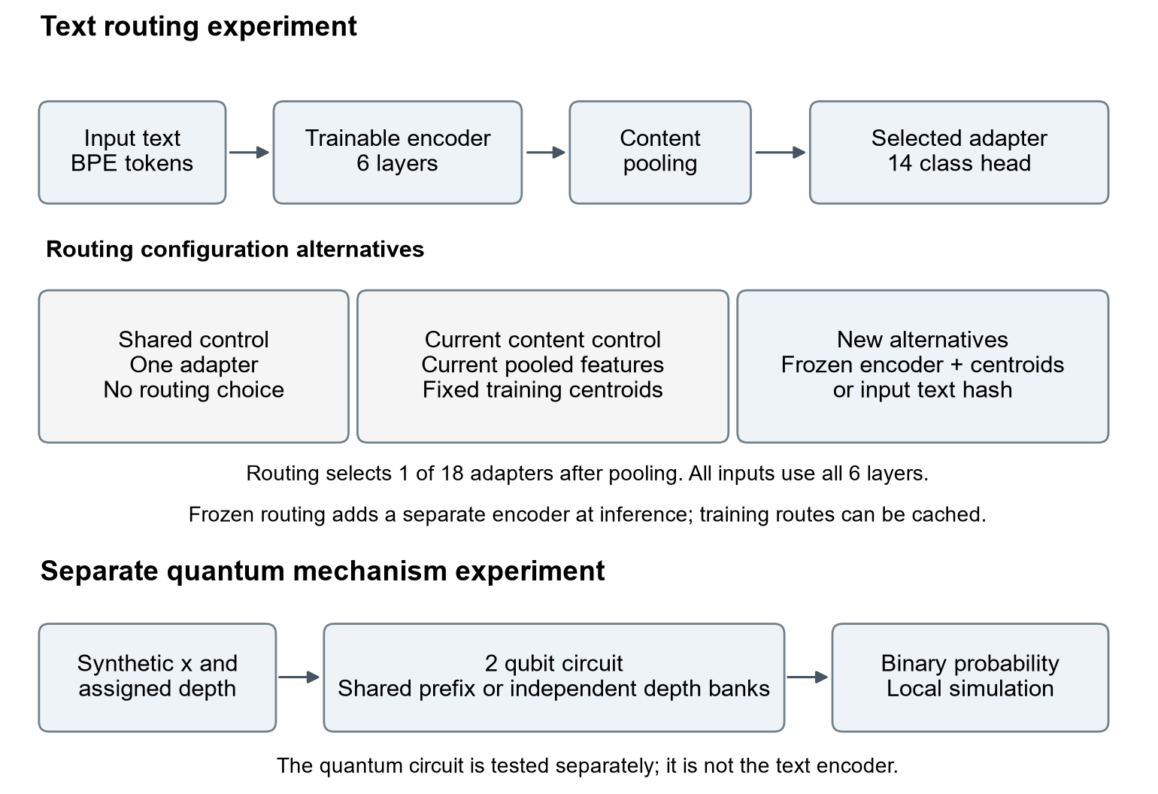
Figure 1. Implemented v0.2 comparisons. Every text passes through all six encoder layers before pooling and the adapter. Quantum allocation is classical metadata selecting one two-qubit circuit and parameter bank per record. It does not add qubits or execute parallel quantum branches.
The v0.1 AG News study found shared-adapter macro-F1 of 91.108% and content-routing macro-F1 of 91.071%, with 52.7% more charged training time for content routing. Its paired interval did not resolve a quality benefit. The v0.1 synthetic study found 73.13% F1 for the shared circuit schedule, 92.05% for fixed depth four and 98.52% for MLP129. Those results motivate the controls retained here.
The new text task is DBpedia14, whereas the earlier task was AG News. Raw F1 differences between those datasets do not measure an architectural improvement. All conclusions about v0.2 changes use controls retrained on the same new task and evaluation records. Historical runtimes also use a different task and implementation path, so they do not establish a routing speedup.
Evidence: preserved QPATH RPT 002 and the v0.1 benchmark summaries; current frozen text and quantum protocols. The original v0.1 evidence is retained unchanged.

Fresh data and frozen decisions
The text study uses the authors’ DBpedia14 ontology-classification CSV distribution, Version 2 dated 9 September 2015: 560,000 official training rows and 70,000 official test rows across 14 labels. This is a fresh-task replication. Each original control is retrained on the same new split as the candidate; subtracting the earlier AG News score from a DBpedia score cannot measure architectural improvement.
Population | Train / validation / test | Fixed sampling or generation
DBpedia14 | 100,800 / 11,200 / 14,000 | 7,200 / 800 / 1,000 per label; PCG64 sampling seeds 173 and 174
Synthetic development | 4,800 / 1,600 / 1,600 | Feature / allocation-class / split seeds: 12017 / 12023 / 12029
Synthetic confirmation | 4,800 / 1,600 / 1,600 | Feature / allocation-class / split seeds: 22017 / 22023 / 22029
Synthetic engineering | 4,800 / 1,600 / 1,600 | Feature / allocation-class / split seeds: 32017 / 32023 / 32029

Text canonicalization applies Unicode NFKC, case folding and whitespace collapse to title plus body. The rules exclude training matches to every official test text, conflicting-label duplicate groups, and exact matches to the original official AG News training or test content. Same-label duplicates retain their lowest source-row representative. Exactly one redundant training row was quarantined. Canonical hashes are sorted within each label before deterministic sampling; selected splits are disjoint. The independent audit reconstructed all 630,000 source rows and all 126,000 selected encodings. It found zero exact overlap between selected splits or with the old AG News content. Near duplicates and semantic overlap remain unassessed.
The 8,192-token BPE vocabulary is fitted on selected training text only. Sequences contain at most 256 tokens including BOS and EOS; validation and test encoding use the frozen tokenizer. Label checks cover schema, range, counts and duplicate consistency. No manual semantic verification of source labels is claimed.
The separate quantum task draws two coordinates uniformly from [−1, 1] and labels points inside x₀² + x₁² < 2/π as positive. Independent random classes C1–C8 assign depths 4, 4, 3, 3, 2, 2, 1, 1. Each population uses label-by-class stratified splits. An independent reconstruction checked all 24,000 records and found zero exact feature overlap across populations or with v0.1. Random classes do not measure semantic priority.
Test seals are procedural hashes and access rules, not encryption. Labels are used for declared sampling and provenance checks; model selection uses training and validation only. The protocol requires committed confirmation endpoints, independent review and a separate root-issued release before model test evaluation, with an access event written before test loading.
Source: Zhang, Zhao and LeCun, author distribution at https://github.com/zhangxiangxiao/Crepe. The exact archive URL, SHA256 and dataset attribution/licensing notices are retained in classical/data_work/README.txt and classical/data/source.

Text methods and development selection
All text arms use a six-layer pre-normalization Transformer with width 256, four attention heads, feed-forward width 1024, dropout 0.1 and a 14-class head. Adapters have bottleneck width 16 and operate on the pooled representation. Shared uses one adapter; the three routed designs allocate 18 independent adapters. All v0.2 arms use the same grouped dispatch implementation.
Method | How the adapter is chosen | Total parameters
Shared | One adapter for every input | 6,913,310
Current content | Current classifier representation and fixed warmup centroids | 7,057,198
Frozen content | Separate immutable warmup encoder and fixed centroids | 13,958,446
Hash18 | Seeded SHA256 of canonical full input text; no labels or record IDs | 7,057,198

Frozen content adds 6,901,248 frozen parameters; 7,057,198 remain trainable. Input-derived route caching is charged, and uncached inference needs the extra encoder. Frozen routing uses evaluation mode, while current routing uses the training encoder with dropout: stochasticity and feature drift both change. Hash18 removes that extra encoder; stable assignments alone do not imply useful partitions.
Development arm | Validation F1 percent | Charged seconds
Shared | 97.785 | 362.45
Current content | 97.719 | 406.45
Frozen content | 97.526 | 430.56
Hash18 | 97.714 | 377.29

Three development seeds 301 to 303; means at 3000 main updates after a common 1000-update warmup. All 12 runs and three warmups passed independent checks. Charged times include common preparation and warmup charged to each arm; they cannot be summed as elapsed project time.
Hash18 beat frozen content by 0.188 validation F1 percentage points, outside the 0.100-point near-tie band that prefers lower charged time. It passed the development gate without beating shared. The gate allowed mean shortfall of 0.200 points against the best control and up to 0.500 points against shared in each seed. Confirmation was planned regardless; this gate does not establish superiority.
Confirmation used shared, current content and Hash18 with seeds 401 to 405: one common 1000-update warmup and 10000 main updates per arm. The endpoint is the final checkpoint. Development used a shorter cosine schedule. Predeclared cyclic rotation and reversal varied execution order but did not fully balance timing.
Evidence: frozen classical protocols, selection, independent Stage A review and resource definitions.

Text confirmation results
Hash18 did not show a resolved quality improvement over current content routing. All three methods completed five fresh seeds and were evaluated on the same 14,000 DBpedia14 records. The table reports means and sample standard deviations across seeds; F1 and accuracy use percent, while negative log likelihood uses natural-log units per record.
Method | Macro F1 (%)  Mean ± SD | Accuracy (%)  Mean ± SD | NLL  Mean ± SD
Shared | 97.602 ± 0.047 | 97.600 ± 0.047 | 0.12497 ± 0.00511
Current content | 97.642 ± 0.076 | 97.640 ± 0.076 | 0.12532 ± 0.00649
Hash18 | 97.659 ± 0.073 | 97.657 ± 0.073 | 0.12518 ± 0.00364

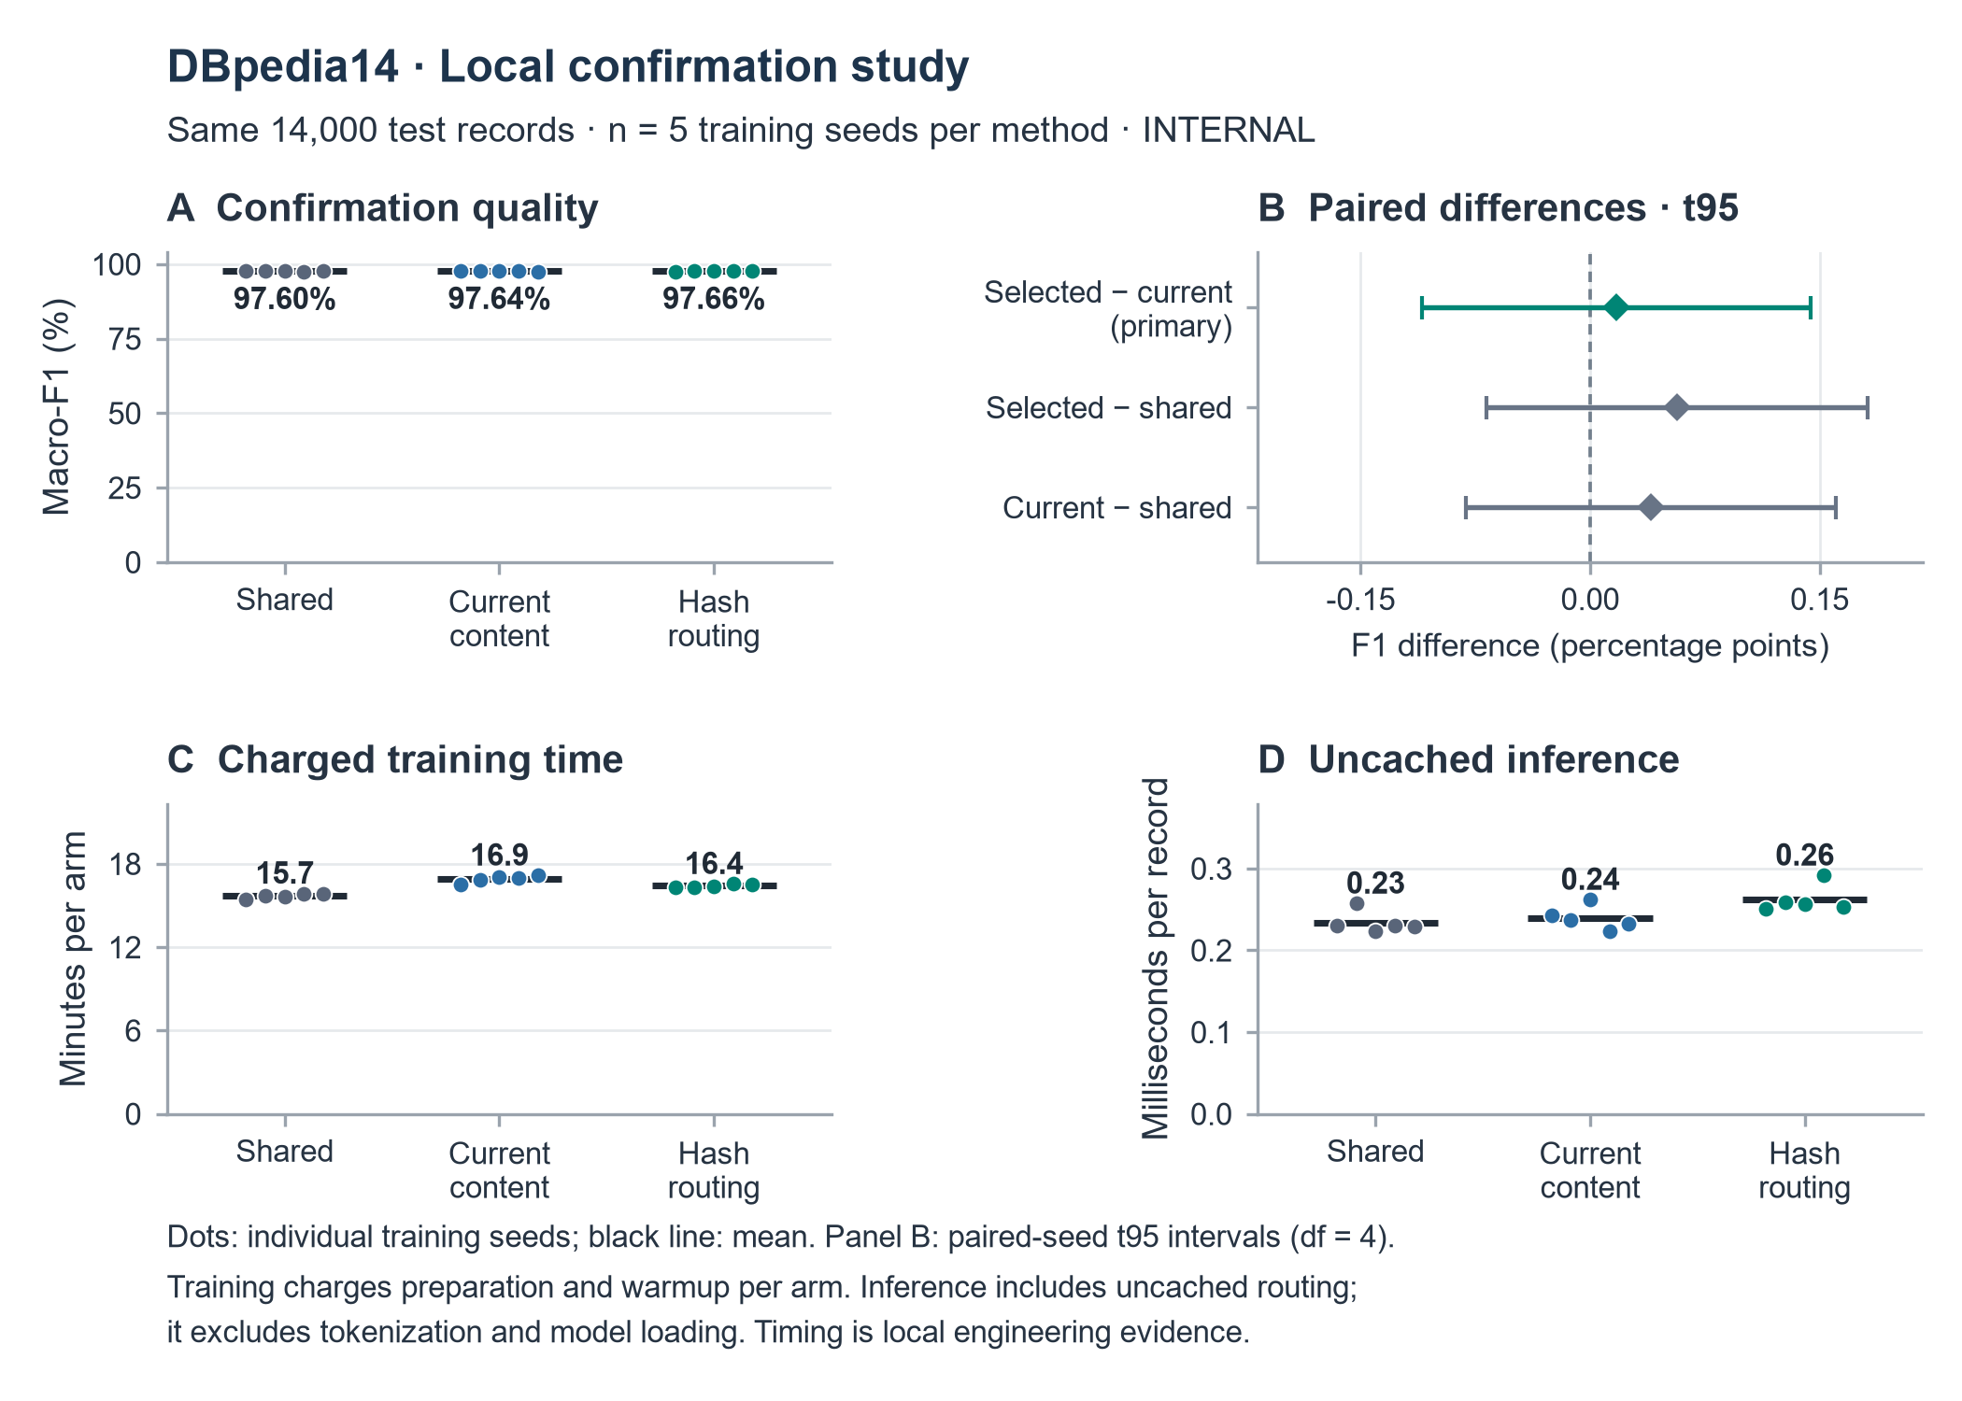
Five paired training seeds, 401 to 405. Dots show individual seeds and black lines show means; panel B uses paired seed t95 intervals. The full F1 scale and separate difference panel prevent small effects from appearing large. Timing boundaries are described below.
Independent replay reproduced all 210,000 saved predictions and adapter assignments with zero disagreements using the original adapter loop. The largest NLL discrepancy was 1.33 × 10⁻⁸. This checks checkpoint loading, batching, dispatch and metric arithmetic; the replay shares the frozen encoder definition.

Text paired effects and uncertainty
The registered primary effect is Hash18 minus current content routing. Its mean was +0.01694 percentage points in macro F1, with paired seed t95 [−0.11024, +0.14412]. The separate conditional record-bootstrap95 was [−0.06259, +0.09428]. Both intervals cross zero. The result does not establish an improvement or equivalence.
Seed | Shared F1  percent | Current F1  percent | Hash18 F1  percent | Hash − current  percentage points
401 | 97.616 | 97.580 | 97.551 | -0.02927
402 | 97.651 | 97.657 | 97.694 | +0.03682
403 | 97.611 | 97.740 | 97.617 | -0.12220
404 | 97.523 | 97.681 | 97.724 | +0.04318
405 | 97.609 | 97.552 | 97.708 | +0.15617

Paired comparison | Mean difference | Seed t95 | Conditional bootstrap95
Hash − current (primary) | +0.01694 | [-0.11024, +0.14412] | [-0.06259, +0.09428]
Hash − shared | +0.05678 | [-0.06762, +0.18118] | [-0.02167, +0.13386]
Current − shared | +0.03984 | [-0.08100, +0.16068] | [-0.03883, +0.11785]

All entries in this comparison table are F1 percentage points. Secondary comparisons remain descriptive; no multiplicity adjustment or equivalence test was registered.
Seed intervals use five paired differences and four degrees of freedom. The 2,000 registered bootstrap resamples use the same sampled canonical test groups for all 15 models and then average across fixed checkpoints. That bootstrap excludes training-seed, candidate-selection and new-dataset uncertainty; it is not combined with the seed interval.
Hash18 exceeded current routing in three seeds and fell below it in two. The endpoint was fixed at 10,000 main updates rather than selected by validation. No checkpoint was changed after test release. These are within-task comparisons; the higher raw DBpedia F1 than historical AG News F1 is not evidence of architectural improvement.

Text routing and resource costs
Hash18 reduced observed charged training time by 2.925% relative to current content routing, but increased uncached inference time by 9.431%. Against shared, it used 4.522% more charged training time and 12.083% more inference time. These local ratios describe measured costs; unresolved quality differences prevent a quality-matched efficiency claim.
Method | Charged time  mean seconds | Uncached inference  mean ms / record | Phase GPU peak  max GiB | Total and trainable  parameters
Shared | 942.12 | 0.2338 | 1.9345 | 6,913,310
Current content | 1014.39 | 0.2395 | 1.9366 | 7,057,198
Hash18 | 984.72 | 0.2620 | 1.9366 | 7,057,198

Phase peak is the maximum across five runs, measured by PyTorch allocated tensor memory after resetting each phase peak. It includes resident warmup state, optimizer and activations; it is not isolated model storage or total driver memory. All listed parameters are trainable.
Method | Active test adapters  every seed | Largest adapter share  mean across seeds | Probe assignments changed  from warmup, mean
Shared | 1 | 100.000% | 0.00%
Current content | 18 | 8.604% | 8.36%
Hash18 | 18 | 5.881% | 0.00%

Current routing changed 8.36% of the fixed 1,000-record training probe from warmup. Hash assignments stayed fixed by construction and had more even test occupancy. Both routed models used all 18 adapters on test records. These diagnostics do not show that route drift caused an accuracy loss or validate semantic priority.
Charged arm time includes data preparation, common warmup, method preparation, training, validation and checkpoint work. Shared preparation is charged repeatedly, so these costs cannot be summed as elapsed project time. The two physical classical training segments totalled 4.657 hours, excluding their review gap, evaluation and reporting; no training incidents were recorded.
Inference used the same label-independent 1,024 records, batches of 64, one warmup and three timed repeats per model. It includes host transfer and uncached routing; tokenization and model loading are excluded. Timing was not isolated from host activity. Shared remains the practical default for simplicity, fewer parameters and the lowest observed costs, while routing remains a research option without a resolved quality gain here.
Evidence: independent confirmation summary and replay arrays; frozen Stage B protocol, completion audit and RESOURCE_DEFINITIONS.json. Every arm used identical sampled record and padded-token work within each seed. Neither text routing nor these timings establish an integrated quantum model or universal speed advantage.

Quantum methods and development selection
Independent depth banks were the strongest of the three new circuit mechanisms in development. This is a two qubit synthetic circle classifier, separate from the text study. Each record executes one circuit at a classically assigned depth; random allocation classes do not measure semantic priority.
The shared schedule uses a prefix of 16 angles at depths 1 to 4. Untied methods allocate 40 independent angles across four banks; minimum depth 2 retains 16 angles but adds work to shallow records. Feature RY rotations, trained RY/RZ rotations and CX gates feed a fixed final rotation and one-qubit probability readout. MLP129 uses the same features and depth information; MLP17 and MLP41 approximate parameter counts, not expressive capacity.
All 27 development runs used seeds 301 to 303, 4,800 training and 1,600 validation records, 200 rounds and 15,000 Adam updates at learning rate 0.01. Each run retained the checkpoint with lowest validation binary cross entropy (BCE), choosing the earliest exact tie. BCE clips probabilities to [0.0000001, 0.9999999].
Method | Params | Validation BCE  Mean ± SD | Circuit examples  Millions per run
Shared schedule | 16 | 0.5021 ± 0.0150 | 20.368
Minimum depth 2 | 16 | 0.4129 ± 0.0037 | 22.208
Untied assigned | 40 | 0.3623 ± 0.0021 | 20.368
Untied balanced | 40 | 0.3638 ± 0.0034 | 80.640
Untied all records | 40 | 0.3639 ± 0.0001 | 80.640
Fixed depth 4 | 16 | 0.2483 ± 0.0009 | 31.680
MLP129 | 129 | 0.0213 ± 0.0010 | 0.000
MLP17 | 17 | 0.5720 ± 0.0246 | 0.000
MLP41 | 41 | 0.2156 ± 0.2413 | 0.000

Three development seeds; SD is the sample standard deviation. All nine arms are shown. Zero circuit examples for MLPs does not mean zero conventional compute. Source: quantum/STAGE_A_SELECTION.json.
Selection considered minimum depth 2, untied assigned and untied balanced only. Untied assigned had the lowest mean BCE (0.3623); balanced was within the frozen 0.002 tolerance but required more circuit work. The work tie rule therefore retained untied assigned. Its validation gain of 0.1398 over the shared schedule exceeded the 0.01 promising threshold. Controls were never eligible to become the selected new mechanism.

Quantum confirmation results
All 40 registered confirmation runs completed on a new synthetic population using seeds 401 to 405. Validation selected checkpoints before the root test release. Every method used the same 1,600 test records, and all saved probabilities passed independent numerical replay. F1 uses a 0 to 1 scale: 0.8144 equals 81.44%.
Method | Params | Test BCE  Mean ± SD | Test macro F1  Mean ± SD
Shared schedule | 16 | 0.5189 ± 0.0070 | 0.7183 ± 0.0153
Fixed depth 4 | 16 | 0.2609 ± 0.0004 | 0.9332 ± 0.0035
Untied assigned | 40 | 0.3745 ± 0.0011 | 0.8144 ± 0.0024
Untied balanced | 40 | 0.3772 ± 0.0028 | 0.8093 ± 0.0056
Untied all records | 40 | 0.3765 ± 0.0004 | 0.8102 ± 0.0020
MLP129 | 129 | 0.0257 ± 0.0028 | 0.9904 ± 0.0026
MLP17 | 17 | 0.5957 ± 0.0184 | 0.6254 ± 0.0594
MLP41 | 41 | 0.1566 ± 0.0709 | 0.9239 ± 0.0367

Untied assigned reduced BCE by 0.1444 versus the shared schedule: paired seed t95 [−0.1543, −0.1345]. The separate conditional record-bootstrap95 was [−0.1547, −0.1338]. Both support a gain beyond the prespecified 0.01 engineering threshold. Secondary F1 increased by 9.61 percentage points, with paired t95 [7.58, 11.65]. Fixed depth 4 and MLP129 remained better; MLP41 also had lower mean BCE, with greater seed variation.

Quantum confirmation visual comparison
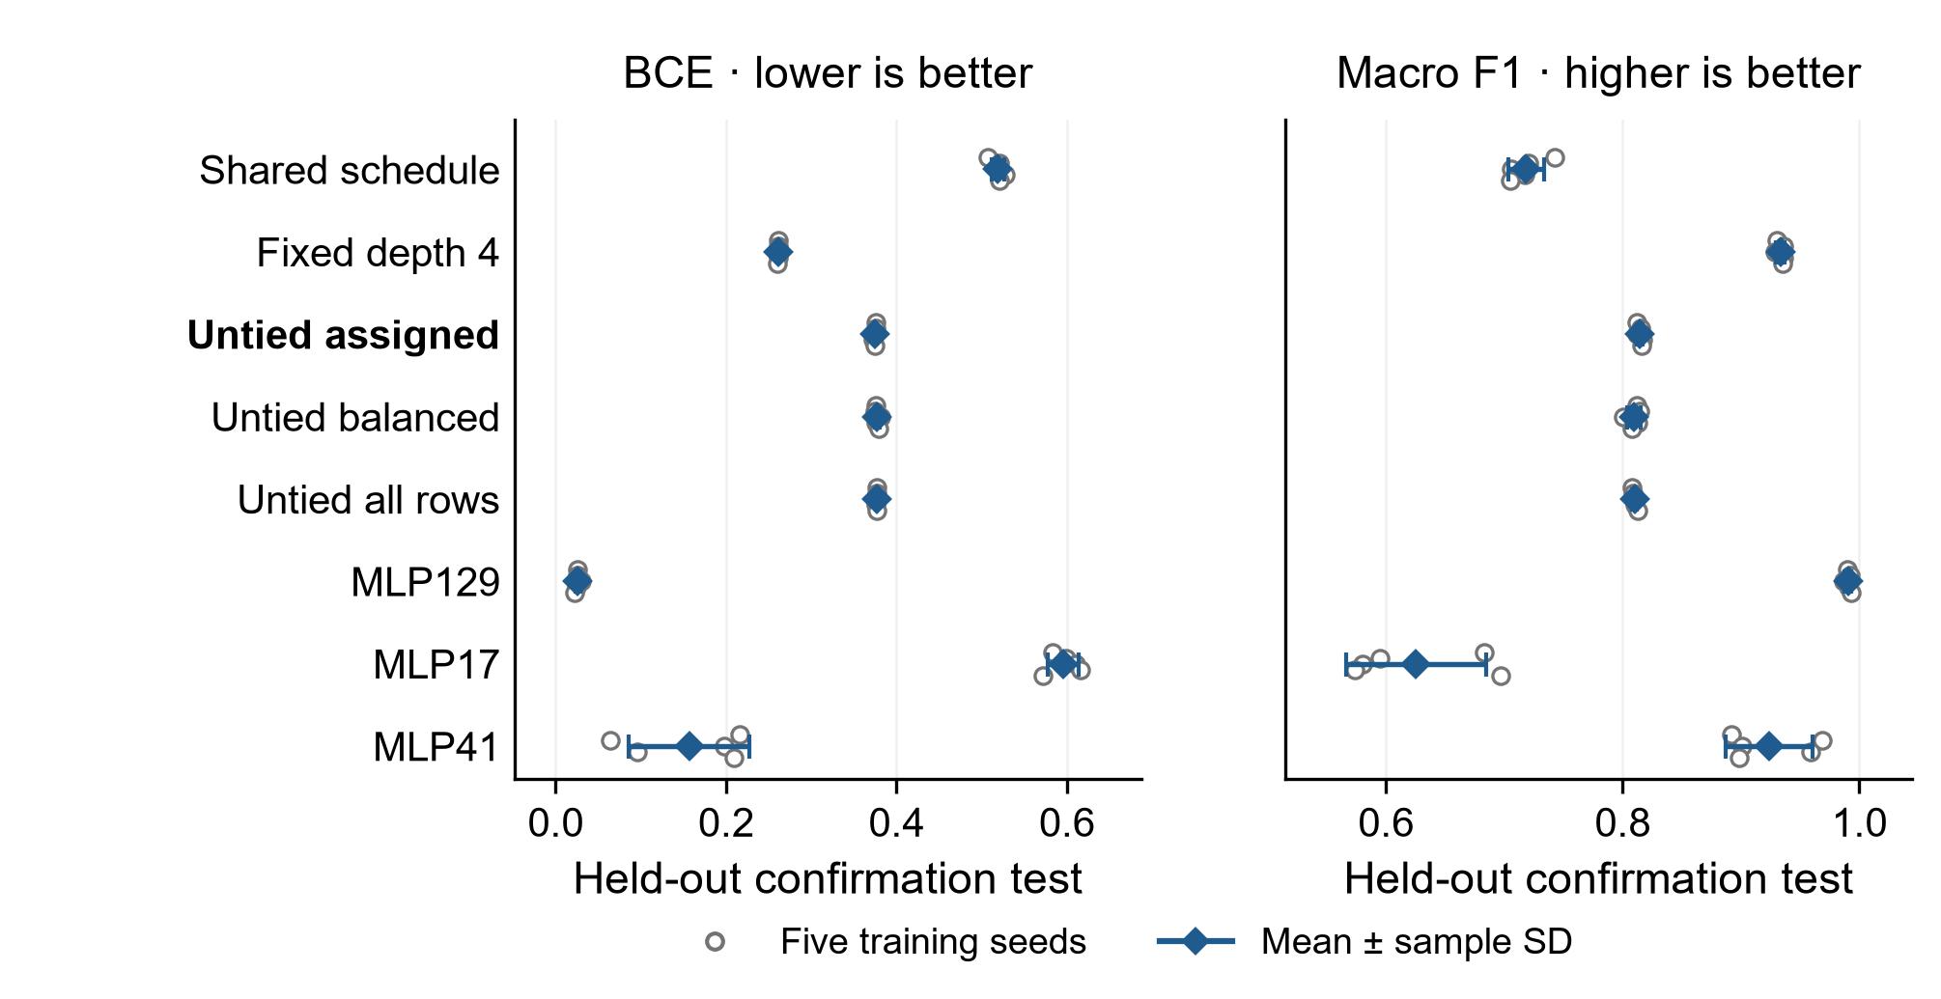
Five seeds; figure bars show sample SD, not the paired t95 intervals on the preceding page. F1 uses an explicitly cropped numeric axis. Seed t95 uses four degrees of freedom; the 2,000-resample bootstrap conditions on fixed checkpoints and excludes selection and new-population uncertainty. Source: quantum/confirmation_evaluation/summary.json and the verified figure metadata.
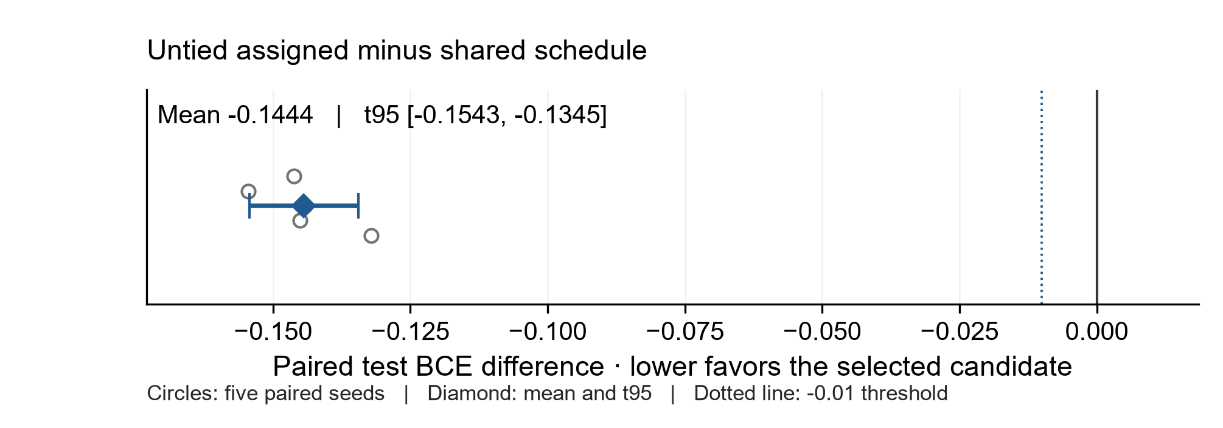
The primary paired BCE contrast is negative for every seed; lower BCE is better. The interval describes five training-seed differences and does not include candidate-selection or new-task uncertainty.

Quantum work costs and mechanism evidence
Untying preserved record visits, depths and parameter-shift circuit-example work, but increased allocated angles from 16 to 40 and changed which records update each parameter. Its mean loop time rose by 82.35%. The gain therefore does not isolate removal of gradient interference or establish a runtime advantage.
Method | Visits  Millions | Circuit examples  Millions | Layer applications  Millions | Mean loop  Seconds
Shared schedule | 0.96 | 20.104 | 59.742 | 344.90
Fixed depth 4 | 0.96 | 31.680 | 126.720 | 365.54
Untied assigned | 0.96 | 20.104 | 59.742 | 628.93
Untied balanced | 3.84 | 80.640 | 240.000 | 754.84
Untied all records | 3.84 | 80.640 | 240.000 | 750.61
MLP129 | 0.96 | 0.000 | 0.000 | 2.21
MLP17 | 0.96 | 0.000 | 0.000 | 1.94
MLP41 | 0.96 | 0.000 | 0.000 | 2.03

Per-run training work; means over five seeds for elapsed loop time. Loop time includes all training and validation rounds plus checkpoint/log writes, but excludes initialization and later diagnostics. Concurrent workload and implementation overhead affect timing. Source: quantum/report_data/quantum_report_data.json and RESOURCE_DEFINITIONS.json.
Balanced exposure used four times the record visits and 4.011 times the circuit examples, retaining 15,000 global updates. Its BCE difference from assigned was +0.0027, t95 [−0.0010, 0.0065]. Giving every bank all training records at the same expanded work changed BCE by −0.0007 versus balanced, t95 [−0.0045, 0.0031]. Neither descriptive comparison resolves a benefit; neither establishes equivalence.
Depth-one fitting remained weak in the prespecified training diagnostics: selected-checkpoint BCE averaged 0.6925 for shared and 0.6861 for untied assigned; untied depths 2 to 4 averaged 0.2817, 0.2664 and 0.2505. Shared gradient cosines for depth pairs 1/2, 2/4 and 3/4 averaged −0.546, −0.560 and −0.584, each negative in all five seeds. These local raw gradients are not Adam directions or causal proof. No circuit training probabilities reached clipping bounds; some MLP probabilities did.
Quantum development took 50.27 minutes and confirmation 47.73 minutes; launch through confirmation training completion took 100.26 minutes including review. Summed loop time was 9,001.68 and 14,255.01 seconds respectively because runs overlapped. All 67 quantum runs completed with no excluded failure. These figures cover quantum training only.

Local quantum readiness and next steps
The trained candidate passed local circuit checks on eight label-independent validation records per checkpoint: 40 circuits, 120 matrix comparisons, maximum matrix error 1.05 × 10⁻¹⁵ and exact Aer probability error 1.33 × 10⁻¹⁵. There were 400 Aer executions and 1,024,000 simulated shots, with zero failures of the registered family-wise sampling bound (alpha 0.01). QASM, counts, mappings, versions and hashes are preserved.
A separate full-test sensitivity analysis drew ideal binomial counts from frozen probabilities at 1,024 and 4,096 shots per record. Five measurement repeats were averaged within each checkpoint before summarizing the five training seeds. Budgets used independent streams; 1,024-shot counts were not prefixes of 4,096-shot counts.
Readout budget | BCE  Mean ± SD | Macro F1  Mean ± SD
Exact probabilities | 0.3745 ± 0.0011 | 0.8144 ± 0.0024
1,024 shots | 0.3747 ± 0.0011 | 0.8177 ± 0.0020
4,096 shots | 0.3746 ± 0.0011 | 0.8174 ± 0.0028

Finite-shot SD is across five checkpoint-level repeat means; there are five training replicates, not 25. Binomial draws represented 204.8 million Bernoulli trials, distinct from the Aer fixture shots. Source: quantum/confirmation_evaluation/summary.json; independent count replay used recorded NumPy 2.5.4.
Small observed F1 increases under sampling do not show that noise improves generalization. Training used exact probabilities. RY/RZ/CX compilation targets a local simulator basis, not an IBM device instruction set or calibrated noise model. The study used zero physical shots and zero hardware jobs.

Recommended next decisions
Retain untied assigned as the better scheduled-circuit research baseline, alongside fixed depth 4 and both larger MLP controls. In a new preregistered local study, test minimum-depth or encoding changes for shallow records, with controls that distinguish added capacity from sharing. Use fresh data and measure any added work against quality gains. Do not tune further on this confirmation test.
If an IBM pilot is later authorized, first select a backend, compile to its actual instruction set and layout, and repeat the frozen validation fixture with a fixed shot budget and device noise assumptions. Its initial question should be whether hardware reproduces probabilities within stated uncertainty. This synthetic mechanism evidence does not establish quantum advantage, semantic prioritization or an integrated quantum LLM.
Readiness sources: quantum/local_readiness_results/summary.json, READINESS_PROTOCOL.json and saved circuit/count artifacts. Interpretation boundaries: quantum/ARCHITECTURE_SCOPE_NOTES.txt. Recommendations are future work, not completed experiments.

Statistical interpretation and reproduction

What the comparisons estimate
Confirmation uses five new training seeds, 401–405, paired across methods on one fixed test set per task. The text primary contrast is selected candidate minus current content routing in macro F1; a positive difference favors the candidate. The quantum primary contrast is selected candidate minus the original shared schedule in binary cross entropy (BCE); a negative difference favors the candidate. Quantum BCE clips probabilities to [10⁻⁷, 1 − 10⁻⁷]. Macro F1 averages all declared labels, with zero contribution for a zero denominator. F1 differences are reported in percentage points.
Method summaries use the five-seed mean and sample standard deviation. A paired contrast subtracts the two methods within each seed before calculating its mean, standard deviation and descriptive Student t 95% interval with four degrees of freedom. The five seeds do not establish broad equivalence or performance on other datasets. Secondary comparisons and diagnostics remain descriptive and are not adjusted for multiplicity.

Two separate uncertainty summaries
The registered record bootstrap uses 2,000 resamples with replacement: unique canonical test groups for text and test records for quantum. Each paired comparison shares the same resampled records across methods and all five seeds, then averages the five seed metrics or differences. Percentile 2.5% and 97.5% bounds describe record uncertainty conditional on the trained checkpoints. PCG64 seeds are 88002 for text and 88003 for quantum. This interval does not include training-seed, candidate-selection or new-dataset uncertainty and is not combined with the seed t interval.
Quantum readout sensitivity averages five measurement repeats within each frozen checkpoint before summarizing the five checkpoints. It remains n = 5 training seeds. The 1,024- and 4,096-shot budgets use separate random draws. Probability-level binomial trials, local Aer simulated circuit shots and physical hardware shots are different quantities. A small sampled F1 increase does not establish a benefit from noise.

Evidence boundaries and reproduction
The text Transformer and two-qubit synthetic classifier are separate modules tested in separate experiments. These results do not validate an integrated quantum text encoder or LLM. Independent synthetic draws repeat the same circle problem; exact duplicate exclusion does not establish freedom from semantic overlap. Untying circuit banks changes capacity and parameter-specific training exposure. Local concurrent timings do not establish hardware-independent speed, energy savings or quantum advantage. Simulator compilation is not an IBM device validation.
Reproduction evidence is indexed by the frozen task protocols and selections, data manifests and source notices, checkpoint and prediction hashes, release/access records, environment locks, independent analyses and delivery manifest. Preserve original paths recorded in releases; a relocated replay needs a reviewed path mapping. Use a separate experiment directory for new runs and retain the sealed evidence. Exact binomial replay requires the recorded NumPy 2.5.4 environment. Dataset attribution and licensing notices accompany the retained source files.

Recommended next experiments

Text routing
Use shared as the default for the next implementation baseline: it has the lowest measured training and inference cost, while the five-seed intervals do not resolve a quality disadvantage. Keep Hash18 as a reproducible stable-partition control. Its charged training time was 2.93% lower than current content, but its measured uncached inference time was 9.43% higher. Do not promote Hash18 as an established accuracy or latency improvement.
Before another long run, register a decision threshold that matters operationally, such as a justified minimum F1 gain or cost reduction, and power the study against that threshold. Investigate grouped dispatch and small adapter batches with a separate profiler. Repeat timing in isolated, interleaved trials with the same batch sizes and input distribution; retain both end-to-end and compute-only measurements. Profiling changes must not be confused with evidence of better representation learning.
A new routing hypothesis should test whether partitions carry useful task information. Compare parameter-matched shared capacity, stable random/hash partitions and a fixed semantic router under a common information budget. Account for the hash using full canonical text while the classifier sees at most 256 tokens. Predeclare any extra encoder cost. Add a second fresh text task and reserve a new holdout before changing the architecture.

Quantum mechanism
Retain untied assigned as the improved scheduled-circuit candidate, with fixed depth four and MLP129 as mandatory controls. Untying improved F1 by 9.61 percentage points but remained 11.88 points below fixed depth four and 17.60 points below MLP129. The next study should separate parameter capacity, depth-specific exposure and data partitioning through predeclared controls. Equal global update counts do not match per-parameter training exposure.
In the training diagnostics, depth-one fitting remained near chance. Test a minimum-depth or revised encoding hypothesis with fresh confirmation data and explicit layer, circuit and runtime budgets. More circuit work is a cost, not a free improvement. The expanded-exposure controls did not resolve a gain here; avoid scaling them simply because they consumed more work.

IBM pilot boundary
A later IBM pilot can answer whether the frozen two-qubit circuit survives a chosen device mapping and realistic noise. First specify the backend, calibration snapshot, supported instruction set, layout, transpilation settings, mitigation policy, shot budget and stop criteria. Compare ideal simulation, matched noise simulation and the device using the same frozen circuits. This is an engineering pilot, not a new claim of predictive superiority. Hardware submission remains a separate authorized step; this package contains local readiness evidence only.
Keep the report internal. Before a paper, repeat the decisive comparisons on additional tasks and seeds, address the capacity and information-budget differences, and review the full source, attribution and failure record. Do not tune on the released confirmation tests.

Completion and evidence index
Text training totalled 16,765.40 seconds (4.657 hours) and 194,000 physical optimizer updates. Quantum development launch to confirmation completion took 6,015.39 seconds (100.26 minutes), overlapping text training. Preparation, evaluation, audits and reporting add time. Per-arm charges double-count common preparation and are not project wall time.
Gate | Recorded outcome
Text development and confirmation | 12 + 15 complete endpoints; 3 + 5 common warmups; both independent completion reviews PASS
Quantum development and confirmation | 27 + 40 complete endpoints; independent endpoint and output reviews PASS
Text test release and replay | Release 15:58:26 UTC, first model test access 15:59:11 UTC; 210,000 predictions replayed exactly
Quantum test release and replay | Release 12:57:12 UTC, first model test access 12:57:26 UTC; maximum probability discrepancy 4.78 × 10⁻¹⁵
Baseline preservation | All 2,081 payload hashes PASS at 16:05:23 UTC on 18 October 2026
Local circuit readiness | 40 fixtures; 120 matrix comparisons; 400 Aer executions; 1,024,000 simulated shots; zero physical shots

One independent quantum count-replay attempt used plotting NumPy 2.3.5 and did not reproduce saved binomial draws. Its log and source are preserved. Replaying with the recorded NumPy 2.5.4 reproduced every count array exactly; no model, data or experimental result changed. Packaging-helper compatibility fixes and the original figure glyph issue are also retained separately. There were no failed training or official evaluation attempts.

Where to inspect the evidence
Start with REPRODUCE_INTERNAL.txt. Governance holds protocols, approvals, baseline checks and host records. Classical and quantum retain source, data, logs, checkpoints, environments and predictions. Analysis holds independent reviews and statistics; report_work retains document inputs, figures, authoring code and the final page-review record.
The docs folder contains the final Word report. DELIVERY_MANIFEST.json lists copied payload sizes and SHA256 hashes. DELIVERY_VERIFICATION.json and DELIVERY_VERIFICATION_INDEPENDENT.json hold actual post-copy results. These verification records are excluded from payload hashing to avoid circularity. Hash agreement checks integrity, not authenticity.
Environment records, source notices and setup instructions are included. No clean-room or relocated full reproduction is claimed. Original absolute paths require a reviewed mapping in a new workspace. Close Word before package verification so temporary owner files cannot enter the inventory.

Study v0.2 report edition note
Report edition 1 prepared 29 October 2026. Repository edition v1.0 is separate from study v0.2.
Anthony Siljeg — Founder, Alnotrea Labs · Company affiliation: Alnotrea Pty Ltd · Q-Pathformer Initiative. Anthony Siljeg is the licensor; company affiliation does not transfer ownership.
The preceding historical report is preserved in full, including its results, figures, tables, limitations, internal labels and recommendations. Those labels describe the original study. This edition appends this note and updates descriptive metadata only. It does not claim new experiments, hardware execution or present-day device qualification.
Controlled original report prose, table presentation and original report figures are licensed under CC BY 4.0 by Anthony Siljeg, as identified in the accompanying report scope and adoption records. https://creativecommons.org/licenses/by/4.0/ . Previously applicable grants remain in force for inherited expression. This report grant does not cover datasets, third-party dependencies, software, model artifacts, architecture documents or complete archives.
Original source: QPATH-RPT-003_Improvement_Study_and_Baseline_Comparison_v0.2.docx. Original SHA-256: fb6a575707c3e2952d418bf20d3b3fcfff1929edf05c4a9f1a1d53b94abb9172. See the accompanying edition-change and source records for the preservation checks.

