Q Pathformer Flexible Readouts and Classical Controls
  - Internal experiment report
Prepared for Anthony Siljeg | Alnotrea Labs | 19 October 2026
QPATH RPT006 | Study version 0.5 | Internal use only
A learned circuit readout materially improves this small Q Pathformer component on classical simulation. Scalar and five-moment readouts reach about 99.1 to 99.6 percent macro F1 on the fresh circle and ellipse tests. Training the circuit core matters: leaving it random produces much weaker results. Strong classical trigonometric controls still offer the most attractive accuracy and cost combination in this experiment.

Main measured results
Model | Circle 1 F1 | Circle 2 F1 | Ellipse F1
Legacy | 95.22% | 97.08% | 94.69%
Scalar | 99.54% | 99.22% | 99.06%
Multi | 99.55% | 99.51% | 99.29%
Frozen | 81.36% | 76.43% | 82.67%
Trig routed | 99.77% | 99.56% | 99.59%
Trig global | 99.91% | 99.74% | 99.37%
MLP global | 99.70% | 99.35% | 99.17%
These are means across five training seeds per population, using the same 1,600 test records for every model within each population. Later tables report all eleven arms, variation and probability losses. The scores describe simple two-dimensional classification; they do not establish language-model performance or the complete Q Pathformer architecture.

Recommended decision
Continue with a classical implementation track led by the Trig25 controls and an exact classical representation of the learned circuit logits. Keep Scalar as the simpler future circuit-testing candidate and Multi as a useful comparison when its extra observables justify two measurement settings. Validate these choices on a broader, separately registered task suite before any hardware request.

Purpose and previous evidence
This study asks which small model recipe is most useful on classical compute and which circuit ingredients deserve further testing. Quantum computational advantage is not the primary objective. The comparison addresses the output readout and model capacity while holding the learned spatial router fixed.
Version 0.4 showed that meaningful spatial routing helped the two-layer circuit, while strong trigonometric and global neural-network controls remained difficult to beat. The table gives historical mean macro F1 percentages across five seeds. These are separate old datasets and training runs.
Historical v0.4 model | Circle 1 | Circle 2 | Ellipse
Circuit with k means | 98.32 | 97.16 | 94.41
Routed Trig25 | 99.75 | 99.65 | 99.56
Global width 32 MLP | 99.39 | 99.11 | 99.16
Version 0.5 draws fresh coordinates, fits new routers and uses new training seeds. Its logit models optimize stable native binary cross entropy, whereas the older recipes used clipped probability loss and clipping derivatives. The global neural-network architecture remains width 32, but initialization and training details are not a paired repeat. Consequently, subtracting a historical v0.4 score from a v0.5 score does not isolate an architectural improvement.
The decisive comparisons are between models trained and evaluated on the same fresh v0.5 split. These are two-dimensional synthetic classification experiments. They do not evaluate language understanding, a large language model, or the complete proposed Q Pathformer architecture.

Architecture of the comparison
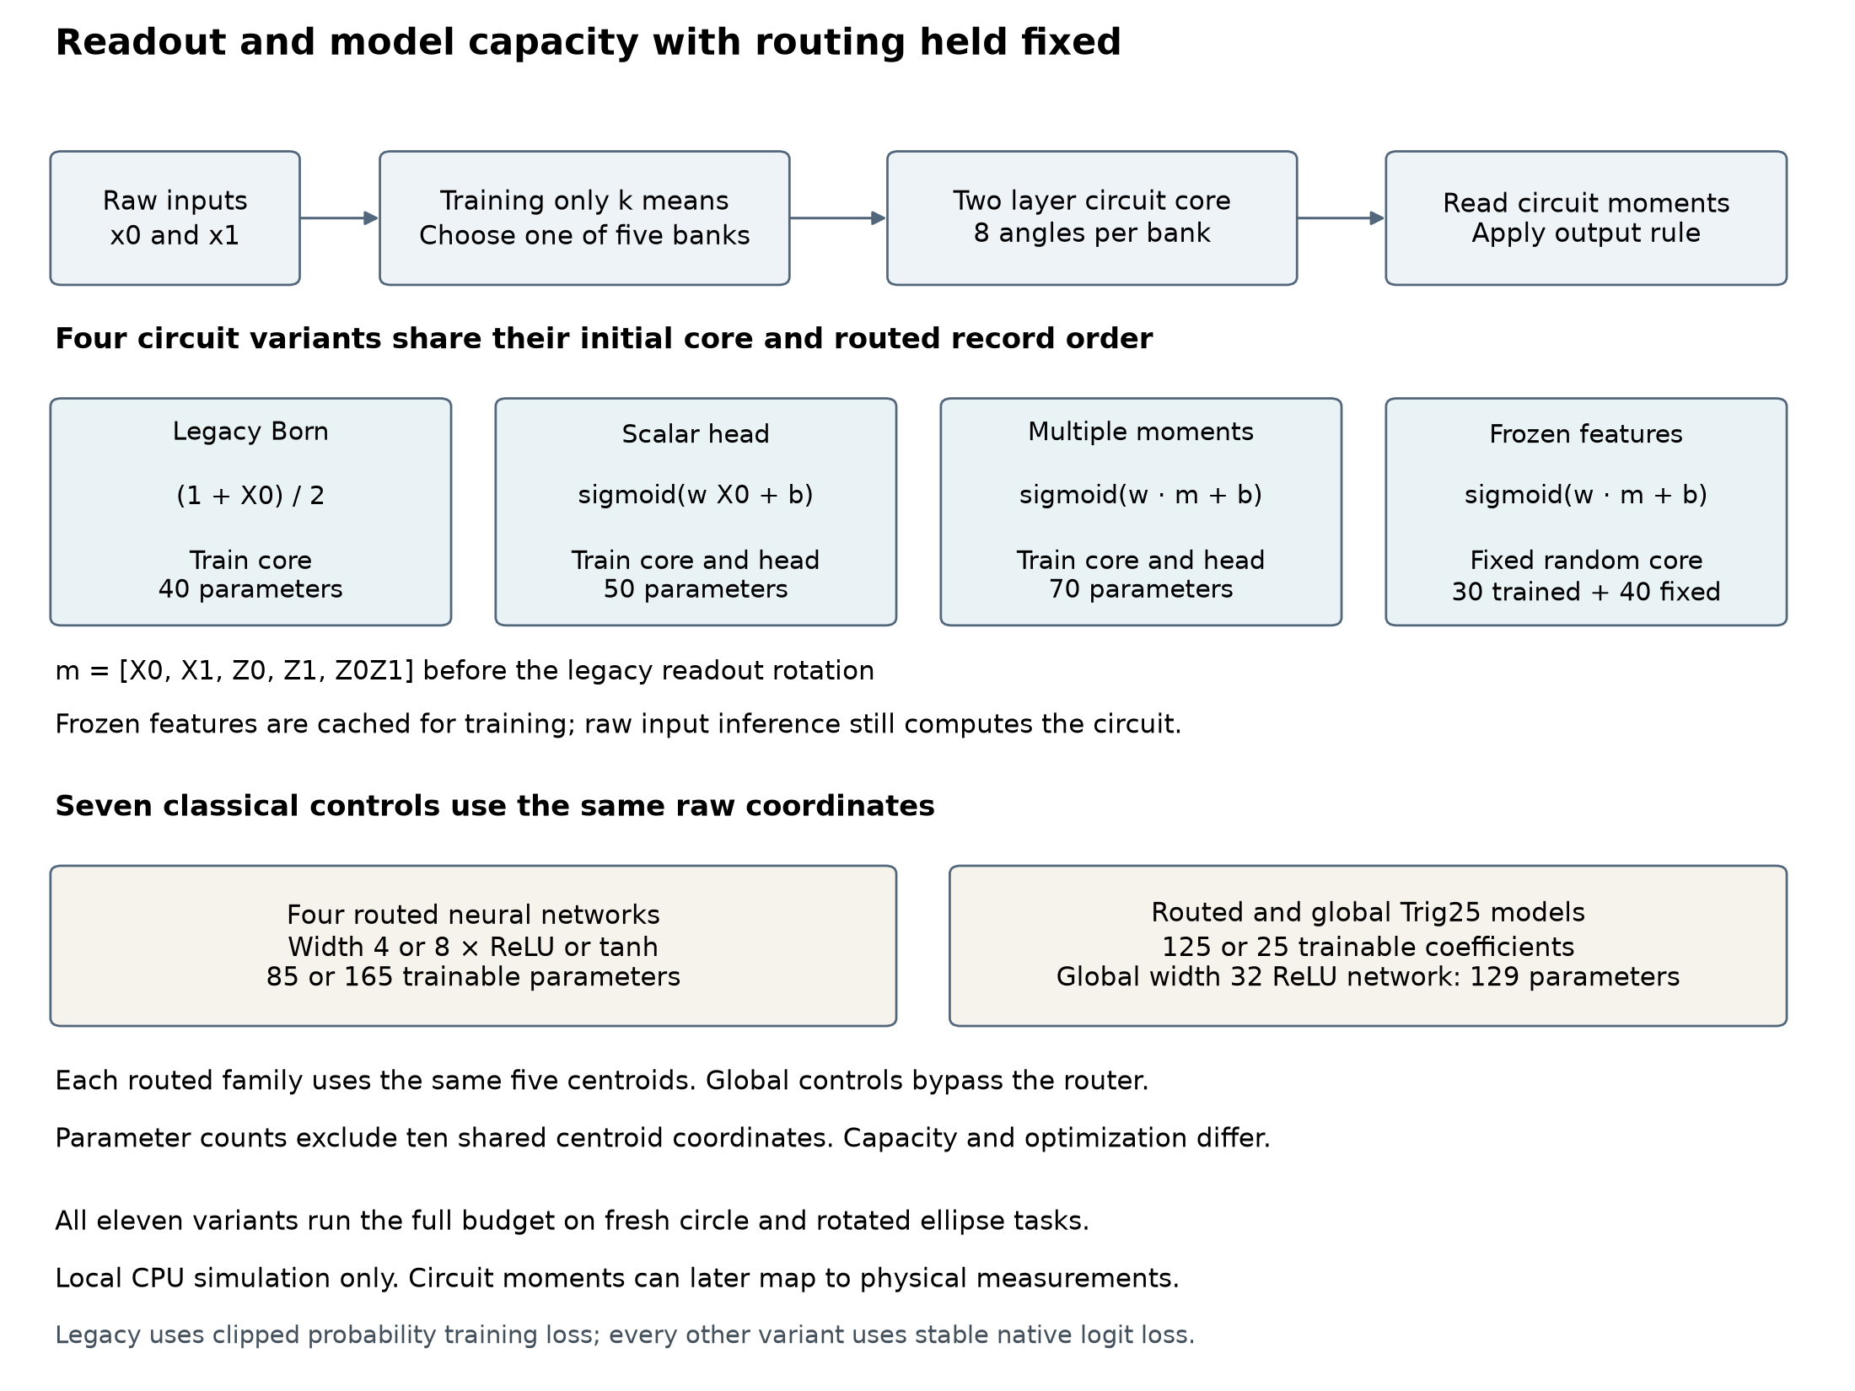
Figure 1. Eleven registered model recipes. The circuit is simulated on a classical CPU. A bank is a separate parameter set selected by the classical router.
Each circuit bank uses two qubits and repeats the same layer twice: encode each coordinate with RY(pi x), apply trainable RY and RZ rotations to each qubit, then apply CX from qubit 0 to qubit 1. This gives eight circuit angles per bank. The new readouts use moments before the old final readout rotation.

Models and capacity
Short name | Readout or model | Trained | Fixed
Legacy | Born probability from X0 | 40 | 0
Scalar | One moment and sigmoid head | 50 | 0
Multi | Five moments and sigmoid head | 70 | 0
Frozen | Fixed core and five-moment head | 30 | 40
ReLU 4 | Five width 4 neural networks | 85 | 0
ReLU 8 | Five width 8 neural networks | 165 | 0
Tanh 4 | Five width 4 neural networks | 85 | 0
Tanh 8 | Five width 8 neural networks | 165 | 0
Trig routed | Five Trig25 linear logits | 125 | 0
Trig global | One Trig25 linear logit | 25 | 0
MLP global | One width 32 ReLU network | 129 | 0
Counts describe allocated model scalars. Routed recipes also retain ten centroid coordinates, shared across arms within a population. Only one bank is active per record. Parameter counts do not equate functional capacity or execution cost.
The legacy probability is (1 + X0) / 2. Scalar applies sigmoid(w X0 + b). Multi and Frozen apply sigmoid(w dot m + b), where m contains X0, X1, Z0, Z1 and Z0Z1. The scalar head starts at w = 2 and b = 0; the five-moment head starts at [2, 0, 0, 0, 0] and b = 0. Their initial predictions match each other, but not the legacy linear probability link.
All four circuit recipes share the same initial random core. Frozen never trains that core and never receives a pretrained core. Its train and validation moments are computed once, cached and bound to the raw inputs, routes and core. Cache creation and storage are charged separately; raw-input inference still runs the circuit.
Trig25 uses the full tensor product of [1, cos(pi x), sin(pi x), cos(2 pi x), sin(2 pi x)] for the two coordinates. It is a deliberately strong smooth-feature control. Same-width ReLU and tanh models start from identical Xavier weights and zero biases.

Fresh tasks and fixed routing
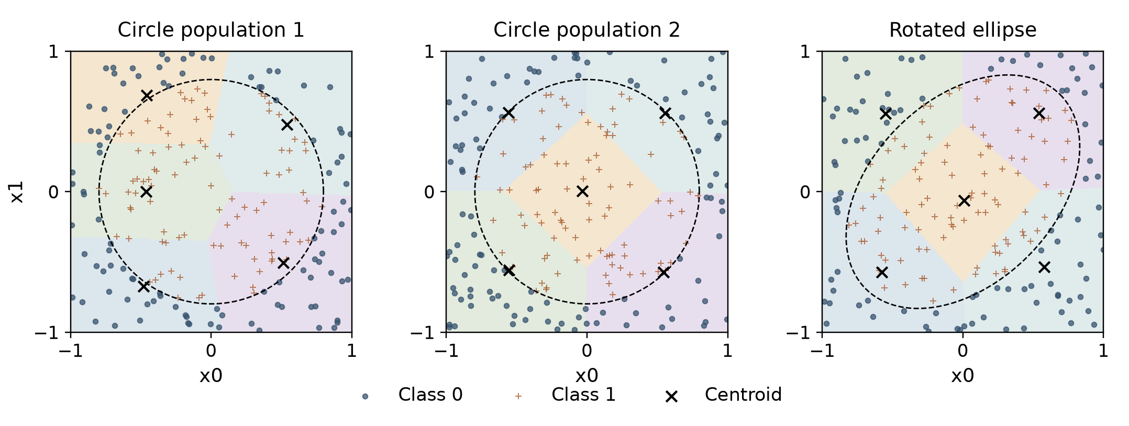
Figure 2. Training-only partitions. Each panel shows the 200 training records with the lowest IDs. The dashed analytical label boundary is illustrated for explanation and is never supplied to a model or router.
Inputs are independently drawn uniformly from [-1, 1] squared. Circle labels use x0 squared plus x1 squared less than 2/pi. The ellipse is rotated 45 degrees, has area 2 and axis ratio 1.5. The ellipse changes the decision boundary under the same input distribution; this is not an out-of-distribution test.
Stage | Populations | Seeds | Runs
Engineering | Circle and ellipse | 8901 | 22
Development A | Circle and ellipse | 901 to 903 | 66
Confirmation B | Two circles and one ellipse | 1001 to 1005 | 165
Each population has 4,800 training, 1,600 validation and 1,600 test records. The seven populations contain 56,000 new records. Exact float64 coordinate exclusions found no reuse against 112,000 unique historical coordinates or earlier v0.5 populations. Independent reconstruction checked all 21 payloads and 126 arrays, including the seven training-only routing policies.
Every routed arm in a population shares the same five-centroid router. Hash routes remain in the data for provenance and route diagnostics, but no hash-routed arm is trained in v0.5. Global controls bypass routing. This design measures readout and capacity differences conditional on this fixed spatial partition.

Training and evaluation controls
Every official endpoint runs 200 full rounds, with batch size 64 and 75 updates per round: 15,000 updates. Adam uses learning rate 0.01, betas 0.9 and 0.999, epsilon 1e-8 and no weight decay. All methods share the seeded record order within a population and seed. There is no early stopping.
The selected checkpoint is the earliest exact minimum of full validation clipped binary cross entropy across all 200 rounds. The legacy model retains its previous clipped-probability training objective. Every other model uses stable native logit loss, softplus(z) minus y z, whose derivative is sigmoid(z) minus y. Confident wrong logit predictions therefore continue receiving a gradient even beyond the reporting clip range.
Common comparison loss clips probabilities to [1e-7, 1 - 1e-7]. This bounded score supports a consistent selection and comparison rule, but it is not strictly proper on the full raw probability interval. Native loss, probability and logit extrema, clipping counts, wrong clipped predictions and raw Brier score provide complementary diagnostics.
All eleven methods proceed from development to confirmation, regardless of development rank. Training sources, settings, data seals and analysis rules are frozen. Every round retains parameters, validation probabilities, native losses and available logits, sample orders and resource ledgers. Independent replay verifies all saved validation states, selection and committed files; it does not repeat every Adam update or independently recreate every intermediate batch gradient.
Confirmation test model outputs stay withheld until all 165 full endpoints are committed, both audits pass and root issues a hash-bound evaluation release. The test seal is a procedural integrity boundary, not encryption. Official predictions and statistics then require independent replay. Readiness diagnostics cannot change checkpoint selection or the comparison family.

Questions and uncertainty
Primary BCE contrast | What it tests
Scalar minus Legacy | Changed output link, learned readout and native training recipe
Multi minus Scalar | Five observables instead of one within the same logit framework
Multi minus Frozen | Training the circuit core versus fixed random circuit features
Multi minus Trig routed | Complete predictor recipes with different parameterizations
Each contrast is assessed separately on the two circle populations and ellipse, giving twelve primary comparisons. Negative BCE difference favors the first model. A difference of 0.01 is the registered practical reference; its relevance is specific to this task and loss.
Five paired seed differences give a mean, sample standard deviation and t interval with four degrees of freedom. Primary BCE intervals use nominal 99.5833 percent confidence for a Bonferroni family of twelve. Ordinary 95 percent intervals for secondary results are descriptive. Small seed counts and the t approximation limit precision; the fifteen seed-population cells are not pooled as independent tasks.
A second analysis draws 10,000 paired multinomial record resamples per population, using the same record counts for every method and checkpoint. Macro F1 is recomputed for each checkpoint before averaging the five scores. These intervals describe variation among test records conditional on the already trained checkpoints. They are separate from seed uncertainty and do not add training replications. Extreme adjusted bootstrap tails remain approximate.
Macro F1 averages the two class F1 values, with class 1 assigned when probability is at least 0.5. Brier is mean squared raw probability error. Ten fixed probability bins show counts, mean probability and positive fraction. ECE is a descriptive weighted bin discrepancy, not standalone proof of calibration. No calibrator is fitted on test labels.
Steps to 97 percent use validation macro F1 only. Report the first crossing and the third consecutive qualifying check, with the start of that sequence. Nonreachers remain explicitly counted at the 15,000-update horizon. Conditional medians among successful runs do not imply actual saved training: all endpoints execute the full budget.

Accuracy across the fresh tasks
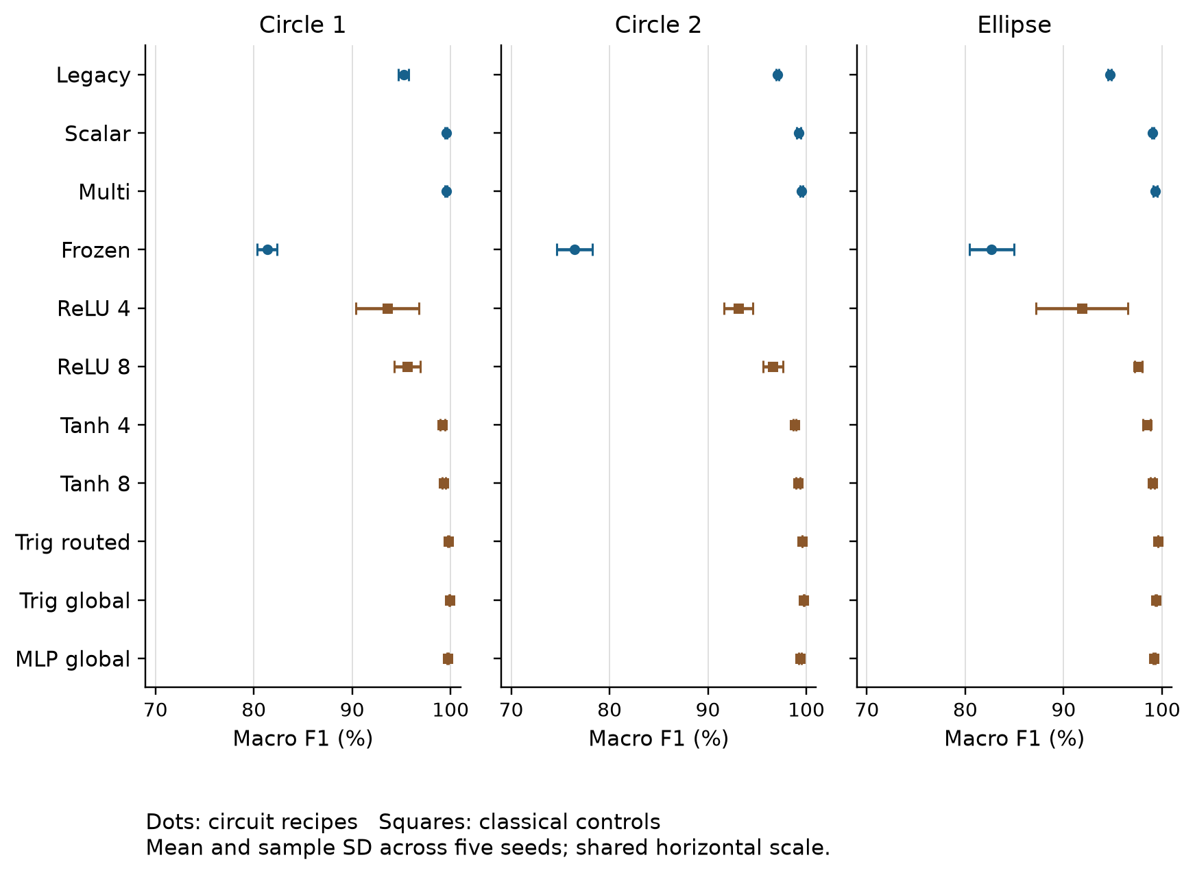
Figure 3. Independent confirmation populations. Error bars are sample standard deviations across five seeds, not confidence intervals.
The flexible circuit recipes are competitive with the strong controls on these tasks. Global Trig25 has the highest mean F1 on both circles, while routed Trig25 has the highest mean F1 on the ellipse and the lowest mean BCE on all three populations. No single ranking captures both classification and probability quality.
Small routed ReLU networks perform less well than the corresponding tanh models under this fixed recipe. The global width 32 network remains strong. This supports testing activation, feature family and optimization choices; it does not show that circuits generally outperform neural networks.

Circle 1 confirmation results
All results use the same 1,600 test records in this population and five separately trained checkpoints per model. Macro F1 and BCE show the mean and sample standard deviation across seeds. Brier and ECE are seed means; full seed values and accuracy are retained in the evidence.
Model | F1 percent | BCE | Brier | ECE
Legacy | 95.22 +/- 0.51 | 0.2228 +/- 0.0014 | 0.0584 | 0.1348
Scalar | 99.54 +/- 0.09 | 0.0136 +/- 0.0016 | 0.0037 | 0.0060
Multi | 99.55 +/- 0.12 | 0.0131 +/- 0.0013 | 0.0036 | 0.0059
Frozen | 81.36 +/- 1.01 | 0.3916 +/- 0.0152 | 0.1273 | 0.0442
ReLU 4 | 93.55 +/- 3.19 | 0.1265 +/- 0.0575 | 0.0416 | 0.0180
ReLU 8 | 95.60 +/- 1.32 | 0.0927 +/- 0.0256 | 0.0296 | 0.0154
Tanh 4 | 99.16 +/- 0.24 | 0.0282 +/- 0.0030 | 0.0075 | 0.0131
Tanh 8 | 99.31 +/- 0.16 | 0.0211 +/- 0.0008 | 0.0055 | 0.0104
Trig routed | 99.77 +/- 0.06 | 0.0105 +/- 0.0002 | 0.0026 | 0.0062
Trig global | 99.91 +/- 0.03 | 0.0124 +/- 0.0000 | 0.0027 | 0.0096
MLP global | 99.70 +/- 0.05 | 0.0141 +/- 0.0003 | 0.0035 | 0.0079
Lower BCE and Brier indicate better probability predictions. F1 uses the fixed 0.5 decision threshold. ECE is a descriptive ten-bin discrepancy and should be interpreted with bin counts, not as a standalone calibration ranking.
On Circle 1, Scalar improves F1 by 4.31 percentage points over Legacy. Multi adds only 0.01 points over Scalar. Trig global has the highest F1, while Trig routed has lower BCE; these metrics answer different questions.

Circle 2 confirmation results
All results use the same 1,600 test records in this population and five separately trained checkpoints per model. Macro F1 and BCE show the mean and sample standard deviation across seeds. Brier and ECE are seed means; full seed values and accuracy are retained in the evidence.
Model | F1 percent | BCE | Brier | ECE
Legacy | 97.08 +/- 0.14 | 0.1794 +/- 0.0002 | 0.0447 | 0.1309
Scalar | 99.22 +/- 0.18 | 0.0168 +/- 0.0020 | 0.0051 | 0.0053
Multi | 99.51 +/- 0.17 | 0.0130 +/- 0.0010 | 0.0037 | 0.0052
Frozen | 76.43 +/- 1.80 | 0.4489 +/- 0.0173 | 0.1497 | 0.0362
ReLU 4 | 93.09 +/- 1.46 | 0.1419 +/- 0.0294 | 0.0462 | 0.0221
ReLU 8 | 96.61 +/- 1.00 | 0.0745 +/- 0.0182 | 0.0235 | 0.0131
Tanh 4 | 98.80 +/- 0.14 | 0.0333 +/- 0.0009 | 0.0094 | 0.0120
Tanh 8 | 99.15 +/- 0.21 | 0.0276 +/- 0.0012 | 0.0076 | 0.0109
Trig routed | 99.56 +/- 0.00 | 0.0120 +/- 0.0001 | 0.0033 | 0.0049
Trig global | 99.74 +/- 0.05 | 0.0143 +/- 0.0001 | 0.0036 | 0.0089
MLP global | 99.35 +/- 0.14 | 0.0178 +/- 0.0004 | 0.0049 | 0.0075
Lower BCE and Brier indicate better probability predictions. F1 uses the fixed 0.5 decision threshold. ECE is a descriptive ten-bin discrepancy and should be interpreted with bin counts, not as a standalone calibration ranking.
On Circle 2, Scalar improves F1 by 2.14 percentage points over Legacy, and Multi adds 0.29 points over Scalar. The routed trigonometric model has nearly identical F1 across seeds; the full per-seed predictions and probability losses are retained.

Ellipse confirmation results
All results use the same 1,600 test records in this population and five separately trained checkpoints per model. Macro F1 and BCE show the mean and sample standard deviation across seeds. Brier and ECE are seed means; full seed values and accuracy are retained in the evidence.
Model | F1 percent | BCE | Brier | ECE
Legacy | 94.69 +/- 0.17 | 0.2134 +/- 0.0113 | 0.0570 | 0.1288
Scalar | 99.06 +/- 0.13 | 0.0260 +/- 0.0018 | 0.0074 | 0.0103
Multi | 99.29 +/- 0.21 | 0.0210 +/- 0.0016 | 0.0058 | 0.0085
Frozen | 82.67 +/- 2.25 | 0.4070 +/- 0.0160 | 0.1289 | 0.0563
ReLU 4 | 91.86 +/- 4.69 | 0.1562 +/- 0.0898 | 0.0511 | 0.0242
ReLU 8 | 97.59 +/- 0.38 | 0.0603 +/- 0.0117 | 0.0180 | 0.0118
Tanh 4 | 98.45 +/- 0.37 | 0.0414 +/- 0.0064 | 0.0118 | 0.0143
Tanh 8 | 99.02 +/- 0.21 | 0.0312 +/- 0.0022 | 0.0085 | 0.0145
Trig routed | 99.59 +/- 0.03 | 0.0140 +/- 0.0002 | 0.0036 | 0.0091
Trig global | 99.37 +/- 0.04 | 0.0201 +/- 0.0001 | 0.0051 | 0.0123
MLP global | 99.17 +/- 0.10 | 0.0222 +/- 0.0007 | 0.0060 | 0.0107
Lower BCE and Brier indicate better probability predictions. F1 uses the fixed 0.5 decision threshold. ECE is a descriptive ten-bin discrepancy and should be interpreted with bin counts, not as a standalone calibration ranking.
On the ellipse, Scalar improves F1 by 4.38 percentage points over Legacy, and Multi adds 0.23 points over Scalar. Routed Trig25 remains ahead of Multi in both mean F1 and mean BCE. These are same-task comparisons, not a subtraction of old v0.4 scores.

Primary probability loss comparisons
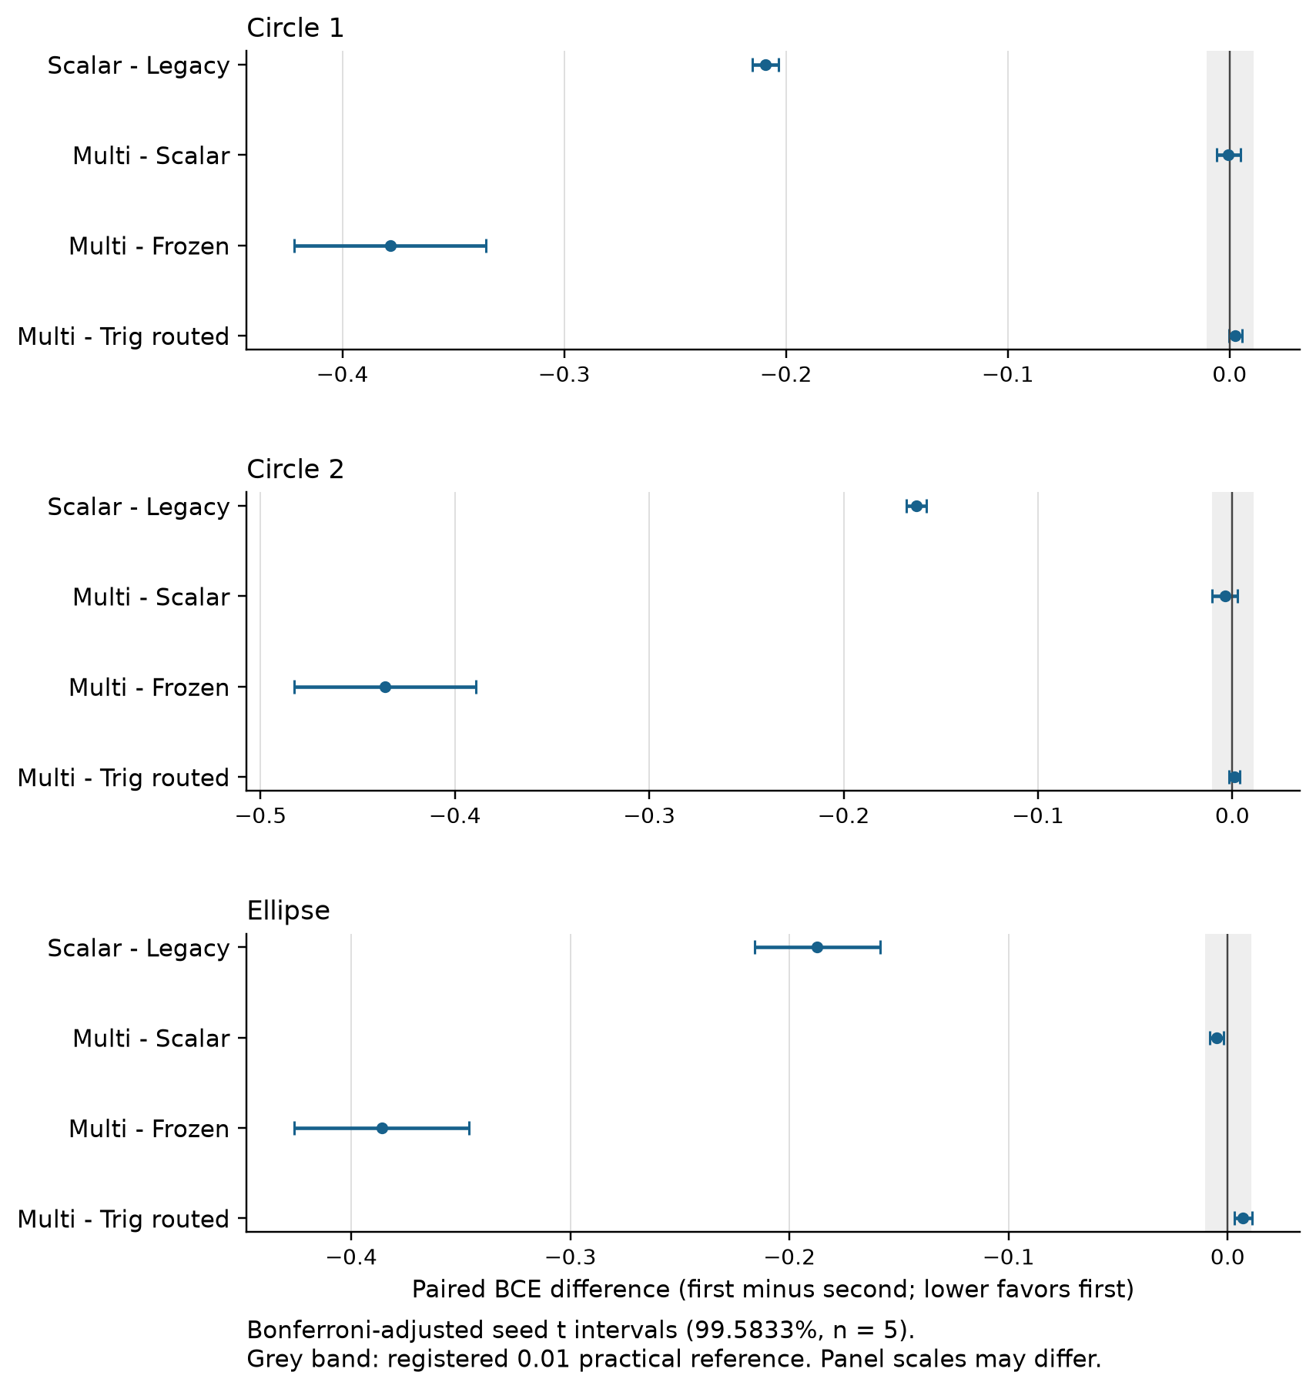
Figure 4. First model minus second. Negative differences favor the first model. The intervals adjust for twelve primary comparisons.
The large gains are the changed Scalar recipe versus Legacy and trained Multi versus the random Frozen core. Adding observables produces a smaller, task-dependent improvement. These contrasts do not isolate a quantum computational advantage.

Primary intervals for the two circles

Circle 1 primary differences
Both intervals use the registered adjustment for twelve primary comparisons. Seed t intervals have 99.5833 percent nominal confidence across five paired seeds. Record intervals are conditional paired bootstrap percentiles for the already trained checkpoints; they are separate sources of uncertainty.
Contrast | Mean | Seed interval | Record interval
Scalar minus Legacy | -0.2092 | [-0.2151, -0.2032] | [-0.2251, -0.1942]
Multi minus Scalar | -0.0005 | [-0.0058, +0.0049] | [-0.0036, +0.0026]
Multi minus Frozen | -0.3785 | [-0.4216, -0.3354] | [-0.4134, -0.3459]
Multi minus Trig routed | +0.0026 | [-0.0004, +0.0057] | [+0.0007, +0.0048]

Circle 2 primary differences
Both intervals use the registered adjustment for twelve primary comparisons. Seed t intervals have 99.5833 percent nominal confidence across five paired seeds. Record intervals are conditional paired bootstrap percentiles for the already trained checkpoints; they are separate sources of uncertainty.
Contrast | Mean | Seed interval | Record interval
Scalar minus Legacy | -0.1626 | [-0.1679, -0.1574] | [-0.1761, -0.1489]
Multi minus Scalar | -0.0038 | [-0.0104, +0.0028] | [-0.0077, -0.0004]
Multi minus Frozen | -0.4359 | [-0.4825, -0.3893] | [-0.4689, -0.4045]
Multi minus Trig routed | +0.0010 | [-0.0017, +0.0037] | [-0.0031, +0.0044]
Both circle Multi-minus-Scalar seed intervals include zero. Circle 2 has a negative conditional record interval despite the wider seed interval crossing zero: the fixed-checkpoint record comparison and variation across training seeds describe different uncertainty. Neither interval should replace the other.

Primary intervals for the ellipse

Ellipse primary differences
Both intervals use the registered adjustment for twelve primary comparisons. Seed t intervals have 99.5833 percent nominal confidence across five paired seeds. Record intervals are conditional paired bootstrap percentiles for the already trained checkpoints; they are separate sources of uncertainty.
Contrast | Mean | Seed interval | Record interval
Scalar minus Legacy | -0.1874 | [-0.2160, -0.1587] | [-0.2009, -0.1732]
Multi minus Scalar | -0.0050 | [-0.0083, -0.0017] | [-0.0084, -0.0018]
Multi minus Frozen | -0.3860 | [-0.4259, -0.3462] | [-0.4246, -0.3499]
Multi minus Trig routed | +0.0070 | [+0.0029, +0.0110] | [+0.0044, +0.0099]

What the registered comparisons support
Scalar lowers BCE versus Legacy by 0.1626 to 0.2092 across the three populations. Every adjusted seed and record interval is negative, and the gains exceed the registered 0.01 practical reference. This combines a learned output link with a changed native training loss; it cannot attribute the entire gain to the readout alone.
Multi lowers BCE versus Scalar on the ellipse by 0.0050. Both adjusted intervals exclude zero, but the observed change is below the 0.01 practical reference. The two circle contrasts do not establish a consistent extra-observable benefit across seeds. This is not a formal equivalence test.
Multi lowers BCE versus Frozen by 0.3785, 0.4359 and 0.3860. All adjusted intervals support substantial gains from training the core under this initialization and recipe. This does not test a pretrained frozen core or every possible random-feature distribution.
Multi has higher mean BCE than routed Trig25 in every population. On the ellipse the adjusted seed interval is [0.0029, 0.0110], and the record interval is [0.0044, 0.0099]. Both favor Trig25, while the seed interval still permits a difference above the practical reference. Circle seed intervals include zero; the Circle 1 record interval favors Trig25. The study does not establish general equivalence or superiority between these parameterizations.

Probability quality and model capacity
The flexible readouts improve probability quality as well as thresholded F1. Scalar and Multi have mean ECE about 0.005 to 0.010 across the tasks, compared with about 0.129 to 0.135 for Legacy. Raw Brier scores also fall sharply. ECE remains a descriptive fixed-bin statistic; calibration conclusions require the retained bin counts and more diverse data.
Frozen illustrates why ECE alone is insufficient: its mean ECE is lower than Legacy in these populations, but its F1, BCE and Brier scores are much worse. A predictor can be less confident without providing better discrimination.

Clipping and native objectives
All recorded training wrong-clipped visits and test wrong-clipped pairs are zero. Many confidently correct logit outputs pass outside the common reporting clip interval. Native and common test mean losses differ by at most 6.99e-8 here. The package retains counts, raw extrema, native losses and selected-checkpoint logits. Training counts represent repeated visits, not unique records. Stable native logistic loss and its gradient remain active beyond the reporting clip; the Legacy objective has different clipping behavior.

Why the classical feature control matters
An independently checked mathematical argument places each depth-two circuit moment in the tensor Fourier basis with frequencies up to two in each coordinate. Consequently, a linear combination of these moments plus a bias, followed by a sigmoid, can be represented in Trig25 for each fixed routing bank. The current frozen circuit source was checked against this argument.
This containment concerns the Scalar, Multi and Frozen logits. It does not equate the Legacy Born-probability link with a finite Trig25 logit, and it does not equate training landscapes, parameter counts, regularization or hardware costs. A direct compiled classical evaluator of each learned circuit logit is a promising next implementation test; no such deployment-latency experiment was run here.
Routed Trig25 has 125 trained coefficients versus 70 for Multi and 50 for Scalar; global Trig25 uses 25. Routing adds ten stored centroid coordinates to each routed recipe. These counts and the exact span argument help interpret capacity, but do not establish a globally optimal model.

Circle 1 steps to 97 percent
First n counts runs reaching 97 percent macro F1 once. Streak n counts runs completing three consecutive qualifying validation checks. Medians include only reaching runs; nonreachers are censored at 15,000 updates. A median between observed steps is an arithmetic summary. Every run completed the full budget, so these are descriptive milestones rather than measured training savings.
Model | First n | Median step | Streak n | Median step
Legacy | 0/5 | Not reached | 0/5 | Not reached
Scalar | 5/5 | 375 | 5/5 | 525
Multi | 5/5 | 300 | 5/5 | 450
Frozen | 0/5 | Not reached | 0/5 | Not reached
ReLU 4 | 0/5 | Not reached | 0/5 | Not reached
ReLU 8 | 0/5 | Not reached | 0/5 | Not reached
Tanh 4 | 5/5 | 2,625 | 5/5 | 2,775
Tanh 8 | 5/5 | 1,575 | 5/5 | 1,725
Trig routed | 5/5 | 75 | 5/5 | 225
Trig global | 5/5 | 300 | 5/5 | 450
MLP global | 5/5 | 225 | 5/5 | 375
These milestones use validation observations every 75 optimizer updates. Test scores are from the separately selected minimum-validation-BCE checkpoint. A fast validation crossing is not evidence that the same test score would hold at that early round.

Circle 2 steps to 97 percent
First n counts runs reaching 97 percent macro F1 once. Streak n counts runs completing three consecutive qualifying validation checks. Medians include only reaching runs; nonreachers are censored at 15,000 updates. A median between observed steps is an arithmetic summary. Every run completed the full budget, so these are descriptive milestones rather than measured training savings.
Model | First n | Median step | Streak n | Median step
Legacy | 5/5 | 450 | 5/5 | 600
Scalar | 5/5 | 300 | 5/5 | 450
Multi | 5/5 | 225 | 5/5 | 375
Frozen | 0/5 | Not reached | 0/5 | Not reached
ReLU 4 | 0/5 | Not reached | 0/5 | Not reached
ReLU 8 | 4/5 | 1,800 | 3/5 | 4,050
Tanh 4 | 5/5 | 2,100 | 5/5 | 2,400
Tanh 8 | 5/5 | 1,575 | 5/5 | 1,875
Trig routed | 5/5 | 75 | 5/5 | 225
Trig global | 5/5 | 225 | 5/5 | 375
MLP global | 5/5 | 225 | 5/5 | 375
These milestones use validation observations every 75 optimizer updates. Test scores are from the separately selected minimum-validation-BCE checkpoint. A fast validation crossing is not evidence that the same test score would hold at that early round.

Ellipse steps to 97 percent
First n counts runs reaching 97 percent macro F1 once. Streak n counts runs completing three consecutive qualifying validation checks. Medians include only reaching runs; nonreachers are censored at 15,000 updates. A median between observed steps is an arithmetic summary. Every run completed the full budget, so these are descriptive milestones rather than measured training savings.
Model | First n | Median step | Streak n | Median step
Legacy | 4/5 | 3,337.5 | 0/5 | Not reached
Scalar | 5/5 | 300 | 5/5 | 450
Multi | 5/5 | 225 | 5/5 | 375
Frozen | 0/5 | Not reached | 0/5 | Not reached
ReLU 4 | 1/5 | 1,125 | 1/5 | 1,275
ReLU 8 | 5/5 | 975 | 5/5 | 1,125
Tanh 4 | 5/5 | 1,575 | 5/5 | 2,400
Tanh 8 | 5/5 | 1,200 | 5/5 | 1,950
Trig routed | 5/5 | 75 | 5/5 | 225
Trig global | 5/5 | 150 | 5/5 | 300
MLP global | 5/5 | 300 | 5/5 | 450
These milestones use validation observations every 75 optimizer updates. Test scores are from the separately selected minimum-validation-BCE checkpoint. A fast validation crossing is not evidence that the same test score would hold at that early round.

Circle 1 CPU execution costs
Medians across five seed runs. Loop seconds include validation and evidence writing under concurrent seed workers; they are elapsed wall times, not process CPU seconds. Inference microseconds per record use uncached raw inputs, routing and model prediction, after warmup, excluding loading and I/O. Cache seconds and feature-array bytes are separate preparation costs; array bytes exclude file headers and container overhead.
Model | Loop sec | Infer us per record | Cache sec | Array bytes
Legacy | 590.0 | 3.80 | 0.000 | 0
Scalar | 499.3 | 3.30 | 0.000 | 0
Multi | 538.7 | 3.42 | 0.000 | 0
Frozen | 9.5 | 3.36 | 0.016 | 256,000
ReLU 4 | 10.9 | 0.50 | 0.000 | 0
ReLU 8 | 11.0 | 0.49 | 0.000 | 0
Tanh 4 | 10.9 | 0.51 | 0.000 | 0
Tanh 8 | 11.2 | 0.60 | 0.000 | 0
Trig routed | 10.6 | 0.81 | 0.000 | 0
Trig global | 6.0 | 0.32 | 0.000 | 0
MLP global | 5.9 | 0.14 | 0.000 | 0
The host was an AMD Ryzen AI 9 HX 370 with 12 physical cores and 24 logical processors. Training used three concurrent seed workers in A and five in B, with one BLAS thread per worker. All training and simulation used the CPU; no GPU was used. Batch inference timings use 1,024 raw validation inputs after warmup. They do not include application startup or model loading.

Circle 2 CPU execution costs
Medians across five seed runs. Loop seconds include validation and evidence writing under concurrent seed workers; they are elapsed wall times, not process CPU seconds. Inference microseconds per record use uncached raw inputs, routing and model prediction, after warmup, excluding loading and I/O. Cache seconds and feature-array bytes are separate preparation costs; array bytes exclude file headers and container overhead.
Model | Loop sec | Infer us per record | Cache sec | Array bytes
Legacy | 586.8 | 3.70 | 0.000 | 0
Scalar | 500.1 | 3.13 | 0.000 | 0
Multi | 535.5 | 2.68 | 0.000 | 0
Frozen | 9.6 | 3.23 | 0.015 | 256,000
ReLU 4 | 11.0 | 0.49 | 0.000 | 0
ReLU 8 | 11.1 | 0.50 | 0.000 | 0
Tanh 4 | 10.9 | 0.56 | 0.000 | 0
Tanh 8 | 11.1 | 0.48 | 0.000 | 0
Trig routed | 10.6 | 0.79 | 0.000 | 0
Trig global | 6.0 | 0.34 | 0.000 | 0
MLP global | 6.0 | 0.15 | 0.000 | 0
Each trainable quantum core uses one forward state evolution plus sixteen parameter-shift evolutions per training record for its eight angles. Requested observables reuse each resulting state. Classical heads and the two physical measurement settings are accounted separately; observable count is not multiplied into an invented number of state evolutions.

Ellipse CPU execution costs
Medians across five seed runs. Loop seconds include validation and evidence writing under concurrent seed workers; they are elapsed wall times, not process CPU seconds. Inference microseconds per record use uncached raw inputs, routing and model prediction, after warmup, excluding loading and I/O. Cache seconds and feature-array bytes are separate preparation costs; array bytes exclude file headers and container overhead.
Model | Loop sec | Infer us per record | Cache sec | Array bytes
Legacy | 571.9 | 2.76 | 0.000 | 0
Scalar | 514.9 | 3.13 | 0.000 | 0
Multi | 546.3 | 3.07 | 0.000 | 0
Frozen | 9.7 | 3.35 | 0.015 | 256,000
ReLU 4 | 11.0 | 0.49 | 0.000 | 0
ReLU 8 | 11.1 | 0.51 | 0.000 | 0
Tanh 4 | 11.0 | 0.52 | 0.000 | 0
Tanh 8 | 11.1 | 0.59 | 0.000 | 0
Trig routed | 10.7 | 0.79 | 0.000 | 0
Trig global | 6.1 | 0.34 | 0.000 | 0
MLP global | 5.8 | 0.14 | 0.000 | 0
Development A took 48.04 minutes and confirmation B took 86.92 minutes of observed stage wall time. The two sequential stages therefore took 2.25 hours, excluding preparation, audits, scoring, simulator checks and report work. All 231 full endpoints performed 3,465,000 optimizer updates in total.

What the execution costs mean
Across the populations, median training-loop times are about 499 to 515 seconds for Scalar and 536 to 546 seconds for Multi, versus about 11 seconds for routed Trig25 and 6 seconds for global Trig25. These loops include validation and evidence writes under concurrency. They show a large practical classical cost gap in the present implementation, not an isolated hardware efficiency benchmark.
Median raw-input inference is about 2.68 to 3.42 microseconds per record for Multi, 0.79 to 0.81 for routed Trig25 and 0.32 to 0.34 for global Trig25 at the measured batch size. The global MLP is also fast, about 0.14 to 0.15 microseconds per record. Different implementations, batch sizes or devices may change these ratios.
Frozen trains its head in roughly 9.5 to 9.7 seconds after a roughly 0.015 to 0.016 second moment-cache preparation. Its 6,400 training and validation records require 256,000 feature-array bytes, excluding file headers and other stored data. This saving comes with poor predictive performance here. Uncached raw-input inference still evaluates its core, so head-training speed is not an end-to-end inference speedup.
Routed Trig25 reaches validation F1 of 97 percent at the first 75-update check in every confirmation run and completes a three-check streak at 225 updates. Scalar and Multi reach it quickly too. The study nevertheless runs every model to 15,000 updates, so no early-stopping wall-time saving was measured.
No energy, FLOP, device-hour or cloud-cost measurements were collected. Statevector work, classical operation counters, shot budgets, stored cache bytes and elapsed CPU times are separate quantities. Their arithmetic cannot be used to infer a quantum speed advantage.

Local circuit readiness
The complete local capsule checks 60 selected circuit checkpoints on 1,920 checkpoint-fixture pairs. Each population uses the 32 validation records with the lowest IDs, shared across seeds and circuit methods. No test labels select fixtures or alter models.
Matrix, production and ideal Aer checks passed the registered 2e-12 tolerance. The largest compiled unitary error was 2.08e-13; the largest Aer moment error was 9.99e-16. A separate auditor reconstructed the logical noise distributions and every joint multinomial draw before these results were approved.

Abstract compiled circuit resources
Model | Setting | Operations | CX gates | Depth
Legacy | XX | 23 to 24 | 2 | 13
Scalar | XX | 24 to 25 | 2 | 13 to 14
Multi | XX | 24 | 2 | 13
Multi | ZZ | 18 | 2 | 10
Frozen | XX | 24 | 2 | 13
Frozen | ZZ | 18 | 2 | 10
Ranges cover every registered input and selected checkpoint on the abstract two-qubit target. Counts exclude final measurement operations in these compiled unitary circuits. XX rotates both qubits even when only X0 is needed; its extra rotation is charged. Original legacy q0-only readout checks are retained separately. Noise is applied to logical gates, so these compilation counts are not a physical device noise model.
Compilation uses an abstract bidirectional two-qubit target, basis rz sx x cx, optimization level 1 and fixed transpiler seed 590017. This is a software compatibility check rather than a device-specific compilation or calibration result.
Scalar and Legacy need one XX setting per input. Multi and Frozen use XX for X0 and X1 and ZZ for Z0, Z1 and Z0Z1. Moments within a setting come from the same joint bitstrings. The common XX circuit rotates both qubits, including the unnecessary q1 rotation for a scalar-only readout; the capsule charges this actual implementation.

Illustrative logical noise
Noise errors are absolute changes in predicted probability from the ideal density predictor, averaged across 32 fixed validation fixtures and five checkpoints. Class changes compare the fixed 0.5 decisions with ideal decisions; they are not classification error against labels. Mild and stress are illustrative logical-gate scenarios, not measured device calibration.
Mild uses depolarizing strengths 0.001 after logical one-qubit gates and 0.01 after CX, with symmetric readout flips of 0.01. Stress uses 0.005, 0.03 and 0.03 respectively. Encoding and readout rotations are included. Noise is attached to logical gates, not the compiled basis gates.

Circle 1 logical noise sensitivity
Model | Mild mean error | Stress mean error | Mild class change % | Stress class change %
Legacy | 0.0155 | 0.0504 | 0.00 | 0.00
Scalar | 0.0017 | 0.0069 | 0.00 | 0.00
Multi | 0.0015 | 0.0054 | 0.00 | 1.25
Frozen | 0.0304 | 0.0862 | 3.75 | 10.62

Circle 2 logical noise sensitivity
Model | Mild mean error | Stress mean error | Mild class change % | Stress class change %
Legacy | 0.0173 | 0.0565 | 0.00 | 0.00
Scalar | 0.0004 | 0.0017 | 0.00 | 0.00
Multi | 0.0006 | 0.0027 | 0.00 | 0.00
Frozen | 0.0080 | 0.0263 | 1.25 | 2.50

Ellipse logical noise sensitivity
Model | Mild mean error | Stress mean error | Mild class change % | Stress class change %
Legacy | 0.0154 | 0.0501 | 0.00 | 0.00
Scalar | 0.0020 | 0.0095 | 0.00 | 0.00
Multi | 0.0006 | 0.0024 | 0.00 | 0.00
Frozen | 0.0112 | 0.0372 | 1.25 | 2.50
Small average deviations do not bound every input. For example, Scalar on the ellipse has mean stress deviation 0.0095 but maximum deviation 0.2924 among these fixtures. The limited sample and fixed noise scenarios do not establish performance on a real device.

Circle 1 finite shot checks
The shot tables give mean absolute deviation from the same scenario density prediction across five training seeds, five shot repeats and 32 fixed fixtures. These are descriptive nested samples, not 25 independent trained models. Budgets are per measurement setting: Multi and Frozen require twice as many total shots per record. Joint bitstring counts preserve covariance among observables. The saved sigmoid head is applied to each sampled set of moments; nonlinear head bias is retained. Shot deviation and noise distortion should not be added as independent errors.
Model | Scenario | Settings | 1024 per setting | 8192 per setting
Legacy | Ideal | 1 | 0.0085 | 0.0029
Legacy | Mild | 1 | 0.0090 | 0.0032
Legacy | Stress | 1 | 0.0100 | 0.0037
Scalar | Ideal | 1 | 0.0128 | 0.0030
Scalar | Mild | 1 | 0.0099 | 0.0039
Scalar | Stress | 1 | 0.0133 | 0.0045
Multi | Ideal | 2 | 0.0141 | 0.0050
Multi | Mild | 2 | 0.0123 | 0.0041
Multi | Stress | 2 | 0.0136 | 0.0038
Frozen | Ideal | 2 | 0.0153 | 0.0054
Frozen | Mild | 2 | 0.0161 | 0.0058
Frozen | Stress | 2 | 0.0173 | 0.0060

Circle 2 finite shot checks
The shot tables give mean absolute deviation from the same scenario density prediction across five training seeds, five shot repeats and 32 fixed fixtures. These are descriptive nested samples, not 25 independent trained models. Budgets are per measurement setting: Multi and Frozen require twice as many total shots per record. Joint bitstring counts preserve covariance among observables. The saved sigmoid head is applied to each sampled set of moments; nonlinear head bias is retained. Shot deviation and noise distortion should not be added as independent errors.
Model | Scenario | Settings | 1024 per setting | 8192 per setting
Legacy | Ideal | 1 | 0.0070 | 0.0025
Legacy | Mild | 1 | 0.0079 | 0.0028
Legacy | Stress | 1 | 0.0095 | 0.0033
Scalar | Ideal | 1 | 0.0034 | 0.0007
Scalar | Mild | 1 | 0.0037 | 0.0011
Scalar | Stress | 1 | 0.0037 | 0.0014
Multi | Ideal | 2 | 0.0017 | 0.0004
Multi | Mild | 2 | 0.0027 | 0.0007
Multi | Stress | 2 | 0.0045 | 0.0014
Frozen | Ideal | 2 | 0.0133 | 0.0048
Frozen | Mild | 2 | 0.0146 | 0.0048
Frozen | Stress | 2 | 0.0144 | 0.0052

Ellipse finite shot checks
The shot tables give mean absolute deviation from the same scenario density prediction across five training seeds, five shot repeats and 32 fixed fixtures. These are descriptive nested samples, not 25 independent trained models. Budgets are per measurement setting: Multi and Frozen require twice as many total shots per record. Joint bitstring counts preserve covariance among observables. The saved sigmoid head is applied to each sampled set of moments; nonlinear head bias is retained. Shot deviation and noise distortion should not be added as independent errors.
Model | Scenario | Settings | 1024 per setting | 8192 per setting
Legacy | Ideal | 1 | 0.0083 | 0.0028
Legacy | Mild | 1 | 0.0083 | 0.0033
Legacy | Stress | 1 | 0.0099 | 0.0038
Scalar | Ideal | 1 | 0.0084 | 0.0030
Scalar | Mild | 1 | 0.0097 | 0.0029
Scalar | Stress | 1 | 0.0116 | 0.0047
Multi | Ideal | 2 | 0.0050 | 0.0015
Multi | Mild | 2 | 0.0061 | 0.0018
Multi | Stress | 2 | 0.0071 | 0.0020
Frozen | Ideal | 2 | 0.0154 | 0.0048
Frozen | Mild | 2 | 0.0158 | 0.0051
Frozen | Stress | 2 | 0.0163 | 0.0057

Simulator evidence and its limits
The capsule retains 2,880 required measurement-setting circuits plus 480 original legacy readout checks. There are 10,080 logical density evaluations, 2,700 joint count arrays and 1,800 saved finite-shot predictor arrays.
Actual measured Aer smoke tests comprise 1,440 circuit experiments and 1,474,560 simulated measurement shots. Separately, probability-level multinomial sampling represents 398,131,200 trials. These are distinct simulation costs and neither is physical device usage.
The measured Aer smoke uses eight of the 32 fixtures per checkpoint, 1,024 shots per setting and ideal plus mild scenarios. Its standardized residuals are descriptive; there is no post-hoc stochastic selection threshold. The full finite-shot sweep uses 1,024 and 8,192 shots per setting and five repeats for each noise scenario.
A learned sigmoid head can amplify errors near its threshold and saturate elsewhere. Applying it to estimated moments creates nonlinear plug-in bias; the package retains bias and variance across repeats. Raising the shot budget addresses sampling variability but does not remove systematic logical noise. Average shot deviation and average noise distortion cannot be added as if independent.
The independent capsule audit reconstructs mathematical moments, noise channels, joint counts, predictor summaries and accounting. It checks QASM inventory and recorded compiled residuals; it does not independently rerun the compiler or rerandomize the measured Aer experiments. Local readiness therefore supports a later bounded hardware pilot, not hardware accuracy, latency or advantage claims.

Recommended next experiment

Make the classical version cheaper
Build and verify an exact Trig25 evaluator of each learned Scalar and Multi logit under its frozen router. Check raw probabilities, classes and native losses against the original circuit evaluator, then benchmark batch size one and realistic batches on the same host. This tests whether circuit training can supply useful compact parameterization while classical inference avoids statevector simulation.

Separate readout improvements from training changes
Register a matched experiment that isolates the output link, learnable head and stable native loss. Keep Scalar as the economical reference; retain Multi to test its modest ellipse gain and robustness. Include global and routed Trig25, global MLP and tanh controls, using matched selection rules and explicit training-time budgets as well as update counts.

Move beyond nearly solved boundaries
Use fresh, more varied boundary families and a modest real tabular task with fixed preprocessing and a held-out evaluation plan. Vary label noise, class balance, input dimension and router count in a bounded design. The current circles and ellipse are smooth and well matched to low-frequency features, so further fractional F1 gains alone would be weak evidence of broader usefulness.

Prepare a small later hardware pilot
After the broader local evidence, freeze a device-specific inference capsule with Scalar and Multi, a fixed set of inputs and checkpoint identities, an explicit calibration snapshot and a shot budget per setting. Compare ideal simulation, the selected device noise model and observed counts. Start with inference parity and stability; quantum training on hardware is a separate, more expensive question.
These are recommendations for a new registered study. No additional model search, task generation or hardware job was performed after the v0.5 confirmation results.

Limitations and interpretation
This study tests a shallow two-qubit classifier component with a classical spatial router and classical heads. It does not train the proposed full multistate language architecture, process language data, or compare with foundation models. High F1 on these small tasks is useful engineering evidence within that narrow scope.
Two independently sampled circles and one ellipse, with five training seeds each, provide limited coverage. Inputs are uniform in two dimensions and labels are deterministic smooth boundaries. Seed intervals condition on the chosen split, router and recipe; record bootstrap intervals condition on the trained checkpoints. These uncertainties do not cover arbitrary future tasks or data shifts.
Model counts, functional families and optimization landscapes differ. The common router is held fixed, so v0.5 does not re-establish a general routing benefit or isolate capacity at a matched parameter budget. Weak small ReLU results under this recipe are not a verdict on neural networks. Trig25 is particularly suitable for these smooth low-dimensional tasks.
Historical v0.4 results use different data, seeds and parts of the training recipe. They provide context only. Same-task Legacy and the fresh classical controls are the valid anchors for interpreting this study. Scalar versus Legacy changes more than one mechanism, and an interval including zero is not proof of equality.
Resource measurements are local CPU observations under concurrent seed workers and a single inference batch size. They exclude isolated deployment tests, GPU runs, energy measurement and physical quantum devices. Illustrative noise and finite-shot checks reuse small validation fixture sets and cannot substitute for hardware evidence.
The favorable outcome is a better understood readout mechanism and a clear practical direction for the classical implementation. It does not show quantum advantage, a universal accuracy improvement, or a globally optimal architecture.

Integrity and reproducibility
All 22 short engineering endpoints, 66 full development endpoints and 165 full confirmation endpoints completed. Both official stages ran every registered arm and full budget, with no rank-based elimination or early stopping. The official training sources and test-file inventory remained frozen.
Independent validation replay covered 13,200 development rounds and 33,000 confirmation rounds: 73.92 million saved validation predictions in total, with zero class disagreements. It verified saved states, selection and committed evidence rather than rerunning every optimizer update or independently measuring execution time.
Root released confirmation evaluation only after both full endpoint audits passed. Independent test replay checked 264,000 checkpoint-record predictions, with zero class disagreements and maximum probability difference 8.22e-15. All three paired bootstrap count arrays matched exactly. Five training seeds remain five replications despite repeated use of each test record.
No official training, evaluation or local capsule failure required a retry. Development-time synthetic test failures and their corrections are retained, including source-review iterations and numerical test fixtures. They occurred before the corresponding frozen official execution. Report and packaging helper reviews are retained separately; they do not modify training results.
After execution, all 19,263 prior v0.4 payloads and the four Baseline4 seal files matched their before hashes. The Baseline4 archive agreed with its external manifest and companion hash. This preservation check does not claim to re-extract every archived payload.
The delivery includes immutable run evidence, source, runtime records, frozen protocols, data/router policies, logs, every-round arrays, selected and final checkpoints, predictions, uncertainty analyses, local circuit artifacts and report source. DELIVERY_MANIFEST.json and two separate verification records establish package integrity after copying. README.txt and REPRODUCTION_GUIDE.txt describe safe replay in a writable copy.

Evidence index
Evidence | Package location
Frozen design and analysis | governance/STUDY_PLAN.json  governance/ANALYSIS_PROTOCOL.json
Fresh data and routers | quantum/data/DATA_SEAL.json
All official training states | quantum/stage_A/  quantum/stage_B/
Official confirmation results | quantum/confirmation_evaluation/
Independent prediction and statistics | analysis/independent_replay/confirmation_replay/
Validation milestones and costs | analysis/learning_resources/stage_A_v01/  analysis/learning_resources/stage_B_v01/
Circuit and shot evidence | quantum/local_readiness_confirmation/
Independent simulator checks | analysis/classical_review/confirmation_readiness_audit/
Approved report inputs and source | report_work/ROOT_REPORT_INPUTS.json  report_work/report_content.json
Prior version preservation | governance/baseline_v04_after.json  governance/baseline4_after.json
Full numeric results are retained in JSON and per-endpoint evidence, including all secondary contrasts, native objectives, calibration bins, extrema, route exposure, counters and conditional bootstrap distributions. The report presents decision-relevant summaries without replacing those records.

Technical references
Schuld, Sweke and Meyer. The effect of data encoding on the expressive power of variational quantum machine learning models. Physical Review A 103, 032430 (2021). https://arxiv.org/abs/2008.08605. Background: encoding gates constrain accessible Fourier frequencies; repeated encoding can broaden the spectrum.
Bowles, Ahmed and Schuld. Better than classical? The subtle art of benchmarking quantum machine learning models (2024). https://arxiv.org/abs/2403.07059. Background: experimental design and strong classical comparisons matter when interpreting small simulated quantum classifiers.
The specific depth-two logit-span argument and numerical reconstruction in this package are an independent study check. The cited papers do not establish the measured Q Pathformer results. All v0.5 outcome claims are supported by the committed local study evidence.

Q Pathformer study v0 5 release edition
Edition note dated 29 October 2026. This Word edition preserves the original study report in full and adds this release note after it. The companion PDF is rendered from this Word edition. Repository edition v1.0 is separate from study v0.5.
Anthony Siljeg — Founder, Alnotrea Labs · Company affiliation: Alnotrea Pty Ltd · Q-Pathformer Initiative. Anthony is the licensor; company affiliation is not a transfer of ownership.
The original scientific text, results, figures, tables, limitations and historical recommendations are unchanged. Historical internal-use labels and evidence paths are retained as source context. References to a complete delivery describe the retained full study archive, not the curated release downloads.
On 29 October 2026, Anthony Siljeg adopted CC BY 4.0 for controlled original report prose, table presentation and original report figures, and this edition note, under the same scoped scheme as the earlier studies. Exact report and guidance scope records are supplied with this edition. Existing permissions in previously licensed expression remain in force. Third-party sources, architecture documents outside this report, datasets, models and full archives retain separate terms.
The release omits raw data, checkpoints, installed environments and full operational archives from its curated downloads. It does not repeat training, scoring, simulated shot sampling or hardware jobs. The original findings and historical recommendations are not revalidated as current device guidance.

