Q Pathformer
Harder tasks and faster inference
  - Internal research report | Version 0.6
QPATH RPT007 | 19 October 2026 | Prepared for Anthony Siljeg

Main finding
The richer circuit readout improves the two difficult clean-boundary tasks, but the routed trigonometric control remains the stronger classical recipe on both. Exact conversion makes the trained circuits faster on a CPU without changing their decisions. The optimized learned trigonometric control has similar inference cost.
Mean macro F1 percent | Checker-board | Spiral | Noisy annulus | Rare disks
Scalar | 73.03 | 77.60 | 86.20 | 99.12
Multi | 78.55 | 84.71 | 86.92 | 98.85
Tanh routed | 60.02 | 66.05 | 83.07 | 94.17
Trig routed | 89.57 | 92.05 | 86.81 | 98.67
Trig global | 48.89 | 57.57 | 82.14 | 99.30
MLP global | 69.55 | 75.77 | 85.28 | 95.12
Each value averages five training seeds on one fresh 1,600-record test set per task. These are local CPU results; the quantum circuits were simulated. The noisy task uses observed labels. Seed variability, primary loss comparisons and limits are reported below.
Recommended next direction: retain routed Trig25 as the main classical reference, improve boundary representation and optimization under matched budgets, and retain the compact Multi circuit as a simulator and future hardware candidate. Hardware use remains a later, separate decision.

What the confirmation study shows
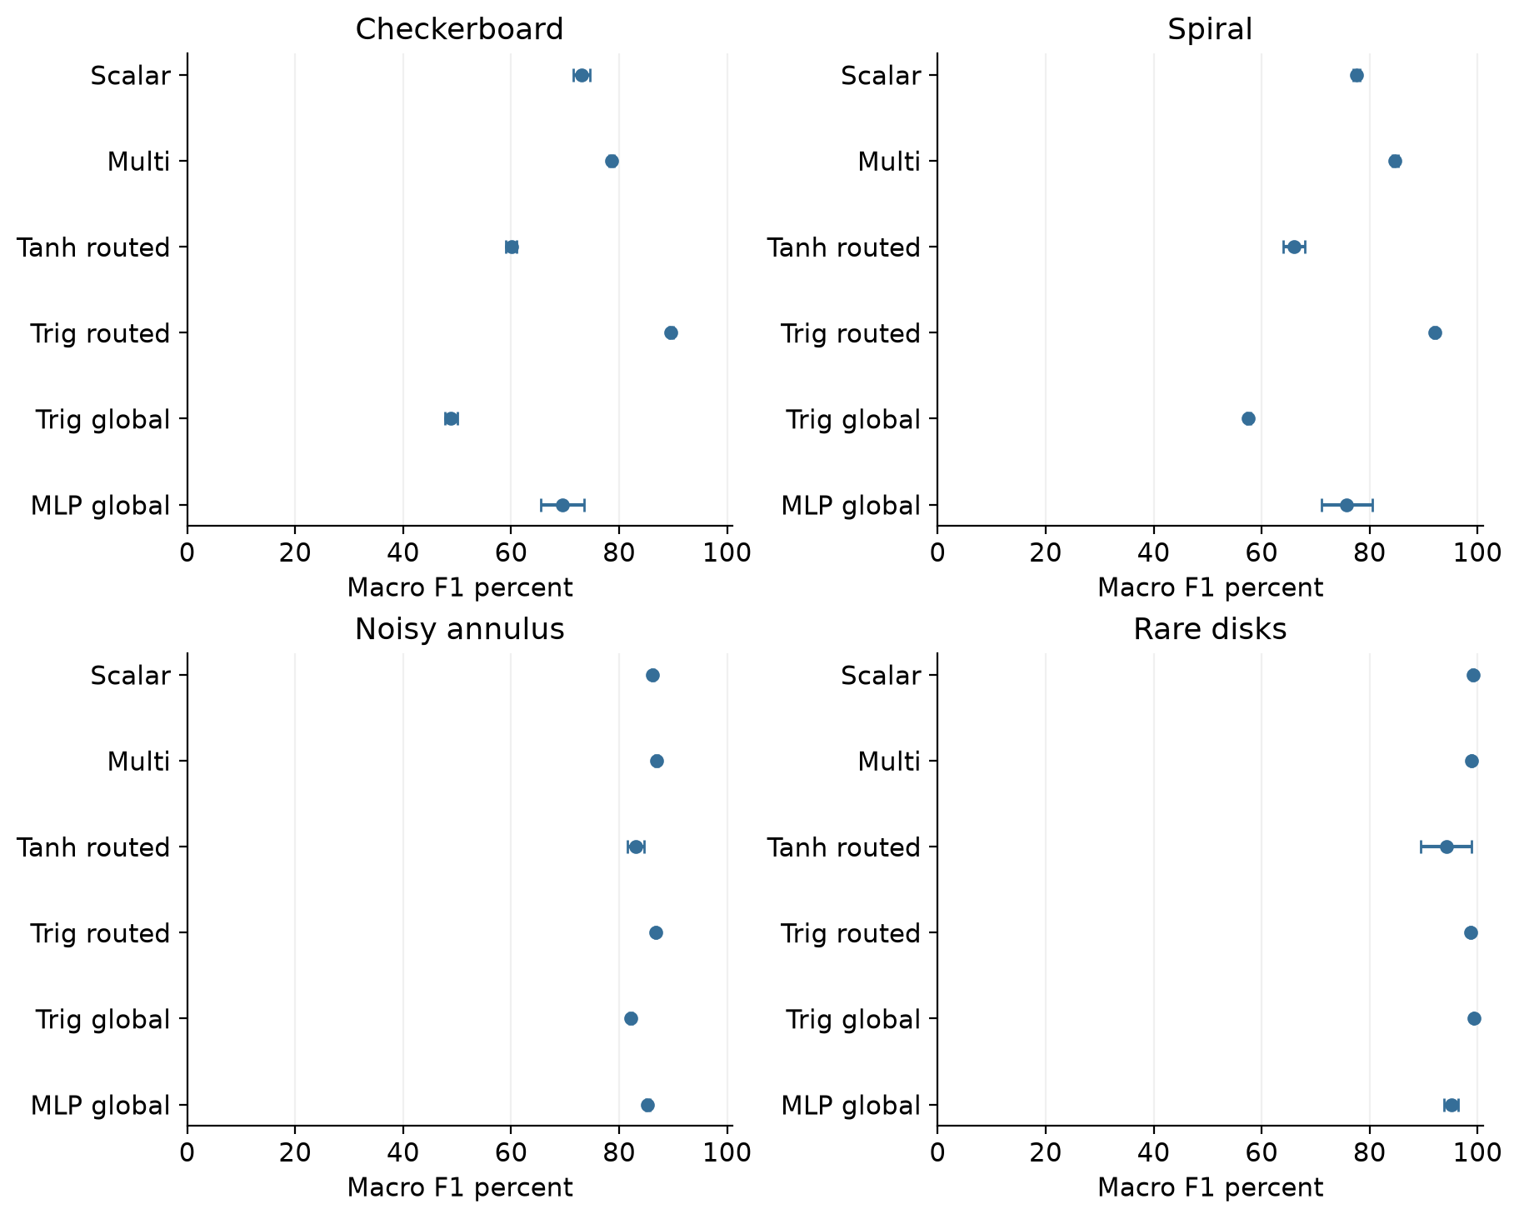
Figure 1. Mean macro F1 and sample standard deviation across five training seeds, shown separately for each confirmation task. Error bars describe training-seed variability conditional on the fixed split and router; they are not confidence intervals.
The task difficulty is specific: checkerboard and spiral expose representation and optimization gaps; annulus exposes label-noise and probability-quality limits; rare disks test small disconnected positive regions. Strong performance on rare disks does not erase the weaker outcomes on other boundaries.

Checkerboard confirmation results
Each row summarizes five selected training-seed checkpoints evaluated on the same 1,600 test records. F1 and BCE show mean and sample standard deviation across seeds. Accuracy and Brier are seed means; lower BCE and Brier are better.
Model | F1 percent | BCE | Accuracy percent | Brier
Scalar | 73.03 +/- 1.52 | 0.5780 +/- 0.0120 | 73.07 | 0.1897
Multi | 78.55 +/- 0.48 | 0.5216 +/- 0.0031 | 78.59 | 0.1656
Tanh routed | 60.02 +/- 1.00 | 0.6511 +/- 0.0066 | 60.21 | 0.2291
Trig routed | 89.57 +/- 0.39 | 0.3050 +/- 0.0014 | 89.57 | 0.0877
Trig global | 48.89 +/- 1.15 | 0.6965 +/- 0.0003 | 49.24 | 0.2517
MLP global | 69.55 +/- 4.02 | 0.5667 +/- 0.0343 | 69.56 | 0.1928

Checkerboard registered BCE differences
Contrast | Mean | Seed interval | Record interval
Multi minus Scalar | -0.0564 | [-0.0920, -0.0209] | [-0.0833, -0.0286]
Scalar minus Trig routed | +0.2730 | [+0.2388, +0.3072] | [+0.2401, +0.3041]
Multi minus Trig routed | +0.2166 | [+0.2075, +0.2256] | [+0.1905, +0.2412]
Trig routed minus Trig global | -0.3915 | [-0.3961, -0.3869] | [-0.4291, -0.3464]
Negative differences favor the first model. Seed intervals use five paired differences and a t distribution with four degrees of freedom; nominal confidence is 99.6875 percent for the sixteen-comparison family. Record intervals are separate, adjusted paired-bootstrap percentiles conditional on the fitted checkpoints. They describe different uncertainty sources and are not combined.
Multi improves over Scalar by 5.53 F1 percentage points. Its primary BCE advantage exceeds the registered 0.01 practical reference in magnitude, and both adjusted interval types remain negative. Trig routed achieves still lower BCE than either circuit recipe. The large routed-versus-global Trig difference combines spatial partitioning with five times as many coefficients; this experiment does not isolate a routing-only effect.

Spiral confirmation results
Each row summarizes five selected training-seed checkpoints evaluated on the same 1,600 test records. F1 and BCE show mean and sample standard deviation across seeds. Accuracy and Brier are seed means; lower BCE and Brier are better.
Model | F1 percent | BCE | Accuracy percent | Brier
Scalar | 77.60 +/- 0.60 | 0.5007 +/- 0.0029 | 77.60 | 0.1577
Multi | 84.71 +/- 0.58 | 0.4253 +/- 0.0084 | 84.71 | 0.1262
Tanh routed | 66.05 +/- 2.00 | 0.5682 +/- 0.0227 | 66.06 | 0.1947
Trig routed | 92.05 +/- 0.32 | 0.2483 +/- 0.0009 | 92.05 | 0.0658
Trig global | 57.57 +/- 0.35 | 0.6679 +/- 0.0004 | 57.62 | 0.2386
MLP global | 75.77 +/- 4.66 | 0.4695 +/- 0.0415 | 75.77 | 0.1529

Spiral registered BCE differences
Contrast | Mean | Seed interval | Record interval
Multi minus Scalar | -0.0754 | [-0.1036, -0.0471] | [-0.1020, -0.0448]
Scalar minus Trig routed | +0.2524 | [+0.2441, +0.2608] | [+0.2122, +0.2905]
Multi minus Trig routed | +0.1770 | [+0.1528, +0.2013] | [+0.1474, +0.2085]
Trig routed minus Trig global | -0.4196 | [-0.4224, -0.4169] | [-0.4603, -0.3675]
Negative differences favor the first model. Seed intervals use five paired differences and a t distribution with four degrees of freedom; nominal confidence is 99.6875 percent for the sixteen-comparison family. Record intervals are separate, adjusted paired-bootstrap percentiles conditional on the fitted checkpoints. They describe different uncertainty sources and are not combined.
Multi improves over Scalar by 7.11 F1 percentage points, with a primary BCE advantage supported by both adjusted interval types. Trig routed remains better on the registered primary loss. The wider free feature coefficients and the constrained trainable circuit are different hypothesis classes; these results cannot isolate approximation limits from optimizer difficulty.

Noisy annulus confirmation results
Each row summarizes five selected training-seed checkpoints evaluated on the same 1,600 test records. F1 and BCE show mean and sample standard deviation across seeds. Accuracy and Brier are seed means; lower BCE and Brier are better.
Model | F1 percent | BCE | Accuracy percent | Brier
Scalar | 86.20 +/- 0.23 | 0.4106 +/- 0.0017 | 86.24 | 0.1209
Multi | 86.92 +/- 0.32 | 0.4091 +/- 0.0024 | 86.96 | 0.1202
Tanh routed | 83.07 +/- 1.54 | 0.4322 +/- 0.0095 | 83.12 | 0.1331
Trig routed | 86.81 +/- 0.16 | 0.4032 +/- 0.0010 | 86.88 | 0.1175
Trig global | 82.14 +/- 0.26 | 0.4597 +/- 0.0005 | 82.15 | 0.1389
MLP global | 85.28 +/- 0.37 | 0.4184 +/- 0.0031 | 85.29 | 0.1253

Noisy annulus registered BCE differences
Contrast | Mean | Seed interval | Record interval
Multi minus Scalar | -0.0015 | [-0.0105, +0.0074] | [-0.0118, +0.0090]
Scalar minus Trig routed | +0.0075 | [+0.0032, +0.0117] | [-0.0050, +0.0197]
Multi minus Trig routed | +0.0059 | [+0.0006, +0.0113] | [-0.0027, +0.0143]
Trig routed minus Trig global | -0.0566 | [-0.0590, -0.0541] | [-0.0894, -0.0255]
Negative differences favor the first model. Seed intervals use five paired differences and a t distribution with four degrees of freedom; nominal confidence is 99.6875 percent for the sixteen-comparison family. Record intervals are separate, adjusted paired-bootstrap percentiles conditional on the fitted checkpoints. They describe different uncertainty sources and are not combined.
Multi and Trig routed have close observed-label F1. The circuit-versus-routed-Trig mean BCE gaps are below 0.01; their seed intervals exclude zero, while their record intervals include zero. This is not a robust practical superiority claim. The clearer loss improvement is routed versus global Trig. The noise diagnostics below explain why a 97 percent observed-label target is inappropriate.

Rare disks confirmation results
Each row summarizes five selected training-seed checkpoints evaluated on the same 1,600 test records. F1 and BCE show mean and sample standard deviation across seeds. Accuracy and Brier are seed means; lower BCE and Brier are better.
Model | F1 percent | BCE | Accuracy percent | Brier
Scalar | 99.12 +/- 0.20 | 0.0135 +/- 0.0007 | 99.64 | 0.0036
Multi | 98.85 +/- 0.20 | 0.0146 +/- 0.0006 | 99.53 | 0.0039
Tanh routed | 94.17 +/- 4.72 | 0.0523 +/- 0.0296 | 97.56 | 0.0163
Trig routed | 98.67 +/- 0.12 | 0.0149 +/- 0.0002 | 99.45 | 0.0042
Trig global | 99.30 +/- 0.08 | 0.0167 +/- 0.0002 | 99.71 | 0.0042
MLP global | 95.12 +/- 1.33 | 0.0523 +/- 0.0124 | 97.97 | 0.0154

Rare disks registered BCE differences
Contrast | Mean | Seed interval | Record interval
Multi minus Scalar | +0.0011 | [-0.0018, +0.0040] | [-0.0008, +0.0034]
Scalar minus Trig routed | -0.0014 | [-0.0036, +0.0007] | [-0.0047, +0.0012]
Multi minus Trig routed | -0.0003 | [-0.0025, +0.0019] | [-0.0026, +0.0016]
Trig routed minus Trig global | -0.0018 | [-0.0022, -0.0013] | [-0.0046, +0.0016]
Negative differences favor the first model. Seed intervals use five paired differences and a t distribution with four degrees of freedom; nominal confidence is 99.6875 percent for the sixteen-comparison family. Record intervals are separate, adjusted paired-bootstrap percentiles conditional on the fitted checkpoints. They describe different uncertainty sources and are not combined.
Trig global has the highest descriptive mean F1, while Scalar has the lowest mean BCE. These rankings answer different questions. All four primary mean BCE differences are smaller than 0.01 and all adjusted record intervals include zero. The routed-versus-global Trig seed interval excludes zero, but this alone does not establish a practically useful gain. Positive recall and training stability remain relevant.

Noisy annulus positive class and probability quality
Observed positive prevalence is 47.19 percent in the shared 1,600-record test set.
Model | Precision percent | Recall percent | Average precision percent | ECE
Scalar | 85.17 | 85.77 | 84.49 | 0.0732
Multi | 86.33 | 85.99 | 83.62 | 0.0771
Tanh routed | 82.18 | 82.01 | 83.49 | 0.0458
Trig routed | 87.20 | 84.61 | 84.19 | 0.0721
Trig global | 79.14 | 84.42 | 83.20 | 0.0536
MLP global | 82.38 | 87.58 | 84.42 | 0.0758
Values are descriptive five-seed means. Positive precision and recall use the unchanged 0.5 threshold. Precision is defined as zero when there are no predicted positives; recall and average precision are undefined when there are no actual positives and are shown as Not defined. Average precision groups tied scores; ECE uses ten fixed bins. No calibration function is fitted.
Model | TN mean | FP mean | FN mean | TP mean
Scalar | 732.2 | 112.8 | 107.4 | 647.6
Multi | 742.2 | 102.8 | 105.8 | 649.2
Tanh routed | 710.8 | 134.2 | 135.8 | 619.2
Trig routed | 751.2 | 93.8 | 116.2 | 638.8
Trig global | 677.0 | 168.0 | 117.6 | 637.4
MLP global | 703.4 | 141.6 | 93.8 | 661.2
Confusion counts are means of five seed-specific tables on the same 1,600 records, not counts pooled over 8,000 independent records. TN and TP are correct negative and positive decisions; FP and FN are their respective errors.

Rare disks positive class and probability quality
Observed positive prevalence is 11.69 percent in the shared 1,600-record test set.
Model | Precision percent | Recall percent | Average precision percent | ECE
Scalar | 98.51 | 98.40 | 99.93 | 0.0071
Multi | 97.97 | 97.97 | 99.91 | 0.0074
Tanh routed | 89.80 | 89.73 | 96.46 | 0.0150
Trig routed | 97.45 | 97.86 | 99.86 | 0.0063
Trig global | 98.93 | 98.61 | 99.96 | 0.0106
MLP global | 90.93 | 91.87 | 97.51 | 0.0141
Values are descriptive five-seed means. Positive precision and recall use the unchanged 0.5 threshold. Precision is defined as zero when there are no predicted positives; recall and average precision are undefined when there are no actual positives and are shown as Not defined. Average precision groups tied scores; ECE uses ten fixed bins. No calibration function is fitted.
Model | TN mean | FP mean | FN mean | TP mean
Scalar | 1410.2 | 2.8 | 3.0 | 184.0
Multi | 1409.2 | 3.8 | 3.8 | 183.2
Tanh routed | 1393.2 | 19.8 | 19.2 | 167.8
Trig routed | 1408.2 | 4.8 | 4.0 | 183.0
Trig global | 1411.0 | 2.0 | 2.6 | 184.4
MLP global | 1395.8 | 17.2 | 15.2 | 171.8
Confusion counts are means of five seed-specific tables on the same 1,600 records, not counts pooled over 8,000 independent records. TN and TP are correct negative and positive decisions; FP and FN are their respective errors.

Noise and native-loss diagnostics
The annulus test set contains 176 independently flipped labels out of 1,600 (11.0 percent). The known generator conditional probabilities 0.1 and 0.9 achieve observed accuracy 89.00 percent, F1 88.97 percent and BCE 0.3471 on this realization. This analytic reference has privileged generator knowledge and is not a learned competitor.
Model | Latent-clean F1 percent | Observed-label F1 percent
Scalar | 95.98 | 86.20
Multi | 96.85 | 86.92
Tanh routed | 92.32 | 83.07
Trig routed | 97.31 | 86.81
Trig global | 90.94 | 82.14
MLP global | 95.06 | 85.28
Clean-label scoring is a post-release diagnostic of boundary learning. It was excluded from fitting, routing and checkpoint selection. Its larger F1 does not replace the primary observed-label result. Expected Bayes observed-label accuracy is 90 percent under the declared independent label flips; it is not a hard finite-sample ceiling.

Probability clipping and confidently wrong predictions
Spiral Trig routed has mean native logit BCE 0.25158, compared with common clipped BCE 0.24828. There are 5 wrong-clipped checkpoint-record occurrences across its five checkpoints; repeated records across seeds are not independent observations. Native loss reveals the extra penalty of these extreme errors. The primary model ordering is unchanged.
All models train using stable native logit BCE; the common clipped score is used for selection and registered comparisons. Raw probabilities also feed Brier and ECE. Fixed-bin ECE is descriptive and cannot alone prove calibration. Detailed native logits, reliability bins, class metrics and per-seed outcomes for every task remain in the evidence package.

Purpose and previous evidence
We are developing a useful classical implementation of the Q Pathformer ideas and preparing a small circuit version for later hardware testing. This study tests selected classifier components. It does not implement or validate the full proposed language-model architecture, and quantum computational advantage is not its success criterion.
The previous study used two-dimensional circles and a rotated ellipse. Flexible circuit readouts achieved high classification scores, while strong trigonometric controls remained competitive. The historical table reports v0.5 mean macro F1 percentages across five training seeds.
Historical v0.5 model | Circle 1 | Circle 2 | Ellipse
Scalar | 99.54 | 99.22 | 99.06
Multi | 99.55 | 99.51 | 99.29
Tanh routed | 99.31 | 99.15 | 99.02
Trig routed | 99.77 | 99.56 | 99.59
Trig global | 99.91 | 99.74 | 99.37
MLP global | 99.70 | 99.35 | 99.17
Version 0.6 holds the six selected model recipes fixed and changes the task suite, data, routers and random seeds. It also tests a faster classical representation of each learned circuit. Old and new scores answer different questions: subtracting v0.5 F1 from v0.6 F1 is not a paired architectural improvement measure. The useful comparisons are between models on the same fresh task.

Models and their classical implementation
Model | Learned predictor | Trained scalars
Scalar | Five circuit banks and one-moment sigmoid heads | 50
Multi | Five circuit banks and five-moment sigmoid heads | 70
Tanh routed | Five width 8 tanh neural networks | 165
Trig routed | Five linear logits over 25 trigonometric features | 125
Trig global | One linear logit over 25 trigonometric features | 25
MLP global | One width 32 ReLU neural network | 129
Every routed model shares the same five-centroid spatial partition, learned from training coordinates only. It adds ten centroid coordinates, counted separately from model parameters. A record activates one bank. Equal parameter counts would not imply equal function classes, optimization difficulty or execution cost.
Each circuit bank has two qubits and two repeated layers. A layer encodes each raw coordinate through RY(pi x), applies a trainable RY and RZ rotation to each qubit, then applies CX. There are eight trainable angles per bank. The Scalar head applies a sigmoid to a learned affine function of X0. Multi uses X0, X1, Z0, Z1 and Z0Z1. All circuit states and training gradients are simulated on a classical CPU.
Scalar and Multi start from the same circuit angles and matching initial predictions. Both train the core and head together. The classical Trig25 feature vector is the tensor product of [1, cos(pi x), sin(pi x), cos(2 pi x), sin(2 pi x)] for the two coordinates. These are strong controls matched to the frequency span of this particular shallow encoding circuit.
The exact converted representation is the same learned circuit predictor expressed using 25 real trigonometric coefficients per bank. It is not an additional trained model or an accuracy improvement. A successful conversion can improve CPU inference while retaining the learned decision function; it says nothing by itself about performance on a quantum device.

Architecture components under test
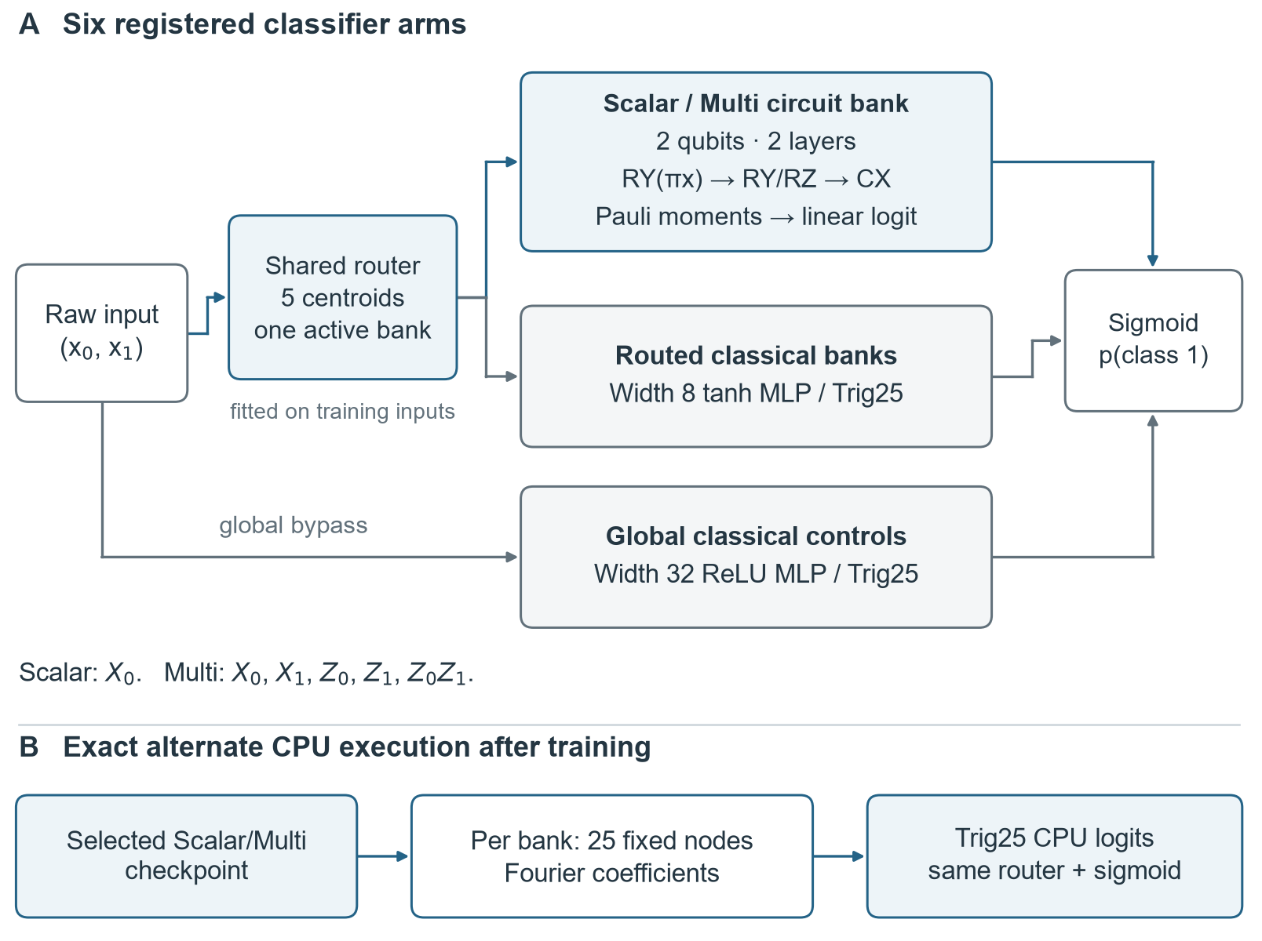
Figure 2. Six classifier recipes share fresh raw two-dimensional inputs. Routed arms use five training-only centroid regions; global arms bypass the router. The circuit path can be converted exactly to a classical trigonometric logit. This is a component study, not a complete language-model implementation.

Four harder fresh task families
Task | Boundary or challenge | Primary labels
Checkerboard | Product of two shifted sine waves at frequency 3 pi | Clean binary
Spiral | Angle and radius determine an oscillating spiral boundary | Clean binary
Noisy annulus | Ring with squared radius between 0.25 and 0.85 | Independent 10 percent flips
Rare disks | Union of three small disconnected disks | About 11.4 percent positive
Each family uses independent raw coordinates drawn uniformly from [-1, 1] squared. There are separate engineering, development and confirmation populations for all four families. Each population contains 4,800 training, 1,600 validation and 1,600 test records. Observed-label stratification preserves the realized prevalence rather than balancing the classes.
The data contain 96,000 new unique coordinates across twelve populations. Independent reconstruction checked 36 payloads, 288 arrays and twelve train-only router policies. Exact float64 coordinate exclusions cover 168,000 unique historical points and earlier v0.6 populations, with signed zero normalized. This establishes exact-coordinate freshness, not statistical independence from every prior design decision.
The annulus flips each label independently with probability 0.10; the realized flip fraction is not forced to equal ten percent. Its clean boundary and flip mask are excluded from model fitting, routing, checkpoint selection and predictions. Observed labels are the primary evaluation target. Clean-label and known conditional-probability results are clearly labeled post-release generator diagnostics, not additional learned competitors.
For the noisy annulus, ninety percent is the expected accuracy of the known clean decision rule against independently flipped labels. It is not a strict finite-sample ceiling. A validation target of 97 percent is therefore unsuitable as an expected generalization requirement. For rare disks, a high accuracy can hide missed positives, so the report also shows prevalence, positive recall and precision, confusion counts and average precision.
These are stress tests of higher frequency, topology, label noise and class rarity. They remain four synthetic two-dimensional families. They do not establish real tabular, vision or language performance; confirmation uses fresh records from each specified family rather than an out-of-distribution guarantee.

Fresh task geometry and spatial routing
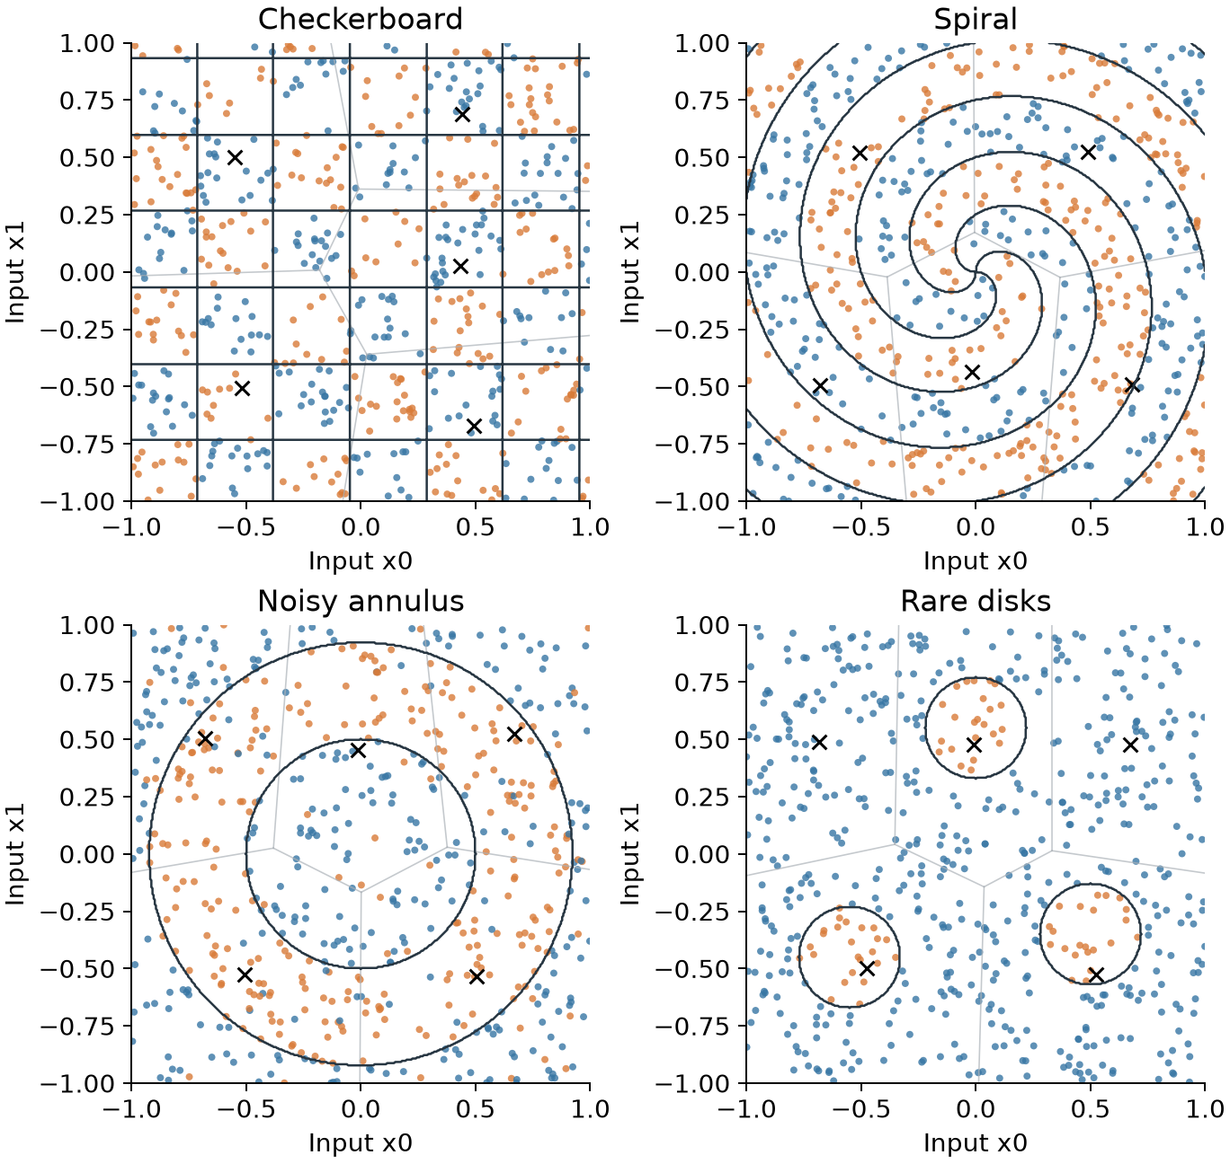
Figure 3. The 600 lowest-ID training records per confirmation population. Blue and orange mark observed labels 0 and 1; dark curves show known clean generator boundaries. Pale lines and crosses show the training-only Voronoi partition and centroids. No test outcomes are used for this illustration.

Fixed training and independent confirmation
Stage | Training seeds | Runs | Updates per run
Engineering | 10901 | 24 | 225
Development A | 1101 and 1102 | 48 | 15000
Confirmation B | 1201 to 1205 | 120 | 15000
Every full endpoint runs 200 rounds, each containing 75 batches of 64 examples. Adam uses learning rate 0.01, betas 0.9 and 0.999, epsilon 1e-8 and no weight decay. All six arms use stable native logit binary cross entropy. Record order is paired across methods within each population and training seed.
Checkpoint selection uses the earliest exact minimum of full-validation common clipped binary cross entropy across all 200 rounds. Every run finishes the full budget. All models proceed to confirmation regardless of development rank; there is no early stopping, arm removal or test-based reselection.
The common reporting loss clips probabilities to [1e-7, 1 - 1e-7]. Native logit loss, raw Brier score, reliability bins, probability extremes and confidently wrong predictions provide complementary information. Clipping the comparison score does not clip the native training gradient.
Before test outcomes are released, both audits check every saved validation state and its predictions, checkpoint selection, input orders, update and work counters, and committed file identities. Independent replay uses separate mathematical implementations. It does not rerun every optimizer update or reconstruct every intermediate mini-batch gradient. A procedural test seal and hash-bound release enforce the order of operations; the files are not encrypted.
Training uses two concurrent seed workers in development and five in confirmation, with one BLAS thread per worker. Training elapsed times include validation and evidence writing. The separate inference benchmark runs serially after relevant training and audit jobs stop, so its measurements have a different concurrency context.

Comparisons and uncertainty
Primary loss contrast | Question
Multi minus Scalar | Do extra observables help this trained predictor
Scalar minus Trig routed | How the compact circuit recipe compares with the wider matched feature span
Multi minus Trig routed | Whether the richer circuit readout matches that control
Trig routed minus Trig global | What the spatial partition and extra bank capacity jointly add
Each contrast is evaluated separately on four confirmation populations, forming sixteen registered primary BCE comparisons. Negative differences favor the first model. The registered practical reference is 0.01 BCE; it is specific to this score and task context, not a universal utility threshold.
Five paired seed differences give a mean, sample standard deviation and t interval with four degrees of freedom. Primary intervals use nominal 99.6875 percent confidence for the sixteen-comparison Bonferroni family. Secondary 95 percent intervals and F1 rankings are descriptive. The twenty seed-population combinations are not pooled as independent tasks.
A separate paired bootstrap uses 10,000 common record-count draws within each population. Macro F1 is recomputed for each checkpoint before averaging five results. These intervals are conditional on the fitted checkpoints and describe test-record variation; they do not add training replications or replace the seed intervals. Extreme adjusted bootstrap percentiles are approximate.
Macro F1 averages the two class F1 scores at the fixed threshold p >= 0.5. Brier is mean squared raw probability error. ECE uses ten fixed equal-width probability bins and remains descriptive. Average precision groups identical scores and weights each group-end precision by its positive-recall increment; it is not trapezoidal PR area. No test threshold or calibration function is fitted.
Validation steps to 90, 95 and 97 percent are descriptive. First crossing and three-consecutive-check confirmation are shown with nonreachers censored at 15,000 updates. Reached-only medians exclude failures to reach and must be read alongside counts. Every endpoint is required to finish the full budget, so these milestones do not define training savings.

Validation milestones on the harder tasks
Every confirmation run completed 200 rounds and 15,000 optimizer updates. The registered 90, 95 and 97 percent macro F1 thresholds describe the saved validation learning curves; they did not stop training or select checkpoints. Selection used minimum validation common clipped BCE.
The table gives 90 percent milestones for five training seeds. Each cell shows reached/censored counts, followed by conditional median updates at the first crossing / the third consecutive qualifying validation check. The first and three-check counts happen to match in these cells. A check occurs every 75 updates.
Model | Checkerboard 90% | Spiral 90% | Annulus 90%
Scalar | 0/5  not reached / not reached | 0/5  not reached / not reached | 0/5  not reached / not reached
Multi | 0/5  not reached / not reached | 0/5  not reached / not reached | 0/5  not reached / not reached
Tanh routed | 0/5  not reached / not reached | 0/5  not reached / not reached | 0/5  not reached / not reached
Trig routed | 5/0  10,950 / 12,600 | 5/0  3,225 / 4,200 | 0/5  not reached / not reached
Trig global | 0/5  not reached / not reached | 0/5  not reached / not reached | 0/5  not reached / not reached
MLP global | 0/5  not reached / not reached | 0/5  not reached / not reached | 0/5  not reached / not reached
Only routed Trig reaches 90 percent on checkerboard and spiral. None of the six methods reaches either 95 or 97 percent on these three validation populations: each such cell has zero reached and five censored runs. Nonreachers remain censored at 15,000 updates; they are not assigned that update as a successful crossing.
The noisy annulus uses observed labels with independent 10 percent flips. A 97 percent generalization requirement is inappropriate for that mechanism. Its latent clean labels are reserved for supplemental post-release diagnosis and do not enter these milestones.
First crossing and three-check confirmation answer different questions. A later qualifying streak need not start at the first crossing, so confirmation need not occur just 150 updates later. Reached-only medians are conditional summaries, not estimates of time to success for every run. No measured early-stopping saving is claimed.

Validation milestones on the rare positive disks
Each cell reports reached/censored runs out of five, followed by the median optimizer update among reached runs. The two tables distinguish a single crossing from three consecutive qualifying validation checks. These are observed-label validation scores, not repeated test evaluations.

First threshold crossing
Model | 90%: counts; update | 95%: counts; update | 97%: counts; update
Scalar | 5/0; 375 | 5/0; 450 | 5/0; 600
Multi | 5/0; 300 | 5/0; 375 | 5/0; 450
Tanh routed | 5/0; 6,450 | 3/2; 6,525 | 3/2; 7,200
Trig routed | 5/0; 75 | 5/0; 150 | 5/0; 150
Trig global | 5/0; 225 | 5/0; 375 | 5/0; 750
MLP global | 5/0; 3,450 | 4/1; 9,750 | 3/2; 13,950

Third consecutive qualifying check
Model | 90%: counts; update | 95%: counts; update | 97%: counts; update
Scalar | 5/0; 525 | 5/0; 600 | 5/0; 750
Multi | 5/0; 450 | 5/0; 525 | 5/0; 600
Tanh routed | 5/0; 6,600 | 3/2; 6,825 | 3/2; 11,250
Trig routed | 5/0; 225 | 5/0; 300 | 5/0; 300
Trig global | 5/0; 375 | 5/0; 525 | 5/0; 900
MLP global | 5/0; 3,600 | 3/2; 8,850 | 0/5; not reached
Routed Trig confirms 97 percent earliest in all five runs, with a 300-update median, followed by Multi at 600, Scalar at 750 and global Trig at 900. Tanh routed confirms it in three runs; its 11,250-update median excludes the two nonreachers. Global MLP crosses 97 percent in three runs but confirms it in none. Different reached subsets can reverse first-crossing versus confirmation medians.
All runs still consumed the full registered budget. Comparing these descriptive milestones does not measure retraining savings, and the four task families are not pooled into a single time-to-target statistic.

Actual training costs and feature reuse
The table gives mean elapsed training-loop seconds across five confirmation seeds, separately for each population. The loop includes training, all validation checks and within-loop checkpoint/evidence writing. It excludes initial setup and is not CPU-process time. Concurrent workers and system load affect these measurements.
Model | Checkerboard s | Spiral s | Annulus s | Disks s
Scalar | 236.65 | 237.37 | 281.77 | 446.39
Multi | 251.40 | 253.65 | 401.21 | 460.99
Tanh routed | 5.44 | 5.43 | 7.14 | 9.86
Trig routed | 5.34 | 5.40 | 6.74 | 8.31
Trig global | 2.83 | 2.81 | 3.36 | 4.87
MLP global | 2.97 | 3.02 | 3.97 | 4.26
Stage | Endpoints | Launcher wall s | Summed loop s
A | 48 | 1930.44 | 3844.71
B | 120 | 2760.77 | 13255.80
Summed endpoint seconds exceed elapsed launcher wall time because workers overlap. Shared generation, router fitting and route-application charges are accounting allocations reused across arms and seeds; they are not repeated actual project wall time. Raw-input inference timers collected alongside training are descriptive reference measurements. The isolated deployment benchmark reports inference separately.
Every registered arm has zero frozen quantum-moment cache bytes and creation time. This field does not measure all temporary feature arrays or route caching. Training reuses saved input-only route assignments; their creation charge is separate. Trig computes its 25 features on each forward or gradient call and reuses that call-local matrix for its logits and coefficient gradient. There is no persistent precomputed Trig training/validation design matrix in the retained trainer.
Per Trig endpoint, recorded logical feature values are 24 million for training and 8 million for validation. The separate selected-training diagnostic adds 120,000, selected-validation replay 40,000, four uncached inference forwards 102,400 and the fifth route-cached comparison 25,600. That fifth comparison still constructs Trig features. These are logical counts, not measured FLOPs, allocated bytes, energy or hardware shots.
Both circuit arms use one base plus sixteen parameter-shift core evolutions per training record for eight angles. Multi obtains five observables from each state; five moments must not be charged as five independent state evolutions. Physical measurement-setting equivalents and simulator-shot budgets are reported separately.

Preservation, reproduction and interpretation limits
Read-only before and after checks confirm that the prior delivered v0.5 evidence and Baseline5 seal files remain unchanged. The checks were run after the scientific work and independent deployment audit completed.
Preserved evidence | Verified coverage | Result
Delivered v0.5 | 30,234 payloads; 2,812,931,271 payload bytes, plus manifest and both verification metadata files | PASS; exact before-state match
Baseline5 seal | Four files; 18,604,336,561 bytes, including the complete archive | PASS; exact before-state match
Baseline5 preservation hashes all four seal files and checks the archive hash against its external manifest and companion checksum. It does not re-extract or revalidate every ZIP member. No baseline files were written.
The final internal Word report is docs/QPATH-RPT-007_Harder_Tasks_and_Faster_Inference_v0.6.docx. Retained evidence includes protocols, data/routers, all-round checkpoints, released predictions, independent replays, learning summaries, simulator and deployment outputs, reviews and source hashes. Final delivery acceptance requires DELIVERY_MANIFEST.json and both independent delivery-verification records to agree; report preparation itself does not establish that later acceptance.
For reproduction, first verify the delivered manifest read-only, then use governance/prepare_reproduction_copy.py with an explicit fresh destination and receipt. Run derived checks in that writable copy with fresh output paths; do not remove completed outputs or rewrite sealed metadata. The evaluator/replay validates original provenance and maps paths to the copied package. README.txt and REPRODUCTION_GUIDE.txt are generated by the reviewed helper after final Word QA.
Numerical replay requires the recorded Python 3.12.14 / NumPy 2.5.4 environment. The local simulator has a separate Qiskit/Aer/IBM Runtime installation lock; scientific plots have a separate plotting specification. Virtual environments are not delivered. Version inventories are not wheel-hash locks, and Word/font/render dependencies remain machine-specific. No clean-room portability claim is made.
All 36 saved data payloads and 12 router policies support retained-model replay. Full original data regeneration additionally requires the exact 65 historical exclusion inputs and reviewed path mapping. Exact-coordinate novelty does not establish semantic novelty. These four synthetic two-dimensional families do not validate real tabular data, language modeling or the full proposed Q-Pathformer architecture.
Five training seeds per population remain five replications conditional on one split/router/recipe. The four populations stay separate; paired-record bootstrap intervals describe uncertainty conditional on trained checkpoints. Technical timing or shot repeats are not additional training seeds. Capacity, routing and representation differ between some controls, so neither model rankings nor CPU timings establish universal quantum advantage, physical-device latency or energy savings.

Exact conversion and fair inference timing
For each selected Scalar and Multi checkpoint, the producer evaluates each forced bank on a fixed five-by-five coordinate grid and converts its logits to real Trig25 coefficients. The independent reference instead propagates Laurent polynomials through half-angle gates and observable products. Agreement between these distinct constructions checks the representation rather than fitting an approximation to test labels.
Checks cover all banks, validation records, test records after release, fixed off-grid probes and actual routing-boundary probes. Coefficient differences are also summarized by their per-bank L1 norm. Because each basis feature is bounded by one, that norm bounds the difference between the two coefficient polynomials for any real input; a quarter of it bounds their sigmoid difference, apart from floating-point evaluation error. Finite fixture checks alone are not a proof of every-input numerical equality.
The conversion stores 125 float64 coefficients per routed model, or 1,000 parameter bytes. This exceeds Scalar original parameter bytes of 400 and Multi bytes of 560. Router coordinates and file-container overhead are separate. Compilation, loading and artifact storage are reported independently from hot inference latency.
The benchmark uses the 1,024 lowest-ID validation inputs, with labels excluded. Batch sizes are 1, 32 and 1,024; each representation receives two warmup and fifteen timed trials. Raw-input routing, feature construction and sigmoid evaluation are included. The learned Trig25 controls also use the same fast coefficient kernel in a separately identified representation, while retaining their original implementation timings.
Method order rotates and reverses deterministically; circuit and converted order alternates. Technical timing repeats do not create more training seeds. The measurements describe this CPU, software, batch work and process state. They exclude model loading and make no energy, universal speed or quantum-device-time claim.

Exact conversion and its costs
All 40 selected Scalar and Multi circuit checkpoints were converted after training. Each bank uses 25 fixed, period-two Fourier construction points, without labels, regression or routing those construction points. The resulting tensor Trig25 coefficients represent the same learned logit. These are alternate representations of existing checkpoints, not additional trained models.
Across saved validation/test, off-grid, boundary and forced-bank checks, the producer recorded maximum absolute probability difference 7.16e-15 and logit difference 6.39e-14, with zero classification differences. Independent Laurent-polynomial reconstruction also passed. The analytical identity applies to the retained two-layer encoding and linear Pauli head; the finite checks quantify float64 agreement, not a proof for other circuit families.
Population | Model | Compile ms | Original load ms | Coefficient load ms
Checkerboard | Scalar | 1.004 | 0.405 | 0.221
Checkerboard | Multi | 1.055 | 0.446 | 0.238
Spiral | Scalar | 1.019 | 0.414 | 0.233
Spiral | Multi | 1.059 | 0.461 | 0.236
Noisy annulus | Scalar | 1.009 | 0.431 | 0.232
Noisy annulus | Multi | 1.061 | 0.465 | 0.233
Rare disks | Scalar | 1.020 | 0.412 | 0.227
Rare disks | Multi | 1.060 | 0.493 | 0.238
Entries are medians of five one-time measurements per population. Original loading includes model initialization and selected-checkpoint arrays; coefficient loading reads only the coefficient table from its saved artifact. These are different payloads and warm file-cache conditions, not a controlled cold-start speed comparison. Compilation excludes file serialization and uses 125 statevector examples per checkpoint.
The shared policy was loaded once per population, outside these timings: Checkerboard 0.190 ms; Spiral 0.147 ms; Noisy annulus 0.150 ms; Rare disks 0.161 ms. This policy loading is also excluded from steady-state inference latency.
Each converted five-bank table stores 125 float64 coefficients, or 1,000 bytes, versus 400 bytes of Scalar parameters and 560 bytes of Multi parameters. The shared router adds 80 bytes of centroid coordinates. Retained conversion files are 4,486 bytes for Scalar and 8,486 bytes for Multi because they also include construction evidence; archive size is not the minimal inference state.
At inference the converted model evaluates 25 real basis values and a 25-term dot product for the selected bank, followed by sigmoid. It uses no statevector. The same optimized kernel is available to learned Trig25 controls, so any gain over the original circuit implementation is a classical representation gain, not an exclusive quantum algorithm advantage.

Checkerboard CPU inference
Microseconds per record, including raw-input routing where used, features and sigmoid. Each entry is the median of five checkpoint-specific medians on this population; each checkpoint median uses 15 timed trials after two warmups. Batch sizes and call counts differ as registered, so compare models within a column. Populations are kept separate.
Representation | Batch 1 | Batch 32 | Batch 1024
Scalar circuit | 184.086 | 26.732 | 1.206
Scalar compiled | 36.866 | 1.433 | 0.209
Multi circuit | 193.654 | 28.362 | 1.275
Multi compiled | 36.447 | 1.426 | 0.208
Tanh routed | 38.619 | 2.804 | 0.219
Trig routed original | 44.086 | 3.710 | 0.285
Trig routed optimized | 36.417 | 1.401 | 0.208
Trig global original | 18.280 | 0.733 | 0.113
Trig global optimized | 17.927 | 0.715 | 0.116
MLP global | 13.440 | 0.514 | 0.053
The learned Trig controls and compiled circuits use the same optimized coefficient kernel. Original Trig timings are retained for transparency. These are implementation timings on one CPU session, not quantum hardware timings or independent statistical replicates. All three named-process isolation checks passed; unrelated operating-system work was not eliminated.

Spiral CPU inference
Microseconds per record, including raw-input routing where used, features and sigmoid. Each entry is the median of five checkpoint-specific medians on this population; each checkpoint median uses 15 timed trials after two warmups. Batch sizes and call counts differ as registered, so compare models within a column. Populations are kept separate.
Representation | Batch 1 | Batch 32 | Batch 1024
Scalar circuit | 183.196 | 26.486 | 1.204
Scalar compiled | 36.684 | 1.431 | 0.209
Multi circuit | 192.978 | 28.107 | 1.271
Multi compiled | 36.453 | 1.413 | 0.207
Tanh routed | 38.613 | 2.781 | 0.219
Trig routed original | 43.931 | 3.681 | 0.288
Trig routed optimized | 36.345 | 1.393 | 0.207
Trig global original | 18.250 | 0.729 | 0.112
Trig global optimized | 17.898 | 0.710 | 0.115
MLP global | 13.376 | 0.514 | 0.052
The learned Trig controls and compiled circuits use the same optimized coefficient kernel. Original Trig timings are retained for transparency. These are implementation timings on one CPU session, not quantum hardware timings or independent statistical replicates. All three named-process isolation checks passed; unrelated operating-system work was not eliminated.

Noisy annulus CPU inference
Microseconds per record, including raw-input routing where used, features and sigmoid. Each entry is the median of five checkpoint-specific medians on this population; each checkpoint median uses 15 timed trials after two warmups. Batch sizes and call counts differ as registered, so compare models within a column. Populations are kept separate.
Representation | Batch 1 | Batch 32 | Batch 1024
Scalar circuit | 332.232 | 47.195 | 2.183
Scalar compiled | 65.627 | 2.586 | 0.375
Multi circuit | 348.055 | 50.662 | 2.340
Multi compiled | 63.721 | 2.522 | 0.375
Tanh routed | 67.450 | 5.041 | 0.389
Trig routed original | 77.679 | 6.452 | 0.513
Trig routed optimized | 66.716 | 2.475 | 0.372
Trig global original | 31.863 | 1.260 | 0.195
Trig global optimized | 31.734 | 1.248 | 0.200
MLP global | 23.425 | 0.826 | 0.092
The learned Trig controls and compiled circuits use the same optimized coefficient kernel. Original Trig timings are retained for transparency. These are implementation timings on one CPU session, not quantum hardware timings or independent statistical replicates. All three named-process isolation checks passed; unrelated operating-system work was not eliminated.
The later annulus and disks blocks are slower across almost all implementations. Population blocks ran sequentially, so this session-wide shift cannot be attributed to task complexity. Interpret the paired, alternating-order representation comparisons within each checkpoint; the cause of the broader timing drift was not measured.

Rare disks CPU inference
Microseconds per record, including raw-input routing where used, features and sigmoid. Each entry is the median of five checkpoint-specific medians on this population; each checkpoint median uses 15 timed trials after two warmups. Batch sizes and call counts differ as registered, so compare models within a column. Populations are kept separate.
Representation | Batch 1 | Batch 32 | Batch 1024
Scalar circuit | 328.416 | 46.984 | 2.163
Scalar compiled | 65.376 | 2.405 | 0.361
Multi circuit | 347.633 | 50.423 | 2.294
Multi compiled | 64.643 | 2.504 | 0.359
Tanh routed | 67.515 | 4.915 | 0.375
Trig routed original | 77.672 | 6.386 | 0.498
Trig routed optimized | 65.495 | 2.552 | 0.350
Trig global original | 31.856 | 1.166 | 0.184
Trig global optimized | 30.959 | 1.198 | 0.193
MLP global | 23.011 | 0.825 | 0.089
The learned Trig controls and compiled circuits use the same optimized coefficient kernel. Original Trig timings are retained for transparency. These are implementation timings on one CPU session, not quantum hardware timings or independent statistical replicates. All three named-process isolation checks passed; unrelated operating-system work was not eliminated.
The later annulus and disks blocks are slower across almost all implementations. Population blocks ran sequentially, so this session-wide shift cannot be attributed to task complexity. Interpret the paired, alternating-order representation comparisons within each checkpoint; the cause of the broader timing drift was not measured.

Local quantum simulator scope
The local capsule uses the forty selected Scalar and Multi checkpoints and the thirty-two lowest-ID validation records per population. Labels do not select these fixtures. Scalar consumes one XX measurement setting; Multi consumes XX and ZZ. Joint bitstring counts preserve covariance between observables measured in the same setting.
Three separate scenarios are registered: ideal execution, an illustrative logical-gate depolarizing/readout model, and one archived Manila device snapshot. The illustrative model is not stacked on the snapshot model. Compilation uses a fixed physical pair, fixed optimization level and fixed transpiler seed without device, layout or pair search.
The retained snapshot comes from the packaged FakeManilaV2 data in IBM Runtime 0.50.0 and records properties dated 27 May 2024. It is historical, approximate device context rather than current calibration. Everything runs locally in a separate simulator environment. No IBM account, service call, cloud job or quantum hardware is used.
Density simulations save native channel and readout evidence for independent matrix replay. Joint multinomial trials use 1,024 and 8,192 shots per setting and five repeats per scenario; fixed learned heads are applied once to the estimated moments. Separate measured Aer smoke jobs use actual local simulator sampling. Represented multinomial draws and actual Aer simulated shots are counted separately.
Noise-induced probability changes and class differences are diagnostics on reused validation fixtures, not a hardware accuracy estimate. Nonlinear sigmoid heads can introduce finite-shot bias. Real-device crosstalk, drift, queueing and broader noise mismatches remain untested. These checks assess readiness for a future bounded hardware experiment, not authorization to run one.

Simulator coverage and measured work
This local capsule covers 40 selected checkpoints and 1,280 checkpoint-fixture pairs. Each population contributes the same 32 lowest-ID validation records for all five training seeds and both circuit readouts. Record selection uses IDs, not labels or performance. No test labels, physical quantum shots or live IBM service are used.
Ideal circuits, a fixed illustrative logical noise model, and the retained FakeManila device snapshot are separate scenarios. The snapshot properties date from 27 May 2024; they do not describe current hardware. Archived noise applies to compiled native gates on fixed physical qubits 0 and 1. It is never stacked on the illustrative logical noise.

Actual local simulator work
The capsule ran 1,920 required setting circuits, 5,760 density evaluations (1,920 logical two-qubit and 3,840 compiled five-qubit), and retained 1,800 joint count arrays plus 1,200 predictor arrays. These arrays represent 265,420,800 probability-level multinomial trials. Separately, 960 Aer measured experiments produced 983,040 simulated shots on eight fixtures per checkpoint under ideal and archived noise. No physical shots were taken.
Independent replay reconstructed the retained noise channels, densities, counts and heads. Numerical agreement passed; stochastic measured residuals were retained without a pass/fail retry rule. These fixtures establish implementation consistency and local noise sensitivity, not hardware efficacy or generalization across devices. Extra XX rotation of the second qubit is charged even for Scalar.
Sources: quantum/local_readiness_confirmation/report.json and finite_shot_summary.json; independently reconstructed in analysis/classical_review/confirmation_readiness_audit/summary.json. All quantities are population-specific and use validation fixtures only.

Checkerboard local simulator diagnostics
Probability distortion compares each noisy density predictor with its ideal counterpart. Values below describe 160 checkpoint-fixture pairs within this population: five checkpoints reuse 32 validation records. The decision-change count is a threshold change, not an accuracy loss.
Model | Noise scenario | Mean abs change | Max abs change | Decisions changed
Scalar | Mild logical | 0.0355 | 0.0919 | 14 / 160
Scalar | Archived Manila | 0.0493 | 0.1286 | 15 / 160
Multi | Mild logical | 0.0336 | 0.0765 | 8 / 160
Multi | Archived Manila | 0.0466 | 0.1020 | 11 / 160

Joint finite-shot readout
Model | Scenario | Bias 1024 | Var 1024 | Bias 8192 | Var 8192
Scalar | Ideal | 0.0308 | 8.41e-03 | 0.0112 | 8.22e-04
Scalar | Mild logical | 0.0307 | 6.08e-03 | 0.0109 | 9.13e-04
Scalar | Archived Manila | 0.0282 | 7.04e-03 | 0.0108 | 9.58e-04
Multi | Ideal | 0.0262 | 5.30e-03 | 0.0102 | 9.96e-04
Multi | Mild logical | 0.0310 | 6.94e-03 | 0.0101 | 9.11e-04
Multi | Archived Manila | 0.0298 | 7.34e-03 | 0.0097 | 1.27e-03
Bias is the mean absolute empirical bias of the five-repeat mean probability around the same scenario density predictor; Var is the mean sample variance across those five repeats. Both are averaged over the 32 fixtures and then the five training seeds, within this population. They are descriptive estimates, not fitted corrections or confidence intervals; the signed bias is retained in the machine-readable report.
Budgets are shots per measurement setting: Scalar uses one XX setting, while Multi uses XX and ZZ, so Multi costs twice as many shots per prediction. Joint four-outcome counts retain within-setting covariance. Replicates are nested within checkpoints; the 1,024 and 8,192 draws have distinct seeds and do not share a shot prefix.
Sources: quantum/local_readiness_confirmation/report.json and finite_shot_summary.json; independently reconstructed in analysis/classical_review/confirmation_readiness_audit/summary.json. All quantities are population-specific and use validation fixtures only.

Spiral local simulator diagnostics
Probability distortion compares each noisy density predictor with its ideal counterpart. Values below describe 160 checkpoint-fixture pairs within this population: five checkpoints reuse 32 validation records. The decision-change count is a threshold change, not an accuracy loss.
Model | Noise scenario | Mean abs change | Max abs change | Decisions changed
Scalar | Mild logical | 0.0109 | 0.0658 | 0 / 160
Scalar | Archived Manila | 0.0152 | 0.0884 | 1 / 160
Multi | Mild logical | 0.0167 | 0.0613 | 3 / 160
Multi | Archived Manila | 0.0213 | 0.0902 | 4 / 160

Joint finite-shot readout
Model | Scenario | Bias 1024 | Var 1024 | Bias 8192 | Var 8192
Scalar | Ideal | 0.0365 | 1.60e-02 | 0.0145 | 2.60e-03
Scalar | Mild logical | 0.0439 | 2.02e-02 | 0.0146 | 3.46e-03
Scalar | Archived Manila | 0.0478 | 1.88e-02 | 0.0158 | 2.85e-03
Multi | Ideal | 0.0312 | 1.27e-02 | 0.0126 | 1.42e-03
Multi | Mild logical | 0.0346 | 1.30e-02 | 0.0107 | 1.58e-03
Multi | Archived Manila | 0.0351 | 1.31e-02 | 0.0124 | 1.68e-03
Bias is the mean absolute empirical bias of the five-repeat mean probability around the same scenario density predictor; Var is the mean sample variance across those five repeats. Both are averaged over the 32 fixtures and then the five training seeds, within this population. They are descriptive estimates, not fitted corrections or confidence intervals; the signed bias is retained in the machine-readable report.
Budgets are shots per measurement setting: Scalar uses one XX setting, while Multi uses XX and ZZ, so Multi costs twice as many shots per prediction. Joint four-outcome counts retain within-setting covariance. Replicates are nested within checkpoints; the 1,024 and 8,192 draws have distinct seeds and do not share a shot prefix.
Sources: quantum/local_readiness_confirmation/report.json and finite_shot_summary.json; independently reconstructed in analysis/classical_review/confirmation_readiness_audit/summary.json. All quantities are population-specific and use validation fixtures only.

Noisy annulus local simulator diagnostics
Probability distortion compares each noisy density predictor with its ideal counterpart. Values below describe 160 checkpoint-fixture pairs within this population: five checkpoints reuse 32 validation records. The decision-change count is a threshold change, not an accuracy loss.
Model | Noise scenario | Mean abs change | Max abs change | Decisions changed
Scalar | Mild logical | 0.0135 | 0.0391 | 0 / 160
Scalar | Archived Manila | 0.0193 | 0.0535 | 0 / 160
Multi | Mild logical | 0.0137 | 0.0326 | 1 / 160
Multi | Archived Manila | 0.0225 | 0.0732 | 2 / 160

Joint finite-shot readout
Model | Scenario | Bias 1024 | Var 1024 | Bias 8192 | Var 8192
Scalar | Ideal | 0.0073 | 5.16e-04 | 0.0025 | 7.45e-05
Scalar | Mild logical | 0.0072 | 5.72e-04 | 0.0025 | 7.76e-05
Scalar | Archived Manila | 0.0077 | 6.45e-04 | 0.0029 | 9.32e-05
Multi | Ideal | 0.0076 | 5.94e-04 | 0.0023 | 6.08e-05
Multi | Mild logical | 0.0080 | 7.53e-04 | 0.0027 | 8.36e-05
Multi | Archived Manila | 0.0076 | 7.57e-04 | 0.0027 | 7.82e-05
Bias is the mean absolute empirical bias of the five-repeat mean probability around the same scenario density predictor; Var is the mean sample variance across those five repeats. Both are averaged over the 32 fixtures and then the five training seeds, within this population. They are descriptive estimates, not fitted corrections or confidence intervals; the signed bias is retained in the machine-readable report.
Budgets are shots per measurement setting: Scalar uses one XX setting, while Multi uses XX and ZZ, so Multi costs twice as many shots per prediction. Joint four-outcome counts retain within-setting covariance. Replicates are nested within checkpoints; the 1,024 and 8,192 draws have distinct seeds and do not share a shot prefix.
Sources: quantum/local_readiness_confirmation/report.json and finite_shot_summary.json; independently reconstructed in analysis/classical_review/confirmation_readiness_audit/summary.json. All quantities are population-specific and use validation fixtures only.

Rare disks local simulator diagnostics
Probability distortion compares each noisy density predictor with its ideal counterpart. Values below describe 160 checkpoint-fixture pairs within this population: five checkpoints reuse 32 validation records. The decision-change count is a threshold change, not an accuracy loss.
Model | Noise scenario | Mean abs change | Max abs change | Decisions changed
Scalar | Mild logical | 0.0026 | 0.0850 | 1 / 160
Scalar | Archived Manila | 0.0029 | 0.0986 | 1 / 160
Multi | Mild logical | 0.0032 | 0.1226 | 1 / 160
Multi | Archived Manila | 0.0053 | 0.2141 | 1 / 160

Joint finite-shot readout
Model | Scenario | Bias 1024 | Var 1024 | Bias 8192 | Var 8192
Scalar | Ideal | 0.0018 | 8.98e-04 | 0.0006 | 2.10e-04
Scalar | Mild logical | 0.0022 | 5.29e-04 | 0.0006 | 1.37e-04
Scalar | Archived Manila | 0.0026 | 8.19e-04 | 0.0010 | 1.95e-04
Multi | Ideal | 0.0022 | 1.00e-03 | 0.0008 | 9.91e-05
Multi | Mild logical | 0.0005 | 5.90e-04 | 0.0007 | 1.33e-04
Multi | Archived Manila | 0.0020 | 1.05e-03 | 0.0005 | 9.10e-05
Bias is the mean absolute empirical bias of the five-repeat mean probability around the same scenario density predictor; Var is the mean sample variance across those five repeats. Both are averaged over the 32 fixtures and then the five training seeds, within this population. They are descriptive estimates, not fitted corrections or confidence intervals; the signed bias is retained in the machine-readable report.
Budgets are shots per measurement setting: Scalar uses one XX setting, while Multi uses XX and ZZ, so Multi costs twice as many shots per prediction. Joint four-outcome counts retain within-setting covariance. Replicates are nested within checkpoints; the 1,024 and 8,192 draws have distinct seeds and do not share a shot prefix.

Recommendations before another study

Classical accuracy and efficiency
Use routed Trig25 as the principal classical baseline for complex boundaries and keep global Trig25 as a lower-cost option when the geometry permits it. Preserve the optimized inference implementation for both. Next compare higher frequency or localized features, controlled bank counts and stronger optimization using fresh populations. Match capacity, training work and inference cost separately; one scalar parameter count cannot equalize all three.
To resolve capacity versus routing, add a global control with comparable coefficient capacity and a routed control with a constrained total parameter budget. Include a routing intervention while holding the feature basis and budget fixed. The current routed/global comparison changes partitioning and parameter count together.

Circuit and simulator path
Retain Multi as the flexible readout candidate because it improves the clean hard-boundary tasks relative to Scalar. Its measurement requirement is larger: two settings rather than one at the same shots per setting. Use exact compiled inference for local deployment when storage is acceptable. Neither the conversion nor the local simulator establishes an advantage over the equally optimized classical feature control.
Before requesting hardware, define acceptable output error, decision stability and measurement budget on validation fixtures; broaden noise and layout sensitivity checks; and select a small frozen checkpoint and fixture capsule. A later hardware experiment should compare against the same compiled reference. The archived Manila snapshot is historical and does not predict current device performance.

Generalization and scientific limits
The next accuracy study should add independent population draws and at least one real-world small task after its protocol is fixed. Five seeds on one split per family provide limited uncertainty coverage. These experiments validate selected two-dimensional classifier mechanisms, not the full Q Pathformer architecture, an LLM, universal AI superiority or quantum computational advantage. No new study or hardware job is authorized by this recommendation.

Audit evidence and source map
All 24 engineering endpoints and 168 full training endpoints completed. Separate all-round audits covered 48 development and 120 confirmation endpoints before root test release. Independent prediction and statistics replay agreed with all 192,000 confirmation checkpoint-record classifications. Those evaluations reuse 6,400 unique test records across five seeds and six methods, rather than creating 192,000 independent records.
The evidence package contains fixed protocols, fresh data and routers, source/environment records, every-round logs and checkpoints, official per-seed predictions and statistics, independent replay, exact conversion coefficients and parity fixtures, isolated timing trials, local simulator circuits/counts, preservation records and delivery verification. Failure and recovery records are retained. Full optimizer trajectories were not independently retrained.
Evidence area | Package location
Design and release | governance/; quantum/STAGE_A_FREEZE.json; quantum/STAGE_B_FREEZE.json; quantum/EVALUATION_RELEASE.json
Training and fresh data | quantum/data/; quantum/stage_A/; quantum/stage_B/
Test outcomes and replay | quantum/confirmation_evaluation/; analysis/independent_replay/confirmation_replay/
Conversion and CPU timing | quantum/deployment_confirmation/; analysis/classical_review/confirmation_deployment_audit/
Local simulator | quantum/local_readiness_confirmation/; analysis/classical_review/confirmation_readiness_audit/
Reproduction and integrity | README.txt; REPRODUCTION_GUIDE.txt; DELIVERY_MANIFEST.json; DELIVERY_VERIFICATION*.json

External documentation for simulator scope
IBM local testing mode: https://quantum.cloud.ibm.com/docs/en/guides/local-testing-mode
IBM fake provider and historical snapshots: https://quantum.cloud.ibm.com/docs/en/api/qiskit-ibm-runtime/fake-provider
Pinned package metadata: https://pypi.org/pypi/qiskit-ibm-runtime/0.50.0/json. Scientific results in this report are derived from the retained local evidence, not these documentation pages.

Q Pathformer study v0 6 release edition
Edition note dated 29 October 2026. This Word edition preserves the original study report in full and adds this release note after it. The companion PDF is rendered from this Word edition. Repository edition v1.0 is separate from study v0.6.
Anthony Siljeg — Founder, Alnotrea Labs · Company affiliation: Alnotrea Pty Ltd · Q-Pathformer Initiative. Anthony is the licensor; company affiliation is not a transfer of ownership.
The original scientific text, results, figures, tables, limitations and historical recommendations are unchanged. Historical internal-use labels and evidence paths are retained as source context. References to a complete delivery describe the retained full study archive, not the curated release downloads.
On 29 October 2026, Anthony Siljeg adopted CC BY 4.0 for controlled original report prose, table presentation and original report figures, and this edition note, under the same scoped scheme as the earlier studies. Exact report and guidance scope records are supplied with this edition. Existing permissions in previously licensed expression remain in force. Third-party sources, architecture documents outside this report, datasets, models and full archives retain separate terms.
The release omits raw data, checkpoints, installed environments and full operational archives from its curated downloads. It does not repeat training, scoring, simulated shot sampling or hardware jobs. The original findings and historical recommendations are not revalidated as current device guidance.

