**YourTelebot.**

Щелкните, чтобы ввести текст. 2

Щелкните, чтобы ввести текст. 2

Щелкните, чтобы ввести текст. 3

Щелкните, чтобы ввести текст. 4

Щелкните, чтобы ввести текст. 6

Щелкните, чтобы ввести текст. 7

9

10

11

12

17

|  |  |
| --- | --- |
|  |  |
| settings | Dict () |
| lang1 | Dict () |
| lang2 | Dict () |
| langN | Dict () |

|  |  |
| --- | --- |
| 1 | data["settings"] |

|  |  |
| --- | --- |
| 1 | print(data["settings"]) |

|  |  |  |
| --- | --- | --- |
|  |  |  |
| language | str | “en” |
| token | str | “” |
| users | list (str) | [] |
| botWorked | bool | false |
| groups | bool | false |
| answerWithPic | bool | true |
| hide | bool | false |
| log | bool | false |
| 2mesMode | bool | false |
| autoSave | bool | false |
| tempFolder | str | “temp” |

|  |  |
| --- | --- |
| 1 | print(data["settings"]["hide"]) *# : False* |
| 2 | data["settings"]["hide"] = not data["settings"]["hide"] *#* |
| 3 | print(data["settings"]["hide"]) *# : True* |

|  |  |
| --- | --- |
| 1 | print(data.keys()) |
| 2 | *# : dict_keys(['settings', en, 'ru'])* |

|  |  |  |
| --- | --- | --- |
|  |  |  |
| error | dict |  |
| log | dict |  |
| messages | dict |  |
| system | dict |  |

|  |  |
| --- | --- |
| 1 | tk["bg"] = black *#* |
| 2 | tk.title("YourTelebot") *#* |

|  |  |
| --- | --- |
| 1 | token.get() *# Получить токен бота, в  виде строки.* |
| 2 | users.get("1.0","end-1c").split("\n") *# Получить список пользователей.* |
| 3 | hideSpoiler.get() *# Получить булевое значение настройки «скрыть под спойлером»* |
| 4 | *# Все переменные подобного рода: token, users, hideSpoiler, twoMesMode, logs, autoSave, language* |

**writeInConsole(***text***)**

**openData()**

**answerWithPic(***message, text***)**

|  |  |
| --- | --- |
| 1 | bot=telebot.TeleBot(data["settings"]["token"],parse_mode="html") |
| 2 | @bot.message_handler(commands=["start"]) |
| 3 | def start(message): |
| 4 | answerWithPic(message, "text") |

**mode2mes(***bot, message***)**

**botFunc()** **start(***message***)**, **text(***message***)** и **media(***message***)**

**botStartStop()**

**log(***text, message***)**

**help()**

**saveSettings()**

**setTag(***text, message***)**

|  |  |  |
| --- | --- | --- |
|  | **\*** |  |
| b | bold |  |
| blackquote | bq |  |
| code | cod |  |
| date | - |  |
| h | hide |  |
| i | italic |  |
| ip | - |  |
| n | - |  |
| now | - |  |
| tempFolder | - |  |
| time | - |  |
| spoiler | sp |  |
| u | underline |  |
| x | - |  |
| y | - |  |

*

|  |  |  |
| --- | --- | --- |
|  | **\*** |  |
| user_username | message |  |
| user_id | message |  |
| user_first_name | message |  |
| user_last_name | message |  |
| bot_username | bot |  |
| bot_id | bot |  |
| location | otherInfo |  |
| org | otherInfo |  |
| timezone | otherInfo |  |

*

|  |  |
| --- | --- |
| 1 | if value: |
| 2 | replaces.update({ |
| 3 | "[Tag]":"<Tag>" |
| 4 | *# “[value]”:value* |
| 5 | }) |

|  |  |
| --- | --- |
| 1 | *# “create”:* |
| 2 | case "create": |
| 3 | with open(file,"w") as createFile: |
| 4 | bot.send_message(chat.id,setTag(data[lang]["messages"]["create"],message).replace("[file]",file)) |
| 5 | *# [file]* |

1. yourTeleBot.pyw
2. data
3. temp
4. tl

**data**.

1. .ttf
2. settings
3. splashes.txt
4. images
5. log.txt
6. voice.mp3
7. photo.jpg

**tl**

1. dark.html light.html
2. error.txt
3. log.txt
4. manual.docx
5. messages.txt
6. system.txt

<https://creativecommons.org/licenses/by/4.0/>

|  |  |
| --- | --- |
| 1 | <div style="border: 1px solid #DADBDF; padding: 3rem 0; text-align: center; font-size: 1.5rem; color: #02000A; background-color: #E8E6EA"><p><a style="text-decoration: none; color: #2E5D42" href="https://github.com/YourTelebot">YourTelebot</a> © 2024 by <a style="text-decoration: none; color: #2E5D42" href="https://t.me/qpikzzbot">qpikzz</a> is licensed under <a style="text-decoration: none; color: #2E5D42" href="https://creativecommons.org/licenses/by/4.0/">CC BY 4.0</a></p><p style="font-size: 1rem;">differences from the original version:</p><p style="font-size: 1rem; color: #2E5D42;" id="changes"> |
| 2 |  |
| 3 | </p></div> |

|  |  |
| --- | --- |
| 1 | [YourTelebot](https://github.com/YourTelebot) © 2024 by [qpikzz](https://t.me/qpikzzbot) is licensed under [CC BY 4.0](https://creativecommons.org/licenses/by/4.0/). Differences from the original version: [changes] |

|  |  |
| --- | --- |
| 1 | case _: |
| 2 | bot.send_message(chat.id, text) |

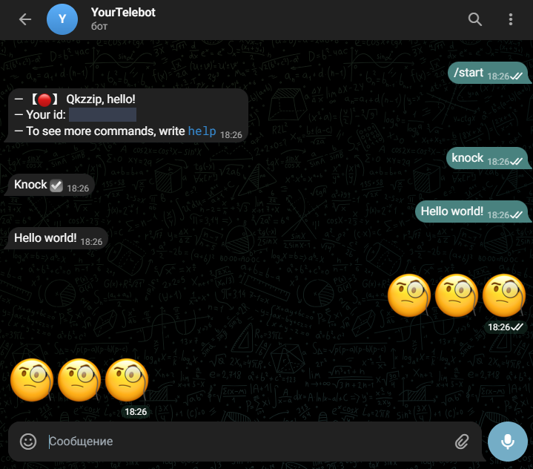

|  |  |
| --- | --- |
| 1 | "whachaMean":"Что это значит??? Я не знаю такой команды :(" |

|  |  |
| --- | --- |
| 1 | case _: |
| 2 | bot.send_message(chat.id,setTag(data[lang]["messages"]["whachaMean"], None)) |

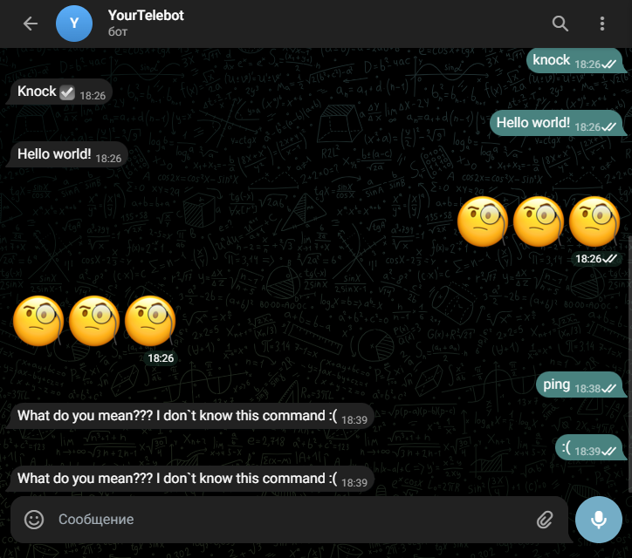

|  |  |
| --- | --- |
| 1 | "randomDefault":"Случайное число от 0 до 100: [cod][rand][/cod]", |
| 2 | "randomWithA":"Случайное число от 0 до [A]: [cod][rand][/cod]", |
| 3 | "randomWithAB":"Случайное число от [A] до [B]: [cod][rand][/cod]" |

|  |  |
| --- | --- |
| 1 | case "random": |
| 2 | rand = text.split() *#* |
| 3 | rand.pop(0) *#* |
| 4 | rand = list(map(int, rand)) *#* |

|  |  |
| --- | --- |
| 1 | if not rand: |
| 2 | bot.send_message(chat.id, setTag(data[lang]["messages"]["randomDefault"], None).replace("[rand]",str(r.randint(0,100)))) |

|  |  |
| --- | --- |
| 1 | elif len(rand) == 1: |
| 2 | if rand[0] == 0: |
| 3 | bot.send_message(chat.id, setTag(data[lang]["messages"]["randomWithA"], None).replace("[rand]","0 ¯\\_(ツ)_/¯").replace("[A]","0")) |
| 4 | else: |
| 5 | bot.send_message(chat.id, setTag(data[lang]["messages"]["randomWithA"], None).replace("[rand]",str(r.randint(min(0,rand[0]),max(0,rand[0])))).replace("[A]",str(rand[0]))) |

|  |  |
| --- | --- |
| 1 | else: |
| 2 | if rand[0] == rand[1]: |
| 3 | bot.send_message(chat.id, setTag(data[lang]["messages"]["randomWithAB"], None).replace("[rand]",f"{rand[0]} ¯\\_(ツ)_/¯").replace("[A]",str(rand[0])).replace("[B]",str(rand[1]))) |
| 4 | else: |
| 5 | bot.send_message(chat.id, setTag(data[lang]["messages"]["randomWithAB"], None).replace("[rand]",str(r.randint(min(rand[0],rand[1]),max(rand[0],rand[1])))).replace("[A]",str(min(rand[0],rand[1]))).replace("[B]",str(max(rand[0],rand[1])))) |

|  |  |
| --- | --- |
| 1 | "numberRandomError":"[n][cod]random 1 10[/cod]" |

Весь код команды выглядит вот так:

|  |  |
| --- | --- |
| 1 | case "random": |
| 2 | try: *#* |
| 3 | rand = text.split() *#* |
| 4 | rand.pop(0) *#* |
| 5 | rand = list(map(int, rand)) *#* |
| 6 |  |
| 7 | if not rand: |
| 8 | bot.send_message(chat.id, setTag(data[lang]["messages"]["randomDefault"], None).replace("[rand]",str(r.randint(0,100)))) |
| 9 |  |
| 10 | elif len(rand) == 1: |
| 11 | if rand[0] == 0: |
| 12 | bot.send_message(chat.id, setTag(data[lang]["messages"]["randomWithA"], None).replace("[rand]","0 ¯\\_(ツ)_/¯").replace("[A]","0")) |
| 13 | else: |
| 14 | bot.send_message(chat.id, setTag(data[lang]["messages"]["randomWithA"], None).replace("[rand]",str(r.randint(min(0,rand[0]),max(0,rand[0])))).replace("[A]",str(rand[0]))) |
| 15 |  |
| 16 | else: |
| 17 | if rand[0] == rand[1]: |
| 18 | bot.send_message(chat.id, setTag(data[lang]["messages"]["randomWithAB"], None).replace("[rand]",f"{rand[0]} ¯\\_(ツ)_/¯").replace("[A]",str(rand[0])).replace("[B]",str(rand[1]))) |
| 19 | else: |
| 20 | bot.send_message(chat.id, setTag(data[lang]["messages"]["randomWithAB"], None).replace("[rand]",str(r.randint(min(rand[0],rand[1]),max(rand[0],rand[1])))).replace("[A]",str(min(rand[0],rand[1]))).replace("[B]",str(max(rand[0],rand[1])))) |
| 21 |  |
| 22 | except ValueError: *#* |
| 23 | bot.send_message(chat.id, setTag(data[lang]["error"]["numberRandomError"], None)) |

• •