IST 363

# Lab 10

## react 1

3. 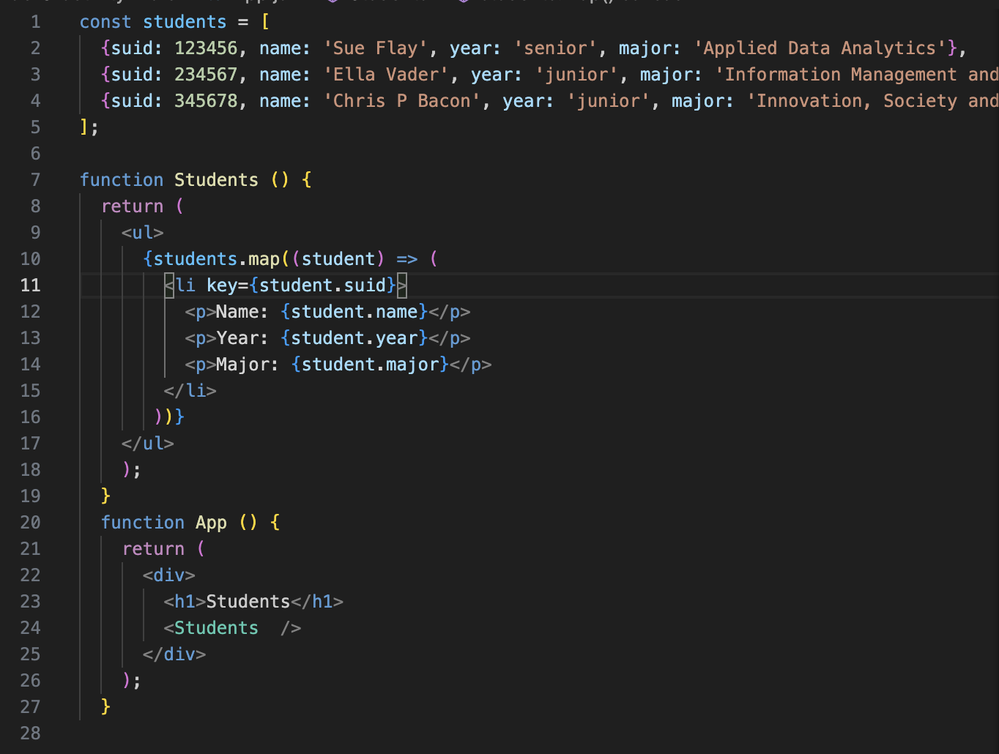

6. write brief answers to the questions below

a. React combines JavaScript and HTML language together for better performance.

b. React components start with a capital letter so JSX knows it’s a component instead of an html element

c. JSX allows HTML code to be implemented in JavaScript.

d. Class is a reverse keyword in JavaScript, so when using JSX className has to be used instead of class.

e. Curly braces inserts JavaScript expressions in JSX.

f. Improved organization and reusability.

g. Code duplication or components with multiple responsibilities,

h. Yes, we did it in this lab.

i. The element’s value is controlled by React state, which is a manageable for the user.