Grid:



Will split the map by this number, such as 3x3, 4x4. etc…

DeleteEmptyLevel:



When split by grid, there may some empty level because you don’t want to put anything at that area, which means load the empty level will cause extra calculations. Check this will ensure the result levels must with stuffs. Only effect on “SplitMap” button.

CreatePlane



Check this will also add a plane on the map like a tile. Only effect on “SplitMap” button.

Spilt as Size

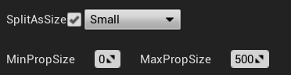

Sometimes we want bigger stuffs should be loaded as a farer distance than the smallers.This can give a label on the level, and split as MinPropSize – MaxPropSize, that means out of this range would not be include to the split levels. Only effect on “SplitMap” button.

For simple use, no need to check on this.--×

SplitMap:



This will split the whole map to NxN grids but without landscapes. If there miss some special stuffs,please tell me 173681019@qq,com.

SplitLandscape:



This will split the landscape to NxN grids.

SplitByGridAndMerge:



Staticmeshactors in map will be merged by the NxN grids.(means no matter how many staticmeshes in the maps, with a mouse click there will be max to NxNs



You can change the save path here.