1.Create a blueprint based MaterialReaderActor

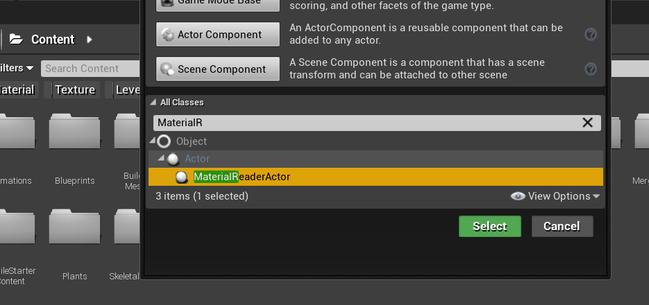

2.Drag it into world

3.Put material with parameters here.

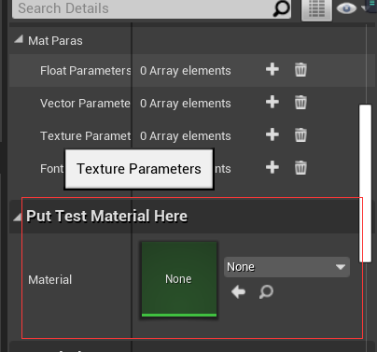

4.Auto read parameters, you can change the value in live without create any mat instance.

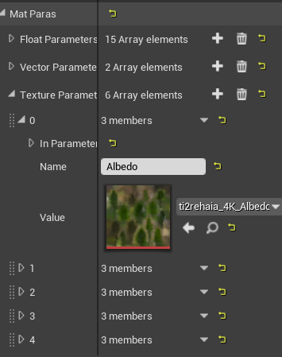

5.For other uses you can use these functons in blueprint also.

