layout_constraintTop_toBottomOf
app:layout_constraintLeft_toLeftOf="@id/rootLayout"
app:layout_constraintLeft_toRightOf="@id/rootLayout"
app:layout_constraintRight_toLeftOf="@id/rootLayout"
app:layout_constraintRight_toRightOf="@id/rootLayout"
app:layout_constraintTop_toBottomOf="@id/rootLayout"
app:layout_constraintTop_toTopOf="@id/rootLayout"
app:layout_constraintBottom_toBottomOf="@id/rootLayout"
app:layout_constraintBottom_toTopOf="@id/rootLayout"
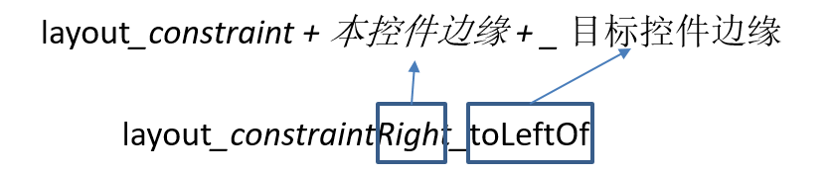

layout_constraintHorizontal_bias
android:layout_width="wrap_content" 可以 是 wrap_content 或者 200dp，对match_parent 无效
<ImageView
android:layout_width="200dp"
android:layout_height="0dp"
android:src="@drawable/timg"
app:layout_constraintHorizontal_bias="0.3"
app:layout_constraintLeft_toLeftOf="@+id/rootLayout"
app:layout_constraintRight_toRightOf="@+id/rootLayout"
/>
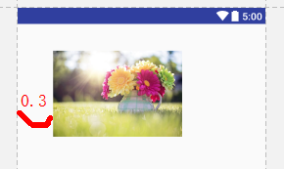

layout_constraintVertical_bias
android:layout_height="wrap_content" 可以 是 wrap_content 或者 200dp，对match_parent 无效
<ImageView
android:layout_width="match_parent"
android:layout_height="wrap_content"
android:src="@drawable/timg"
app:layout_constraintBottom_toBottomOf="@id/rootLayout"
app:layout_constraintTop_toTopOf="@id/rootLayout"
app:layout_constraintVertical_bias="0.3"
/>
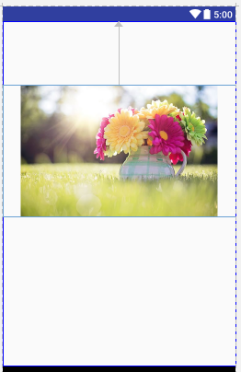

layout_constraintDimensionRatio

<ImageView
android:layout_width="0dp"
android:layout_height="wrap_content"
android:adjustViewBounds="true"
android:src="@drawable/timg"
app:layout_constraintDimensionRatio="16:10"
app:layout_constraintLeft_toLeftOf="@id/rootLayout"
app:layout_constraintRight_toRightOf="@id/rootLayout"/>
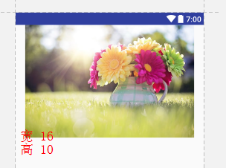

layout_constraintHorizontal_weight
app:layout_constraintHorizontal_weight="2" 要结合 app:layout_constraintHorizontal_chainStyle="spread_inside" （非 packed ）
app:layout_constraintHorizontal_chainStyle 这个属性只加给 ConstraintLayout 的第一个直接子控件 有效
<TextView
android:id="@+id/textView1"
android:layout_width="0dp"
android:layout_height="wrap_content"
android:background="@color/colorPrimary"
android:gravity="center"
android:text="首页"
android:textColor="#FFFFFF"
app:layout_constraintHorizontal_chainStyle="spread_inside"
app:layout_constraintHorizontal_weight="2"
app:layout_constraintLeft_toLeftOf="@+id/rootLayout"
app:layout_constraintRight_toLeftOf="@+id/textView2"
app:layout_constraintTop_toTopOf="@+id/rootLayout"/>
<TextView
android:id="@+id/textView2"
android:layout_width="0dp"
android:layout_height="wrap_content"
android:background="@color/colorPrimaryDark"
android:gravity="center"
android:text="新闻"
android:textColor="#FFFFFF"
app:layout_constraintHorizontal_weight="5"
app:layout_constraintLeft_toRightOf="@id/textView1"
app:layout_constraintRight_toRightOf="@+id/rootLayout"
app:layout_constraintTop_toTopOf="@+id/rootLayout"/>
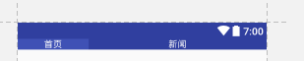 2:5 展示

layout_constraintHorizontal_chainStyle
app:layout_constraintHorizontal_chainStyle="packed" 写在 ConstraintLayout 的第一个直接子控件有效 有 "packed"、"spread"、"spread_inside"3种属性
<?xml version="1.0" encoding="utf-8"?>
<android.support.constraint.ConstraintLayout
xmlns:android="http://schemas.android.com/apk/res/android"
xmlns:app="http://schemas.android.com/apk/res-auto"
xmlns:tools="http://schemas.android.com/tools"
android:id="@+id/rootLayout"
android:layout_width="match_parent"
android:layout_height="match_parent"
tools:context="com.alex.constraintlayout.MainActivity"
tools:ignore="all">
<TextView
android:id="@+id/textView1"
android:layout_width="80dp"
android:gravity="center"
android:layout_height="wrap_content"
android:background="@color/colorPrimary"
android:text="首页"
android:textColor="#FFFFFF"
app:layout_constraintHorizontal_chainStyle="packed"
app:layout_constraintLeft_toLeftOf="parent"
app:layout_constraintRight_toLeftOf="@+id/textView2"
app:layout_constraintTop_toTopOf="parent"/>
<TextView
android:id="@+id/textView2"
android:layout_width="80dp"
android:gravity="center"
android:layout_height="wrap_content"
android:background="@color/colorPrimary"
android:text="新闻"
android:textColor="#FFFFFF"
app:layout_constraintLeft_toRightOf="@id/textView1"
app:layout_constraintRight_toLeftOf="@id/textView3"
app:layout_constraintTop_toTopOf="parent"/>
<TextView
android:id="@+id/textView3"
android:layout_width="80dp"
android:gravity="center"
android:layout_height="wrap_content"
android:background="@color/colorPrimary"
android:text="娱乐"
android:textColor="#FFFFFF"
app:layout_constraintLeft_toRightOf="@id/textView2"
app:layout_constraintRight_toRightOf="parent"
app:layout_constraintTop_toTopOf="parent"/>
</android.support.constraint.ConstraintLayout>

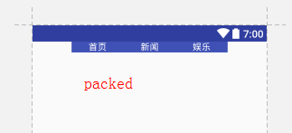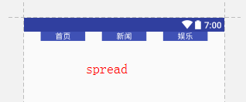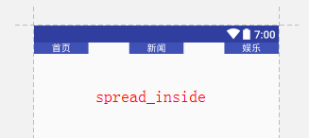
packed 居中紧凑； spread均分所有间距展开；spread_inside均分内部间距展开；

ConstraintSet

ConstraintSet constraintSet = new ConstraintSet();
constraintSet.clone(this, R.layout.activity_main);
if (Build.VERSION.SDK_INT >= Build.VERSION_CODES.KITKAT) {
TransitionManager.beginDelayedTransition(constraintLayout);
}
constraintSet.constrainWidth(R.id.button2, isFirst ? 100 : 600);
constraintSet.setHorizontalBias(R.id.button3, isFirst ? 0F : 1F);
constraintSet.applyTo(constraintLayout);

注意
没有match_parent 换成 0dp

complie
com.android.support.constraint:constraint-layout:1.0.1
com.android.support.constraint:constraint-layout:1.0.2

参考
https://blog.stylingandroid.com/tag/constraintlayout/
http://www.jianshu.com/p/575829baa39d
https://github.com/xitu/gold-miner/blob/master/TODO/constraint-layout-visual-design-editor-hell.md

