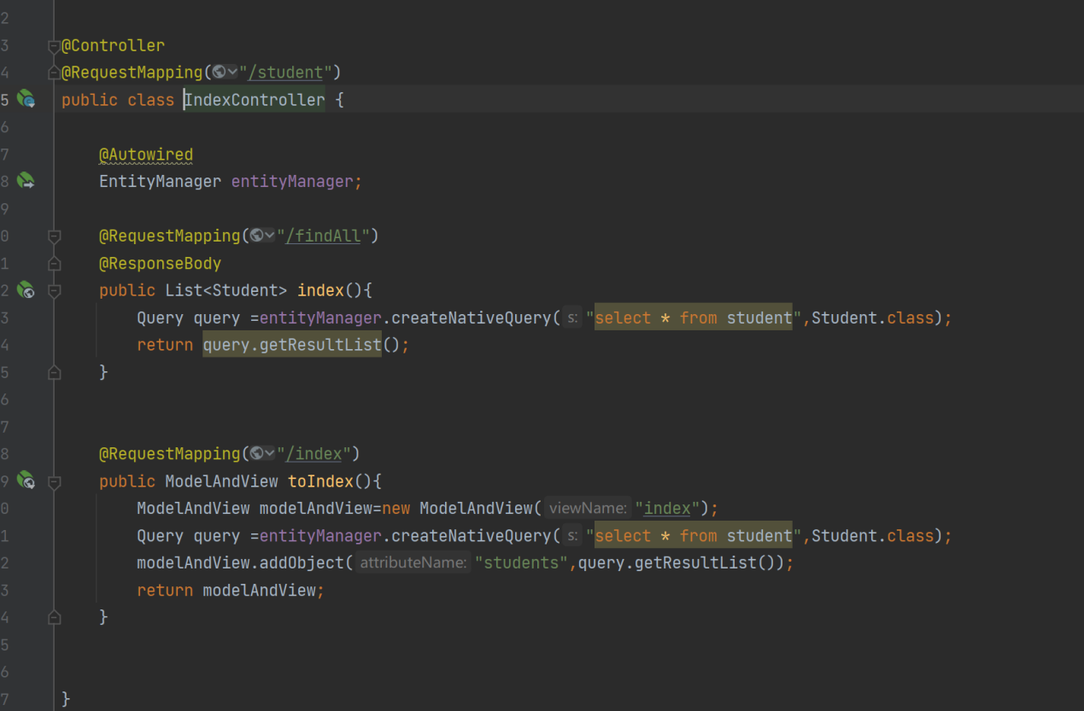

I used spring boot here.

For more information about that: <https://spring.io/projects/spring-boot>

Use ReuqestMapping to mark the url of the API.(@RequestMapping is an annotation used to process request address mapping)

The @ReuqestMapping in “Class” marks the upper level of the url (student).

The @ReuqestMapping in “Method”marks the lower level of the url(findall) .

API is in the “IndexController” when the user access API the “IndexController” will call 

to invoke the database

The API access the location url.

Backend is all java code of the project.