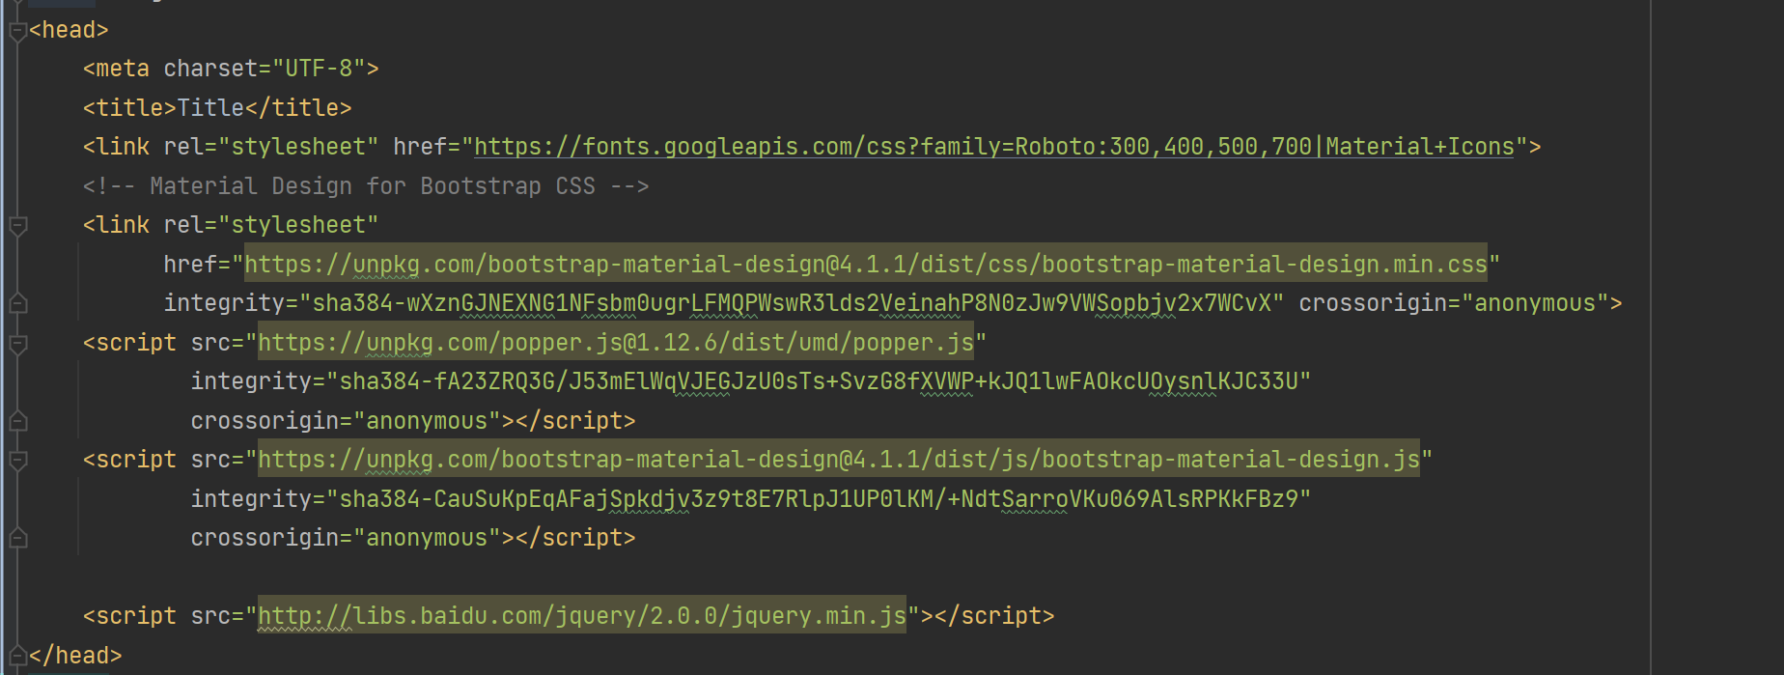

Bootstrap and jquery are used for the header of the page. Mainly use for page style.

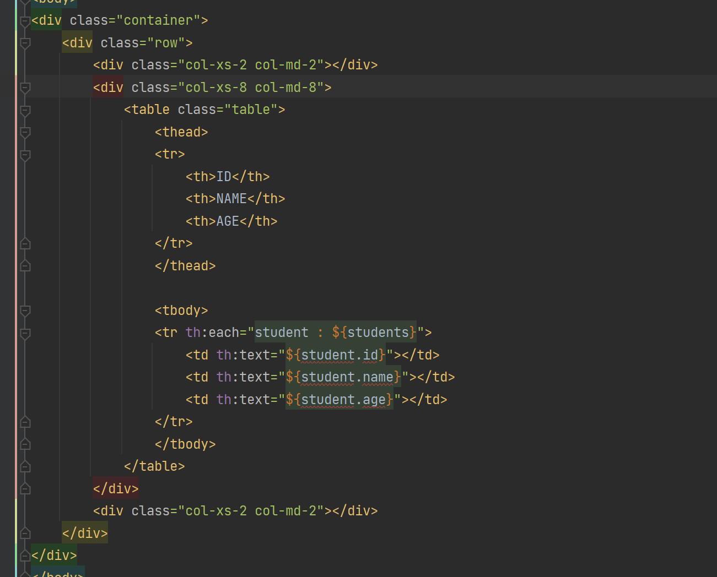

Use table to display data.

The frontend show the data , The backend is all the code that will affect the frontend

Bootstrap uses grid layout, which divides the page into 12 columns. For example Col-md-8 occupies 8/12 of them.

th:each is used to read data in a loop.

Th:text is used to render data.