sudo apt-get remove docker docker-engine docker.io containerd runc

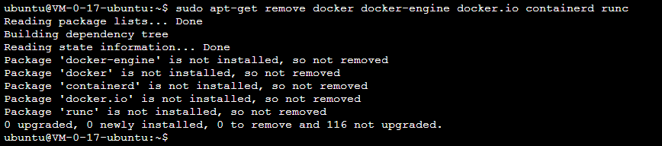

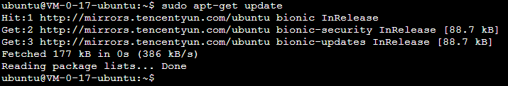

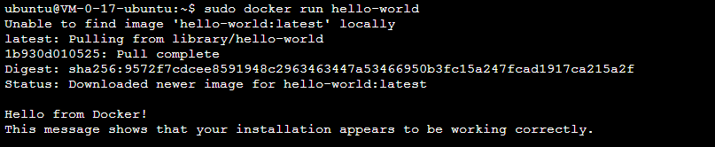

sudo apt-get remove docker docker-engine docker.io containerd run

sudo apt-get update

sudo apt-get install apt-transport-https ca-certificates curl gnupg-agent software-properties-common

curl -fsSL https://download.docker.com/linux/ubuntu/gpg | sudo apt-key add -

sudo apt-key fingerprint 0EBFCD88

sudo add-apt-repository "deb [arch=amd64] https://download.docker.com/linux/ubuntu $(lsb_release -cs) stable"

sudo apt-get update

sudo apt-get install docker-ce docker-ce-cli containerd.io

sudo docker run hello-world

sudo docker run -it -p 1880:1880 --name mynodered nodered/node-red

nodered 访问网址 http://106.54.19.80:1880

在某文件夹下打开命令行窗口：shift+右键