移动平台应用开发上机实验报告
实验项目名称： | 基本表单组件 |  |  | 实验日期： | 2020.6.1
学 生 姓 名： | 刘永伦 | 专业班级： | 软件171 | 学 号： | 17425037
- 实验目的
- 熟悉vue基本语法
- 熟悉基础UI组件开发
- 熟悉HBuilder X开发环境
- 实验内容
1. 实现基本的表单组件，包括按钮、文本输入框等
2. 手机上效果如下图所示
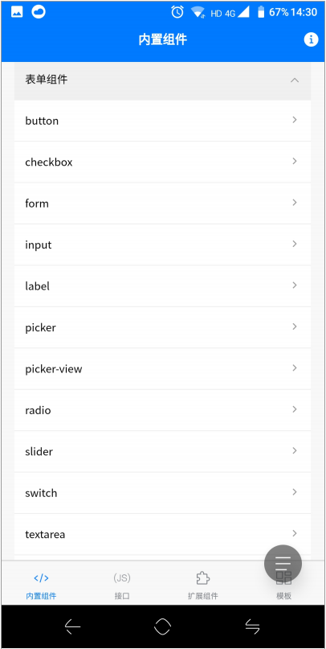
- 概要设计
1 首先实现伸缩列表，方便收纳
2 在index文件中由js动态返回列表的数据项，这样可以方便后期维护。
3 根据vue的组件化开发思想，需要依次在component中实现对应的组件，然后再在index的方法中与Onclick事件绑定即可。
- 详细设计
Index.nvue文件
<template>
<view class="uni-container">
<view class="uni-header-logo">
<image class="uni-header-image" src="/static/componentIndex.png"></image>
</view>
<view class="uni-hello-text">
<text class="hello-text">表单组件实验</text>
</view>
<!--这里通过遍历的方式添加数据项-->
<view class="uni-panel" v-for="(item, index) in list" :key="item.id">
<view class="uni-panel-h" :class="item.open ? 'uni-panel-h-on' : ''" @click="triggerCollapse(index)">
<text class="uni-panel-text">{{item.name}}</text>
<text class="uni-panel-icon uni-icon" :class="item.open ? 'uni-panel-icon-on' : ''">{{item.pages ? '&#xe581;' : '&#xe470;'}}</text>
</view>
<view class="uni-panel-c" v-if="item.open">
<view class="uni-navigate-item" v-for="(item2,key) in item.pages" :key="key" @click="goDetailPage(item2)">
<text class="uni-navigate-text">{{item2.name ? item2.name : item2}}</text>
<text class="uni-navigate-icon uni-icon">&#xe470;</text>
</view>
</view>
</view>
</view>
</template>
<script>
// TODO 修复Android v3 加载过慢问题
// #ifdef APP-PLUS
var domModule = weex.requireModule('dom');
domModule.addRule('fontFace', {
'fontFamily': "uniicons",
'src': "url('/static/uni.ttf')"
});
// #endif

import uLink from '@/components/uLink.vue'
export default {
components: {
uLink
},
data() {
return {
list: [{
id: 'form',
name: '表单组件实验',
open: false,
pages: ['button', 'checkbox', 'form', 'input', 'label', 'picker', 'picker-view', 'radio',
'slider',
'switch', 'textarea',
// #ifdef APP-PLUS || MP-WEIXIN || H5
'editor',
// #endif
]
}],
navigateFlag: false
}
},
methods: {
triggerCollapse(e) {
if (!this.list[e].pages) {
this.goDetailPage(this.list[e].url);
return;
}
for (var i = 0; i < this.list.length; ++i) {
if (e === i) {
this.list[i].open = !this.list[e].open;
} else {
this.list[i].open = false;
}
}
},
goDetailPage(e) {
if (this.navigateFlag) {
return;
}
this.navigateFlag = true;
if (typeof e === 'string') {
uni.navigateTo({
url: '/pages/component/' + e + '/' + e
})
} else {
uni.navigateTo({
url: e.url
})
}
setTimeout(() => {
this.navigateFlag = false;
}, 200)
}
}
}
</script>

<style>
@import '../../common/uni-nvue.css';
</style>
以上代码可以实现主页部分。
对应组件部分：
按钮：
<template>
<view>
<page-head :title="title"></page-head>
<view class="uni-padding-wrap uni-common-mt">
<button type="primary">页面主操作 Normal</button>
<button type="primary" :loading="loading">页面主操作 Loading</button>
<button type="primary" disabled="true">页面主操作 Disabled</button>

<button type="default">页面次要操作 Normal</button>
<button type="default" disabled="true">页面次要操作 Disabled</button>

<button type="warn">警告类操作 Normal</button>
<button type="warn" disabled="true">警告类操作 Disabled</button>

<view class="button-sp-area">
<button type="primary" plain="true">按钮</button>
<button type="primary" disabled="true" plain="true">不可点击的按钮</button>

<button type="default" plain="true">按钮</button>
<button type="default" disabled="true" plain="true">按钮</button>

<button class="mini-btn" type="primary" size="mini">按钮</button>
<button class="mini-btn" type="default" size="mini">按钮</button>
<button class="mini-btn" type="warn" size="mini">按钮</button>
</view>
<!-- #ifdef MP-WEIXIN || MP-QQ -->
<button open-type="launchApp" app-parameter="uni-app" @error="openTypeError">打开APP</button>
<button open-type="feedback">意见反馈</button>
<!-- #endif -->
</view>
</view>
</template>
<script>
export default {
data() {
return {
title: 'button',
loading: false
}
},
onLoad() {
this._timer = null;
},
onShow() {
this.clearTimer();
this._timer = setTimeout(() => {
this.loading = true;
}, 300)
},
onUnload() {
this.clearTimer();
this.loading = false;
},
methods: {
openTypeError(error) {
console.error('open-type error:', error);
},
clearTimer() {
if (this._timer != null) {
clearTimeout(this._timer);
}
}
}
}
</script>

<style>
button {
margin-top: 30rpx;
margin-bottom: 30rpx;
}

.button-sp-area {
margin: 0 auto;
width: 60%;
}

.mini-btn {
margin-right: 10rpx;
}
</style>
输入框：
<template>
<view class="nvue-page-root">
<view class="page-title">
<view class="page-title__wrapper">
<text class="page-title__text">{{title}}</text>
</view>
</view>
<view class="uni-common-mt">
<view class="uni-form-item uni-column">
<view class="title"><text class="uni-form-item__title">可自动聚焦的 input</text></view>
<view class="uni-input-wrapper">
<input class="uni-input" focus placeholder="自动获得焦点" />
</view>
</view>
<!-- #ifdef APP-PLUS -->
<view v-if="platform==='ios'&&!isNvue" class="uni-form-item uni-column">
<view class="title"><text class="uni-form-item__title">隐藏 iOS 软键盘上的导航条</text></view>
<view class="uni-input-wrapper">
<input class="uni-input" placeholder="触摸其他地方收起键盘" @focus="onFocus" @blur="onBlur" />
</view>
</view>
<!-- #endif -->
<view class="uni-form-item uni-column">
<view class="title"><text class="uni-form-item__title">键盘右下角按钮显示为搜索</text></view>
<view class="uni-input-wrapper">
<input class="uni-input" confirm-type="search" placeholder="键盘右下角按钮显示为搜索" />
</view>
</view>
<!-- #ifndef H5 -->
<view class="uni-form-item uni-column">
<view class="title"><text class="uni-form-item__title">键盘右下角按钮显示为发送</text></view>
<view class="uni-input-wrapper">
<input class="uni-input" confirm-type="send" placeholder="键盘右下角按钮显示为发送" />
</view>
</view>
<!-- #endif -->
<view class="uni-form-item uni-column">
<view class="title"><text class="uni-form-item__title">控制最大输入长度的 input</text></view>
<view class="uni-input-wrapper">
<input class="uni-input" maxlength="10" placeholder="最大输入长度为10" />
</view>
</view>
<view class="uni-form-item uni-column">
<view class="title"><text class="uni-form-item__title">实时获取输入值：{{inputValue}}</text></view>
<view class="uni-input-wrapper">
<input class="uni-input" @input="onKeyInput" placeholder="输入同步到view中" />
</view>
</view>
<view class="uni-form-item uni-column">
<view class="title"><text class="uni-form-item__title">控制输入的 input</text></view>
<view class="uni-input-wrapper">
<input class="uni-input" @input="replaceInput" v-model="changeValue" placeholder="连续的两个1会变成2" />
</view>
</view>
<!-- #ifndef MP-BAIDU -->
<view class="uni-form-item uni-column">
<view class="title"><text class="uni-form-item__title">控制键盘的 input</text></view>
<view class="uni-input-wrapper">
<input class="uni-input" ref="input1" @input="hideKeyboard" placeholder="输入123自动收起键盘" />
</view>
</view>
<!-- #endif -->
<view class="uni-form-item uni-column">
<view class="title"><text class="uni-form-item__title">数字输入的 input</text></view>
<view class="uni-input-wrapper">
<input class="uni-input" type="number" placeholder="这是一个数字输入框" />
</view>
</view>
<view class="uni-form-item uni-column">
<view class="title"><text class="uni-form-item__title">密码输入的 input</text></view>
<view class="uni-input-wrapper">
<input class="uni-input" password type="text" placeholder="这是一个密码输入框" />
</view>
</view>
<view class="uni-form-item uni-column">
<view class="title"><text class="uni-form-item__title">带小数点的 input</text></view>
<view class="uni-input-wrapper">
<input class="uni-input" type="digit" placeholder="带小数点的数字键盘" /> </view>
</view>
<view class="uni-form-item uni-column">
<view class="title"><text class="uni-form-item__title">身份证输入的 input</text></view>
<view class="uni-input-wrapper">
<input class="uni-input" type="idcard" placeholder="身份证输入键盘" /> </view>
</view>
<view class="uni-form-item uni-column">
<view class="title"><text class="uni-form-item__title">控制占位符颜色的 input</text></view>
<view class="uni-input-wrapper">
<input class="uni-input" placeholder-style="color:#F76260" placeholder="占位符字体是红色的" />
</view>
</view>
<view class="uni-form-item uni-column">
<view class="title"><text class="uni-form-item__title">带清除按钮的输入框</text></view>
<view class="uni-input-wrapper">
<input class="uni-input" placeholder="带清除按钮的输入框" :value="inputClearValue" @input="clearInput" />
<text class="uni-icon" v-if="showClearIcon" @click="clearIcon">&#xe434;</text>
</view>
</view>
<view class="uni-form-item uni-column">
<view class="title"><text class="uni-form-item__title">可查看密码的输入框</text></view>
<view class="uni-input-wrapper">
<input class="uni-input" placeholder="请输入密码" :password="showPassword" />
<text class="uni-icon" :class="[!showPassword ? 'uni-eye-active' : '']" @click="changePassword">&#xe568;</text>
</view>
</view>
</view>
</view>
</template>
<script>
import pageHead from '@/components/page-head.vue'
export default {
components: {
pageHead
},
data() {
return {
title: 'input',
focus: false,
inputValue: '',
showClearIcon: false,
inputClearValue: '',
changeValue: '',
showPassword: true,
src: '../../../static/eye-1.png',
platform: '',
isNvue: false,
}
},
methods: {
onKeyInput: function(event) {
this.inputValue = event.detail.value
},
replaceInput: function(event) {
var value = event.detail.value;
if (value === '11') {
this.changeValue = '2';
}
},
hideKeyboard: function(event) {
if (event.detail.value === '123') {
uni.hideKeyboard();
}
},
clearInput: function(event) {
this.inputClearValue = event.detail.value;
if (event.detail.value.length > 0) {
this.showClearIcon = true;
} else {
this.showClearIcon = false;
}
},
clearIcon: function() {
this.inputClearValue = '';
this.showClearIcon = false;
},
changePassword: function() {
this.showPassword = !this.showPassword;
},
onFocus() {
this.$mp.page.$getAppWebview().setStyle({
softinputNavBar: 'none'
})
},
onBlur() {
this.$mp.page.$getAppWebview().setStyle({
softinputNavBar: 'auto'
})
}
},
onLoad() {
this.platform = uni.getSystemInfoSync().platform
// #ifdef APP-PLUS-NVUE
this.isNvue = true
// #endif
}
}
</script>

<style scoped>
.nvue-page-root {
background-color: #F8F8F8;
padding-bottom: 20px;
}

.page-title {
/* #ifndef APP-NVUE */
display: flex;
/* #endif */
flex-direction: row;
justify-content: center;
align-items: center;
padding: 35rpx;
}

.page-title__wrapper {
padding: 0px 20px;
border-bottom-color: #D8D8D8;
border-bottom-width: 1px;
}

.page-title__text {
font-size: 16px;
height: 48px;
line-height: 48px;
color: #BEBEBE;
}

.title {
padding: 5px 13px;
}

.uni-form-item__title {
font-size: 16px;
line-height: 24px;
}

.uni-input-wrapper {
/* #ifndef APP-NVUE */
display: flex;
/* #endif */
padding: 8px 13px;
flex-direction: row;
flex-wrap: nowrap;
background-color: #FFFFFF;
}

.uni-input {
height: 28px;
line-height: 28px;
font-size: 15px;
padding: 0px;
flex: 1;
background-color: #FFFFFF;
}

.uni-icon {
font-family: uniicons;
font-size: 24px;
font-weight: normal;
font-style: normal;
width: 24px;
height: 24px;
line-height: 24px;
color: #999999;
}

.uni-eye-active {
color: #007AFF;
}
</style>
复选框：
<template>
<view>
<page-head :title="title"></page-head>
<view class="uni-padding-wrap uni-common-mt">
<view class="uni-title uni-common-mt">默认样式</view>
<view>
<checkbox-group>
<label>
<checkbox value="cb" checked="true" />选中
</label>
<label>
<checkbox value="cb" />未选中
</label>
</checkbox-group>
</view>
<view class="uni-title uni-common-mt">不同颜色和尺寸的checkbox</view>
<view>
<checkbox-group>
<label>
<checkbox value="cb" checked="true" color="#FFCC33" style="transform:scale(0.7)" />选中
</label>
<label>
<checkbox value="cb" color="#FFCC33" style="transform:scale(0.7)" />未选中
</label>
</checkbox-group>
</view>
</view>

<view class="uni-padding-wrap">
<view class="uni-title uni-common-mt">
推荐展示样式
<text>\n使用 uni-list 布局</text>
</view>
</view>
<view class="uni-list">
<checkbox-group @change="checkboxChange">
<label class="uni-list-cell uni-list-cell-pd" v-for="item in items" :key="item.value">
<view>
<checkbox :value="item.value" :checked="item.checked" />
</view>
<view>{{item.name}}</view>
</label>
</checkbox-group>
</view>
</view>
</template>
<script>
export default {
data() {
return {
title: 'checkbox 复选框',
items: [{
value: 'USA',
name: '美国'
},
{
value: 'CHN',
name: '中国',
checked: 'true'
},
{
value: 'BRA',
name: '巴西'
},
{
value: 'JPN',
name: '日本'
},
{
value: 'ENG',
name: '英国'
},
{
value: 'FRA',
name: '法国'
}
]
}
},
methods: {
checkboxChange: function (e) {
var items = this.items,
values = e.detail.value;
for (var i = 0, lenI = items.length; i < lenI; ++i) {
const item = items[i]
if(values.indexOf(item.value) >= 0){
this.$set(item,'checked',true)
}else{
this.$set(item,'checked',false)
}
}
}
}
}
</script>

<style>
.uni-list-cell {
justify-content: flex-start
}
</style>

- 运行结果和分析

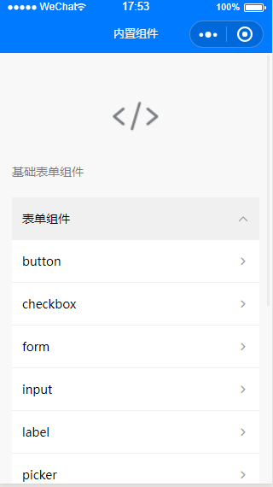
主页效果：
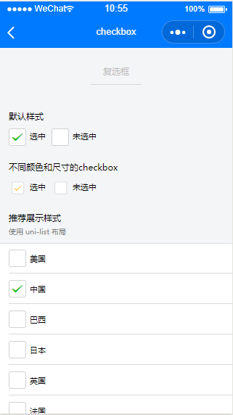
复选框
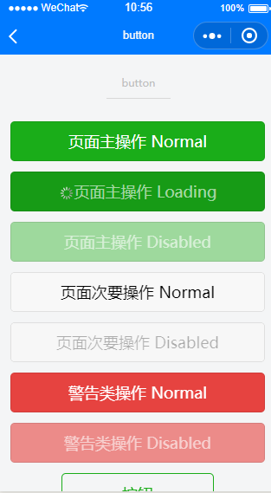
按钮
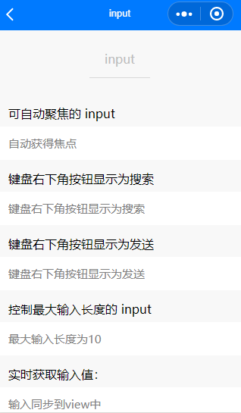
输入框
Vue的组件化开发中，如果需要填充数据项时尽可能使用动态添加的方式，这样可以让代码更短，增强代码的可读性，从而方便进行后期维护。
对应模块也最好都封装到一个component中，这样更符合组件化的思想，这样封装好的组件在需要时可以直接引用。

评分标准 | 每次实验给出多个测试用例进行测试，根据题目难度的不同、用例检测的功能不同，每次实验会按照不同的权重给出成绩，具体见每次实验的实验总结。  注：若发现抄袭，被抄袭人和抄袭人本次实验报告总分评定为0分。

