移动平台应用开发上机实验报告
实验项目名称： | 基本图片浏览 |  |  | 实验日期： | 2020.6.8
学 生 姓 名： | 刘永伦 | 专业班级： | 软件171 | 学 号： | 17425037
- 实验目的
- 熟悉图片分类的业务逻辑。
2.熟悉如何对图片数据进行展示。
二、实验内容
1. 实现基本的图片浏览功能，尽可能带分类。
2. 手机上效果如下图所示
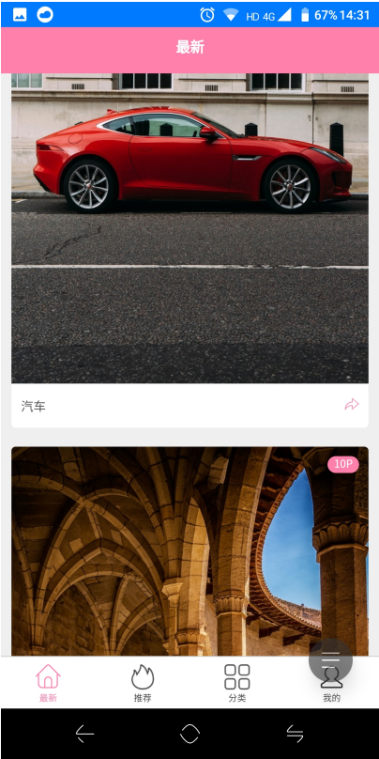

三、概要设计
1设计tapbar，在底部实现其导航逻辑功能。
2 设计图片页面的布局排版，实现其函数功能。
3设计图片详情页面，实现其基本的浏览和分享功能。
四、详细设计
项目文件目录：
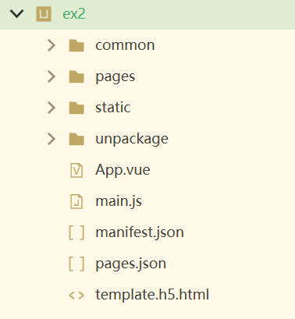
New.vue文件即首页
<template>
<view class="index">
<block v-for="item in list" :key="item.img_src">
<view class="card" @click="goDetail(item)">
<image class="card-img" :src="item.img_src" mode="aspectFill"></image>
<text class="card-num-view">{{item.img_num}}P</text>
<view class="card-bottm row">
<view class="car-title-view row">
<text class="card-title">{{item.title}}</text>
</view>
<view @click.stop="share(item)" class="card-share-view"></view>
</view>
</view>
</block>
<text class="loadMore">加载中...</text>
</view>
</template>

<script>
export default {
data() {
return {
refreshing: false,
providerList: [],
list: [],
fetchPageNum: 1
}
},
onLoad() {
this.getData();
uni.getProvider({
service: 'share',
success: (e) => {
let data = []
for (let i = 0; i < e.provider.length; i++) {
switch (e.provider[i]) {
case 'weixin':
data.push({
name: '分享到微信好友',
id: 'weixin'
})
data.push({
name: '分享到微信朋友圈',
id: 'weixin',
type: 'WXSenceTimeline'
})
break;
case 'qq':
data.push({
name: '分享到QQ',
id: 'qq'
})
break;
default:
break;
}
}
this.providerList = data;
},
fail: (e) => {
console.log('获取分享通道失败', e);
}
});
},
onReachBottom() {
console.log('滑动到页面底部')
this.getData();
},
onPullDownRefresh() {
console.log('下拉刷新');
this.refreshing = true;
this.getData();
},
methods: {
getData() {
uni.request({
url: this.$serverUrl + '/api/picture/posts.php?page=' + (this.refreshing ? 1 : this.fetchPageNum) +
'&per_page=5',
success: (ret) => {
console.log('data', ret);
if (ret.statusCode !== 200) {
console.log('失败!');
} else {
if (this.refreshing && ret.data[0].id === this.list[0].id) {
uni.showToast({
title: '已经最新',
icon: 'none',
})
this.refreshing = false;
uni.stopPullDownRefresh();
return;
}
if (this.refreshing) {
this.refreshing = false;
uni.stopPullDownRefresh()
this.list = ret.data;
this.fetchPageNum = 2;
} else {
this.list = this.list.concat(ret.data);
this.fetchPageNum += 1;
}
}
}
});
},
goDetail(e) {
uni.navigateTo({
url: '../detail/detail?data=' + encodeURIComponent(JSON.stringify(e))
})
},
share(e) {
if (this.providerList.length === 0) {
uni.showModal({
title: '当前环境无分享渠道!',
showCancel: false
})
return;
}
let itemList = this.providerList.map(function(value) {
return value.name
})
uni.showActionSheet({
itemList: itemList,
success: (res) => {
uni.share({
provider: this.providerList[res.tapIndex].id,
scene: this.providerList[res.tapIndex].type && this.providerList[res.tapIndex].type === 'WXSenceTimeline' ?
'WXSenceTimeline' : 'WXSceneSession',
type: 0,
title: 'uni-app模版',
summary: e.title,
imageUrl: e.img_src,
href: 'https://uniapp.dcloud.io',
success: (res) => {
console.log('success:' + JSON.stringify(res));
},
fail: (e) => {
uni.showModal({
content: e.errMsg,
showCancel: false
})
}
});
}
})
}
}
}
</script>

<style>

</style>

推荐页：

<template>
<view class="index">
<view class="grid">
<view class="grid-c-06" v-for="item in lists" :key="item.guid">
<view class="panel" @click="goDetail(item)">
<image class="card-img card-list2-img" :src="item.img_src"></image>
<text class="card-num-view card-list2-num-view">{{item.img_num}}P</text>
<view class="card-bottm row">
<view class="car-title-view row">
<text class="card-title card-list2-title">{{item.title}}</text>
</view>
<view @click.stop="share(item)" class="card-share-view"></view>
</view>
</view>
</view>
</view>
<text class="loadMore">加载中...</text>
</view>
</template>

<script>
export default {
data() {
return {
refreshing: false,
lists: [],
fetchPageNum: 1
}
},
onLoad() {
this.getData();
uni.getProvider({
service: 'share',
success: (e) => {
let data = [];
for (let i = 0; i < e.provider.length; i++) {
switch (e.provider[i]) {
case 'weixin':
data.push({
name: '分享到微信好友',
id: 'weixin'
});
data.push({
name: '分享到微信朋友圈',
id: 'weixin',
type: 'WXSenceTimeline'
});
break;
case 'qq':
data.push({
name: '分享到QQ',
id: 'qq'
});
break;
default:
break;
}
}
this.providerList = data;
},
fail: (e) => {
console.log('获取登录通道失败', e);
}
});
},
onPullDownRefresh() {
console.log('下拉刷新');
this.refreshing = true;
this.getData();
},
onReachBottom() {
this.getData();
},
methods: {
getData() {
uni.request({
url: this.$serverUrl + '/api/picture/posts.php?page=' + (this.refreshing ? 1 : this.fetchPageNum) +
'&per_page=10',
success: (ret) => {
console.log(ret)
if (ret.statusCode !== 200) {
console.log('请求失败:', ret)
} else {
if (this.refreshing && ret.data[0].id === this.lists[0].id) {
uni.showToast({
title: '已经最新',
icon: 'none',
});
this.refreshing = false;
uni.stopPullDownRefresh();
return;
}
let list = [],
data = ret.data;
for (let i = 0, length = data.length; i < length; i++) {
var item = data[i];
item.guid = this.newGuid() + item.id
list.push(item);
}
console.log('得到list', list);
if (this.refreshing) {
this.refreshing = false;
uni.stopPullDownRefresh()
this.lists = list;
this.fetchPageNum = 2;
} else {
this.lists = this.lists.concat(list);
this.fetchPageNum += 1;
}
}
}
});
},
newGuid() {
let s4 = function() {
return (65536 * (1 + Math.random()) | 0).toString(16).substring(1);
}
return (s4() + s4() + "-" + s4() + "-4" + s4().substr(0, 3) + "-" + s4() + "-" + s4() + s4() + s4()).toUpperCase();
},
goDetail(e) {
uni.navigateTo({
url: '../detail/detail?data=' + encodeURIComponent(JSON.stringify(e))
})
},
share(e) {
if (this.providerList.length === 0) {
uni.showModal({
title: '当前环境无分享渠道!',
showCancel: false
})
return;
}
let itemList = this.providerList.map(function(value) {
return value.name
})
uni.showActionSheet({
itemList: itemList,
success: (res) => {
uni.share({
provider: this.providerList[res.tapIndex].id,
scene: this.providerList[res.tapIndex].type && this.providerList[res.tapIndex].type === 'WXSenceTimeline' ?
'WXSenceTimeline' : 'WXSceneSession',
type: 0,
title: 'uni-app模版',
summary: e.title,
imageUrl: e.img_src,
href: 'https://uniapp.dcloud.io',
success: (res) => {
console.log('success:' + JSON.stringify(res));
},
fail: (e) => {
uni.showModal({
content: e.errMsg,
showCancel: false
})
}
});
}
})
}
}
}
</script>

<style>
.grid{
padding-top: 10px;
}
</style>

分类页：

<template>
<view class="index">
<view class="tags">
<block v-for="value in data" :key="value.key">
<view class="tag" @tap="goList(value)">
<image class="tag-img" :src="value.icon"></image>
<text class="tag-text">{{value.type}}</text>
</view>
</block>
</view>
</view>
</template>

<script>
export default {
data() {
return {
data: [{
type: '动物',
id: 1,
key: 1,
icon: '../../static/爱心.png'
},
{
type: '风景',
id: 2,
key: 2,
icon: '../../static/发现.png'
},
{
type: '建筑',
id: 3,
key: 3,
icon: '../../static/直播.png'
},
{
type: '美女',
id: 4,
key: 4,
icon: '../../static/红包.png'
},
{
type: '汽车',
id: 5,
key: 5,
icon: '../../static/物流.png'
},
{
type: '运动',
id: 6,
key: 6,
icon: '../../static/吊牌.png'
},
{
type: '动物',
id: 1,
key: 7,
icon: '../../static/发现.png'
},
{
type: '风景',
id: 2,
key: 8,
icon: '../../static/购物篮.png'
}
]
}
},
methods: {
goList(value) {
uni.navigateTo({
url: '../list/list?type=' + value.type + '&id=' + value.id
})
}
}
}
</script>

<style>

</style>
图片浏览页：
<template>
<view class="index">
<swiper @change="swpierChange" :style="{height:screenHeight + 'px'}">
<swiper-item v-for="(value,index) in data" :key="value" @click="preImg(index)">
<image :src="value" mode="widthFix"></image>
</swiper-item>
</swiper>
<!-- #ifndef H5 -->
<view class="detail-btn-view">
<view class="download" @click="download"></view>
<!-- #ifdef APP-PLUS -->
<view v-if="showBtn" class="setting" @click="setting">设为壁纸</view>
<!-- #endif -->
<view class="collect" @click="collect"></view>
</view>
<!-- #endif -->
</view>
</template>

<script>
export default {
data() {
return {
imgShow: false,
index: 0,
showBtn: false,
screenHeight: 0,
imgLength: 0,
providerList: [],
data: [],
detailDec: ""
}
},
onLoad(e) {
// #ifdef APP-PLUS
if (plus.os.name === 'Android') {
this.showBtn = true;
}
// #endif
this.screenHeight = uni.getSystemInfoSync().windowHeight;
this.detailDec = e.data;
let data = JSON.parse(decodeURIComponent(e.data));
this.imgLength = data.img_num;
this.data.push(data.img_src);
this.getData(data.id);
uni.setNavigationBarTitle({
title: "1/" + this.imgLength
});
// 获取分享通道
uni.getProvider({
service: "share",
success: (e) => {
let data = []
for (let i = 0; i < e.provider.length; i++) {
switch (e.provider[i]) {
case 'weixin':
data.push({
name: '分享到微信好友',
id: 'weixin'
})
data.push({
name: '分享到微信朋友圈',
id: 'weixin',
type: 'WXSenceTimeline'
})
break;
case 'qq':
data.push({
name: '分享到QQ',
id: 'qq'
})
break;
default:
break;
}
}
this.providerList = data;
},
fail: (e) => {
console.log("获取登录通道失败", e);
}
});
},
onShareAppMessage() {
return {
title: '欢迎使用uni-app看图模板',
path: '/pages/detail/detail?data=' + this.detailDec,
imageUrl: this.data[this.index]
}
},
onNavigationBarButtonTap(e) {
if (e.index === 0) {
// #ifdef APP-PLUS
if (this.providerList.length === 0) {
uni.showModal({
title: '当前环境无分享渠道!',
showCancel: false
})
return;
}
let itemList = this.providerList.map(function(value) {
return value.name
})
uni.showActionSheet({
itemList: itemList,
success: (res) => {
uni.share({
provider: this.providerList[res.tapIndex].id,
scene: this.providerList[res.tapIndex].type && this.providerList[res.tapIndex].type === 'WXSenceTimeline' ?
'WXSenceTimeline' : 'WXSceneSession',
type: 0,
title: 'uni-app模版',
summary: '欢迎使用uni-app模版',
imageUrl: this.data[this.index],
href: 'https://uniapp.dcloud.io',
success: (res) => {
console.log('success:' + JSON.stringify(res));
},
fail: (e) => {
uni.showModal({
content: e.errMsg,
showCancel: false
})
}
});
}
});
// #endif
// #ifdef H5
this.collect();
// #endif
}
},
methods: {
download() {
uni.downloadFile({
url: this.data[this.index],
success: (e) => {
uni.saveImageToPhotosAlbum({
filePath: e.tempFilePath,
success: () => {
uni.showToast({
icon: 'none',
title: '已保存到手机相册'
})
},
fail: () => {
uni.showToast({
icon: 'none',
title: '保存到手机相册失败'
})
}
});
},
fail: (e) => {
uni.showModal({
content: '下载失败，' + e.errMsg,
showCancel: false
})
}
})
},
collect() {
uni.showToast({
icon: 'none',
title: '点击收藏按钮'
})
},
//#ifdef APP-PLUS
setting() {
uni.showToast({
icon: 'none',
title: '正在设为壁纸'
})
setTimeout(() => {
var WallpaperManager = plus.android.importClass('android.app.WallpaperManager');
var Main = plus.android.runtimeMainActivity();
var wallpaperManager = WallpaperManager.getInstance(Main);
plus.android.importClass(wallpaperManager);
var BitmapFactory = plus.android.importClass('android.graphics.BitmapFactory');
uni.downloadFile({
url: this.data[this.index],
success: (e) => {
var filePath = plus.io.convertLocalFileSystemURL(e.tempFilePath);
var bitmap = BitmapFactory.decodeFile(filePath);
try {
wallpaperManager.setBitmap(bitmap);
uni.showToast({
icon: 'none',
title: '壁纸设置成功'
})
} catch (e) {
uni.showToast({
icon: 'none',
title: '壁纸设置失败'
})
}
},
fail: () => {
uni.showToast({
icon: 'none',
title: '壁纸设置失败'
})
}
})
}, 100)
},
//#endif
swpierChange(e) {
this.index = e.detail.current;
uni.setNavigationBarTitle({
title: e.detail.current + 1 + '/' + this.imgLength
})
},
preImg(index) {
if (this.imgShow) { //防止点击过快导致重复调用
return;
}
this.imgShow = true;
setTimeout(() => {
this.imgShow = false;
}, 1000)
setTimeout(() => {
uni.previewImage({
current: this.data[index],
urls: this.data
})
}, 150)
},
getData(e) {
uni.request({
url: this.$serverUrl + '/api/picture/detail.php?id=' + e,
success: (res) => {
if (res.data.code !== 0) {
uni.showModal({
content: '请求失败，失败原因：' + res.data.msg,
showCancel: false
})
return;
}

this.data = this.data.concat(res.data.data);
},
fail: () => {
uni.showModal({
content: '请求失败，请重试!',
showCancel: false
})
}
})
}
}
}
</script>

<style>
page {
background-color: #000;
height: 100%;
}

swiper {
flex: 1;
width: 750upx;
background-color: #000;
display: flex;
flex-direction: column;
}

swiper-item {
display: flex;
align-items: center;
}

image {
width: 750upx;
height: 1125upx;
}
</style>

五、运行结果和分析
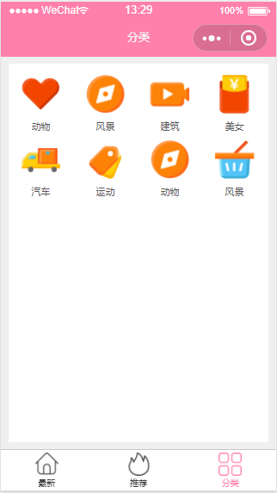
图片分类
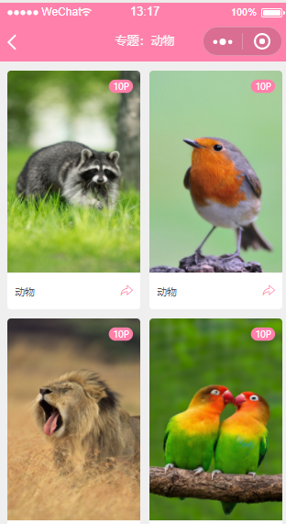
分类浏览
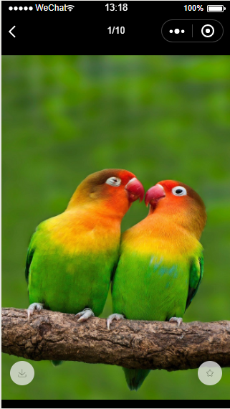
查看图片
Vue在制作具有分类的功能的页面时，最好将数据的部分都在method里面使用函数返回，从而使得template中的代码更加精简，增强代码可读性，出错时也方便排查错误位置。
评分标准 | 每次实验给出多个测试用例进行测试，根据题目难度的不同、用例检测的功能不同，每次实验会按照不同的权重给出成绩，具体见每次实验的实验总结。  注：若发现抄袭，被抄袭人和抄袭人本次实验报告总分评定为0分。

