移动平台应用开发上机实验报告
实验项目名称： | 图文混排新闻分类浏览 |  |  | 实验日期： | 2020.6.15
学 生 姓 名： | 刘永伦 | 专业班级： | 软件171 | 学 号： | 17425037
- 实验目的
通过实战新闻分类浏览的实践，巩固前面所学的uni-app开发知识，增强学生的实际开发业务的能力。
二、实验内容
1. 实现新闻的分类浏览，实现图文混排功能。
2. 手机上效果如下图所示
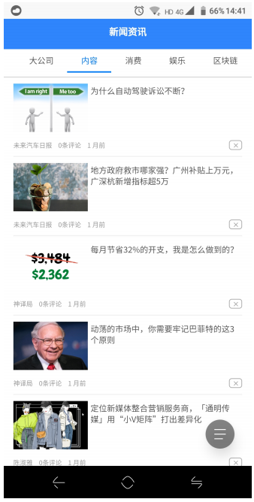

三、概要设计
1 设计上方导航栏，对应不同的导航分类，添加对应的后台函数。
2 设计页面布局，图片加文字的格式以及排版。
3设计详情页面的排版布局，设计其函数逻辑结构。
四、详细设计
项目文件目录：
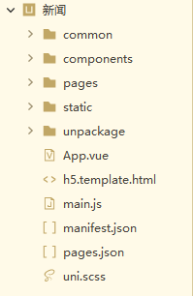
Pages文件夹：存储vue的页面文件，因为vue是组件化开发的，所以有时需要在pages下继续划分组件方便管理。
Static文件夹：存储项目所需要的静态文件，如图片，文本，多媒体等。
Unpackage：安装依赖部分。
Components: 组件文件夹，一般将需要经常使用的页面组件放在components文件夹下。
Common：主要放置通用的css文件和js文件。
App.vue：根组件
main.js：入口文件
主要代码：
detail.vue:
<template>
<view>
<view class="banner" auto-focus>
<image class="banner-img" :src="banner.image_url"></image>
<view class="title-area">
<text class="title-text">{{banner.title}}</text>
</view>
</view>
<view class="article-meta">
<text class="article-meta-text article-author">{{banner.source}}</text>
<text class="article-meta-text article-text">发表于</text>
<text class="article-meta-text article-time">{{banner.datetime}}</text>
</view>
<view class="article-content">
<rich-text :nodes="content" style="font-size: 14px;"></rich-text>
</view>
<view class="comment-wrap"></view>
</view>
</template>

<script>
import htmlParser from '@/common/html-parser'

const FAIL_CONTENT = '<p>获取信息失败1</p>';

function parseImgs(nodes) {
nodes.forEach(node => {
if (
node.name === 'img' &&
node.attrs &&
node.attrs['data-img-size-val']
) {
const sizes = node.attrs['data-img-size-val'].split(',')
const width = uni.upx2px(720 * 0.9)
const height = parseInt(width * (sizes[1] / sizes[0]))
node.attrs.style = `width:${width};height:${height};`
}
if (Array.isArray(node.children)) {
parseImgs(node.children)
}
})
return nodes
}

export default {
data() {
return {
banner: {},
content: []
}
},
onShareAppMessage() {
return {
title: this.banner.title,
path: '/pages/detail/detail?query=' + JSON.stringify(this.banner)
}
},
onLoad(event) {
// 目前在某些平台参数会被主动 decode，暂时这样处理。
try {
this.banner = JSON.parse(decodeURIComponent(event.query));
} catch (error) {
this.banner = JSON.parse(event.query);
}

uni.setNavigationBarTitle({
title: this.banner.title
});

this.getDetail();
},
methods: {
getDetail() {
uni.request({
url: 'https://unidemo.dcloud.net.cn/api/news/36kr/' + this.banner.post_id,
success: (result) => {
let content = FAIL_CONTENT
if (result.statusCode == 200) {
content = result.data.content
}
const nodes = htmlParser(content);
// #ifdef APP-PLUS-NVUE
parseImgs(nodes)
// #endif
this.content = nodes
}
});
}
}
}
</script>

<style>
/* #ifndef APP-PLUS */
page {
min-height: 100%;
}

/* #endif */

.banner {
height: 360upx;
position: relative;
background-color: #ccc;
flex-direction: row;
overflow: hidden;
}

.banner-img {
flex: 1;
}

.title-area {
position: absolute;
left: 30upx;
right: 30upx;
bottom: 30upx;
z-index: 11;
}

.title-text {
font-size: 32upx;
font-weight: 400;
line-height: 42upx;
lines: 2;
color: #ffffff;
overflow: hidden;
}

.article-meta {
padding: 20upx 30upx;
flex-direction: row;
align-items: center;
justify-content: flex-start;
}

.article-meta-text {
color: gray;
}

.article-text {
font-size: 26upx;
line-height: 50upx;
margin: 0 20upx;
}

.article-author {
font-size: 30upx;
}

.article-time {
font-size: 30upx;
}

.article-content {
font-size: 30upx;
padding: 0 30upx;
margin-bottom: 30upx;
overflow: hidden;
}
</style>
Index.vue:
<template>
<view class="tabs">
<scroll-view ref="tabbar1" id="tab-bar" class="tab-bar" :scroll="false" :scroll-x="true" :show-scrollbar="false"
:scroll-into-view="scrollInto">
<view style="flex-direction: column;">
<view style="flex-direction: row;">
<view class="uni-tab-item" v-for="(tab,index) in tabList" :key="tab.id" :id="tab.id" :ref="'tabitem'+index"
:data-id="index" :data-current="index" @click="ontabtap">
<text class="uni-tab-item-title" :class="tabIndex==index ? 'uni-tab-item-title-active' : ''">{{tab.name}}</text>
</view>
</view>
<view class="scroll-view-indicator">
<view ref="underline" class="scroll-view-underline" :class="isTap ? 'scroll-view-animation':''" :style="{left: indicatorLineLeft + 'px', width: indicatorLineWidth + 'px'}"></view>
</view>
</view>
</scroll-view>
<view class="tab-bar-line"></view>
<swiper class="tab-box" ref="swiper1" :current="tabIndex" :duration="300" @change="onswiperchange" @transition="onswiperscroll"
@animationfinish="animationfinish" @onAnimationEnd="animationfinish">
<swiper-item class="swiper-item" v-for="(page, index) in tabList" :key="index">
<!-- #ifndef MP-ALIPAY -->
<newsPage class="page-item" :nid="page.newsid" ref="page"></newsPage>
<!-- #endif -->
<!-- #ifdef MP-ALIPAY -->
<newsPage class="page-item" :nid="page.newsid" :ref="'page' + index"></newsPage>
<!-- #endif -->
</swiper-item>
</swiper>
</view>
</template>

<script>
// #ifdef APP-PLUS
const dom = weex.requireModule('dom');
// #endif

import newsPage from './news-page.nvue';

// 缓存每页最多
const MAX_CACHE_DATA = 100;
// 缓存页签数量
const MAX_CACHE_PAGE = 3;
const TAB_PRELOAD_OFFSET = 1;

export default {
components: {
newsPage
},
data() {
return {
tabList: [{
id: "tab01",
name: '最新',
newsid: 0
}, {
id: "tab02",
name: '大公司',
newsid: 23
}, {
id: "tab03",
name: '内容',
newsid: 223
}, {
id: "tab04",
name: '消费',
newsid: 221
}, {
id: "tab05",
name: '娱乐',
newsid: 225
}, {
id: "tab06",
name: '区块链',
newsid: 208
}],
tabIndex: 0,
cacheTab: [],
scrollInto: "",
navigateFlag: false,
indicatorLineLeft: 0,
indicatorLineWidth: 0,
isTap: false
}
},
onReady() {
this._lastTabIndex = 0;
this.swiperWidth = 0;
this.tabbarWidth = 0;
this.tabListSize = {};
this._touchTabIndex = 0;

// #ifndef MP-ALIPAY
this.pageList = this.$refs.page;
// #endif
// #ifdef MP-ALIPAY
this.pageList = [];
for (var i = 0; i < this.tabList.length; i++) {
this.pageList.push(this.$refs['page' + i][0]);
}
// #endif
this.switchTab(this.tabIndex);

this.getTabbarItemsSize();
},
methods: {
ontabtap(e) {
let index = e.target.dataset.current || e.currentTarget.dataset.current;
//let offsetIndex = this._touchTabIndex = Math.abs(index - this._lastTabIndex) > 1;

// #ifdef APP-PLUS || H5 || MP-WEIXIN || MP-QQ
this.isTap = true;
var currentSize = this.tabListSize[index];
this.updateIndicator(currentSize.left, currentSize.width);
this._touchTabIndex = index;
// #endif

this.switchTab(index);
},
onswiperchange(e) {
// 注意：百度小程序会触发2次

// #ifndef APP-PLUS || H5 || MP-WEIXIN || MP-QQ
let index = e.target.current || e.detail.current;
this.switchTab(index);
// #endif
},
onswiperscroll(e) {
if (this.isTap) {
return;
}

var offsetX = e.detail.dx;
var preloadIndex = this._lastTabIndex;
if (offsetX > TAB_PRELOAD_OFFSET) {
preloadIndex++;
} else if (offsetX < -TAB_PRELOAD_OFFSET) {
preloadIndex--;
}
if (preloadIndex === this._lastTabIndex || preloadIndex < 0 || preloadIndex > this.pageList.length - 1) {
return;
}
if (this.pageList[preloadIndex].dataList.length === 0) {
this.loadTabData(preloadIndex);
}

// #ifdef APP-PLUS || H5 || MP-WEIXIN || MP-QQ
var percentage = Math.abs(this.swiperWidth / offsetX);
var currentSize = this.tabListSize[this._lastTabIndex];
var preloadSize = this.tabListSize[preloadIndex];
var lineL = currentSize.left + (preloadSize.left - currentSize.left) / percentage;
var lineW = currentSize.width + (preloadSize.width - currentSize.width) / percentage;
this.updateIndicator(lineL, lineW);
// #endif
},
animationfinish(e) {
// #ifdef APP-PLUS || H5 || MP-WEIXIN || MP-QQ
let index = e.detail.current;
if (this._touchTabIndex === index) {
this.isTap = false;
}
this._lastTabIndex = index;
this.switchTab(index);
this.updateIndicator(this.tabListSize[index].left, this.tabListSize[index].width);
// #endif
},
getTabbarItemsSize() {
// #ifdef APP-NVUE
dom.getComponentRect(this.$refs.tabbar1, res => {
this.tabbarWidth = res.size.width;
});
dom.getComponentRect(this.$refs['swiper1'], res => {
this.swiperWidth = res.size.width;
});
for (var i = 0; i < this.tabList.length; i++) {
this.getElementSize(dom, this.$refs['tabitem' + i][0], i);
}
// #endif

// #ifdef MP-WEIXIN || H5 || MP-QQ
uni.createSelectorQuery().in(this).select('.tab-box').fields({
dataset: true,
size: true,
}, (res) => {
this.swiperWidth = res.width;
}).exec();
uni.createSelectorQuery().in(this).selectAll('.uni-tab-item').boundingClientRect((rects) => {
rects.forEach((rect) => {
this.tabListSize[rect.dataset.id] = rect;
})
}).exec();
// #endif

// #ifdef APP-NVUE || H5 || MP-WEIXIN || MP-QQ
setTimeout(() => {
this.updateIndicator(this.tabListSize[this.tabIndex].left, this.tabListSize[this.tabIndex].width);
}, 100)
// #endif
},
getElementSize(dom, ref, id) {
dom.getComponentRect(ref, res => {
this.tabListSize[id] = res.size;
});
},
updateIndicator(left, width) {
this.indicatorLineLeft = left;
this.indicatorLineWidth = width;
},
switchTab(index) {
if (this.pageList[index].dataList.length === 0) {
this.loadTabData(index);
}

if (this.tabIndex === index) {
return;
}

// 缓存 tabId
if (this.pageList[this.tabIndex].dataList.length > MAX_CACHE_DATA) {
let isExist = this.cacheTab.indexOf(this.tabIndex);
if (isExist < 0) {
this.cacheTab.push(this.tabIndex);
}
}

this.tabIndex = index;

// #ifdef APP-NVUE
this.scrollTabTo(index);
// #endif
// #ifndef APP-NVUE
this.scrollInto = this.tabList[index].id;
// #endif

// 释放 tabId
if (this.cacheTab.length > MAX_CACHE_PAGE) {
let cacheIndex = this.cacheTab[0];
this.clearTabData(cacheIndex);
this.cacheTab.splice(0, 1);
}
},
scrollTabTo(index) {
const el = this.$refs['tabitem' + index][0];
let offset = 0;
// TODO fix ios offset
if (index > 0) {
offset = this.tabbarWidth / 2 - this.tabListSize[index].width / 2;
if (this.tabListSize[index].right < this.tabbarWidth / 2) {
offset = this.tabListSize[0].width;
}
}
dom.scrollToElement(el, {
offset: -offset
});
},
loadTabData(index) {
this.pageList[index].loadData();
},
clearTabData(index) {
this.pageList[index].clear();
}
}
}
</script>

<style>
/* #ifndef APP-PLUS */
page {
width: 100%;
min-height: 100%;
display: flex;
}

/* #endif */

.tabs {
flex: 1;
flex-direction: column;
overflow: hidden;
background-color: #ffffff;
/* #ifdef MP-ALIPAY || MP-BAIDU */
height: 100vh;
/* #endif */
}

.tab-bar {
width: 750upx;
height: 84upx;
flex-direction: row;
/* #ifndef APP-PLUS */
white-space: nowrap;
/* #endif */
}

/* #ifndef APP-NVUE */
.tab-bar ::-webkit-scrollbar {
display: none;
width: 0 !important;
height: 0 !important;
-webkit-appearance: none;
background: transparent;
}
/* #endif */

.scroll-view-indicator {
position: relative;
height: 2px;
background-color: transparent;
}

.scroll-view-underline {
position: absolute;
top: 0;
bottom: 0;
width: 0;
background-color: #007AFF;
}

.scroll-view-animation {
transition-duration: 0.2s;
transition-property: left;
}

.tab-bar-line {
height: 1upx;
background-color: #cccccc;
}

.tab-box {
flex: 1;
}

.uni-tab-item {
/* #ifndef APP-PLUS */
display: inline-block;
/* #endif */
flex-wrap: nowrap;
padding-left: 20px;
padding-right: 20px;
}

.uni-tab-item-title {
color: #555;
font-size: 30upx;
height: 80upx;
line-height: 80upx;
flex-wrap: nowrap;
/* #ifndef APP-PLUS */
white-space: nowrap;
/* #endif */
}

.uni-tab-item-title-active {
color: #007AFF;
}

.swiper-item {
flex: 1;
flex-direction: column;
}

.page-item {
flex: 1;
flex-direction: row;
position: absolute;
left: 0;
top: 0;
right: 0;
bottom: 0;
}
</style>

五、运行结果和分析
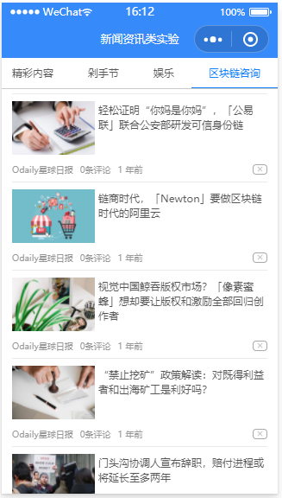
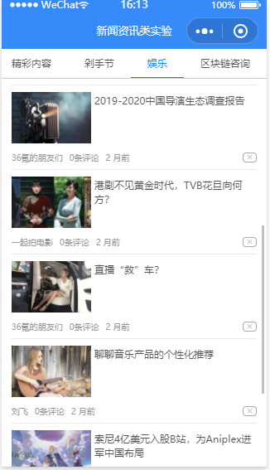
评分标准 | 每次实验给出多个测试用例进行测试，根据题目难度的不同、用例检测的功能不同，每次实验会按照不同的权重给出成绩，具体见每次实验的实验总结。  注：若发现抄袭，被抄袭人和抄袭人本次实验报告总分评定为0分。

