天津大学本科生实验报告专用纸 |  | 天津大学本科生实验报告专用纸
学院 智算学部 年级17专业 软件工程 班级1 姓名 刘坤鑫 学号3017218061  课程名称 移动平台开发 实验日期 2019.5.23 成绩  同组实验者 |  | - 具体实现  2.1 主界面设计  界面分为三个部分：工具栏、对话栏、输入栏。  工具栏包括两个部分：标题、选项设置。选项设置根据需求需要前后添加了三个button，分别实现以下功能：清空聊天记录、语音播报开关、发声人设置。  具体代码如下：  <android.support.design.widget.AppBarLayout  android:id="@+id/abl"  android:layout_width="match_parent"  android:layout_height="wrap_content"  android:background="@color/colorPrimary"  app:layout_constraintTop_toTopOf="parent">  <android.support.constraint.ConstraintLayout  android:layout_width="match_parent"  android:layout_height="wrap_content">  <android.support.v7.widget.Toolbar  android:layout_width="match_parent"  android:layout_height="wrap_content"  app:layout_constraintTop_toTopOf="parent"  app:title="聊天机器人"  tools:layout_editor_absoluteX="0dp" />  <ImageView  android:id="@+id/iv_delete"  android:layout_width="30dp"  android:layout_height="30dp"  android:padding="5dp"  android:layout_marginEnd="12dp"  android:src="@drawable/shanchu"  app:layout_constraintBottom_toBottomOf="parent"  app:layout_constraintEnd_toEndOf="parent"  app:layout_constraintTop_toTopOf="parent" />  <ImageView  android:id="@+id/iv_sound"  android:layout_width="30dp"  android:layout_height="30dp"  android:layout_height="wrap_content"  android:layout_marginStart="12dp"  android:layout_marginTop="8dp"  android:layout_marginBottom="8dp"  android:background="@drawable/bg2"  android:elevation="4dp"  android:maxWidth="250dp"  android:minHeight="40dp"  android:padding="8dp"  android:text="1"  android:textSize="16sp"  app:layout_constraintBottom_toBottomOf="parent"  app:layout_constraintStart_toEndOf="@id/iv_avatar"  app:layout_constraintTop_toTopOf="@id/iv_avatar" />  <TextView  android:id="@+id/tv_date"  android:layout_width="wrap_content"  android:layout_height="wrap_content"  android:layout_marginStart="12dp"  android:text="11:11"  android:textSize="12sp"  app:layout_constraintBottom_toBottomOf="@id/tv_text"  app:layout_constraintStart_toEndOf="@id/tv_text" />  分别表示头像、对话框、时间元素。其中android:elevation="4dp"实现了阴影效果，在android:background="@drawable/bg2"里则实现了边框圆角的效果。  bg2.xml：  <shape xmlns:android="http://schemas.android.com/apk/res/android">  <solid android:color="#CAC8C8" />  <corners android:topLeftRadius="10dp"  android:topRightRadius="10dp"  android:bottomRightRadius="10dp"  android:bottomLeftRadius="10dp"/>  </shape>  我方对话框实现完全同理。  实现item后，外层采用RecyclerView线性排布。  输入栏包含三个元素：语音识别button、输入文本框、发送button。  <android.support.constraint.ConstraintLayout  android:id="@+id/cl_bottom"  android:layout_width="match_parent"  android:layout_height="60dp"  android:background="#ffffff"  android:paddingEnd="12dp"  android:text="点击开始说话"  android:visibility="gone"  app:layout_constraintBottom_toBottomOf="parent"  app:layout_constraintEnd_toStartOf="@id/iv_send"  app:layout_constraintStart_toEndOf="@id/iv_voice"  app:layout_constraintTop_toTopOf="parent" />  <ImageView  android:id="@+id/iv_send"  android:layout_width="40dp"  android:layout_height="40dp"  android:layout_marginEnd="12dp"  android:padding="8dp"  android:background="?attr/selectableItemBackground"  android:src="@drawable/fasong"  app:layout_constraintBottom_toBottomOf="parent"  app:layout_constraintEnd_toEndOf="parent"  app:layout_constraintTop_toTopOf="parent" />  </android.support.constraint.ConstraintLayout>  2.2 设置界面  此界面用于设置发声人。包括设置离线合成还是在线合成。  本项目期待效果是可以切换离线合成和在线合成，在此基础上再选择发声人。所以需要分两个子界面，一个是离线合成的设置，一个是在线合成的设置。  activity_set_pronunciation.xml：  <android.support.design.widget.AppBarLayout  android:id="@+id/abl"  android:layout_width="match_parent"  android:layout_height="wrap_content"  android:background="@color/colorPrimary"  app:layout_constraintTop_toTopOf="parent">  <android.support.constraint.ConstraintLayout  android:layout_width="match_parent"  android:layout_height="wrap_content">  <android.support.v7.widget.Toolbar  android:layout_width="match_parent"  android:layout_height="wrap_content"  app:layout_constraintTop_toTopOf="parent"  android:layout_height="0dp"  android:layout_marginBottom="12dp"  app:layoutManager="android.support.v7.widget.LinearLayoutManager"  app:layout_constraintBottom_toBottomOf="parent"  app:layout_constraintTop_toBottomOf="@id/view">  </android.support.v7.widget.RecyclerView>  其中两个radiobutton切换离线/在线合成，recyclerview存可选发声人。  发声人另外写了一个item，由文本和checkbox组成：  view_name_item.xml：  <TextView  android:id="@+id/tv_name"  android:layout_width="wrap_content"  android:layout_height="wrap_content"  android:layout_marginStart="12dp"  android:textSize="16sp"  app:layout_constraintBottom_toBottomOf="parent"  app:layout_constraintStart_toStartOf="parent"  app:layout_constraintTop_toTopOf="parent" />  <CheckBox  android:id="@+id/cb"  android:layout_width="wrap_content"  android:layout_height="wrap_content"  android:layout_marginEnd="12dp"  app:layout_constraintBottom_toBottomOf="parent"  app:layout_constraintEnd_toEndOf="parent"  app:layout_constraintTop_toTopOf="parent" />  2.3 后台逻辑  集成了讯飞语音识别和图灵机器人的api（需要注册并认证），在构建网络请求的时候使用了Retrofit2框架，在存储聊天记录的时候用了Realm。  相关参考：  讯飞api文档：https://doc.xfyun.cn/msc_android/index.html  图灵机器人文档：https://www.kancloud.cn/turing/www-tuling123-com/718218  Retrofit2框架：https://www.jianshu.com/p/f2644cc784f3  https://www.jianshu.com/p/b25669052335  Realm：https://blog.csdn.net/chen_changtui/article/details/83348319  MainActivity.java：  private void initUI() {  final EditText messageInput = findViewById(R.id.et_message);  final ImageView sendIv = findViewById(R.id.iv_send);  final ImageView voiceIv = findViewById(R.id.iv_voice);  final ImageView deleteIv = findViewById(R.id.iv_delete);  final ImageView soundIv = findViewById(R.id.iv_sound);  final ImageView menuIv = findViewById(R.id.iv_menu);  messageInput.setOnTouchListener((v, event) -> {  if (event.getAction() == MotionEvent.ACTION_UP) {  handler.sendEmptyMessageDelayed(0, 100);  }  return false;  });  //点击后打开讯飞语音识别进行语音识别  voiceIv.setOnClickListener(v -> {  RecognizerDialog mDialog = new RecognizerDialog(MainActivity.this, i -> {  });  mDialog.setListener(new RecognizerDialogListener() {  Gson gson = new Gson();  StringBuilder builder = new StringBuilder();  @Override  public void onResult(RecognizerResult recognizerResult, boolean b) {  String resultString = recognizerResult.getResultString();  //收集文字  if (resultString != null) {  XFResult result = gson.fromJson(resultString, XFResult.class);  builder.append(result.getWord());  }  //语音结束后将收集到的文字作为消息发出  if (b) {  sendMessage(builder.toString());  }  }  @Override  public void onError(SpeechError speechError) {}  messageInput.setText("");  }  });  }  private void initMessageList() {  recyclerView = findViewById(R.id.messageList);  LinearLayoutManager layoutManager = new LinearLayoutManager(this);  layoutManager.setStackFromEnd(true);  recyclerView.setLayoutManager(layoutManager);  RealmResults<Message> data = realm.where(Message.class).sort("date", Sort.ASCENDING).findAll();  adapter = new MessageAdapter(this, realm.copyFromRealm(data));  recyclerView.setAdapter(adapter);  adapter.registerAdapterDataObserver(new RecyclerView.AdapterDataObserver() {  //出现新消息时滚动到底部，保持列表始终显示最新的消息  @Override  public void onItemRangeInserted(int positionStart, int itemCount) {  super.onItemRangeInserted(positionStart, itemCount);  recyclerView.scrollToPosition(adapter.data.size() - 1);  }  });  //列表初始化完成后滚动到底部  recyclerView.scrollToPosition(adapter.data.size() - 1);  }  private void sendMessage(String text) {  //先保存自己发送的消息  adapter.addMessage(new Message(text, true));  //构造请求体发送消息  TulingRequstBody body = new TulingRequstBody();  private String getResourcePath() {  return ResourceUtil.generateResourcePath(this, ResourceUtil.RESOURCE_TYPE.assets, "tts/common.jet") +  ";" +  ResourceUtil.generateResourcePath(this, ResourceUtil.RESOURCE_TYPE.assets, "tts/" + profile.code + ".jet");  }  }  Message.java：  /**  * 消息实体类  */  public class Message extends RealmObject {  public Message(){}  public Message(String text, boolean self) {  this.text = text;  this.self = self;  }  public String text;  public Date date = new Date();  public boolean self;  }  MessageAdapter.java：  /**  * 消息列表的 adapter  */  class MessageAdapter extends RecyclerView.Adapter<MessageAdapter.MessageViewHolder> {  private static final int ROBOT = 1;  private static final int SELF = 2;  private LayoutInflater inflater;  List<Message> data = new ArrayList<>();  private SimpleDateFormat format = new SimpleDateFormat("HH:mm", Locale.getDefault());  @Override  public int getItemViewType(int position) {  Message message = data.get(position);  return message.self ? SELF : ROBOT;  }  class MessageViewHolder extends RecyclerView.ViewHolder {  MessageViewHolder(@NonNull View itemView) {  super(itemView);  }  }  }  MessagePlayProfile.java：  /**  * 存放发英文配置的类  */  public class MessagePlayProfile extends RealmObject {  public MessagePlayProfile() {  }  MessagePlayProfile(boolean isLocal, String code) {  this.isLocal = isLocal;  this.code = code;  }  boolean isLocal = true;  String code = "xiaoyan";  }  MyApp.java：  /**  * 用于网络请求的辅助类  */  public class NetHelper {  private static NetHelper instance;  public static NetHelper getInstance() {  if (instance == null) {  instance = new NetHelper();  }  return instance;  }  private Retrofit retrofit;  private NetHelper() {  Retrofit.Builder builder = new Retrofit.Builder();  builder.addConverterFactory(GsonConverterFactory.create(new Gson()));  builder.addCallAdapterFactory(RxJava2CallAdapterFactory.create());  builder.baseUrl("http://openapi.tuling123.com/");  retrofit = builder.build();  }  private final static String TU_LING_URL = "http://openapi.tuling123.com/openapi/api/v2";  Observable<TulingResultBody> sendMessage(TulingRequstBody body) {  return retrofit.create(TulingApi.class).sendMessage(TU_LING_URL, body)  .subscribeOn(Schedulers.io());  }  }  PronunciationNames.java：  /**  * 发音人相关数据，可在这里变更替换发音人  */  class PronunciationNames {  static final HashMap<String, String> codeAndName = new HashMap<>();  static final HashMap<String, String> nameAndCode = new HashMap<>();  static class Remote {  static final String XU_XIAO_BAO = "aisbabyxu";  static final String CHNEG_CHENG = "x_chengcheng";  static final String XIAO_RONG = "x_xiaorong";  static final String XIAO_MEI = "x_xiaomei";  static final String JOHN = "x_john";  static final String[] codeList = {XU_XIAO_BAO, CHNEG_CHENG, XIAO_RONG, XIAO_MEI, JOHN};  }  }  SetPronunciationActivity.java：  /**  * 设置发音人的界面  */  public class SetPronunciationActivity extends AppCompatActivity {  private Realm realm;  private RecyclerView recyclerView;  @Override  protected void onCreate(@Nullable Bundle savedInstanceState) {  super.onCreate(savedInstanceState);  setContentView(R.layout.activity_set_pronunciation);  recyclerView = findViewById(R.id.name_list);  realm = Realm.getDefaultInstance();  //取出保存的发音人配置  MessagePlayProfile profile = realm.where(MessagePlayProfile.class).findFirst();  if (profile == null) {  return;  }  //在线合成点击后替换发音人列表数据为在线发音人  online.setOnCheckedChangeListener((buttonView, isChecked) -> {  if (isChecked) {  ArrayList<String> remoteName = new ArrayList<>();  for (String code : PronunciationNames.Remote.codeList) {  String name = PronunciationNames.codeAndName.get(code);  remoteName.add(name);  }  adapter.changeData(remoteName, false);  }  });  }  class NameAdapter extends RecyclerView.Adapter<NameAdapter.NameViewHolder> {  private List<String> data = new ArrayList<>();  private LayoutInflater inflater;  private boolean isLocal;  NameAdapter(Context context, List<String> data, boolean isLocal) {  this.isLocal = isLocal;  this.inflater = LayoutInflater.from(context);  this.data.addAll(data);  }  void changeData(List<String> data, boolean isLocal) {  this.isLocal = isLocal;  this.data.clear();  this.data.addAll(data);  notifyDataSetChanged();  }  TulingApi.java：  public interface TulingApi {  @POST  Observable<TulingResultBody> sendMessage(@Url String url, @Body TulingRequstBody postParmas);  }  TulingRequstBody.java：  /**  * 图灵机器人的请求实体类，部分信息已经使用默认值配置，调用时需要传递的只是 inputText  */  class TulingRequstBody {  private int reqType = 0;  Perception perception = new Perception();  private UserInfo userInfo = new UserInfo();  private class UserInfo {  private String apiKey = "02ad6413903c44eabd7663b602f052c6";  private String userId = "460081";  }  class Perception {  InputText inputText = new InputText();  private SelfInfo selfInfo = new SelfInfo();  }  private class SelfInfo {  Location location = new Location();  }  private class Location {  String city = "北京";  String province = "北京";  String street = "天安门";  }  class InputText {  String text;  }  }  /**  * 讯飞的语音合成结果实体类，包含了一些不必要参数，用 getWord 直接提取相关文本  */  public class XFResult {  private int sn;  private boolean ls;  private int bg;  private int ed;  List<Ws> ws;  class Ws {  private int bg;  List<Cw> cw;  }  class Cw {  private int sc;  private String w;  }  String getWord() {  StringBuilder builder = new StringBuilder();  for (int i = 0; i < ws.size(); i++) {  Ws ws = this.ws.get(i);  for (int j = 0; j < ws.cw.size(); j++) {  Cw cw = ws.cw.get(j);  builder.append(cw.w);  }  }  return builder.toString();  }  }  三、 效果展示：  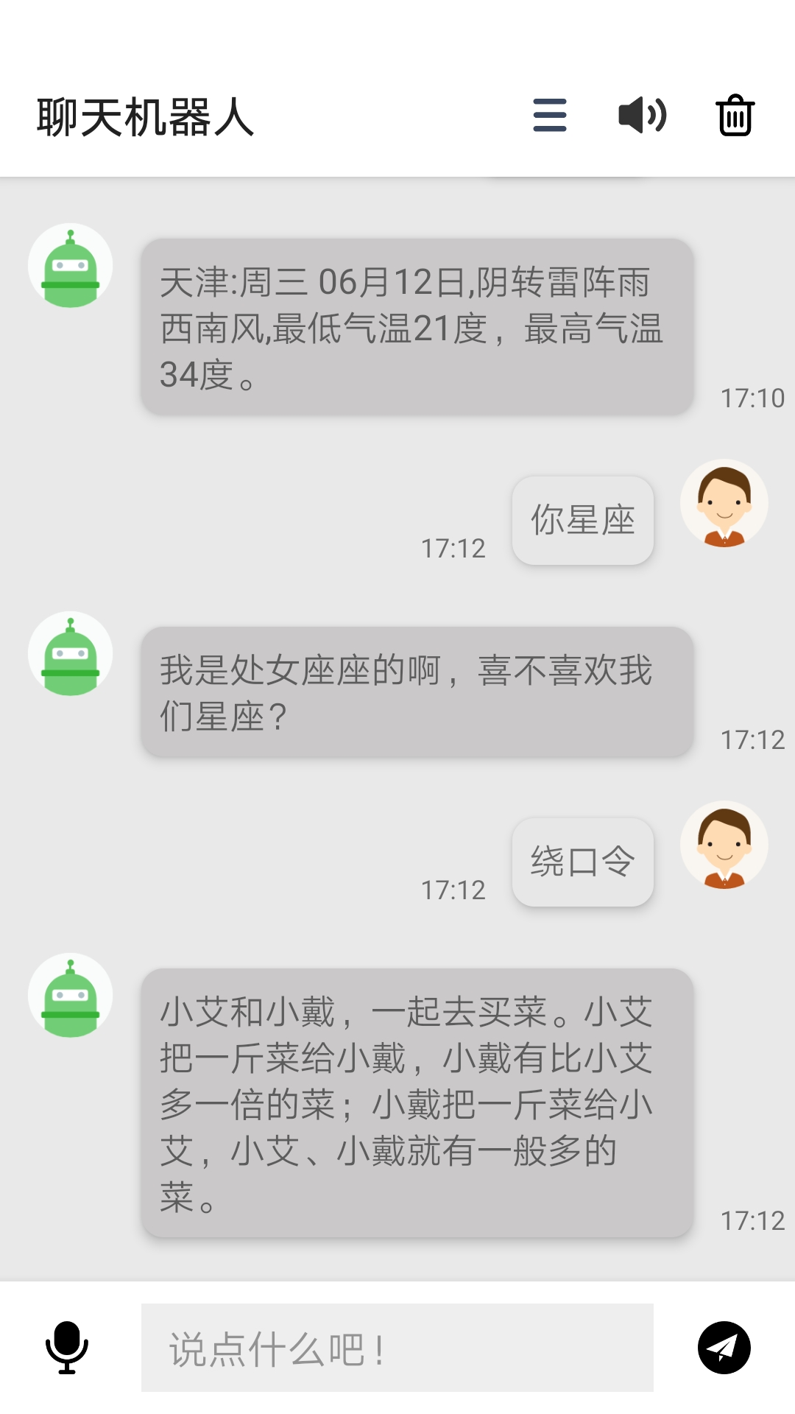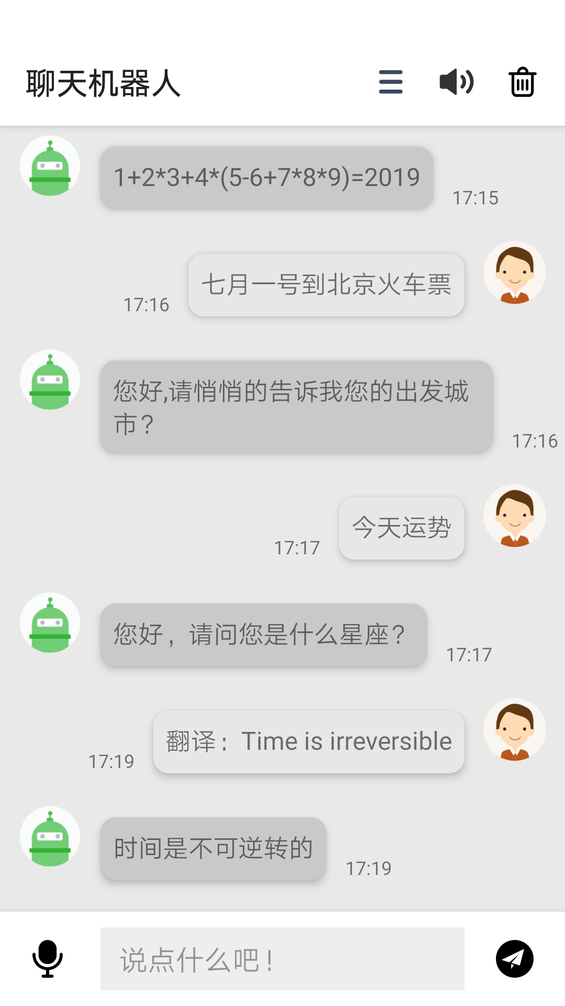  四、 开发环境  Windows10  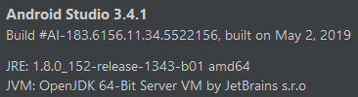  教师签字：  年 月 日

基于语音识别的智能聊天机器人
- 功能概述
- 基于科大讯飞，实现语音识别，语音合成，支持方言、多种发声。
- 基于图灵机器人，实现智能聊天，包含以下功能：数字计算、语料库、中英互译、聊天对话等。详见https://www.kancloud.cn/turing/www-tuling123-com/718219。
- 仿微信聊天界面，简洁风格，丝般顺滑。
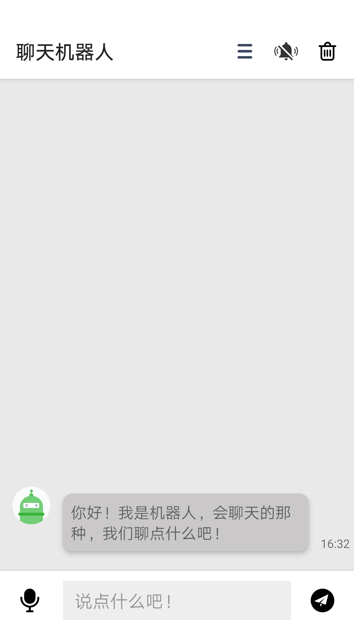
android:padding="3dp"
android:layout_marginEnd="12dp"
android:src="@drawable/jinyin"
android:background="?attr/selectableItemBackground"
app:layout_constraintBottom_toBottomOf="parent"
app:layout_constraintEnd_toStartOf="@id/iv_delete"
app:layout_constraintTop_toTopOf="parent" />

<ImageView
android:id="@+id/iv_menu"
android:layout_width="30dp"
android:layout_height="30dp"
android:padding="5dp"
android:layout_marginEnd="12dp"
android:src="@drawable/caidan"
android:background="?attr/selectableItemBackground"
app:layout_constraintBottom_toBottomOf="parent"
app:layout_constraintEnd_toStartOf="@id/iv_sound"
app:layout_constraintTop_toTopOf="parent" />
</android.support.constraint.ConstraintLayout>
</android.support.design.widget.AppBarLayout>
其中button控件采用了ImageView控件实现。
对话框要求实现仿微信聊天界面的功能。
分析聊天界面，有以下要素：人物头像、对话框、发送时间。其中人物对话己方在右，对方在左。
采用的解决方案如下：先实现我方和对方的item元素：
view_message_robot_item.xml：
<ImageView
android:id="@+id/iv_avatar"
android:layout_width="40dp"
android:layout_height="40dp"
android:elevation="4dp"
android:layout_marginStart="12dp"
android:src="@drawable/robot_avatar"
app:layout_constraintStart_toStartOf="parent"
app:layout_constraintTop_toTopOf="parent" />

<TextView
android:id="@+id/tv_text"
android:layout_width="wrap_content"

android:elevation="8dp"
app:layout_constraintBottom_toBottomOf="parent">

<ImageView
android:id="@+id/iv_voice"
android:layout_width="40dp"
android:layout_height="40dp"
android:layout_marginStart="12dp"
android:padding="8dp"
android:src="@drawable/yuyin"
android:background="?attr/selectableItemBackground"
app:layout_constraintBottom_toBottomOf="parent"
app:layout_constraintStart_toStartOf="parent"
app:layout_constraintTop_toTopOf="parent" />

<EditText
android:id="@+id/et_message"
android:layout_width="0dp"
android:layout_height="40dp"
android:layout_marginStart="12dp"
android:layout_marginEnd="12dp"
android:background="#11000000"
android:hint="说点什么吧！"
android:maxLines="1"
android:paddingStart="12dp"
android:paddingEnd="12dp"
app:layout_constraintBottom_toBottomOf="parent"
app:layout_constraintEnd_toStartOf="@id/iv_send"
app:layout_constraintStart_toEndOf="@id/iv_voice"
app:layout_constraintTop_toTopOf="parent" />

<Button
android:id="@+id/bt_voice"
android:layout_width="0dp"
android:layout_height="40dp"
android:layout_marginStart="12dp"
android:layout_marginEnd="12dp"
android:background="#ffffff"
android:gravity="center"
android:maxLines="1"
android:paddingStart="12dp"

app:title="设置发音人" />
</android.support.constraint.ConstraintLayout>
</android.support.design.widget.AppBarLayout>

<RadioGroup
android:id="@+id/rg"
android:layout_width="match_parent"
android:layout_height="wrap_content"
android:layout_marginTop="24dp"
android:gravity="center"
android:orientation="horizontal"
app:layout_constraintEnd_toEndOf="parent"
app:layout_constraintStart_toStartOf="parent"
app:layout_constraintTop_toBottomOf="@id/abl">

<RadioButton
android:id="@+id/rb_offline"
android:layout_width="wrap_content"
android:layout_height="wrap_content"
android:text="离线合成" />

<RadioButton
android:id="@+id/rb_online"
android:layout_width="wrap_content"
android:layout_height="wrap_content"
android:layout_marginStart="30dp"
android:text="在线合成" />
</RadioGroup>

<View
android:id="@+id/view"
android:layout_width="match_parent"
android:layout_height="1dp"
android:layout_marginTop="24dp"
android:background="#11000000"
app:layout_constraintTop_toBottomOf="@id/rg" />

<android.support.v7.widget.RecyclerView
android:id="@+id/name_list"
android:layout_width="match_parent"
@SuppressLint({"CheckResult", "ClickableViewAccessibility", "HandlerLeak"})
public class MainActivity extends AppCompatActivity {

private MessageAdapter adapter;
private boolean isPlayMessage = false;
private RecyclerView recyclerView;

private Handler handler = new Handler() {
@Override
public void handleMessage(android.os.Message msg) {
super.handleMessage(msg);
recyclerView.scrollToPosition(adapter.data.size() - 1);
}
};

private Realm realm;

private MessagePlayProfile profile;

@Override
protected void onCreate(Bundle savedInstanceState) {
super.onCreate(savedInstanceState);
setContentView(R.layout.activity_main);

new RxPermissions(this).request(
Manifest.permission.RECORD_AUDIO
).subscribe(b -> {
if (!b) MainActivity.this.finish();
}, Throwable::printStackTrace);

realm = Realm.getDefaultInstance();
profile = realm.where(MessagePlayProfile.class).findFirst();

initMessageList();
initUI();
}

/**
* 初始化页面相关控件
*/

});
mDialog.show();
});

//机器人消息的语音播报开关
soundIv.setOnClickListener(v -> {
if (isPlayMessage) {
soundIv.setImageDrawable(getDrawable(R.drawable.jinyin));
} else {
soundIv.setImageDrawable(getDrawable(R.drawable.shenyin));
}
isPlayMessage = !isPlayMessage;
});

//清空所有消息
deleteIv.setOnClickListener(v -> new AlertDialog.Builder(MainActivity.this)
.setTitle("删除消息")
.setMessage("此操作将会删除所有消息")
.setPositiveButton("删除", (dialog, which) -> {
realm.executeTransaction(_realm -> _realm.deleteAll());
adapter.clear();
dialog.dismiss();
})
.setNegativeButton("取消", (dialog, which) -> dialog.dismiss())
.create().show());

menuIv.setOnClickListener(v -> {
startActivity(new Intent(this, SetPronunciationActivity.class));
});

//发送文本消息
sendIv.setOnClickListener(v -> {
String text = messageInput.getText().toString().trim();
if (!TextUtils.isEmpty(text)) {
sendMessage(messageInput.getText().toString().trim());

body.perception.inputText.text = text;
NetHelper.getInstance().sendMessage(body)
.observeOn(AndroidSchedulers.mainThread())
.subscribe(result -> {
TulingResultBody.Results results = result.results.get(0);

//获取返回的文本内容并保存消息，然后根据开关选择是否播报消息
if (results.resultType.equals("text")) {
adapter.addMessage(new Message(results.values.text, false));
if (isPlayMessage) {
playMessage(results.values.text);
}
}

}, throwable -> Toast.makeText(MainActivity.this, "机器人没能收到这条消息", Toast.LENGTH_SHORT).show());
}

private void playMessage(String text) {
SpeechSynthesizer speechSynthesizer = SpeechSynthesizer.createSynthesizer(this, null);
speechSynthesizer.setParameter(SpeechConstant.PARAMS, null);
//配置在线或离线合成
if (!profile.isLocal) {
speechSynthesizer.setParameter(SpeechConstant.ENGINE_TYPE, SpeechConstant.TYPE_CLOUD);
speechSynthesizer.setParameter(SpeechConstant.VOICE_NAME, profile.code);

} else {
speechSynthesizer.setParameter(SpeechConstant.ENGINE_TYPE, SpeechConstant.TYPE_LOCAL);
String resourcePath = getResourcePath();
speechSynthesizer.setParameter(ResourceUtil.TTS_RES_PATH, resourcePath);
speechSynthesizer.setParameter(SpeechConstant.VOICE_NAME, profile.code);
}
speechSynthesizer.setParameter(SpeechConstant.VOICE_NAME, profile.code);
speechSynthesizer.setParameter(SpeechConstant.SPEED, "50");
speechSynthesizer.setParameter(SpeechConstant.PITCH, "50");
speechSynthesizer.setParameter(SpeechConstant.VOLUME, "50");
speechSynthesizer.setParameter(SpeechConstant.STREAM_TYPE, "3");
speechSynthesizer.startSpeaking(text, null);
}

MessageAdapter(Context context, List<Message> data) {
this.inflater = LayoutInflater.from(context);
this.data.addAll(data);
}

void clear() {
data.clear();
notifyDataSetChanged();
}

void addMessage(Message message) {
data.add(message);
notifyItemInserted(data.size());
Realm realm = Realm.getDefaultInstance();
realm.executeTransaction(_realm -> _realm.copyToRealm(message));
realm.close();
}

@NonNull
@Override
public MessageViewHolder onCreateViewHolder(@NonNull ViewGroup viewGroup, int type) {
int resId = type == ROBOT ? R.layout.view_message_robot_item : R.layout.view_message_self_item;
return new MessageViewHolder(inflater.inflate(resId, viewGroup, false));
}

@Override
public void onBindViewHolder(@NonNull MessageViewHolder messageViewHolder, int i) {
Message message = data.get(i);
TextView textView = messageViewHolder.itemView.findViewById(R.id.tv_text);
TextView dateView = messageViewHolder.itemView.findViewById(R.id.tv_date);

textView.setText(message.text);
dateView.setText(format.format(message.date));
}

@Override
public int getItemCount() {
return data.size();
}

public class MyApp extends Application {
@Override
public void onCreate() {
super.onCreate();

//初始化数据库，主要是添加默认的第一条消息和默认的发音人配置
Realm.init(this);
Realm realm = Realm.getDefaultInstance();
Message message = realm.where(Message.class).findFirst();
if (message == null) {
realm.executeTransaction(_realm ->
_realm.copyToRealm(new Message("你好！我是机器人，会聊天的那种，我们聊点什么吧！", false)));
}

MessagePlayProfile profile = realm.where(MessagePlayProfile.class).findFirst();
if (profile == null) {
realm.executeTransaction(_realm ->
_realm.copyToRealm(new MessagePlayProfile(true,"xiaoyan")));
}

//发音人数据初始化
PronunciationNames.init();

//讯飞 SDK 初始化
SpeechUtility.createUtility(this, SpeechConstant.APPID +"=5cff673b");
}
}
NetHelper.java：

static void init() {
codeAndName.put(XIAO_YAN, "小燕(普通话)");
codeAndName.put(XIAO_FENG, "小锋(普通话)");

codeAndName.put(XU_XIAO_BAO, "许小宝(普通话)");
codeAndName.put(CHNEG_CHENG, "程程(普通话)");
codeAndName.put(XIAO_RONG, "小蓉(四川话)");
codeAndName.put(XIAO_MEI, "小梅(广东话)");
codeAndName.put(JOHN, "John(英语)");

nameAndCode.put("小燕(普通话)", XIAO_YAN);
nameAndCode.put("小锋(普通话)", XIAO_FENG);

nameAndCode.put("许小宝(普通话)", XU_XIAO_BAO);
nameAndCode.put("程程(普通话)", CHNEG_CHENG);
nameAndCode.put("小蓉(四川话)", XIAO_RONG);
nameAndCode.put("小梅(广东话)", XIAO_MEI);
nameAndCode.put("John(英语)", JOHN);
}

static class Local {
static final String XIAO_YAN = "xiaoyan";
static final String XIAO_FENG = "xiaofeng";
static final String[] codeList = {XIAO_YAN, XIAO_FENG};
}

//根据配置显示默认显示的发音人列表
String[] codes = profile.isLocal ? PronunciationNames.Local.codeList : PronunciationNames.Remote.codeList;
ArrayList<String> names = new ArrayList<>();
for (String code : codes) {
String name = PronunciationNames.codeAndName.get(code);
names.add(name);
}

NameAdapter adapter = new NameAdapter(this, names, profile.isLocal);
recyclerView.setAdapter(adapter);

RadioButton offline = findViewById(R.id.rb_offline);
RadioButton online = findViewById(R.id.rb_online);

//根据配置选中默认的发音人选项
offline.setChecked(profile.isLocal);
online.setChecked(!profile.isLocal);

//离线合成点击后替换发音人列表数据为离线发音人
offline.setOnCheckedChangeListener((buttonView, isChecked) -> {
if (isChecked) {
ArrayList<String> localNames = new ArrayList<>();
for (String code : PronunciationNames.Local.codeList) {
String name = PronunciationNames.codeAndName.get(code);
localNames.add(name);
}
adapter.changeData(localNames, true);
}
});

@NonNull
@Override
public NameViewHolder onCreateViewHolder(@NonNull ViewGroup viewGroup, int i) {
return new NameViewHolder(inflater.inflate(R.layout.view_name_item, viewGroup, false));
}

@Override
public void onBindViewHolder(@NonNull NameViewHolder nameViewHolder, int i) {
String name = data.get(i);

MessagePlayProfile profile = realm.where(MessagePlayProfile.class).findFirst();
if (profile == null) return;
TextView nameView = nameViewHolder.itemView.findViewById(R.id.tv_name);
nameView.setText(name);
CheckBox cb = nameViewHolder.itemView.findViewById(R.id.cb);
cb.setChecked(profile.code.equals(PronunciationNames.nameAndCode.get(name)));
cb.setOnClickListener(v -> {
if (cb.isChecked()) {
realm.executeTransaction(realm -> {
profile.code = PronunciationNames.nameAndCode.get(name);
profile.isLocal = isLocal;
});
notifyDataSetChanged();
}
cb.setChecked(true);
});
}

@Override
public int getItemCount() {
return data.size();
}

class NameViewHolder extends RecyclerView.ViewHolder {

NameViewHolder(@NonNull View itemView) {
super(itemView);
}
}
}
}

TulingResultBody.java：
/**
* 图灵机器人 api 返回的实体类，主要数据在 results 的 values 中
*/
class TulingResultBody {
Intent intent;
List<Results> results;

class Results {
int groupType;
String resultType;
Values values;
}

class Values {
String url;
String text;
}

class Intent {
int code;
String intentName;
String actionName;
Parameters parameters;
}

class Parameters {
String nearby_place;
}
}
XFResult.java：

