# Tasks

1. Install MuJava. The instruction of how to install and use Mujava can be seen in https://cs.gmu.edu/~offutt/mujava/ .
2. Two small programs are given for your task. BubbleSort.java is an implementation of bubble sort algorithm and BackPack.java is a solution of 01 backpack problem. Try to generate Mutants of 2 given programs with MuJava.
3. Write testing sets for 2 programs with Junit, and run mutants on the test sets with MuJava.

# Steps of the Experiment

1. Create a new directory “C:\MuJava”. Place the files related to MuJava in it. Configure the environment variables “CLASSPATH”.

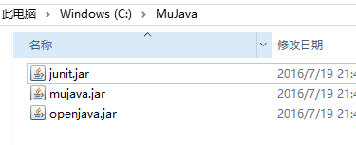

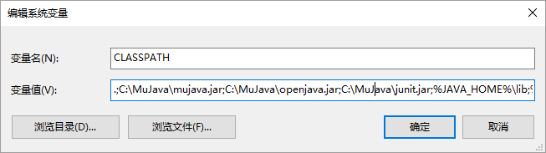

1. Create a new directory “C:\MuJavaHome” with the following structure.

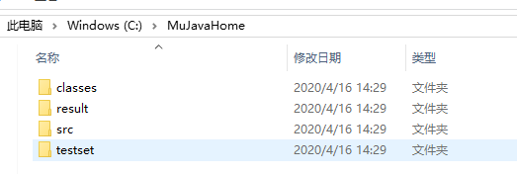

1. Put some files in path “C:\MuJavaHome”.

mujava.config

MuJava_HOME=C:\MuJavaHome

GenMutants.cmd

java mujava.gui.GenMutantsMain

RunTest.cmd

java mujava.gui.RunTestMain > TestResult.txt

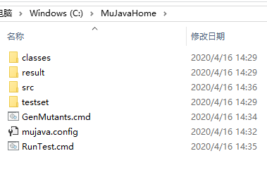

1. Put “BackPack.java” and “BubbleSort.java” in “src”.

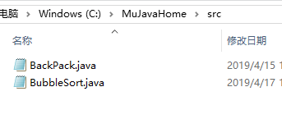

1. Compile the Java file and put the generated “.class” file into the classes floder.

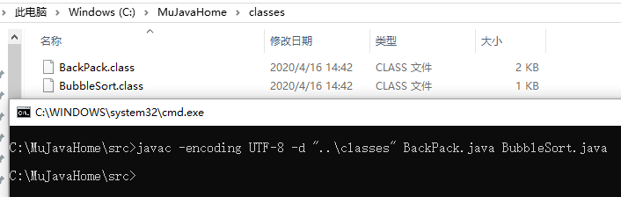

1. Run the “GenMutants.cmd”, and enter the MuJava GUI.

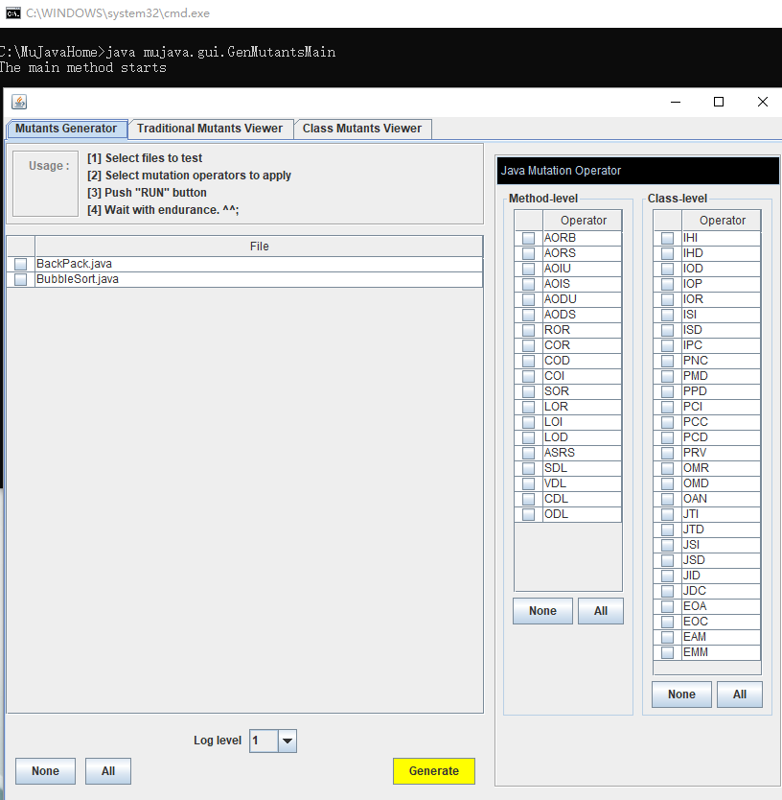

1. Select files to test. Select mutation operators to apply. Push “Generate” button. And you can see the results in “Traditional Mutants Viewer” and “Class Mutants Viewer”. Files for the variants are located in the “result” folder.

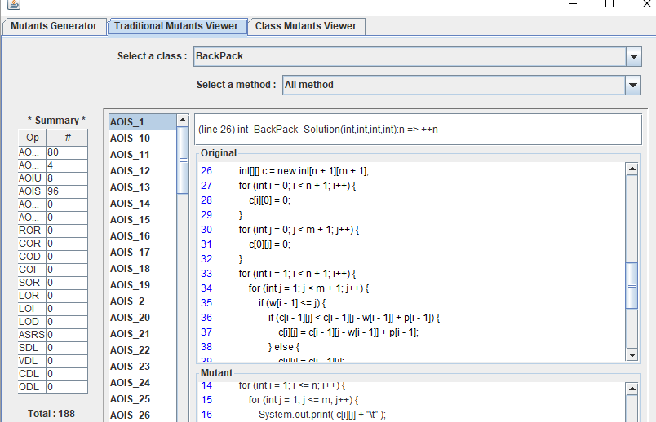

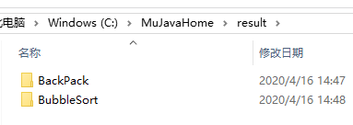

1. Write the test Java file. Compile it and put the “class” file into “testset” folder.

TestBackPack.java

import org.junit.Assert;

import org.junit.Test;

public class TestBackPack {

@Test

public void BackPack() {

int m = 10;

int n = 3;

int w[] = {3, 4, 5};

int p[] = {4, 5, 6};

int c[][] = BackPack.BackPack_Solution(m, n, w, p);

int target[][]={

{0, 0, 4, 4, 4, 4, 4, 4, 4, 4},

{0, 0, 4, 5, 5, 5, 9, 9, 9, 9},

{0, 0, 4, 5, 6, 6, 9, 10, 11, 11},

};

Assert.assertArrayEquals(target, c);

}

}

TestBubbleSort.java

import org.junit.Assert;

import org.junit.Test;

public class TestBubbleSort {

@Test

public void BubbleSort() {

int target[]={1,2,3,4,5,6};

int test[]={3,2,1,6,5,4};

int c[]=BubbleSort.BubbleSort(test);

Assert.assertArrayEquals(target, c);

}

}

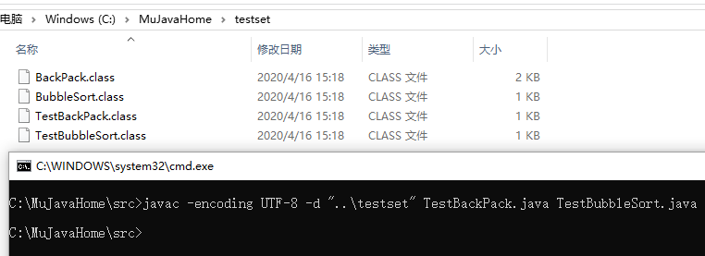

1. Run the “RunTest.cmd”. Enter the GUI, set the parameters and run. We can see the result as following.

