表名：u_analysis_dw.msr_bank_promo

Location: hdfs://ns1/user/u_analysis/private/dw/msr_bank_promo

更新频率:daily

数据时间范围：2019-10-01~2020-10-16

|  |  |  |  |  |
| --- | --- | --- | --- | --- |
| **Col_Name** | **Data_Type** | **Comment** | **Case** | **Data_Source** |
| member_id | string | 会员id | MEM_00005188348 | u_analysis_dw.siebel_cx_order |
| external_order_id | string | 连接外部表的订单号 | 2020030222001440841431665596 | u_analysis_ods.urp_alipay/  u_analysis_ods.urp_wechat/  u_analysis_ods.urp_bank |
| map_col | string | 连接外部表的订单号的字段名 | alipay_order_id |  |
| order_id | string | 订单号 | 1-3SHYJHM1 | u_analysis_dw.siebel_cx_order |
| order_date | string | 订单日期 | 2020-03-02 08:02:07 | u_analysis_dw.siebel_cx_order |
| payment_amount | decimal(10,2) | 支付金额 | 58 | u_analysis_ods.urp_alipay/  u_analysis_ods.urp_wechat/  u_analysis_ods.urp_bank |
| business_discount | decimal(10,2) | 商户折扣 | 0 | u_analysis_ods.urp_alipay/  u_analysis_ods.urp_wechat/  u_analysis_ods.urp_bank |
| platform_discount | decimal(10,2) | 平台折扣 | 15 | u_analysis_ods.urp_alipay/  u_analysis_ods.urp_wechat/  u_analysis_ods.urp_bank |
| # |  |  |  |  |
| promo_channel | string | 折扣渠道  wechat/alipay/bank | alipay |  |
| promo_tag | string | 促销代码 | ICBC_70-15 |  |
| pdate | string | 日期 | 2020-03-02 |  |

external_order_id，map_col说明：

map_col为 u_analysis_ods.urp_alipay/u_analysis_ods.urp_wechat/u_analysis_ods.urp_bank 中连接外部表的字段名。如alipay_order_id,wechat_order_id,business_order_id

external_order_id 则保存的是连接外部表的字段值。如202003022200144084143166559

下图为有问题的活动标记

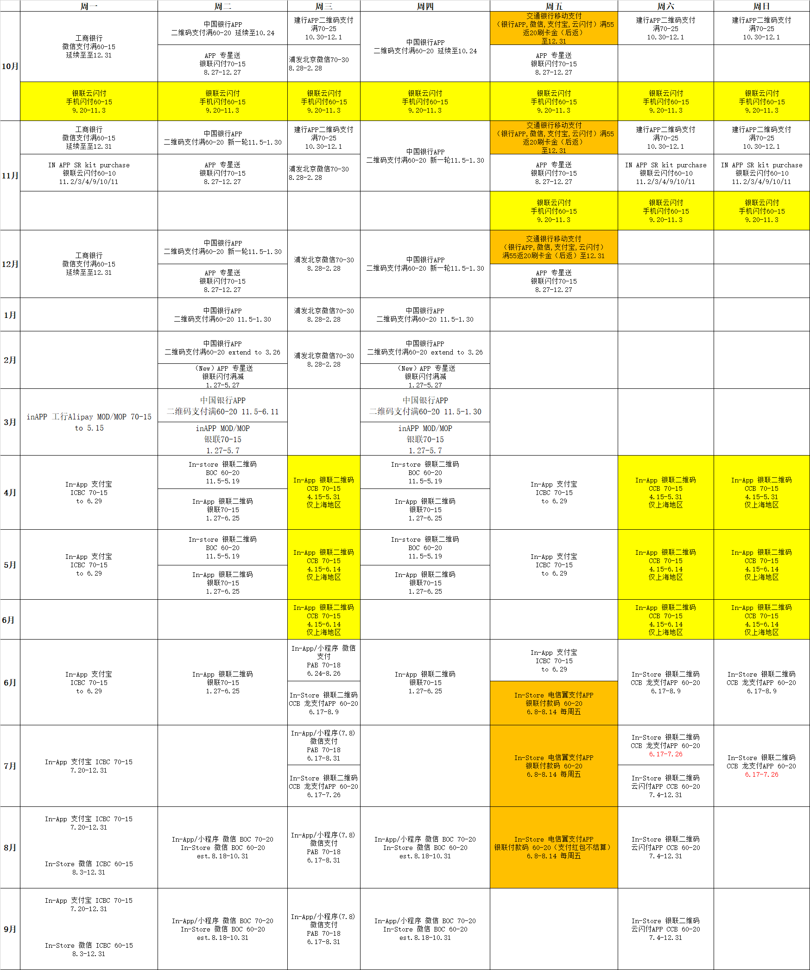

图中标黄的为

1.银联云闪付 手机闪付60-15 9.20-11.3 订单号找不到可以匹配的逻辑

2.In-App 银联二维码CCB 70-15 4.15-6.14仅上海地区 未提供活动码

图中标橙的均为后返活动，在交易数据中无法感知

In-Store 电信翼支付APP银联付款码 60-20 6.8-8.14

交通银行移动支付（银行APP,微信,支付宝,云闪付）满55返20刷卡金（后返）至12.31