Betaflight 编译makefile文件

**主makefile文件里面有汇总需要运行的.mk文件(即所有的makefile文件)**

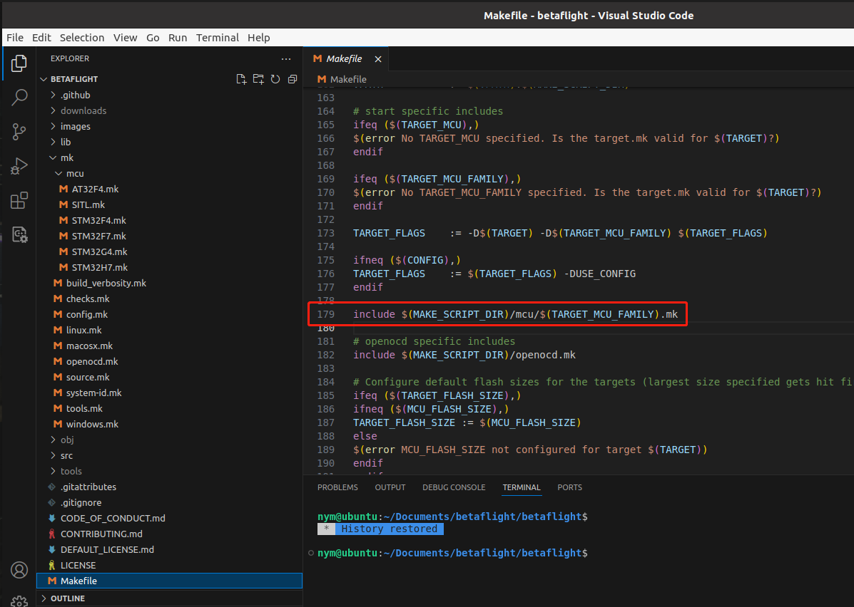

**Makefile控制编译的所有.c文件**

先make clean，把编译的文件清掉：

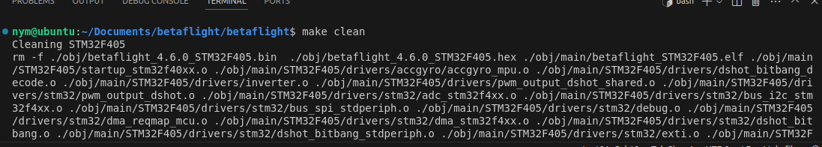

再编译，编译的是这个版本的betaflight：

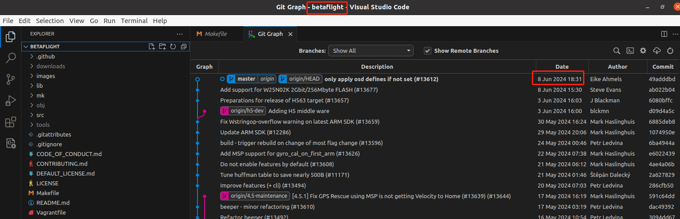

nym@ubuntu:~/Documents/betaflight/betaflight$ make TARGET=STM32F405 DEBUG=INFO

make -j ./obj/betaflight_4.6.0_STM32F405.hex

make[1]: Entering directory '/home/nym/Documents/betaflight/betaflight'

EF HASH -> ./obj/main/STM32F405/.efhash_e6ff2cfe9c0fb8981809703bd7a45612

%% (speed optimised) ./src/main/drivers/accgyro/accgyro_mpu.c

%% startup_stm32f40xx.s

%% (optimised) ./src/main/drivers/dshot_bitbang_decode.c

%% (size optimised) ./src/main/drivers/inverter.c

%% (speed optimised) ./src/main/drivers/pwm_output_dshot_shared.c

%% (optimised) ./src/main/drivers/stm32/pwm_output_dshot.c

%% (optimised) ./src/main/drivers/stm32/adc_stm32f4xx.c

%% (optimised) ./src/main/drivers/stm32/bus_i2c_stm32f4xx.c

%% (optimised) ./src/main/drivers/stm32/bus_spi_stdperiph.c

%% (optimised) ./src/main/drivers/stm32/debug.c

%% (optimised) ./src/main/drivers/stm32/dma_reqmap_mcu.c

%% (optimised) ./src/main/drivers/stm32/dma_stm32f4xx.c

%% (optimised) ./src/main/drivers/stm32/dshot_bitbang.c

%% (optimised) ./src/main/drivers/stm32/dshot_bitbang_stdperiph.c

%% (optimised) ./src/main/drivers/stm32/exti.c

%% (optimised) ./src/main/drivers/stm32/io_stm32.c

%% (optimised) ./src/main/drivers/stm32/light_ws2811strip_stdperiph.c

%% (optimised) ./src/main/drivers/stm32/persistent.c

%% (optimised) ./src/main/drivers/stm32/pwm_output.c

%% (optimised) ./src/main/drivers/stm32/rcc_stm32.c

%% (optimised) ./src/main/drivers/stm32/sdio_f4xx.c

%% (optimised) ./src/main/drivers/stm32/serial_uart_stdperiph.c

%% (optimised) ./src/main/drivers/stm32/serial_uart_stm32f4xx.c

%% (optimised) ./src/main/drivers/stm32/system_stm32f4xx.c

%% (optimised) ./src/main/drivers/stm32/timer_stdperiph.c

%% (optimised) ./src/main/drivers/stm32/timer_stm32f4xx.c

%% (optimised) ./src/main/drivers/stm32/transponder_ir_io_stdperiph.c

%% (optimised) ./src/main/drivers/stm32/usbd_msc_desc.c

%% (optimised) ./src/main/drivers/stm32/camera_control.c

%% (optimised) ./src/main/startup/system_stm32f4xx.c

%% arm_bitreversal2.S

%% (optimised) ./src/main/drivers/flash.c

%% (optimised) ./src/main/drivers/flash_m25p16.c

%% (optimised) ./src/main/drivers/flash_w25n.c

%% (optimised) ./src/main/drivers/flash_w25q128fv.c

%% (optimised) ./src/main/drivers/flash_w25m.c

%% (optimised) ./src/main/io/flashfs.c

%% (optimised) ./src/main/drivers/usb_msc_common.c

%% (optimised) ./src/main/drivers/stm32/usb_msc_f4xx.c

%% (optimised) ./src/main/msc/usbd_storage.c

%% (optimised) ./src/main/msc/usbd_storage_emfat.c

%% (optimised) ./src/main/msc/emfat.c

%% (optimised) ./src/main/msc/emfat_file.c

%% (optimised) ./src/main/msc/usbd_storage_sd_spi.c

%% (optimised) ./src/main/msc/usbd_storage_sdio.c

%% (optimised) ./src/main/drivers/sdcard.c

%% (optimised) ./src/main/drivers/sdcard_spi.c

%% (optimised) ./src/main/drivers/sdcard_sdio_baremetal.c

%% (optimised) ./src/main/drivers/sdcard_standard.c

%% (optimised) ./src/main/io/asyncfatfs/asyncfatfs.c

%% (optimised) ./src/main/io/asyncfatfs/fat_standard.c

%% (optimised) ./src/main/build/build_config.c

%% (optimised) ./src/main/build/debug.c

%% (optimised) ./src/main/build/debug_pin.c

%% (optimised) ./src/main/build/version.c

%% (size optimised) ./src/main/main.c

%% (optimised) ./src/main/pg/motor.c

%% (optimised) ./src/main/pg/rcdevice.c

%% (optimised) ./src/main/pg/pin_pull_up_down.c

%% (optimised) ./src/main/pg/stats.c

%% (optimised) ./src/main/pg/bus_i2c.c

%% (optimised) ./src/main/pg/timerio.c

%% (optimised) ./src/main/pg/gyrodev.c

%% (optimised) ./src/main/pg/dyn_notch.c

%% (optimised) ./src/main/pg/pinio.c

%% (optimised) ./src/main/pg/max7456.c

%% (optimised) ./src/main/pg/scheduler.c

%% (optimised) ./src/main/pg/rpm_filter.c

%% (optimised) ./src/main/pg/vtx_io.c

%% (optimised) ./src/main/pg/board.c

%% (optimised) ./src/main/pg/pg.c

%% (optimised) ./src/main/pg/usb.c

%% (optimised) ./src/main/pg/dashboard.c

%% (optimised) ./src/main/pg/displayport_profiles.c

%% (optimised) ./src/main/pg/rx.c

%% (optimised) ./src/main/pg/rx_spi.c

%% (optimised) ./src/main/pg/timerup.c

%% (optimised) ./src/main/pg/mco.c

%% (optimised) ./src/main/pg/gps.c

%% (optimised) ./src/main/pg/beeper_dev.c

%% (optimised) ./src/main/pg/vtx_table.c

%% (optimised) ./src/main/pg/gps_rescue.c

%% (optimised) ./src/main/pg/bus_spi.c

%% (optimised) ./src/main/pg/flash.c

%% (optimised) ./src/main/pg/rx_pwm.c

%% (optimised) ./src/main/pg/sdio.c

%% (optimised) ./src/main/pg/beeper.c

%% (optimised) ./src/main/pg/bus_quadspi.c

%% (optimised) ./src/main/pg/rx_spi_cc2500.c

%% (optimised) ./src/main/pg/vcd.c

%% (optimised) ./src/main/pg/gps_lap_timer.c

%% (optimised) ./src/main/pg/rx_spi_expresslrs.c

%% (optimised) ./src/main/pg/msp.c

%% (optimised) ./src/main/pg/piniobox.c

%% (optimised) ./src/main/pg/sdcard.c

%% (optimised) ./src/main/pg/serial_uart.c

%% (optimised) ./src/main/pg/adc.c

%% (speed optimised) ./src/main/common/maths.c

%% (optimised) ./src/main/common/bitarray.c

%% (optimised) ./src/main/common/strtol.c

%% (optimised) ./src/main/common/crc.c

%% (optimised) ./src/main/common/huffman.c

%% (optimised) ./src/main/common/time.c

%% (optimised) ./src/main/common/uvarint.c

%% (speed optimised) ./src/main/common/typeconversion.c

%% (optimised) ./src/main/common/string_light.c

%% (optimised) ./src/main/common/huffman_table.c

%% (speed optimised) ./src/main/common/encoding.c

%% (optimised) ./src/main/common/printf_serial.c

%% (speed optimised) ./src/main/common/filter.c

%% (speed optimised) ./src/main/common/sdft.c

%% (optimised) ./src/main/common/sensor_alignment.c

%% (optimised) ./src/main/common/explog_approx.c

%% (optimised) ./src/main/common/gps_conversion.c

%% (optimised) ./src/main/common/streambuf.c

%% (speed optimised) ./src/main/common/stopwatch.c

%% (optimised) ./src/main/common/printf.c

%% (optimised) ./src/main/common/colorconversion.c

%% (size optimised) ./src/main/config/config_eeprom.c

%% (size optimised) ./src/main/config/simplified_tuning.c

%% (optimised) ./src/main/config/config.c

%% (size optimised) ./src/main/config/config_streamer.c

%% (size optimised) ./src/main/config/feature.c

%% (size optimised) ./src/main/cli/cli.c

%% (size optimised) ./src/main/cli/settings.c

%% (speed optimised) ./src/main/drivers/adc.c

%% (optimised) ./src/main/drivers/dshot.c

%% (optimised) ./src/main/drivers/dshot_dpwm.c

%% (optimised) ./src/main/drivers/dshot_command.c

%% (speed optimised) ./src/main/drivers/buf_writer.c

%% (speed optimised) ./src/main/drivers/bus.c

%% (size optimised) ./src/main/drivers/bus_i2c_config.c

%% (optimised) ./src/main/drivers/bus_i2c_busdev.c

%% (optimised) ./src/main/drivers/bus_i2c_utils.c

%% (optimised) ./src/main/drivers/bus_i2c_soft.c

%% (optimised) ./src/main/drivers/bus_octospi.c

%% (speed optimised) ./src/main/drivers/bus_quadspi.c

%% (speed optimised) ./src/main/drivers/bus_spi.c

%% (size optimised) ./src/main/drivers/bus_spi_config.c

%% (size optimised) ./src/main/drivers/bus_spi_pinconfig.c

%% (optimised) ./src/main/drivers/display.c

%% (optimised) ./src/main/drivers/buttons.c

%% (optimised) ./src/main/drivers/display_canvas.c

%% (optimised) ./src/main/drivers/dma_common.c

%% (speed optimised) ./src/main/drivers/io.c

%% (optimised) ./src/main/drivers/light_led.c

%% (optimised) ./src/main/drivers/mco.c

%% (optimised) ./src/main/drivers/motor.c

%% (optimised) ./src/main/drivers/pinio.c

%% (optimised) ./src/main/drivers/pin_pull_up_down.c

%% (optimised) ./src/main/drivers/resource.c

%% (speed optimised) ./src/main/drivers/serial.c

%% (size optimised) ./src/main/drivers/serial_pinconfig.c

%% (speed optimised) ./src/main/drivers/serial_uart.c

%% (size optimised) ./src/main/drivers/serial_uart_pinconfig.c

%% (optimised) ./src/main/drivers/sound_beeper.c

%% (optimised) ./src/main/drivers/stack_check.c

%% (speed optimised) ./src/main/drivers/system.c

%% (optimised) ./src/main/drivers/timer_common.c

%% (optimised) ./src/main/drivers/transponder_ir_arcitimer.c

%% (optimised) ./src/main/drivers/transponder_ir_ilap.c

%% (optimised) ./src/main/drivers/transponder_ir_erlt.c

%% (size optimised) ./src/main/fc/board_info.c

%% (optimised) ./src/main/fc/dispatch.c

%% (optimised) ./src/main/fc/hardfaults.c

%% (speed optimised) ./src/main/fc/tasks.c

%% (speed optimised) ./src/main/fc/runtime_config.c

%% (optimised) ./src/main/fc/stats.c

%% (optimised) ./src/main/io/beeper.c

%% (optimised) ./src/main/io/piniobox.c

%% (size optimised) ./src/main/io/serial.c

%% (optimised) ./src/main/io/smartaudio_protocol.c

%% (optimised) ./src/main/io/statusindicator.c

%% (optimised) ./src/main/io/tramp_protocol.c

%% (size optimised) ./src/main/io/transponder_ir.c

%% (size optimised) ./src/main/io/usb_cdc_hid.c

%% (optimised) ./src/main/io/usb_msc.c

%% (optimised) ./src/main/msp/msp.c

%% (optimised) ./src/main/msp/msp_box.c

%% (optimised) ./src/main/msp/msp_build_info.c

%% (size optimised) ./src/main/msp/msp_serial.c

%% (speed optimised) ./src/main/scheduler/scheduler.c

%% (optimised) ./src/main/sensors/adcinternal.c

%% (optimised) ./src/main/sensors/battery.c

%% (optimised) ./src/main/sensors/current.c

%% (optimised) ./src/main/sensors/voltage.c

%% (optimised) ./src/main/target/config_helper.c

%% (size optimised) ./src/main/fc/init.c

%% (optimised) ./src/main/fc/controlrate_profile.c

%% (optimised) ./src/main/drivers/accgyro/gyro_sync.c

%% (optimised) ./src/main/drivers/rx/rx_spi.c

%% (optimised) ./src/main/drivers/rx/rx_xn297.c

%% (optimised) ./src/main/drivers/rx/rx_pwm.c

%% (optimised) ./src/main/drivers/serial_softserial.c

%% (speed optimised) ./src/main/fc/core.c

%% (speed optimised) ./src/main/fc/rc.c

%% (optimised) ./src/main/fc/rc_adjustments.c

%% (speed optimised) ./src/main/fc/rc_controls.c

%% (optimised) ./src/main/fc/rc_modes.c

%% (optimised) ./src/main/flight/position.c

%% (optimised) ./src/main/flight/failsafe.c

%% (optimised) ./src/main/flight/gps_rescue.c

%% (optimised) ./src/main/fc/gps_lap_timer.c

%% (speed optimised) ./src/main/flight/dyn_notch_filter.c

%% (speed optimised) ./src/main/flight/imu.c

%% (speed optimised) ./src/main/flight/mixer.c

%% (size optimised) ./src/main/flight/mixer_init.c

%% (optimised) ./src/main/flight/mixer_tricopter.c

%% (speed optimised) ./src/main/flight/pid.c

%% (size optimised) ./src/main/flight/pid_init.c

%% (speed optimised) ./src/main/flight/rpm_filter.c

%% (optimised) ./src/main/flight/servos.c

%% (optimised) ./src/main/flight/servos_tricopter.c

%% (size optimised) ./src/main/io/serial_4way_avrootloader.c

%% (size optimised) ./src/main/io/serial_4way.c

%% (size optimised) ./src/main/io/serial_4way_stk500v2.c

%% (speed optimised) ./src/main/rx/ibus.c

%% (optimised) ./src/main/rx/jetiexbus.c

%% (optimised) ./src/main/rx/msp.c

%% (optimised) ./src/main/rx/pwm.c

%% (speed optimised) ./src/main/rx/frsky_crc.c

%% (speed optimised) ./src/main/rx/rc_stats.c

%% (speed optimised) ./src/main/rx/rx.c

%% (size optimised) ./src/main/rx/rx_bind.c

%% (speed optimised) ./src/main/rx/rx_spi.c

%% (optimised) ./src/main/rx/rx_spi_common.c

%% (speed optimised) ./src/main/rx/crsf.c

%% (optimised) ./src/main/rx/ghst.c

%% (speed optimised) ./src/main/rx/sbus.c

%% (speed optimised) ./src/main/rx/sbus_channels.c

%% (speed optimised) ./src/main/rx/spektrum.c

%% (speed optimised) ./src/main/rx/srxl2.c

%% (size optimised) ./src/main/io/spektrum_vtx_control.c

%% (optimised) ./src/main/io/spektrum_rssi.c

%% (speed optimised) ./src/main/rx/sumd.c

%% (optimised) ./src/main/rx/sumh.c

%% (speed optimised) ./src/main/rx/xbus.c

%% (speed optimised) ./src/main/rx/fport.c

%% (optimised) ./src/main/rx/msp_override.c

%% (speed optimised) ./src/main/sensors/acceleration.c

%% (size optimised) ./src/main/sensors/acceleration_init.c

%% (speed optimised) ./src/main/sensors/boardalignment.c

%% (optimised) ./src/main/sensors/compass.c

%% (speed optimised) ./src/main/sensors/gyro.c

%% (size optimised) ./src/main/sensors/gyro_init.c

%% (optimised) ./src/main/sensors/initialisation.c

%% (optimised) ./src/main/blackbox/blackbox.c

%% (optimised) ./src/main/blackbox/blackbox_encoding.c

%% (optimised) ./src/main/blackbox/blackbox_io.c

%% (size optimised) ./src/main/cms/cms.c

%% (size optimised) ./src/main/cms/cms_menu_blackbox.c

%% (size optimised) ./src/main/cms/cms_menu_failsafe.c

%% (size optimised) ./src/main/cms/cms_menu_firmware.c

%% (size optimised) ./src/main/cms/cms_menu_gps_rescue.c

%% (size optimised) ./src/main/cms/cms_menu_gps_lap_timer.c

%% (size optimised) ./src/main/cms/cms_menu_imu.c

%% (size optimised) ./src/main/cms/cms_menu_ledstrip.c

%% (size optimised) ./src/main/cms/cms_menu_main.c

%% (size optimised) ./src/main/cms/cms_menu_misc.c

%% (size optimised) ./src/main/cms/cms_menu_osd.c

%% (size optimised) ./src/main/cms/cms_menu_power.c

%% (size optimised) ./src/main/cms/cms_menu_saveexit.c

%% (size optimised) ./src/main/cms/cms_menu_vtx_common.c

%% (size optimised) ./src/main/cms/cms_menu_vtx_rtc6705.c

%% (size optimised) ./src/main/cms/cms_menu_vtx_smartaudio.c

%% (size optimised) ./src/main/cms/cms_menu_vtx_tramp.c

%% (size optimised) ./src/main/cms/cms_menu_persistent_stats.c

%% (size optimised) ./src/main/cms/cms_menu_rpm_limit.c

%% (size optimised) ./src/main/cms/cms_menu_quick.c

%% (size optimised) ./src/main/drivers/display_ug2864hsweg01.c

%% (size optimised) ./src/main/drivers/light_ws2811strip.c

%% (optimised) ./src/main/drivers/rangefinder/rangefinder_hcsr04.c

%% (optimised) ./src/main/drivers/rangefinder/rangefinder_lidartf.c

%% (size optimised) ./src/main/drivers/serial_escserial.c

%% (size optimised) ./src/main/drivers/vtx_common.c

%% (optimised) ./src/main/drivers/vtx_table.c

%% (size optimised) ./src/main/io/dashboard.c

%% (optimised) ./src/main/io/displayport_frsky_osd.c

%% (optimised) ./src/main/io/displayport_max7456.c

%% (optimised) ./src/main/io/displayport_msp.c

%% (optimised) ./src/main/io/displayport_oled.c

%% (optimised) ./src/main/io/displayport_srxl.c

%% (optimised) ./src/main/io/displayport_crsf.c

%% (optimised) ./src/main/io/displayport_hott.c

%% (optimised) ./src/main/io/frsky_osd.c

%% (optimised) ./src/main/io/rcdevice_cam.c

%% (optimised) ./src/main/io/rcdevice.c

%% (optimised) ./src/main/io/gps.c

%% (optimised) ./src/main/io/ledstrip.c

%% (optimised) ./src/main/io/pidaudio.c

%% (size optimised) ./src/main/osd/osd.c

%% (size optimised) ./src/main/osd/osd_elements.c

%% (size optimised) ./src/main/osd/osd_warnings.c

%% (optimised) ./src/main/sensors/barometer.c

%% (optimised) ./src/main/sensors/rangefinder.c

%% (optimised) ./src/main/telemetry/telemetry.c

%% (optimised) ./src/main/telemetry/crsf.c

%% (optimised) ./src/main/telemetry/ghst.c

%% (optimised) ./src/main/telemetry/srxl.c

%% (optimised) ./src/main/telemetry/frsky_hub.c

%% (optimised) ./src/main/telemetry/hott.c

%% (optimised) ./src/main/telemetry/jetiexbus.c

%% (optimised) ./src/main/telemetry/smartport.c

%% (optimised) ./src/main/telemetry/ltm.c

%% (optimised) ./src/main/telemetry/mavlink.c

%% (optimised) ./src/main/telemetry/msp_shared.c

%% (optimised) ./src/main/telemetry/ibus.c

%% (optimised) ./src/main/telemetry/ibus_shared.c

%% (optimised) ./src/main/sensors/esc_sensor.c

%% (size optimised) ./src/main/io/vtx.c

%% (size optimised) ./src/main/io/vtx_rtc6705.c

%% (size optimised) ./src/main/io/vtx_smartaudio.c

%% (size optimised) ./src/main/io/vtx_tramp.c

%% (size optimised) ./src/main/io/vtx_control.c

%% (size optimised) ./src/main/io/vtx_msp.c

%% (size optimised) ./src/main/cms/cms_menu_vtx_msp.c

%% (size optimised) ./src/main/drivers/accgyro/accgyro_spi_lsm6dso_init.c

%% (size optimised) ./src/main/drivers/accgyro/accgyro_spi_icm20689.c

%% (size optimised) ./src/main/drivers/accgyro/accgyro_mpu6050.c

%% (speed optimised) ./src/main/drivers/accgyro/accgyro_spi_lsm6dso.c

%% (speed optimised) ./src/main/drivers/accgyro/accgyro_mpu3050.c

%% (optimised) ./src/main/drivers/accgyro/accgyro_spi_icm20649.c

%% (optimised) ./src/main/drivers/accgyro/accgyro_spi_lsm6dsv16x.c

%% (optimised) ./src/main/drivers/accgyro/accgyro_spi_l3gd20.c

%% (optimised) ./src/main/drivers/accgyro/accgyro_virtual.c

%% (size optimised) ./src/main/drivers/accgyro/accgyro_spi_icm426xx.c

%% (speed optimised) ./src/main/drivers/accgyro/accgyro_spi_bmi270.c

%% (size optimised) ./src/main/drivers/accgyro/accgyro_spi_mpu6500.c

%% (size optimised) ./src/main/drivers/accgyro/accgyro_spi_mpu9250.c

%% (speed optimised) ./src/main/drivers/accgyro/accgyro_spi_bmi160.c

%% (size optimised) ./src/main/drivers/accgyro/accgyro_spi_mpu6000.c

%% (size optimised) ./src/main/drivers/accgyro/accgyro_mpu6500.c

%% (optimised) lib/main/BoschSensortec/BMI270-Sensor-API/bmi270_maximum_fifo.c

%% (size optimised) ./src/main/drivers/barometer/barometer_bmp085.c

%% (optimised) ./src/main/drivers/barometer/barometer_virtual.c

%% (size optimised) ./src/main/drivers/barometer/barometer_ms5611.c

%% (optimised) ./src/main/drivers/barometer/barometer_lps22df.c

%% (size optimised) ./src/main/drivers/barometer/barometer_qmp6988.c

%% (size optimised) ./src/main/drivers/barometer/barometer_2smpb_02b.c

%% (optimised) ./src/main/drivers/barometer/barometer_dps310.c

%% (size optimised) ./src/main/drivers/barometer/barometer_lps.c

%% (optimised) ./src/main/drivers/barometer/barometer_bmp388.c

%% (size optimised) ./src/main/drivers/barometer/barometer_bmp280.c

%% (optimised) ./src/main/drivers/compass/compass_mpu925x_ak8963.c

%% (size optimised) ./src/main/drivers/compass/compass_lis3mdl.c

%% (size optimised) ./src/main/drivers/compass/compass_ak8963.c

%% (size optimised) ./src/main/drivers/compass/compass_ak8975.c

%% (size optimised) ./src/main/drivers/compass/compass_hmc5883l.c

%% (optimised) ./src/main/drivers/compass/compass_virtual.c

%% (size optimised) ./src/main/drivers/compass/compass_lis2mdl.c

%% (size optimised) ./src/main/drivers/compass/compass_ist8310.c

%% (size optimised) ./src/main/drivers/compass/compass_qmc5883l.c

%% (speed optimised) ./src/main/drivers/max7456.c

%% (size optimised) ./src/main/drivers/vtx_rtc6705.c

%% (size optimised) ./src/main/drivers/vtx_rtc6705_soft_spi.c

%% (optimised) ./lib/main/STM32F4/Drivers/STM32F4xx_StdPeriph_Driver/src/stm32f4xx_rcc.c

%% (optimised) ./lib/main/STM32F4/Drivers/STM32F4xx_StdPeriph_Driver/src/stm32f4xx_gpio.c

%% (optimised) ./lib/main/STM32F4/Drivers/STM32F4xx_StdPeriph_Driver/src/stm32f4xx_tim.c

%% (optimised) ./lib/main/STM32F4/Drivers/STM32F4xx_StdPeriph_Driver/src/stm32f4xx_wwdg.c

%% (optimised) ./lib/main/STM32F4/Drivers/STM32F4xx_StdPeriph_Driver/src/stm32f4xx_exti.c

%% (optimised) ./lib/main/STM32F4/Drivers/STM32F4xx_StdPeriph_Driver/src/stm32f4xx_adc.c

%% (optimised) ./lib/main/STM32F4/Drivers/STM32F4xx_StdPeriph_Driver/src/stm32f4xx_dcmi.c

%% (optimised) ./lib/main/STM32F4/Drivers/STM32F4xx_StdPeriph_Driver/src/stm32f4xx_flash.c

%% (optimised) ./lib/main/STM32F4/Drivers/STM32F4xx_StdPeriph_Driver/src/stm32f4xx_dfsdm.c

%% (optimised) ./lib/main/STM32F4/Drivers/STM32F4xx_StdPeriph_Driver/src/stm32f4xx_dma.c

%% (optimised) ./lib/main/STM32F4/Drivers/STM32F4xx_StdPeriph_Driver/src/stm32f4xx_dac.c

%% (optimised) ./lib/main/STM32F4/Drivers/STM32F4xx_StdPeriph_Driver/src/stm32f4xx_rtc.c

%% (optimised) ./lib/main/STM32F4/Drivers/STM32F4xx_StdPeriph_Driver/src/stm32f4xx_pwr.c

%% (optimised) ./lib/main/STM32F4/Drivers/STM32F4xx_StdPeriph_Driver/src/stm32f4xx_i2c.c

%% (optimised) ./lib/main/STM32F4/Drivers/STM32F4xx_StdPeriph_Driver/src/stm32f4xx_iwdg.c

%% (optimised) ./lib/main/STM32F4/Drivers/STM32F4xx_StdPeriph_Driver/src/stm32f4xx_ltdc.c

%% (optimised) ./lib/main/STM32F4/Drivers/STM32F4xx_StdPeriph_Driver/src/misc.c

%% (optimised) ./lib/main/STM32F4/Drivers/STM32F4xx_StdPeriph_Driver/src/stm32f4xx_sdio.c

%% (optimised) ./lib/main/STM32F4/Drivers/STM32F4xx_StdPeriph_Driver/src/stm32f4xx_syscfg.c

%% (optimised) ./lib/main/STM32F4/Drivers/STM32F4xx_StdPeriph_Driver/src/stm32f4xx_fsmc.c

%% (optimised) ./lib/main/STM32F4/Drivers/STM32F4xx_StdPeriph_Driver/src/stm32f4xx_usart.c

%% (optimised) ./lib/main/STM32F4/Drivers/STM32F4xx_StdPeriph_Driver/src/stm32f4xx_rng.c

%% (optimised) ./lib/main/STM32F4/Drivers/STM32F4xx_StdPeriph_Driver/src/stm32f4xx_dma2d.c

%% (optimised) ./lib/main/STM32F4/Drivers/STM32F4xx_StdPeriph_Driver/src/stm32f4xx_spi.c

%% (optimised) ./lib/main/STM32_USB_OTG_Driver/src/usb_dcd_int.c

%% (optimised) ./lib/main/STM32_USB_OTG_Driver/src/usb_core.c

%% (optimised) ./lib/main/STM32_USB_OTG_Driver/src/usb_dcd.c

%% (optimised) ./lib/main/STM32_USB_Device_Library/Core/src/usbd_req.c

%% (optimised) ./lib/main/STM32_USB_Device_Library/Core/src/usbd_core.c

%% (optimised) ./lib/main/STM32_USB_Device_Library/Core/src/usbd_ioreq.c

%% (optimised) ./lib/main/STM32_USB_Device_Library/Class/cdc/src/usbd_cdc_core.c

%% (optimised) ./lib/main/STM32_USB_Device_Library/Class/hid/src/usbd_hid_core.c

%% (optimised) ./lib/main/STM32_USB_Device_Library/Class/hid_cdc_wrapper/src/usbd_hid_cdc_wrapper.c

%% (optimised) ./lib/main/STM32_USB_Device_Library/Class/msc/src/usbd_msc_core.c

%% (optimised) ./lib/main/STM32_USB_Device_Library/Class/msc/src/usbd_msc_bot.c

%% (optimised) ./lib/main/STM32_USB_Device_Library/Class/msc/src/usbd_msc_data.c

%% (optimised) ./lib/main/STM32_USB_Device_Library/Class/msc/src/usbd_msc_scsi.c

%% (optimised) ./src/main/rx/cc2500_common.c

%% (optimised) ./src/main/rx/cc2500_frsky_shared.c

%% (optimised) ./src/main/rx/cc2500_frsky_d.c

%% (optimised) ./src/main/rx/cc2500_frsky_x.c

%% (optimised) ./src/main/rx/cc2500_sfhss.c

%% (optimised) ./src/main/rx/cc2500_redpine.c

%% (optimised) ./src/main/rx/a7105_flysky.c

%% (optimised) ./src/main/rx/cyrf6936_spektrum.c

%% (optimised) ./src/main/drivers/rx/expresslrs_driver.c

%% (optimised) ./src/main/rx/expresslrs.c

%% (optimised) ./src/main/rx/expresslrs_common.c

%% (optimised) ./src/main/rx/expresslrs_telemetry.c

%% (optimised) ./src/main/drivers/rx/rx_cc2500.c

%% (optimised) ./src/main/drivers/rx/rx_a7105.c

%% (optimised) ./src/main/drivers/rx/rx_cyrf6936.c

%% (optimised) ./src/main/drivers/rx/rx_sx127x.c

%% (optimised) ./src/main/drivers/rx/rx_sx1280.c

%% (optimised) ./src/main/drivers/stm32/vcpf4/stm32f4xx_it.c

%% (optimised) ./src/main/drivers/stm32/vcpf4/usb_bsp.c

%% (optimised) ./src/main/drivers/stm32/vcpf4/usbd_desc.c

%% (optimised) ./src/main/drivers/stm32/vcpf4/usbd_usr.c

%% (optimised) ./src/main/drivers/stm32/vcpf4/usb_cdc_hid.c

%% (optimised) ./src/main/drivers/stm32/vcpf4/usbd_cdc_vcp.c

%% (optimised) ./src/main/drivers/stm32/serial_usb_vcp.c

%% (optimised) ./src/main/drivers/usb_io.c

%% (size optimised) lib/main/google/olc/olc.c

Linking STM32F405

Memory region Used Size Region Size %age Used

FLASH: 392 B 16 KB 2.39%

FLASH_CONFIG: 0 GB 16 KB 0.00%

FLASH1: 558413 B 992 KB 54.97%

SYSTEM_MEMORY: 0 GB 29 KB 0.00%

RAM: 99112 B 128 KB 75.62%

CCM: 15156 B 64 KB 23.13%

BACKUP_SRAM: 0 GB 4 KB 0.00%

MEMORY_B1: 0 GB 0 GB

text data bss dec hex filename

551337 7468 106408 665213 a267d ./obj/main/betaflight_STM32F405.elf

Creating HEX ./obj/betaflight_4.6.0_STM32F405.hex

make[1]: Leaving directory '/home/nym/Documents/betaflight/betaflight'

**一共差不多编译了10+38*9+22=374个.c文件。**

STM32F4.mk

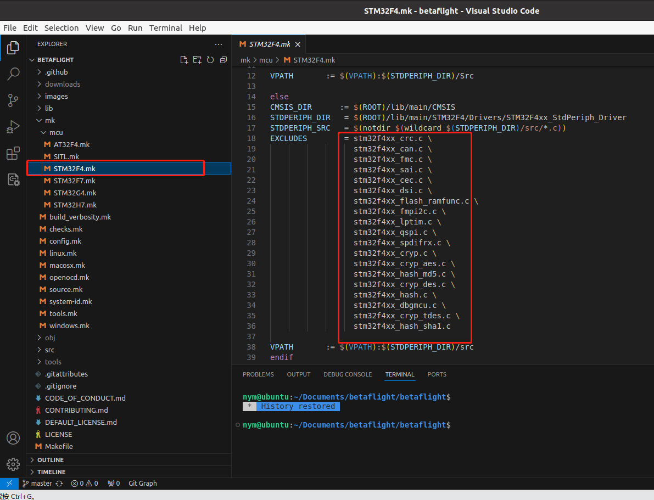

**Makefile调用的所有.mk文件**

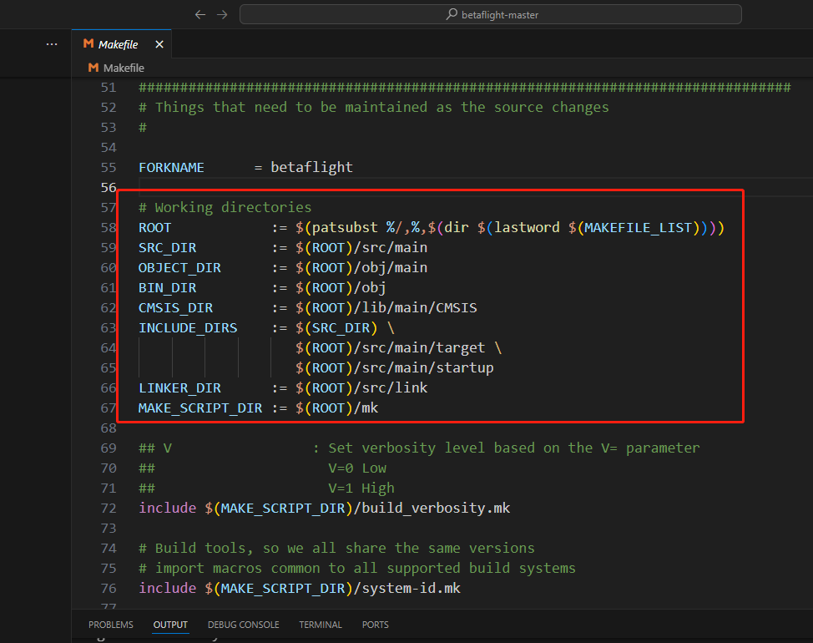

# 路径表示

ROOT            = 初始路径

SRC_DIR         = /src/main

OBJECT_DIR      = /obj/main

BIN_DIR         = /obj

CMSIS_DIR       = /lib/main/CMSIS

INCLUDE_DIRS    = /src/main \

                  /src/main/target \

                  /src/main/startup

LINKER_DIR      = /src/link

MAKE_SCRIPT_DIR = /mk

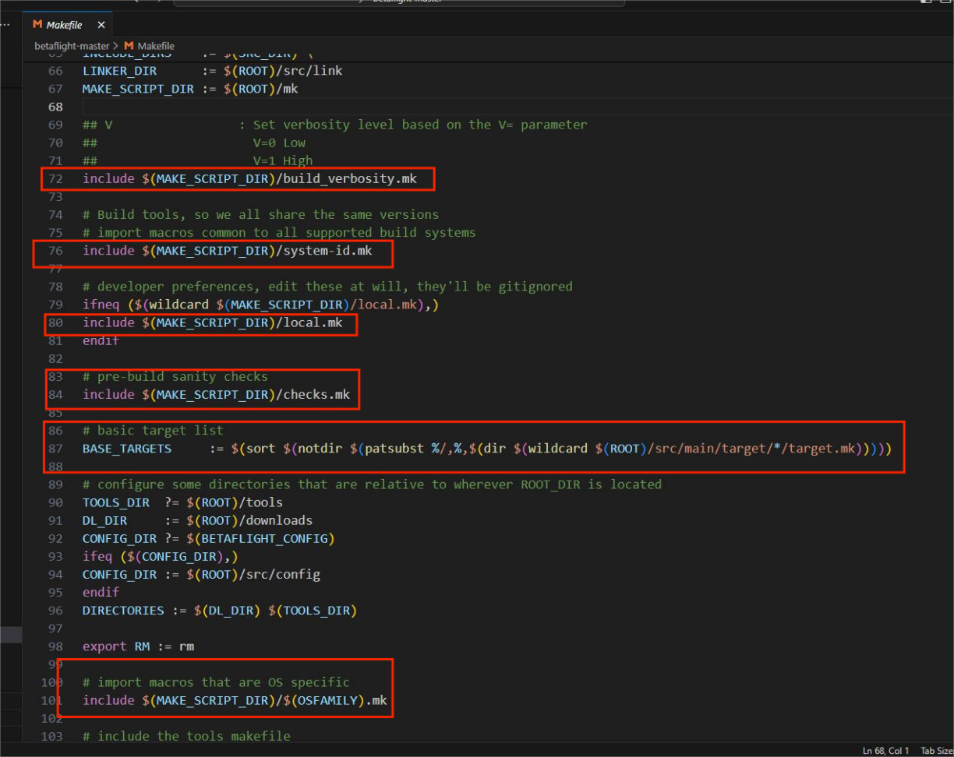

# 路径表示

/mk/build_verbosity

/mk/system-id.mk

/mk/checks.mk

/mk/checks.mk

/mk/linux

# Linux

ifeq ($(UNAME), Linux)

  OSFAMILY := linux

endif

include $(MAKE_SCRIPT_DIR)/tools.mk

/mk/tools.mk

include $(MAKE_SCRIPT_DIR)/config.mk

/mk/tools.mk/config.mk

include $(ROOT)/src/main/target/$(TARGET)/target.mk

/src/main/target/STM32F405/target.mk

include $(MAKE_SCRIPT_DIR)/mcu/$(TARGET_MCU_FAMILY).mk

/mk/mcu/STM32F4.mk

include $(MAKE_SCRIPT_DIR)/openocd.mk

/mk/openocd.mk

**其中**$(TARGET_MCU_FAMILY): 即$(TARGET_MCU_FAMILY)=STM32F4

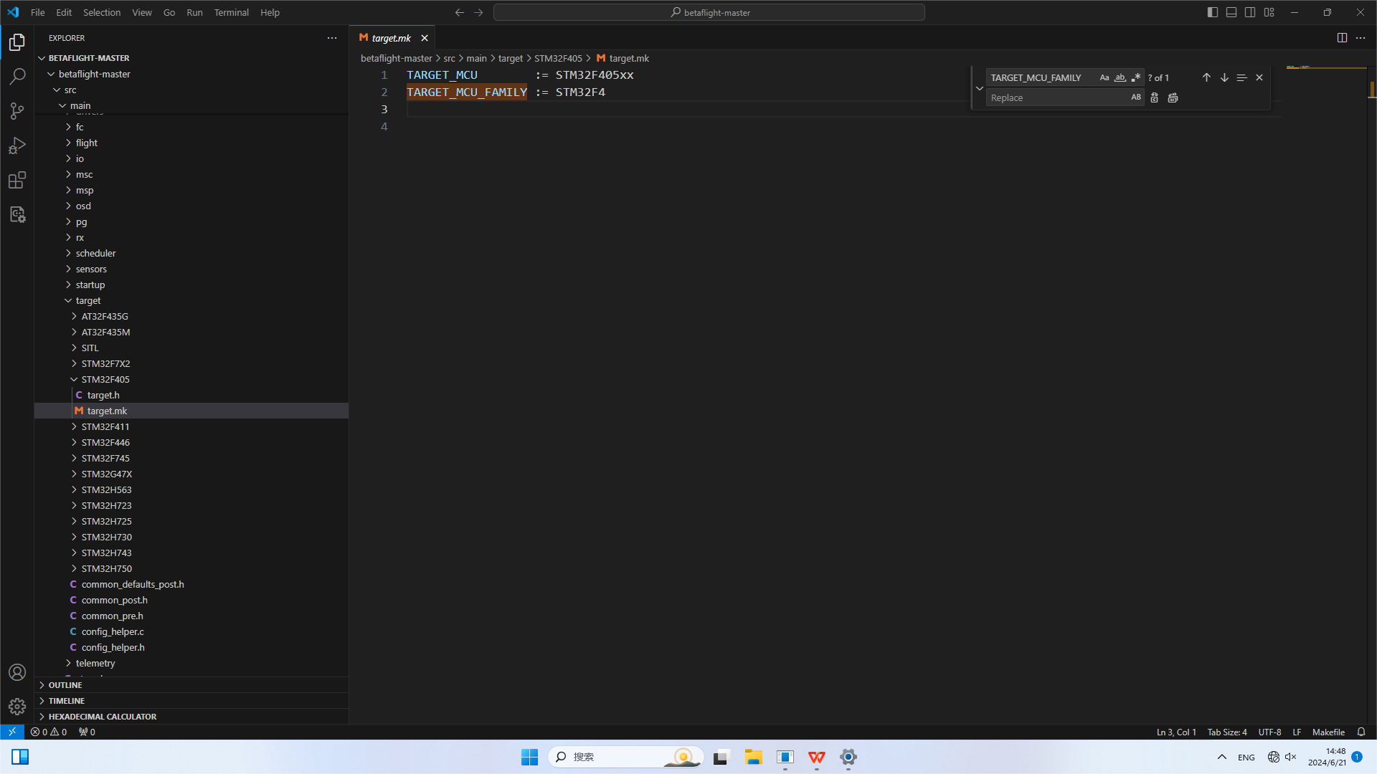

**Makefile文件命令解读**

**$**

首先命令先让**TARGET**=STM32F405

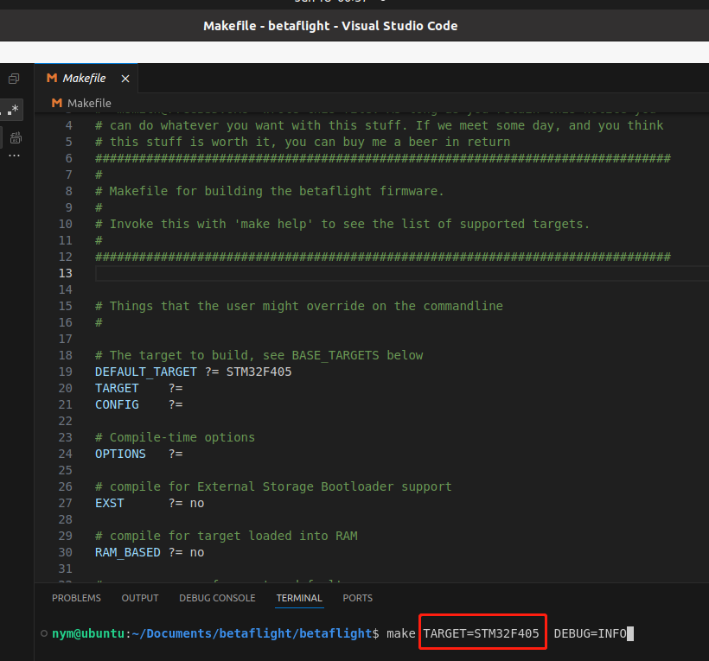

这里的$(TARGET)就等于STM32F405 了：

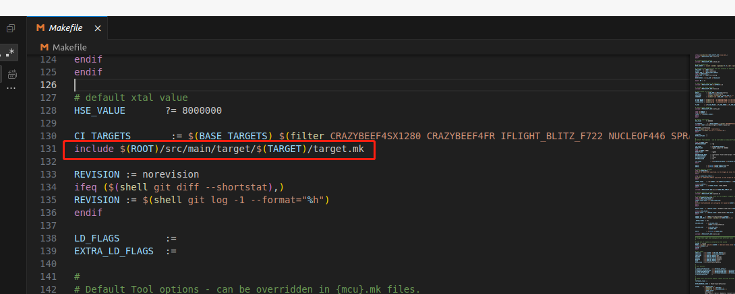

所以上面的命令就把路径src/main/target/STM32F405$/target.mk文件包含进来编译了；

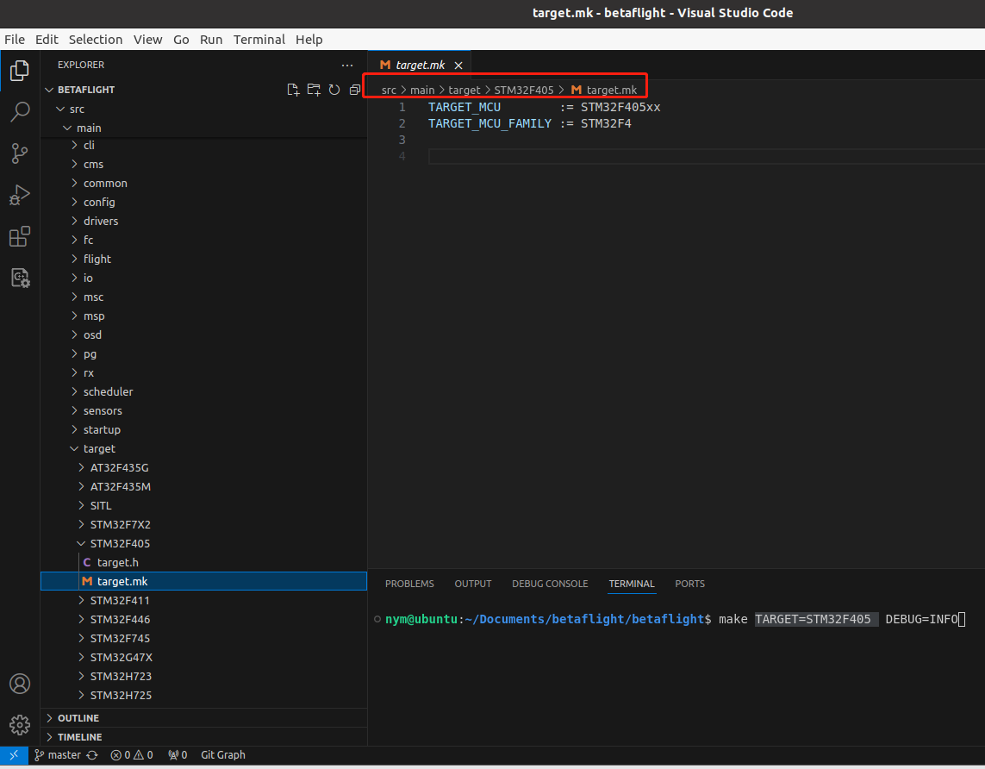

**用各种变量名称代替路径：**



# 路径表示

ROOT            = 初始路径

SRC_DIR         = /src/main

OBJECT_DIR      = /obj/main

BIN_DIR         = /obj

CMSIS_DIR       = /lib/main/CMSIS

INCLUDE_DIRS    = /src/main \

                  /src/main/target \

                  /src/main/startup

LINKER_DIR      = /src/link

MAKE_SCRIPT_DIR = /mk

**@echo**

下面命令就是

target-mcu=$(TARGET_MCU_FAMILY) : $(TARGET_MCU)

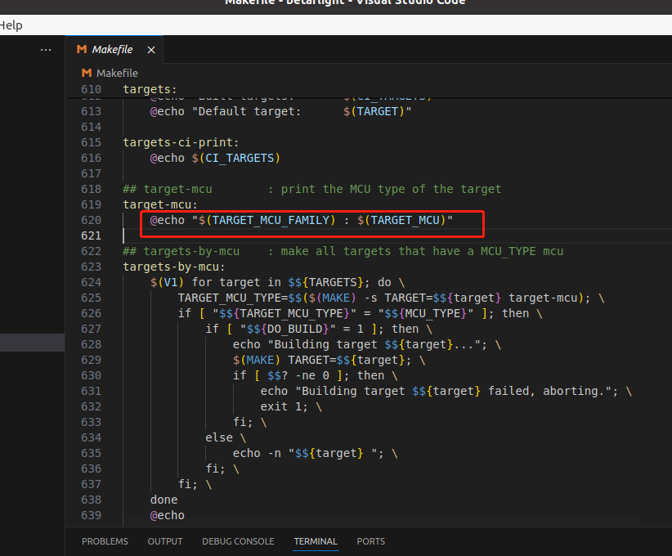

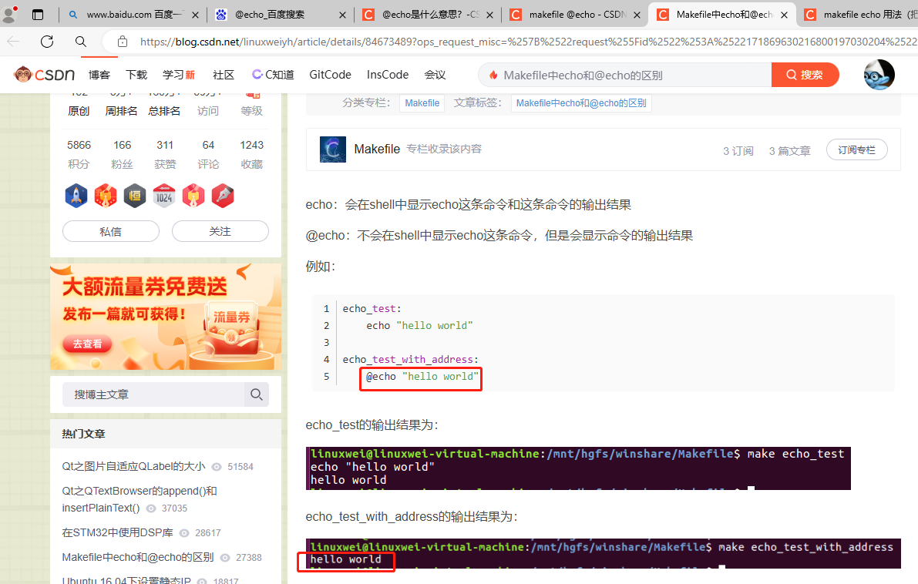

**网上发布的编译好的固件**

[Releases · betaflight/betaflight (github.com)](https://github.com/betaflight/betaflight/releases)

在[Releases 132](https://github.com/betaflight/betaflight/releases)

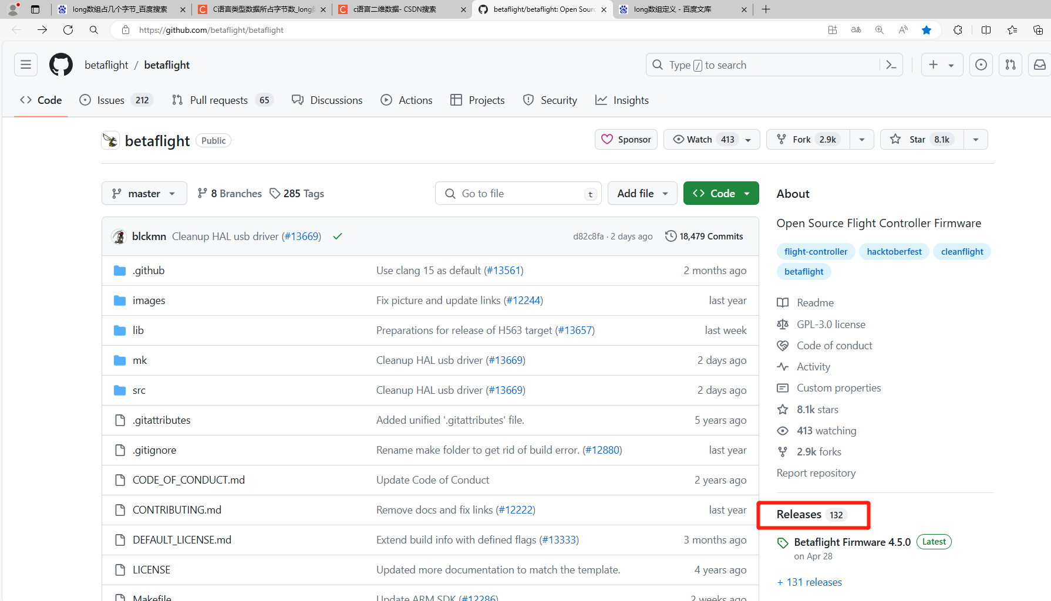

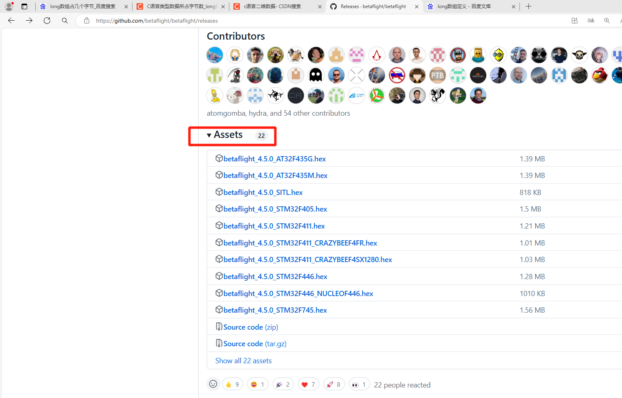

拉到最下面还有历史发布的其他版本：

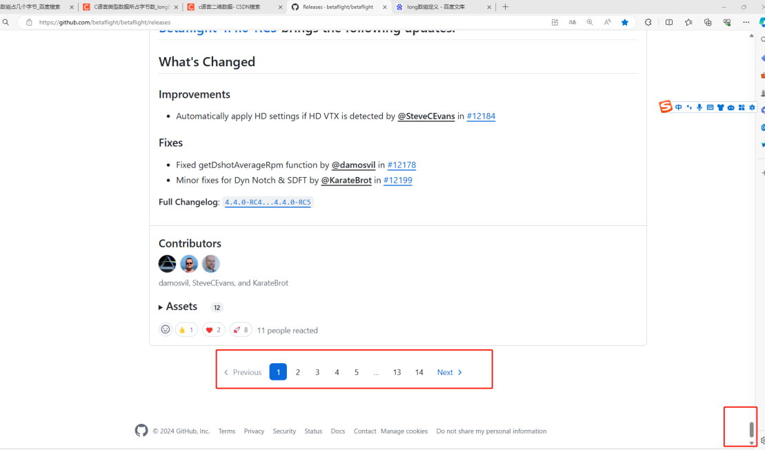

Config 配置文件

[unified-targets/configs/default at master · betaflight/unified-targets (github.com)](https://github.com/betaflight/unified-targets/tree/master/configs/default)

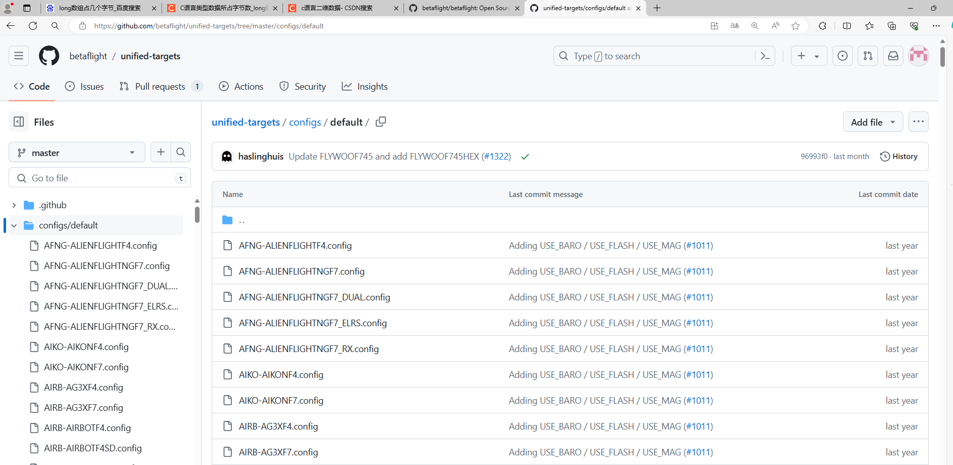

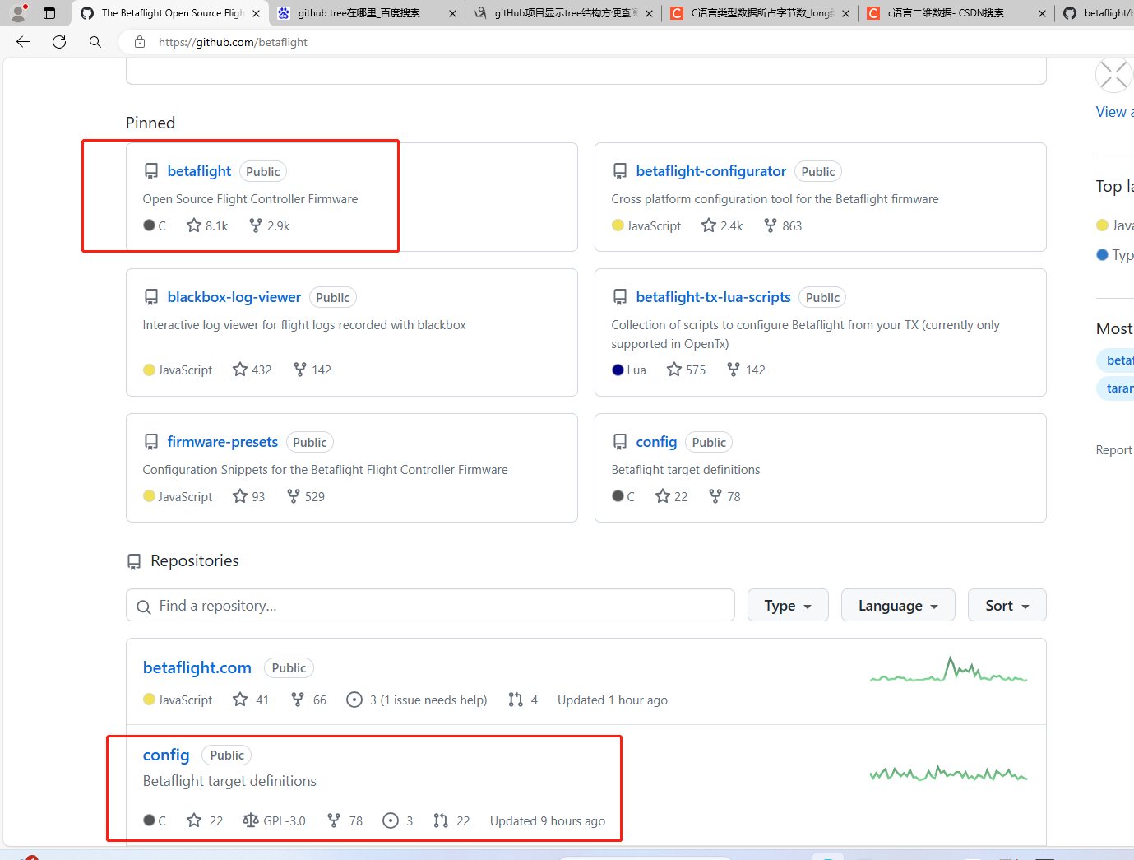

把它git clone下来可以看到历史版本：

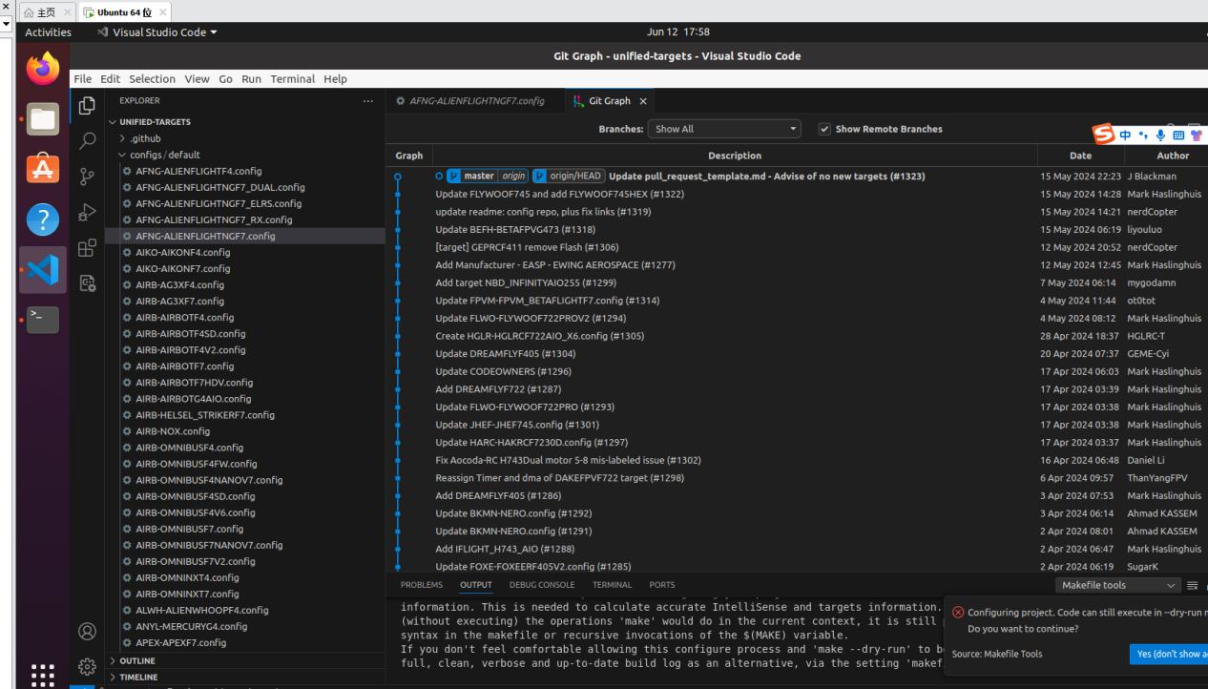

安装开发环境或ubuntu遇到的问题

make arm_sdk_install

nym@ubuntu:~/Documents/betaflight/betaflight$ make arm_sdk_install

mkdir -p tools

mkdir -p downloads

/bin/sh: 1: curl: not found

make: *** [mk/tools.mk:68: downloads/arm-gnu-toolchain-13.2.rel1-x86_64-arm-none-eabi.tar.xz?rev=e434b9ea4afc4ed7998329566b764309&hash=CA590209F5774EE1C96E6450E14A3E26] Error 127

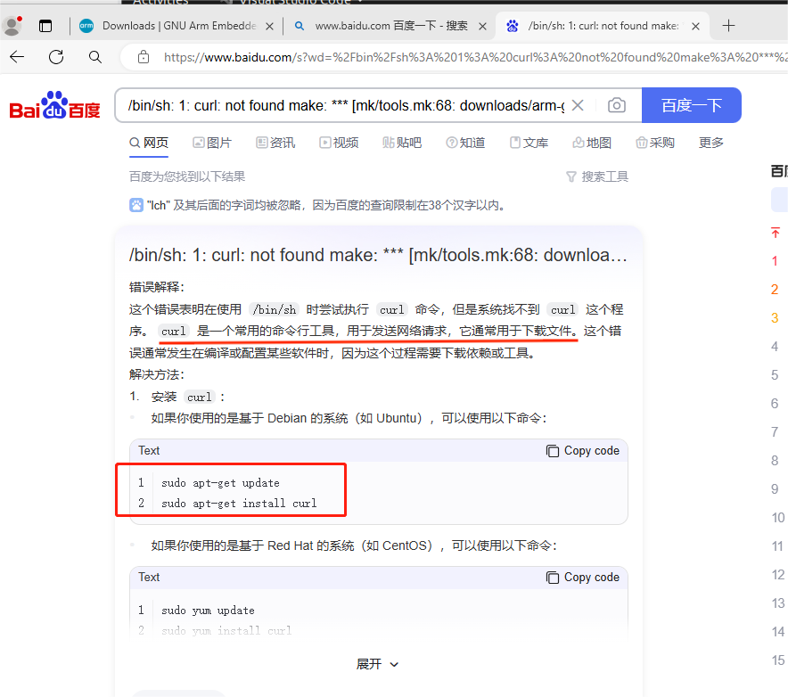

sudo apt-get update

sudo apt-get install curl