HOW TO

**Remove and replace characters from a field in an attribute table**

Last Published: December 3, 2020

**Summary**

The instructions provided describe how to remove and replace characters from a field in an attribute table using the Field Calculator in ArcMap. In this example, the hyphen character ( - ) is replaced and removed to provide better readability.

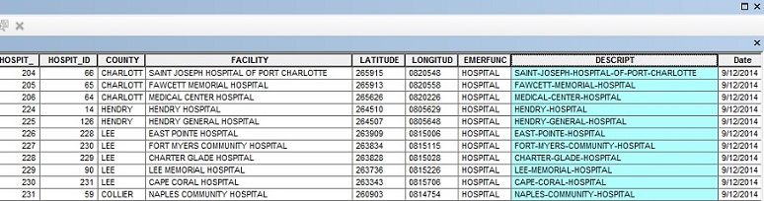

**Procedure**

1. Open ArcMap.
2. Right-click the selected layer in **Table Of Contents**, and select **Open Attribute Table**.

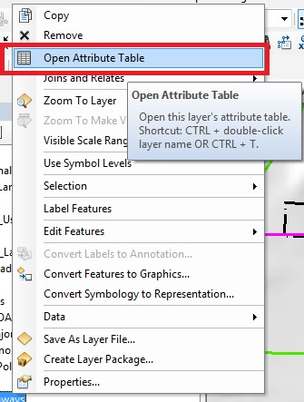

1. Start an edit session via the **Editor**toolbar for the selected layer.

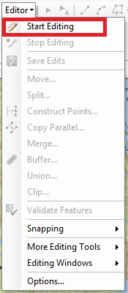

1. Right-click the field, and select **Field Calculator...**.

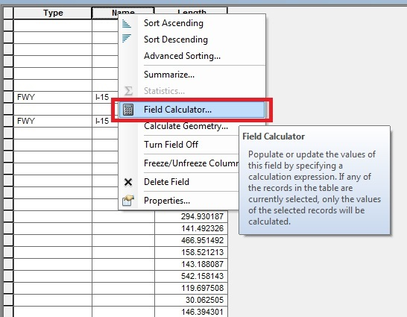

1. In **Field Calculator**, click the **Python** parser, and double-click the desired field name to insert the field name in the codeblock.
2. Click the **String** radio button, and in the **Functions** list, click **.replace()**.
3. Within the bracket in .replace(), type *"-"," "* to replace hyphens with a space, as shown below.

**Code:**

![FieldName]!.replace("-"," ")

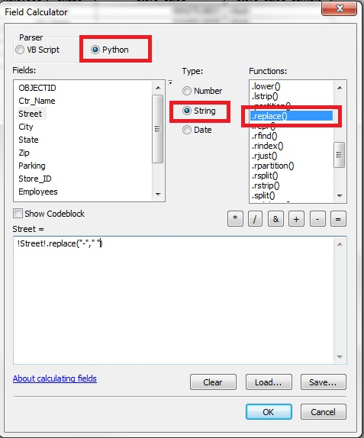

1. Click **OK**. The hyphens are removed.

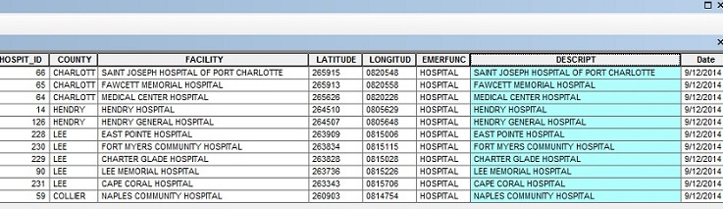

1. In the **Editor** toolbar, select **Stop Editing** and click **Save Edits** to save the changes.