This document describes the installation of VizStack, as well as basic configuration and usage.

Please read through the sections below for details about VizStack version 0.3-1:

VizStack: An Introduction 3
VizStack Modes of Operation 3
Supported VizStack Platforms 4
Installing VizStack and Dependencies 4
Installing the Base Operating System 5
Kernel Setup on Each Node 5
Installing VizStack and Required Software 6
Installing nVidia Graphics Drivers 6
RedHat Enterprise Linux 5, and XC 4.0 6
SuSE Enterprise Linux 10 SP2 7
Configuring Required Software 7
QuickStart Steps For XC 7
Network Time Protocol (NTP) 8
Munge 8
SLURM 9
HP Remote Graphics Software 10
TurboVNC/VirtualGL 10
Installing/Configuring Other Software 11
ParaView 11
Other Application Software 11
Configuring password-less SSH 11
Configuring VizStack 12
Single Node Configuration 12
Sea of Nodes Configuration 12
Using VizStack with Batch Schedulers 13
Starting the VizStack System State Manager(SSM) 14
Using VizStack 14
Remote Desktop Sessions using HP Remote Graphics 15
Using RGS with batch schedulers 15
Remote Desktop Session using TurboVNC/VirtualGL 16
Using TurboVNC with batch schedulers 16
Avizo 17
ParaView 17
“Local” Desktop 17
Special setup needed for local desktops 18
VizStack Resource Numbering Conventions 19
VizStack GPU numbering 19
GPU Display Output Numbering 20
Configuring Tiled Displays 21
A single tile 21
Displays in a 2x1 layout from a single GPU 24
Displays in a 2x2 layout from two GPUs on the same node 25
2x2 layout from two GPUs from two nodes 26
2x1 layout from two GPUs on two nodes 27
Altering the order in which VizStack drives displays 28
Using Display Output 0 as a console 29
Using a 4x2 tiled display in multiple ways without recabling 30
Using Display Devices with VizStack 32
In-built Display Device Support 32
Configuring site-specific Display Devices 32
The VizStack Python API 34

VizStack: An Introduction

VizStack is a software stack that turns a one or more machines with GPUs installed in them into a shared, multi-user visualization resource. VizStack provides utilities to allocate resources (GPUs), run applications on them, and free them when they are no longer needed. VizStack provides ways to configure and drive display devices, as well as higher level constructs like Tiled Displays.

VizStack manages only the visualization resources (GPUs, X servers), and does not provide any utilities to do system management/setup on the nodes. VizStack can dynamically setup the visualization resources to meet any application requirement.

For ease of use, VizStack provides integrations with HP Remote Graphics Software and TurboVNC/VirtualGL, as well as popular visualization applications.

VizStack Modes of Operation

VizStack can run in three modes

- Sea of Nodes mode: In this mode, VizStack manages the visualization resources on two or more nodes. One of these nodes needs to run VizStack’s System State Manager (SSM) “daemon” process. The node running the SSM may or may not have GPUs in it. To run VizStack in this mode, you typically need to configure an “application launcher”. With this release, you have a choice of using one or more application launchers:
  - SLURM, an open source resource manager
  - SSH. You’d typically want to setup your nodes for password-less SSH.
  - Local “exec”. This allows users to allocate and use GPUs on the node from where their jobs get scheduled. If you’re looking to use VizStack in conjuction with a scheduler, then you may use either this application launcher, or SSH.
In the sea-of-nodes configuration, you will additionally need to configure Munge on all the nodes.

- Single Node mode: In this mode, VizStack manages the visualization resources on exactly one physical node. Using this mode instantly converts a single node into a shareable visualization resource. You may also use the node to drive a large display wall or any other display system. This is the easiest way to try out VizStack. If you choose to run VizStack in this mode, then you don’t need to configure Munge and SLURM.

- Static Configuration: This mode allows one to setup a static configuration of X servers, GPUs, display devices. This mode will be described in later versions of this document.

Typically, you may choose to use a remote visualization solution with VizStack. VizStack provides direct integration with two software solutions for remote visualization:

- HP Remote Graphics Software. This provides one remote visualization session per physical node.

- TurboVNC with VirtualGL for running OpenGL apps. You may have one remote visualization session per GPU.

You will need to manually install and configure the remote visualization solutions of your choice. Note that these solutions are independent of each other, and you can use one or both of them at the same time.

Supported VizStack Platforms

VizStack is supported on every qualified server graphics platform. It will also work on blade workstations and workstations, provided they have nVidia graphics cards on them. A list of platforms at this time is:
- Servers : DL 160 G5, DL 380 G5, DL 585 G5, DL785 G5, ML 370 G6
- Blade Workstation : xw460c
- Workstations: xw8600, Z series workstations will work as well.

Older servers & workstations will work, so long as we support nvidia graphics cards on them. This includes DL140/145, xw8200/9300/8400.

The following is a list of supported graphic options:
- High End: Quadro FX 5800, 5600, 4600. QuadroPlex 2200 D2, QuadroPlex 2100 S4, QuadroPlex 2100 M4
- Medium : Quadro FX 3700, 3500
- Entry Range: Quadro FX 1700, 1500

Other platforms/graphics options will be easy to get up and running. The support is limited to “qualified server graphics platforms” to guarantee that the server and graphics combination is known to work.

Installing VizStack and Dependencies

Before you can install and use VizStack, you need to install the OS which will form the underlying environment first. VizStack additionally depends on the availability of a few additional software packages (over and above) the OS.

Note that VizStack does not provide for node management, golden imaging, installing Infiniband, configuring IP addresses, etc. VizStack can manage the visualization resources on one or more nodes. Before installing VizStack on a group of nodes, you need to install the OS on each and every node.

The steps needed to install VizStack roughly are
- Installing the base operating system
- Kernel setup on each node.
- Installing software dependencies needed for VizStack, including graphics drivers
- Install VizStack RPM

Installing the Base Operating System
VizStack is tested to run over the following linux variants
- RedHat Enterprise Linux Version 5.1 (RHEL 5.1) x86_64
- SuSE Linux Enterprise Server 10 SP2 (SLES 10 SP2) x86_64
- CMU based on RHEL 5.1 or SLES 10 SP2
- HP XC 4.0 (debranded RHEL 5.1)

VizStack possibly will run on RHEL 5.3 as well, but this has not been tested.

You will need to install one of these operating systems on a set of nodes. Note that it is possible to install VizStack on a single node as well. This is the easiest way to try out VizStack, and is highly recommended.

The number of configuration steps needed to get VizStack running are least if you are trying to use VizStack on HP XC 4.0. It is possible to get VizStack up and running on an XC/SVA 4.0 system very quickly, using the instructions given in “QuickStart Steps For XC”.

Once you have one or more nodes with these OSes installed, then you are ready to take the next step.

Kernel Setup on Each Node
This is applicable if you are using SLES. During installation, SLES configures the kernel to use a VGA mode instead of a text mode for the virtual consoles. Usage of the video mode can cause screen corruptions and crashes when X servers start and stop. To avoid this, we recommend that you turn off usage of any kind of VGA modes by the kernel.

You can do this by editing /boot/grub/menu.lst and removing any “vga=” options in the file.

Installing VizStack and Required Software
VizStack is distributed as a .tar.gz file. One file is provided for each supported platform, currently limited to RHEL5(including XC 4.0), and SLES10 SP2. Each file includes the VizStack RPM, this document, as well any software packages that VizStack depends on. Most dependencies are available in the distribution file.

If you have an earlier version of VizStack installed, then be sure to remove it from all the nodes using “rpm –e vizstack”. At this time, you cannot use the upgrade option with the VizStack RPM.

You will need to install the VizStack RPM, as well as all dependencies on all the nodes which you want to use with VizStack. Note that, if you want to use VizStack in a standalone configuration, then you only need to install the VizStack RPM (and its dependencies) on one node.

Important Note: The VizStack RPM includes files in /etc/profile.d. These files set up the user environment for proper execution. This environment is also needed for the VizStack administrative scripts to run. So, after you install the VizStack RPM, you must logout and log back in again before you run the next commands.

Installing nVidia Graphics Drivers

First, download the nVidia graphics drivers relevant to your operating system and hardware from http://www.nvidia.com/drivers/. You will need to choose “Linux 64 bit” as the Operating System, and the select the product type/series corresponding to the graphics options you have installed.

If you intend to run CUDA programs then you will need to install the driver needed for the version of CUDA of your choice. Be sure to check that it is compatible with the graphics hardware you have installed.

The driver can be installed on one node by running a single command. E.g,, if you downloaded version 177.70.35, then you would run :

# sh NVIDIA-Linux-x86_64-177.70.35-pkg2.run

Note that you must stop all X servers before trying to install the driver. Switching to run-level 3 is recommended.

RedHat Enterprise Linux 5, and XC 4.0

You’d typically start off by unpacking the package

# cd /tmp
# tar –xvzf vizstack-0.3-1-RHEL5.tar.gz
vizstack-0.3-1-RHEL5/
vizstack-0.3-1-RHEL5/deps
vizstack-0.3-1-RHEL5/deps/non-xc4
vizstack-0.3-1-RHEL5/deps/non-xc4/munge-0.4.2-1.x86_64.rpm
vizstack-0.3-1-RHEL5/deps/non-xc4/munge-libs-0.4.2-1.x86_64.rpm
vizstack-0.3-1-RHEL5/deps/non-xc4/slurm-1.2.35-1.x86_64.rpm
vizstack-0.3-1-RHEL5/deps/non-xc4/slurm-auth-munge-1.2.35-1.x86_64.rpm
vizstack-0.3-1-RHEL5/deps/xerces-c-2.7.0-7.el5.x86_64.rpm
vizstack-0.3-1-RHEL5/vizstack-0.3-1.x86_64.rpm
vizstack-0.3-1-RHEL5/VizStack-Documentation.pdf

You will need to install the VizStack RPM, as well as these dependencies on all the nodes which you want to use with VizStack. If you are installing on XC 4.0, then you should avoid installing the packages in the “non-xc4” directory; all you need to do is install the xerces RPM, and the VizStack RPM.

SuSE Enterprise Linux 10 SP2

First, use the YaST2 tool to install the package “python-xml”. This is used by VizStack.fro XML processing.

After this, start off by unpacking the package

# cd /tmp
# tar –xvzf vizstack-0.3-1-SLES10.2.tar.gz
vizstack-0.3-1-SLES10.2/
vizstack-0.3-1-SLES10.2/vizstack-0.3-1.x86_64.rpm
vizstack-0.3-1-SLES10.2/deps
vizstack-0.3-1-SLES10.2/deps/munge-0.4.2-1.x86_64.rpm
vizstack-0.3-1-SLES10.2/deps/munge-libs-0.4.2-1.x86_64.rpm
vizstack-0.3-1-SLES10.2/deps/slurm-1.2.35-1.x86_64.rpm
vizstack-0.3-1-SLES10.2/deps/slurm-auth-munge-1.2.35-1.x86_64.rpm
vizstack-0.3-1-SLES10.2/deps/libXerces-c28-2.8.0-30.30.x86_64.rpm
vizstack-0.3-1-SLES10.2/VizStack-Documentation.pdf

Configuring Required Software

Depending on the mode in which you want to run VizStack (and the kind of applications you want to use), you will need to configure some of the installed software. Please follow the steps in the next section to install/configure the required software.

QuickStart Steps For XC

It is easiest & fastest to install VizStack on an SVA/XC 4.0 system. This happens because many of the dependent packages are already installed & configured on an XC system.

If you are installing VizStack on an XC 4.0 system, then you can be done in the following simple steps:
- Change the SLURM configuration. In the SLURM configuration for the visualization nodes, change “Shared=NO” to “Shared=FORCE”. Make this the default partition. Edit /hptc_cluster/etc/slurm/slurm.conf, make this change.
- Reconfigure SLURM
# scontrol reconfig

If you want to use HP RGS or TurboVNC/VirtualGL, then typically you would want to install these packages on the head node, and then image the other nodes. Refer to the sections “HP Remote Graphics Software” and “TurboVNC/VirtualGL” for additional configuration steps. After this, you may directly jump to “Configuring VizStack”.

Network Time Protocol (NTP)

Time needs to be in sync on all the nodes that run VizStack. For this, you may need to configure each node to use an NTP server. With XC, you’d typically have done this step while creating the golden image.

Munge
Munge is used by VizStack to identify user processes. XC 4.0 installs and configures Munge automatically; if you are using XC, then you don’t need to do anything for Munge.

Munge needs a secret key to work. To generate the key

# dd if=/dev/urandom bs=1 count=1024 > /etc/munge/munge.key

The above command finishes very quickly, but generates a pseudo-random key. If security is a concern, then consider using the below command line.

(Note: this will take a long time to finish!)
# dd if=/dev/random bs=1 count=1024 > /etc/munge/munge.key

Next, you need to propagate this secret key to all the nodes of the cluster. You may use scp for this purpose, as in the example below. The example assumes a cluster with 5 nodes named as node1, node2,..., node5.

# for node in node1 node2 node3 node4 node5; do
scp /etc/munge/munge.key root@$node:/etc/munge;
done;

Finally, restart the Munge daemon (on all the nodes)
# service munge restart

SLURM
If you want to use VizStack on two or more nodes, then you may choose to use the SLURM scheduler as an application launch mechanism. Alternatively, you may use password-less SSH too. If you prefer to use password-less SSH, then you can skip configuring SLURM.

Using SLURM makes it easier to dynamically administer a few nodes of the system without affecting the users who may be using the remaining nodes. Also, SLURM configuration is done once and works for all users. If you prefer password-less SSH, then bear in mind that the password-less SSH setup may need to be done individually for each user.

- First, create a user (and group) named ‘slurm’ on all the nodes, ensuring that this user has the same user-id and group-id on all nodes.

# for ((i = 1; i <= 5; i++)); do
ssh root@node$i /usr/sbin/groupadd –g 666 slurm;
ssh root@node$i /usr/sbin/useradd -g 666 -u 666 -M -s /sbin/nologin slurm; done

In this case, the user will have a uid and gid of 666.

- Create the JobCredentialPrivateKey file on the master node

# openssl genrsa -out /etc/slurm/slurm.key 1024

and create the JobCredentialPublicCertificate too

# openssl rsa -in /etc/slurm/slurm.key -pubout -out /etc/slurm/slurm.cert

- Make a copy of the slurm example file from /etc/slurm/slurm.conf.example and edit it in your favorite editor. Assuming that your nodes are named node1, node2,...,node5 and the node named node1 is the master/control/head node, your file needs to look like

ControlMachine=node1
...
SlurmUser=slurm
...
JobCredentialPrivateKey=/etc/slurm/slurm.key
JobCredentialPublicCertificate=/etc/slurm/slurm.cert
...
NodeName=node[1-5] State=UNKNOWN
PartitionName=viz Nodes=node[1-5] Default=YES RootOnly=NO Shared=FORCE MaxTime=INFINITE State=UP

- After making these changes, copy the slurm.conf, slurm.key and slurm.cert files
to all the nodes.

# for ((i = 2; i <= 5; i++)); do
scp /etc/slurm/slurm.conf /etc/slurm/slurm.key /etc/slurm/slurm.cert root@node$i:/etc/slurm ;
done

- Restart the slurm daemon on all the nodes.
# for ((i = 1; i <= 5; i++));
do ssh root@node$i /sbin/service slurm restart ;
done

If everything went well, you should see all the nodes show up as idle, when you type in sinfo :
# sinfo –h
viz* up infinite 5 idle node[1-5]

HP Remote Graphics Software
If you want to use RGS, then you will need to install the RGS package on all nodes. VizStack was tested with the most recent version of RGS : version 5.2.5.
Currently, there is no mechanism to limit the set of nodes where VizStack will use RGS. After installing RGS, you will need to do a few manual configuration steps. Edit the file /etc/opt/hpremote/rgsender/rgsenderconfig, and make the following changes
- Rgsender.Network.IsListenOnAllInterfacesEnabled=1
- Rgsender.IsIloRemoteConsoleEnabled=1 (if the node is a blade workstation)
- Rgsender.IsBlankScreenAndBlockInputEnabled=0

Again, note that you need to make these changes on every node. We recommend that you make the change once and propagating the changes via tools like scp OR pdcp.

The RGS sender (component that remotes the desktop) servers connections on TCP port number 42966. You need to ensure that you configure your network stack to allow incoming connections on this port. This step is crucial. If you miss this, then you will be able to start remote desktop sessions, but users will not be able to connect to them.

TurboVNC/VirtualGL
You will need to install VirtualGL and TurboVNC on all the nodes. The following packages were tested with VizStack
- turbovnc-0.5.1.i386.rpm
- turbojpeg-1.11.x86_64.rpm
- virtualGL-2.1.2.x86_64.rpm

The TurboVNC server listens to connections on TCP port 5901, 5902, etc. Ensure that your network stack allows incoming connections to these ports. VizStack, by default configures each node to allow as many TurboVNC sessions as there are GPUs on the system. So, if you have two GPUs on the system, then you need to open TCP ports 5901, 5902. If you have more GPUs, then you need to open more ports.

TurboVNC needs another big setup step as well. On every node, for every user that intends to use TurboVNC, you need to ensure that a password file is setup. NFS shared home directories may help reduce setup effort here. If a user runs the TurboVNC script without running the “vncpasswd” command, then they will be prompted to enter a password. The password will only apply to the node where the session is running at, unless you have a shared home directory set up. Note that this scenario typically occurs in a demo kind of environment rather that in a production environment where you will already have a shared file-system in place.

Installing/Configuring Other Software

ParaView

The VizStack software bundle includes a precompiled version of ParaView. This is provided as a convenience for the RHEL platform. This also needs installation of MPICH2 for functioning.

Other Application Software
You may want to use a variety of applications on your visualization resources. You will need to install/configure these, install their license and start any daemon processes that may be needed.

Configuring password-less SSH
Some applications (e.g. Ensight) use passwordless SSH to run the parallel rendering parts of the application. VizStack’s Amira integration script uses it to copy configuration files to other nodes. Similaryly, VizStack’s ParaView script also uses passwordless SSH.
If you intend to use these applications, then you’ll need to setup password-less SSH for each user. Password-less SSH can be setup in a few steps. The following web page serves as a good tutorial:
http://www.cs.toronto.edu/~murray/compnotes/passwordless_ssh.html

If you are on XC/SVA you can run the command ssh_create_shared_keys to create the shared keys. Password-less SSH can be setup in a variety of other ways as well, and it is up-to you to use the right method for your site.

Configuring VizStack
As with the single node configuration, ensure that the X servers are not running on any nodes where VizStack needs to be configured. Switching to runlevel 3 is recommended.

Single Node Configuration
As root, execute the following command

# /opt/vizstack/sbin/vs-configure-standalone

This command will detect the number and type of GPUs on this node, and configure VizStack. It also sets up VizStack configuration needed for TurboVNC and RGS, irrespective of whether these are installed on the nodes.

Sea of Nodes Configuration
In this mode, VizStack manages the visualization resources on more than one node. VizStack is flexible enough to adapt to your environment, and meet your needs of configuring and managing your visualization resources.

To use the full functionality of VizStack, you will need to configure VizStack to use either SLURM or password-less SSH as an application launch mechanism.

To configure with SLURM, use

# /opt/vizstack/sbin/vs-configure-system –s slurm <list of nodes>

To configure with SSH, use

# /opt/vizstack/sbin/vs-configure-system –s ssh <list of nodes>

Note that <list_of_nodes> may be specified in the SLURM notation, or as multiple names on the command line. If you have GPUs on the machine where you’re running this command from, then you need to include the hostname of this node as well. If your nodes are not in the default partition, then you may use the “-p” command line option and specify the partition name.

If you want to access remote visualization sessions (RGS/TurboVNC) over a network which is not the same as where your nodes are defined, then you may use the following variant:

# /opt/vizstack/sbin/vs-configure-system –m <netmask> –s slurm <list of nodes>

Here, <netmask> is the TCPv4 netmask (dotted a.b.c.d) of the interface which you want to use for remote access.

This command will detect the number and type of GPUs on all the listed nodes, and configure VizStack to use them. It also sets up VizStack configuration needed for TurboVNC and RGS, irrespective of whether these are installed on the nodes. The node from where this command is executed is configured to be the master node. You’ll need to run the VizStack System State Manager (SSM) on this node.

NOTE: You need to ensure that the hostnames names of the nodes are resolvable on all the nodes where you intend to use VizStack. This can be achieved in many ways: keeping /etc/hosts in sync, setting up NIS name resolution. Many cluster management utilities (e.g. CMU, XC) automatically do this for you.

The SSM, by default, services requests on TCP port number 50000. The other visualization nodes managed by VizStack need to be able to connect to the SSM, i.e. to this port on the master host. If your nodes are in an internal network without restrictions in terms of internal connections, then this is not a concern. Otherwise, you may need to configure your firewall to achieve this.

Using VizStack with Batch Schedulers

VizStack is meant for use in multi-user, multi-session environment. Such environments may use schedulers to enable sharing of resources confirming to various site-specific policies. Note that VizStack does not schedule jobs. VizStack, at this software release, does not integrate directly with schedulers (later releases will integrate directly)

However, you may use VizStack to manage a “remote visualization farm” configuration with batch schedulers. This configuration lets you assign a GPU to each user for use as a remote, 3D accelerated desktop. The VizStack remote access scripts have a “batch” mode to aid this.

Example with LSF:

First, you need to configure LSF to associate GPUs as resources on the nodes which have them. GPUs, in LSF terms, need to be configured as resources with numeric attributes. GPUs as resources need to be defined in the file “lsf.shared”. You’ll need to add a line like the following:

gpu Numeric () Y Y (Number of GPUs)

This line tells LSF that “gpu” is a resource of type “Numreric” that is “increasing” and “consumable”.

If you want to use HP RGS, then you may also add another line

rgs Numeric () Y Y (Single usage of RGS)

After this, you need to tell LSF which nodes have how many GPUs. You need to edit your cluster definition file (lsf.cluster.<name>) for this. In the “resources” column for each hostname, add the number of GPUs which are present in the particular host.

e.g., the lines in your installation could look like
alpha13 ! ! 1 3.5 () () (gpu=2,rgs=1)
alpha14 ! ! 1 3.5 () () (gpu=1,rgs=1)
alpha15 ! ! 1 3.5 () () (gpu=4,rgs=1)

Here, alpha13, alpha14 and alpha15 have 2, 1 and 4 GPUs, respectively. Note that this does not differentiate between the kind of GPUs. For now, it is recommended that you have the same kind of GPUs in your system.

Also, note that all nodes define “rgs=1”. This means that one or zero instances of RGS may be active on the node.

Next, ensure that LSF picks up the changes in your configuration file. Also define any queues for user access, etc.

Configure VizStack using the below command. Note that you will need to have password-less SSH setup for root to do this.

# /opt/vizstack/sbin/vs-configure-system –s local –c ssh <list of nodes>

Starting the VizStack System State Manager(SSM)
VizStack relies on one “daemon” process to maintain the dynamic state of visualization resources in the system. This daemon acts as a gatekeeper for access to all visualization resources. If this program is not running, then no user applications (the ones using the GPUs) will be able to run. So, you need to start the SSM before you can run user scripts which request visualization resources. This is done by executing the command below as root:
# /opt/vizstack/bin/vs-ssm

This is strictly not a daemon process at this time, and prints out debug messages. Later releases of VizStack will improve this behaviour.

Using VizStack

VizStack provides a few scripts to aid usage of the visualization resources. Currently, there are two categories of scripts: remote visualization scripts(RGS, TurboVNC/VirtualGL) and application launch scripts(Amira/ParaView)

The application scripts need access to a Tiled Display to run. Tiled Displays need to be configured manually at this time, as described in the section Configuring Tiled Displays.

Remote Desktop Sessions using HP Remote Graphics

The script “viz_rgs” allocates remote desktop sessions using HP RGS software. You need to run this script as a regular user; it will not run as root. Sample invocations are shown below.

Allocate an RGS desktop on a single GPU, picking up a node automatically. Note that the node where the RGS desktop is running can use the other GPUs (i.e. excluding the one which is in use by RGS)

$ viz_rgs

This script will print out the connection information that the user needs to enter into the RGS client program. After authentication, the user will be able to use the desktop. User gives up the desktop either by logging out or by killing the script (former method is recommended).

Start an RGS desktop on a GPU with a specific desktop size

$ viz_rgs –g 1600x1200

Note that this resolution does not need to match any physical display device resolution. The only restriction is that the width of the desktop must be a multiple of 8. E.g, the following is allowed too –

$ viz_rgs –g 1000x1000

Desktop sizes can go really large: up-to 8192x8192 on Quadro FX 5800/4800/1800, and 4096x4096 on 5600/4600/1700. Note that large desktops can directly result in sluggish performance and higher bandwidth usage.

Note that the desktop sessions started using ‘viz_rgs’ are completely secure. This is achieved by running the applications in a virtual frame buffer. The desktop pixels on these sessions is never sent to the display output on the graphics card.

Using RGS with batch schedulers
Use the following command
$ bsub –R “rusage[gpu=1,rgs=1]” /opt/vizstack/bin/viz_rgs –b

Note that viz_tvnc will allocate a GPU on the node where the script gets scheduled, and setup RGS to use that GPU. However, it will not do any site specific operations that may be needed to inform the user how this session may be used (e.g. by sending email). You may choose to redirect the output of the script to a file, and get the connection information from there.

NOTE: the script will allocate an RGS session on the node irrespective of whether you reserve a GPU. This happens since VizStack cannot query LSF and find out what resources were allocated to a particular user. Later releases of VizStack will be able to query the scheduler about what resources were allocated to a node, and then use that information to require the user to reserve GPUs using LSF/other schedulers.

Remote Desktop Session using TurboVNC/VirtualGL
The script ‘viz_tvnc’ allocates remote desktop sessions using TurboVNC. With the default VizStack configuration, a single node can host as many TurboVNC sessions as there are GPUs in the machine.

Usage as same as RGS,

$ viz_tvnc

Will allocate a TurboVNC session. You need to use the TurboVNC client program to connect to the desktop. To run OpenGL applications inside this session, use the following command

$ vglrun <appname> <args>

Again, viz_tvnc can be run with any arbitrary resolution, subject to the “multiple of 8” restriction.

Using TurboVNC with batch schedulers
If you have configured LSF as mentioned earlier in this document, a user may start an TurboVNC session using

$ bsub –R “rusage[gpu=1]” /opt/vizstack/bin/viz_tvnc -b

Note that viz_tvnc will allocate a GPU on the node where the script gets scheduled, and setup TurboVNC to use that GPU. However, it will not do any site specific operations that may be needed to inform the user how this session may be used. You may choose to redirect the output of the script to a file, and get the connection information from there.

NOTE: the script will allocate a TurboVNC session on the node irrespective of whether you reserve a GPU. This happens since VizStack cannot query LSF and find out what resources were allocated to a particular user. Later releases of VizStack will be able to query the scheduler about what resources were allocated to a node, and then use that information to require the user to reserve GPUs using LSF/other schedulers.

Avizo

VizStack provides a script that makes it easy to run MCS Avizo on a tiled display. VizStack ‘s Avizo script relies on prior setup of passwordless SSH. To run Avizo on a tiled display, run

# viz_avizovr -t tile2x1

This works, provided there is a tiled display named “tile2x1”

ParaView

The VizStack ParaView script needs mpich2 to be installed and configured. The relevant rpms for RHEL5.x are

mpich2-devel-1.0.8p1-2.el5.x86_64.rpm
mpich2-libs-1.0.8p1-2.el5.x86_64.rpm
mpich2-1.0.8p1-2.el5.x86_64.rpm

To run ParaView on a tiled display, run

# viz_paraview -t tile2x1

This works, provided there is a tiled display named tile1x1. ParaView has been only tested on Redhat as there are some core issues compiling ParaView on SLES 10.2.

“Local” Desktop

Sometimes, the user would want to directly interact with one OR more GPUs using an X server with a directly connected keyboard/mouse. This is equivalent to using the GPUs and Input devices as if they were part of a local desktop.

If you want to use such a local desktop setup, then you need to use the viz_desktop script. This script accepts a Tiled Display as an input argument. The tiled display needs to be setup such that a keyboard and a mouse are part of the tiled display specification. The tiled display can use as many GPUs as needed from a single machine. The input tiled display is restricted to include GPUs only from a single machine. If you pass a Tiled Display which does not adhere to these restrictions, then the script will not start the desktop.

Starting a local desktop is as easy as running the other scripts
# viz_desktop –t my_4x4_display

Special setup needed for local desktops
After you run the script, the desktop starts up. At this point, you may find that you are unable to use either the keyboard/mouse with the desktop. As a rule of thumb, first check that these are indeed connected to the right machine.

It is likely that you will find that pressing keys on the keyboard does not cause anything to happen, while the mouse is working fine all the time. You may observe that pressing the caps lock key turns the LED on/off as expected. However, the keyboard doesn’t work.

This is not a VizStack issue per-se, but more of a RedHat Linux issue. VizStack uses a “-sharevts” option when starting the X servers. When this is used, it is observed that the PS/2 keyboard attached to the system does not work at all. Not using the sharevts option lets the keyboard work normally. If you configured the tiled display to use all GPUs on that node, then VizStack will not use the “-sharevts” option, resulting in everything working satisfactorily. If you don’t use all the GPUs in the tiled display, then the unused GPUs will be allocated by VizStack to other jobs on demand. VizStack will use the “-sharevts” option in this case, and you may notice that the keyboard just does not work.

If you face this problem, then there is a way out. The solution consists of
- Using a USB keyboard
- Creating/modifying a keyboard template to use this USB keyboard.

After you connect the USB keyboard, first ensure that it shows up in the “lsusb” listing. Also, check the file /proc/bus/input/devices, and ensure that your keyboard shows up. E.g., you may identify some lines similar to these in /proc/bus/input/devices

I: Bus=0003 Vendor=03f0 Product=0024 Version=0300
N: Name="CHICONY HP Basic USB Keyboard"
P: Phys=usb-0000:00:07.1-1.3.1/input0
S: Sysfs=/class/input/input5
H: Handlers=kbd event2
B: EV=120003
B: KEY=1000000000007 ff87207ac14057ff febeffdfffefffff fffffffffffffffe
B: LED=7

This shows that you have a keyboard available as device /dev/input/event2 (note: event2 comes from the “Handlers” line in the device information). Assuming this is the only keyboard you would be using with this system, modify the file /etc/vizstack/templates/keyboard/SystemKeyboard.xml on the node where the keyboard is installed. The text in bold shows what the template needs to look like.

<keyboard …>
<name>SystemKeyboard</name>
<driver>evdev</driver>
<option>
<name>Device</name>
<value>/dev/input/event2</value>
</option>
</keyboard>

After this change, test with the desktop script on the node. You should be able to use the keyboard at this time.

VizStack Resource Numbering Conventions

VizStack numbers the visualization resources on each node in a particular order. Knowing this numbering convention is important to do certain tasks like
- Configuring Tiled Displays to use specific GPUs
- Configuring the firewall for remote visualization services like TurboVNC

VizStack GPU numbering

Systems controlled by VizStack may have one/more GPUs on each node. It is not necessary that the nodes have a homogeneous configuration. In particular, this means that
- a node is not restricted to have the same number of GPUs as another node
- a node does not need to have the same kind of GPUs as another node.
- on a node, you may choose to connect GPUs on any available slots independent of how you may have connected the GPUs on any other node
- GPUs can be connected to display devices in any layout you choose. Again, the display connections on a node need not match the connections on another node.

This flexibility provided by VizStack provides you the flexibility to configure nodes independently depending on how you intend to use the visualization resources. However, it also introduces the problem of addressing. Suppose you need to drive a tiled display or a CAVE. You may physically connect the outputs of GPUs on one/more nodes to the display devices. However, you still need to tell VizStack what GPUs have been connected to displays.

VizStack identifies each GPU on a node via a number, called the “index”. An index that applies to a GPU is a “GPU index”. The index of a GPU on a node can range from 0 to (number of GPUs on the system)-1. Note that all GPUs on the system are assigned a unique index. The GPUs could be discrete GPUs connected to PCI slots, or may be included inside external QuadroPlex graphics devices.

Each GPU is assigned an index when VizStack’s configuration script is run. The index of a GPU depends on two things
- Which PCI slot the GPU is sitting on
- If the GPU is inside a QuadroPlex, then the GPUs position in the QuadroPlex as well as the PCI slot where the QuadroPlex is connected to matter as well.
- What other GPUs are connect to the system affect the numbering as well.

VizStack uses the following algorithm to number the GPUs
- Find all the GPUs on the system
- Order the GPUs by their PCI id.
- The index of a GPU is its position in the sorted list.

While this is fine from a system point of you, you would want to associate the GPU index with a physical GPU. Determining the physical position of a GPU by index is not difficult.

First, we will consider the case where you have only Quadro FX GPUs installed on the machine. With the machine in the rack mounted configuration, just count the GPUs from left to right. GPU index 0 is the leftmost GPU, GPU index 1 is the next GPU to its right, GPU index 2 is the next GPU, and so on.

Next, consider the case of QuadroPlex D series external graphics boxes. These connect to the machine via a HIC (Host Interface Card) that is plugged into a PCI express slot. For performance reasons, we recommended that you use a PCIe 16x slot where possible. A single machine may have one or more QuadroPlexes connected to it, subject to slot limitations. First locate the HIC corresponding to the QuadroPlex on the system. Next count from left to right again. The index of a GPU is the number of GPUs preceeding it when counting from the left. A HIC is counted equal to the number of GPUs inside the QuadroPlex connected to it. Inside a QuadroPlex, the GPUs are again counted from left to right (when looking from the rear).

GPU Display Output Numbering

VizStack works with a variety of nVidia GPUs. VizStack can use the GPUs to drive a variety of display devices. VizStack can also drive one/more of a GPUs display outputs at the same time. VizStack uses a convention to refer to the display outputs.

Figure 1 shows how VizStack numbers the port numbers on a variety of GPUs. The convention used for the QuadroFX 5600 applies to the GPUs inside the QuadroPlex 2100 D2 as well. Note that the picture shows the GPUs as you would see them from the back of a server/workstation.
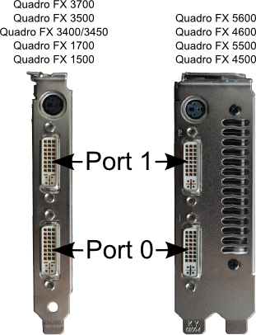
Figure 1 VizStack Display Output Numbering Convention

Configuring Tiled Displays

VizStack uses a “resource group” specification to define Tiled Displays, also known as “Display Walls”. A tiled display can be used to drive one/more displays from a single GPU, multiple displays from multiple GPUs on the same node, as well as GPUs spread across multiple nodes. Optionally, these displays could be running in stereo mode according to the capabilities of the display device. Additionally, Xinerama may be used over one or more GPUs – typically either for application compatibility, or to get a single large desktop. Finally, you may choose a rotation mode for all the display devices included in the tiled display.

VizStack currently does not provide any tool to configure a tiled display. You’ll need to edit the file /etc/vizstack/resource_group_config.xml to add definitions for tiled displays. After you define one/more tiled displays by editing this file, you need to follow it up by restarting the SSM.

VizStack supports many options to configure tiled displays. We explain common cases with examples.

A single tile

Figure 2 presents the simplest example of a tiled display. It is presented here for introducing the basic concepts.
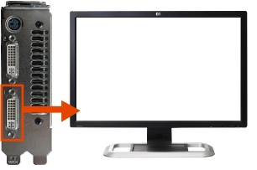
Figure 2 : A single tile "tiled display"

The XML in Figure 3 defines a tiled display called “simple” that drives a single “LP3065” monitor being using GPU-0 installed on the node named “node1”. Note that no specific mode is specified for the display device, so it will run at it’s default resolution and refresh rate – i.e. 2560x1600@60 Hz. Also, note the display is connected to Port 0 of the GPU.

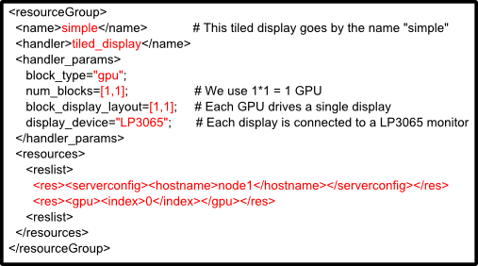
Figure 3 XML for single tile
The tiled display is called “simple”, so would use it the VizStack scripts by using the “-t” switch. E.g., you would use it with Avizo by using the command line

# viz_avizovr -t simple

The XML for this resource group defines the “handler” as “tiled_display”. Currently this is the only supported value. This means that the current resource group defines a handler of type “tiled display”.

The string inside handler_params defines the arguments for the tiled display. You have a choice of specifying one/more parameters here. The string is processed as a python code fragment, so you may specify various kinds of values (strings, lists, etc) inside the string. For reasons of security, function calls are not allowed inside the handler parameters.

You may specify all the parameters for the tiled display as variables inside handler_params, according to the table below.

Parameter Name | Parameter Type | Valid Values | Description
block_type | String | “gpu” | Specifies the basic building block of the Tiled Display. “gpu” is the only allowed value at the moment. Later versions of VizStack may allow usage of a quadroplex device as the basic building block.
num_blocks | [int,int] | [>=1,>=1] | Defines the arrangement of the blocks (i.e. GPUs) in this tiled display. Number of GPUs per row by number of GPUs per column.
block_display_layout | [int, int] |  | Defines how each GPU is configured to drive its displays. 2x1 means the two displays are side by side. 1x2 means the two displays are vertically aligned.
display_device | string |  | Name of the display device connected. All outputs are assumed to be connected to the same display device.
display_mode | string |  | Name of the display mode. E.g., 2560x1600_60
stereo_mode | string | “active”  “passive”  “SeeReal_ stereo_dfp”  “Sharp3D_ stereo_dfp” | If you want to enable stereo, then set this parameter to one of the valid values. If this is “passive”, then block_display_layout can only be [1,1], since the other GPU display output will be used for the alternate eye.
combine_displays | boolean | True  False | If True, then the Xinerama extension is used to combine all X server screens. This may result in low performance if multiple GPUs are used. Use this for either legacy applications or to get a large desktop
group_blocks | [int, int] | [>=1,>=1] | The arrangement of the GPUs per X server – number of cols by number of rows. This is used to group GPUs together, and specify their layout inside an X server.
remap_display_outputs | [int, int, [int]] | [0:noutputs, 0:noutputs ,[0:noutputs]] | Causes VizStack to change the order in which it drives the display output ports. See “Altering the order in which VizStack drives displays” for more information.
Work-in-progress options
one_screen_per_display | Boolean | False  True | Setting this to True will cause each display output to run on a separate X screen.
rotate | string | “none”  “portrait”  “inverted_portrait”  “inverted_landscape” | Define the physical orientation of the display devices. The same setting applies to all. This is implemented and works, but may not give expected results. This will be usable when “one_screen_per_display” is implemented

Displays in a 2x1 layout from a single GPU

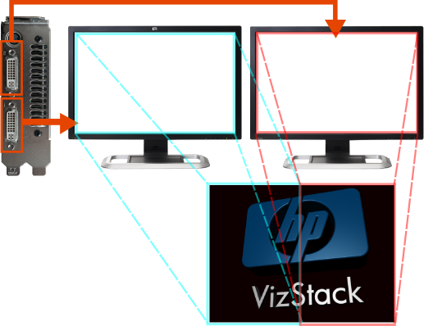
Figure 4 Two displays side by side from a single GPU

Figure 5 shows the XML corresponding to what is needed to drive two monitors side by side from a single GPU. The change needed to the XML, compared to the 2x1 case, is shown in red.
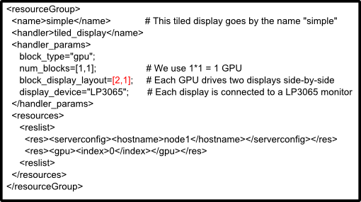
Figure 5 XML needed for 2x1 from a single GPU

Note that the two display outputs from the GPU are configured to drive a single large frame-buffer. To achieve this, the X server is configured to drive a single “screen” with the effective resolution of the two displays. Note that changing “block_display_layout” from [2,1] to [1,2] would result in the displays being setup one below the other.

Displays in a 2x2 layout from two GPUs on the same node
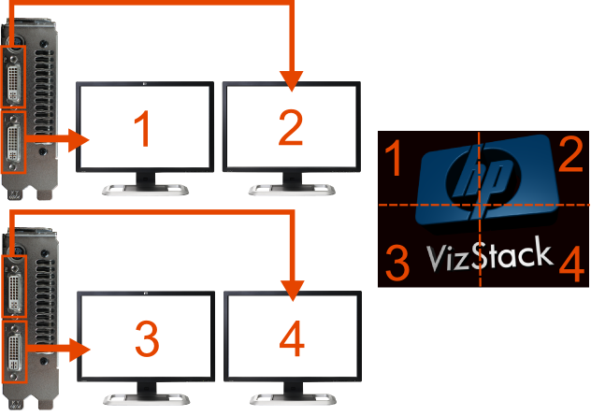
Figure 6 Four displays in a 2x2 configuration

The differences between this configuration and the 2x1 configuration are highlighted in red. Note that num_blocks gets a new value equal to [1,2]. Note that we also ask for an extra GPU, GPU #1 on “node1”.

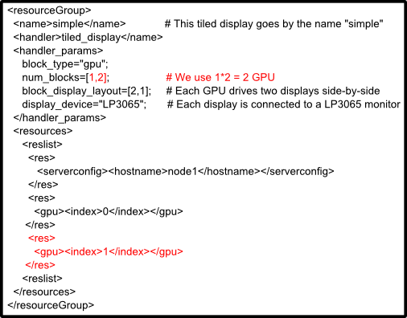
Figure 7 XML for 2x2 layout from two GPUs on the same node

2x2 layout from two GPUs from two nodes
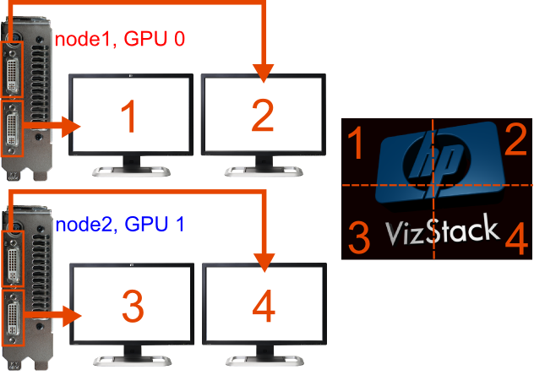
Figure 8: 2x2 layout from two separate nodes

In this configuration, two nodes “node1” and “node2” are driving the 4 displays, two each from one GPU on each node. The changes needed to the XML are shown in red & blue. Note that the GPUs on the nodes are not at the same location; node1 uses GPU0 and node2 uses GPU1.

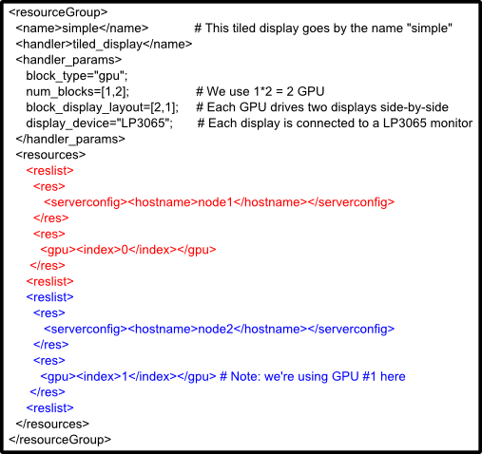
Figure 9 XML needed for 2x2 layout from two separate nodes

2x1 layout from two GPUs on two nodes

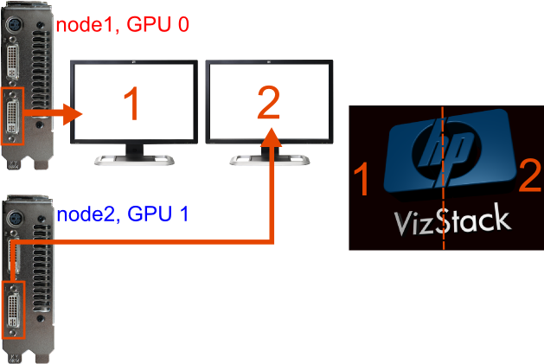
Figure 10 2 GPUs from 2 nodes driving a 2x1 layout

Figure 10 shows how to drive two display devices from two nodes, in a side by side layout. The changes needed in the XML (compared to the previous example) are shown in red in Figure 11. block_display_layout is now set to [1,1] to indicate that 1 display will be driven by each GPU. num_blocks is changed to [2,1] to indicate the horizontal layout.

Note that changing num_blocks to [1,2] would convert this into a 1x2 vertical layout.
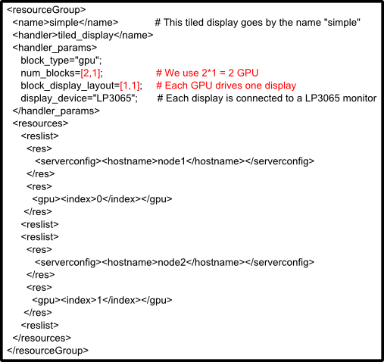
Figure 11 XML needed to drive a 2x1 display from two GPUs on two nodes

Altering the order in which VizStack drives displays

GPU managed by VizStack may have 2 (FX5600, etc) or 3 display outputs(FX5800, etc). In all the examples till now, the displays have been driven from the graphics card output ports in a certain order. E.g., if you set display_block_layout to [2,1], then you effectively ask for Display Output 0 to be connected to a display device and Output 1 to be connected to a display device that is positioned to the right of the other display.

Sometimes, you may want to change this order. For instance, if you have a console attached to Display Output 0, you would want to avoid VizStack from displaying the output on port 0. Another reason could that you want to use a rectangular tiled display in various ways without modifying the wiring.

VizStack’s tiled displays support a parameter “remap_display_outputs”, which lets you do this. “remap_display_outpus” is a list of port numbers. VizStack sends the output normally intended port port #n to the port specified by the nth element in the list.

Some illustrative examples follow
Value of  remap_display_outputs | Effect
[0,1] | No effect.
[1] | Display that would have normally have been driven via port 0 is driven via port 1. Refer to “Using Display Output 0 as a console” for an example usage.
[1,0] | Output normally sent to port 0 is sent to port 1, and output that would have been sent to port 1 is sent to port 0. Essentially, this swaps the positions of the two displays.
[1,2] | Send the display output normally sent to port 0 to port 1, and output normally send to port 1 to port 2. This effectively lets you drive a passive stereo pair from a single FX 5800, while still leaving the console free to be used otherwise. Note that port #2 is only available on the FX 5800, 4800, 3800 and 1800

Note that “remap_display_outputs” can only have as elements as needed for the specified block_display_layout. Alternatively, remap_port_index must have exactly block_display_layout[0]*block_display_layout[1] elements. So, if you have display_block_layout=[2,1], you'll need to have exactly two elements in remap_port_index.

Using Display Output 0 as a console

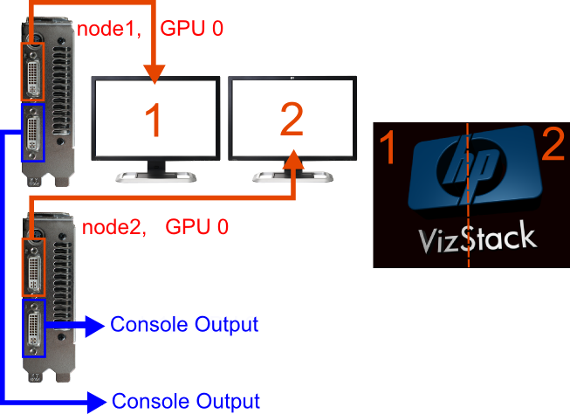
Figure 12 2x1, while using Display Output 0 as the console

Consider that setup in Figure 12, where you have two systems, each with 1 GPU (more is possible too). And you want to use display output port 0 of each of them as a system console. This case could happen on a workstation. Display Port 0 is typically used by the BIOS for output. When the kernel comes up, it also tends to use the same. You would have connected the console output to some low-end device, e.g. a KVM dongle. Naturally you want to avoid using it as a display output. You’d use the parameter “remap_display_outputs” to get around this problem, as shown in the XML in Figure 13.
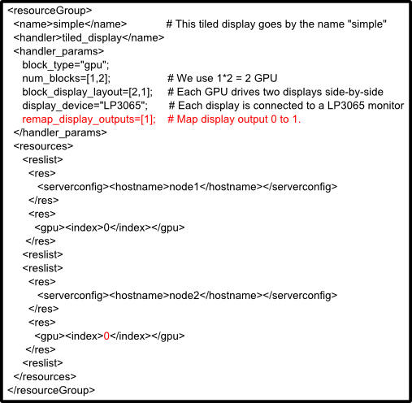
Figure 13 XML needed to avoid usage of display output 0

Using a 4x2 tiled display in multiple ways without recabling

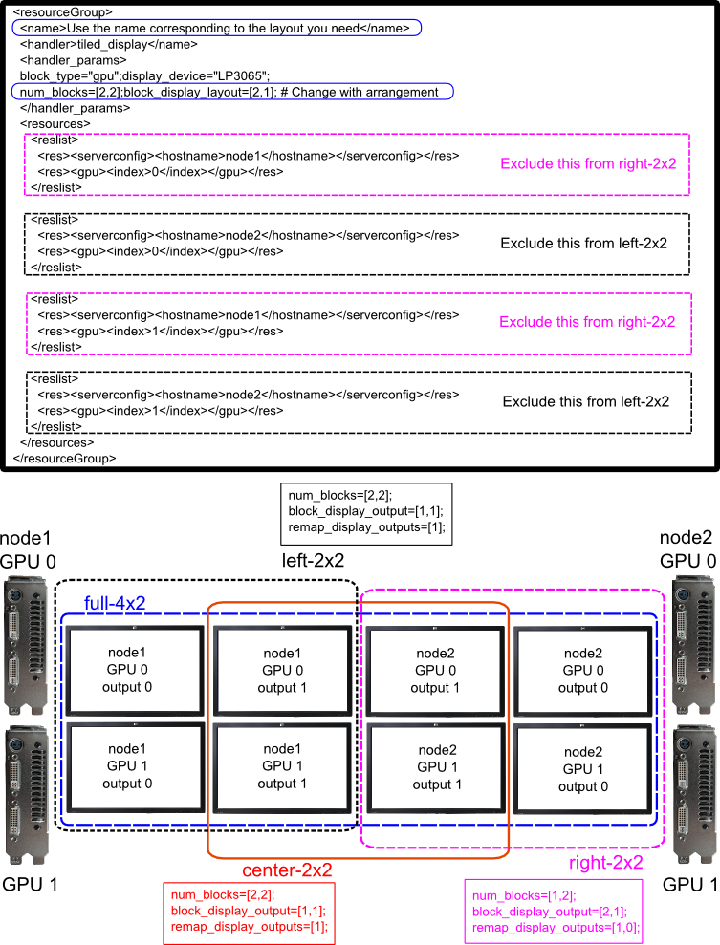

Figure 14 Using a 4x2 tiled display in a variety of ways

Typically, the cabling from the graphics cards to the displays is fixed and cannot be changed. Figure 14 shows a fairly non-standard scenario. We have two nodes, each with two GPUs. They are connected to a 4x2 tiled display, consisting of 8 HP LP3065 monitors. The user wants to use the displays in 3 different ways (more are possible, but these 4 are enough to demonstrate the principles).
- left-2x2 : Left half using all GPUs on node1
- right-2x2 : Right half using all GPUs on node2
- center-2x2: 2x2 tiles in the center, but using all GPUs.

Note that the four displays on the right are wired in a slightly different way : output port 0 is connected to the monitor on the right, and ouput port 1 is connected to the monitor on the left. Figure 14 shows the XML & the parameters needed to achieve each different scenario as well.

Note that, with this arrangement, the whole 4x2 (called “full-4x2”) display cannot be addressed together as a large display. So using such layouts is not recommended. However, the whole 4x2 can be used if the user is willing to modify application scripts to address this specific scenario.

Using Display Devices with VizStack

In-built Display Device Support

The following display devices have built-in definitions defined in VizStack
- HP LP3065
- HP LP2065
- Tridelity MV 2700. This is Tridelity’s 27” multi-view autostereoscopic display. This is internally based on a Samsung SyncMaster display.
- HP AVO Smart Cable; this is HP’s standard KVM dongle
- HP L1955
- Sony SRX PJ

Using other display devices will need you to configure them specifically for VizStack.

Configuring site-specific Display Devices
VizStack can be configured to use a variety of display devices: Stereo Projectors, TFT monitors, CRT Monitors, and in general in any display device. VizStack comes with built-in definitions for a few display devices. If VizStack already defines a template for your display device, then you are in luck. Otherwise, don’t worry – it’s not hard to setup VizStack to use your display device.

Before VizStack can use a specific kind of display device, you need to create what is called a display device template for it. Creating the display device template lets you define settings for a display device once and reuse the settings later for any number of display devices of the same kind.

Most display devices can describe their capabilities to a graphics card, using a data structure called Extended Display Identification Data (EDID). The graphics card uses this information to determine what modes are supported on the display device, as well as to compute the display signal timing for the supported modes.

If a graphics card is directly connected to a display device (using either a VGA or DVI cable), then the graphics card will get access to the EDID. If the connection is made a DVI extender, then the graphics card may not have access to the EDID. DVI extenders come in two types: ones that support DDC (Display Data Channel) protocol and once that don’t. If you use a DVI extender which supports DDC, then you may treat the connection as a local connection. If your DVI extender does not support DDC, then you will need to get the EDID of the display device manually.

One way to get the EDID is to use a laptop with Windows installed on it. Connect the display device to the laptop, and configure Windows to enable/drive it. Make sure that windows can detect the details of the display device (name of the device, etc). The next step is extracting the actual EDID information about the device. One way to get the actual EDID data is by downloading the softMCCS tool (available from http://www.entechtaiwan.com/lib/softmccs.shtm). To extract the EDID file for the connected display,
- run softMCCS.

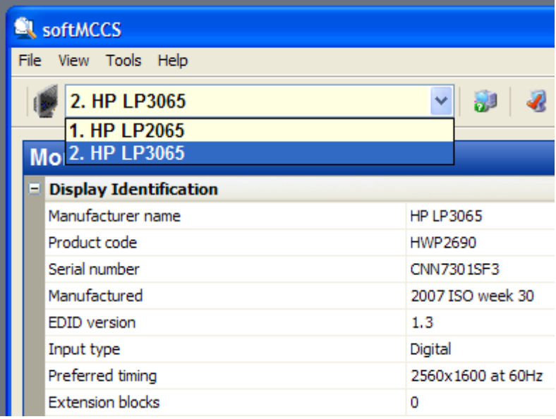
- Select the display device that you connected on the drop down list
- Select File | Save As … and save the file at a convenient location
- Copy the file over to the master visualization node. If you use FTP, then ensure that you copy the file as a binary file.
After you get an EDID file, then you need to create an XML template file for the display. Examples are it /etc/vizstack/templates/displays. Note that the display templates need to be propagated to each node, and need to be available at the same path on all the nodes.

The VizStack Python API

A major part of VizStack is the API. This API is written in the popular programming language, Python. This API is used heavily in VizStack. All application scripts, as well as the remote access scripts are written using it.

- The VizJob API exposes an object oriented interface to work with visualization resources. VizStack treats a system as a collection of the following types of visualization resources GPUs (Graphics Processing Units) : discrete QuadroFX cards, as well as GPUs inside QuadroPlexes
- SLI bridges: discrete SLI bridges, and each QuadroPlex has one/two (Note: this is not available at this time)
- Input Devices : keyboards, mice
- X Servers : ‘normal’ and virtual X servers

These resources are exposed directly to programmers using the vsapi. Using the vsapi, a programmer can
- Allocate a set of resources constituting a visualization job
- Free the resources when they are no longer needed
- Determine what resources are allocated to which jobs.
- Configure X servers in a way that matches application needs
  - with one or more screens
  - each screen can control one or more GPUs
  - GPUs can be configured to drive display devices configured with VizStack
  - SLI modes, stereo can be setup (Note: not at this time)
  - Optionally, a keyboard and mouse can be used as input devices
  - all resources can be configured independently of each other
- Start and stop X servers when needed
  - more than one X server can be run used on a node
- Run application components on chosen X servers/screens
- Enable/disable frame lock
- Query VizStack's system configuration. This allows an application to enumerate all available resources, and determine what resources may be suitable for the application.
- Query runtime configuration

The VizStack scripts viz_rgs, viz_tvnc, and viz_avizovr use the VizStack API, and serve as examples of usage. Documentation for the API can be obtained using regular python mechanisms.
Example of getting documentation on the python command line
>>> import vsapi
>>> help(vsapi.ResourceAccess)
>>> help(vsapi.Server)
>>> help(vsapi.GPU)
>>> help(vsapi.Screen)

The directory “/opt/vizstack/share/samples” contains many commented examples that use the vsapi in a variety of interesting ways.

Workstations may be configured with ATI graphics cards as well, so this is mentioned explicitly. At this time, ProLiant servers are being qualified only with nVidia graphics cards.

