4.5

1. ****so b1=[1 -2] and a1=[1 1.5 0.5].

B.

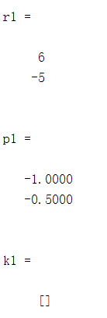

Using **residue()** we get r1=[6;-5] and p1=[-1;-0.5]. So we can write the partial fraction expansion of ****. After recombine it we get the same answer as part(a).

c.****Using inverse Fourier transform we get 

and because ****,it is absolutely integrable.

1. ****so b1=[3 10 5] and a1=[1 7 16 12].

E.

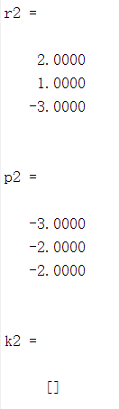

Using **residue()** we get r2=[2;1;-3] and p2=[-3;-2;-2]. So we can write the partial fraction expansion of ****. After recombine it we get the same answer as part(a).

F.****Using inverse Fourier transform we get 

and because ****it is absolutely integrable.

G.****so b1=[-4] and a1=[1 0 -4].

H.

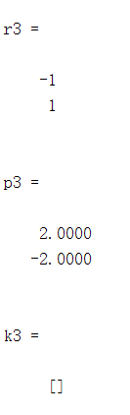

Using **residue()** we get r3=[-1;1] and p3=[2;-2]. So we can write the partial fraction expansion of ****. After recombine it we get the same answer as part(a).

1. ****Using inverse Fourier transform we get 

and because ****it is absolutely integrable. It is not causal because when t<0, h3(t) does not equal to zero.