Contents

1 Introduction 2

1.1 Why Choose Mobile Games 2

1.2 Why Choose Puzzle Game 2

2 App Development Phase 3

2.1 Choose Mobile Development Platform 3

2.2 Design Puzzle Game Algorithm 4

2.3 Design Interface 5

3 App Test Phase 5

3.1 Play Puzzle Game 5

3.2 Run Puzzle Game on IPad 6

4 Future Developments 6

5 Conclusion 7

6 Reflection of reports writting 8

7 References 8

**Puzzle Game Based on iOS**

# 1 Introduction

With technology development, the popularity of mobile applications has soared over the last few years. Among these mobile applications, applications of video games played on mobile device take up the largest amount that the publics use in daily life.

## Why Choose Mobile Games

Today, according to a new study from The NPD Group, the average number of time that mobile users cost to play mobile games has grown 57 percent since 2012. In addition, nearly 9 percent of them became a new mobile gamer in the past year by playing games on a recently acquired tablet. As a result, this data shows that mobile games are very popular among the publics. With analyzing this data, there are reasons why mobile games are so attractive.

First of all, one reason is that they are so easy to play. No matter what types they may be, such as puzzle, simulation, adventure, arcade or action, the rules of play are usually simple. Besides, they often involve basic tasks such as matching, pointing and shooting, and managing time. Therefore, both adults and children can pick them up with no special skills needed. Furthermore, because mobile games can be played over short bouts of time, people find them can be quite convenient stress relievers on public transport and during breaks from works.

Thus, based on the market research of mobile applications, our team decided to design a mobile game because these is a large potential market to promote it, and we can provide entertainment for people who need to relieve stress.

## 1.2 Why Choose Puzzle Game

Puzzle game as one of genres of video game mainly focus on puzzle solving. These puzzles in puzzle game often require many problem solving skills, including logic, pattern recognition, sequence solving, and word completion.

For reasons mentioned above, this type of game can easily raise people’s interests and attract for people at different ages. Thus, our team hopes to design a puzzle game based on iOS, because it can be widely accepted by the publics and the challenge we might meet will improve our coding skills.

# 2 App Development Phase

## 2.1 Choose Mobile Development Platform

First, for the case of building a puzzle game based on iOS, we choose objective-c to program, because it is the primary programming language that writes software for OS X and iOS.

Secondly, we use xcode to code, test, and emulate the puzzle game. Xcode is an [integrated development environment](https://en.wikipedia.org/wiki/Integrated_development_environment) (IDE) containing a suite of [software development](https://en.wikipedia.org/wiki/Software_development) tools developed by [Apple](https://en.wikipedia.org/wiki/Apple_Inc.) for developing software for [OS X](https://en.wikipedia.org/wiki/OS_X) and [iOS](https://en.wikipedia.org/wiki/IOS).



Then, we choose framework of cocos2d to design the puzzle game. Cocos2d is an open source software framework. It is the world’s No.1 open-source game development platform. Generally, it can be easily used to build games, apps.



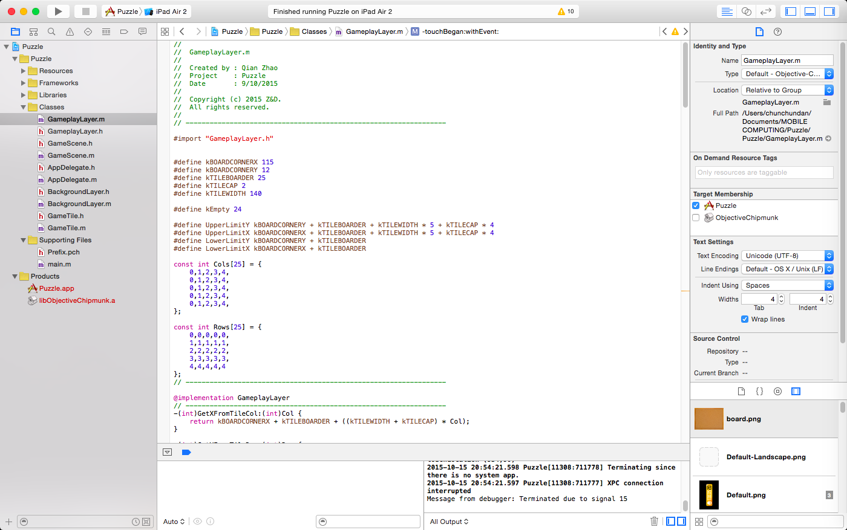

## 2.2 Design Puzzle Game Algorithm

The advantages of cocos2d game engine is that it is a well structured platform. It consists of CCScene, CCNode and CCSprite.

Scene is the main components for game to to load all the layers of a 2d game you need here is defined as a CCNode. And the CCSprite is a functional element that inherit from CCNode which can save images, audio, video etc.

Therefore, the main structure of our designed game as shown in following figure:

GameScene

CCdirector

TileLayer

BoardLayer

## 

There is only one game scene in our application, we didn’t use menu scene in this prototype to make the structure of this app much easier to achieve. Our game scene includes two layers (created by CCNode). The BoardLayer is just a picture load from the inner resources folder. As illustrated in figure it was aligned in the lower layer. The main functional layer which is tilegame layer. We load all the tile picture sprites into this layer. Tile gamelayer lay above the boardlayer thus when we enable touch to drag all the tiles pictures above the board. Touch listener of cocos2d set default listen from from layer and we disabled touch interaction (self.userInteractionEnabled = NO)of the board in case it affected the normal touch function of tile. The CCDirector mainly deal with the main windows and view.

Algorithm inside tile game layer is:

split image and render to the whole board by carefully calculation of board.

Enable touchbegun and touchmove and confine touches inside board.

The function triggered by click on tile rect

Make animation by drag tile from current location to the empty rect location

kBOARDCORNERX + kTILEBOARDER + ((kTILEWIDTH + kTILECAP) *Col);

kBOARDCORNERY + kTILEBOARDER + ((kTILEWIDTH + kTILECAP) *Row);

where kBOARDCORNERX is the x coordinate of boad inner corner, kTILEBOARDER is the thickness of board boundary, ktitlewidth is the width of tile and ktitlecap is the

The tile aligned by the above function to yield the colomn and row position of each tile rect (also including empty rect for tile further to move in). By taking the animation from a moveable tile to the empty rect we can complete the basic rules of tiles on the board.

We use a function follow the rules and move tiles randomly to shuffle the board for user to play and a reset function when user cannot solve the puzzle he can restart and shuffle again.

We also add sound effect and winner picture to award user’s success in solving the puzzle. All sounds file were added by the singleton OALSimpleAudio.

## 2.3 Design Interface

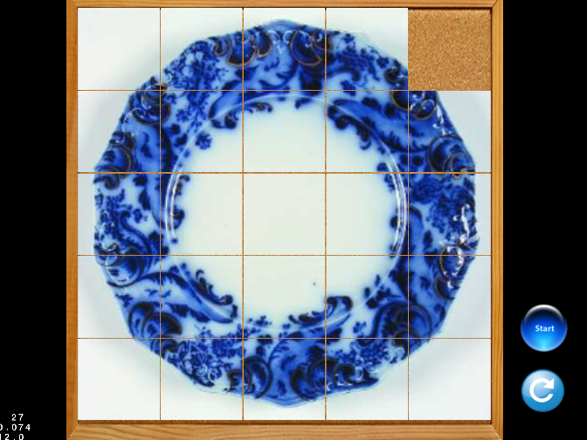

Just as shown the interface design is quite simple and direct. User can enter the play scene directly start and reset board all from this interface.

# 3 App Test Phase

## 3.1 Play Puzzle Game

* **Touch Play Button**

Before users touch play button, all the blocks listed will show an entire image of the original picture. When players start to play, the order of each block will change.

During the period of playing, players need to move blocks. When there is a blank around a block, this block can be moved to the blank place.

For finishing the puzzle game, few steps are needed to move the block till all the blocks stand in the original order, which means customer can see the entire picture of what they puzzle.

* **Touch Reset Button**

When customers think it is hard to finish the puzzle game, they can touch reset button to restart playing the game.

## 3.2 Run Puzzle Game on IPad

Please refer to demo video.

# 4 Future Developments

For optimize users’ experience of puzzle game, our team hope to add some features on it in the future.

* Log in Facebook: share the score of game

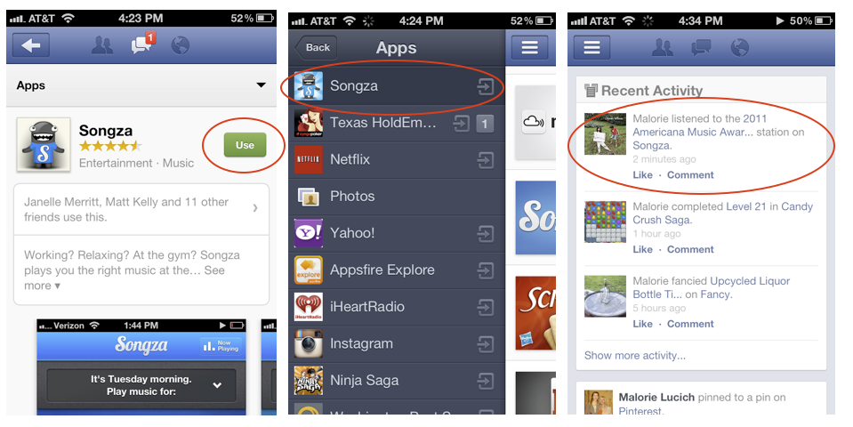

* Log in Game Centre: rank in the list

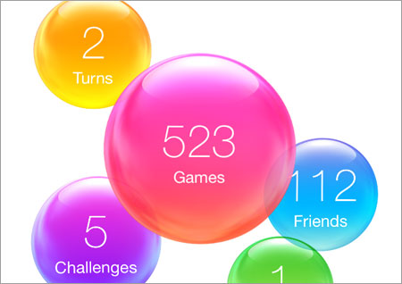

* Log in Instagram: pick up photo from gallery of Insgram to be the puzzle picture



# 5 Conclusion

We complete the prototype of the sliding puzzle game on iOS system. We achieved the main functionality. We have learnt cocos2d framework to develop our application. This is a huge challenge for us. If we can more familiar with this system, we could be able to add more features to this game. We will make our effort to accomplish this game.

# 6 Reflection of reports writting

Qian(430564266) wrote the App Development Phase and the rest was written by Chunchun (440473116).

# 7 References

1.Gavalas, Damianos; Economou, D., "Development Platforms for Mobile Applications: Status and Trends," in Software, IEEE , vol.28, no.1, pp.77-86, Jan.-Feb. 2011

2.Jon-Chao Hong, Ming-Yueh Hwang, Ker-Ping Tam, Yi-Hsuan Lai, Li-Chun Liu, Effects of cognitive style on digital jigsaw puzzle performance: A GridWare analysis, Computers in Human Behavior, Volume 28, Issue 3, pp.s 920-928, May 2012

3.Lima, J.P.; Teixeira, J.M.; Teichrieb, V., "RGB-D Based Detection of Texture-Less Planar Objects Applied to an AR Jigsaw Puzzle," in Virtual and Augmented Reality (SVR), 2014 XVI Symposium on , vol., no., pp.80- 88, 12-15 May 2014

4.Diah, N.M.; Ismail, Marina; Ahmad, S.; Syed Anwar Shahrim Syed Abdullah, "Jawi on Mobile devices with Jawi wordsearch game application," in Science and Social Research (CSSR), 2010 International Conference on , vol., no., pp.326-329, 5-7 Dec. 201